PREDICTIVE ANALYSIS OF STOCK PRICES USING MACHINE LEARNING TECHNIQUES

A PROJECT BASED LEARNING REPORT
Submitted by
SRIJITH
RISHI
Submitted in partial fulfilment of the requirement
for the
Project Based Learning component of Machine Learning

BACHELOR OF TECHNOLOGY
In
COMPUTER SCIENCE AND BUSINESS SYSTEMS

CHENNAI INSTITUTE OF TECHNOLOGY, CHENNAI 
Affiliated to Anna University, Chennai
(Autonomous)
i
OCTOBER 2026

Vision of the Institute:
To be an eminent centre for Academia, Industry and Research by imparting knowledge, relevant practices and inculcating human values to address global challenges through novelty and sustainability.

Mission of the Institute:
IM1. To creates next generation leaders by effective teaching learning
methodologies and in still Scientifics Park in them to meet the
global challenges.
IM2. To transform lives through deployment of emerging technology, novelty
and sustainability.
IM3. To inculcate human values and ethical principles to cater the societal needs.
IM4. To contributes towards the research ecosystem by providing a suitable,

ii
DEPARTMENT OF COMPUTER SCIENCE AND ENGINEERING (COMPUTER SCIENCE AND BUSINESS SYSTEMS)
Vision of the Department:

To be a Centre of excellence in computing and business systems by integrating technology, analytics, innovation, and human values to develop globally competent professionals who drive sustainable and ethical business solutions.

Mission of the Department:
DM1. To impart holistic education integrating computer science concepts, business systems, and analytical skills through innovative teaching-learning methodologies.
DM2. To develop competent professionals capable of leveraging emerging technologies to address contemporary issues in business and societal challenges through innovation and sustainability.
DM3. To inculcate ethical values, professionalism, and social responsibility among students to contribute effectively to the society.
DM4. To strengthen the research and innovation ecosystem by fostering collaboration with academia, industry, and R&D establishments.
DM5. To promote entrepreneurship, leadership, and continuous learning through skill development, industry immersion and incubation.
To provide strong fundamentals and technical skills for Computer Science
applications through effective teaching learning methodologies.
DM2. To transform lives of the students by nurturing ethical values, creativity and novelty to become Entrepreneurs and establish start-ups.
DM3. To habituate the students to focus on sustainable solutions to improve the
quality of life and the welfare of the society.
iii

BONAFIDE CERTIFICATE
This is to certify that the Project–Based Learning report titled PREDICTIVE ANALYSIS OF STOCK PRICES USING MACHINE LEARNING TECHNIQUES is a Bonafide record of work carried out by SRIJITH - 210425244059 and RISHI - 210425244048 of the Department of Computer Science and Business Systems, Chennai Institute of Technology, as part of the continuous, mentor–guided Project-Based Learning (PBL) component of the Machine Learning course during the academic year [2026–2027] under my supervision
SIGNATURE  Mr. G. Senthil Kumar M.Tech.,(Ph.d).,  Head of the Department,  Dept. of Computer Science  and Business Systems  Chennai Institute of Technology,  Chennai – 69. | SIGNATURE  Dr. B. Sundarambal, Ph.D.,  Professor,  Dept. of Computer Science and Business Systems  Chennai Institute of Technology,  Chennai – 69.
Submitted for the final review held on …………………….

Internal Examiner External Examiner
iv
DECLARATION
We jointly declare that the PBL report on PREDICTIVE ANALYSIS OF STOCK PRICES USING MACHINE LEARNING TECHNIQUES is the result of original work done by us and best of our knowledge, similar work has not been submitted to “ANNA UNIVERSITY, CHENNAI” for the requirement of Degree of BACHELOR OF TECHNOLOGY. This PBL report is submitted on the partial fulfilment of the requirement of the award of Degree ofCOMPUTER SCIENCE AND ENGINEERING (COMPUTER SCIENCE AND BUSINESS SYSTEMS)

Signature

[SRIJITH]

[RISHI]
Place: Chennai
Date
v
ACKNOWLEDGEMENT
We wish to express our sincere gratitude to our honorable Chairman SHRI. P. SRIRAM for providing immense facilities at our institution.
We are very proudly rendering our thanks to our Principal Dr.A.RAMESH M.E, Ph.D., for the facilities and the encouragement given by him to the progress and completion of our project.
We would like to express special thanks of gratitude to our Dean Dr. V. SRINIVASA RAO, M.E., Ph.D., who has been the key spring of motivation to us throughout the completion of our course and project work.
We proudly render our immense gratitude to the Head of the Department Mr. G. Senthil Kumar M.Tech., (Ph.d.,) for his effective leadership, encouragement and guidance in the project.
We would like to extend our thanks to the Project Co-ordinator Dr.P.AURCHANA M.Tech.,Ph.d., Professor, Department of Computer Science and Engineering, for their valuable suggestions throughout this project.
We express our sincere gratitude to our project mentor Dr. B. Sundarambal, Ph.D., Professor, Department of Computer Science and Business Systems, for her continuous guidance, valuable feedback and encouragement at every stage of this project.
We wish to acknowledge the help received from the class advisors Dr.N.KIRUBAKARAN , Associate Professor, of the Department of Computer Science and Business Systems and others for providing valuable suggestions and for the successful completion of the project.
SRIJITH - 210425244059
RISHI - 210425244048
ABSTRACT
vi
Forecasting the direction of a stock market index is a widely studied but difficult machine learning problem, because daily price movements are noisy and markets adapt quickly to new information. This project develops a machine learning system that predicts whether the NIFTY 50 index will close higher (UP) or lower (DOWN) on the next trading day and also estimates the next-day closing price. Daily open, high, low, close and volume data for 3,601 trading days (February 2012 to September 2026) are converted into technical indicators such as moving-average ratios, Relative Strength Index, Moving Average Convergence Divergence, volatility and volume features. The study applies all five units of the Machine Learning course: bias–variance analysis; linear regression by least squares and gradient descent, logistic regression, Naive Bayes, Support Vector Machine, decision tree and random forest; gradient boosting, a voting ensemble, K-Nearest Neighbours and K-Means market-regime clustering; a tuned Multilayer Perceptron; and walk-forward cross-validation with bootstrap confidence intervals, McNemar's test and the paired t-test. A Random Forest selected by walk-forward cross-validation (mean ROC-AUC 0.554) reached 52.32% accuracy and a ROC-AUC of 0.530 on a 711-day hold-out period, which is not statistically different from the 52.60% majority-class baseline (McNemar p = 0.95). The results show that daily NIFTY 50 direction is only weakly predictable from price-based indicators and that rigorous, time-ordered evaluation is essential to avoid overstated accuracy. The complete system is delivered as a menu-driven command line application.

Keywords:
Stock Market Prediction, NIFTY 50, Technical Indicators, Random Forest, Support Vector Machine (SVM), Multilayer Perceptron (MLP), K-Means Clustering, Walk-Forward Cross-Validation, McNemar's Test, Machine Learning (ML)
vii
v
vii
TABLE OF CONTENTS
viii
Chapter No | Title | Page No
1 | INTRODUCTION
 | 1.1 Background | 1
 | 1.2 Driving Questions | 2
 | 1.3 Objectives | 2
 | 1.4 Scope and Limitations | 2
2 | LITERATURE SURVEY
 | 2.1 Related Approaches | 4
 | 2.2 Summary Table | 5
 | 2.3 What This Told Us? | 6
3 | PROJECT PLANNING AND TEAM ORGANISATION
 | 3.1 Weekly PBL Progress Log | 7
 | 3.2 Requirements | 8
 | 3.3 Feasibility | 8
4 | ITERATIVE DESIGN AND DEVELOPMENT
 | 4.1 System Architecture | 9
 | 4.2 Iteration 1 - Baseline | 10
 | 4.3 Iteration 2 - Refinement | 11
 | 4.4 Final Approach | 12
 | 4.5 Training Procedure | 12
5 | IMPLEMENTATION
 | 5.1 Module Description | 14
 | 5.2 Key Code Snippets | 15
 | 5.3 User Interface/Demo (if Applicable) | 22
6 | RESULTS AND DISCUSSION
 | 6.1 Evaluation Metrics | 28
 | 6.2 Results Across Iterations | 29
 | 6.3 Discussion | 33
 | 6.4 Limitations | 33
7 | TEAM REFLECTION AND LEARNING OUTCOMES
 | 7.1 Individual Reflections  7.2 Team Learning | 34  34
 | 7.3 Course Outcomes – Evidence Summary | 35
8 | CONCLUSION AND FUTURE SCOPE
 | 8.1 Conclusion | 36
 | 8.2 Future Scope | 36
 | REFERENCES | 37
 | APPENDIX
 | A.2 Self and Peer Assessment | 39

ix
LIST OF FIGURES
Figures No | Title of the Figure | Page No
4.1 | System Architecture Diagram | 10
5.3.1 | Main Menu of the CLI Application | 22
5.3.2 | Dataset Overview | 23
5.3.3 | Model Training and Comparison | 24
5.3.4 | Full ML Study Output | 25
5.3.5 | Market Regime Detection using K-Means | 26
5.3.6 | Price and Trend Prediction | 27
6.2(a) | Model Performance Comparison | 30
6.2(b) | Confusion Matrix | 30
6.2(c) | ROC Curve | 31
6.2(d) | Bias–Variance Trade-off | 31
6.2(e) | Actual vs Predicted Closing Price | 32

x

LIST OF TABLES
Table No | Title of the Table | Page No
2.2 | Literature Survey | 5
3.1 | Weekly PBL Progress Log | 7
3.2 | Hardware and Software Requirements | 8
6.2 | Results Across Iterations | 29
6.3 | Next-Day Closing Price Prediction Results | 32
6.4 | Statistical Significance Tests | 32
7.2 | Course Outcomes | 35
A.1 | Self and Peer Assessment | 39

xi
LIST OF ABBREVIATIONS
ML Machine Learning
NSE National Stock Exchange of India
OHLCV Open, High, Low, Close and Volume
SMA Simple Moving Average
EMA Exponential Moving Average
RSI Relative Strength Index
MACD Moving Average Convergence Divergence
ATR Average True Range
SVM Support Vector Machine
RF Random Forest
KNN K-Nearest Neighbours
MLP Multilayer Perceptron
CV Cross-Validation
ROC-AUC Area Under the ROC Curve
MCC Matthews Correlation Coefficient
MAE Mean Absolute Error
RMSE Root Mean Squared Error
PBL Project-Based Learning
CLI Command Line Interface
CSV Comma-Separated Values
xii

CHAPTER 1

INTRODUCTION

1.1 Background

Stock markets play a central role in the Indian economy, and the NIFTY 50 index of the National Stock Exchange (NSE) tracks fifty of the largest and most liquid Indian companies. Investors, traders and fund managers constantly try to anticipate whether the market will rise or fall, because even a small but reliable edge in predicting direction can influence trading and risk-management decisions. Daily index movements, however, are driven by economic news, global markets, interest rates, investor sentiment and many other factors, which makes them highly noisy and difficult to forecast.

Traditional approaches to market forecasting rely on technical analysis, in which analysts read charts and indicators such as moving averages, the Relative Strength Index and the Moving Average Convergence Divergence, or on fundamental analysis of company and economic data. These methods are often subjective and difficult to test systematically. Machine learning offers an alternative by learning the relationship between historical indicator values and future price movements directly from data. Classical algorithms such as Linear and Logistic Regression, Naive Bayes, Support Vector Machine, Decision Tree and Random Forest, ensemble methods such as boosting and voting, and neural networks such as the Multilayer Perceptron can all be trained on the same features and compared objectively.

A major challenge is that financial time series are non-stationary and close to random at the daily horizon, as suggested by the Efficient Market Hypothesis. A model that is evaluated with a random train-test split, or that is selected using the test data, can report misleadingly high accuracy. This project therefore builds a complete, time-ordered machine learning pipeline for NIFTY 50 next-day direction prediction, compares models from all five units of the Machine Learning course against a simple majority-class baseline, and uses statistical tests to check whether any observed improvement is genuine. The system is implemented as an interactive command line application.

1.2 Driving Question

Can machine learning models trained on historical price and volume indicators predict the next-day direction of the NIFTY 50 index more accurately than a simple baseline, when they are evaluated in a strictly time-ordered and statistically sound way?

The project focuses on developing a command line application that downloads or loads NIFTY 50 daily data, engineers technical indicator features, trains and compares regression, classification, ensemble, clustering and neural network models, and predicts whether the next trading day will close UP or DOWN together with a probability. It also estimates the next-day closing price and reports the statistical significance of the results.

1.3 Objectives
The major objectives of the project are:
- To collect NIFTY 50 daily OHLCV data and engineer leakage-free technical indicator features for next-day prediction.
- To develop and compare regression, classification, ensemble, clustering and neural network models covering all five units of the Machine Learning course.
- To evaluate the models using walk-forward cross-validation, a time-ordered hold-out period and metrics such as Accuracy, Balanced Accuracy, F1-score and ROC-AUC, and to test significance against a majority-class baseline.
- To develop an interactive command line application for data exploration, visualisation, model comparison, price prediction and next-day trend prediction.

1.4 Scope and Limitations
Scope
The project focuses on predicting the next-day direction (UP or DOWN) of the NIFTY 50 index using machine learning, together with an estimate of the next-day closing price. The system uses daily open, high, low, close and volume data and computes features such as returns, moving-average ratios, RSI, MACD, Bollinger %B, Average True Range, volatility and volume z-scores. The project includes Linear Regression (least squares and gradient descent), Logistic Regression, Naive Bayes, Support Vector Machine, Decision Tree, Random Forest, K-Nearest Neighbours, Gradient Boosting, a soft voting ensemble, K-Means and Gaussian Mixture clustering for market regimes, and a tuned Multilayer Perceptron. Models are compared using walk-forward cross-validation and a 711-day hold-out period, and the final model is selected by cross-validated ROC-AUC. Bootstrap confidence intervals, McNemar's test and the paired t-test are used to judge whether the results are statistically meaningful.
Overall, the scope of the project extends beyond training a single model by providing a reproducible experimental framework that maps every stage of the pipeline to a unit of the Machine Learning syllabus and reports results honestly against a baseline.
Limitations
The system uses only the price and volume history of the index itself; it does not use news, global market data, macroeconomic variables or investor sentiment, which also drive market movements. Daily direction is close to random, and the selected model does not achieve a statistically significant improvement over the majority-class baseline on the hold-out period. The models are trained on data from 2012 to 2023 and may behave differently in future market conditions. Transaction costs and slippage are not modelled, so the application is not a trading system and its predictions must not be used as investment advice. Live data download depends on the Yahoo Finance service through the yfinance library; an offline copy of the dataset is bundled for reproducibility.

CHAPTER 2

CONCEPT EXPLORATION

2.1 Related Approaches

2.1.1 Classical Machine Learning Approaches

Early studies on stock direction prediction used classical machine learning algorithms with technical indicators as inputs. Huang et al. [3] showed that Support Vector Machines forecast the weekly direction of the NIKKEI 225 better than discriminant analysis and back-propagation neural networks, and Patel et al. [1] compared Artificial Neural Networks, SVM, Random Forest and Naive Bayes on the CNX Nifty and S&P BSE Sensex indices. These models are simple to implement and interpret, and they provide a strong baseline before more complex models are introduced.

2.1.2 Ensemble and Deep Learning Approaches

Ensemble methods combine many learners to reduce variance or bias. Ballings et al. [4] found that ensembles such as Random Forest outperformed single classifiers for stock direction prediction, and Krauss et al. [5] combined deep neural networks, gradient-boosted trees and random forests on S&P 500 stocks. Fischer and Krauss [6] applied Long Short-Term Memory networks to the same market, while noting that the predictive edge weakened in later years as markets became more efficient.

2.1.3 Market Efficiency and Market Regimes

The Efficient Market Hypothesis [9] states that prices quickly reflect available information, which implies that past prices alone should have little power to predict future returns. Large-scale studies such as Gu et al. [8] find that machine learning can still extract small but real signals, but the achievable accuracy for short-horizon direction is usually only slightly above 50%.

Markets also move through different states, such as calm uptrends and volatile sell-offs. Unsupervised clustering algorithms such as K-Means can group trading days into such market regimes using momentum and volatility features. In this project the regime label produced by K-Means is added as an extra input to the supervised models, linking unsupervised and supervised learning.

2.1.4 Evaluation of Time-Series Models

Financial data are ordered in time, so randomly shuffling the data before splitting allows a model to learn from the future and overstates its accuracy. Bergmeir and Benítez [10] discuss cross-validation schemes for time series, and Dietterich [11] recommends statistical tests such as McNemar's test and the cross-validated paired t-test to decide whether one classifier is genuinely better than another.

2.2 Summary Table
Table 2.2: Literature Survey
Ref. | Approach / Model | Main Technique | Dataset/ Application | Reported Result/ Contribution
[1] | ANN, SVM, RF and Naive Bayes | Trend data from 10 indicators | CNX Nifty and S&P BSE Sensex | Trend signals improved accuracy; RF best
[2] | ANN and SVM | Ten technical indicators | Istanbul Stock Exchange index | ANN more accurate than SVM
[3] | Support Vector Machine | Compared with LDA, QDA and Elman networks | NIKKEI 225 weekly direction | SVM beat the other single classifiers
[4] | Ensembles vs single classifiers | RF, AdaBoost and kernel factory | European listed companies | Random Forest performed best
[5] | DNN, GBT and Random Forest | Equal-weighted ensemble | S&P 500 stocks | Ensemble strongest; returns fell later
[6] | LSTM network | Compared with RF, DNN and LR | S&P 500 stocks (1992–2015) | LSTM best; edge weakened after 2010
[7] | Tree-based classifiers | Random Forest and XGBoost | Listed company stocks | Accurate over longer horizons
[8] | ML for asset pricing | Trees and neural networks | Large panel of US stocks | Small but real predictive signals

2.3 What This Told Us?
The literature showed that technical indicators combined with SVM, Random Forest, boosting and neural networks are the most common approach, that ensembles often perform best, and that the reported edge depends on the market, horizon and evaluation method and shrinks as markets become efficient. This motivated us to compare models from every syllabus unit on the same NIFTY 50 data, with strictly time-ordered evaluation and a simple baseline.
CHAPTER 3

PROJECT PLANNING AND TEAM ORGANISATION
3.1 Weekly PBL Progress Log
Table.3.1: Weekly PBL Progress Log
Week | Milestone / Task | Work Done | Mentor Remarks
1–2 | Problem framing and dataset exploration | Selected the NIFTY 50 index, defined the UP/DOWN target and explored the data. | Problem statement and dataset selection reviewed and approved
3–4 | Literature study and feature design | Studied classical ML, ensembles, neural networks and time-series evaluation. | Literature study completed and suitable approaches identified
5–7 | Iteration 1 – Baseline | Built the CLI, computed indicators and trained baseline models. | Baseline reviewed; evaluation issues identified for refinement
8–10 | Iteration 2 – Refinement | Added stationary features, regimes, ensembles, MLP and walk-forward CV. | Refined approach and evaluation method approved
11–12 | Final evaluation and demonstration | Hold-out testing, statistical tests, CLI integration and documentation. | Final system reviewed; completed successfully

3.2 Requirements
Table.3.2: Hardware and Software Requirements
Category | Requirement
Processor / RAM | Intel Core i5 or equivalent / Minimum 8GB recommended
Programming language | Python 3.x
Libraries / frameworks | Pandas, NumPy, Scikit-learn, SciPy, Matplotlib, yfinance and Joblib
Development environment | VS Code / Python virtual environment
Version control | Git and GitHub
Dataset | NIFTY 50 daily OHLCV data, February 2012 – September 2026 (3,601 trading days)

3.3 Feasibility
The project is feasible within the Project Based Learning timeframe because it uses freely available NIFTY 50 market data and established open-source Python libraries. Pandas and NumPy support data handling and feature engineering, Scikit-learn provides all the required regression, classification, clustering and neural network algorithms, SciPy provides the statistical tests, and Matplotlib supports visualisation. The complete study runs in a few minutes on a standard personal computer, so no GPU or paid cloud resources are needed.
The modular structure of the project also allows development to proceed incrementally. Data download and preprocessing were developed first, followed by the baseline models, the command line interface, the advanced features, clustering, the neural network and the statistical evaluation module. This supports the iterative PBL process and allows each module to be tested independently before final integration.

CHAPTER 4

ITERATIVE DESIGN AND DEVELOPMENT

4.1 System Architecture
The proposed system follows an end-to-end pipeline for predicting the next-day direction of the NIFTY 50 index. It begins with data acquisition, where daily open, high, low, close and volume (OHLCV) data are downloaded from Yahoo Finance using the yfinance library or loaded from a bundled CSV file containing 3,601 trading days from February 2012 to September 2026.
In the preprocessing and feature engineering stage, the data are sorted by date, rows with missing values created by rolling windows are removed, and the target is set to 1 (UP) if the next day's close is higher than today's close and 0 (DOWN) otherwise. Iteration 1 uses the original features: OHLCV values, 20-day SMA, 20-day EMA, daily return, RSI and MACD. Iteration 2 uses sixteen stationary features such as 1-, 5- and 10-day returns, price-to-moving-average ratios, normalised MACD, volatility, Average True Range, Bollinger %B, candle shape, opening gap and volume z-score. A K-Means clustering step adds a market-regime label (Bullish, Sideways or Bearish) to these features.
The features are passed to the model layer, which contains regression models for the next-day closing price and classification models for the next-day direction: Logistic Regression, Naive Bayes, SVM, Decision Tree, Random Forest, K-Nearest Neighbours, Gradient Boosting, a soft voting ensemble and a Multilayer Perceptron. Every model is evaluated with five-fold walk-forward cross-validation on the training period (May 2012 – November 2023), and the model with the highest mean cross-validated ROC-AUC is selected. In the final run Random Forest was selected and then tested once on the unseen hold-out period (November 2023 – September 2026).
The evaluation layer computes Accuracy, Precision, Recall, F1-score, Balanced Accuracy, Matthews Correlation Coefficient and ROC-AUC, and applies bootstrap confidence intervals, McNemar's test and the paired t-test. The output layer is a menu-driven command line interface that shows the dataset, plots charts, compares models, predicts the next-day closing price and predicts tomorrow's trend with its probability. All figures, result tables and the final model are also saved to a results folder.
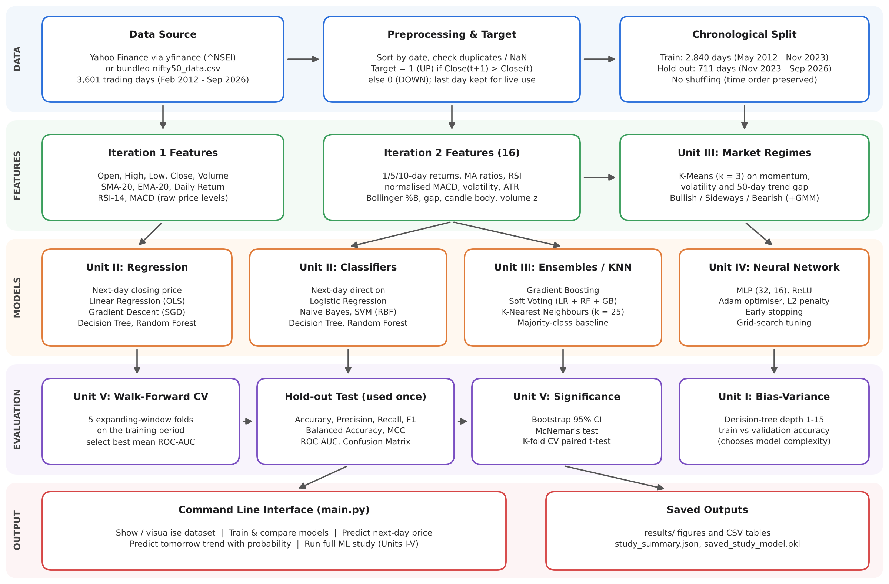
Fig :4.1. System Architecture Diagram
4.2 Iteration 1 - Baseline
The first development iteration focused on building a working command line application and a basic prediction pipeline. Daily data were downloaded with yfinance, and technical indicators such as the 20-day SMA, 20-day EMA, daily return, 14-day RSI and MACD were computed. Linear Regression, Decision Tree and Random Forest regressors were trained to predict the next-day closing price, and Logistic Regression, Decision Tree, Random Forest and K-Nearest Neighbours classifiers were trained to predict the next-day direction using a single chronological 80:20 split.
The baseline revealed important problems. The classifiers reached only 47.98–51.46% test accuracy, below the 52.58% obtained by always predicting UP, and choosing the best model by F1-score favoured models that predicted UP on most days. The tree-based regressors produced average errors of more than 3,900 index points, because the index in the test period rose above any value seen in training and tree models cannot extrapolate. In addition, the last row of the dataset was wrongly labelled DOWN, and the price prediction option used the second-last day instead of the latest day. These observations motivated the next iteration.
4.3 Iteration 2 – Refinement
The second iteration focused on correcting the weaknesses of the baseline and applying the remaining units of the syllabus.
Raw price levels were replaced by sixteen stationary features, so that the models see comparable values in every year. A bias–variance analysis of decision trees with depth 1 to 15 was carried out, K-Means clustering was used to detect market regimes, and Naive Bayes, SVM, Gradient Boosting, a soft voting ensemble and a Multilayer Perceptron were added. The MLP hyper-parameters were tuned with a grid search over hidden-layer sizes and L2 regularisation strength.
The evaluation method was also redesigned. All models were compared using five-fold walk-forward cross-validation on the training period only, the model with the highest mean ROC-AUC was selected, and the hold-out period was used only once for the final test. A majority-class baseline, bootstrap confidence intervals, McNemar's test and the paired t-test were added so that every claimed improvement could be checked statistically. The labelling and prediction bugs found in Iteration 1 were fixed, and the study was integrated into the CLI as a new menu option.

Final Approach

The Random Forest classifier is used as the final prediction model because it achieved the highest mean walk-forward cross-validated ROC-AUC of 0.554 among the evaluated models. The selected model is refitted on all labelled days and predicts the probability that the next trading day will close higher. On the 711-day hold-out period it achieved 52.32% accuracy and a ROC-AUC of 0.530.
The final system integrates the following major components:
- Data and Feature Module: Loads NIFTY 50 OHLCV data and computes sixteen leakage-free technical features and the next-day UP/DOWN target.
- Market Regime Detection: Uses K-Means clustering on momentum, volatility and trend features to label each day as Bullish, Sideways or Bearish.
- Model Comparison and Selection: Trains classical, ensemble and neural network models and selects the best one using walk-forward cross-validation.
- Statistical Evaluation and Prediction: Reports bootstrap confidence intervals, McNemar's and paired t-tests, and predicts tomorrow's trend with its probability.
  - Training Procedure
The training procedure begins with dataset preparation, where 3,601 daily NIFTY 50 records from 21 February 2012 to 25 September 2026 are loaded, sorted by date and checked for duplicates and missing values. No missing values or duplicate dates were found.
During feature engineering, rolling-window indicators are computed using only the data available at the close of each day. The first 49 rows, which do not have enough history for the 50-day moving average, are removed, leaving 3,551 labelled days after the final unlabelled day is set aside for live prediction.
The data are then split chronologically. The first 80% of the days (2,840 days, May 2012 to November 2023) form the training period, and the remaining 711 days (November 2023 to September 2026) form the hold-out test period. The proportion of UP days is 53.9% in training and 52.6% in the hold-out period.
Within the training period, a bias–variance curve is used to choose the decision tree depth, K-Means is fitted to identify three market regimes, and the MLP is tuned using grid search with walk-forward cross-validation. Scaling and clustering are placed inside Scikit-learn pipelines so that they are fitted only on the training folds.
Each candidate model is evaluated with five-fold walk-forward cross-validation, in which each fold trains on all earlier days and validates on the next block of days. The mean cross-validated ROC-AUC is used to rank the models because it measures ranking ability independently of the 0.5 decision threshold and is not inflated by always predicting the majority class.
Based on the cross-validation results, the Random Forest classifier achieved the highest mean ROC-AUC of 0.554 and was selected. All models are then trained on the full training period and evaluated once on the hold-out period.
The hold-out predictions are analysed with a bootstrap 95% confidence interval for accuracy, McNemar's test against the majority-class baseline and against Logistic Regression, and a paired t-test on the cross-validation folds. For price prediction, Linear Regression fitted by least squares and by gradient descent, Decision Tree and Random Forest regressors are compared against a naive forecast that tomorrow's close equals today's close.
Finally, the selected model is refitted on all labelled days and saved, and the complete application is tested to verify data loading, visualisation, model comparison, price prediction and next-day trend prediction.

CHAPTER 5

IMPLEMENTATION

5.1 Module Description
5.1.1 Data Acquisition Module
Downloads NIFTY 50 daily OHLCV data from Yahoo Finance with yfinance (data_fetch.py), or loads the bundled nifty50_data.csv file when offline.
5.1.2 Preprocessing and Feature Engineering Module
Computes the technical indicators, creates the next-day UP/DOWN and closing-price targets and splits the data chronologically (preprocess.py).
5.1.3 Model Training Module
Trains the Iteration 1 regressors and classifiers, selects the regression model with the lowest error and saves the models with Joblib (train_model.py).
5.1.4 Market Regime and Neural Network Modules
Clusters trading days into market regimes with K-Means and a Gaussian Mixture Model (unsupervised.py) and builds and tunes the Multilayer Perceptron (neural_net.py). K-Means uses three descriptors:

10-day return (momentum)

10-day volatility of daily returns

Distance of the close from its 50-day moving average

Resulting regime label: Bullish, Sideways or Bearish

The regime label is appended to the features of every supervised model.
5.1.5 Evaluation Module
Implements walk-forward cross-validation, the metrics, bootstrap confidence intervals, McNemar's test, the paired t-test and the bias–variance curve (evaluation.py).

5.1.6 Experiment Module
Runs Iteration 1 and Iteration 2 end to end, selects the best model and saves all figures, tables and the final model (experiments.py).

5.1.7 Visualisation and Prediction Modules
Draws price, moving-average, volume, correlation and target charts (visualize.py) and predicts the next-day price and trend (predict.py).
5.1.8 Command Line Interface Module
The CLI (main.py) integrates all functions into a single menu-driven application.
The main menu options include:

Download Stock Data and Show Dataset

Visualize Dataset

Train Models and Compare Models

Predict Future Stock Price

Predict Tomorrow Trend

Stock Information

Run Full ML Study (Units I–V)

5.2 Key Code Snippets
5.2.1 Feature Engineering and Target Creation
Converts raw OHLCV data into stationary, leakage-free features and creates the next-day target; every value on day t uses only data available at the close of day t.
Main functions:

Computes returns, moving-average ratios, RSI and volatility.

Adds MACD, ATR, Bollinger %B, candle shape, gap and volume z-score.

Creates the UP/DOWN target from the next day's close.

Keeps the latest unlabelled day aside for live prediction.
def add_advanced_features(df): # preprocess.py (Iteration 2)
out = df[['Open', 'High', 'Low', 'Close', 'Volume']].copy()
close = out['Close']
# Momentum: past returns over 1, 5 and 10 trading days
out['Return_1'] = close.pct_change(1)
out['Return_5'] = close.pct_change(5)
out['Return_10'] = close.pct_change(10)
# Trend: distance of price from its moving averages
out['Close_SMA20_Ratio'] = close / close.rolling(20).mean() - 1
out['Close_SMA50_Ratio'] = close / close.rolling(50).mean() - 1
# Oscillator: 14-day RSI scaled to 0-1
delta = close.diff()
gain = delta.clip(lower=0).rolling(14).mean()
loss = (-delta.clip(upper=0)).rolling(14).mean().replace(0, 1e-10)
out['RSI_14'] = (100 - 100 / (1 + gain / loss)) / 100
# ... MACD, volatility, ATR, Bollinger %B, gap, candle body, volume z-score
out.dropna(inplace=True)
return out

def build_direction_dataset(df_features):
data = df_features.copy()
next_close = data['Close'].shift(-1)
# Target: 1 (UP) if tomorrow's close is higher, else 0 (DOWN)
data['Target_Trend'] = (next_close > data['Close']).astype(float)
data.loc[next_close.isna(), 'Target_Trend'] = np.nan
X_live = data[ADVANCED_FEATURES].iloc[[-1]] # used for live prediction
data = data.dropna(subset=['Target_Trend'])
X = data[ADVANCED_FEATURES]
y = data['Target_Trend'].astype(int)
return X, y, X_live
# experiments.py - chronological split (no shuffling)
feats = add_advanced_features(raw_df)
X, y, X_live = build_direction_dataset(feats)
split = int(len(X) * train_ratio) # train_ratio = 0.8
X_train, X_test = X.iloc[:split], X.iloc[split:]
y_train, y_test = y.iloc[:split], y.iloc[split:]

5.2.2. Walk-Forward Cross-Validation and Model Selection
The evaluation code compares every model using expanding-window cross-validation, so each model is always validated on days that come after its training days. The model with the highest mean ROC-AUC across the five folds is selected.

In the final run the mean cross-validated ROC-AUC ranged from 0.528 (Logistic Regression) to 0.554 (Random Forest), while the majority-class baseline scored 0.500. The fold-to-fold standard deviation of ROC-AUC was between 0.008 and 0.032, which shows that the differences between the models are small.

The selected model is evaluated only once on the hold-out period, and McNemar's test is then used to check whether its errors differ significantly from those of the baseline.
def walk_forward_cv(model, X, y, n_splits=5):
rows = []
splitter = TimeSeriesSplit(n_splits=n_splits)
for fold, (tr, va) in enumerate(splitter.split(X), start=1):
m = clone(model).fit(X.iloc[tr], y.iloc[tr])
pred, prob = m.predict(X.iloc[va]), _positive_proba(m, X.iloc[va])
r = classification_report_dict(y.iloc[va], pred, prob)
r['Fold'] = fold
rows.append(r)
return pd.DataFrame(rows)

# experiments.py - model selection with walk-forward CV (training period only)
cv_tables, cv_rows = {}, []
for name, model in models.items():
folds = walk_forward_cv(model, X_train, y_train, n_splits=n_splits)
cv_tables[name] = folds
cv_rows.append({'Model': name,
'CV ROC-AUC': folds['ROC-AUC'].mean(), ...})
cv_summary = pd.DataFrame(cv_rows).set_index('Model')
candidates = cv_summary.drop(index='Majority Baseline')
best_name = candidates['CV ROC-AUC'].idxmax()

# Final hold-out evaluation (the test period is used only once, here)
for name, model in models.items():
m = clone(model).fit(X_train, y_train)
pred = m.predict(X_test)
prob = None if name == 'Majority Baseline' else m.predict_proba(X_test)[:, 1]
r = classification_report_dict(y_test, pred, prob)
5.2.3 Market Regimes and Statistical Testing
The regime code clusters trading days with K-Means inside a Scikit-learn pipeline step, and the statistical code applies McNemar's test with continuity correction to compare two classifiers on the same test days.
# unsupervised.py - K-Means market regimes as a pipeline step
class RegimeFeatureAdder(BaseEstimator, TransformerMixin):
def fit(self, X, y=None):
R = _regime_matrix(X, self.feature_names)
self.scaler_ = StandardScaler().fit(R)
Z = np.clip(self.scaler_.transform(R), -CLIP_Z, CLIP_Z)
self.kmeans_ = KMeans(n_clusters=self.n_clusters, n_init=10,
random_state=self.random_state).fit(Z)
return self

def transform(self, X):
R = _regime_matrix(X, self.feature_names)
Z = np.clip(self.scaler_.transform(R), -CLIP_Z, CLIP_Z)
labels = self.kmeans_.predict(Z)
one_hot = np.eye(self.n_clusters)[labels]
return np.hstack([np.asarray(X, dtype=float), one_hot])

# evaluation.py - McNemar's test on paired predictions
def mcnemar_test(y_true, pred_a, pred_b):
y_true, pred_a, pred_b = map(np.asarray, (y_true, pred_a, pred_b))
a_ok, b_ok = pred_a == y_true, pred_b == y_true
b = int(np.sum(a_ok & ~b_ok)) # A right, B wrong
c = int(np.sum(~a_ok & b_ok)) # A wrong, B right
if b + c == 0:
return {'b': b, 'c': c, 'chi2': 0.0, 'p_value': 1.0}
chi2 = (abs(b - c) - 1) ** 2 / (b + c)
return {'b': b, 'c': c, 'chi2': float(chi2),
'p_value': float(stats.chi2.sf(chi2, df=1))}

# Selected model vs majority-class baseline on the 711 hold-out days
mcnemar_test(y_test, test_pred[best_name], test_pred['Majority Baseline'])
# Result: b = 121, c = 123, chi2 = 0.004, p = 0.949 (not significant)

5.3 User Interface
The Stock Market Predictor provides a menu-driven command line interface that integrates data exploration, visualisation, model training, statistical evaluation and prediction features.
5.3.1. Main Menu:
The main menu provides access to all ten functions of the application. On start-up it automatically loads 3,601 NIFTY 50 trading days from the bundled dataset, so it also works without an internet connection. The Run Full ML Study option executes the experiments for all five syllabus units, and the Predict Tomorrow Trend option uses the model selected by that study.
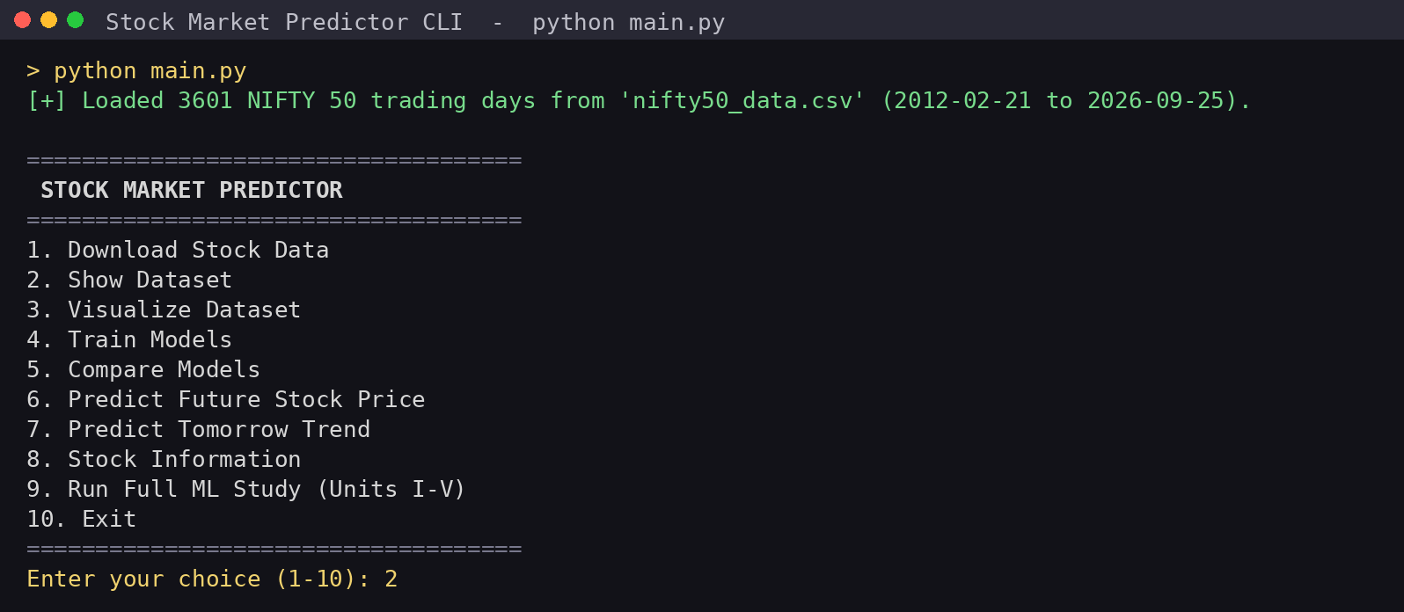 Fig.5.3.1: Main Menu of the CLI Application
5.3.2. Dataset Overview:
The Show Dataset option displays the first ten rows of the NIFTY 50 data together with the number of rows and columns, column names, data types, missing values and the dataset location. The dataset contains 3,601 rows, five numeric columns and no missing values.
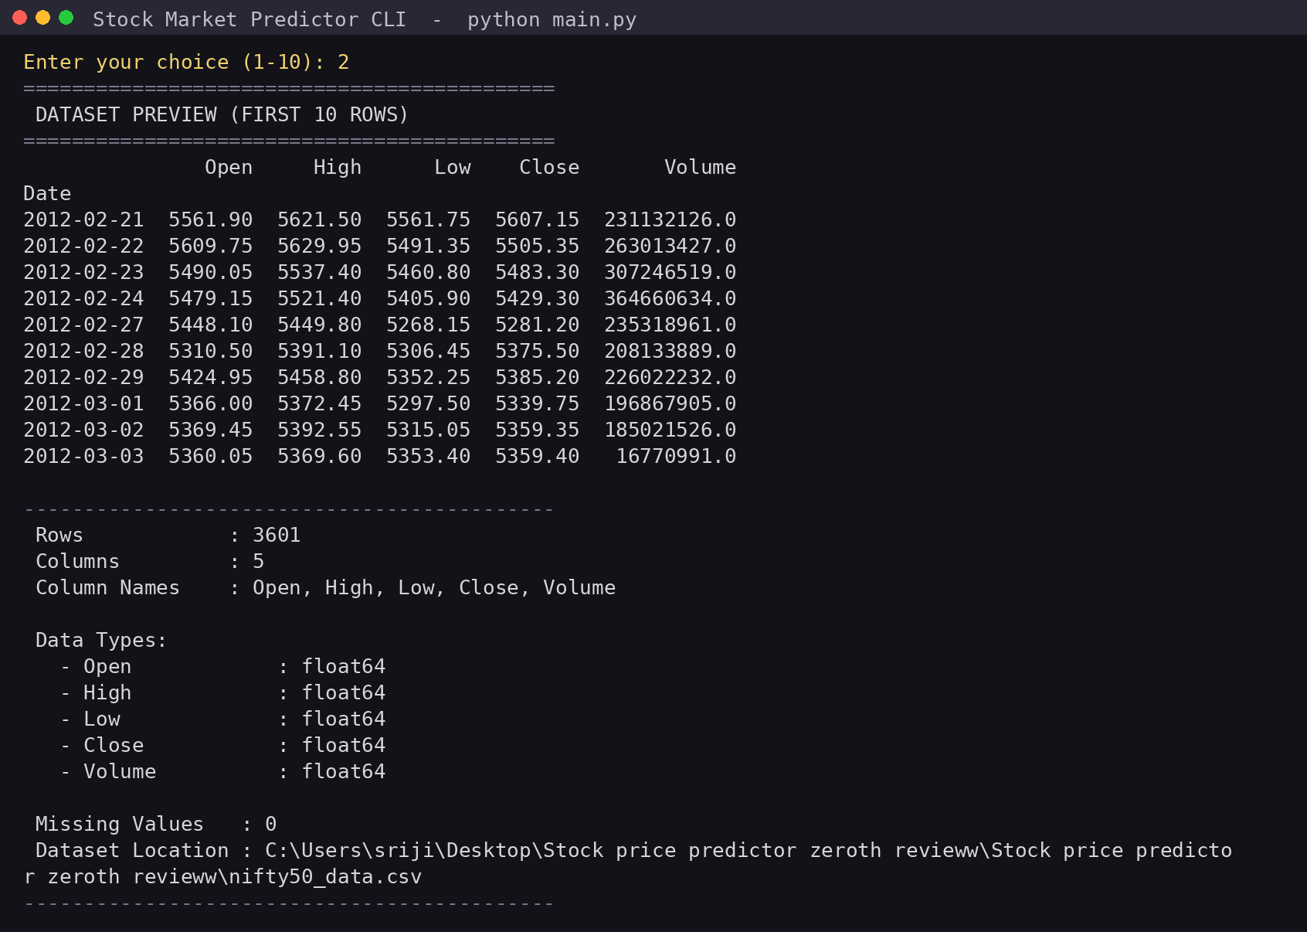
Fig 5.3.2: Dataset Overview
5.3.3. Model Training and Comparison:
The Train Models option trains the Iteration 1 regression and classification models and displays a comparison table. Linear Regression has a mean absolute error of 154.87 points, the tree-based regressors fail with errors above 3,900 points, and the baseline classifiers stay close to 50% accuracy.
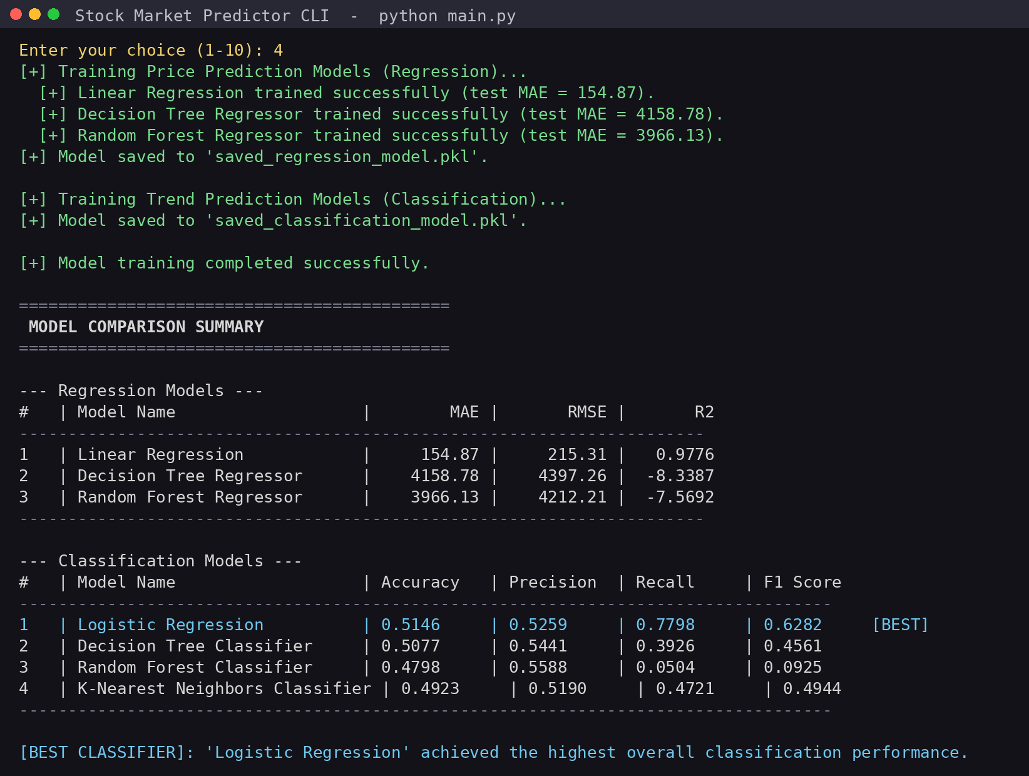 Fig 5.3.3 – Model Training and Comparison
5.3.4. Full ML Study:
The Run Full ML Study option executes Iteration 2 and prints the walk-forward cross-validated ROC-AUC and hold-out metrics of all ten models, the selected model, its bootstrap confidence interval and the McNemar test result.
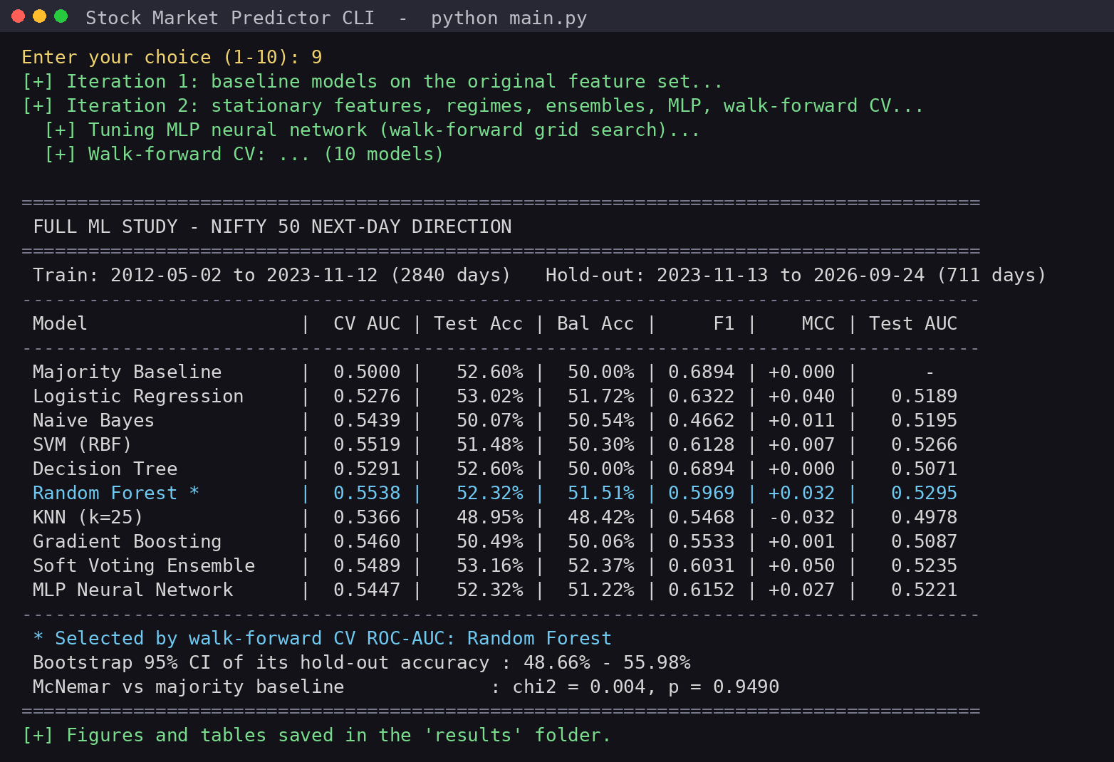 Fig.5.3.4: Full ML Study Output
5.3.5 Market Regime Detection
The market regime chart shows the NIFTY 50 closing price coloured by the K-Means regime of each day, together with the silhouette score for different numbers of clusters. Bearish days cluster around sharp falls such as March 2020, while long rallies are labelled Bullish. Three clusters were kept because they give interpretable market states, although the silhouette score is highest for two clusters.
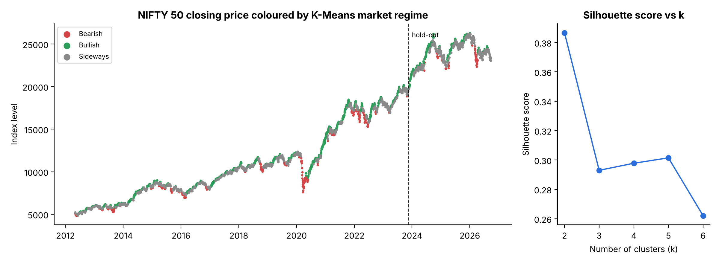Fig.5.3.5 – Market Regime Detection using K-Means
5.3.6 Price and Trend Prediction
The Predict Future Stock Price option uses the Linear Regression model to estimate the next-day closing price, and the Predict Tomorrow Trend option uses the model selected by the full study to predict whether the next trading day will close UP or DOWN. Using data up to 25 September 2026, the price model estimated a close of 23,071.77 points and the Random Forest predicted UP for 28 September 2026 with a probability of 51.16%, a low confidence that is realistic for daily market direction.
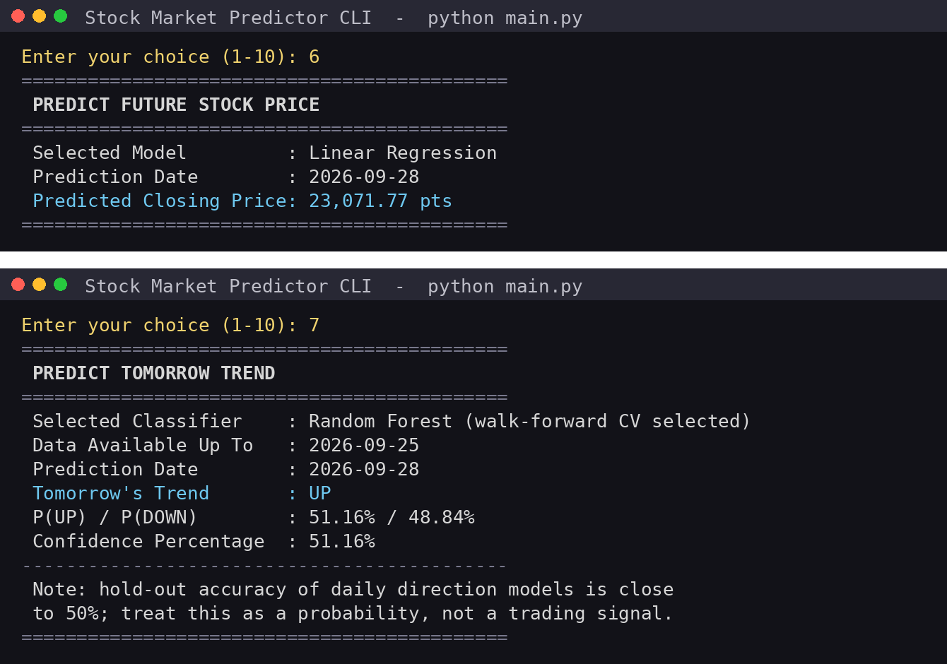Fig.5.3.6: Price and Trend Prediction

CHAPTER 6
RESULTS AND DISCUSSION

6.1 Evaluation Metrics
Accuracy
Represents the proportion of days whose direction is predicted correctly. It must be compared with the majority-class baseline (always UP gives about 52–54%)
$$Accuracy=\frac{Correct Predictions}{Total Predictions}$$

Precision
Represents the proportion of days predicted as UP that actually closed higher. It indicates the reliability of UP predictions

$$Precision=\frac{TP}{TP+FP}$$

Recall
Represents the proportion of actual UP days that the model correctly identified. It indicates how effectively the system detects rising days

$$Recall=\frac{TP}{TP+FN}$$

F1-Score
Combines precision and recall into a single balanced measure of UP-day prediction

$$F1=2×\frac{Precision×Recall}{Precision+Recall}$$
6.2 Results Across Iterations
Table 6.2 compares the Iteration 1 baseline classifiers (original features, single split) with the Iteration 2 models (stationary features, regime clustering and walk-forward selection). Both are tested on the same period, November 2023 to September 2026. Balanced Accuracy (the mean recall of UP and DOWN days) and ROC-AUC (the probability that a random UP day is scored above a random DOWN day) are also reported, because unlike accuracy they are not inflated by always predicting UP. The selected model is shown in bold.
Table 6.2: Results Across Iterations
Model | CV ROC-AUC | Accuracy (%) | Balanced Accuracy (%) | ROC-AUC
Iteration 1 – Baseline (original features, single 80:20 split)
Majority Baseline (always UP) | – | 52.58 | 50.00 | –
Logistic Regression | – | 51.46 | 50.02 | 0.516
Decision Tree | – | 50.77 | 51.39 | 0.504
Random Forest | – | 47.98 | 50.31 | 0.504
K-Nearest Neighbours | – | 49.23 | 49.34 | 0.483
Iteration 2 – Refinement (stationary features + regimes, walk-forward selection)
Majority Baseline (always UP) | 0.500 | 52.60 | 50.00 | –
Logistic Regression | 0.528 | 53.02 | 51.72 | 0.519
Naive Bayes | 0.544 | 50.07 | 50.54 | 0.520
SVM (RBF) | 0.552 | 51.48 | 50.30 | 0.527
Decision Tree | 0.529 | 52.60 | 50.00 | 0.507
Random Forest | 0.554 | 52.32 | 51.51 | 0.530
KNN (k=25) | 0.537 | 48.95 | 48.42 | 0.498
Gradient Boosting | 0.546 | 50.49 | 50.06 | 0.509
Soft Voting Ensemble | 0.549 | 53.16 | 52.37 | 0.523
MLP Neural Network | 0.545 | 52.32 | 51.22 | 0.522

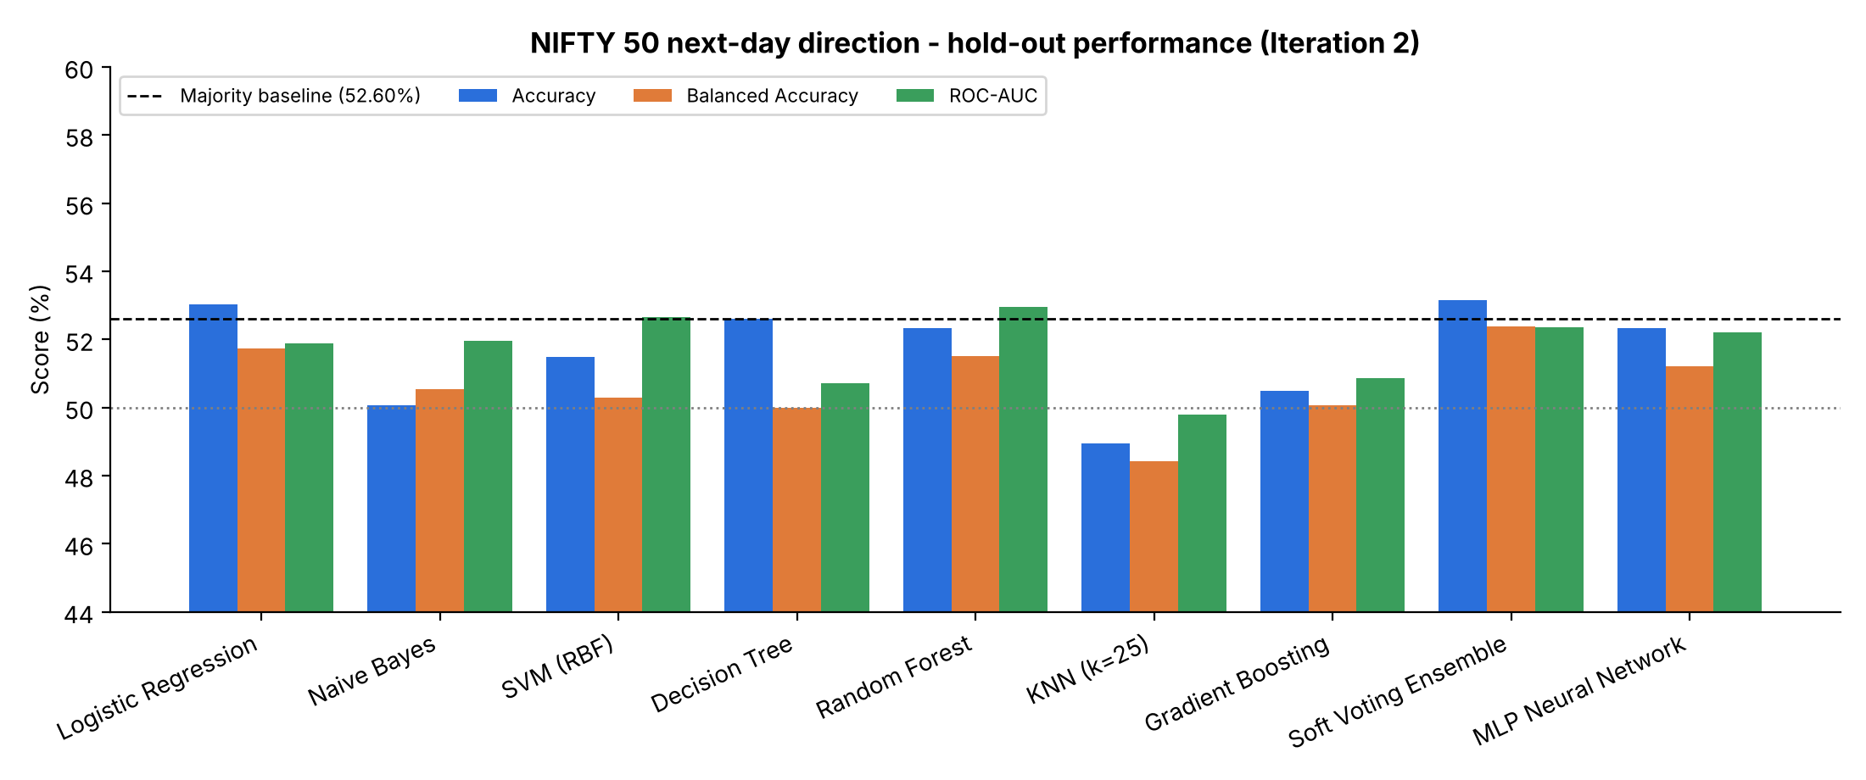Fig.6.2(a): Model Performance Comparison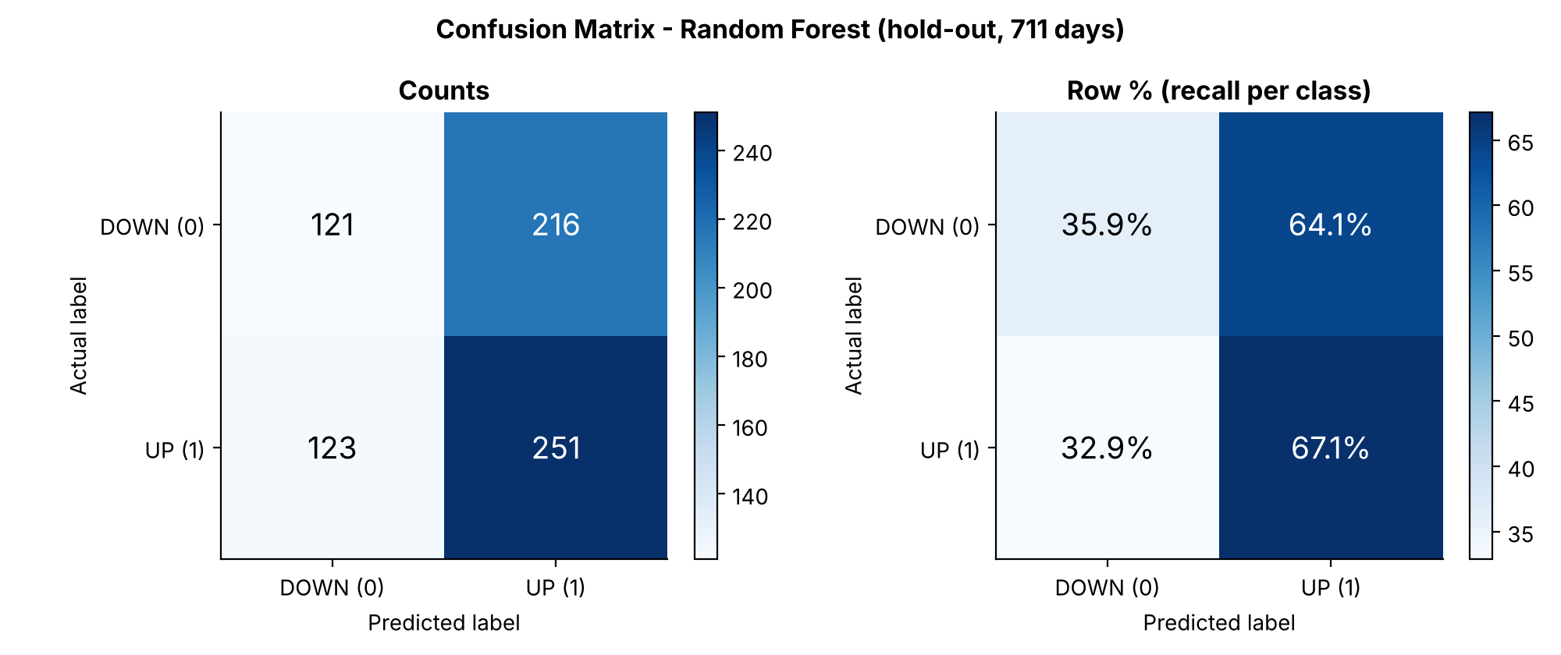
Fig.6.2(b): Confusion Matrix
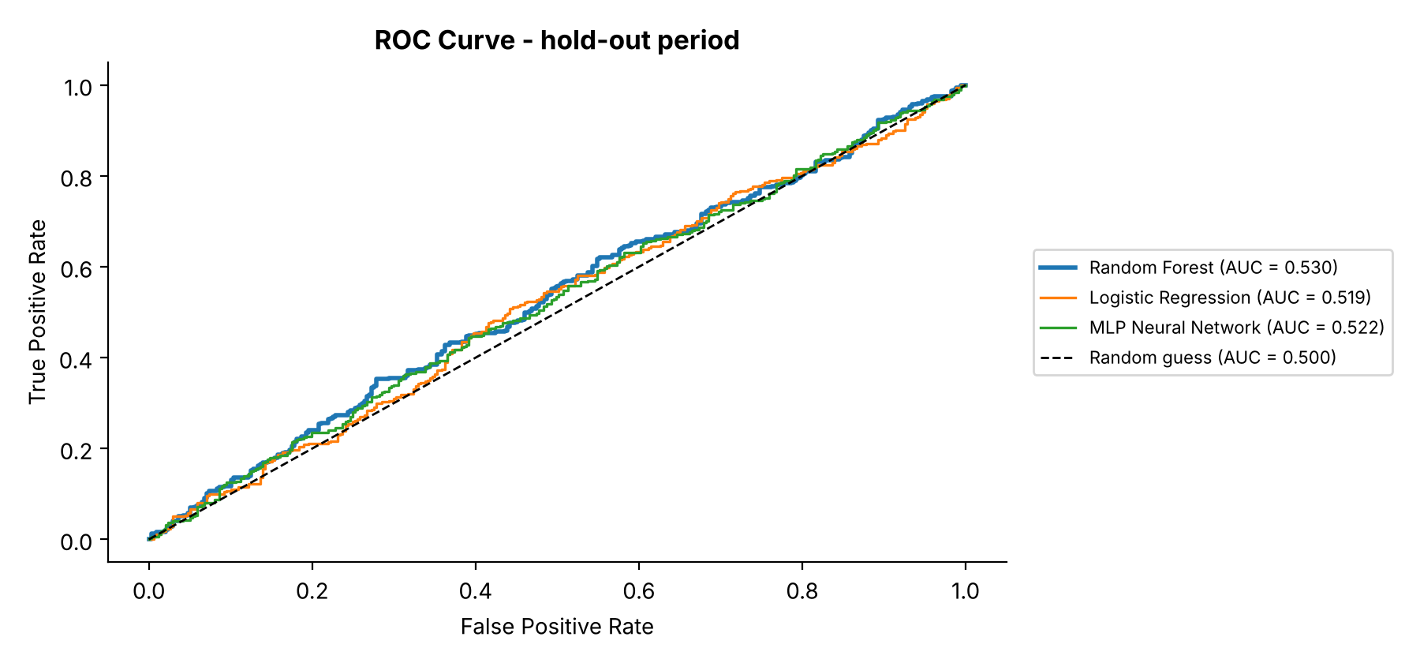
Fig.6.2(c): ROC Curve
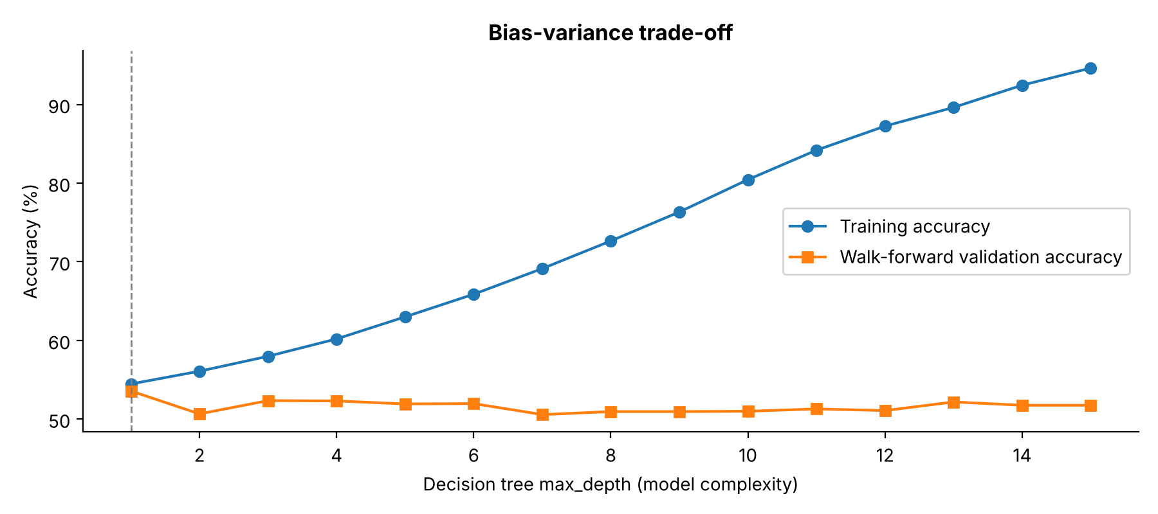
Fig.6.2(d): Bias–Variance Trade-off
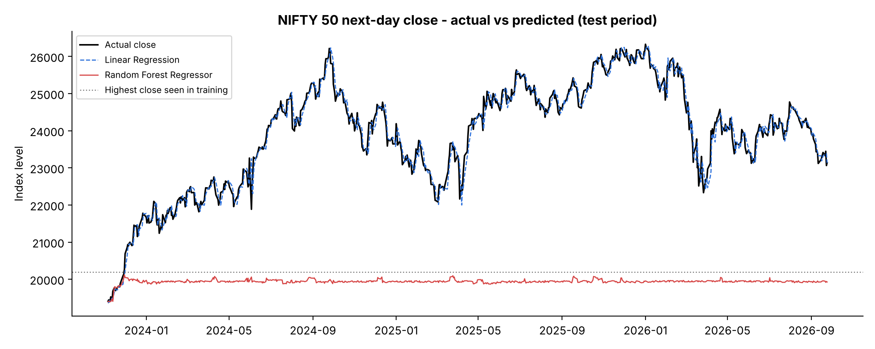
Fig.6.2(e): Actual vs Predicted Closing Price
Table 6.3 shows the next-day closing price results of Iteration 1. The naive forecast assumes that tomorrow's close equals today's close; Fig.6.2(e) shows why the tree-based regressors fail.
Table 6.3: Next-Day Closing Price Prediction Results
Model | MAE (points) | RMSE (points) | MAPE (%) | R²
Naive forecast (tomorrow = today) | 142.31 | 198.64 | 0.60 | 0.981
Linear Regression (least squares) | 154.87 | 215.31 | 0.65 | 0.978
Linear Regression (gradient descent) | 156.56 | 215.89 | 0.66 | 0.977
Decision Tree Regressor | 4,158.78 | 4,397.26 | 17.09 | −8.339
Random Forest Regressor | 3,966.13 | 4,212.21 | 16.28 | −7.569
Table 6.4 summarises the statistical tests (Unit V) applied to the selected model.
Table 6.4: Statistical Significance Tests
Test | Comparison | Statistic | p-value | Conclusion
Bootstrap 95% CI | RF hold-out accuracy | 48.66% – 55.98% | – | Contains baseline
McNemar's test | RF vs majority baseline | χ² = 0.004 | 0.949 | Not significant
McNemar's test | RF vs Logistic Regression | χ² = 0.095 | 0.758 | Not significant
CV paired t-test (AUC) | RF vs Logistic Regression | t = 2.142 | 0.099 | Not significant
CV paired t-test (accuracy) | RF vs majority baseline | t = −0.212 | 0.843 | Not significant

6.3 Discussion
The results show that next-day NIFTY 50 direction is only weakly predictable from price and volume indicators. In walk-forward cross-validation all Iteration 2 models reached a mean ROC-AUC of only 0.528–0.554, and the selected Random Forest scored 52.32% on the hold-out period, slightly below the 52.60% of always predicting UP. Its bootstrap 95% interval (48.66%–55.98%) contains the baseline and McNemar's test (p = 0.949) shows no significant difference. The soft voting ensemble had the best hold-out accuracy (53.16%) but was not selected, because the hold-out data were never used for model selection.
Deeper decision trees reached 94.6% training accuracy while validation accuracy stayed near 51–54%, a clear case of over-fitting. Linear Regression reached an R² of 0.978 but was slightly worse than the naive forecast (MAE 154.87 vs 142.31 points), and the tree regressors failed above their training range. These findings agree with the Efficient Market Hypothesis: model complexity alone does not improve performance.
6.4 Limitations
- Only NIFTY 50 price and volume data are used; news and macro data are not.
- The selected model is not significantly better than the baseline.
- Financial data are non-stationary, so performance may change over time.
- Transaction costs and slippage are not modelled.
- Walk-forward folds overlap, so the paired t-test p-values are approximate.

CHAPTER 7

TEAM REFLECTION AND LEARNING OUTCOMES

7.1 Individual Reflections

SRIJITH

I contributed to the design of the overall pipeline, the feature engineering, the Iteration 2 study and the statistical evaluation of the models. Through this project, I gained practical experience in time-series data handling, model selection with walk-forward cross-validation and interpreting results honestly against a baseline. One of the major challenges was understanding why models that looked good in cross-validation did not beat the baseline on the hold-out data. The PBL process helped me improve my debugging, problem-solving and teamwork skills.

RISHI

I contributed to the implementation and testing of the command line interface, data download, visualisation and the baseline models. I gained practical knowledge of Python, Pandas, Scikit-learn and Matplotlib, and of integrating different modules into a single application. Working on the project helped me understand the importance of testing individual modules before complete integration, and how small bugs such as a wrongly labelled last row can silently affect results.

7.2 Team Learning

The project helped the team understand that developing a machine learning application involves much more than training a model. The team had to collect data, engineer features, avoid data leakage, compare many models, evaluate them correctly, build a user interface, debug and test.

The PBL process also improved the team's ability to divide tasks and integrate individual contributions into a common project. Regular testing helped identify issues such as the mislabelled last row, the price prediction using the wrong day and the failure of tree-based regressors on new price levels.

The iterative approach taught the team that the first working implementation is rarely the final solution, and that an honest comparison with a simple baseline is more valuable than a high but unreliable accuracy figure.

7.3 Course Outcomes — Evidence Summary
Table 7. 2: Course Outcomes
Course Outcome | Course Outcome
CO1 | Unit I – Framed NIFTY 50 next-day direction as a supervised binary classification problem and used the bias–variance curve to select model complexity.
CO2 | Unit II – Applied Linear Regression (least squares and gradient descent), Logistic Regression, Naive Bayes, SVM, Decision Tree and Random Forest.
CO3 | Unit III – Applied Gradient Boosting, a soft voting ensemble, KNN, and K-Means and Gaussian Mixture clustering for market regimes.
CO4 | Unit IV – Built and tuned a Multilayer Perceptron with ReLU activation, Adam optimiser, L2 regularisation and early stopping.
CO5 | Unit V – Evaluated models using walk-forward cross-validation, bootstrap confidence intervals, McNemar's test and the paired t-test.
CO6 | Developed a command line application and worked collaboratively through an iterative Project Based Learning process.

CHAPTER 8

CONCLUSION AND FUTURE SCOPE

8.1 Conclusion

This project developed a machine learning system for predicting the next-day direction and closing price of the NIFTY 50 index, using 3,601 trading days of data and models from all five units of the Machine Learning course. Regression, classification, ensemble, clustering and neural network models were compared using walk-forward cross-validation and a time-ordered hold-out period. Random Forest achieved the highest cross-validated ROC-AUC of 0.554 and was selected as the final model, but its hold-out accuracy of 52.32% was not significantly different from the majority-class baseline.

The project demonstrates that daily stock market direction is very difficult to predict from historical price data alone, and that correct, leakage-free evaluation with statistical testing is essential before trusting any accuracy figure. The PBL process also provided practical experience in data engineering, model development, evaluation, debugging and building a complete command line application.

8.2 Future Scope

The system can be extended with additional data sources such as global indices, India VIX, foreign institutional investor flows and news sentiment.

Longer prediction horizons such as weekly direction, sequence models such as LSTM, and strategies that act only on high-confidence days can be explored.

A backtesting module with transaction costs and a web dashboard with automatic daily updates can be added to make the system more practical.

REFERENCES
[1] J. Patel, S. Shah, P. Thakkar, and K. Kotecha, “Predicting stock and stock price index movement using Trend Deterministic Data Preparation and machine learning techniques,” Expert Systems with Applications, vol. 42, no. 1, pp. 259–268, 2015, doi: 10.1016/j.eswa.2014.07.040.
[2] Y. Kara, M. Acar Boyacioglu, and Ö. K. Baykan, “Predicting direction of stock price index movement using artificial neural networks and support vector machines: The sample of the Istanbul Stock Exchange,” Expert Systems with Applications, vol. 38, no. 5, pp. 5311–5319, 2011, doi: 10.1016/j.eswa.2010.10.027.
[3] W. Huang, Y. Nakamori, and S.-Y. Wang, “Forecasting stock market movement direction with support vector machine,” Computers & Operations Research, vol. 32, no. 10, pp. 2513–2522, 2005, doi: 10.1016/j.cor.2004.03.016.
[4] M. Ballings, D. Van den Poel, N. Hespeels, and R. Gryp, “Evaluating multiple classifiers for stock price direction prediction,” Expert Systems with Applications, vol. 42, no. 20, pp. 7046–7056, 2015, doi: 10.1016/j.eswa.2015.05.013.
[5] C. Krauss, X. A. Do, and N. Huck, “Deep neural networks, gradient-boosted trees, random forests: Statistical arbitrage on the S&P 500,” European Journal of Operational Research, vol. 259, no. 2, pp. 689–702, 2017, doi: 10.1016/j.ejor.2016.10.031.
[6] T. Fischer and C. Krauss, “Deep learning with long short-term memory networks for financial market predictions,” European Journal of Operational Research, vol. 270, no. 2, pp. 654–669, 2018, doi: 10.1016/j.ejor.2017.11.054.
[7] S. Basak, S. Kar, S. Saha, L. Khaidem, and S. R. Dey, “Predicting the direction of stock market prices using tree-based classifiers,” The North American Journal of Economics and Finance, vol. 47, pp. 552–567, 2019, doi: 10.1016/j.najef.2018.06.013.
[8] S. Gu, B. Kelly, and D. Xiu, “Empirical asset pricing via machine learning,” The Review of Financial Studies, vol. 33, no. 5, pp. 2223–2273, 2020, doi: 10.1093/rfs/hhaa009.
[9] E. F. Fama, “Efficient capital markets: A review of theory and empirical work,” The Journal of Finance, vol. 25, no. 2, pp. 383–417, 1970, doi: 10.1111/j.1540-6261.1970.tb00518.x.
[10] C. Bergmeir and J. M. Benítez, “On the use of cross-validation for time series predictor evaluation,” Information Sciences, vol. 191, pp. 192–213, 2012, doi: 10.1016/j.ins.2011.12.028.
[11] T. G. Dietterich, “Approximate statistical tests for comparing supervised classification learning algorithms,” Neural Computation, vol. 10, no. 7, pp. 1895–1923, 1998, doi: 10.1162/089976698300017197.
[12] F. Pedregosa et al., “Scikit-learn: Machine learning in Python,” Journal of Machine Learning Research, vol. 12, pp. 2825–2830, 2011.

APPENDIX
A.1 Full Source Code
The complete source code of the project, including the bundled NIFTY 50 dataset and the results folder, is maintained in the project's GitHub repository.
GitHub Repository:
https://github.com/SrijithLegend/NIFTY50-Stock-Market-Predictor
A.2 Self and Peer Assessment
Table A.1: Self and Peer Assessment
Team Member | Self-Rated Contribution (%) | Peer-Rated Contribution (%) | Remarks
SRIJITH | 50% | 50% | Contributed to pipeline design, feature engineering, the Iteration 2 study, statistical evaluation, debugging and report preparation.
RISHI | 50% | 50% | Contributed to CLI development, data download, visualisation, baseline models, testing and final system verification.

