**AUTHOR: RISHI KUMAR SONI**

**UTA ID: 1001774020**

**Net Id: rxs4020**

**PART 3**

**EXTENDED ENTITY RELATIONSHIP DIAGRAM:**

**PART1**

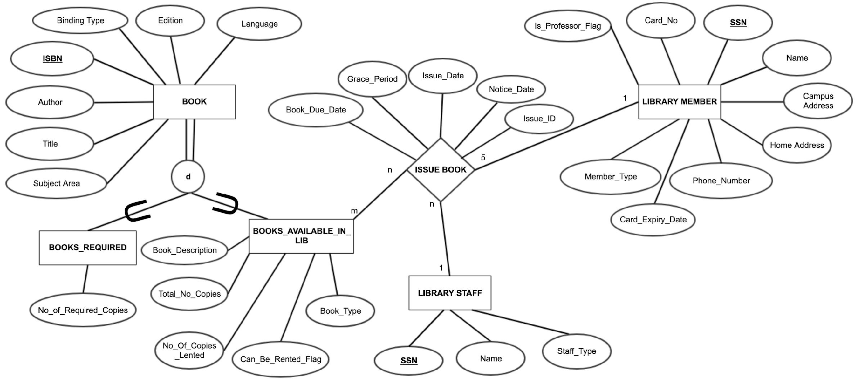

**NOTE: Please Zoom the Diagram , if Diagram is not visible.**

There are 6 **entities** that are being used in the EER Diagram.

1. **BOOK:**

**Attributes: ISBN,** Author, Title, Subject Area, Binding Type, Edition, Language

1. **LIBRARY MEMBER:**

**Attributes: SSN ,** Name, Campus Address, Home Address, Phone_Number, Member_Type, Card_No, Card_Expiry_Date, Is_Professor_Flag

1. **LIBRARY STAFF:**

**Attributes: SSN,** Name, Staff_Type.

1. **ISSUE BOOK:**

**Attributes:** Issue_Date, Notice_Date, Book_Due_Date, Grace_Period, **Issue_Id**

1. **BOOKS_AVAILABLE_IN_LIBRARY:**

**Attributes:** Book_Description, Book_Type , Total_No_Copies, No_Of_Copies_lented, Can_Be_Rented_Flag

1. **BOOKS_REQUIRED:**

**SCHEMA DIAGRAM: EER DIAGRAM TO RELATIONAL MAPPING**

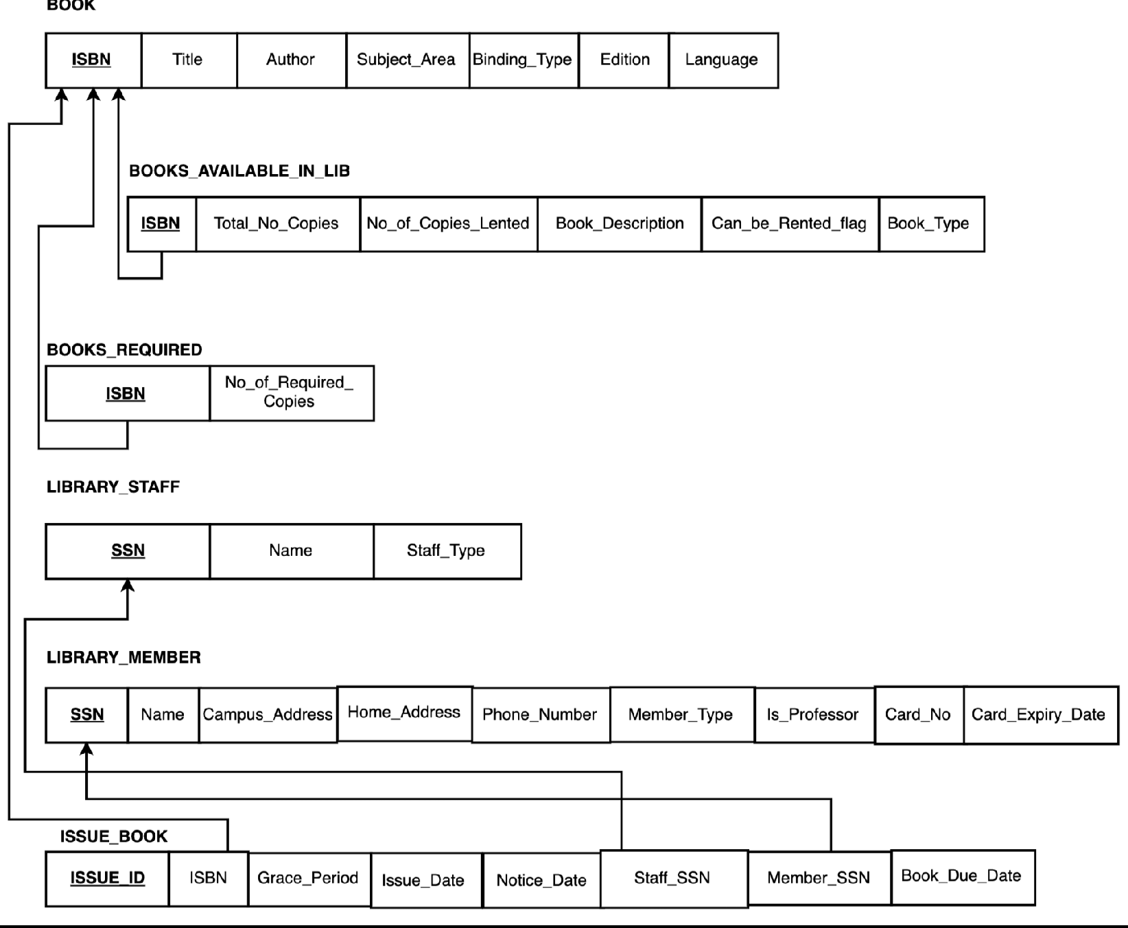

**TABLES CREATED:**

1. **BOOK**
2. **LIBRARY_MEMBER**
3. **LIBRARY_STAFF**
4. **ISSUE_BOOK**
5. **BOOKS_AVAILABLE_IN_LIB**
6. **BOOKS_REQUIRED**

**Mapping of Subclasses and Super Classes-**

**CREATE TABLES QUERIES**

**BOOK:**

CREATE TABLE BOOK (

ISBN VARCHAR (10) NOT NULL,

Title VARCHAR (25) NOT NULL,

AUTHOR VARCHAR (25) NOT NULL,

SUBJECT_AREA VARCHAR (25) NOT NULL,

LANGUAGE VARCHAR (15) NOT NULL,

BINDING_TYPE VARCHAR (10) NOT NULL,

EDITION VARCHAR (10) NOT NULL,

**Primary key (ISBN)**);

**BOOKS_AVAILABLE_IN_LIB:**

CREATE TABLE BOOKS_AVAILABLE_IN_LIB(

ISBN VARCHAR (10) NOT NULL,

**CAN_BE_RENTED_FLAG NUMBER (1,0) NOT NULL**,

TOTAL_NO_COPIES INT NOT NULL,

NO_OF_COPIES_LENTED INT NOT NULL,

BOOK_DESCRIPTION VARCHAR (40),

BOOK_TYPE VARCHAR (40),

**Primary key (ISBN),**

**FOREIGN KEY (ISBN) REFERENCES BOOK(ISBN)**);

**BOOKS_REQUIRED:**

CREATE TABLE BOOKS_REQUIRED (ISBN VARCHAR (10) NOT NULL,

NO_OF_REQUIRED_COPIES INT NOT NULL,

**Primary key (ISBN)**,

**FOREIGN KEY (ISBN) REFERENCES BOOK(ISBN)**);

**LIBRARY_STAFF:**

CREATE TABLE LIBRARY_STAFF (

SSN VARCHAR (10) NOT NULL,

Name VARCHAR (40) NOT NULL,

Staff Type VARCHAR (20) NOT NULL,

**Primary Key (SSN)**);

**LIBRARY_MEMBER:**

CREATE TABLE LIBRARY_MEMBER (

SSN VARCHAR (10) NOT NULL,

NAME VARCHAR (30) NOT NULL,

CAMPUS_ADDRESS VARCHAR (40) NOT NULL,

HOME_ADDRESS VARCHAR (40) NOT NULL,

PHONE_NUMBER NUMBER (10) NOT NULL,

CARD_NUMBER VARCHAR (10) NOT NULL,

CARD_EXPIRY_DATE DATE NOT NULL,

**IS_PROFESSOR_FLAG CHAR (5) CHECK (IS_PROFESSOR_FLAG IN('TRUE','FALSE'))**,

Member Type VARCHAR (30),

**primary key (SSN)**);

**ISSUE_BOOK:**

CREATE TABLE ISSUE_BOOK (

ISSUE_ID INT NOT NULL,

MEMBER_SSN VARCHAR (10) NOT NULL,

STAFF_SSN VARCHAR (10) NOT NULL,

ISBN VARCHAR (10) NOT NULL,

ISSUE_DATE DATE NOT NULL,

NOTICE_DATE DATE NOT NULL,

GRACE_PERIOD INT NOT NULL,

BOOK_DUE_DATE DATE,

**Primary key (ISSUE_ID),**

**FOREIGN KEY (MEMBER_SSN) REFERENCES LIBRARY_MEMBER(SSN) ,**

**FOREIGN KEY (STAFF_SSN) REFERENCES LIBRARY_STAFF(SSN),**

**FOREIGN KEY (ISBN) REFERENCES BOOK(ISBN)**);

.