**CodePulse**

**Team management and code deployment platform**

**Project overview:**

Code Pulse is a comprehensive platform designed for team management and code deployment, utilizing the MERN (Mongodb, Express.js, React.js, Node.js) stack. with a focus on streamlining communication, facilitating efficient code deployment, and ensuring robust security measures, Code Pulse aims to optimize team collaboration and project management processes.

**1. Architecture overview:**

Code Pulse's architecture comprises:

* **Frontend**: Developed using react.js, offering intuitive interfaces for team management, code deployment, and real-time communication.
* **Backend**: Powered by express.js and node.js, providing restful apis for user authentication, project management, and integration with version control systems.
* **Database**: Utilizes mongodb for storing user data, project information, deployment configurations, and related metadata.

**2. Database design:**

Code Pulse's mongodb database includes collections such as:

* **Users Collection**: Stores user profiles, authentication credentials, and access permissions.
* **Projects Collection**: Contains project details, including name, description, collaborators, and associated repositories.
* **Deployments Collection**: Stores deployment configurations, history, and related metadata for each project.

**3. Schema models:** ( This is the format of database tables )

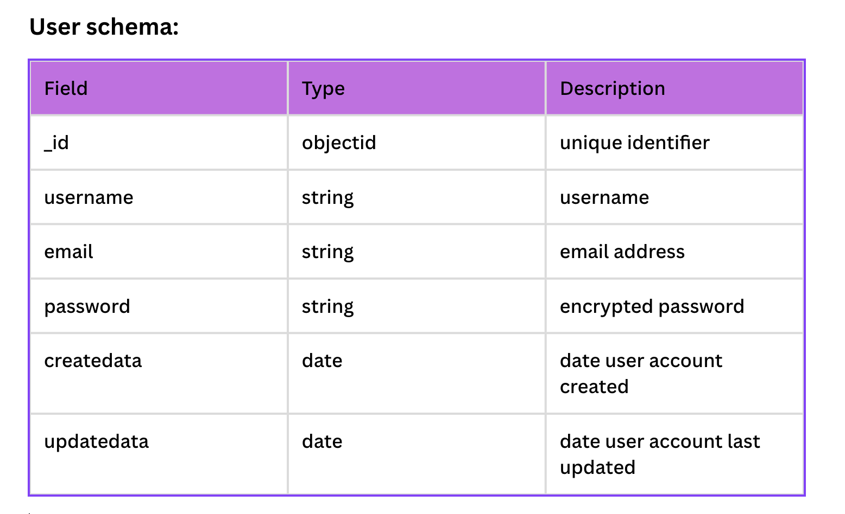

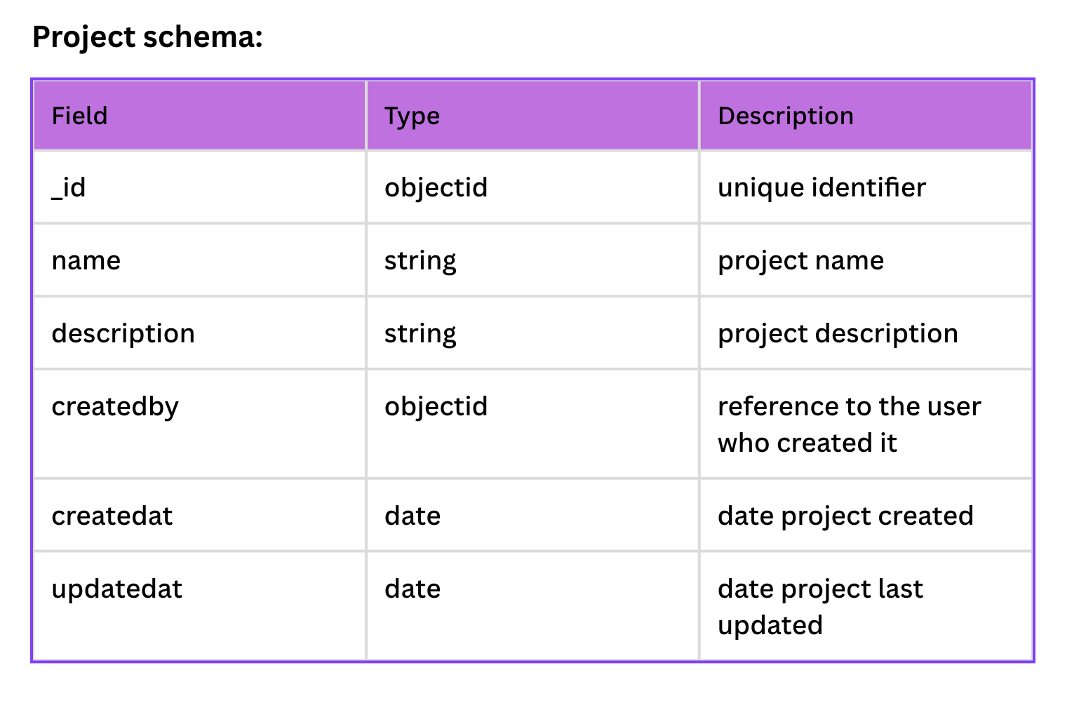

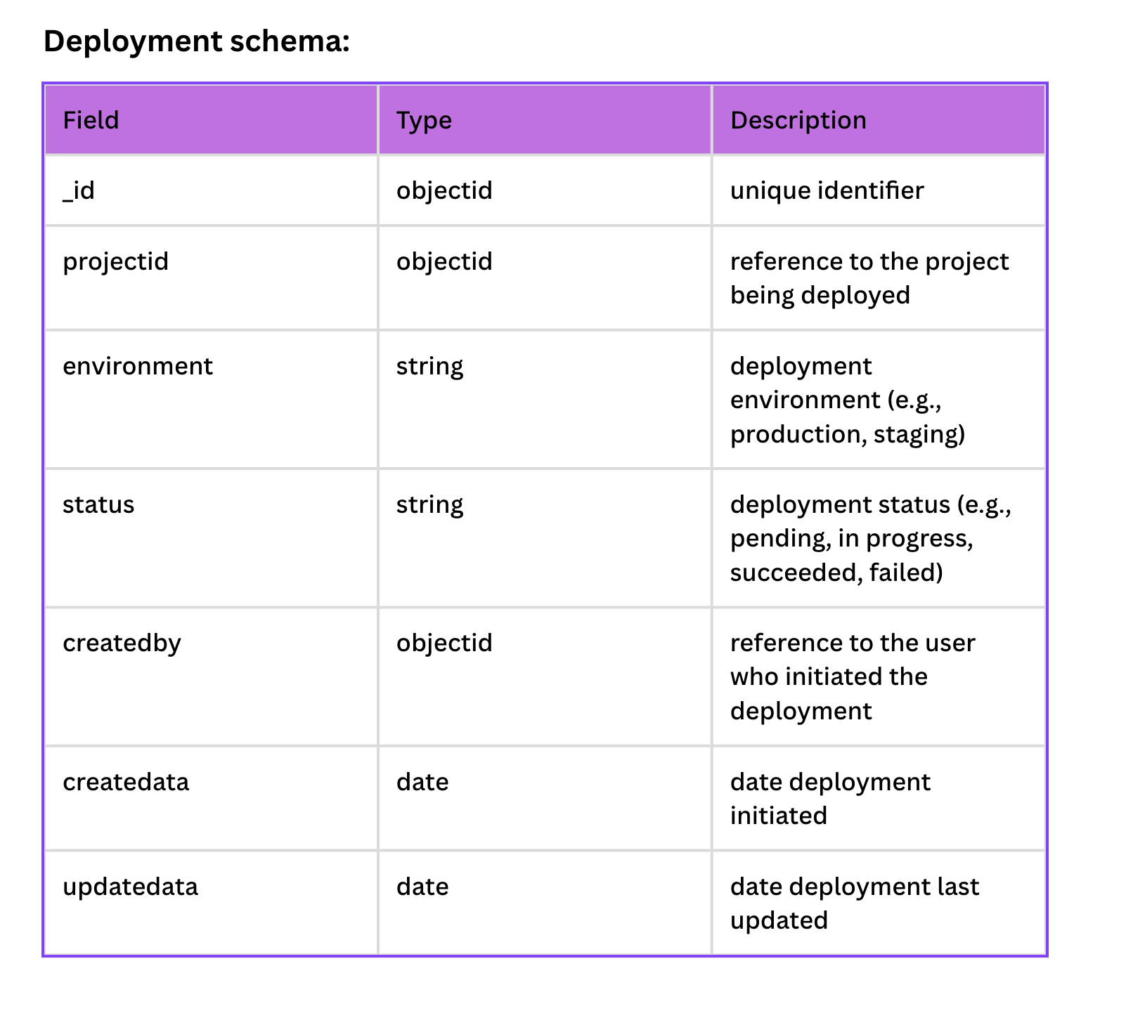

**4. API Design:**

Code Pulse's backend exposes restful apis for various functionalities:

* Authentication apis:
  + **/api/auth/register**: Register a new user.
  + **/api/auth/login**: Authenticate user credentials and generate jwt tokens.
  + **/api/auth/user**: Retrieve current user details.
* Project management apis:
  + **/api/projects/create**: Create a new project.
  + **/api/projects/:projectid**: Retrieve, update, or delete a project.
  + **/api/projects/:projectid/collaborators**: Manage project collaborators.
* Deployment apis:
  + **/api/deployments/:projectid:** Initiate, Monitor, and Manage code deployments for a project.

**5. Frontend Design:**

Code Pulse's frontend components include:

* **Authentication**: User Registration and login interfaces.
* **Project dashboard:** Displays projects, their status, and recent activity.
* **Project management:** Allows users to create, edit, and delete projects, manage collaborators, and configure deployment settings.
* **Code deployment**: Provides interfaces for initiating and monitoring code deployments.
* **Real-time communication**: Integrates chat functionality for team communication and collaboration.

**5.1 Our Dashboard**

( This is how our **Finished project** will look like )

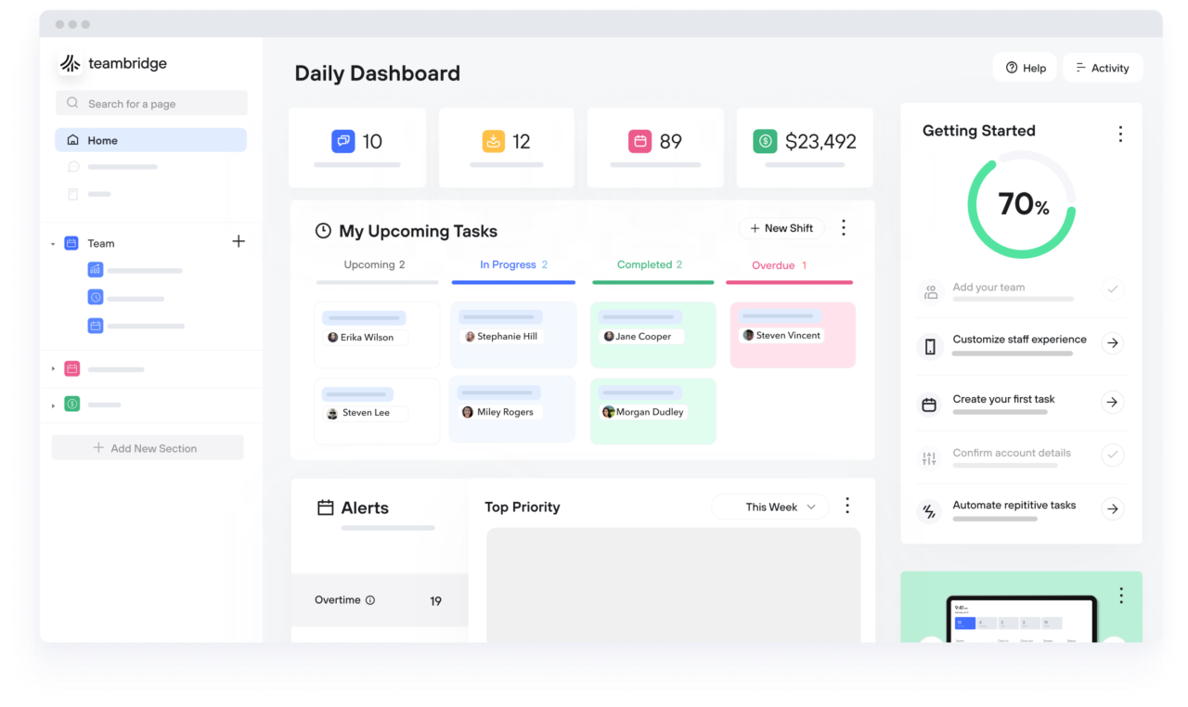

**6. Data Flow Diagram:**

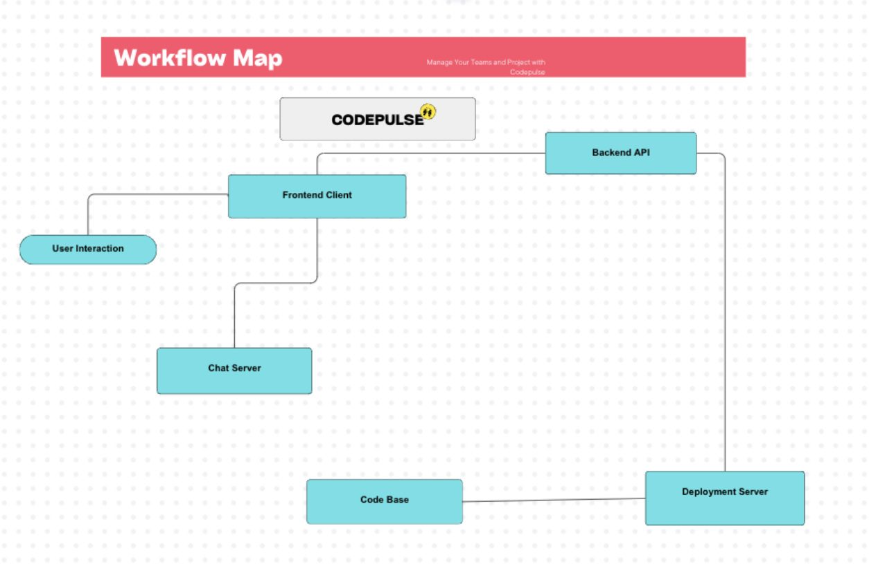

**7. How will we Deploy:**

Code Pulse can be deployed on cloud platforms like aws, azure, or google cloud platform. But for this scale for the UCA project we will utilise VERCEL for hosting our project backend, and Mongodb atlas for database hosting this ensures scalability and reliability.

**8. Testing:**

Comprehensive unit tests for frontend components using jest and backend apis using mocha/chai ensure code quality and reliability. integration tests verify end-to-end functionality and system interoperability.

**9. Scalability and Performance:**

Employing microservices architecture, caching mechanisms, and horizontal scaling strategies ensures scalability. performance optimizations, including asynchronous processing and data caching, guarantee fast response times and efficient resource utilization.

**10. Security:**

Code Pulse prioritizes security by implementing encryption for sensitive data, **input validation** to **prevent injection attacks**, and **role-based access control** for user permissions. utilizing secure **authentication mechanisms**, such as jwt tokens, enhances user authentication and authorization processes.

**11. Accessibility:**

Adhering to web accessibility standards ensures usability for all users, including those with disabilities. features such as keyboard navigation support, semantic html markup, and aria roles enhance accessibility and user experience.

**12. Conclusion:**

Code Pulse endeavors to streamline team management and code deployment processes, fostering collaboration, efficiency, and security within development teams. by adhering to best practices, implementing robust features, and prioritizing user experience, Code Pulse aims to become a vital tool for modern development workflows.