RISHIT SHETTY
(LV)
CUSTOM BATTERY MANAGEMENT SYSTEM USING BQ79616 EVM-021 FOR 16-S PRECISION BATTERY MONITOR, CELL BALANCING, AND INTEGRATED PROTECTION

DOC-HVL26

INTRODUCTION

BQ79616 is a 64 pin precision battery monitoring integrated circuit. It helps in cell voltage measurement, temperature monitoring , hardware protection and inter-device communication.
The purpose of using this in our BMS is that we stack several cells in HV for acquiring high voltage. BQ79616 can read a maximum of 16 cells simultaneously and provide MCUs accurate details for State Of Charge (SOC) calculation within 128 microseconds. It has built in OV/UV comparators, which work separately from ADC. If the digital side fails, analog still protects the hardware.
This device supports capacitive, capacitive-choke, and transformer isolation types. ADC has a low-pass filter for noise reduction (IN built).

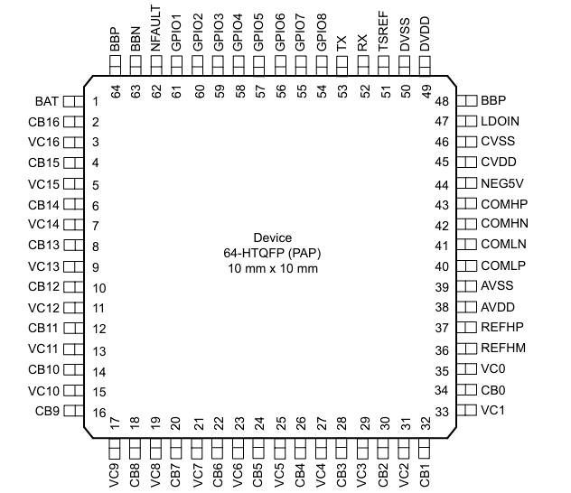

WAKE UP

It is the conversion of the lower power state of the device to ACTIVE mode , where all functions are operational.
SLEEP2ACTIVE (SLEEP TO ACTIVE) 250-300 microseconds.
WAKE TONE (SHUTDOWN TO ACTIVE) 2-2.5 milliseconds.

Steps for SHUTDOWN TO ACTIVE
- Hold Rx LOW for 2-2.5 milliseconds (t_{HLD_WAKE})
- Release Rx to HIGH (pull up)
- Takes 6-10 milliseconds for IC transitioning
- Ready for communication
- ACTIVE Mode

Steps for SLEEP TO ACTIVE
- Hold Rx LOW for 250-300 microseconds
- Release Rx to HIGH (pull up)
- Wait for 300 microseconds
- Ready for communication
- ACTIVE Mode

We woke up the IC in both closed and open conditions of the DIP switches. Out of which open condition was the favourable one to not use resistor ladder and access the actual 10s cells.

NOTE :- TX OF MCU IS CONNECTED TO USB 2ANY TX WHICH IS INTERNALLY CONNECTED TO BQs RX
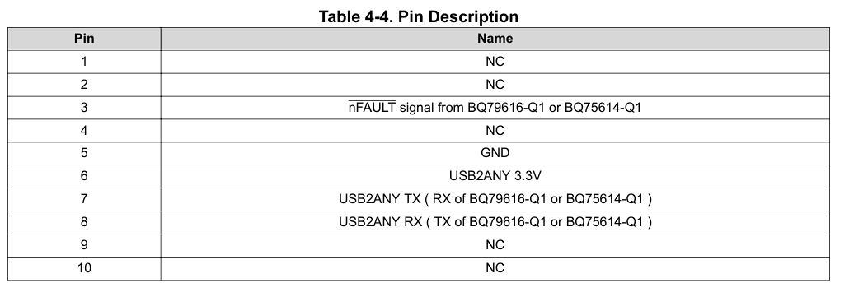
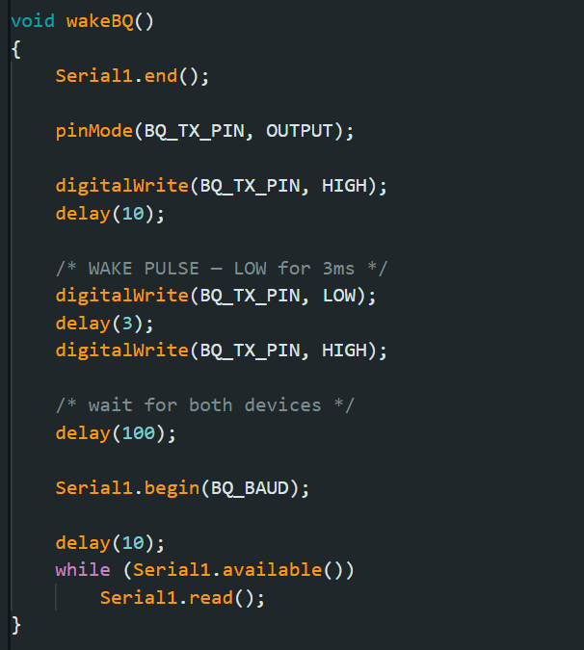
This code snippet is for Arduino Mega 2560 through which we woke up IC

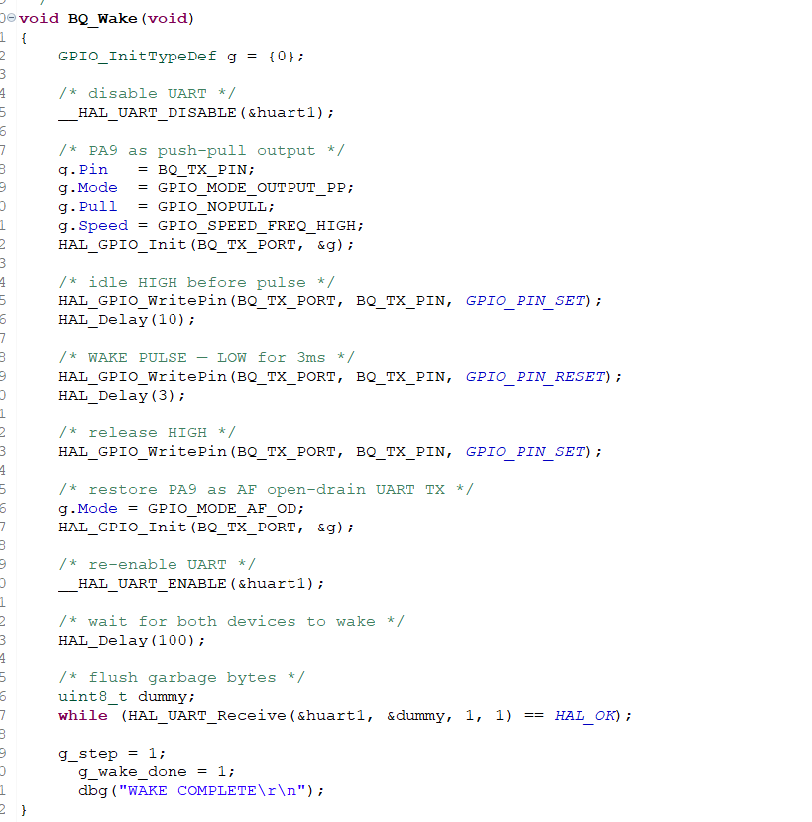
This code snippet is for STM32F103C8T6 (Blue Pill) through which IC woke up

DAISY CHAIN COMMUNICATION

The daisy chain communication interface on the bq7961X family of devices is a proprietary protocol developed by Texas Instruments. It is designed using differential signaling to minimize Electro-Magnetic Susceptibility (EMS) and strengthen Bulk Current Injection (BCI) immunity. The differential communication transmits complement data on the COM*P and COM*N pins, respectively. This interface is bi-directional and half duplex, and, therefore, has a transmitter (TX) and receiver (RX) on the COMH (high -side) and COML (low-side) interfaces
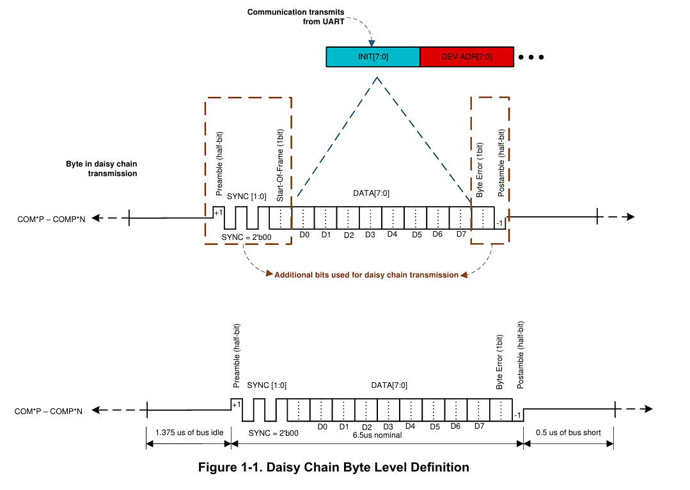
BYTE DIVISION:-
0.5 BIT PREAMBLE
0.5 BIT POSTAMBLE
2 BITS SYNC
8 BITS DATA
1 BIT BYTE ERROR
1 BIT START OF FRAME
COMMUNICATION FRAME ANATOMY:-
INIT 1 BYTE
DEV ADDR 1 BYTE
REG ADDR 2 BYTE
CRC (CYCLIC REDUNDANCY CHECK) 2 BYTE
DATA VARIABLE SIZE

STM32F103C8T6 CONFIGURATIONS
PA9-USART 1 TX -Asynchronous
PA10-USART 1 RX-Asynchronous
PD0- RCC_OSC_IN
PD1-RCC_OCC_OUT
PC13-GPIO OUTPUT

To go through our entire code kindly click on the link to get redirected to our github repository :-
https://github.com/rishit1317/BMS-Using-BQ79616-EVM-021-.git

HARDWARE EVM-021 CONFIGURATIONS:-
J21 J18 J2 are populated
J1 is open
We are using only 7 cells for testing therefore cell 8 to cell 16 must be populated with cell 7
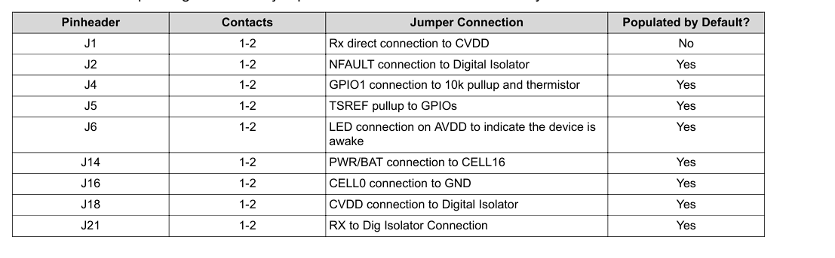
PWR Testing and Populated with Cell 7 according to this
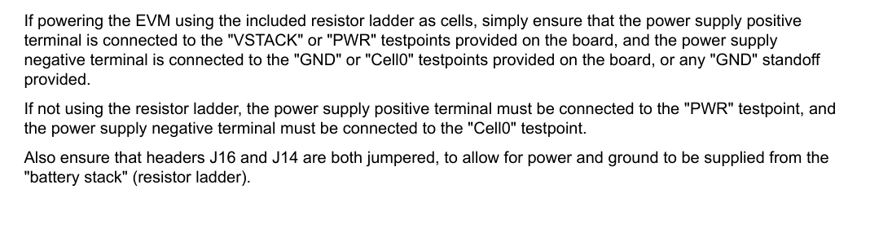
DIP Switches (Cell Input Selection)
The EVM-021 has DIP switches that control whether the resistor ladder (built-in dummy cells for bench testing) or external battery cells are connected to the voltage sensing inputs (VC0–VC16).
DIP Switch State | Connection | Use Case
CLOSED | Resistor ladder connected to VC pins | Bench testing with internal dummy resistors — no real cells needed
OPEN | External battery cells connected to VC pins | Real cell stack

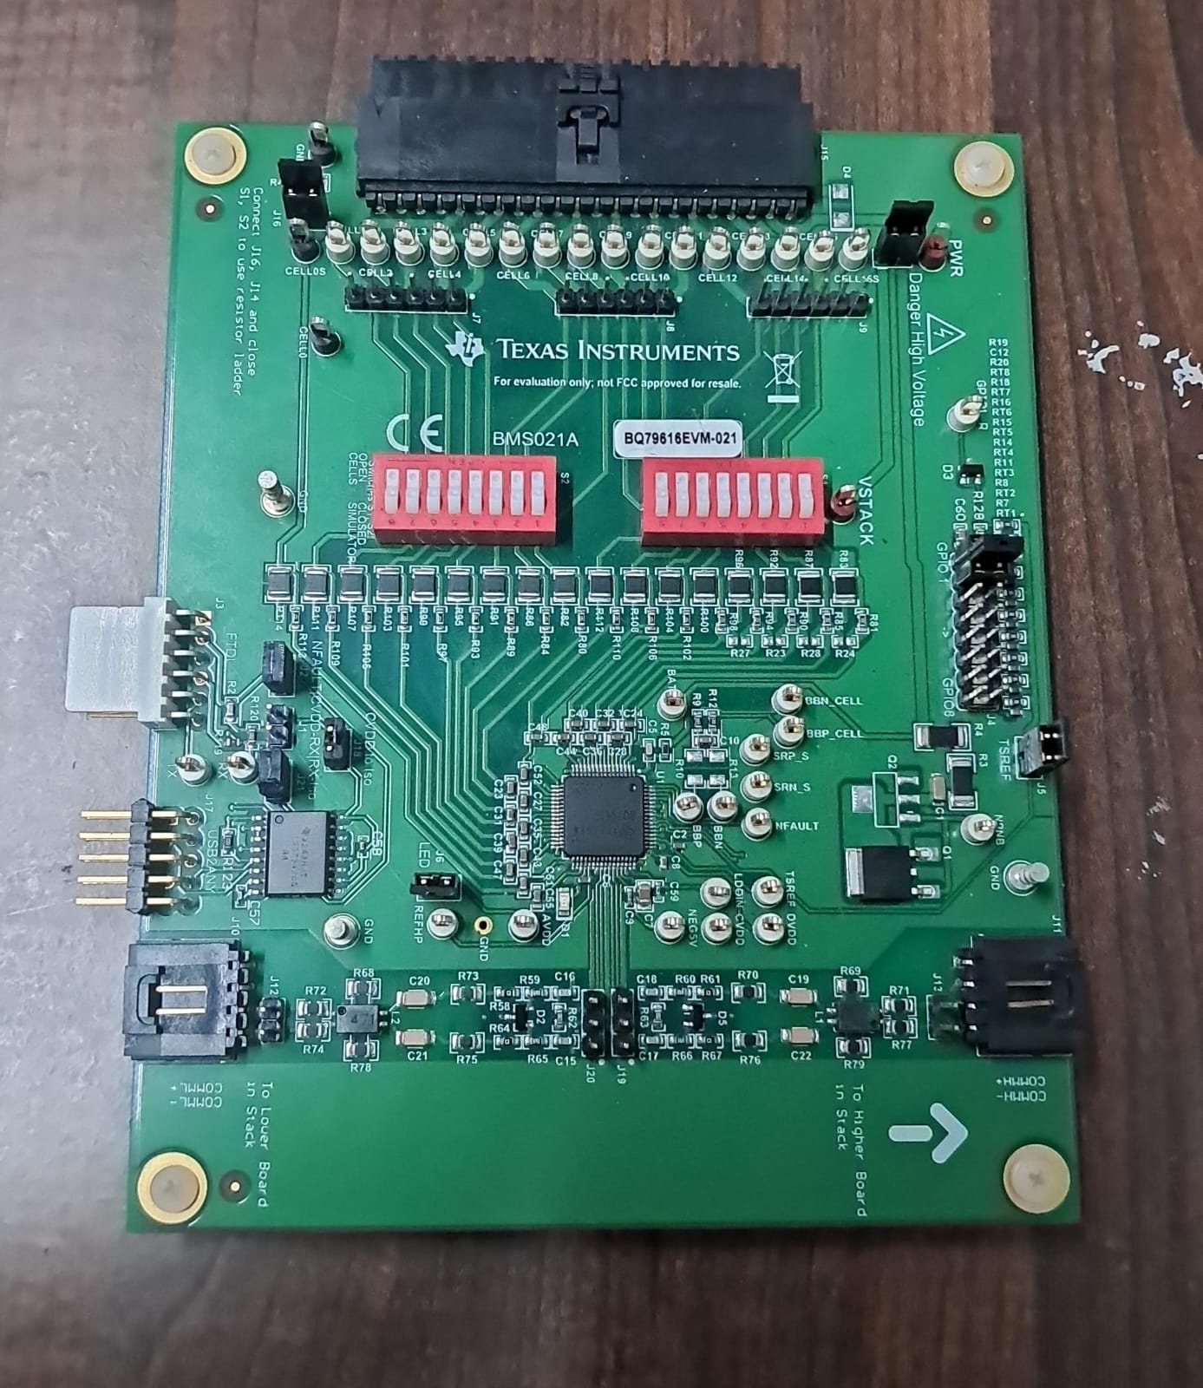

Isolation Blocks
The EVM-021 uses digital isolators on three critical signal paths to provide galvanic isolation between the high-voltage battery domain and the low-voltage MCU domain:
1. UART RX Path — J21
BQ79616 TX → Digital Isolator → J21 (1-2) → J15 pin 7 (USB2ANY RX / MCU RX)
- Isolates the TX data from the bq79616 going back to the host MCU
2. UART TX Path — J18
MCU TX → J15 pin 8 (USB2ANY TX) → Digital Isolator → J18 (1-2) → BQ79616 RX
- Isolates the command data from the MCU going into the bq79616
3. nFAULT Signal — J2
BQ79616 nFAULT → J2 (1-2) → Digital Isolator → J15 pin 3 (to MCU)
- Provides an isolated fault indicator to the host — critical for safety

ISSUES:-
- PA9 is able to transmit signals but during reception we receive a timeout error.
- PA10 is unable to receive the PARTID that we are transmitting after following the required steps given in the datasheet
- Autoaddressing has been performed just for checking if IC wakes up in daisy chain communication and it did wake up but still the communication error establishment persists.
- Also on Arduino Mega 2560 serial monitor when we set the baud rate on serial monitor to 1Mbps we see boxes instead of actual words.When we switch to 115200 bauds/sec we could see the actual words.
- Major problem is the UART establishment between the IC and MCU,we think we are transmitting the right frames but ultimately the IC is ignoring all the frames
- We have thought of switching to SPI communication protocol but would require an additional Bridge Device along with Stack Devices

We have added a sufficient amount of comments for proper understanding of the code.
Also for your reference you may go through the documents for frame sending and software design which is present in the github repo.
RESOURCES
BQ79616 DATASHEET
BQ79616 EVM021 EVALUATION MODULE
BQ79616 EVM021 CONTROL MODULE
DAISY CHAIN IMPLEMENTATION
BQ79616 FRAME SENDING AND SOFTWARE DESIGN
GITHUB REPOSITORY

