

Set Operations On Numbers
02.10.2017
DS project for 3rd SEM - Section-B
52 Anurag Mishra
53 Aman Saxena
54 Rishit Ratna
55 Vyshnav Ayilliath
56 Anmol Nanchahal

Problem Statement

Write a C application to implement a complete library for Set Operations on numbers. The library must provide options for creating sets, you are free to use any data structure. Perform the following Operations:
i) Union of Sets v) Compute Power Set
ii) Intersection vi) Set Difference
iii) Set Membership vii) Set Inclusion
iv) Complement viii) Cartesian Product

Data Structure Used:
Doubly Linked List without header node and not circularly linked.
typedef struct Node{
int number;
struct Node *right_ptr;
struct Node *left_ptr;
}Node;

Algorithms

Union of Sets

- Step 1: Join Both the linked list
- Step 2: Delete every Duplicate element

Intersection of sets

- Step 1: For each element in the first linked list, iterate through the 2nd list.
- Step 2: Repeat until end of list 1.

III. Set Membership
- Step 1: Ask user for an element to compare
- Step 2: Iterate through list and Check if it is present in list 1.
- Step 3: Do the same for list 2.

IV. Compliment

- Step 1: Take list 1 as the Universal Set.
- Step 2: Display all elements present in list one but not in Universal Set.

V. Power Set

Step 1: Find the number of elements(n) in the given List
- Step 2: Run a for loop for 0 to n-1
- Step 3: For each iteration a different Sequence of binary codes will be generated which selects whether an element is there in that set or not.
- Step 4: Display each of combination.

VI. Set Difference

Step 1: Assume list 1 - list 2
- Step 2: For every element in list 2 run a loop
- Step 3: Check if the Corresponding number is present in list 1 and delete it.

VI. Set Inclusion

- Step 1: Check if every element of list 2 is present in list 1
- Step 2: If condition is satisfied, then list 2 is a subset of list 1.

VI. Cartesian Product

Step 1: For an element is list 1, make a pair with every element of list 2

Step 2: Do this for every element in list 1.

Functions Used

I. Ins_node : Inserts nodes into a given Linked List.

II. Delete: Delete an element from a node

III. Display: Display a linked list

IV. UnionList: Union of two lists

V. IntersectionList: Intersection of two Lists

VII. SetMemberShip : Check the membership of an element in a list

VIII. Complement: Find the complement of a Set

VII. PowerSet: Find the PowerSet of a Set

VII. SetDifference : Difference between Two sets

VII. SetContainment: Checks if one set is a subset of another

VIII. CartesianProduct: Finds cartesian Product of two sets

IX. CreateSet: Creates a Set

X. Screen: Displays the required Screen

XI. Copy: Copies one Linked List to the other

Input/Output
It is a menu driven Program. Hence Every step can be followed methodically.

I. Creates a Set
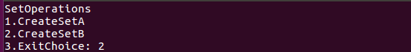

II. Enter Elements
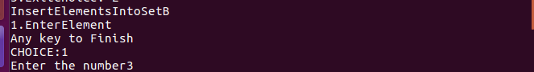

II. Output:
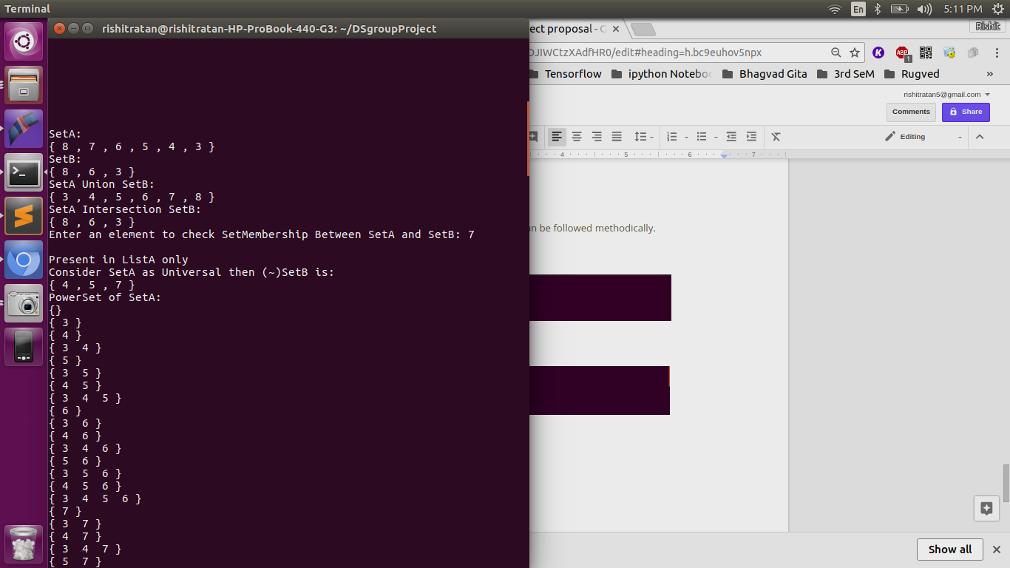

II. Union:

II. Intersection
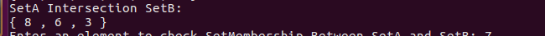

II. Power Sets

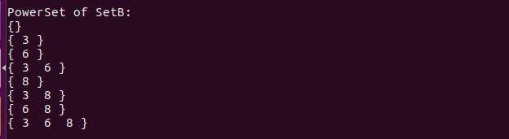

II. Cartesian Product
