**Steps to Install R:**

* 1. Open an internet browser and go to [www.r-project.org](http://www.r-project.org/).

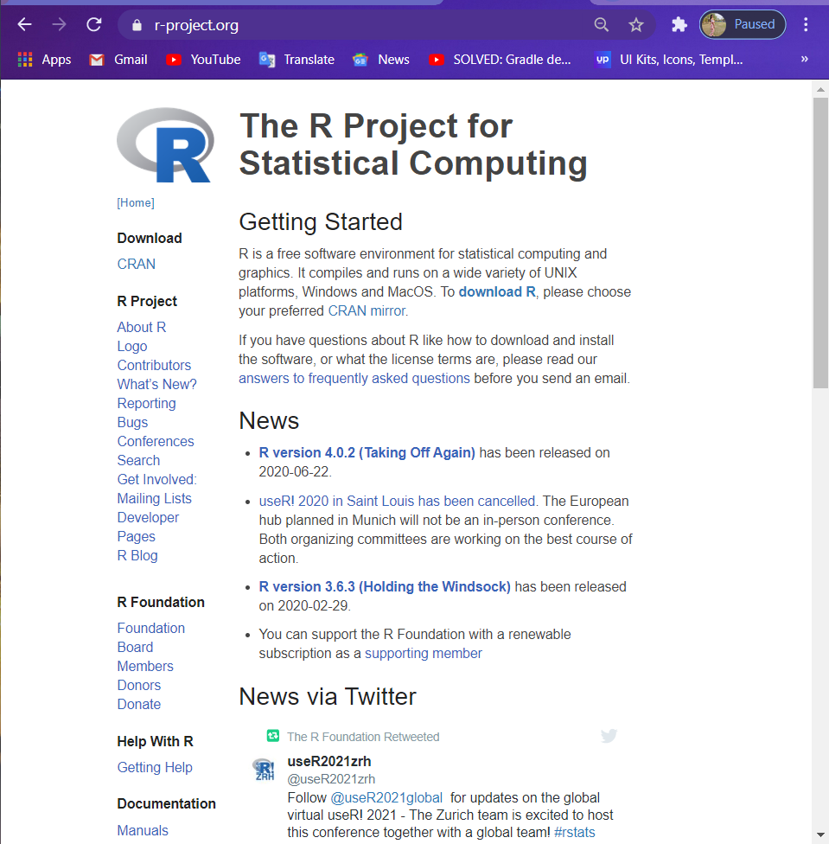

* 1. Click the "download R" link in the middle of the page under "Getting Started."



* 1. Select a CRAN location (a mirror site) and click the corresponding link.  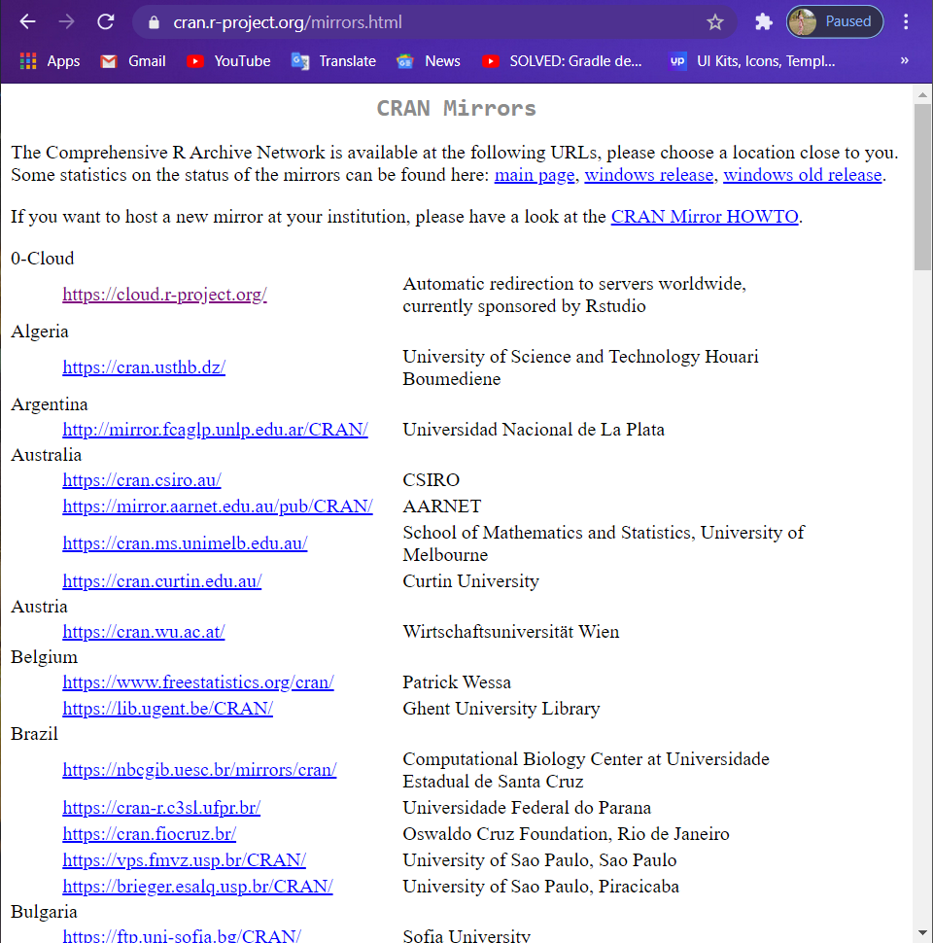
  2. Click on the "Download R for Windows" link at the top of the page.

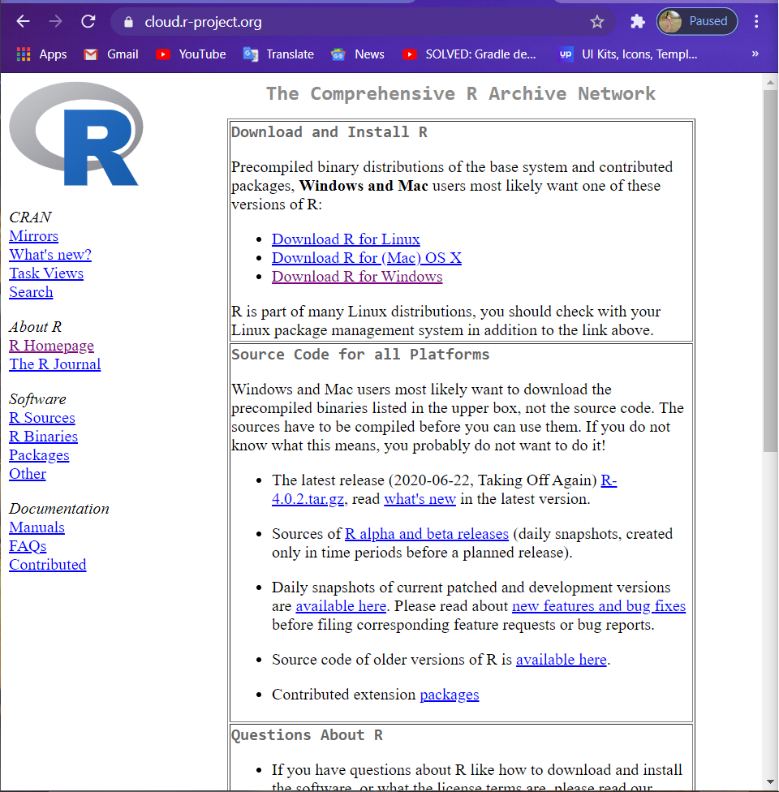

* 1. Click on the "install R for the first time" link at the top of the page.

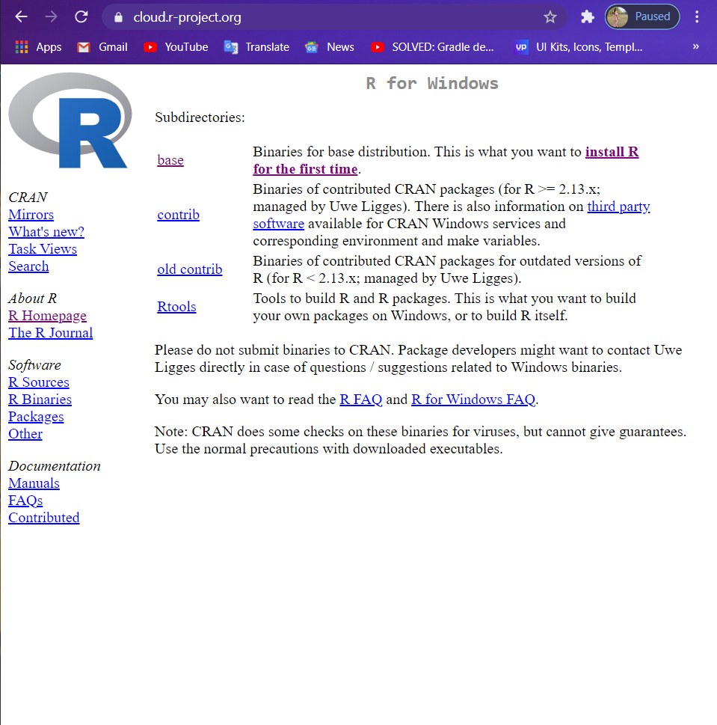

* 1. Click "Download R for Windows" and save the executable file somewhere on your computer.

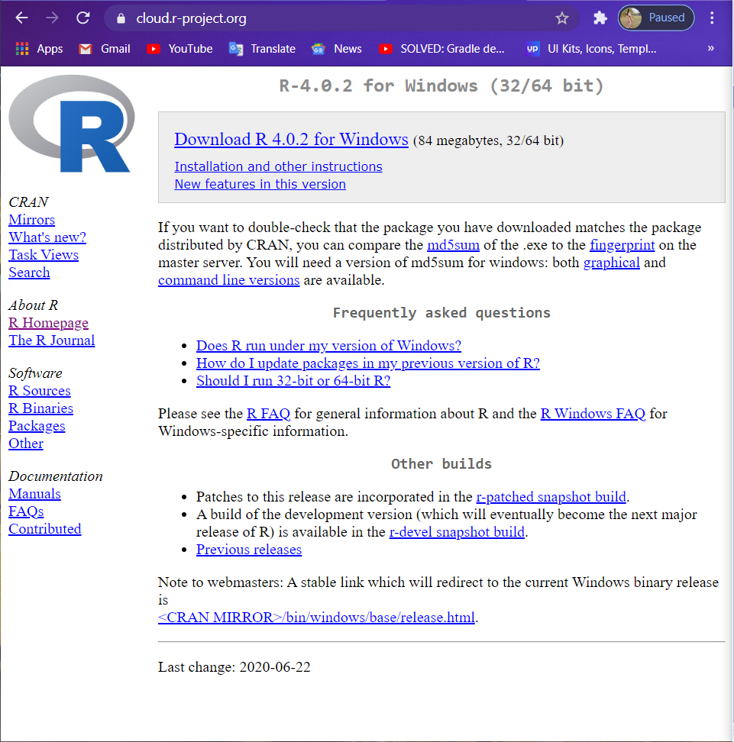

* 1. Run the .exe file and follow the installation instructions.

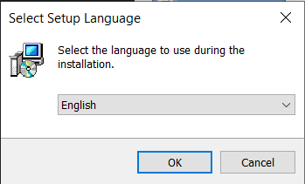

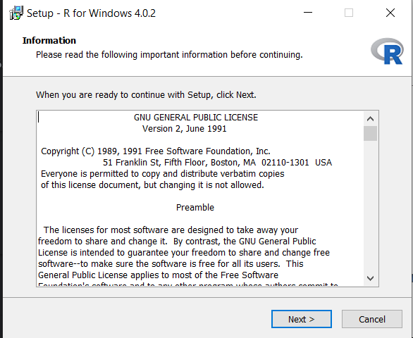

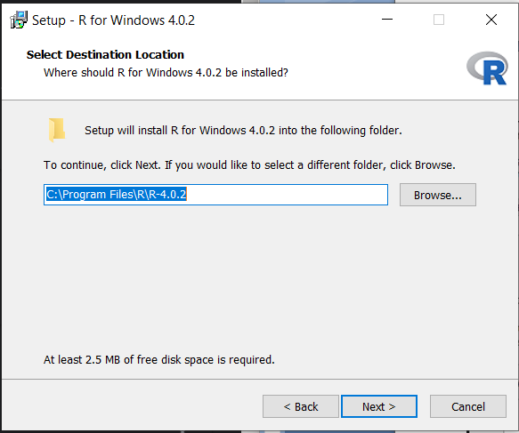

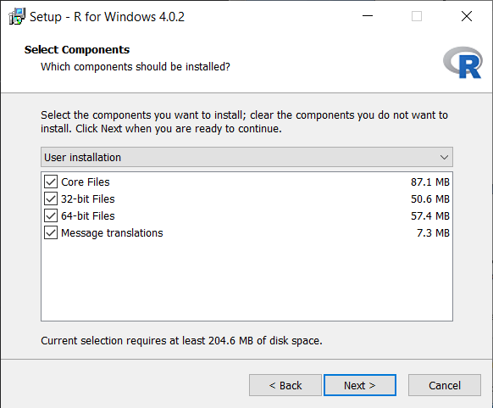

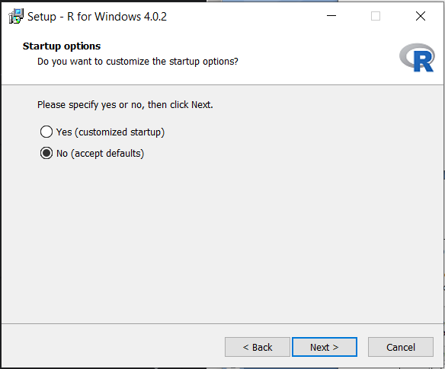

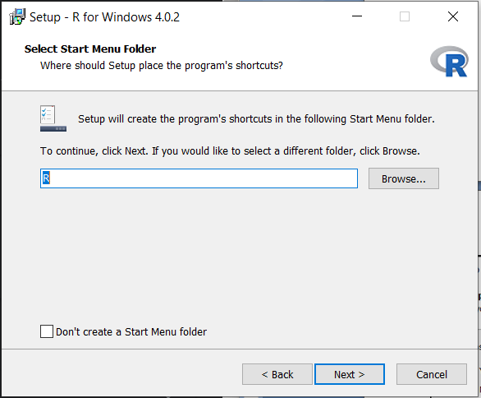

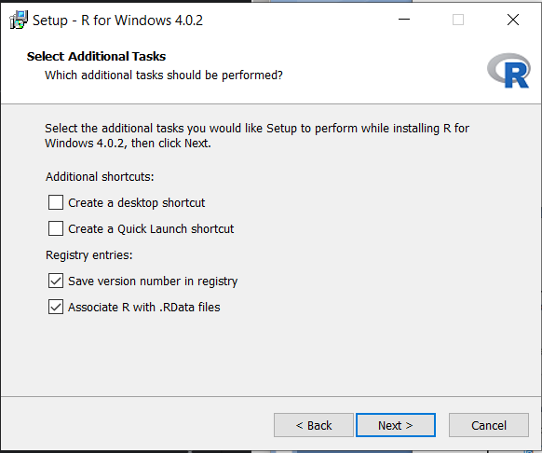

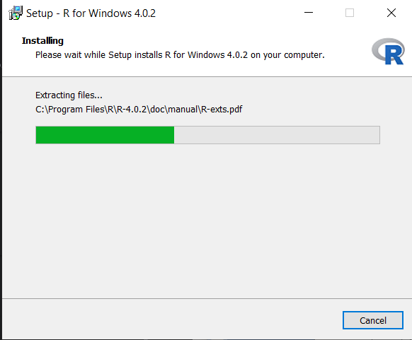

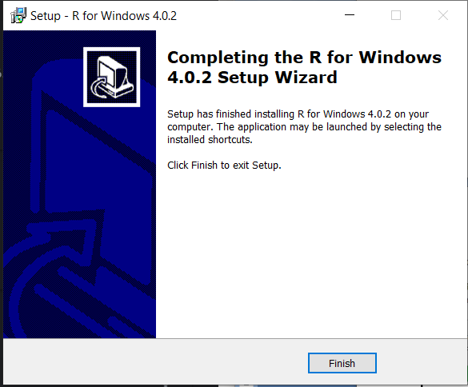

* 1. Now that R is installed, this is how R looks and now you need to download and install RStudio.

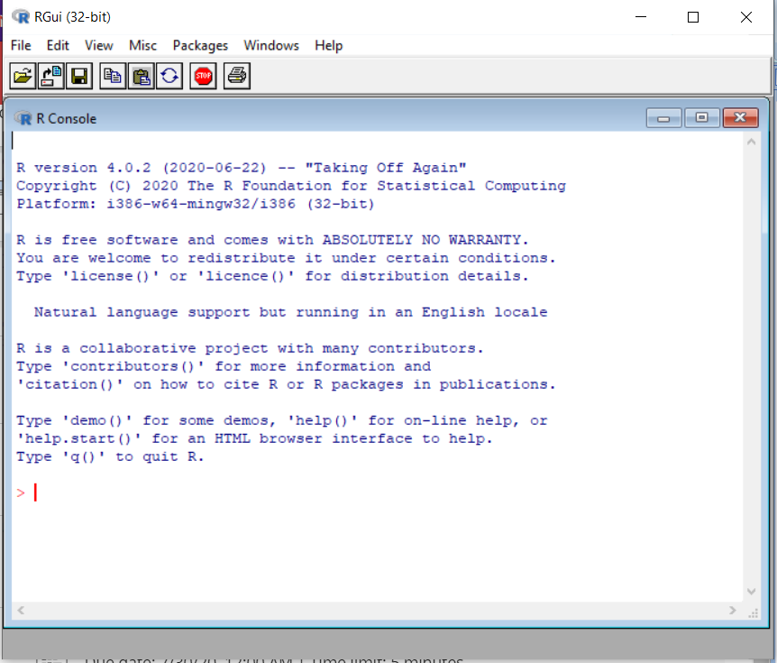

**Steps to Install RStudio:**

* 1. Go to [www.rstudio.com](http://www.rstudio.com/) and click on the "Products->Open-Source->RStudio" button.

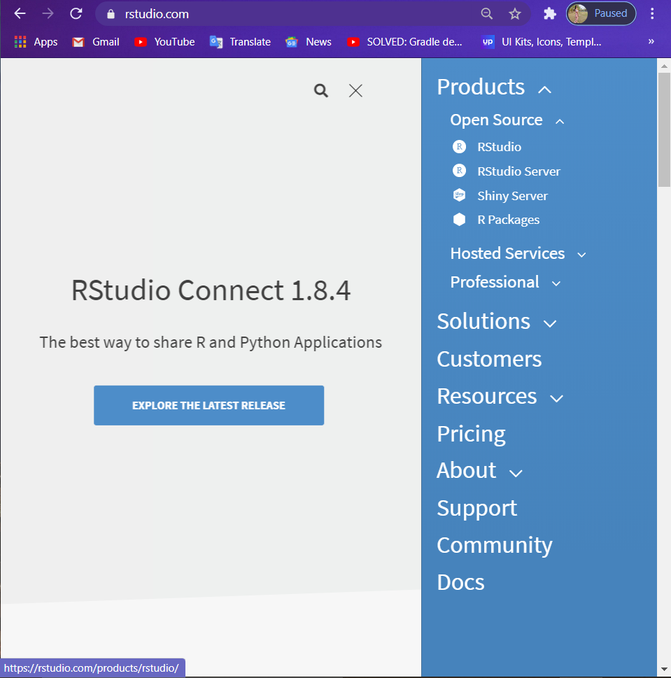

* 1. Click on "Download RStudio Desktop."

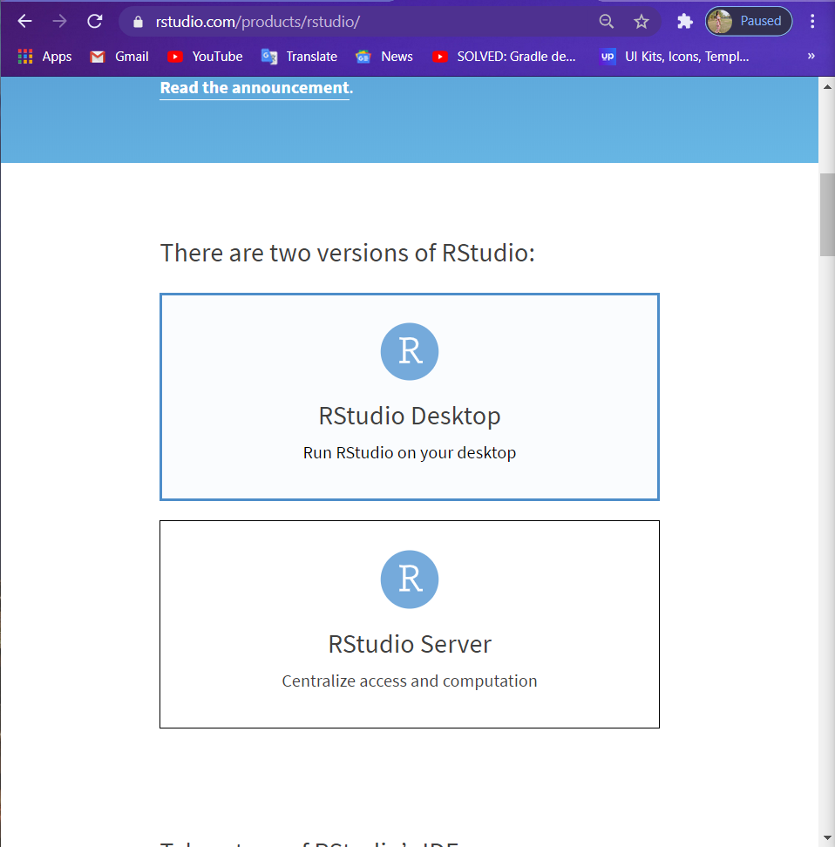

* 1. Click on the version recommended for your system, or the latest Windows version, and save the executable file.

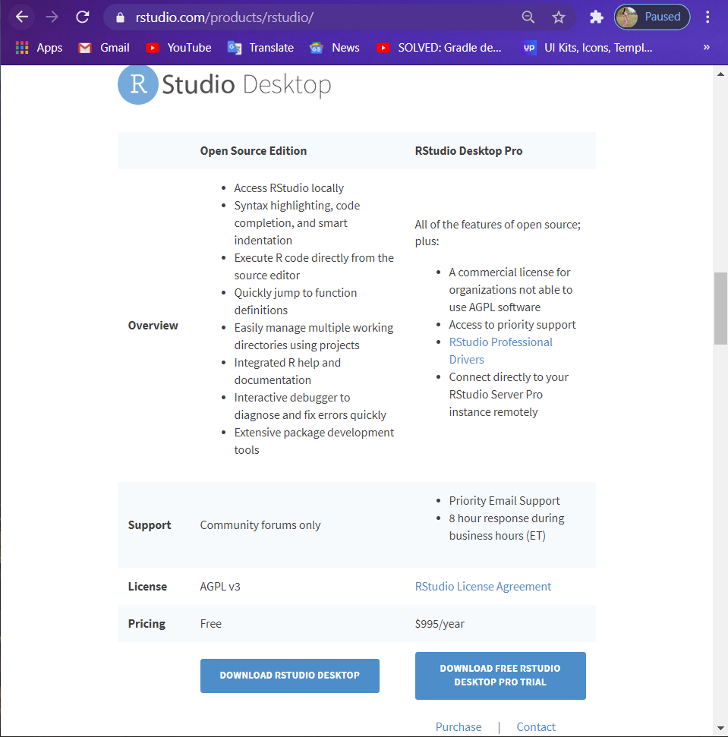

* 1. Run the .exe file and follow the following installation instructions.

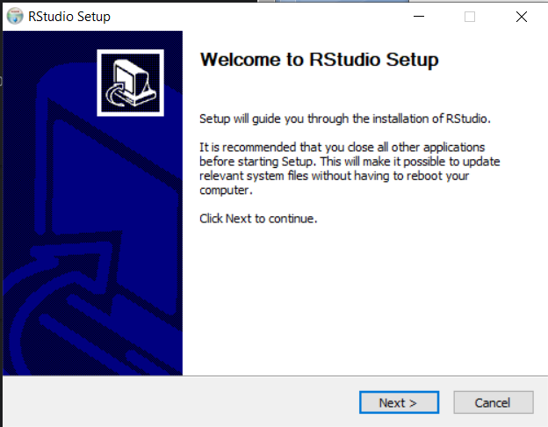

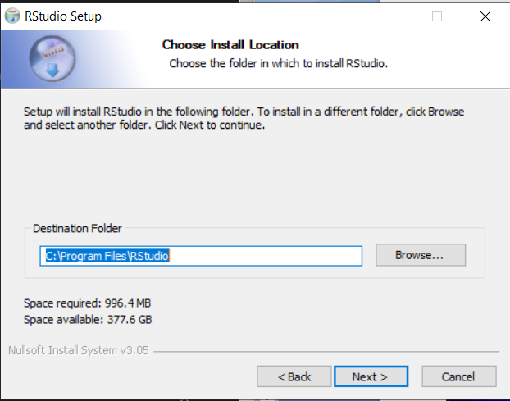

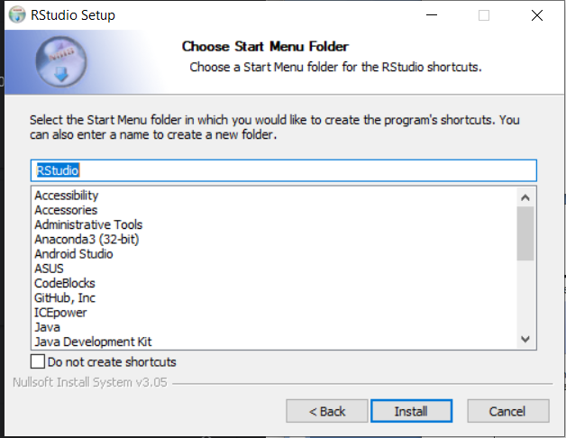

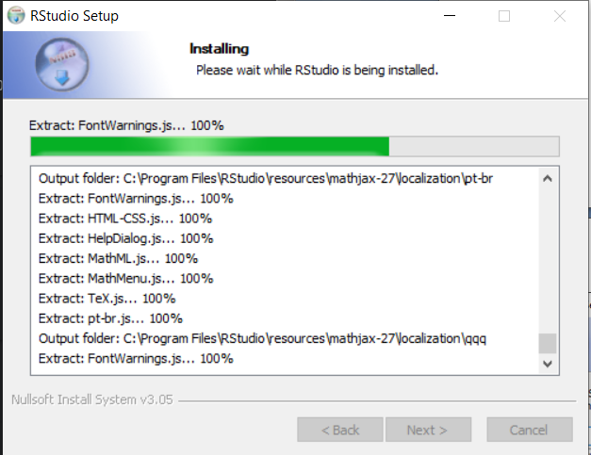

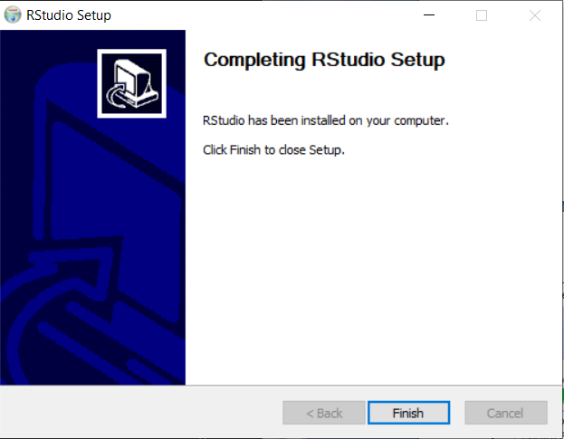

5. R Studio is successfully installed on our computer.This is how R studio looks. Now we will install some packages so that we can work smoothly with R on R Studio.

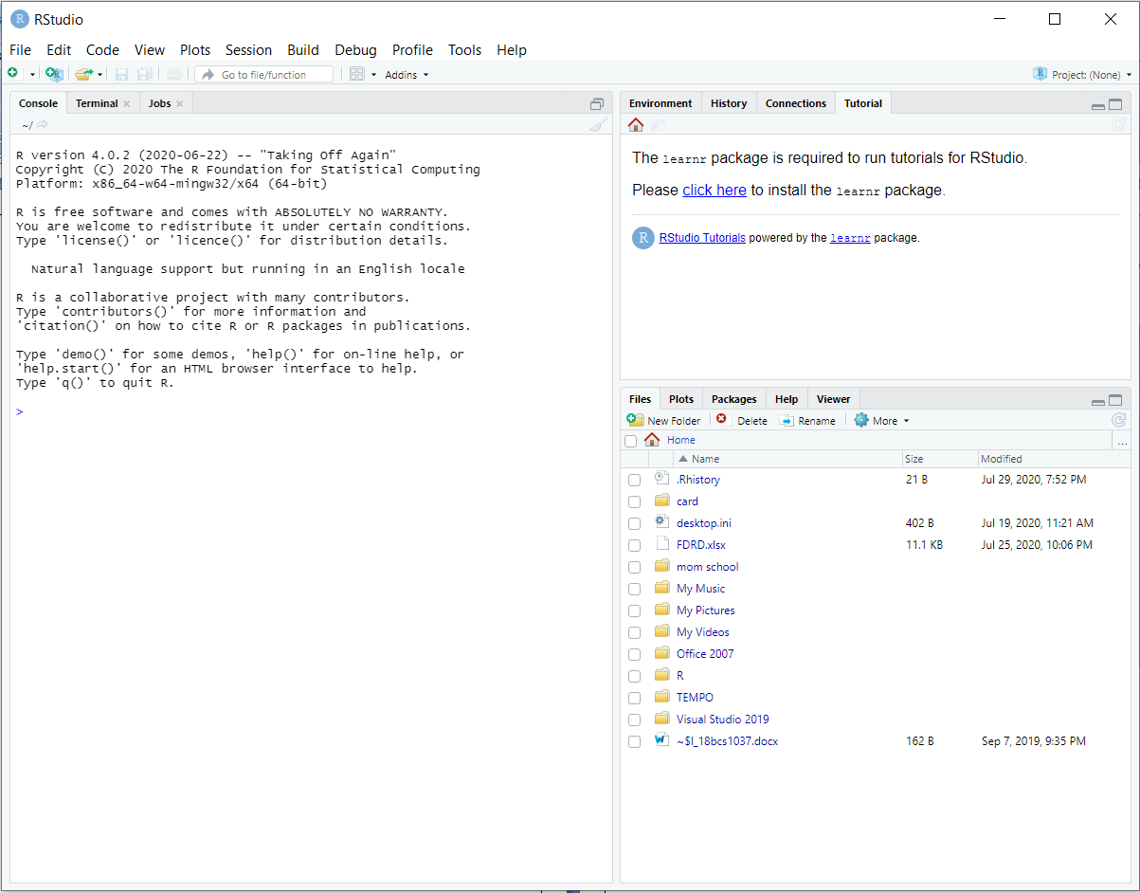

**To install R packages:**

1.Open R and go to Packages->Install Package.

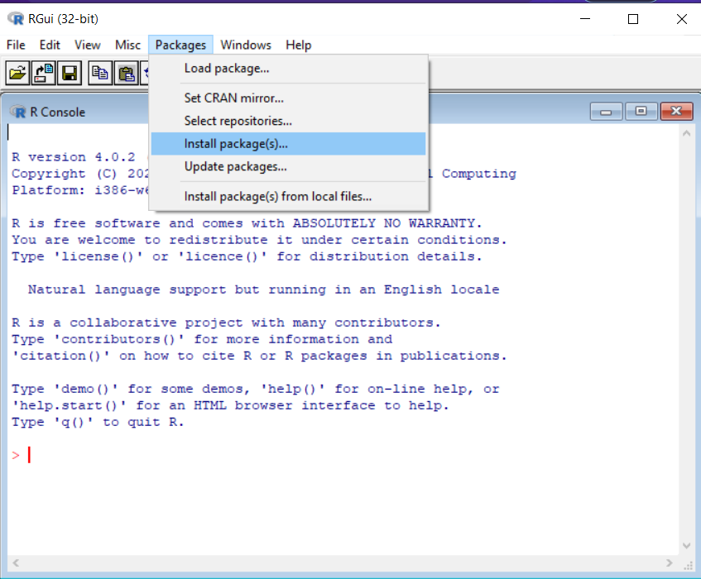

2. Select the CRAN mirror. Here, I am selecting 0-Cloud[https]. Then click OK.

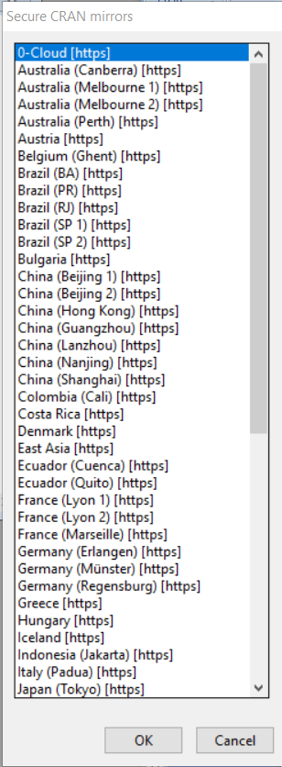

3. Click on the package name you want to download. Here, I am installing the learnr package.

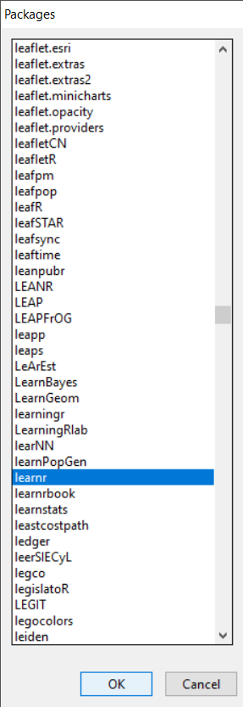

4.Wait for the the dialog box to complete 100%.

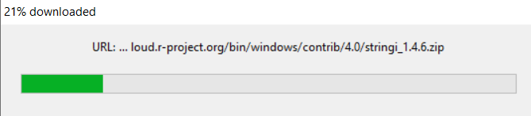

5. After all the files are downloaded, RGui will automatically install them.

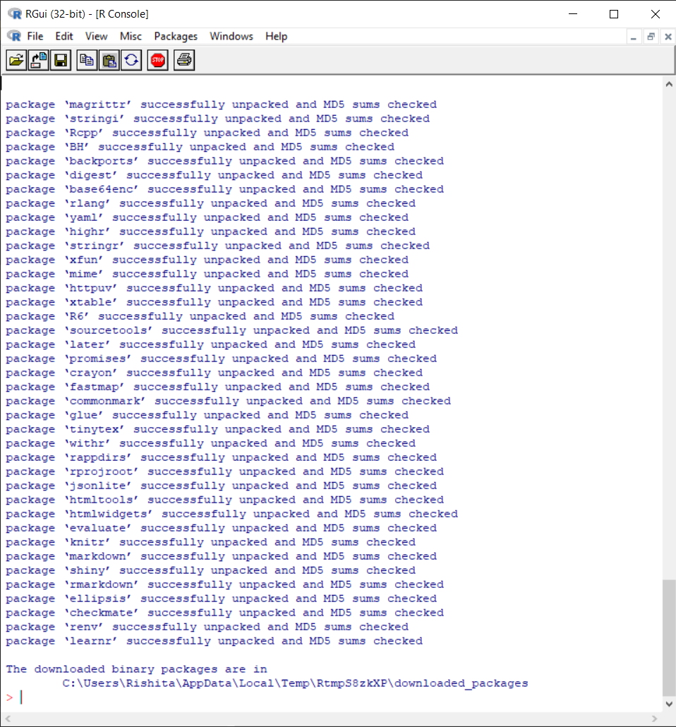

6. R packages are installed and now we can work with R on R Studio without any hassles.