**Project Title:**

Decoding the Buy Box: A Visual Deep Dive into Amazon’s Sales Dynamics

**Prepared By:**

Rishita Singh  
Data Research Intern | Data and Product Analytics Enthusiast

June 2025

**Executive Summary**

This report presents a sales performance analysis of Amazon's global retail data using Power BI. The objective is to identify revenue patterns, category profitability, and region-wise contributions to support strategic business decisions. The dashboard highlights key performance indicators (KPIs) and enables slicing of the data by region, category, and sales channel. Insights from this report can assist category managers, regional heads, and pricing teams in optimizing performance and profitability.

**Project Overview**

| **Component** | **Details** |
| --- | --- |
| **Data Source** | Simulated Amazon sales dataset |
| **Reporting Tool** | Microsoft Power BI |
| **Data Fields** | Order Date, Region, Category, Sales Channel, Profit, Revenue, Cost, Units Sold, Priority |
| **Time Frame** | 2010–2017 |
| **Supporting Tools** | Excel (data prep), Python (exploration), DAX (metrics) |

**Dashboard Features**

* **KPI Indicators:** Total Profit, Revenue, Units Sold, Average Order Value
* **Region-wise Sales Visualization** (using map and bar chart)
* **Category & Channel Contribution Charts**
* **Profit Margin & Discount Impact Analysis**
* **Order Priority vs. Profit Breakdown**
* **Interactive Filters:** Region, Category, Month, Channel

**Key Findings**

1. **Sub-Saharan Africa** accounts for the **highest revenue** (~$40M), indicating high-volume market penetration.
2. **Cosmetics** is the most **profitable product category**, contributing over $14.5M in profits globally.
3. **Online sales** contribute **58.14% of overall revenue**, but **offline sales** outperform in Office Supplies and high-cost items.
4. **Fruits, Beverages, and Snacks** show **consistently poor performance** across regions — both in sales and margins.
5. No consistent correlation was observed between **discounting and higher sales**, especially in the Asia and MENA regions.

**Visual Overview**

* Map: Revenue by Region
* Bar Chart: Profit by Category
* Pie Chart: Channel-wise Revenue Split

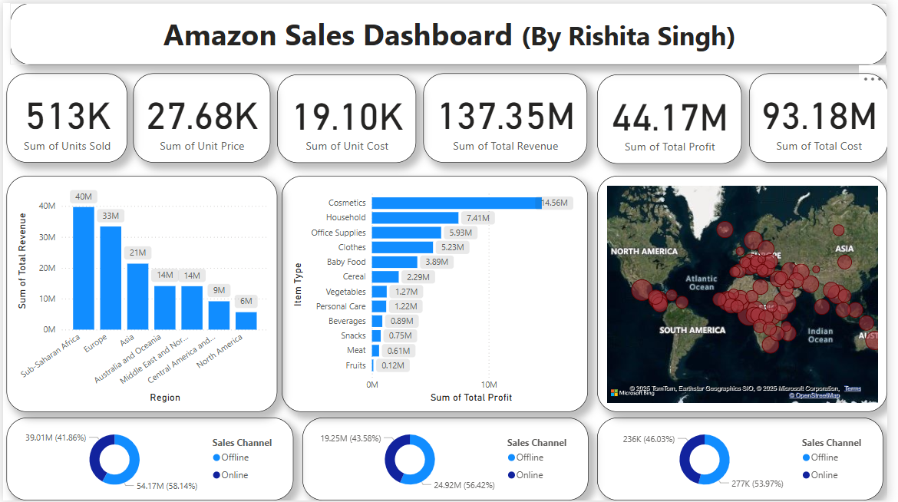 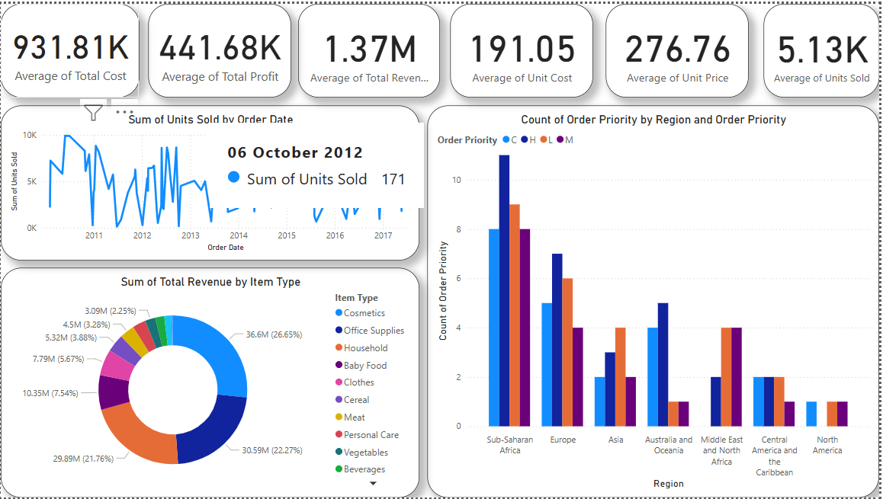

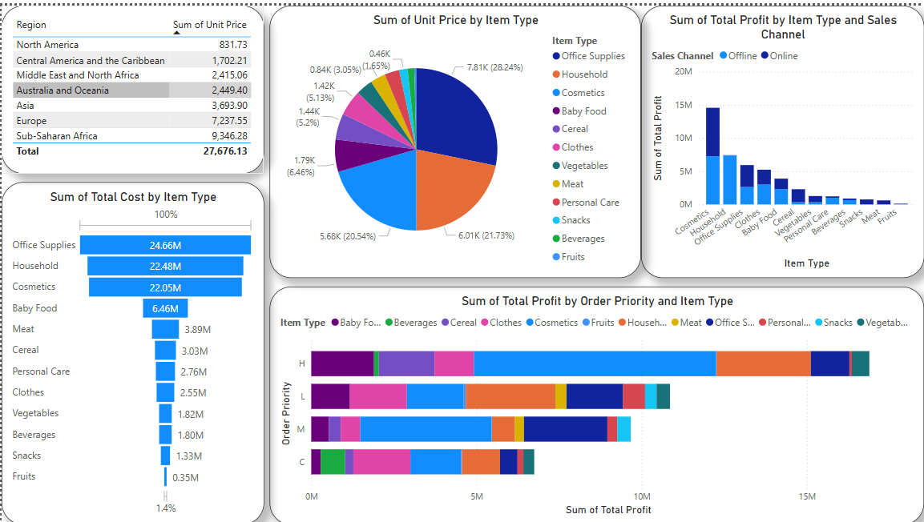

**Business Recommendations**

| **#** | **Recommendation** | **Justification** |
| --- | --- | --- |
| 1 | Focus on high-margin categories like **Cosmetics** and **Office Supplies** | These consistently deliver high profits with stable volume |
| 2 | Optimize **discount strategy** in low-ROI regions | Discounts are not improving sales in certain regions, draining profits |
| 3 | Discontinue or rework **low-performing categories** | Fruits, Snacks, and Beverages yield low margins despite discounts |
| 4 | Expand **offline operations** for profitable, non-digital product lines | Offline sales outperform in specific categories, especially bulk supplies |
| 5 | Use **Order Priority as a segmentation metric** | High-priority orders yield stronger profits — can be leveraged for upselling |

**Data Preparation Summary**

* Cleaned null entries in Profit, Discount, and Priority fields
* Standardized category and region labels
* Transformed Order Date into Date/Time format for temporal analysis
* Created calculated columns and custom DAX measures:
  + Profit Margin = Profit ÷ Revenue
  + YoY Growth %
  + Average Order Value

**Future Scope**

* Add forecasting trends using built-in Power BI analytics
* Integrate live data through APIs or Azure for auto-refreshing reports
* Build mobile dashboard layout for executive consumption
* Incorporate RFM segmentation (Recency, Frequency, Monetary) for customer-level insights

**About the Analyst**

**Rishita Singh** is a pre-final year Computer Science Engineering student and a Data Research Intern, specializing in dashboarding and data storytelling using Power BI and Excel. She is currently building portfolio projects in data and product analytics and visual insights for retail and operations.