**UNIT- V**

**SPECTROSCOPIC TECHNIQUES AND APPLICATIONS**

**ESSAY QUESTIONS:**

1  **Explain about UV spectroscopy write the applications of it.**

Ans: Visible wavelength range is from 400 ~ 800 nm.

UV wavelength range from 200 ~ 400 nm .

UV range is of three types.

200 ~ 280 nm is FAR UV

280 ~ 320 nm is Mid UV

320 ~ 400 nm is Near UV

The molecule is irradiated with UV, Visible radiation; it gets excited from lower electronic energy level to higher electronic energy level.

This transition is only possible when radiation with energy is equal to the energy difference between two levels is applied ΔΕ=Ε2-Ε1=*h*ν. The electrons get excited from HOMO to LUMO. UV spectrum has several peaks. λmax is the wavelength that corresponds to maximum absorbance (Not max wavelength)

**Principle:**

1. The Principle of UV-Visible Spectroscopy is based on the absorption of ultraviolet light or visible light by chemical compounds, which results in the production of distinct spectra. 2. Spectroscopy is based on the interaction between light and matter.

1. When the matter absorbs the light, it undergoes excitation and de-excitation, resulting in the production of a spectrum.
2. When matter absorbs ultraviolet radiation, the electrons present in it undergo excitation.
3. This causes them to jump from a ground state (an energy state with a relatively small amount of energy associated with it) to an excited state (an energy state with a relatively large amount of energy associated with it).
4. It is important to note that the difference in the energies of the ground state and the excited state of the electron is always equal to the amount of ultraviolet radiation or visible radiation absorbed by it.

**Electronic transitions:**

Types of Transitions:

σ* Higher Energy Level

π* Higher Energy Level

n Lower Energy Level

Electron gets excited from lower energy level to higher energy level.

1. Absorption of ultraviolet and visible radiation in organic molecules is restricted to certain functional groups (chromophores) that contain valence electrons of low excitation energy.

1. The spectrum of a molecule containing these chromophores is complex.
2. This is because the superposition of rotational and vibrational transitions on the electronic transitions gives a combination of overlapping lines. This appears as a continuous absorption band.

Possible electronic transitions of P, S, and n electrons are;

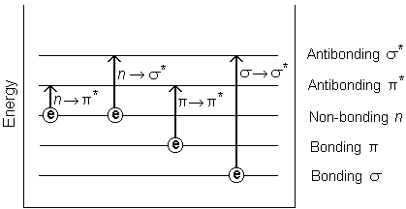

Six possible transitions are seen. Out of these six, four are allowed.

Six possible Transitions: σ→σ* ,π→π*, n →π*, n →σ*, π→σ*, σ→π*

Selection rules: 1. Symmetry Selection 2. Energy Selection

Symmetry Selection Rule: During the transition, same symmetry transition is allowed. Example - σ→σ* ,π→π*

Transition for which symmetry is not conserved is called Symmetry Forbidden (Not Allowed). Example - σ→π*, π→σ*, n →π*, n →σ*

Energy Selection Rule: Lower Energy transitions are allowed.

n →π*, n →σ* are energy allowed transitions.

Hence π→σ*, σ→π* are not allowed by Symmetry or by Energy Selection rule.

σ→σ* In this transition, molecule is excited from σ bonding molecular orbital to σ* anti-bonding molecular orbital

n →σ* In this transition, molecule is excited from n non-bonding molecular orbital to σ*anti-bonding molecular orbital

π→π* In this transition, molecule is excited fromπ bonding molecular orbital to π* anti-bonding molecular orbital

n →π* In this transition, molecule is excited from n non-bonding molecular orbital to π* ant-ibonding molecular orbital

σ→σ* transitions: All alkanes and cyclo-alkanes have only. λmax= 160 nm

n →π* transitions: Is seen in alcohols, amines, ethers. λmax= 160 ~ 180 nm

π→π* transitions: Is seen in alkenes, cyclo-alkenes, aromatic compounds. λmax= 180 ~ 220 nm

n →π* transitions: Is seen in carbonyls, carboxylic acids, esters λmax= 220 ~ 320 nm

Chromophores: Are the colour imparting species in the range of λmax= 400 ~ 800 nm

This is due to π→π* transitions. It is the part of molecule that is responsible for absorption of UV Visible radiation.

**Applications of UV-visible spectroscopy:**

UV/Vis spectroscopy is routinely used in analytical chemistry for the quantitative determination of different analytes, such as transition metal ions, highly conjugated organic compounds, and biological macromolecules. Spectroscopic analysis is commonly carried out in solutions but solids and gases may also be studied.

1. Solutions of transition metal ions can be colored (i.e., absorb visible light) because d electrons within the metal atoms can be excited from one electronic state to another.
2. Organic compounds, especially those with a high degree of conjugation, also absorb light in the UV or visible regions of the electromagnetic spectrum.
3. While charge transfer complexes also give rise to colours, the colours are often too intense to be used for quantitative measurement.

**2. Explain in detail about Woodward Fischer rules.**

**Ans: Woodward- fieser rules:**

 Each type of di-ene or tri-ene system is having a certain fixed value at which absorption takes place; this constitutes the ***Base value or Parent value***. The contribution made by various alkyl substituent’s or ring residue, double bond extending conjugation and polar groups such as –Cl, -Br etc are added to the basic value to obtain λmax for a particular compound.

**i) Conjugated di-ene correlations:**

 a) HomoannularDiene:- Cyclic diene having conjugated double bonds in same ring.

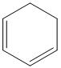

b) HeteroannularDiene:- Cyclic diene having conjugated double bonds in different rings.   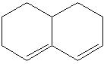

c) Endocyclic double bond:- Double bond present in a ring.

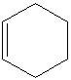

d) Exocyclic double bond: - Double bond in which one of the doubly bonded atoms is a part of a ring system.  Here Ring A has one exo-cyclic and endo-cyclic double bond. Ring B has only one endo-cyclic double bond.

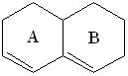

Parent values and increments for different substituent’s /groups:

i) Conjugated diene correlations:

i) Base value for homoannular diene = 253 nm

ii) Base value for heteroannular diene = 214 nm

iii) Alkyl substituent or Ring residue attached to the parent diene = 5 nm

 iv) Double bond extending conjugation = 30 nm

 v) Exocyclic double bonds = 5 nm

 vi) Polar groups:

a) -OAc = 0 nm

  b) -OAlkyl = 6 nm

  c) -Cl, -Br = 5 nm

**Eg:**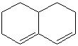

Base value = 214 nm

Ring residue = 3 x 5 = 15 nm

 Exocyclic double bond   = 1 x 5 = 5 nm

 λmax = 214 + 15 + 5 = 234 nm

**3) a.Define Chemical Shift and explain about shielding and deshielding of a proton nucleus.**

Ans: The variations of nuclear magnetic resonance frequencies of the same kind of nucleus due to variations in the electron distribution, is called the chemical shift.

The basic principle of NMR is to apply an external magnetic field called B0 and measure the frequency at which the nucleus achieves resonance.

Electrons orbiting around the nucleus generate a small magnetic field that opposes B0. In this case we say that electrons are shielding the nucleus from B0.

**Shielding:**

The higher the electron density around the nucleus, the higher the opposing magnetic field to

B0 from the electrons, the greater the shielding. Because the proton experiences lower external magnetic field, it needs a lower frequency to achieve resonance, and therefore, the chemical shift shifts upfield (lower ppms).

**Deshielding:**

If the electron density around a nucleus decreases, the opposing magnetic field becomes small and therefore, the nucleus feels more the external magnetic field B0, and therefore it is said to be deshielded. Because the proton experiences higher external magnetic field, it needs a higher frequency to achieve resonance, and therefore, the chemical shift shifts downfield (higher ppms).

**b.Write factors influence chemical shift.**

**Factors influence chemical shift:**

The chemical shift depends on several factors described below.

1. Electro negativity: A proton is said to be de-shielded if it is attached to the electro negative atom or group.

2. Steric effects: In overcrowded molecules, it is possible that some protons may occupy sterically hindered position resulting in Vander Waal’s repulsion. In such molecules the electron cloud of a bulky group (hindering group) will tend to repel the electron cloud surrounding the proton. Thus such a proton will be de-shielded and will resonate at slightly higher value of chemical shift than the expected in the absence of this effect.

3. Hydrogen Bonding: In general hydrogen bonded protons show higher value of chemical shift than the non-hydrogen bonded protons.

4. Solvent Effects: NMR signals for protons attached to carbon are generally shifted slightly by changing solvent except where significant bonding or dipole-dipole interaction might arise.

5. Carbonyl protons: Aldehydic protons experience greater field strength (diamagnetic effect) and consequently resonate at larger value of chemical shift (de-shielding).

6. Alkene Protons: olefin protons experience greater field strength and consequently resonate at larger value of chemical shift.

**4) a) Explain the principle involved in NMR spectroscopy.**

Ans: The principle behind NMR is that -

1. Many nuclei have spin and all nuclei are electrically charged.
2. If an external magnetic field is applied, an energy transfer is possible between the base energy to a higher energy level (generally a single energy gap).
3. The energy transfer takes place at a wavelength that corresponds to radio frequencies and when the spin returns to its base level, energy is emitted at the same frequency.
4. The signal that matches this transfer is measured in many ways and processed in order to yield an NMR spectrum for the nucleus concerned.

**b) How many signals Expected/predict NMR spectrum of i) ethanol ii) cyclobutane iii) 2-chlorobenzene iv) 2-methyl butane-2-ol ?**

**i) ethonol:**

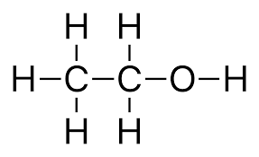

There are 3 groups of protons:

the protons in the CH3 group, the protons in the CH2 group, the proton in the O-H group

Number of signals = number of chemically different groups of protons = 3 signals.

**ii) cyclobutane:**

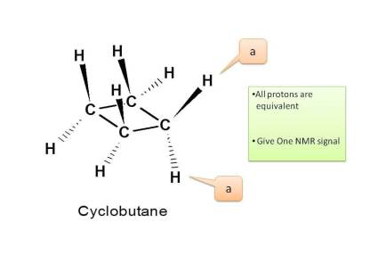

Now in cyclobutane all carbons have same protons hence all these are equivalent. Therefore total number of NMR signals is ONE.

**iii) 2-chlorobenzene:**

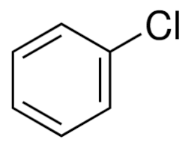

Now in 2-chlorobenzene all carbons have same protons hence all these are equivalent. Therefore total number of NMR signals is Three.

**iv) 2-methyl butane-2-ol:**

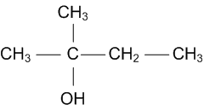

There are 4 groups of protons:

the protons in the 2 CH3 groups on same carbon, the protons in the CH2 group, protons in the CH3 group, the proton in the O-H group. Therefore total number of NMR signals is 4.

**5) Write about MRI.**

Ans: MRI is a medical imaging technique used in radiology to form pictures of the anatomy and the physiological process of the body in both health and disease.

Principle of MRI: The basis of MRI is the directional magnetic field, or moment, associated with charged particles in motion. Nuclei containing an odd number of protons and/or neutrons have a characteristic motion or precession. Because nuclei are charged particles, this precession produces a small magnetic moment. When a human body is placed in a large magnetic field, many of the free hydrogen nuclei align themselves with the direction of the magnetic field.

MRI scanners use strong magnetic field, magnetic field gradient and radio waves to generate images of the organs in the body.

MRI employs radio frequency pulse ranging from 1 to 80MHz.

MRI does not involve x-rays and the use of ionizing radiation. MRI is a medical application of NMR. MRI was originally called NMRI, later on the use of ‘Nuclear’ was dropped to avoid negative association. Magnetic resonance imaging (MRI) systems provide highly detailed images of tissue in the body. The systems detect and process the signals generated when hydrogen atoms, which are abundant in tissue, are placed in a strong magnetic field and excited by a resonant magnetic excitation pulse.

Inside the MRI system is the magnets. These powerful magnets are up to 30,000 times stronger than the earths magnetic field.

MRI works as follows: The human body is mostly water. Water molecules (H2O) contain hydrogen nuclei (protons), which become aligned in a magnetic field. An MRI scanner applies a very strong magnetic field (about 0.2 to 3 teslas, or roughly a thousand times the strength of a typical fridge magnet), which aligns the proton "spins."

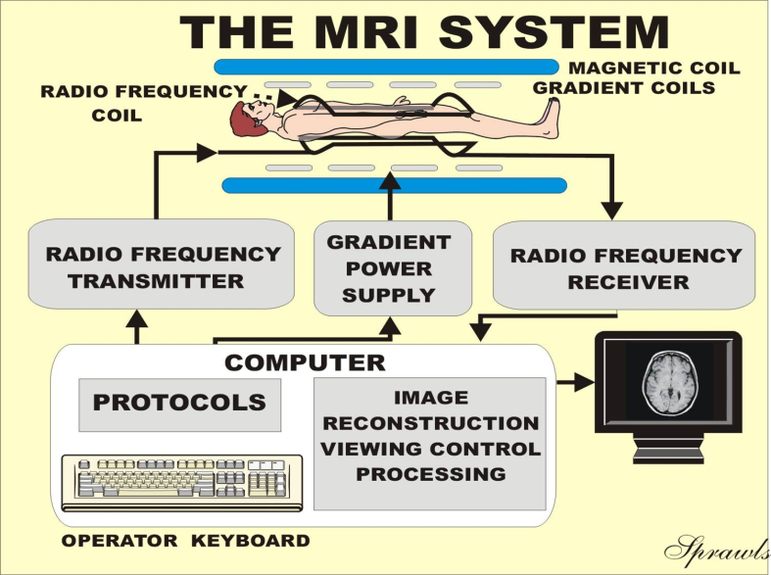

**Applications:**

1. Clinical neurology

– Segmentation and classification

– Measuring volumes of brain structures

– Multiple sclerosis, neurodegeneracy, stroke, …

2. Cardiology

– Either need to image fast, or deal with heart motion!

3. Cancer

– Breast, colorectal, liver, prostate, …

1. Musculoskeletal applications include spinal imaging, assessment of joint diseases and soft tissue tumors or damage.
2. MRI is also used a great deal in basic science to study brain function and cancer growth.
3. Liver and gastrointestinal applications:  rectal cancer and inflammatory bowel diseases.

**6) Write the detailed notes about IR spectroscopy.**

Ans: 1. It is a non destructive identification method available that measures the vibrational energy in a compound.

1. Each chemical bond has a unique vibrational energy. Even a C-C bond will be different from one compound to another depending on what other compounds each carbon is bound so.
2. Due to this unique vibrational energy, each compound will have a unique finger print, or the output.

**Selection rules:**

1. The selection rule says, that vibrations are only IR active (or allowed), if the molecular dipole moment changes during the vibration.

1. A diatomic molecule with the same atoms cannot be excited to vibrate because no dipole moment is present.
2. In contrast, molecules with various types of atoms can interact with incident radiation, and even if a dipole moment is not present in the beginning it can be induced due to antisymmetric displacement of the center of charge (e.g., CO2).

**Molecular vibrations:**

Vibrations fall into the two main categories of stretching and bending.

1. Stretching vibrations:

In this type of vibrations, the bond length is increased or decreased at regular intervals. There are two types of stretching vibrations. Symmetrical stretching and asymmetrical training.

a) Symmetrical stretching- In this type of stretching, bond length increase or decrease symmetrically.

b) Asymmetrical stretching- In this type of stretching, length of one bond increases and the other one decreases.

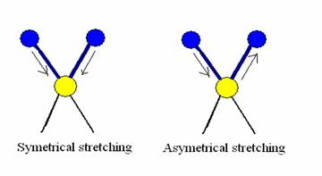

2. Bending vibrations:

In this type of vibrations, a change in bond angle occurs between bonds with a common atom, or there is a movement of a group of atoms with respect to the remainder of the molecule without movement of the atoms in the group with respect to one another. The bending vibrations are also called as deformation vibrations.

These are of two types.

a) In plane bending- In these types of vibrations, there is a change in bond angle. This type of bending takes place within the same plane. In plane bending are of two types.

i. Scissoring: in which bond angle decreases or increases.

ii. Rocking: in which the bond angle is maintained but both bonds moves within the same plane.

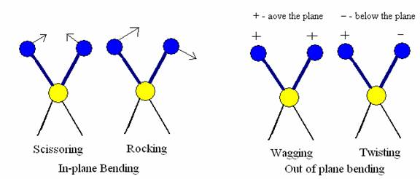

b) Out of plane bending- This type of bending takes place outside of the plan of molecule.

i.Wagging in which both atoms move to one side of the plane

ii. Twisting in which one atom is above the plane and the other is below the plane.



**Identification of different functional groups (-COOH, -OH, -CHO, -NH2):**

Ans: 1. O–H stretch, hydrogen bonded 3500-3200 cm-1

1. C=O stretch: aliphatic aldehydes 1740-1720 cm-1
2. The carbonyl stretch C=O of a carboxylic acid appears as an intense band from 1760-1690 cm-1
3. Amines stretching vibration range from 3400-3500cm-1, bending vibrations range from 1550-1600 cm-1.

**Calculation of number of vibrational degree of freedom of i) CO2 ii) Water**

**iii) SO2.**

**i) CO2** :There are a total of 3 atoms in CO2 molecule. It is a linear molecule so we use

Equation There are 3(3)−5=4

**ii) Water** : It has total 3 atoms in H2O. It is non-linear molecule so we use equation 3n-5.

3(3)-6=3. There are three possible vibrations in H2O.

**iii) SO2:** It has total 3 atoms in SO2. It is non-linear molecule so we use equation 3n-6.

3(3)-6=3. There are three possible vibrations in SO2.

**Applications:**

1. Identification of functional groups and structure of organic compounds.

2. Quantitative analysis of a number of organic compounds.

3. Study of covalent bonds in molecule.

4. Detection of impurities in a compound.

5. Ratio of cis-trans isomers in a mixture of compounds.

6. Shape of symmetry of inorganic molecules.

7. Used in pharmaceutical research.

8. Forensic investigations.

10. Environmental and water quality analysis etc.

**7. a.How do you identify carbonyl compounds , amines using IR spectroscopy?**

Ans: All carbonyl compounds absorb in the region 1760-1665 cm-1 due to the stretching viThe N–H stretches of amines are in the region 3300-3000 cm-1. These bands are weaker and sharper than those of the alcohol O–H stretches which appear in the same region.

In primary amines (RNH2), there are two bands in this region, the asymmetrical N–H stretch and the symmetrical N–H stretch.

Secondary amines (R2NH) show only a single weak band in the 3300-3000 cm-1 region, since they have only one N–H bond. Tertiary amines (R3N) do not show any band in this region since they do not have an N–H bond.bration of the C=O bond.

**b.Write the applications of IR spectroscopy**

**Applications:**

1. Identification of functional groups and structure of organic compounds.

2. Quantitative analysis of a number of organic compounds.

3. Study of covalent bonds in molecule.

4. Detection of impurities in a compound.

5. Ratio of cis-trans isomers in a mixture of compounds.

6. Shape of symmetry of inorganic molecules.

7. Used in pharmaceutical research.

8. Forensic investigations.

10. Environmental and water quality analysis etc.

**8Q)Explain the following i) Chromophore ii) Auxochrome**

# I)Chromophore:

A chromophore is the part of a molecule responsible for its color. The color arises when a molecule absorbs certain wavelengths of visible light and transmits or reflects others.

Ex: -NH2, -NHR, -NR2, -OH, -OR, -X groups.

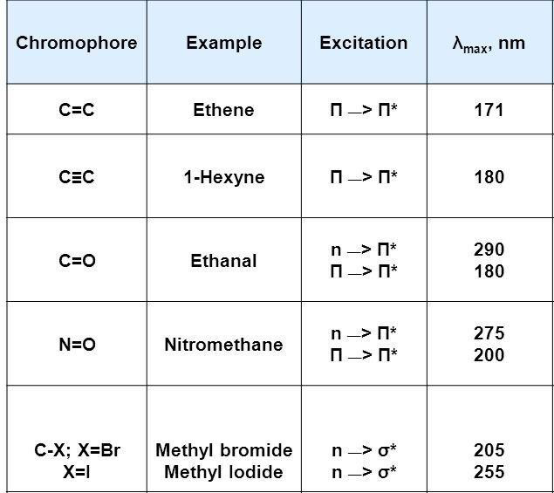

Ii)  **Auxo chromes:**

An auxo chrome is an auxiliary group which interacts with chromophore and causes absorption maximum to a longer wavelength in UV-Visible region.

The effect of chromophore is due to its ability to extend conjugation of a chromophore by the sharing of nonbinding electrons.

Ex: -NH2, -NHR, -NR2, -OH, -OR, -X groups

**9Q) What are the four shifts in Electronic spectra that can affect the absorption Explain?**

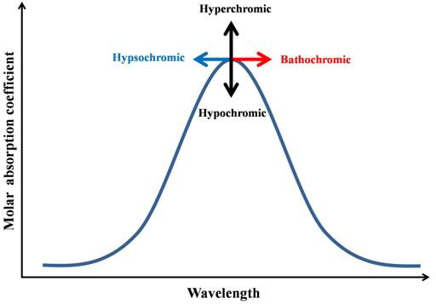

**1)Bathochromic / red shift:** Shift of absorption maximum (λmax) to the longer wavelength is called bathochromic shifts. It occurs due to presence of auxochrome or increase in conjugation.

**2)** **Hypso of chromic / Blue shift**: Shift of absorption maximum (λmax) to the shorter wavelength is called Hypso of chromic shifts. It can occur due to removal of = &  bonds.

**3)** Hyperchromic shift: Increase in the intensity of absorption maximum.

4)Hypochromic shift: Decrease in the intensity of absorption maximum.

**10Q)Write the principle of IR spectra. Explain about types of vibrations?**

# Principle:

All type of molecules cannot interact with IR radiation. Only those molecules which exhibit change in dipole moment during a vibration can exhibit IR spectra. Homo nuclear diatomic molecules like H2, O2. N2 do not show change in dipole movement during vibration, consequently these do not exhibit IR Spectra. When organic molecule is exposed to IR radiation, and if the radiant energy matches the energy of a specific molecular vibration then absorption takes place.

It is a type of absorption spectroscopy used to determine functional groups.

1. Stretching vibrations
2. Bending vibrations
   1. Stretching vibrations: - in this vibration bond length is altered. It is a two types
      1. Symmetric stretching vibrations two bonds increase or decrease in length symmetrically.
      2. Asymmetric stretching vibrations: One bond length increases,

the other decreases

# bending vibrations:

The position of atoms changes with respect to original bond axis.it is two types. In plane bending and out of plane bending

* + 1. In plane bending: change in bond angle. Bending of bonds takes place within same plane

1. Scissoring: bond angle decreases
2. Rocking: movement of atoms takes place in same direction

Out of plane bending:

1. **Wagging:** two atoms move up & down the plane with respect to central atom.
2. **Twisting :** One atom moves up the plane, other atom moves down the plane with respect to central atom

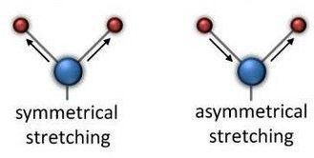

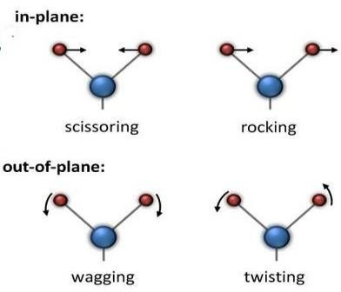

11Q) Write short notes on i)Write the basic principle of NMR

Ii) chemical shift iii) Applications of NMR spectroscopy.

# Principle of NMR:

This technique is associated with nuclear spin. Since a proton is spinning, it generates circulate electric current, which in turn produces a magnetic field, so a spinning proton behaves like a tiny magnet.The nuclear of a Hydrogen atom (Proton) behaves as a spinning bar magnet because it possesses both electric & magnetic spin.

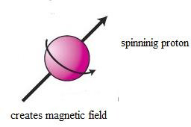

When a proton is placed in external magnetic field (H0), it can align itself in one of two possible orientations with respect to the applied field.

1. Low energy alignment of the nucleus in which the magnetic field of the nucleus is in the same direction as the applied magnetic field.
2. High energy orientation in which the two magnetic fields oppose each other.

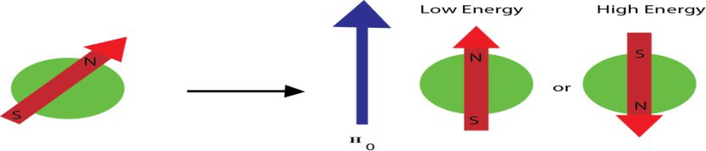

The energy difference between two energy states is very low. A transition from low energy state to high energy state can be obtained by providing energy equal to the difference in energy (ΔE) between the two states.

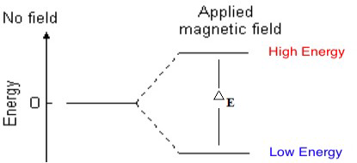

The proton absorb energy and moves from one energy state to the other and this transition is called flipping of proton. When the quantum of energy (hv) of electromagnetic radiation matches with difference of energy between the two energy states at field strength, nucleus and radio frequency are in resonance. Absorption takes place and a signal is observed. All the protons don not absorb at the same frequency. It depends on applied magnetic field strength and protons electric field.

Nuclei with odd mass number of proton or odd number of neutrons or both give NMR spectra.

Ex: 1H,13C,31P ,19F etc., because they have asymmetrical charge distribution. Spin quantum number of the nuclei will be ½, 3/2 , 5/2 etc.,

16O ,12C , 32S , 14N , 2H does not give NMR spectra because of symmetric charge distribution & their spin quantum number is a integral value.

# Interpretation of NMR spectra:

A set of protons with identical electronic environment gives NMR signal at same position. These protons are called equivalent protons. Similarly, protons with different electronic environment with gives NMR signal at different positions. The protons are called nonequivalent protons.

Ex CH4 one signal CH3-CO-CH3 one signal

CH3-CH2-CH3 two signals

CH3-CH2-CH2-OH four signals

Number of signals: Tells about how many types of protons are present in a molecule (equivalent &nonequivalent)

# ii) Chemical shift (position of signals):

When a molecule is placed in a magnetic field, its elections are caused to circulate, and they produce induced / secondary magnetic field. Rotation of electrons about the protons generates a field in such a way that at the proton it opposes the applied field. Therefore, the proton is said to be shielded. Shielding shifts the absorption up field and deshielding shifts the absorption down field. Such shifts in the position of NMR absorptions which arise due to the shielding and d eshielding of proton by the electrons are called chemical shifts.

To calculate chemical shifts for various protons, signal of TMS (tetra methyl silane) is taken as reference.

→ In this four methyl groups are equivalent. So, we get single sharp peak.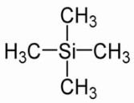

→ TMS is also inert to chemicals.

→ Highly volatile easily removed from the system

→ A little amount of TMS is mix with the compound and then we take the NMR spectra. & TMS is taken as the zero point.

Chemical shift is the difference in the absorption position of a sample proton & absorption position of a reference compound. It is represented by δ. For TMS δ = o

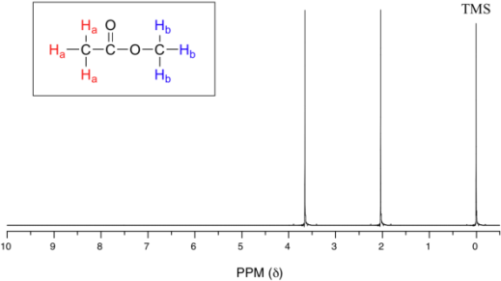



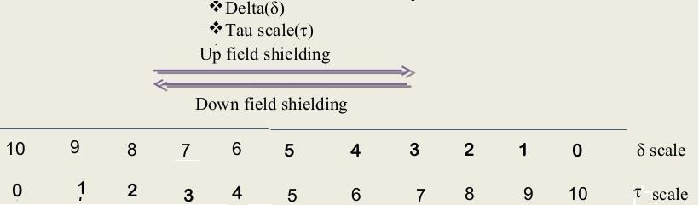

# T = 10-δ

1. 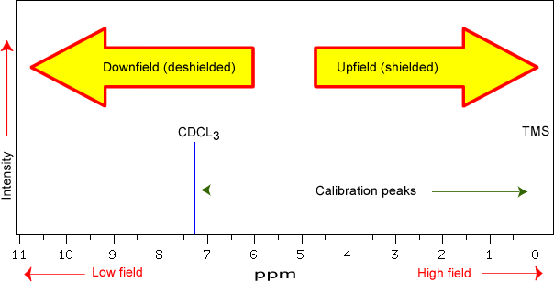

**Iii) Applications of NMR:**

NMR is powerful and useful to carry structural analysis of compound It is used to detect the particular nuclei in compound

The number of signals in the spectrum is eqal to number of kinds of protons in different environment

The chemical shift indicates the no of hydrogen’s present

Spin-spin coupling gives the possible arrangements of groups in the molecule and also the neighboring protons

Used for the construction of MRI which is very useful tool in the medical field to detect the number of deceases like neuro, cardio, muscular problems of human body