
PROJECT REPORT OF RESEARCH STUDY
On
“Exploring the Role of Machine Learning in Predicting and Preventing Suicide Rates among College Students in Karnataka”

Submitted to
RV Institute of Management,
Bangalore

Submitted by,
Dr. Noor Firdoos, Professor
Prof Mithun D J
RV Institute of Management
Jayanagar, 4th T Block, Bangalore

August, 2024

Acknowledgements

We are happy to place on records our gratitude to Dr Purushottam Bung, Director, RV Institute of Management for giving us this opportunity to carry out minor research projects on areas of social relevance and contribute to the society.
We express our heartfelt gratitude to the Directors/HoD’s and faculty of the Colleges from various parts of the Karnataka for permitting us to collect data from the students. Without which we would not have completed our study.
We wish to express our gratitude to the students who put in lot of efforts and helped us in data collection and making this project successful.
We submit our gratitude to Dr M P Shyam, President, RSST, Sri A V S Murthy, Hon. Secretary, RSST, Sri D P Nagaraj, Hon. Joint Secretary, RSST and Sri M D Kasturi Ranga, Chairman, Governing Body, RVIM and the entire management of RSST for their constant encouragement and support, without which the research project would not have been possible.

Research Team

Contents

Sl No | Particulars | Page no.
1 | Acknowledgements | 02
2 | Sanction Order | 04 & 05
3 | Executive Summary | 06
4 | Introduction & Statement of Problem | 07-13
5 | Review of Literature | 13-20
6 | Objectives | 21
7 | Research Questions | 22
8 | Research Framework | 23
9 | Results & Discussion | 23-38
10 | Hypothesis | 39-41
11 | Inferences & Conclusion | 42-44
12 | References | 45-46

Sanction Letter:
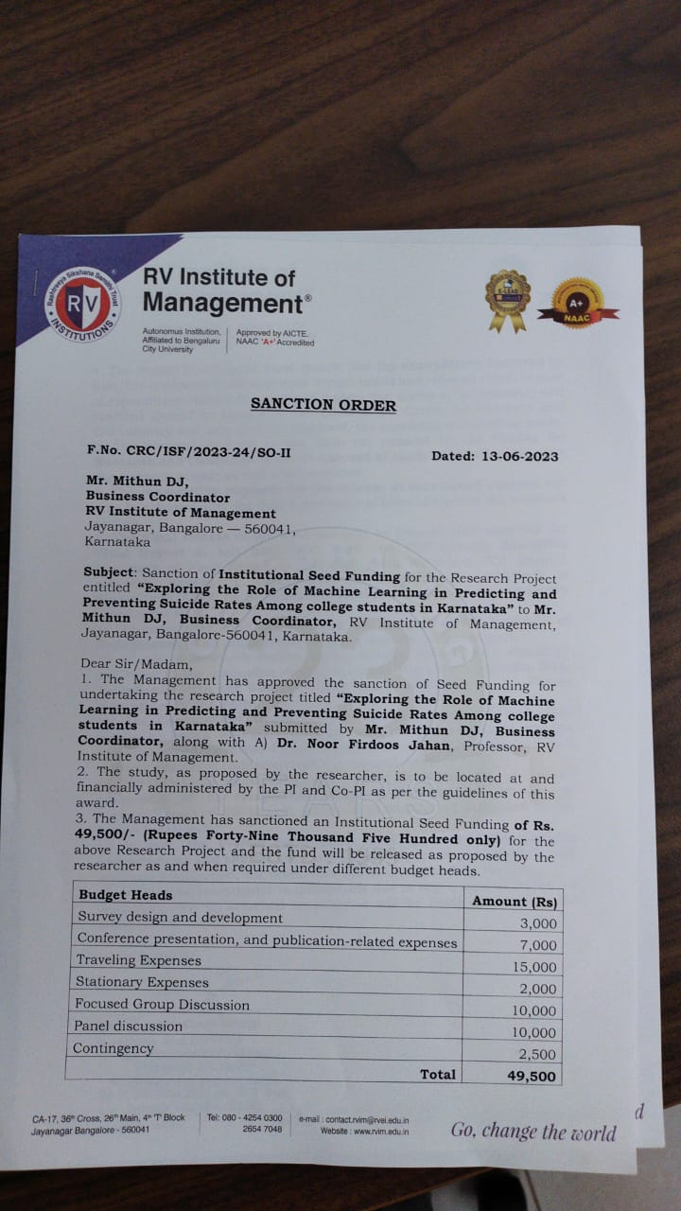



Executive Summary:
India, a vibrant and diverse nation nestled in South Asia, boasts a mosaic of cultures, languages, and traditions that have shaped its rich heritage. Over the decades, India has witnessed notable advancements in various facets of human development, poverty alleviation, and the pursuit of Sustainable Development Goals (SDGs). Central to these advancements has been the country's steadfast commitment to bolstering education, healthcare, and social welfare initiatives, thereby catalysing improvements in the quality of life for its populace and addressing societal disparities. Suicide in India is especially disturbing because of the dangerously high proportion of young individuals engaged(Mohapatra 2021). Individuals under the age of 30 account for a staggering 37.8% of suicides. This amounts to 71% of suicides among those under 44, placing a significant social, emotional, and economic weight on the nation (Mohapatra 2021).
Researching suicidal ideation among college students in Karnataka is important to understand the risk factors and prevalence of suicide among youth, which can inform effective prevention strategies and improve mental health outcomes. Karnataka’s unique cultural, social, and economic context may influence suicidal ideation among its youth population through factors such as stigma around mental health, socioeconomic disparities, and cultural norms regarding seeking help. Understanding suicidal ideation in Karnataka could lead to the development of targeted interventions and policies aimed at reducing suicide rates, ultimately improving mental health outcomes and overall well-being in the state.
The study follows a cross-sectional research design, utilizing quantitative methods to collect and analyse data from a sample of 700 students from the various colleges from across five key districts in Karnataka. The research design includes a pilot study, which was conducted with 150 students to refine the questionnaire and methodology.
The analysis reveals a significant relationship between Age Category and Suicide Ideation, as evidenced by the rejection of the null hypothesis (p = 0.00), A significant relationship was found between Type of Course and Suicide Ideation, with the null hypothesis being rejected (p = 0.000), suggesting that educational background may influence suicidal thoughts. Decision Tree Analysis was employed to further explore the prediction of suicide ideation, focusing on key factors such as gender and responses to specific statements related to suicidal thoughts. The decision tree model effectively categorized individuals based on their endorsement of statements like *"I thought it would be better if I was not alive"* and *"I thought that people would be happier if I was not around."* These statements were found to be strong predictors of suicidal ideation.

Exploring the Role of Machine Learning in Predicting and Preventing Suicide Rates Among college students in Karnataka
Introduction
India, a vibrant and diverse nation nestled in South Asia, boasts a mosaic of cultures, languages, and traditions that have shaped its rich heritage. Over the decades, India has witnessed notable advancements in various facets of human development, poverty alleviation, and the pursuit of Sustainable Development Goals (SDGs). Central to these advancements has been the country's steadfast commitment to bolstering education, healthcare, and social welfare initiatives, thereby catalysing improvements in the quality of life for its populace and addressing societal disparities.
India is dealing with a huge public health issue: suicide. Suicide claims the lives of more than one lakh (100,000) people each year. This figure has climbed rapidly during the last three decades, increasing by 43% between 1975 and 2005(Vijayakumar L, 2008). While the national suicide rate was relatively steady between 1975 and 1985, it increased by 35% in the next decade (1985-1995), and by another 5% between 1995 and 2005(Vijayakumar L, 2008).
Suicide in India is especially disturbing because of the dangerously high proportion of young individuals engaged(Mohapatra 2021). Individuals under the age of 30 account for a staggering 37.8% of suicides. This amounts to 71% of suicides among those under 44, placing a significant social, emotional, and economic weight on the nation (Mohapatra 2021).
India's suicide data also show a distinct gender dynamic. Unlike Western countries, India has a nearly equal suicide rate among young men and women, with a persistently low male-to-female ratio of about 1.4 to one (Vijayakumar L, 2008). This shows that suicide affects young Indian women more than their Western counterparts.
Surprisingly, suicide rates in India vary greatly by region. Southern states such as Kerala, Karnataka, Andhra Pradesh, and Tamil Nadu have far higher rates, topping 15 per 100,000 persons (Vijayakumar L, 2008). Northern states, such as Punjab, Uttar Pradesh, Bihar, and Jammu and Kashmir, have far lower rates, falling below 3 per 100,000 (Vijayakumar L, 2008). This geographical pattern has been continuous throughout the last two decades (Vijayakumar L, 2008).
Karnataka, is situated in the southwestern part of India. It was originally established as Mysore State on November 1, 1956, under the States Reorganisation Act, and later renamed Karnataka in 1973. The state shares its borders with the Lakshadweep Sea to the west, Goa to the northwest, Maharashtra to the north, Telangana to the northeast, Andhra Pradesh to the east, Tamil Nadu to the southeast, and Kerala to the southwest. With a population of 61,130,704 according to the 2011 census, Karnataka ranks as the eighth-most populous state, comprising 31 districts. Historically, the region was part of the Carnatic region under British rule. Bangalore, the state capital, is home to 15,257,000 residents, making it the fourth-largest city in India.
The key achievements of Karnataka in terms of human development, poverty reduction, and achievement of the Sustainable Development Goals (SDGs) could include improvements in education, healthcare, and social welfare programs. Factors contributing to Karnataka's high ranking on the Human Development Index (HDI) compared to other Indian states could include investments in education, healthcare infrastructure, and economic development initiatives. Social issues Karnataka may still face could include issues related to healthcare access, education quality, or unemployment.
In 1987 the Indian State of Karnataka implemented panchayat reform legislation. The ideological orientation of the Janata Government's reforms is considered, together with the question of whether stronger local government in India increases the state's autonomy within the federation. Government of India, (1973). Report by the Task Force on Integrated Rural Development, Planning Commission, New Delhi.
India's suicide rate is similar to that of Australia and the United States, and its rising rates over the past few decades are in line with the general trend worldwide. The National Crime Records Bureau (NCRB; Ministry of Home Affairs) has statistics on suicide in India. In India, the suicide rate increased by 41.3% between 1980 and 1990, or 8.9 per 100,000 people, a compound annual growth rate of 4.1%. The rate began at 6.3 per 100,000 in 1978 and increased to 8.9 per 100,000 in 1990. (National Crime Records Bureau,2014) However, more recent data paint a different picture. Suicide rates varied from 1999 to 2002, then showed a dropping trend from 2003 to 2006, and then a rising trend from 2006 to 2010. (National Crime Records Bureau,2018). In 2009, 10.9 per 100,000 populations was the rate. This signified a 1.7% rise in suicides from the year 2008. According to the most current NCRB study, the rate increased to 11.4 suicides per 100,000 people in 2010, a 5.9% rise. (National Crime Records Bureau, 2018)

Police records serve as the basis for the NCRB statistics. These records' authenticity is called into question by sociocultural considerations. The Indian Penal Code (IPC Section 309) defines suicide attempt as a crime, which discourages reporting. Although all instances are examined by the police, deaths in rural regions are certified by village headmen, or "panchyatdars."(Bose et al. 2006) In rural places, the death registration process is very inefficient. In the end, only roughly 25% of deaths are reported, and only roughly 10% have a medical certification. (Bhat, M.1991) Suicide deaths are often reported as illnesses or accidents in order to evade police inquiries. Due to the shame associated with the procedure, the length of time it takes, and their dread of the body being mutilated, the relatives of suicide victims typically oppose post-mortems. Statistics derived from police records hence under-report suicides.
The national average for suicide rates in India was 11.4 per 100,000 in 2010, although the rates varied greatly throughout the states, from 0.5 per 100,000 in Nagaland to 45.9 per 100,000 in Sikkim (National Crime Records Bureau, 2018). Using information from smaller samples and various techniques, including hospital-based samples, longitudinal cohorts, emergency services, and verbal autopsy, some studies have calculated the annual suicide rate (Joseph et al. 2003)(Soman et al. 2009). Suicide rates are two to three times greater than those seen in other research, according to studies that use verbal autopsy (Joseph et al. 2003). With age-specific suicide rates as high as 148/100,000 and 58/100,000 for young women and men, respectively,(Aaron et al. 2004) and 234/ 100,000 and 147/100,000 for elderly men and women, age-specific suicide rates range from 62 per 100,000 (Gajalakshmi and Peto 2007) to approximately 95 per 100,000 for the general population(Joseph et al. 2003). This rate is roughly 9–10 times higher than the NCRB-reported rate. It is crucial to keep in mind that extrapolating figures from small samples is likely to exaggerate the genuine rate since it ignores variability related to geography, age, and gender, all of which are likely to exist and are also included in the NRCB study.
Variations in suicide death rates across different regions of India have been observed, with the southern states reporting the highest rates and the northern states the lowest. Over the period from 2001 to 2013, there were notable differences in suicide rates between genders, with males consistently showing higher rates compared to females, and this gender gap remained relatively stable over time. Among females, those aged 15–29 years had the highest suicide rates, while for males, the highest rates were observed in the 45–49 age group.
Additionally, it was noted that male suicide rates tended to be elevated in areas with higher levels of unemployment. Surprisingly, regions with greater development exhibited higher suicide rates for both males and females, suggesting a potential association between modernization and increased suicide risk (Halli, S.S., Isac, S., Bhattacharjee, P. et al. Suicidality among gender minorities in Karnataka, South India. BMC Psychiatry 21, 25 (2021). https://doi.org/10.1186/s12888-021-03043-2).
Suicide is a complicated and multifaceted phenomenon with multiple risk factors that contribute to its pathogenic mechanisms (De Berardis et al., 2018). According to Baumeister's (1990) escape theory, self-blame for difficult life circumstances, combined with unfavourable self-perceptions, fuels suicide ideation. According to Shneidman's (1993) theory, the fundamental motivation of suicidal ideation is psychache, which is described as psychological and emotional suffering of unacceptable intensity that is frequently connected with mental illness.
The suicide of a young individual is a tragic event that leaves significant and long-lasting wounds in the hearts of families, friends, and communities. Despite substantial advances in suicide prevention techniques, particularly among young people, the continuation of this serious public health concern highlights the need for continued and expanded efforts. While progress has been made in understanding and implementing effective interventions, the urgency of preventing juvenile suicide necessitates persistent dedication and innovation. It is critical to continue working on the creation and implementation of comprehensive initiatives aimed at reducing the devastating toll of suicide among young people.
Empirical investigations regularly reveal that those who report suicide ideas or attempts have higher levels of mental health symptoms (Bhar et al., 2008; Ducasse et al., 2018; Fredriksen et al., 2017). Symptoms include anhedonia, anxiety problems, depression, and low self-esteem. Furthermore, subjective judgements of life conditions have emerged as potential mechanisms for other risk markers to operate (Heisel & Flett, 2004; Suh et al., 2021).
It is critical to recognise that no single factor can entirely explain suicide; rather, a variety of interconnected factors contribute to suicide risk (Kuroki and Tilley, 2012). Recent studies have emphasised the necessity of using a multifaceted approach to suicide prediction, which takes into account a wide range of risk markers verified by theoretical frameworks and empirical research (Choi et al., 2018; Kuroki & Tilley, 2012; Passos et al., 2016).
Previous research has revealed a disturbing tendency in the field of suicide prevention: people who tragically commit suicide frequently do not seek psychiatric care before their deaths. Despite having mental health concerns, people often seek primary care physicians for help with physical symptoms that may be suggestive of underlying psychological distress (Zalsman et al., 2016). This discovery emphasises the critical need for the creation of a comprehensive screening tool that may be effectively used in primary care or community settings. Such a tool would be crucial for identifying persons who are at a higher risk of suicide and simplifying their access to timely and effective preventive measures (Raue et al., 2014).
Suicidal ideation, defined as thoughts of ending one’s life, and suicide attempts, non-fatal self-injurious behaviour with stated or inferred intent to die, are also common among youth and some of the strongest predictors of future suicide (O’Carrolletal., 1996). It is critical that healthcare systems and educational institutions not only seek to identify kids at risk of suicide, but also be prepared to provide prompt and empathetic help. Suicide and suicidal behaviour are associated with a wide range of risk factors, which span the individual, familial, and social domains. Psychopathology, prior suicidal behaviour, familial suicide, family discord, child abuse, and school or peer-related issues are among the factors considered (Cha et al., 2018). It is critical for healthcare and education stakeholders to recognise and address these multidimensional risk factors thoroughly in order to establish a supportive environment for vulnerable youth's well-being.
A promising analytical approach for incorporating complicated risk factors into clinical suicide signs is Machine Learning (ML). The basic idea underlying machine learning is that it uses past data to identify the typical traits of a class, like those who show signs of suicide. Then, by applying this learned information to fresh, unobserved data, samples with comparable properties are found. Generally, creating a trustworthy machine learning system requires a large amount of input data that contains important information for differentiating between subjects. In order to get greater predicted accuracy, the algorithms are refined iteratively through this procedure.
Early attempts to predict suicide have used unstructured text data, such as social media posts (Cash et al., 2013; Jashinsky et al., 2014) such as transcripts from counselling sessions and posts on social media, to identify unique patterns in natural language linked to suicidal thoughts. Although these methods showed the methodological potential of machine learning, their reliance on non-traditional big data that was not easily accessible during screening limited their applicability to primary care or community settings.
Later studies have demonstrated that machine learning algorithms, which utilise survey or clinical data, are capable of accurately diagnosing persons with suicidal thoughts, attempts, or completions with a degree of accuracy that is sufficient. The comprehension of machine learning's predictive potential in suicide risk assessment and intervention planning has improved as a result of these developments.

Studies have specifically shown how well ML algorithms work at identifying people who might be thinking about suicide (Hill et al., 2017; Ryu et al., 2018), making an attempt at suicide (Bae et al., 2015; Oh et al., 2017; Passos et al., 2016), and complete suicide (Choi et al., 2018; Jiang et al., 2021). Utilising a variety of datasets and advanced algorithms, academics have made noteworthy progress in utilising machine learning (ML) to tackle the intricate problems related to suicide prevention and intervention.
It may be possible to determine priority targets for preventive and intervention initiatives using the prediction models created by this research. A significant portion of people move from suicidal thought to attempt within specified time periods, and suicidal ideation is a crucial prelude to suicide planning or attempts. According to research, for example, 15.6% of people who have suicidal thoughts go on to try suicide within a year, and 31.8% attempt suicide at some point in their lives.
A considerable percentage of those who attempt suicide may go on to make additional attempts, and regrettably, some may ultimately end their lives by suicide. Clinical studies regularly show that a significant portion of people who consider suicide also struggle with mental illness or difficult psychosocial situations as they get closer to making a suicide attempt.
This historical context emphasises how crucial it is to assess those who may be at risk for suicide in the future and to take prompt action to prevent suicide. There is a chance to create an effective screening system that is suited to the requirements of the broader public by using machine learning (ML) techniques on large-scale population data.
Through the utilisation of machine learning algorithms and thorough dataset analysis, researchers can augment their capacity to discern individuals who exhibit elevated susceptibility to suicidal conduct. This proactive strategy makes it possible to undertake focused treatments meant to reduce risk factors and give individuals in need prompt support.
Additionally, ML incorporation into suicide prevention activities has the potential to improve screening campaigns' efficacy and efficiency. Healthcare providers and legislators can optimise resource allocation and prioritise interventions for the most vulnerable people by utilising the predictive potential of machine learning algorithms.
All things considered, the use of machine learning (ML) in suicide prevention is an important development in public health initiatives meant to lower the suicide rate and enhance the prognosis for those who are experiencing suicidal thoughts or actions. By working together on research projects and coming up with creative tech fixes, the field is ready to take big steps towards solving this urgent global health issue.
Statement of problem:
Researching suicidal ideation among college students in Karnataka is important to understand the risk factors and prevalence of suicide among youth, which can inform effective prevention strategies and improve mental health outcomes. Karnataka’s unique cultural, social, and economic context may influence suicidal ideation among its youth population through factors such as stigma around mental health, socioeconomic disparities, and cultural norms regarding seeking help. Understanding suicidal ideation in Karnataka could lead to the development of targeted interventions and policies aimed at reducing suicide rates, ultimately improving mental health outcomes and overall well-being in the state. Targeted interventions based on research findings could help reduce the prevalence of suicide in Karnataka by addressing specific risk factors identified among college students, such as mental health support services, suicide prevention education, and community outreach programs. Possible next steps or areas of focus for research on this topic in Karnataka could include conducting comprehensive surveys or studies to gather data on suicide rates, risk factors, and mental health resources available to college students, as well as evaluating the effectiveness of existing prevention strategies and identifying areas for improvement.
Literature review:
Suicide poses a significant public health challenge in Karnataka, with a notable increase in suicide rates over recent years (Kumar, 2019). Statistics reveal a concerning trend, with a 21.3% rise in suicide rates reported in 2017 alone (Kumar, 2022). A specific study highlights the city of Bangalore as having one of the highest suicide rates in the state, with 37.5 per 100,000 individuals (Tom, 2020).
While completed suicides are a grave concern, they represent only a fraction of the broader issue. Research indicates that for every suicide, there may be up to 50-60 suicide attempts, underlining the magnitude of the problem (McIntire et al., 1977). This finding resonates with international studies, such as those from Sweden, estimating a ratio of 1:10:100 for completed suicides, attempted suicides, and severe suicidal ideation, respectively (Beskow, 1997).
Suicidal ideation, characterized by thoughts and preoccupations with death and suicide, is a significant predictor of suicide attempts and completions (Arria et al., 2009). Among college-age students, suicide ranks as the second leading cause of mortality, with studies indicating a higher prevalence of suicidal thoughts compared to the general population (Gex et al., 1998; Suicide Prevention Resource Center, 2004).
In Karnataka, a notable proportion of suicidal attempts occur among young adults aged 18-25, highlighting a vulnerable demographic (Madhavan et al., 2021). International studies corroborate this, with research from the USA reporting over 13% of students attempting suicide and nearly half pondering suicide during their college years (Mishara, 1982). Similarly, studies from China and Western India reveal significant prevalence rates of suicidal ideation among college students (Xu et al., 2004; Desai et al., 2021).
Gender differences in suicidal ideation are evident, with females reporting higher incidents compared to males (Cole, 1989). Relationship issues, including break-ups, trust issues, and infidelity, are identified as major triggers for suicidal ideation among females (Nemeth et al., 2012).
Urban youth are particularly vulnerable to suicidal ideation, with factors such as social isolation, stress, depressive symptoms, and risky behaviors contributing to their mental health challenges (Albers & Evans, 1994). Academic stress emerges as a significant risk factor among college students, with issues such as low academic performance and perceived academic failure exacerbating suicidal ideation (Arun & Chavan, 2009).
Financial problems faced by college students, often linked to family backgrounds, significantly impact suicidal ideation in Karnataka (Choi et al., 2021). Family discord and dysfunction also play a detrimental role, contributing to youth suicidality (Ai et al., 2017).
Social connectedness and support systems are identified as crucial protective factors against suicidal ideation among college students (Arango et al., 2016). While professional care centres are available, social stigma and the lack of accessible resources often lead students to seek informal support networks instead (O’Donnell et al., 2003).
The study by Mortier et al. investigates the prevalence of suicidal thoughts and behaviors among college students. They found that such thoughts are quite common among this population. The researchers analyzed data from multiple countries to understand the scope of the issue globally. They discovered that around 10% of college students experience suicidal thoughts each year. Moreover, a significant proportion of students also report engaging in suicidal behaviors. Factors like depression, anxiety, and stressful life events were identified as contributing to these thoughts and behaviors. Importantly, the study highlights the need for universities to implement effective mental health support services for students. This research underscores the importance of addressing mental health concerns among college students to prevent suicidal outcomes.
This study in Ethiopia examined suicidal thoughts among university students. They surveyed 836 students and found that 19.9% reported having such thoughts. Factors associated with these thoughts included mental distress, family history of mental illness, low social support, financial difficulties, and substance use like Khat and alcohol. However, gender, age, relationship status, and year of study didn't show significant associations. The study emphasizes the need for suicide prevention strategies targeting these risk factors among university students in Ethiopia. This highlights the importance of addressing mental health issues and providing support to students facing challenges.
This study in Ghana looked at suicidal thoughts and actions among university students. They surveyed 1003 students and found that 15.2% reported having thoughts of suicide, 6.3% had attempted suicide, 24.3% expressed wishes for death, and 6.8% had made plans for suicide. Psychological distress increased the risk of both suicidal thoughts and attempts, while subjective well-being was protective against attempts. Self-esteem was found to be protective against having suicidal thoughts. The study suggests the importance of mental health programs in schools to boost self-esteem, reduce psychological distress, and enhance subjective well-being among young people.
Raj Kishore Ram et al.'s (2021) study contributes to this discourse by examining the prevalence and correlates of suicidal ideation among university students in a specific context. Their findings offer valuable insights for tailoring interventions and support mechanisms to address the mental health needs of this demographic effectively, thereby mitigating the risk of suicidal ideation and promoting overall well-being on college campuses.
This study investigates the predictors of suicidal ideation among college students in China and develops prediction models using the Radial Basis Function Neural Network (RBFNN) method. Over a four-year period, 1,500 students from Sichuan University were followed, with demographic, behavioral, and psychological data collected via computer-based questionnaires. The incidence of suicidal ideation in the last 12 months ranged from 3.00% to 4.07%. The developed models exhibited high prediction accuracies, exceeding 91.7%, and area under curve scores up to 0.96. Previous suicidal ideation and poor subjective sleep quality emerged as robust predictors, emphasizing the importance of addressing mental health and sleep disturbances. Additional potential predictors included poor self-rated mental and physical health, internet addiction, emotional abuse, low household income, and heavy study pressure. These findings underscore the multifaceted nature of suicidal ideation and highlight the need for comprehensive intervention strategies to support the mental well-being of college students in China.
The study examines the prevalence of suicidal ideation and suicide attempt, and associated factors among school-going urban adolescents in Peru. A cross-sectional survey was conducted in a sample of 916 secondary school adolescents in 2014. A structured questionnaire adapted from Global School-based Student Health Survey was used to obtain information. Data were analysed using logistic regression models at 5% level of significance. Overall, 26.3% reported having suicidal ideation, and 17.5% reported having attempted suicide during the past 12 months. Multivariate logistic regression analysis showed that female sex, being in a fight, being insulted, being attacked, perceived unhappiness, smoking and sexual intercourse initiation were significantly associated with increased risk of suicidal ideation, while female sex, being in a fight, being insulted, being attacked, perceived unhappiness, alcohol and illicit drug use were related to suicide attempt.
The study investigated the prevalence and associated factors of suicidal ideation, suicide plans, and suicide attempts among university students in Uganda, particularly in the context of the COVID-19 pandemic. Data was collected from 540 undergraduate students in south-western Uganda, with a focus on demographic and psychosocial factors. The prevalence of past-year suicidal behaviors was found to be significant, with 31.85% reporting suicidal ideation, 8.15% having suicide plans, and 6.11% attempting suicide.
The findings of the study "Ethnic Identity and Loneliness in Predicting Suicide Risk in Latino College Students" (Chang, E. C., Díaz, L,2017) highlight the significance of ethnic identity facets, such as ethnic affirmation and belonging, in mitigating suicide risk among Latino college students.
The research provides a comprehensive examination of coping strategies and suicide risk among at-risk community college students (Martin, L. E., & Bohecker, L., 2021). The authors delve into the intricate interplay between coping mechanisms and suicidal behaviors, shedding light on the challenges faced by this vulnerable student population.
The paper “Suicide ideation among college students: A multivariate analysis” aimed to investigate the factors associated with suicide ideation among college students. It explored various psychosocial risk factors, including depressive symptoms, low social support, affective dysregulation, parent-child conflict, and alcohol use disorder. The study involved a sample of 912 individuals and found that these factors were significant predictors of suicide ideation. Specifically, social support, depressive symptoms, mother-child conflict, father-child conflict, affective dysregulation, and alcohol use disorder were all found to be correlated with higher levels of suicide ideation. (Arria, Amelia & O'Grady, 2009)
The paper “Suicide and Associated Risk Factors Among College Students” (Poorolajal et al. 2017) provides a comprehensive overview of the prevalence of psychiatric distress among college students, focusing on associated risk factors such as mental health issues, substance abuse, sexual behavior, and suicide risk. It sheds light on the challenges faced by university students regarding their mental well-being.
One study examined the relationship between suicide and various risk factors among university students. It underscores the significance of addressing modifiable risk factors like substance abuse, smoking, and psychiatric disorders to mitigate the risk of suicide. The study emphasizes the necessity of interventions that target these factors to enhance the mental health and overall well-being of students.
Another study aims to estimate the prevalence of suicide ideation and attempts among university students while identifying associated risk factors. The findings reveal that factors such as emotional breakdown, drug abuse, psychiatric disorders, and risky behaviors like smoking and sexual activity are significantly linked to suicidal ideation and attempts. This study underscores the importance of addressing these modifiable risk factors to prevent suicide among college students, emphasizing the need for targeted interventions in this regard.
“The Many Faces of Depression in Children and Adolescents” delves into the intricate landscape of depression in children and adolescents, emphasizing its multifaceted nature and the importance of tailored interventions. Highlighting the varied manifestations, including behavioral issues and comorbidities, it underscores the necessity of accurate diagnosis for effective treatment. Exploring risk factors such as genetic predisposition and adverse experiences, it advocates for early identification to mitigate long-term consequences like substance abuse and suicide. The review underscores the vital role of multifaceted interventions, combining psychotherapy, pharmacotherapy, and family support, with cognitive-behavioral therapy and SSRIs emerging as key modalities (David Shaffer, B Waslick, 2008).
Adolescents navigating through academic struggles, behavioral challenges, or family conflicts may perceive themselves as burdensome to their families or peers, a feeling exacerbated by high levels of familial conflict or dysfunction (D. Feldman,Avigal Snir,Alan Apter,2015). Simultaneously, experiences of social rejection, bullying, or a lack of meaningful connections can lead to thwarted belongingness, especially during transitional periods like moving schools or parental divorce.
The study titled "Life-History Factors Influence Teenagers’ Suicidal Ideation: A Model Selection Analysis of the Canadian National Longitudinal Survey of Children and Youth" delves into the intricate interplay of various life-history factors impacting suicidal ideation among teenagers. Utilizing data from the Canadian National Longitudinal Survey of Children and Youth, the research employs model selection analysis to identify significant predictors. The findings shed light on the complex dynamics at play, highlighting the importance of considering diverse factors such as family structure, socio-economic status, parental relationships, and mental health history in understanding adolescent suicidal ideation. This comprehensive approach provides valuable insights for developing targeted interventions and support systems aimed at mitigating the risk of suicide among teenagers in Canada (John P. Ziker1 and Kristin Snopkowsk, 2020).
The meta-analysis titled "Risk Factors for Suicidal Thoughts and Behaviors: A Meta-Analysis of 50 Years of Research" provides a comprehensive synthesis of the literature regarding factors associated with suicidal ideation and behaviors. Spanning five decades of research, the study identifies a diverse range of risk factors including demographic characteristics, mental health conditions, substance abuse, trauma history, and social/environmental factors. Through a rigorous meta-analytic approach, the study quantifies the strength of association between these factors and suicidal outcomes, highlighting statistically significant relationships. Moreover, it emphasizes the complex interplay among these factors, advocating for a multidimensional approach to suicide prevention. By pinpointing key risk factors, the meta-analysis offers valuable insights for intervention and prevention strategies, emphasizing early detection and treatment of mental health issues, substance abuse prevention, and addressing social determinants of health. However, the study acknowledges limitations inherent in the meta-analytic methodology, (Joseph C. Franklin and Jessica D. Ribeiro,2017) such as study heterogeneity and publication bias, and suggests avenues for future research, including the exploration of understudied risk factors and longitudinal investigations into the temporal dynamics of suicidal behaviors.
The rate of suicide is far more prevalent than reported in India over the last few decades. The main objective of this study is to establish the correlation of selected socioeconomic determinants for suicide and its link to the caste issue. This is a cross-sectional study based on police records in Mysore City, Karnataka between the years 2017 to 2021 (Nanjunda DC, Murthy R, 2021). In the study period, 923 suicide cases were registered, of which 57% were from urban areas and 43% were from rural areas. Mental illness, loan and health issues are the major causes of suicide. The 21-30 age groups had the highest rate (32.5%) of suicide suspecting quarter-life crisis in contrast to the national crime record bureau report. Male victims have outnumbered women. The study found socioeconomic factors, like low schooling (24%), unskilled job (43%), poor income (74%), are significantly linked to higher suicide rates. As a first time it is noted that the highest rate of suicide among excluded castes (79.5%). Well-off castes have shown a low rate of suicide (12%). The study concludes that suicide is connected with the disadvantaged caste factor and poor socio-economic deterrents, including low income, low schooling, and occupation. It is advocated that poverty-related mental disorder needs urgent policy interventions today.
Academically typically achieving adolescents were compared with students having academic difficulty on stress and suicidal ideas (Priti Arun, Rohit Garg1, 2017) Materials and Methods: In a cross-sectional study, 75 academically typically achieving adolescents were compared with 105 students with academic difficulty and 52 students with specific learning disability (SLD). Academic functioning was assessed using teacher’s screening instrument, intelligence quotient, and National Institute of Mental Health and Neurosciences index for SLD. Stress and suicidal ideas were assessed using general health questionnaire, suicide risk-11, and Mooney Problem Checklist (MPC). Appropriate statistical methods were applied. Results: Three groups were comparable on age, gender, mother’s working status, being only child, nuclear family, self-reported academic decline, and type of school. About half of adolescents reported psychological problems on General Health Questionnaire (mean score >3 in all the groups). Academically typically achieving adolescents showed higher stressors in peer relationships, planning for future and suicidal ideation compared to adolescents with academic difficulty.
Social media use by minors has significantly increased and has been linked to depression and suicidality. Simultaneously, age-adjusted suicide rates have steadily increased over the past decade in the United States with suicide being the second most common cause of death in youth. Hence, the increase in suicide rate parallels the simultaneous increase in social media use. In addition, the rate of no suicidal self-injury ranges between 14% and 21% among young people. Evidence suggests that self-harming youth is more active on online social networks than youth who do not engage in self-harm behaviour. The role of online social networking on deliberates self-harm and suicidality in adolescents with a focus on negative influence was assessed by conducting a systematized literature review. A literature searches on “PubMed” and “Ovid Medline” using a combination of MeSH terms yielded nine articles for data extraction satisfying predefined inclusion/exclusion criteria
Research gap:
The existing studies delves with studies conducted in various countries and a few in India. Suicide ideation and prevention study in Karnataka among college is not done till date. This study fills this gap and give fair idea about student’s perception on suicide ideation and how it can be prevented.
Scope of the study
The primary aim of this research is to understand the underlying causes and risk factors associated with student suicides in Karnataka and to explore the potential of machine learning in predicting and preventing these suicides. The study employs a comprehensive approach, integrating quantitative data collection and advanced analytical techniques to achieve its objectives.
Objectives of the research
- To Identify the key demographic factors that contribute to suicide ideation among students in Karnataka.
- To understand the Support systems availed by students during the crisis of suicidal ideation.
- To Develop machine learning models to predict and prevent suicide in the Karnataka
- To Suggest evidence-based suicide prevention strategies that can reduce the incidence of suicide and improve the mental health and wellbeing of students in Karnataka
Research Design
The study follows a cross-sectional research design, utilizing quantitative methods to collect and analyse data from a sample of 700 students from the various colleges from across five key districts in Karnataka. The research design includes a pilot study, which was conducted with 150 students to refine the questionnaire and methodology.
Sampling Technique
The study uses a probability sampling technique, specifically cluster sampling. This approach ensures that the sample is representative of the diverse student population across different geographical locations in Karnataka.
Cluster Sampling: The state of Karnataka is divided into five clusters based on administrative headquarters. The selected clusters are:
- Mysore
- Bengaluru
- Belgaum
- Gulbarga
- Mangalore
Participants

There are 689 college students representing colleges from across Karnataka in the study's participant pool. There are both undergraduate and Post graduate students ranging from 18-25. The data collection was conducted via an online survey through a Google form, administered by the authors. Responders were vetted based on criteria like age (18–25), geographical area (Karnataka), and current educational level (Undergraduate or Postgraduate).

Measures

The Adult Suicidal Ideation Questionnaire (ASIQ) (Reynolds, 1991) is an updated version of the Suicidal Ideation Questionnaire (SIQ). It is a self-report instrument developed to measure adult suicidal thoughts. The ASIQ has strong internal consistency (r alpha =.97) and test-retest reliability (rtt =.86) among college students. ASIQ comprises six critical questions that indicate the gravity of suicidal ideation. The questionnaire includes items on demographic information, mental health status, peer pressure, feelings of inferiority, and other potential risk factors for suicide.

Administration: The questionnaire will be administered in a classroom setting to ensure consistency and control over the data collection process.
Data Collection: Trained researchers will administer the questionnaire in person to ensure clarity and to address any queries from the participants.
Confidentiality: All responses will be kept confidential, and data will be anonymized to protect the identity of the participants.

Pilot Study
A pilot study was conducted with 150 students to test the research instruments and refine the methodology. The pilot study helped in identifying potential issues with the questionnaire and provided insights into the data collection process.
Data Analysis
Quantitative Analysis
Descriptive Statistics: Initial analysis will involve descriptive statistics to summarize the demographic characteristics and prevalence of depressive symptoms among the participants.
Inferential Statistics: Inferential statistical methods, such as t-tests and chi-square tests, will be used to identify significant differences and associations between demographic variables and suicide risk factors.
Machine Learning Models: Various machine learning algorithms, including logistic regression, decision trees, and random forests, will be employed to develop predictive models for identifying at-risk students.
Steps in Machine Learning Analysis
Data Pre-processing: Data will be cleaned and pre-processed to handle missing values, outliers, and ensure consistency.
Feature Selection: Key features related to demographic information, mental health status, and other risk factors will be selected for the model.
Model Training and Testing: The dataset will be split into training and testing sets. Models will be trained on the training set and evaluated on the testing set using metrics such as accuracy, precision, recall, and F1 score.
Model Validation: Cross-validation techniques will be used to validate the models and ensure their robustness.
Ethical Considerations
Informed Consent: Participants will be fully informed about the purpose of the study, procedures, and their rights, and consent will be obtained.
Confidentiality: Participant data will be anonymized and stored securely to maintain confidentiality.
Ethical Approval: The study will seek ethical approval from the relevant institutional review board to ensure adherence to ethical standards in research.
Expected Outcomes
The study aims to identify key demographic and psychological factors contributing to student suicides in Karnataka. By leveraging machine learning, the study seeks to develop predictive models that can identify at-risk students and propose effective intervention strategies. The findings will contribute to a better understanding of student suicides and offer practical solutions for prevention, ultimately improving the well-being of students in Karnataka. The college authorities were informed about the general results of the research and encouraged to develop policy measures and preventive and promote activities to reduce stress and suicidal ideation in their respective institutions.

Results – Discussions & Implications:
Exploratory Data Analysis (EDA) is vital for understanding the patterns and factors associated with individuals' thoughts and behaviours. By summarizing and visualizing data related to demographics, mental health status, and various psychological factors, EDA helps identify key trends and correlations. This approach can reveal significant associations between suicide ideation and variables such as social support, personal experiences, and mental health indicators. EDA also aids in detecting anomalies or outliers in the data, guiding the development of targeted interventions and research hypotheses to better address and mitigate suicide risk.

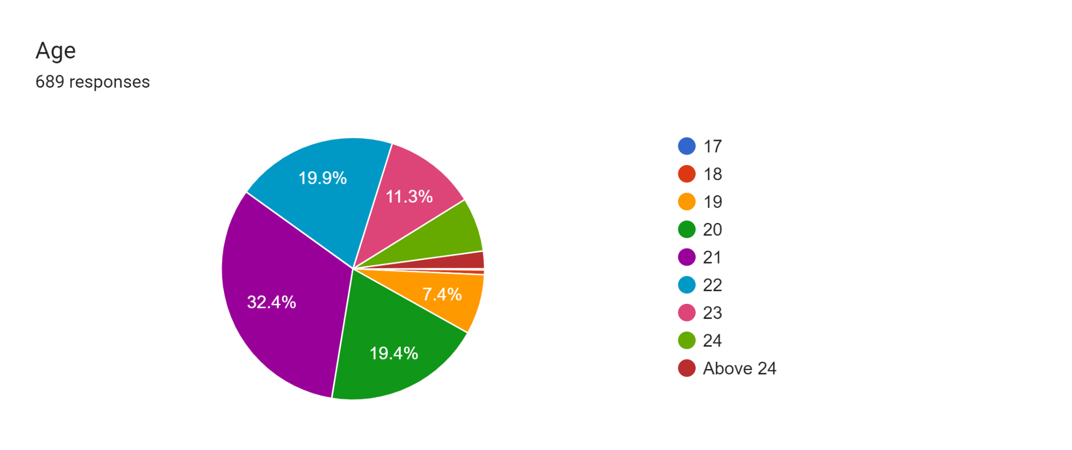
The above pie chart illustrates the percentage distribution of Age of the respondents, revealing that about 32% of them are 21 years.

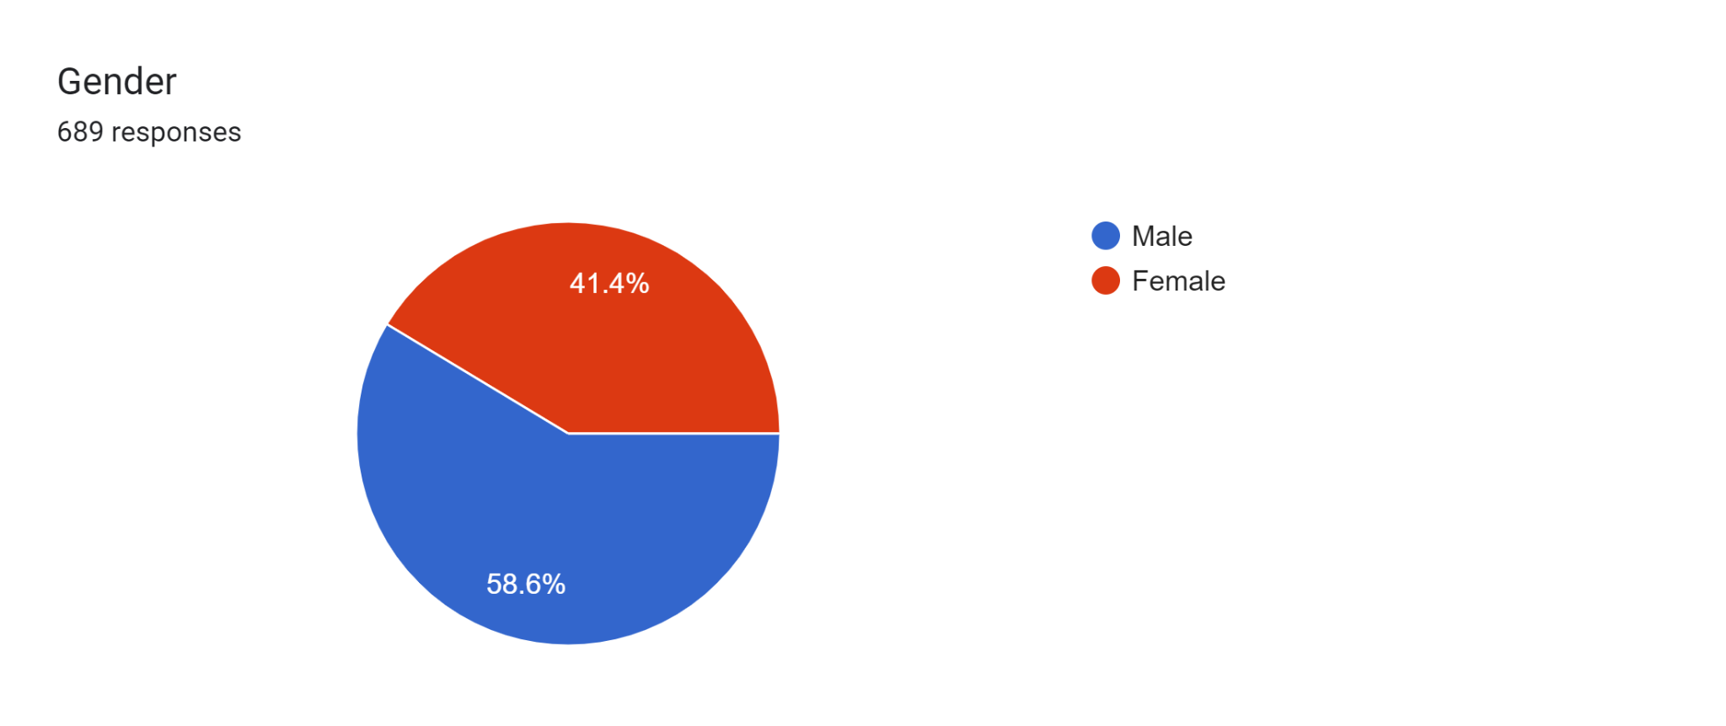 The above pie chart illustrates the percentage distribution of Gender of the respondents, revealing that about 58.6% of them are females.
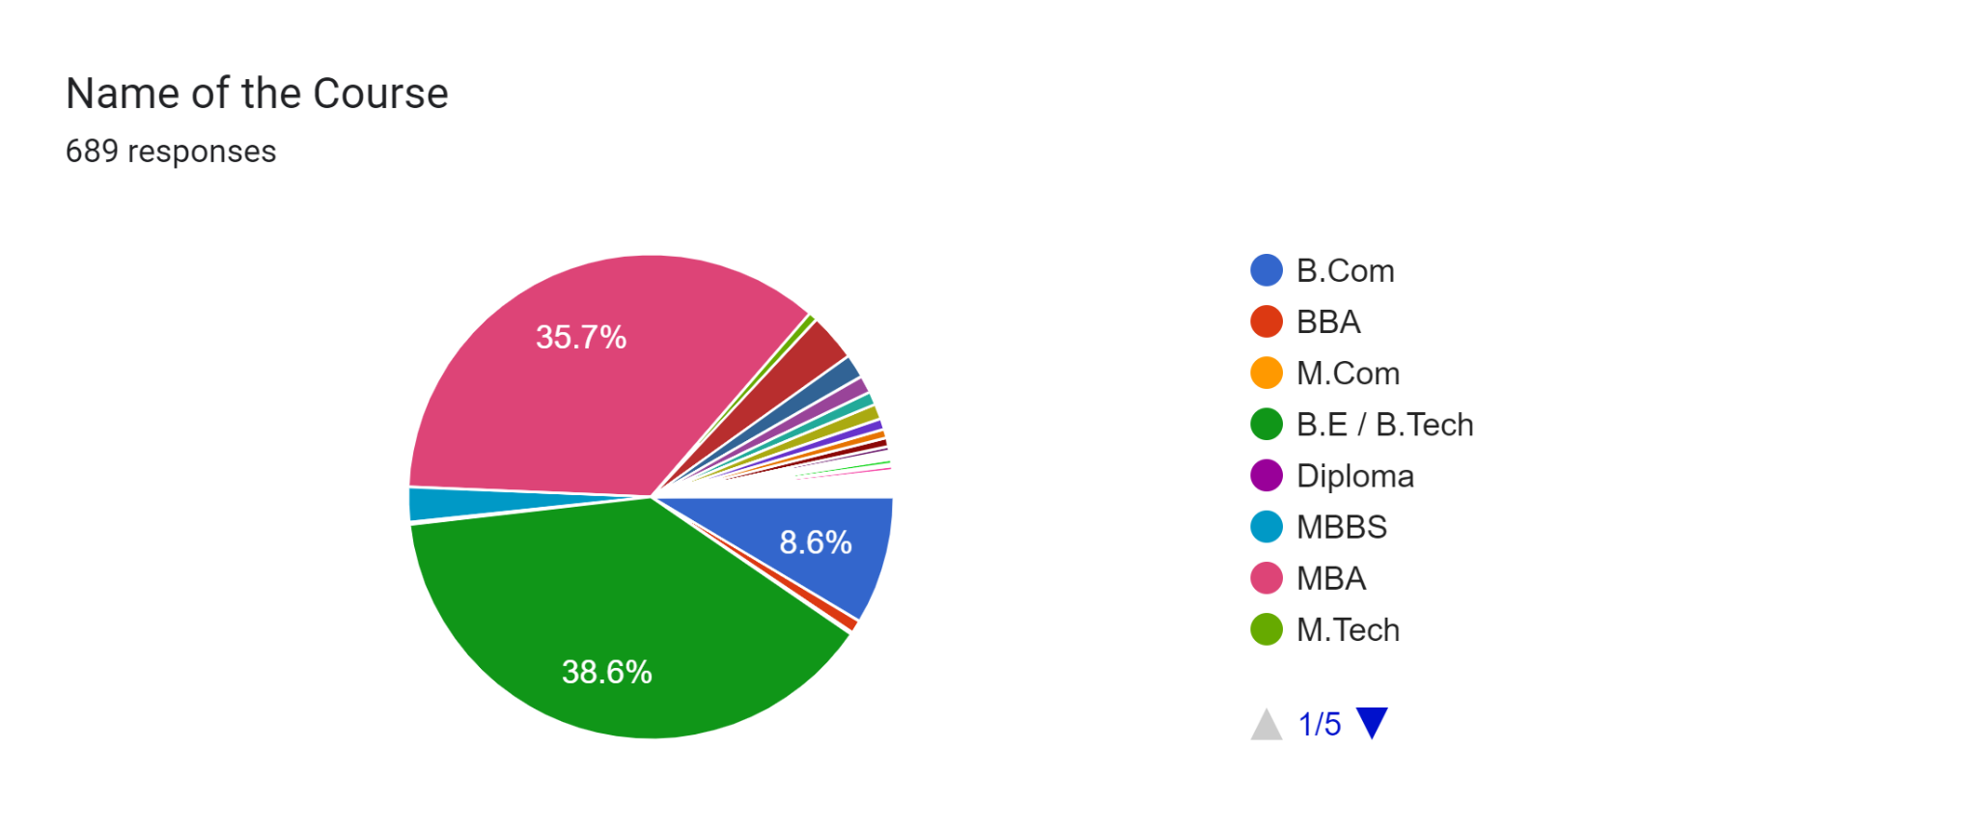
The above pie chart illustrates the percentage distribution of Course of the respondents, revealing that about 38.6% of them are doing BE and 35.7% are doing their MBA Course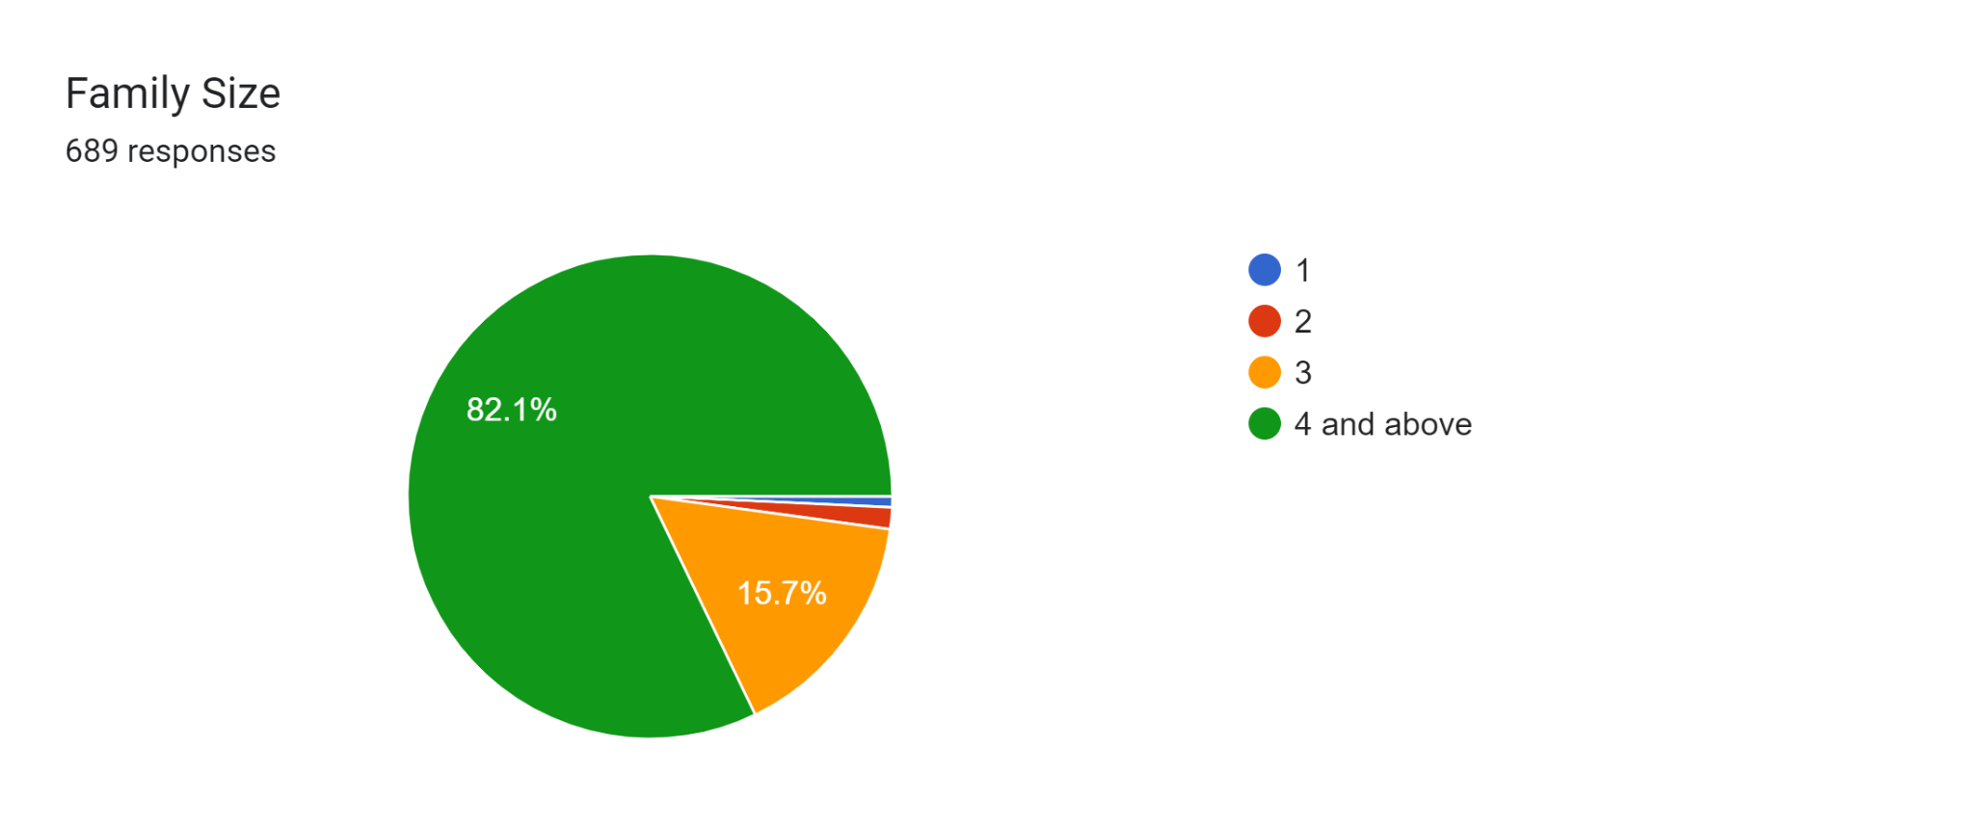
The above pie chart illustrates the percentage distribution of Family size of the respondents, revealing that about 82.1% of them are having more than 4 members in their family
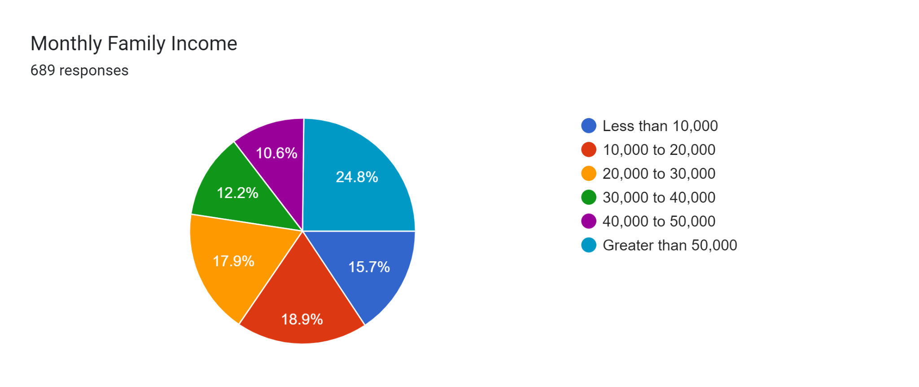
The above pie chart illustrates the percentage distribution of income of the respondents, revealing that about 24.8% of them are having more than 50,000 monthly income
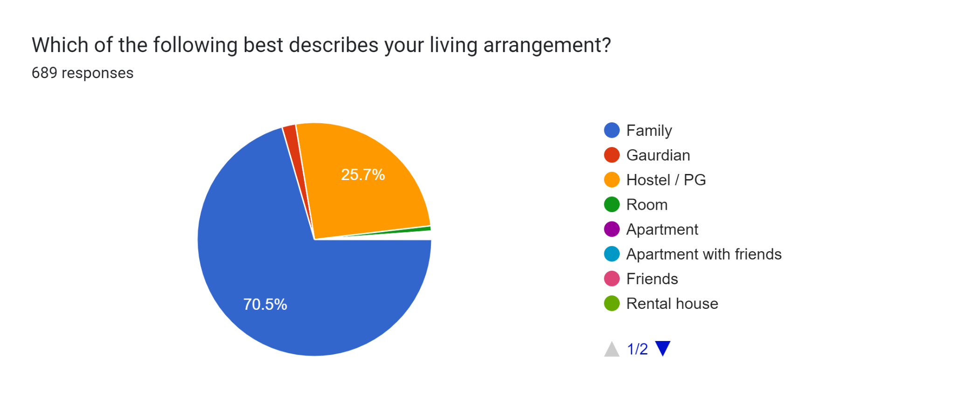
The above pie chart illustrates the percentage distribution of Leaving arrangement of the respondents, revealing that about 70.5% of them are staying with their family
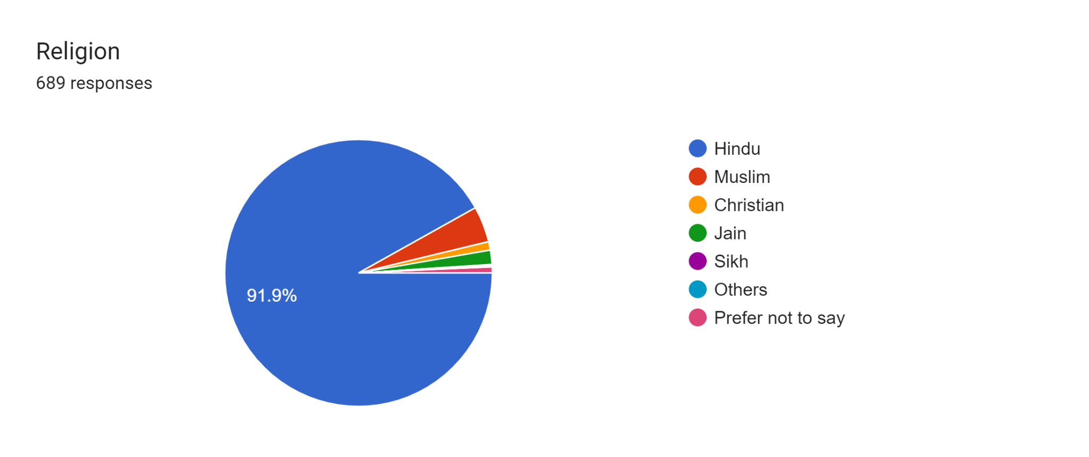
The above pie chart illustrates the percentage distribution of Religion of the respondents, revealing that about 91.9% of them are Hindu.

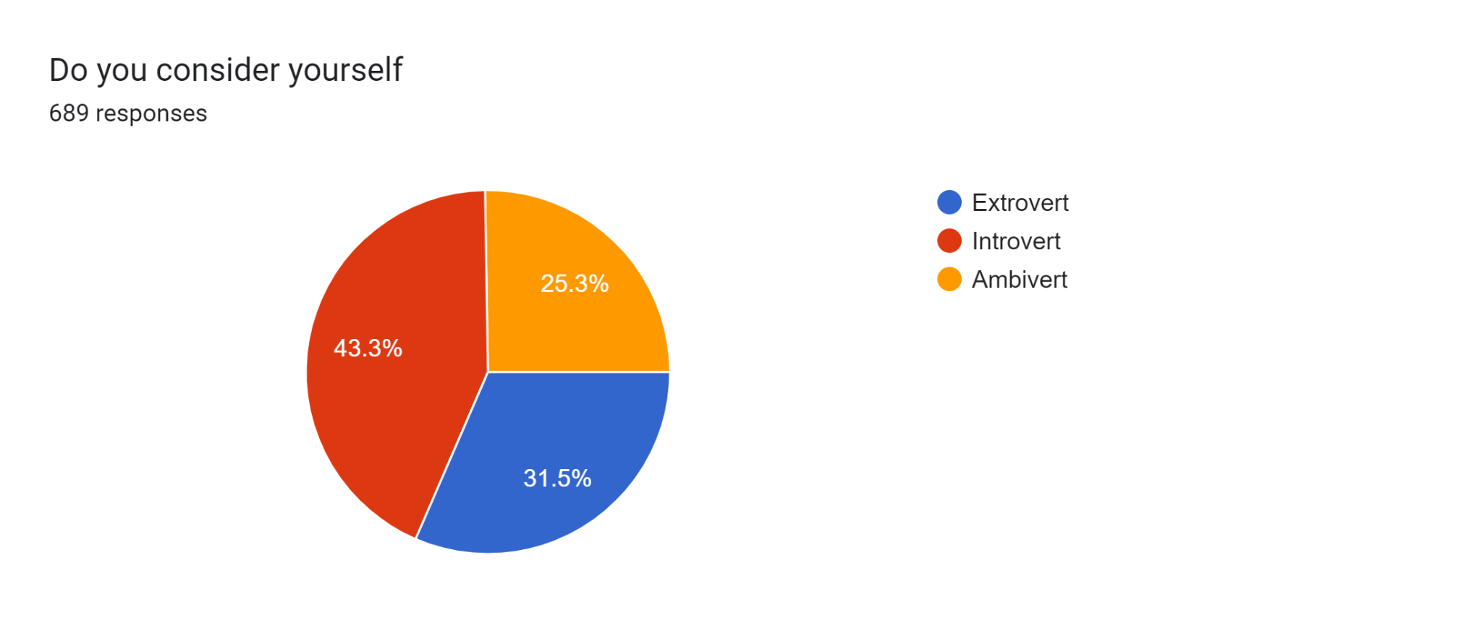
The above pie chart illustrates the percentage distribution of type of personality of the respondents, revealing that about 43.3% of them are Introvert

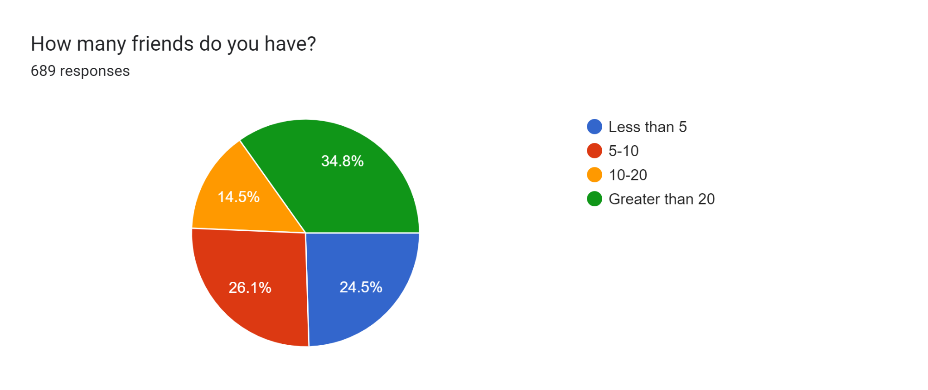
The above pie chart illustrates the percentage distribution of how many friends the respondents have? revealing that about 34.8.5% of them are having more than 20 friends

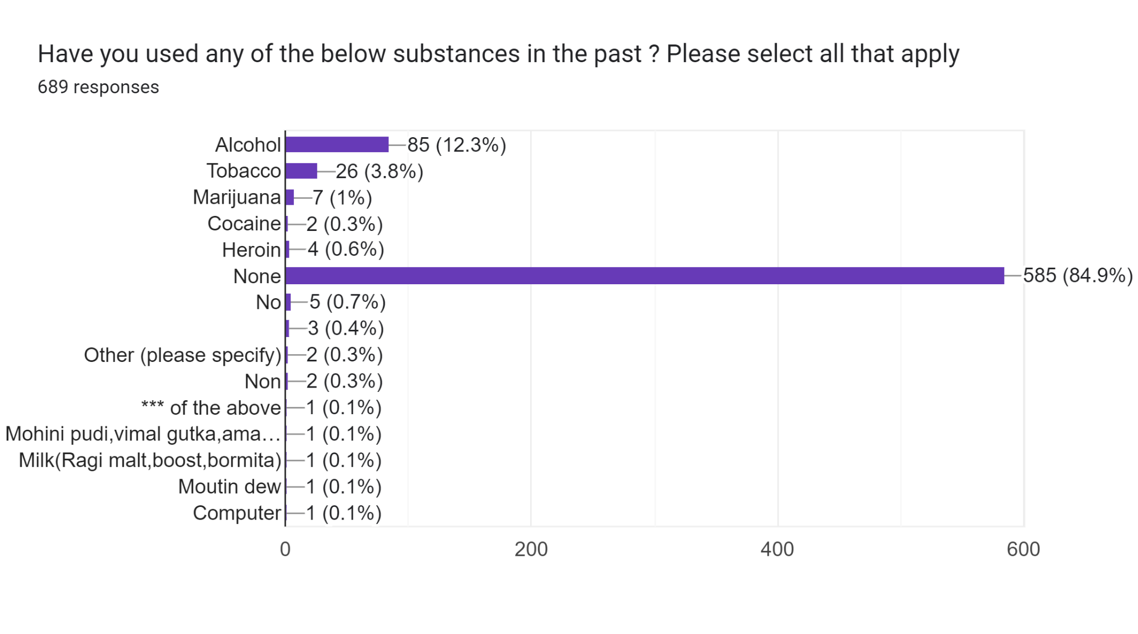
The above pie chart illustrates the percentage distribution of respondents about their addiction, revealing that about 84.9% of them are not having any bad habits

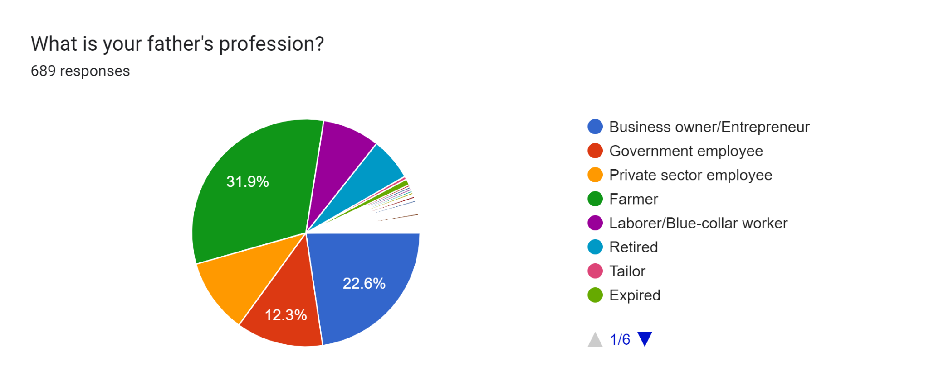
The above pie chart illustrates the percentage distribution of profession of the father of the respondents, revealing that about 31.9% of them are farmer
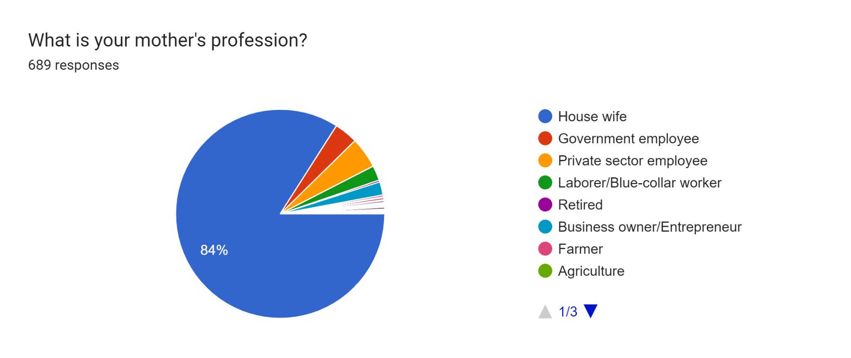

The above pie chart illustrates the percentage distribution of profession of the Mother of the respondents, revealing that about 84% of them are House wife
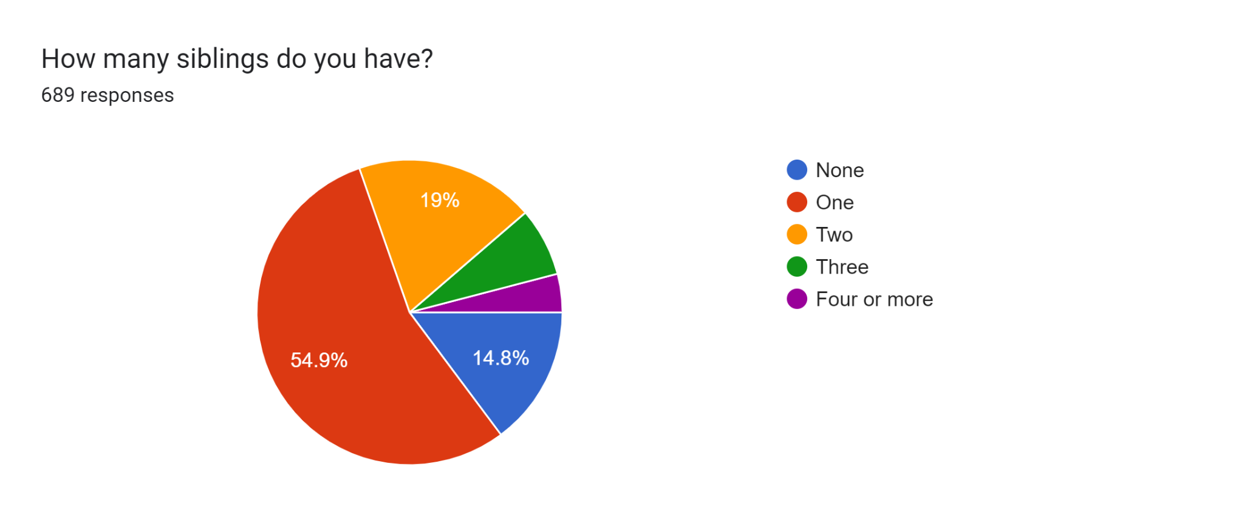
The above pie chart illustrates the percentage distribution of Number of siblings of the respondents, revealing that about 54.9% of them have one sibling
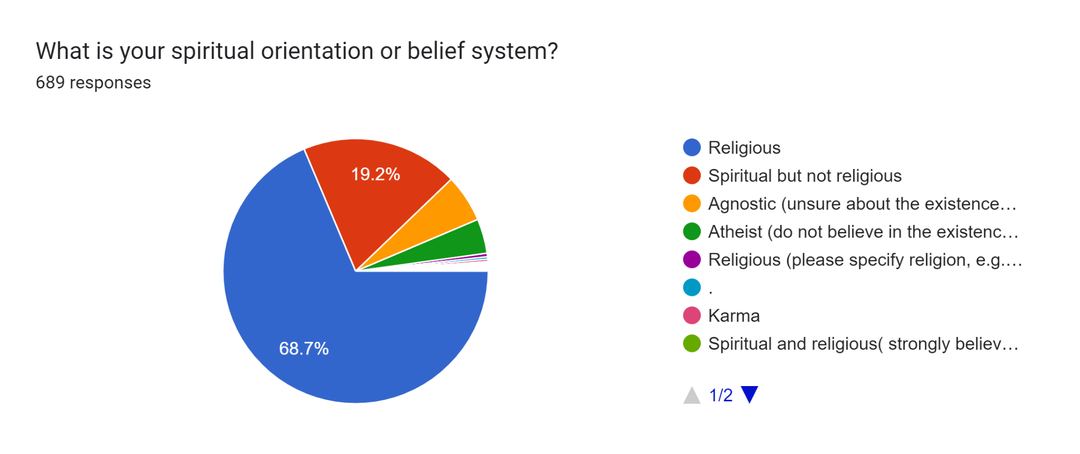

The above pie chart illustrates the percentage distribution of the respondents on spiritual orientation, revealing that about 68.7% of them are religious
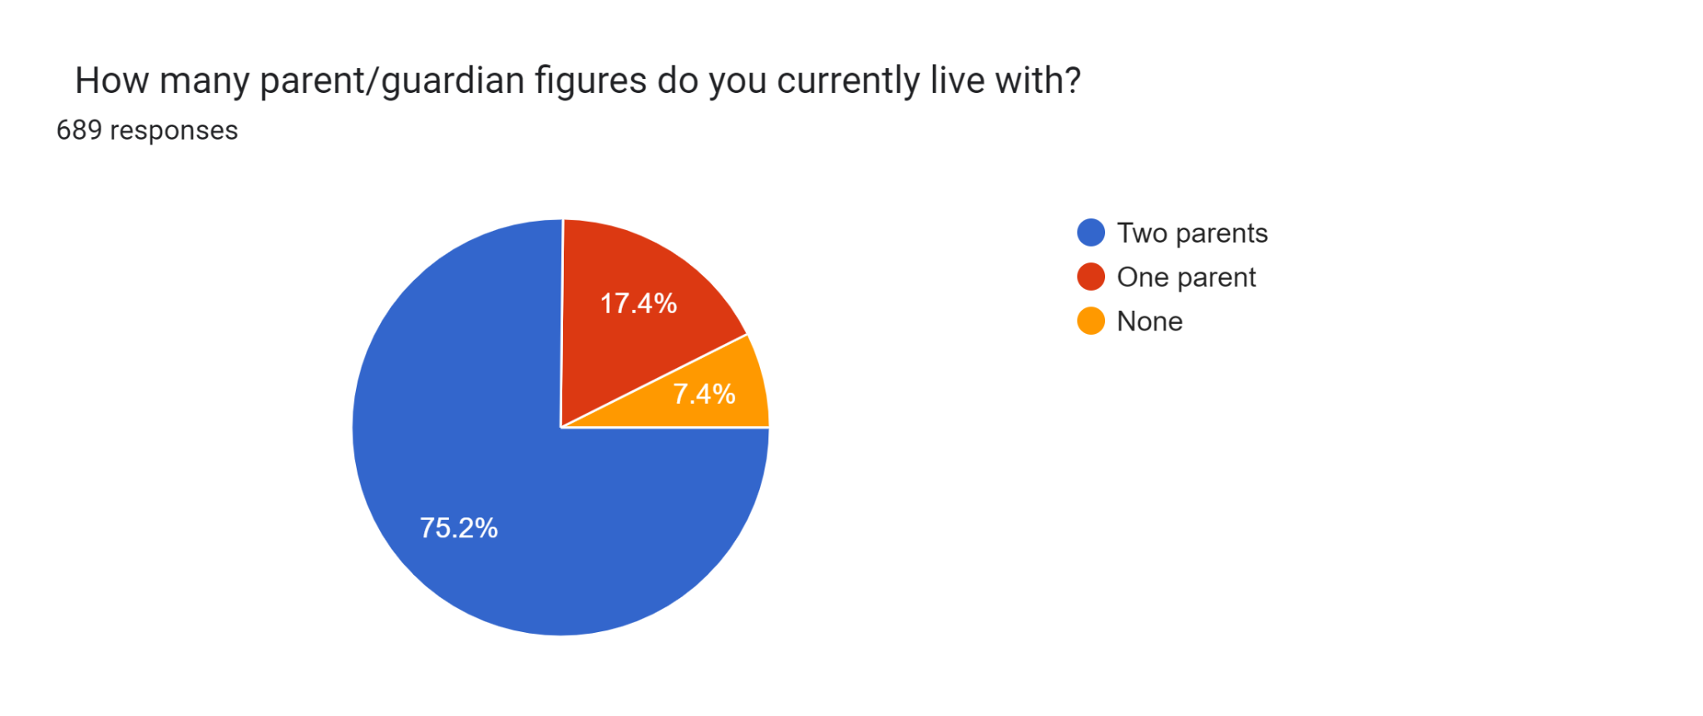
The above pie chart illustrates the percentage distribution of respondents based on their family, revealing that about 75.2% of them are staying with both the parents

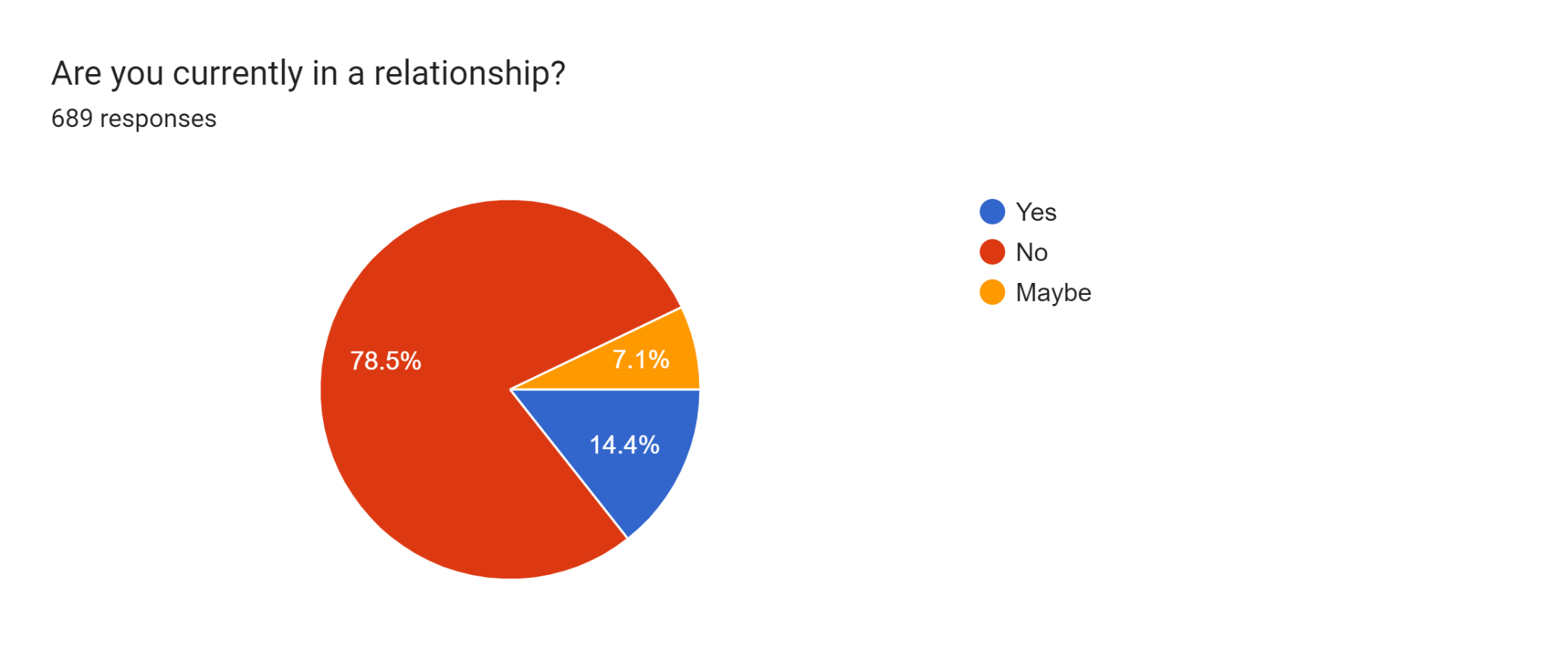
The above pie chart illustrates the percentage distribution respondents if they are in a relationship, revealing that about 78.5% of them are not in any relation
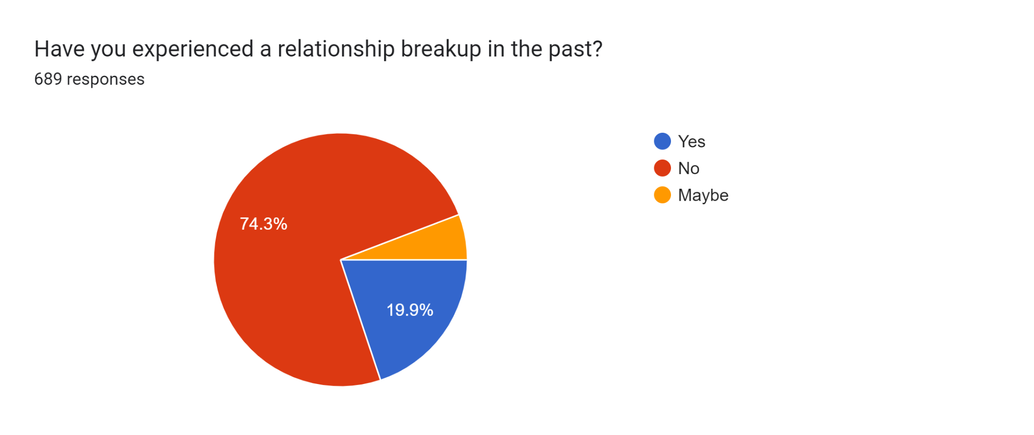
The above pie chart illustrates the percentage distribution respondents if they had any relationship break up, revealing that about 74.3% of them were never had a break up

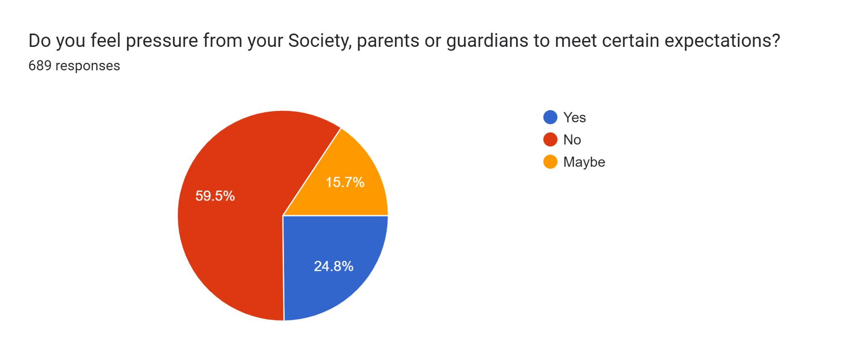
The above pie chart illustrates the percentage distribution respondents if they felt pressure from Society, parent to meet expectations, revealing that about 59.5% of them said No.

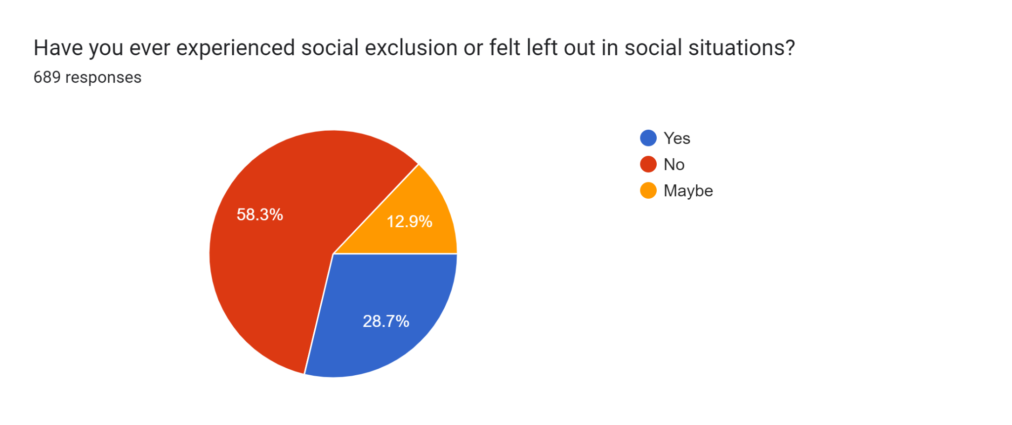
The above pie chart illustrates the percentage distribution respondents if they ever experienced social exclusion, revealing that about 58.3% of them said No.

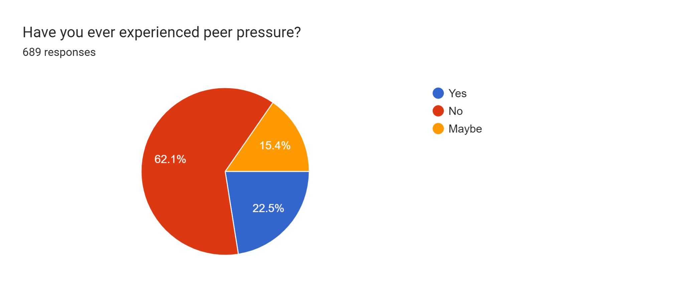
The above pie chart illustrates the percentage distribution respondents if they ever experienced peer pressure, revealing that about 62.1% of them said No.

Form HS – ASIQ
 | Adult suicide Ideation questionnaire (ASIQ) Rating analysis
Items | 1 | 2 | 3 | 4 | 5
I thought it would be better if I was not alive | 4% | 5% | 3% | 4% | 5%
I thought about killing myself | 2% | 4% | 2% | 3% | 3%
I thought about how I would kill myself | 2% | 4% | 3% | 2% | 2%
I thought about when I would kill myself | 3% | 4% | 2% | 2% | 2%
I thought about what to write in a suicide note | 2% | 4% | 2% | 3% | 2%
I thought about telling people I plan to kill myself | 2% | 3% | 2% | 2% | 1%
I thought that people would be happier if I was not around | 6% | 4% | 3% | 2% | 6%
I thought about how people would feel if I killed myself | 4% | 4% | 3% | 3% | 3%
I wished I were dead | 4% | 4% | 2% | 3% | 4%
I thought about how easy it would be to end it all | 3% | 4% | 3% | 3% | 4%
I thought that killing myself would solve my problems | 3% | 4% | 3% | 2% | 3%
I thought that others would be better off if I was dead | 3% | 4% | 3% | 3% | 3%
I wished I had the nerve to kill myself | 2% | 4% | 3% | 2% | 3%
I wished that I had never been born | 4% | 4% | 3% | 4% | 4%
I thought that if I had the chance I would kill myself | 2% | 4% | 3% | 3% | 3%
I thought about ways people kill themselves | 2% | 5% | 4% | 3% | 2%
I thought about killing myself, but would not do it | 2% | 4% | 2% | 3% | 3%
I thought about having a bad accident | 4% | 5% | 3% | 4% | 2%
I thought that life was not worth living | 5% | 4% | 4% | 3% | 3%
I thought that my life was too rotten to continue | 3% | 4% | 3% | 3% | 3%
I thought that the only way to be noticed was to kill myself | 3% | 4% | 3% | 2% | 2%
I thought that if I killed myself people would realize I was worth caring about | 4% | 5% | 2% | 3% | 3%
I thought that no one cared if I lived or died | 3% | 4% | 4% | 3% | 4%
I wondered if I had the nerve to kill myself | 2% | 4% | 3% | 2% | 2%
I thought that if things did not get better I would kill myself | 2% | 4% | 2% | 3% | 3%

As per the above table, only a few respondents that is 5% are having suicide ideation at high risk.

Section 3 - Preventive Measure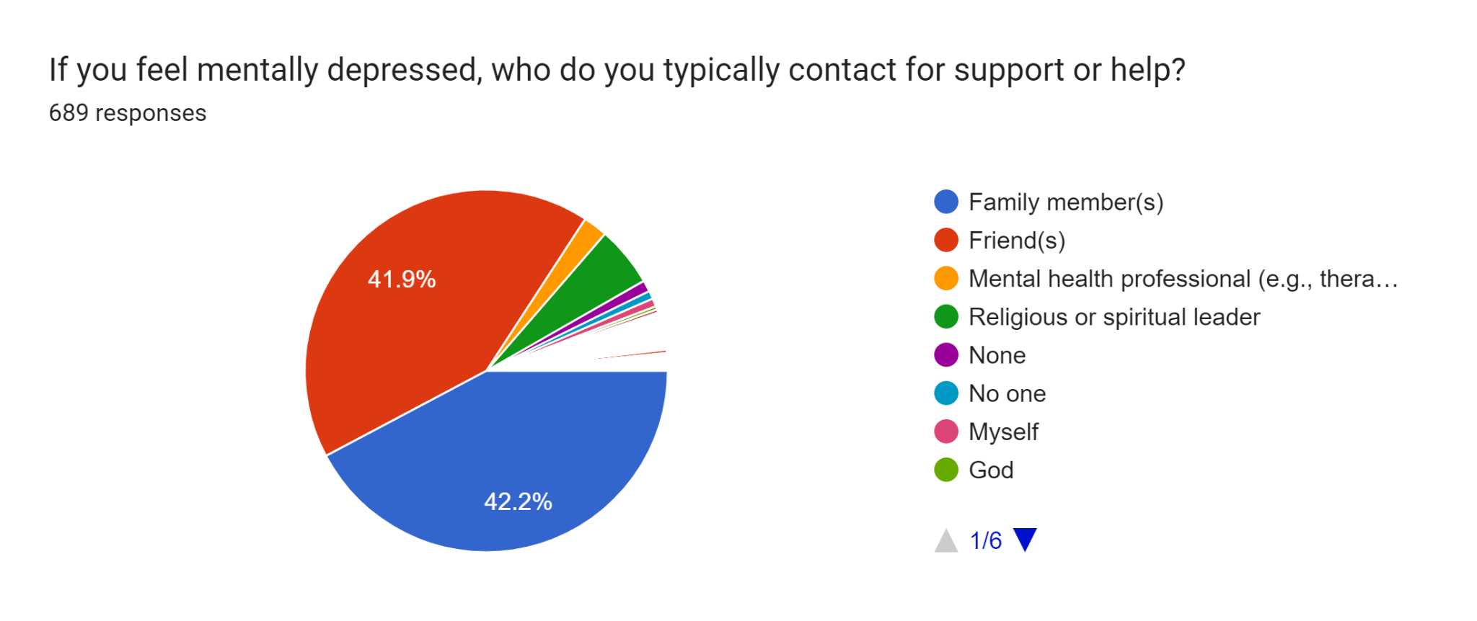
The above pie chart illustrates the support system for the respondents, if they are depressed. Majority says that Family and Friends are the people, whom they wanted to go and talk.

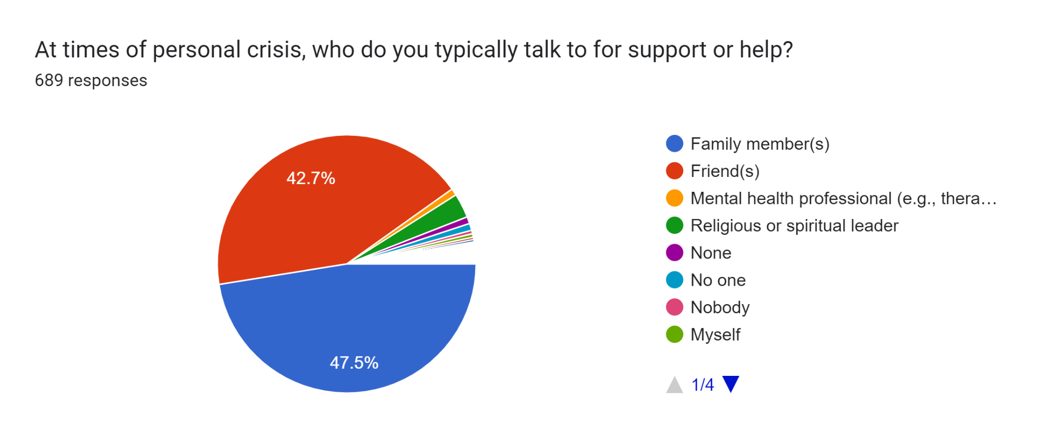
The above pie chart illustrates the support system for the respondents, if they are in personal crisis. Majority says that Family and Friends are the people, whom they wanted to go and talk.

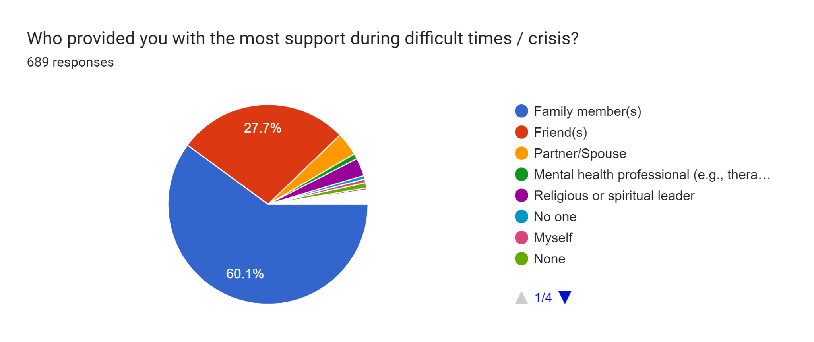
The above pie chart illustrates the support system for the respondents during their difficult times. Majority says that Family and Friends are the people, whom they wanted to go and talk.
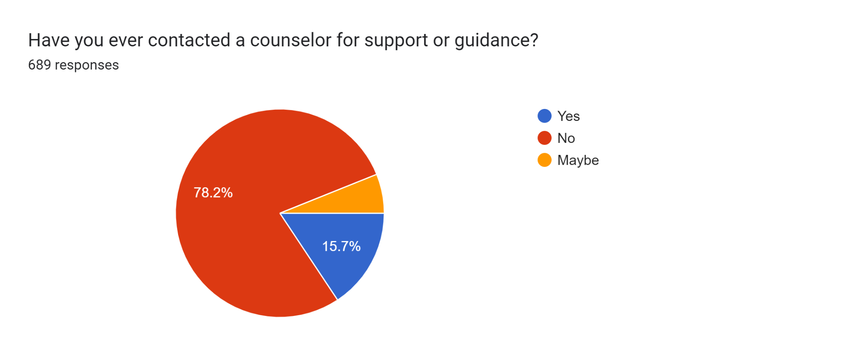
Majority of the respondents that is 78.2% never contacted a counsellor for support till date.
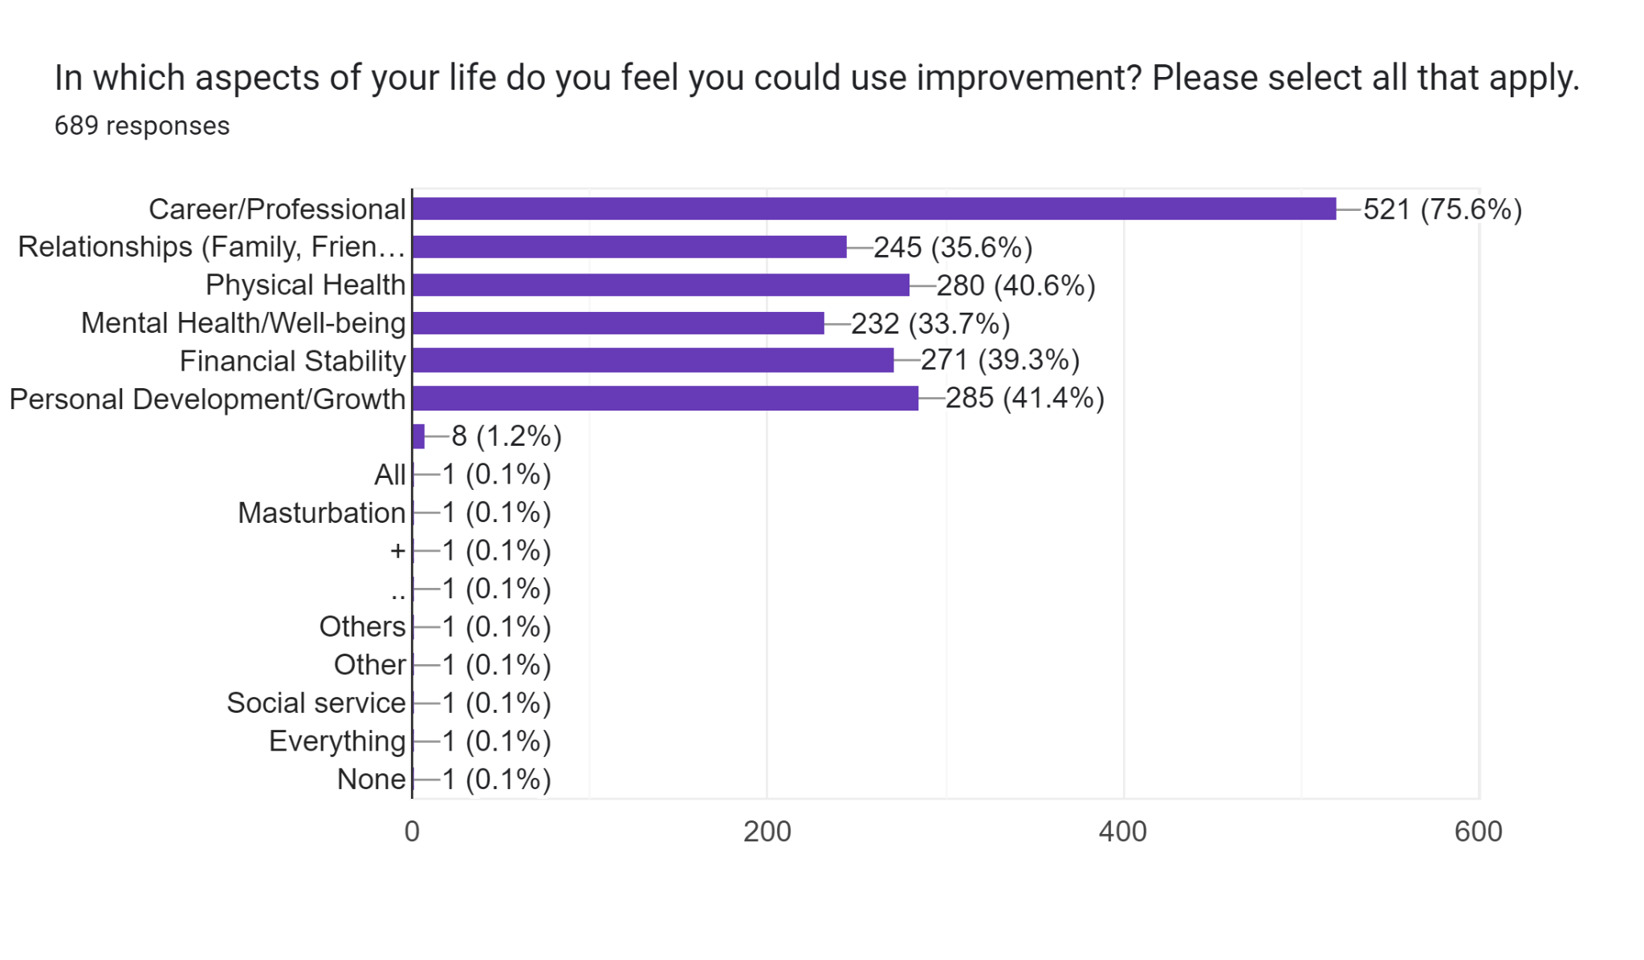
Majority of the respondents wanted to improve in their Career/ profession, I they get a chance.
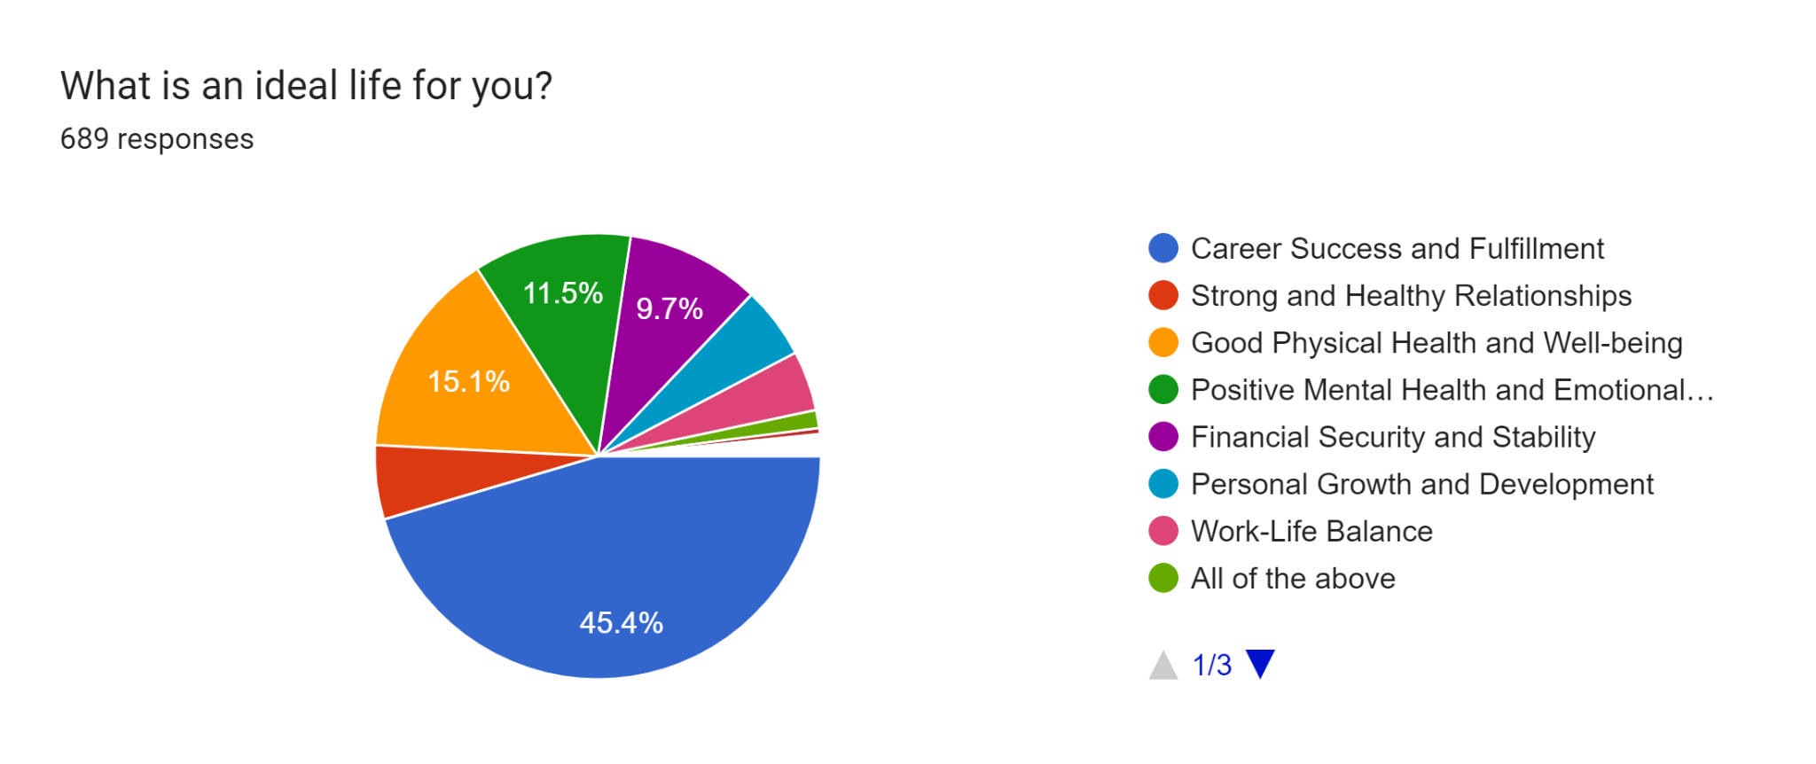
Majority of the respondents that is 45.4% said that the ideal life for them is Career success and Fulfilment.

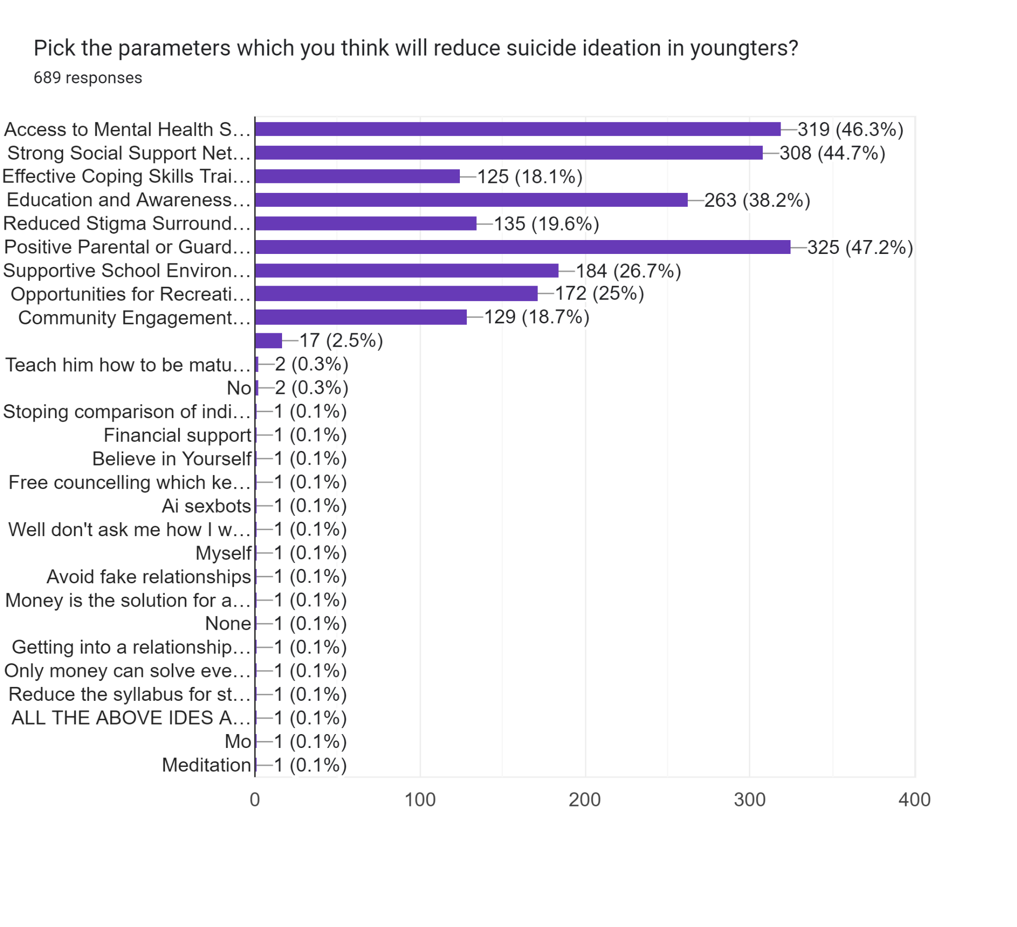
Majority of the respondents told that good parenting and access to mental health service providers along with good social support can reduce suicide ideation among the students.
Reliability analysis:

Reliability analysis is crucial to confirm that a measurement tool consistently measures what it intends to, ensuring accuracy and stability in the results. This process validates that the questionnaire produces dependable and consistent data, which is fundamental for the integrity of research outcomes.

Reliability Statistics
Cronbach's Alpha | N of Items
.985 | 25

The reliability analysis of the Reynolds Suicidal Ideation Questionnaire yielded a Cronbach's Alpha of 0.985 for 25 items. This high value indicates strong internal consistency among the items. A Cronbach's Alpha above 0.9 suggests that the items are highly correlated and reliably measure the construct of suicidal ideation. This level of reliability supports the robustness of the questionnaire in research settings.

Hypothesis Testing:

Hypothesis 1: There is no significant relationship between demographic variables (Age, Gender, College Name, Name of the Course, Family Size, Monthly Family Income, Living Arrangement, Religion, Caste, etc.) and suicide ideation.

Hypothesis 2: There is no significant relationship between substance use (e.g., alcohol) and suicide ideation.

Hypothesis 3: There is no significant relationship between the number of parent/guardian figures and suicide ideation.

Hypothesis 4: There is no significant relationship between thoughts related to suicide (e.g., thinking about killing oneself, wishing to be dead) and suicide ideation.

Hypothesis 5: There is a significant relationship between experiencing social pressures (e.g., societal or parental expectations, peer pressure) and suicide ideation.

Sl. No. | Null Hypothesis | P-value | Inference
1 | There is no relation between Age Category and Suicide ideation | 0.00 | Reject the null hypothesis
2 | There is no relation between Gender and Suicide ideation | 0.777 | Do not reject the null hypothesis
3 | There is no relation between Type of the Course and Suicide ideation | 0.000 | Reject the null hypothesis
4 | There is no relation between Family Size and Suicide ideation | 0.958 | Do not reject the null hypothesis
5 | There is no relation between Monthly Family Income and Suicide ideation | 0.304 | Do not reject the null hypothesis
6 | There is no relation between Living arrangement and Suicide ideation | 0.533 | Do not reject the null hypothesis
7 | There is no relation between Religion and Suicide ideation | 0.211 | Do not reject the null hypothesis
8 | There is no relation between Caste and Suicide ideation | 0.254 | Do not reject the null hypothesis
9 | There is no relation between Personality (Extrovert/Introvert) and Suicide ideation | 0.057 | Do not reject the null hypothesis
10 | There is no relation between Number of Friends and Suicide ideation | 0.000 | Reject the null hypothesis
11 | There is no relation between Hobbies and Suicide ideation | 0.252 | Do not reject the null hypothesis
12 | There is no relation between Substance Use and Suicide ideation | 0.032 | Reject the null hypothesis
13 | There is no relation between Sexual Orientation and Suicide ideation | 0.779 | Do not reject the null hypothesis
14 | There is no relation between Father's Profession and Suicide ideation | 0.293 | Do not reject the null hypothesis
15 | There is no relation between Mother's Profession and Suicide ideation | 0.600 | Do not reject the null hypothesis
16 | There is no relation between Number of Siblings and Suicide ideation | 0.66 | Do not reject the null hypothesis
17 | There is no relation between Spiritual Orientation and Suicide ideation | 0.148 | Do not reject the null hypothesis
18 | There is no relation between Number of Parent/Guardian Figures and Suicide ideation | 0.024 | Reject the null hypothesis
19 | There is no relation between Current Relationship Status and Suicide ideation | 0.000 | Reject the null hypothesis
20 | There is no relation between Breakup Experience and Suicide ideation | 0.000 | Reject the null hypothesis
21 | There is no relation between Pressure from Society/Parents and Suicide ideation | 0.000 | Reject the null hypothesis
22 | There is no relation between Social Exclusion and Suicide ideation | 0.000 | Reject the null hypothesis
23 | There is no relation between Peer Pressure and Suicide ideation | 0.000 | Reject the null hypothesis
24 | There is no relation between Who you contact for support and Suicide ideation | 0.126 | Do not reject the null hypothesis
25 | There is no relation between Who you talk to during a personal crisis and Suicide ideation | 0.031 | Reject the null hypothesis
26 | There is no relation between Who provides the most support and Suicide ideation | 0.013 | Reject the null hypothesis
27 | There is no relation between Contacting a counsellor and Suicide ideation | 0.001 | Reject the null hypothesis
28 | There is no relation between Aspects of life needing improvement and Suicide ideation | 0.025 | Reject the null hypothesis
29 | There is no relation between Ideal Life Parameters and Suicide ideation | 0.314 | Do not reject the null hypothesis
30 | There is no relation between choice of Suicide Prevention Parameters and Suicide ideation | 0.401 | Do not reject the null hypothesis
31 | There is no relation between Thought about being better off dead and Suicide ideation | 0.000 | Reject the null hypothesis
32 | There is no relation between Thought about killing oneself and Suicide ideation | 0.000 | Reject the null hypothesis
33 | There is no relation between Thought about how to kill oneself and Suicide ideation | 0.000 | Reject the null hypothesis
34 | There is no relation between Thought about when to kill oneself and Suicide ideation | 0.000 | Reject the null hypothesis
35 | There is no relation between Thought about writing a suicide note and Suicide ideation | 0.000 | Reject the null hypothesis
36 | There is no relation between Thought about telling people about killing oneself and Suicide ideation | 0.000 | Reject the null hypothesis
37 | There is no relation between Thought about how people would feel if I killed myself and Suicide ideation | 0.000 | Reject the null hypothesis
38 | There is no relation between Wishing to be dead and Suicide ideation | 0.000 | Reject the null hypothesis
39 | There is no relation between Thought about how easy it would be to end it all and Suicide ideation | 0.000 | Reject the null hypothesis
40 | There is no relation between Thought that suicide would solve problems and Suicide ideation | 0.000 | Reject the null hypothesis
41 | There is no relation between Thought that others would be better off if dead and Suicide ideation | 0.000 | Reject the null hypothesis
42 | There is no relation between Wishing to have the nerve to kill oneself and Suicide ideation | 0.000 | Reject the null hypothesis
43 | There is no relation between Wishing to have never been born and Suicide ideation | 0.000 | Reject the null hypothesis
44 | There is no relation between Thought about the chance to kill oneself and Suicide ideation | 0.000 | Reject the null hypothesis
45 | There is no relation between Thought about ways people kill themselves and Suicide ideation | 0.000 | Reject the null hypothesis
46 | There is no relation between Thought about killing oneself but wouldn't do it and Suicide ideation | 0.000 | Reject the null hypothesis
47 | There is no relation between Thought about having a bad accident and Suicide ideation | 0.000 | Reject the null hypothesis
48 | There is no relation between Thought that life is not worth living and Suicide ideation | 0.000 | Reject the null hypothesis
49 | There is no relation between Thought that life is too rotten to continue and Suicide ideation | 0.000 | Reject the null hypothesis
50 | There is no relation between Thought about being noticed through suicide and Suicide ideation | 0.000 | Reject the null hypothesis
51 | There is no relation between Thought that suicide would make people care and Suicide ideation | 0.000 | Reject the null hypothesis
52 | There is no relation between Thought that no one cares if alive or dead and Suicide ideation | 0.000 | Reject the null hypothesis
53 | There is no relation between Thought about the nerve to kill oneself and Suicide ideation | 0.000 | Reject the null hypothesis
54 | There is no relation between Thought about killing oneself if things don't improve and Suicide ideation | 0.000 | Reject the null hypothesis

Based on the above hypothesis testing using Chi Squared we observe the following:
- Significant Relationships: There is a significant relationship between suicide ideation and the following variables:
  - Current Relationship Status
  - Breakup Experience
  - Pressure from Society/Parents
  - Social Exclusion
  - Peer Pressure
  - Contacting a Counsellor
  - Thoughts related to suicide (including thoughts about being better off dead, killing oneself, and other related thoughts)
- No Significant Relationship: Variables such as "Gender," "Monthly Family Income," "Hobbies," "Mother’s Profession," and others do not show a significant link to suicide ideation.
Machine Learning:
A decision tree is a powerful machine learning tool used to model and visualize decision-making processes based on various input variables. In the context of analysing suicide ideation using the provided variables, a decision tree can help identify key factors that influence the likelihood of experiencing suicidal thoughts.

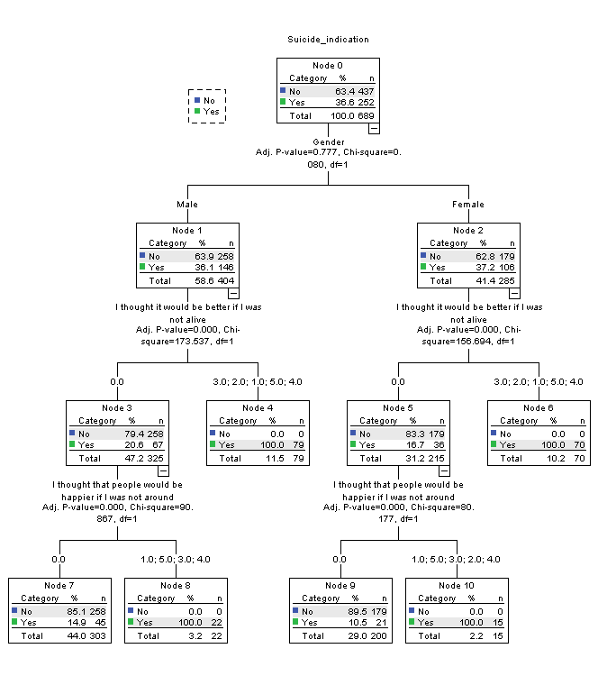

Classification
Observed | Predicted
Observed | No | Yes | Percent Correct
No | 437 | 0 | 100.0%
Yes | 66 | 186 | 73.8%
Overall Percentage | 73.0% | 27.0% | 90.4%
Growing Method: CHAID
Dependent Variable: Suicide indication
Interpretation:
The decision tree presented for predicting suicidal ideation is based on two key factors: Gender and two statements measuring suicidal thoughts—"I thought it would be better if I was not alive" and "I thought that people would be happier if I was not around". The tree divides individuals into male and female groups and uses their responses to these statements to classify the likelihood of suicidal ideation. For males, if the individual does not endorse any of the specified values for both statements, the prediction is "No" for suicidal ideation, with a probability of 85.15% (Node 7). However, if they endorse any of the values for the second statement, the model predicts "Yes" for suicidal ideation, with a certainty of 100% (Node 8). Moreover, if the first statement is endorsed, the prediction is also "Yes" with 100% probability (Node 4).

For females, the tree behaves similarly. If neither of the specified values in both statements are endorsed, the prediction is "No" for suicidal ideation, with a probability of 89.5% (Node 9). However, if the individual endorses any of the specified values in the second statement, the model predicts "Yes" with full certainty (Node 10). Likewise, if the first statement is endorsed, the model also predicts "Yes" with 100% probability (Node 6).

This decision tree highlights how a combination of gender and specific thoughts associated with suicidal ideation is used to make predictions, showing that endorsement of these thoughts, regardless of gender, significantly increases the likelihood of suicidal ideation. The model uses binary decision paths to make these predictions with a clear delineation between males and females.

Conclusions:

1. The analysis reveals a significant relationship between Age Category and Suicide Ideation, as evidenced by the rejection of the null hypothesis (p = 0.00).

2. Gender does not show a significant association with suicide ideation, as the null hypothesis could not be rejected (p = 0.777), indicating no statistical relationship between these variables.

3. A significant relationship was found between Type of Course and Suicide Ideation, with the null hypothesis being rejected (p = 0.000), suggesting that educational background may influence suicidal thoughts.

4. The results indicate a significant correlation between Number of Friends and Suicide Ideation (p = 0.000), implying that social networks may play a critical role in mitigating or exacerbating suicidal tendencies.

5. Substance Use is identified as a significant predictor of suicide ideation, with the null hypothesis being rejected (p = 0.032), underscoring the potential impact of substance abuse on mental health.

6. Conversely, variables such as Family Size, Monthly Family Income, and Living Arrangement do not exhibit statistically significant relationships with suicide ideation, as the null hypotheses for these factors were not rejected (p > 0.05).

7. Religion, Caste, and Sexual Orientation also do not present significant associations with suicide ideation, indicating that these demographic variables are not key predictors in this context.

8. The personality trait of being an Extrovert or Introvert shows no significant influence on suicide ideation (p = 0.057), as the null hypothesis could not be rejected, suggesting personality type may not be a determining factor.

9. The findings indicate no significant relationship between Number of Siblings and suicide ideation (p = 0.66), as the null hypothesis was not rejected.

10. The variables Breakup Experience, Peer Pressure, and Pressure from Society/Parents all demonstrate significant relationships with suicide ideation, with their respective null hypotheses being rejected, highlighting their impact on mental health.

11. Decision Tree Analysis was employed to further explore the prediction of suicide ideation, focusing on key factors such as gender and responses to specific statements related to suicidal thoughts.

12. The decision tree model effectively categorized individuals based on their endorsement of statements like *"I thought it would be better if I was not alive"* and *"I thought that people would be happier if I was not around."* These statements were found to be strong predictors of suicidal ideation.

13. The decision tree identified clear paths for both males and females, with high probabilities of suicidal ideation when certain thought patterns were endorsed, particularly those related to feelings of worthlessness or hopelessness.

14. For males, the absence of these thoughts predicted a lower likelihood of suicide ideation (85.15% probability of "No"), whereas endorsing these statements resulted in a 100% probability of suicide ideation. A similar pattern was observed for females.

15. The decision tree underscores the utility of machine learning in identifying critical risk factors for suicide ideation and demonstrates how binary decision paths can effectively model mental health outcomes, providing valuable insights for prevention efforts.

Scope for Future research
- This study is done only in one state of the country that is Karnataka. Can be repeated in other states as well
- Age group of only 18-25 is taken for the study, other age groups can also be studies.
- A comparison between states and age group can also be repeated
- Government initiates adopted by various states can also be taken as study
References
- Aaron, R., Joseph, A., Abraham, S., Mulayam, J., George, K., Prasad, J., ... & Bose, A. (2004). Suicides in young people in rural southern India. The Lancet, 363(9415), 1117-1118.
- Bae, S., Chung, Y., Ferreira, A., Lim, C., Kaeli, D., & Pereira, F. (2015). Using temporal pattern mining to predict the risk of suicide. In 2015 IEEE International Conference on Data Mining Workshop (ICDMW) (pp. 1501-1507). IEEE.
- Baumeister, R. F. (1990). Suicide as escape from self. Psychological review, 97(1), 90.
- Bhar, S., Brown, G. K., & Beck, A. T. (2008). Dysfunctional beliefs and psychopathology in borderline personality disorder. Journal of Personality Disorders, 22(2), 165-177.
- Bhat, M. (1991). Completeness of death registration in Karnataka. Demography India, 20(1), 35-51.
- Bose, A., Konradsen, F., John, J., Suganthy, P., Muliyil, J., & Abraham, S. (2006). Mortality rate and years of life lost from unintentional injury and suicide in South India. Tropical Medicine & International Health, 11(10), 1553-1556.
- Cash, S. J., Thelwall, M., Peck, S. N., Ferrell, J. Z., & Bridge, J. A. (2013). Adolescent suicide statements on MySpace. Cyberpsychology, Behavior, and Social Networking, 16(3), 166-174.
- Cha, C. B., Franz, P. J., Guzmán, E. M., Glenn, C. R., Kleiman, E. M., & Nock, M. K. (2018). Annual research review: suicide among youth–epidemiology, (potential) etiology, and treatment. Journal of Child Psychology and Psychiatry, 59(4), 460-482.
- Choi, A., Thabtah, F., & Mclaughlin, J. (2018). Prediction of suicide risk using machine learning. In 2018 IEEE International Conference on Bioinformatics and Biomedicine (BIBM) (pp. 1036-1042). IEEE.
- De Berardis, D., Fornaro, M., Valchera, A., Cavuto, M., Perna, G., Di Nicola, M., ... & Serafini, G. (2018). Eradicating suicide among special populations: a systematic review. CNS & Neurological Disorders-Drug Targets (Formerly Current Drug Targets-CNS & Neurological Disorders), 17(8), 614-631.
- Ducasse, D., Holden, R. R., Boyer, L., Artéro, S., Calati, R., Guillaume, S., ... & Courtet, P. (2018). Psychological pain in suicidality: A meta-analysis. Journal of Clinical Psychiatry, 79(3).
- Fredriksen, K. J., Schoeyen, H. K., Johannessen, J. O., Walby, F. A., Birkenaes, A. B., Launes, G., ... & Andreassen, O. A. (2017). Psychotic depression and suicidal behavior. Journal of affective disorders, 215, 213-219.
- Gajalakshmi, V., & Peto, R. (2007). Suicide rates in rural Tamil Nadu, South India: verbal autopsy of 39 000 deaths in 1997-98. International journal of epidemiology, 36(1), 203-207.
- Halli, S.S., Isac, S., Bhattacharjee, P. et al. Suicidality among gender minorities in Karnataka, South India. BMC Psychiatry 21, 25 (2021). https://doi.org/10.1186/s12888-021-03043-2
- Heisel, M. J., & Flett, G. L. (2004). Purpose in life, satisfaction with life, and suicide ideation in a clinical sample. Journal of psychopathology and Behavioral Assessment, 26(2), 127-135.
- Hill, R. M., Oosterhoff, B., Kaplow, J. B., & Palmes, G. (2017). Prediction of adolescent suicide ideation across 2 years: A brief screening measure. Journal of Clinical Child & Adolescent Psychology, 46(6), 871-878.
- Jashinsky, J., Burton, S. H., Hanson, C. L., West, J., Giraud-Carrier, C., Barnes, M. D., & Argyle, T. (2014). Tracking suicide risk factors through Twitter in the US. Crisis.
- Jiang, S., Cetin, M. S., Rashid, M., Calhoun, V. D., & Potenza, M. N. (2021). Predicting suicide attempts in adolescents with machine learning using brain functional connectivity and demographic data. Biological Psychiatry: Cognitive Neuroscience and Neuroimaging, 6(6), 619-629.
- Joseph, A., Abraham, S., Muliyil, J. P., George, K., Prasad, J., Minz, S., ... & Jacob, K. S. (2003). Evaluation of suicide rates in rural India using verbal autopsies, 1994-9. Bmj, 326(7399), 1121-1122.
- Kuroki, Y., & Tilley, J. L. (2012). Recursive partitioning analysis of lifetime suicidal behaviors in Asian Americans. Asian American Journal of Psychology, 3(1), 17.
- Ministry of Home Affairs, National Crime Records Bureau. (2014). Accidental Deaths & Suicides in India 2014. New Delhi: Government of India.
- Ministry of Home Affairs, National Crime Records Bureau. (2018). Accidental Deaths & Suicides in India 2018. New Delhi: Government of India.
- Mohapatra, S. (2021). Suicide in India: A complex problem. Indian Journal of Psychiatry, 63(2), 105.
- O'Carroll, P. W., Berman, A. L., Maris, R. W., Moscicki, E. K., Tanney, B. L., & Silverman, M. M. (1996). Beyond the Tower of Babel: a nomenclature for suicidology. Suicide and Life-Threatening Behavior, 26(3), 237-252.
- Oh, J., Yun, K., Hwang, J. H., & Chae, J. H. (2017). Classification of suicide attempts through a machine learning algorithm based on multiple systemic psychiatric scales. Frontiers in psychiatry, 8, 192.
- Passos, I. C., Mwangi, B., Cao, B., Hamilton, J. E., Wu, M. J., Zhang, X. Y., ... & Soares, J. C. (2016). Identifying a clinical signature of suicidality among patients with mood disorders: a pilot study using a machine learning approach. Journal of affective disorders, 193, 109-116.
- Planning Commission, Government of India. (1973). Report by the Task Force on Integrated Rural Development. New Delhi: Government of India.
- Raue, P. J., Ghesquiere, A. R., & Bruce, M. L. (2014). Suicide risk in primary care: identification and management in older adults. Current psychiatry reports, 16(9), 466.
- Ryu, E., Zhao, Y., Feng, H., Mahnken, J. D., Mansi, I. A., & Goodman, M. (2018). Predicting suicidal ideation from online postings in a military population. In 2018 IEEE International Conference on Healthcare Informatics (ICHI) (pp. 366-367). IEEE.
- Shneidman, E. S. (1993). Suicide as psychache. The Journal of nervous and mental disease, 181(3), 145-147.
- Soman, C. S., Safraj, S., Kutty, V. R., Vijayakumar, K., & Ajayan, K. (2009). Suicide in South India: a community-based study in Kerala. Indian journal of psychiatry, 51(4), 261.
- Suh, S., Choi, H., Yoo, I. Y., Yoo, S. Y., & Kim, H. W. (2021). Mediating effect of meaning in life on the relationship between perceived stress and suicidal ideation among older adults. Geriatric Nursing, 42(1), 138-143.
- Vijayakumar, L. (2008). Indian research on suicide. Indian journal of psychiatry, 50(4), 322.
- Zalsman, G., Hawton, K., Wasserman, D., van Heeringen, K., Arensman, E., Sarchiapone, M., ... & Zohar, J. (2016). Suicide prevention strategies revisited: 10-year systematic review. The Lancet Psychiatry, 3(7), 646-659.

