Suicide Risk Assessment and Mental Health Support System
1. Introduction
Suicide among young adults and university students has emerged as a significant public health concern. Academic stress, social isolation, emotional instability, relationship difficulties, and lack of support systems contribute substantially to suicidal ideation and mental health deterioration.
Traditional assessment methods primarily rely on questionnaire-based evaluation and clinical judgment, which provide only static observations and limited predictive capability.
The proposed Suicide Risk Assessment and Mental Health Support System aims to leverage machine learning, psychometric analysis, explainable artificial intelligence, anomaly detection, and behavioral analytics to identify students at risk, understand the factors influencing suicidal behavior, and recommend personalized interventions.
Unlike conventional classification systems, the proposed framework emphasizes interpretability, preventive action, and mental health support.

2. Problem Statement
Mental health surveys are effective in measuring psychological distress; however, they often fail to provide predictive insights into future risk progression.
Current approaches generally lack:
• Behavioral pattern analysis
• Explainable predictions
• Identification of unusual psychological profiles
• Preventive recommendation mechanisms
• Risk progression simulation
Therefore, an intelligent framework capable of detecting suicide risk, explaining the underlying causes, and suggesting intervention strategies is required.

3. Objectives
The objectives of the proposed system are:
• Predict suicide risk levels
• Categorize individuals into Low, Medium, and High Risk groups
• Identify influential psychological and social factors
• Evaluate questionnaire reliability
• Perform statistical validation
• Detect hidden behavioral patterns
• Discover anomalous mental health profiles
• Develop explainable prediction mechanisms
• Provide personalized recommendations
• Simulate future suicide risk progression
• Integrate emergency support resources

4. Dataset Description
The study utilizes a mental health survey dataset containing responses from approximately 689 participants.
The survey consists of:
Demographic Variables
Gender
Age
Relationship Status
Current Relationship
Breakup Experience
Academic Background

Psychological Variables
Adult Suicidal Ideation Questionnaire (ASIQ)
Psychological Distress Indicators
Peer Pressure
Societal Pressure
Emotional Well-being

Social Variables
Number of Friends
Social Exclusion
Support Availability
Family Support
Friend Support
Counseling Support

Future Variables (Proposed)
Sleep Duration
Screen Time
Academic Performance
Physical Activity
Social Activity
Substance Usage

5. System Architecture
Survey Responses
↓
Data Preprocessing
↓
Psychometric Validation
↓
Feature Engineering
↓
Statistical Analysis
↓
Feature Selection
↓
Anomaly Detection
↓
Behavioral Pattern Discovery
↓
Stacking Ensemble Learning
↓
SHAP Explainability
↓
Bayesian Network
↓
Recommendation Engine
↓
Risk Prediction
↓
Risk Trajectory Simulation
↓
Helpline Integration

6. Work Completed So Far
Layer 1: Data Understanding and Validation
The dataset was imported using Pandas.
Initial exploratory analysis was conducted to understand its structure.
This involved:
• Dataset dimensions
• Missing value analysis
• Column inspection
• Data type verification
• Distribution analysis
Frequency distributions of selected questionnaire responses were examined to understand participant behavior patterns.

Layer 2: Psychometric Validation
ASIQ Question Extraction
Instead of manually specifying ASIQ items, questions were automatically identified using string matching.
Columns containing:
"This thought was in my mind"
were extracted programmatically.
Advantages:
• Scalability
• Automation
• Reduced human error

ASIQ Numerical Encoding
ASIQ responses are stored as textual categories.
Machine learning algorithms require numerical representations.
A custom function named:
convert_asiq_response()
was implemented.
The response mapping is:
Almost Every Day → 6
Couple of Times a Week → 5
Once a Week → 4
Few Times a Month → 3
Rarely → 2
Very Rarely → 1
Never Had This Thought → 0
This transformation converts subjective responses into quantitative measurements.

Psychological Distress Score
After encoding all ASIQ items, they were aggregated.
Feature Created:
Psychological_Distress_Score
Formula:
Psychological_Distress_Score
=
Σ ASIQ Responses
Higher values indicate elevated suicidal ideation.
Histogram analysis was performed to understand score distribution.

Cronbach's Alpha
Since ASIQ is a psychometric questionnaire, reliability analysis was necessary.
Cronbach's Alpha was implemented.
Formula:
α =
(k / (k−1))
×
(1 − Σσ²ᵢ / σ²ₜ)
where:
k
=
number of questionnaire items
σ²ᵢ
=
variance of individual items
σ²ₜ
=
variance of total score
Interpretation:
α > 0.70
Good Reliability
α > 0.80
Very Good Reliability
α > 0.90
Excellent Reliability
This analysis confirms that ASIQ consistently measures suicidal ideation.

Layer 3: Feature Engineering
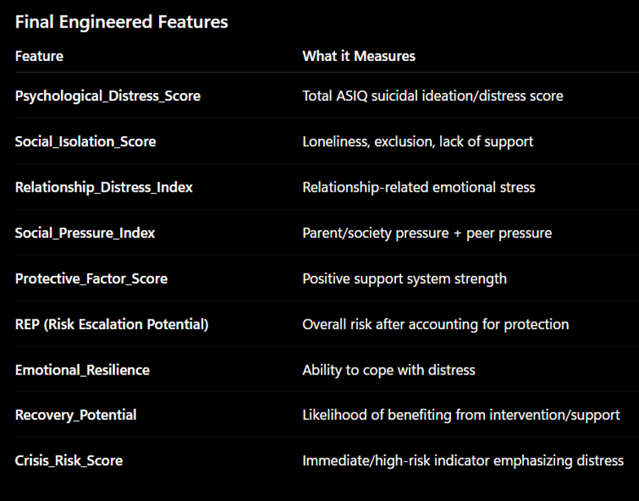
The project derives several psychological indicators from raw survey data.
Feature engineering converts survey responses into meaningful behavioral metrics.

Social Isolation Score
Variables Used:
Number of Friends
Social Exclusion
Friend_Risk Mapping
Social Exclusion Mapping
Formula:
Social_Isolation_Score
=
Friend_Risk

Social_Exclusion
Higher scores indicate stronger isolation tendencies.

Relationship Distress Index
Variables:
Relationship Status
Breakup Experience
Formula:
Relationship_Distress_Index
=
Relationship Status Score

Breakup Score
This feature quantifies emotional stress arising from interpersonal relationships.

Protective Factor Score
Protective variables reduce susceptibility to suicidal behavior.
Variables included:
Family Support
Friend Support
Counseling Support
Professional Help
Feature:
Protective_Factor_Score
Higher values correspond to stronger emotional resilience.

Crisis Risk Score
An overall risk metric was generated.
Formula:
Crisis_Risk_Score
=
Psychological_Distress_Score

Social_Isolation_Score

Relationship_Distress_Index
−
Protective_Factor_Score
High values indicate greater vulnerability.

Layer 4: Risk Label Generation
The dataset originally lacked suicide risk categories.
Risk groups were created using quantile-based binning.
Pandas qcut() was used.
Three classes were generated:
Low Risk
Medium Risk
High Risk
This produced balanced target labels.
Target Variable:
Risk_Level

Layer 5: Statistical Analysis
Several analyses were performed.
Exploratory Data Analysis
Visualizations generated include:
Histogram
Count Plot
Box Plot
Heatmap
Correlation Matrix
Distribution Curves
Objectives:
Understand feature relationships
Identify class imbalance
Detect trends
Study variable interactions

Correlation Analysis
Pearson Correlation Coefficients were calculated.
Variables analyzed:
Psychological_Distress_Score
Social_Isolation_Score
Relationship_Distress_Index
Protective_Factor_Score
Crisis_Risk_Score
Heatmaps were generated.
Strong associations indicate influential predictors.

Chi-Square Testing
Categorical variables were evaluated using Chi-Square tests.
Variables tested:
Gender
Peer Pressure
Relationship Status
Breakup Experience
Societal Pressure
Friends Count
Current Relationship
Interpretation:
p-value < 0.05
Statistically Significant
Significant features are considered useful predictors.

Layer 6: Feature Selection
Categorical variables were encoded using LabelEncoder.
Identifiers removed:
Timestamp
Email Address
Personal Information
Input Matrix:
X
Target Variable:
Risk_Level

Random Forest Importance
Random Forest Classifier was trained.
Feature importance values were extracted.
A feature ranking chart was generated.
Highly influential variables were identified.

SelectKBest
Chi-Square Feature Selection was implemented.
Top 20 predictors were selected.
Only statistically important variables were retained.

Redundancy Reduction
A correlation matrix was computed.
Variables with:
Correlation > 0.90
were removed.
This reduces multicollinearity.
Final feature set:
X_final
Selected features were exported as:
selected_features.csv

Layer 7: Anomaly Detection
Mental health datasets may contain participants exhibiting highly unusual behavioral patterns.
Traditional classifiers may overlook these individuals.
Therefore anomaly detection was proposed.
Methods considered:
Isolation Forest
Local Outlier Factor
One-Class SVM
Isolation Forest is preferred because it performs well on high-dimensional tabular datasets.
Output:
Normal Individual
Moderate Outlier
Critical Outlier
Example:
Very High Distress

No Support

Severe Isolation
↓
Potential Crisis Case
Anomaly scores may also be incorporated into ensemble models.

Layer 8: Behavioral Pattern Discovery
Behavioral clustering aims to discover hidden student groups.
Possible methods:
K-Means Clustering
Hierarchical Clustering
DBSCAN
Example clusters:
Cluster 1
Socially Active Students
Cluster 2
Emotionally Distressed Students
Cluster 3
Academically Pressured Students
Cluster 4
Socially Isolated Students
This provides insight into population-level behavioral trends.

Layer 9: Ensemble Learning
The core prediction engine will utilize stacking ensembles.
Five architectures are proposed.

Ensemble Model 1
Base Models
Random Forest
XGBoost
Logistic Regression
Meta Learner
Logistic Regression

Ensemble Model 2
Base Models
Random Forest
XGBoost
LightGBM
Meta Learner
Logistic Regression

Ensemble Model 3
Base Models
Random Forest
CatBoost
XGBoost
Meta Learner
XGBoost

Ensemble Model 4
Base Models
Random Forest
Extra Trees
Gradient Boosting
XGBoost
Meta Learner
Logistic Regression

Ensemble Model 5
Base Models
Random Forest
LightGBM
CatBoost
Support Vector Machine
Isolation Forest Score
Meta Learner
Logistic Regression

The best-performing architecture will be selected based on evaluation metrics.

Layer 10: Explainable Artificial Intelligence
SHAP values will be utilized.
SHAP explains the contribution of every feature.
Example:
Psychological Distress
+0.42
Social Isolation
+0.31
Relationship Issues
+0.18
Protective Support
−0.14
This makes predictions transparent.

Layer 11: Bayesian Network
Bayesian Networks model probabilistic relationships among psychological variables.
Example:
Breakup
↓
Isolation
↓
Distress
↓
Suicide Risk
Advantages:
Probabilistic inference
Cause-effect relationships
Mental health pathway analysis
Risk propagation analysis

Layer 12: Recommendation Engine
Recommendations will be personalized.
Examples:
High Isolation
→ Increase social engagement
→ Join student communities
High Distress
→ Seek counseling
Relationship Distress
→ Emotional support sessions
Low Protective Factors
→ Family involvement
→ Professional therapy

Layer 13: Risk Trajectory Simulator
The system aims to estimate future suicide risk.
Example:
Current Risk
=
High
Scenario:
Increase social interaction
Reduce screen time
Improve sleep
Predicted Risk
↓
Medium
This enables "what-if" simulations.
Examples:
"What happens if counseling attendance increases?"
"What happens if social isolation decreases?"

Layer 14: Helpline and Support Integration
The final module provides access to support services.
Includes:
Mental Health Helplines
Emergency Contacts
Counseling Centers
University Wellness Services
Crisis Intervention Resources
This transforms the framework from a prediction model into a preventive mental health assistance system.

7. Current Status
Completed Components
✔ Data Cleaning
✔ ASIQ Encoding
✔ Cronbach's Alpha
✔ Feature Engineering
✔ EDA
✔ Correlation Analysis
✔ Chi-Square Tests
✔ Risk Score Construction
✔ Risk Label Generation
✔ Feature Selection
✔ Statistical Validation
✔ Dataset Preparation
Partially Completed
⬜ Anomaly Detection
⬜ Behavioral Clustering
⬜ Ensemble Training
⬜ SHAP Analysis
⬜ Bayesian Network
⬜ Recommendation Engine
⬜ Trajectory Simulation
⬜ Helpline Integration

8. Conclusion
The proposed Suicide Risk Assessment and Mental Health Support System combines psychometric validation, behavioral analytics, explainable machine learning, anomaly detection, probabilistic reasoning, and intervention strategies to create a comprehensive mental health assessment platform.
The preprocessing and statistical validation stages have been successfully completed, and the dataset is now ready for advanced machine learning experimentation and deployment.

