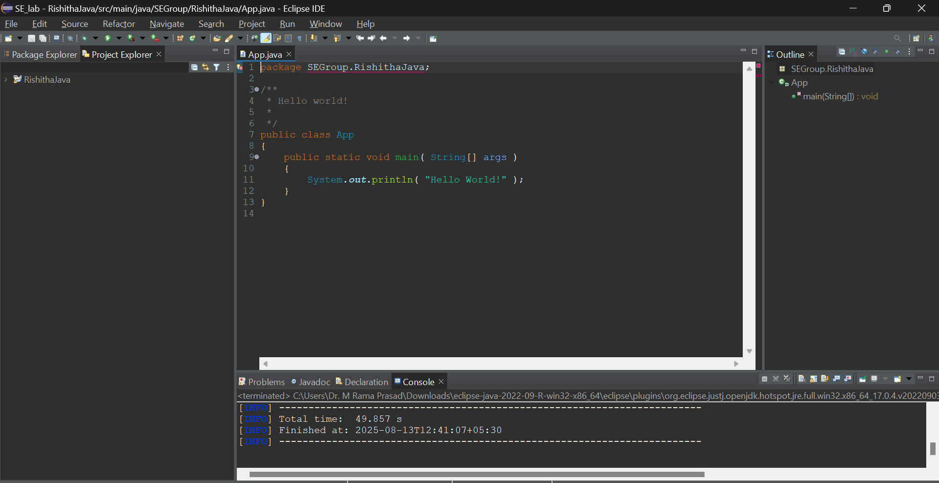

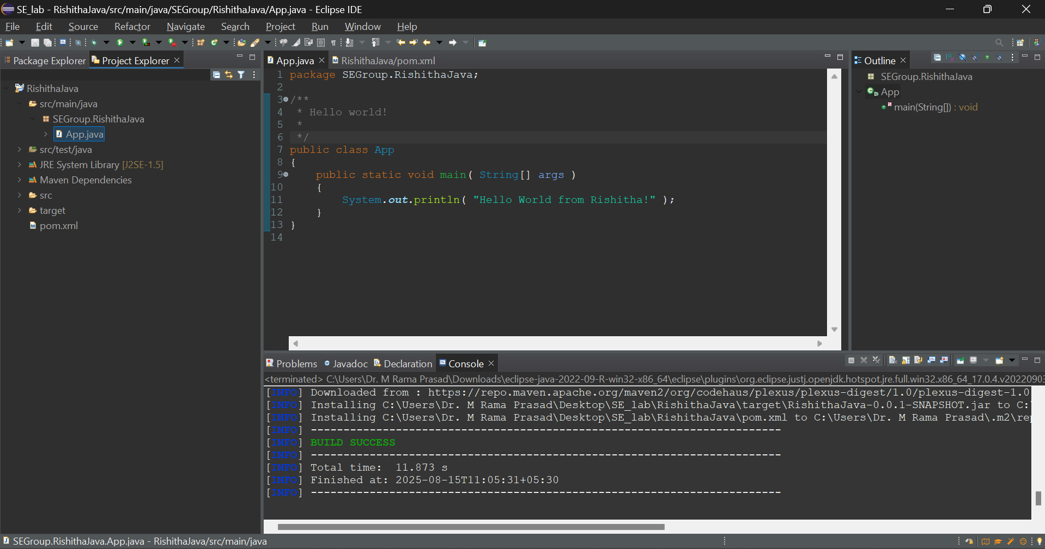
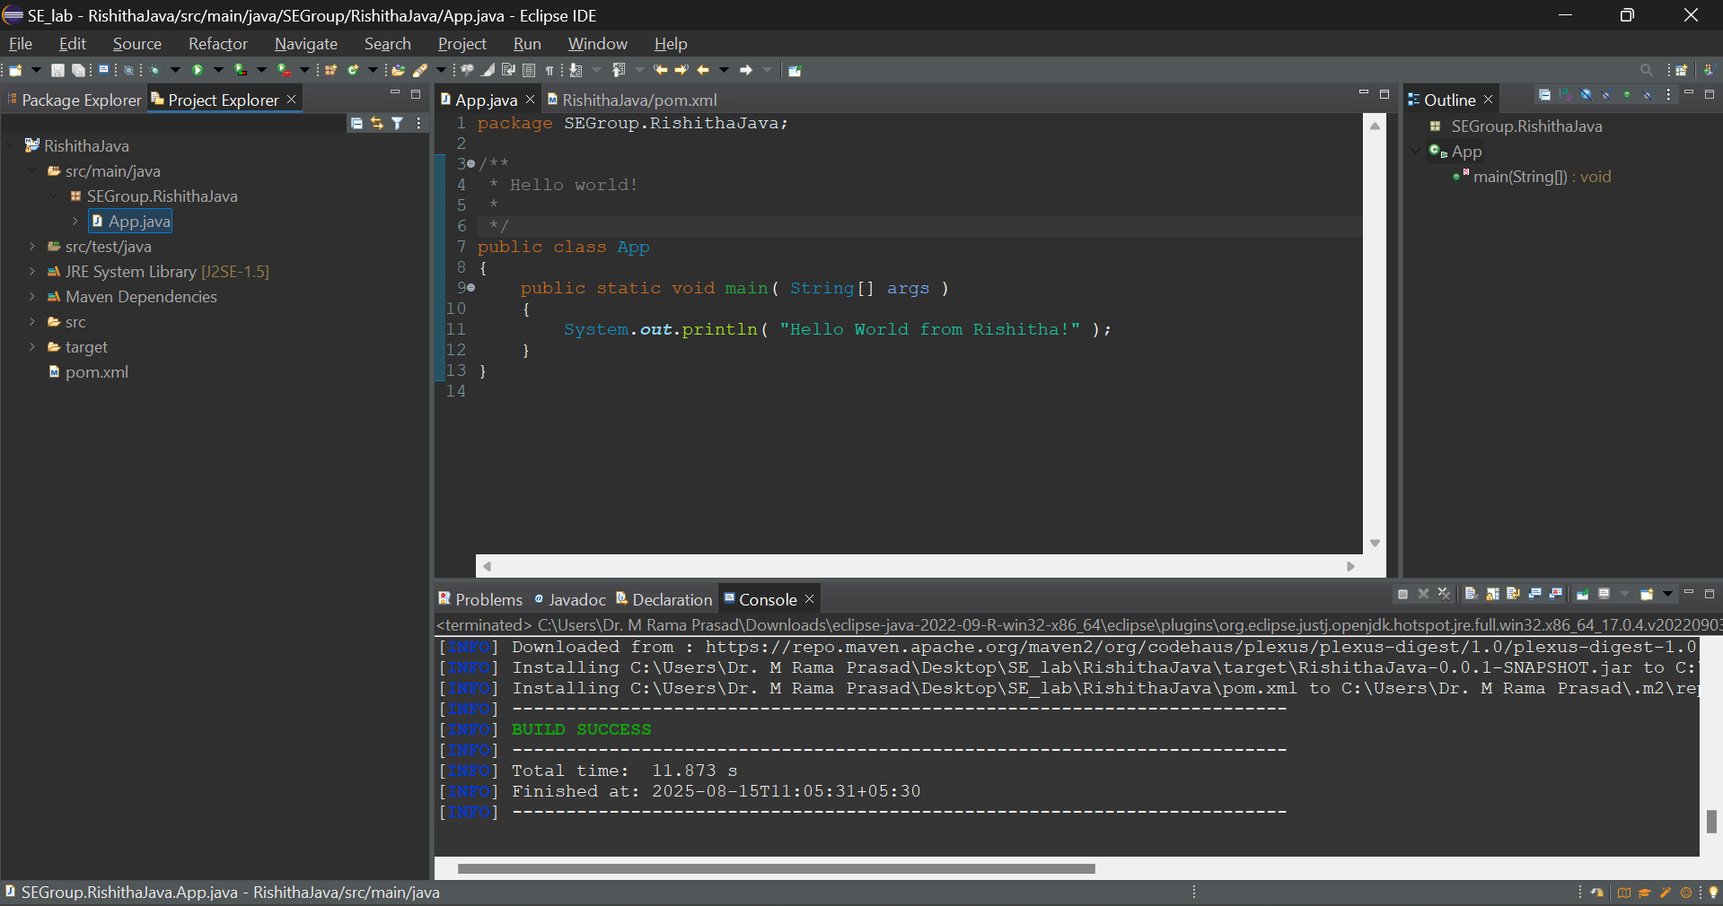
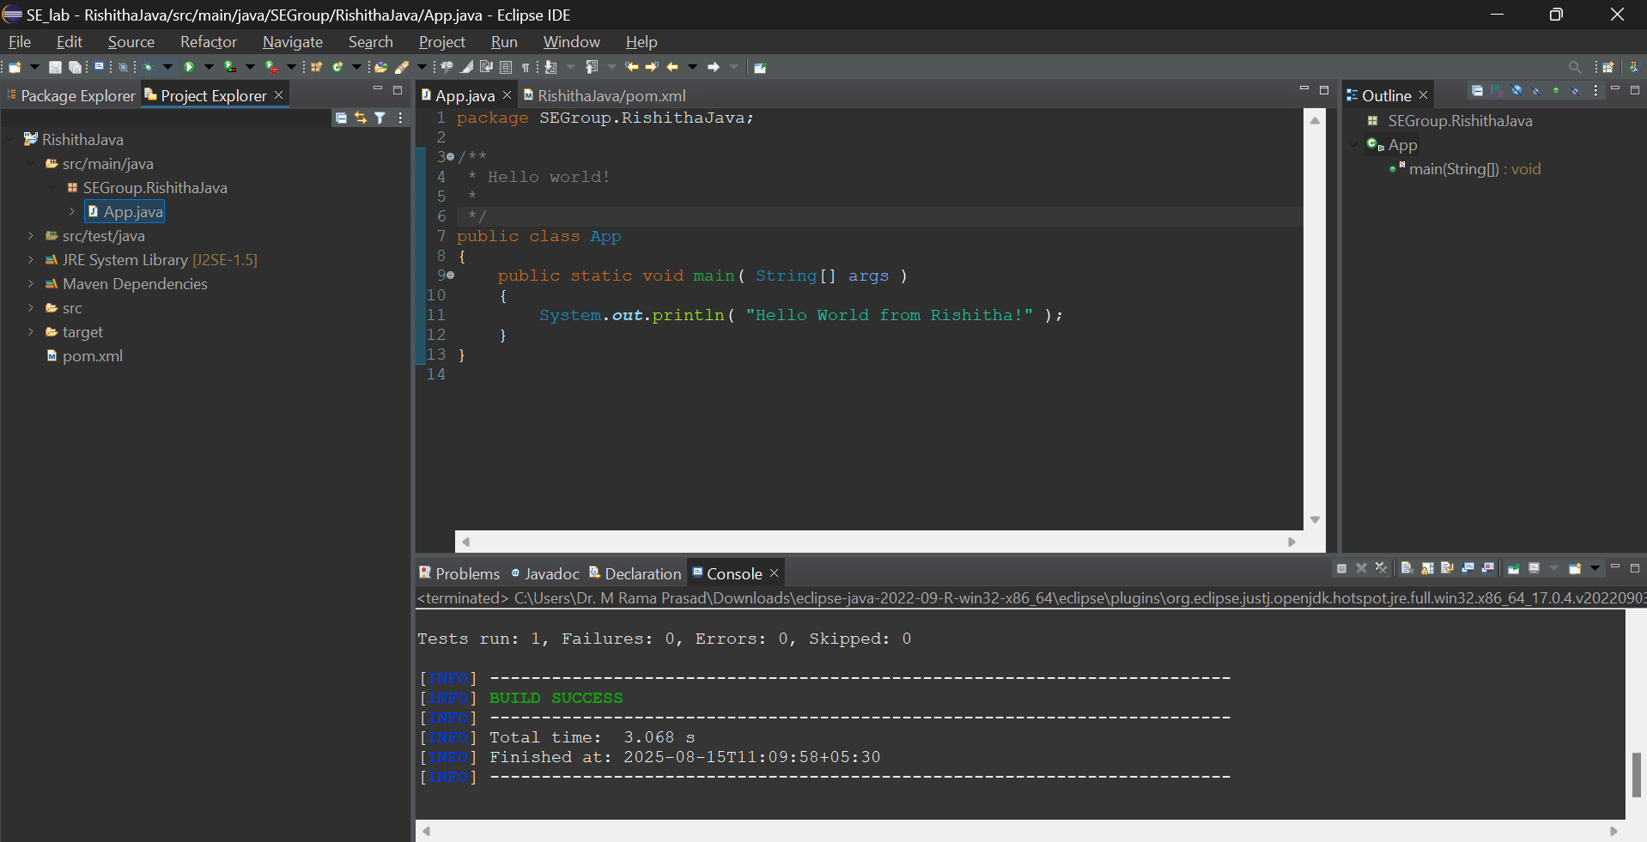
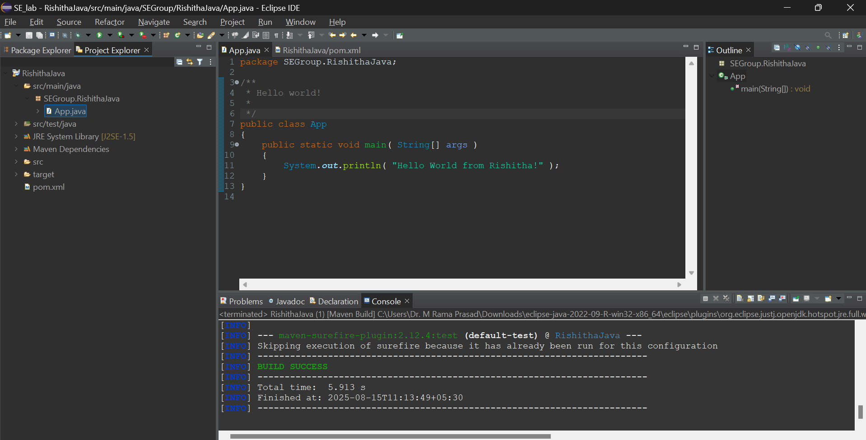
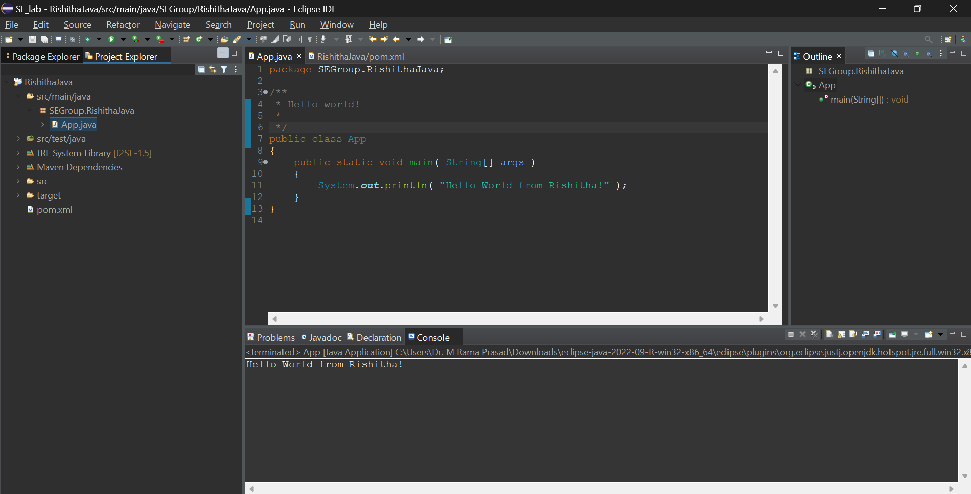
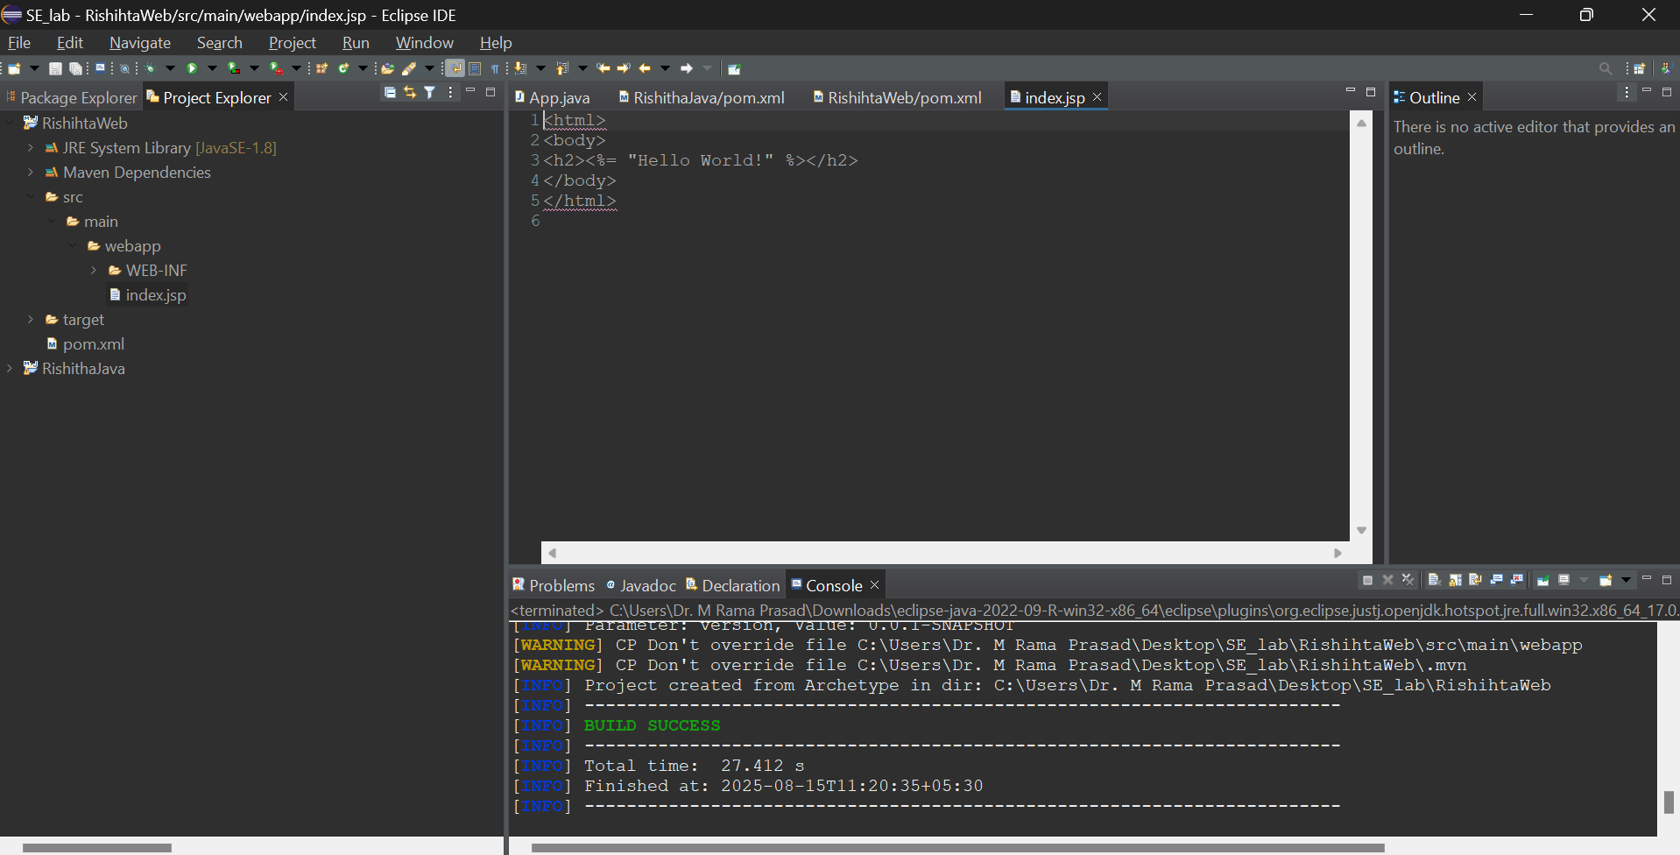
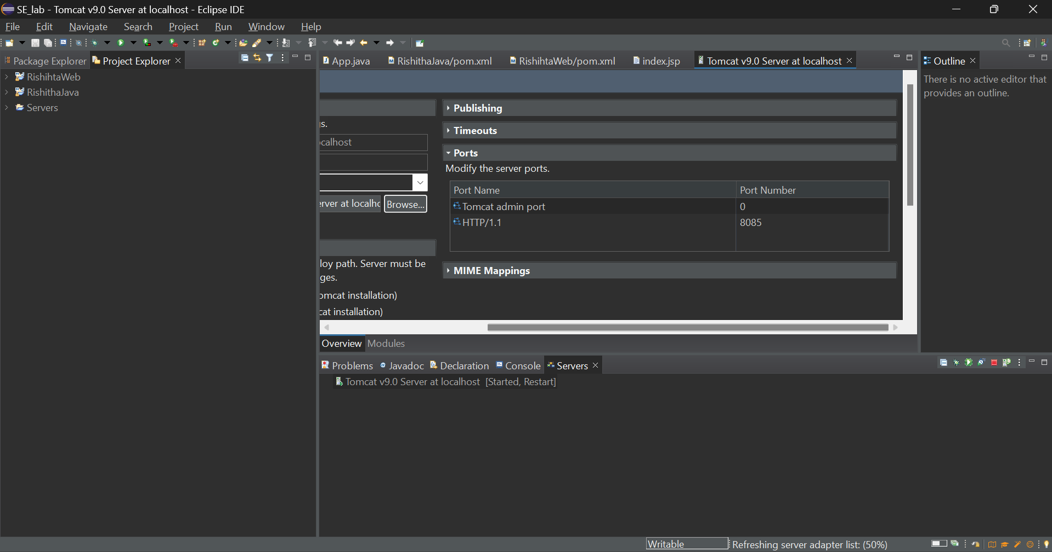
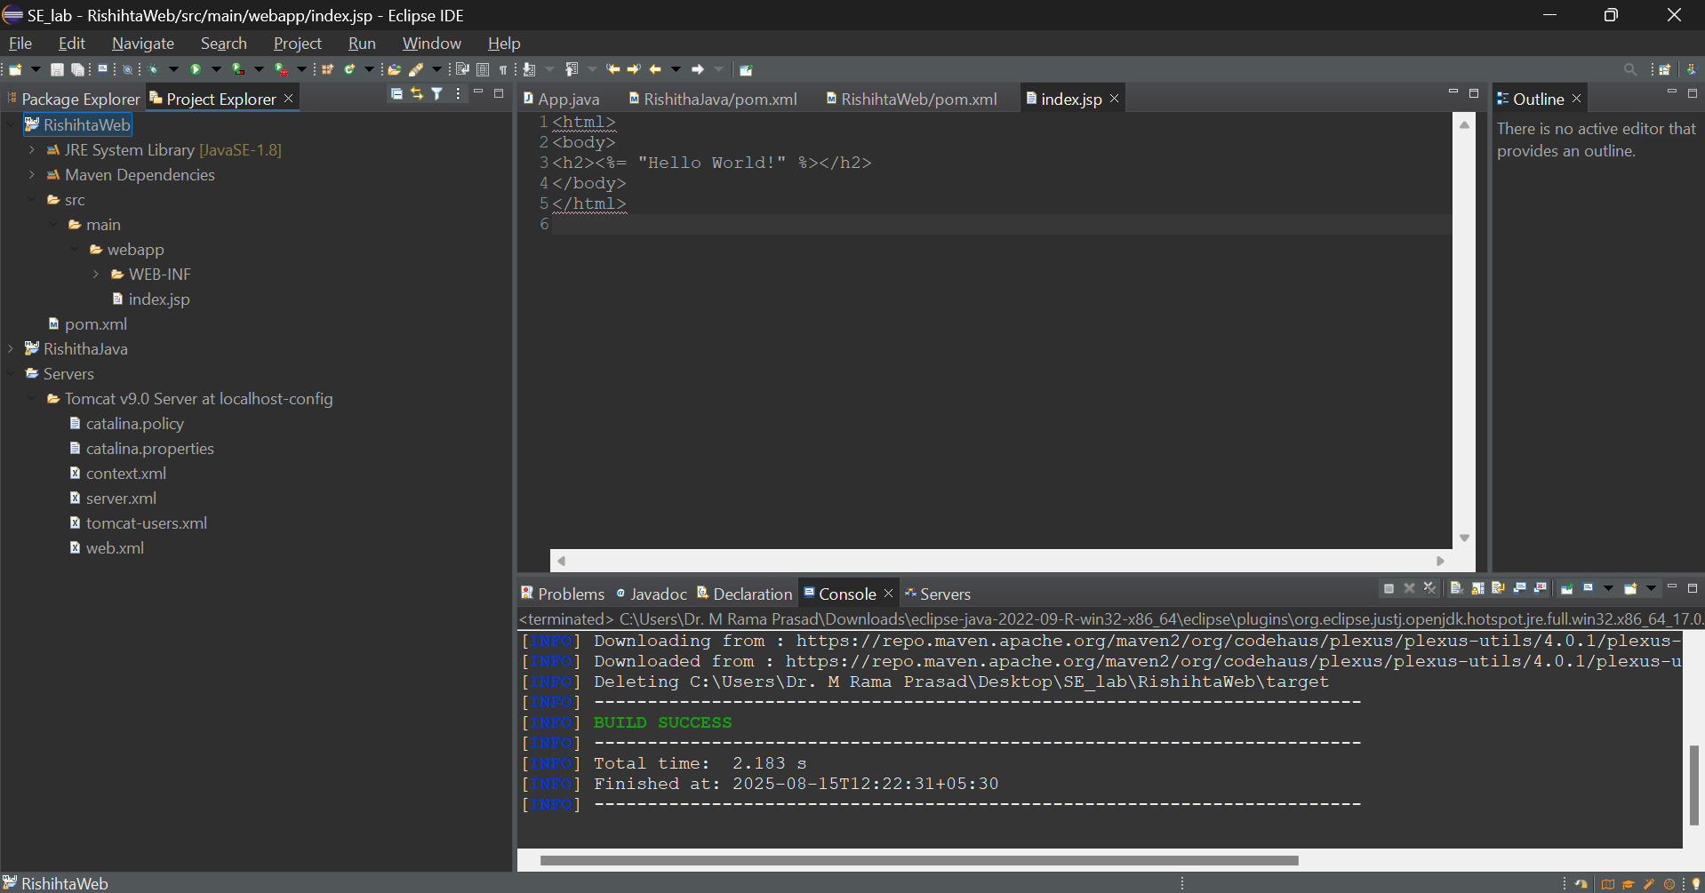
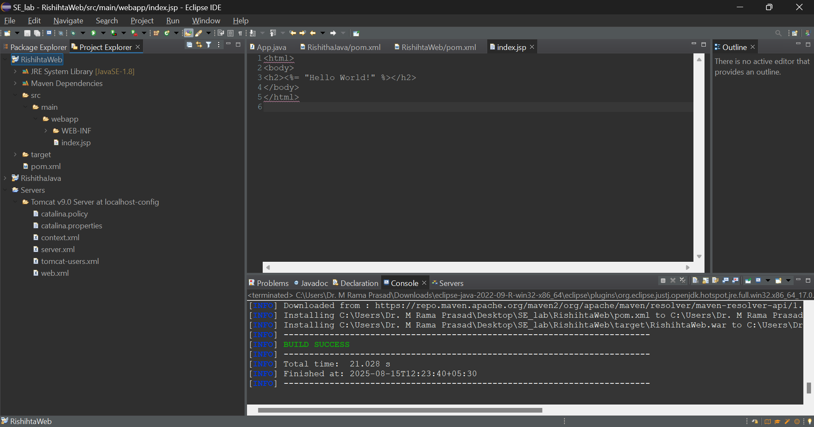
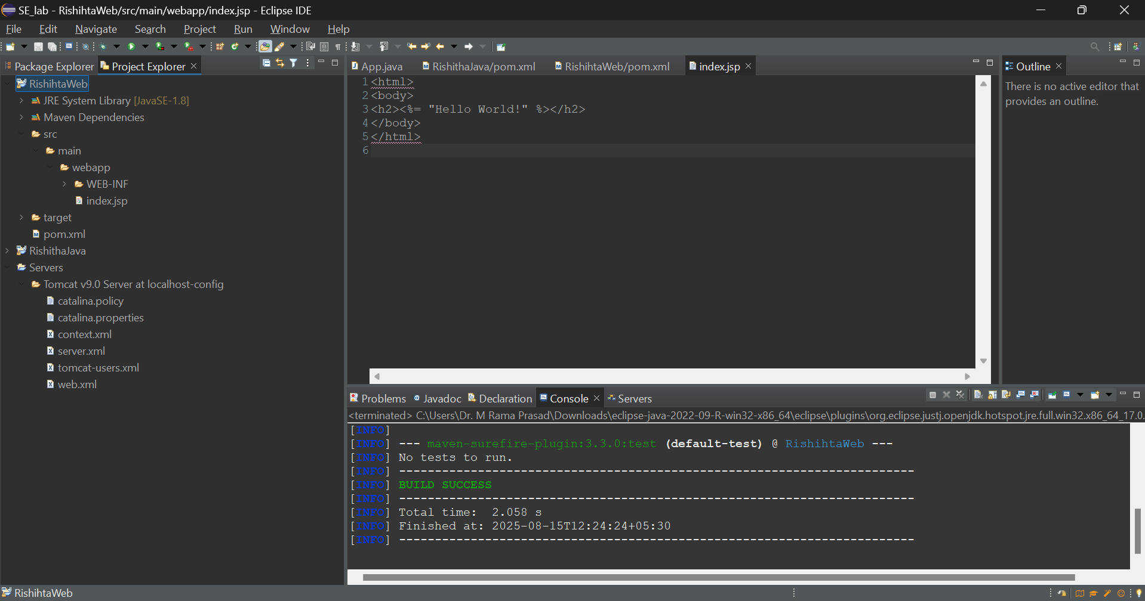
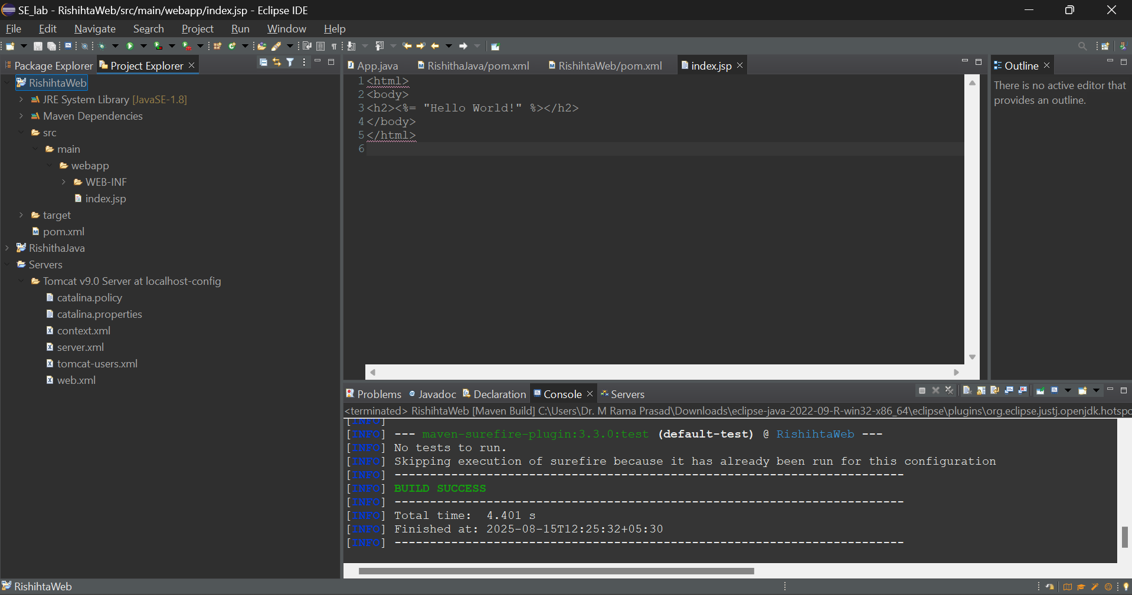
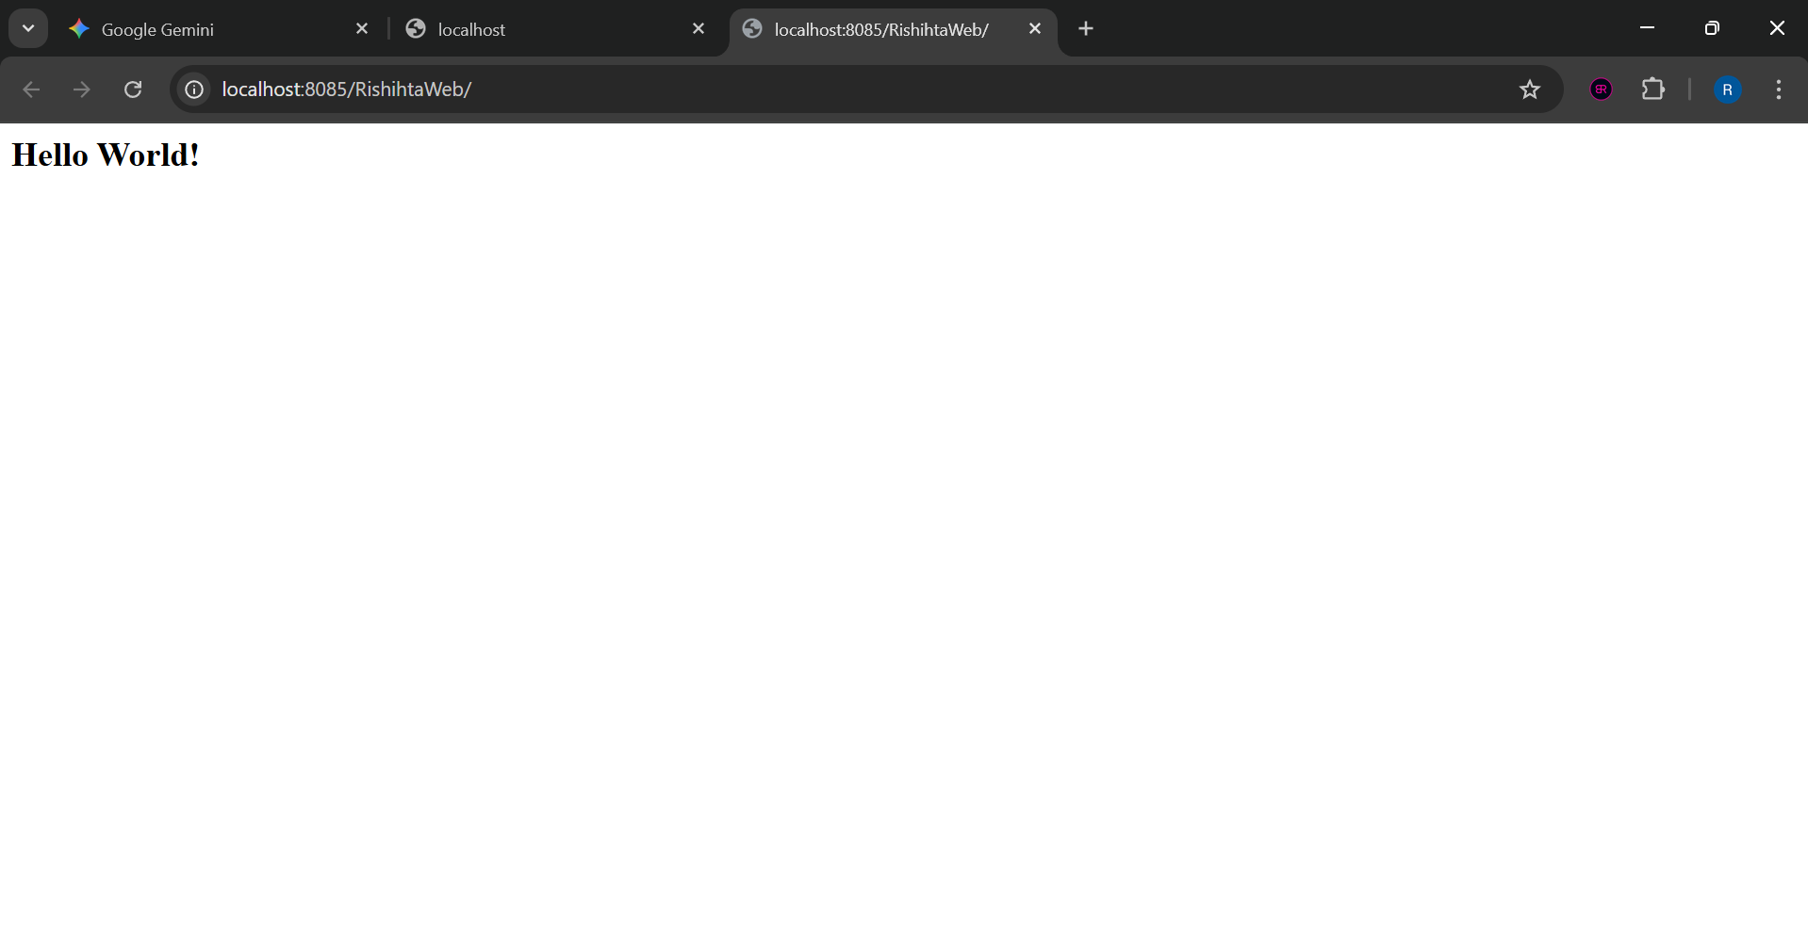
10.Scenario-Based Questions:

1. If my error is about:
Failed to execute goal org.apache.maven.plugins:maven-compiler-plugin:3.8.1:compile
[ERROR] -> [Help 1]
[ERROR] To see the full stack trace of the errors, re-run Maven with the -X switch.
How can I resolve it using maven terminal?
A)You should first rerun Maven with the -X switch to obtain the complete stack trace in order to fix a Failed to execute goal org.apache.maven.plugins:maven-compiler-plugin:3.8.1:compile error. The cause, which is frequently a compilation error in your Java code, is explained in detail here.
The issue's specific file and line of code will be displayed in the stack trace. The error should be fixed once the code has been fixed.
In Terminal -> mvn compile -X
2. A dependency you added is not recognized by the compiler. What steps would you take to confirm it is available in .m2 and listed in the dependency tree?
A)The following procedures can be used to verify whether a dependency is present in the dependency tree and in your local repository (.m2):
Verify.m2: Look for the folder structure of the dependency, which is groupId/artifactId/version, by manually navigating to your.m2/repository directory.
Check the Dependency Tree: From the root directory of your project, run mvn dependency:tree. The complete dependency tree, including all transitive dependencies and their versions, is printed by this command. After that, you can look through the output to find your particular dependency.
3. A teammate sends a .patch file for a bug fix. How would you apply it and include it in your Maven build?
A) Usually, you would use Git to apply a.patch file and include it in your Maven build.
Put the patch on:Run git apply your-teammate.patch after navigating to the directory of your project. The patch file's modifications are applied to your local code by this command.
Commit and Build: You can use mvn clean install to build your project after applying the patch and commit the changes (git commit).
4.You have multiple JUnit test failures and want to rerun only failed tests. How would you approach this?
A)To rerun only failed JUnit tests, you can use the surefire plugin's -Dsurefire.rerunFailingTests property.
In terminal ->mvn test -Dsurefire.rerunFailingTests=true
This command runs all tests first, then only the tests that failed in the first run are run
again in a different execution
5. Your Maven build fails due to “Unsupported class version error.” What plugin and configuration would you review?
Ans)You are attempting to compile or run code using a Java version that is more recent than what your compiler is set up to handle if your build fails with a "Unsupported class version error." The maven-compiler-plugin configuration in your pom.xml file needs to be reviewed.
In particular, make sure the source and target properties correspond to the version of the Java Development Kit (JDK) that you plan to use. For Java 17, for instance, the setup would be:
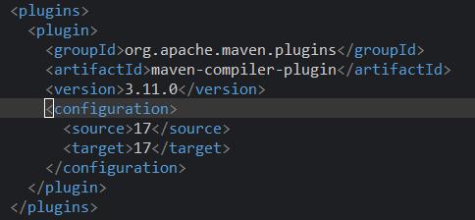
6. You need to change your Java application from a WAR to a standalone JAR. What pom.xml changes are needed?
To change a Java application from a WAR to a standalone JAR, you need to modify the packaging element in your pom.xml and configure a plugin to create an executable JAR.
Change Packaging: Update the <packaging> element from war to jar.
XML -> <packaging>jar</packaging>
Add maven-jar-plugin: Configure the maven-jar-plugin to specify the main class. This makes the JAR executable.
XML ->
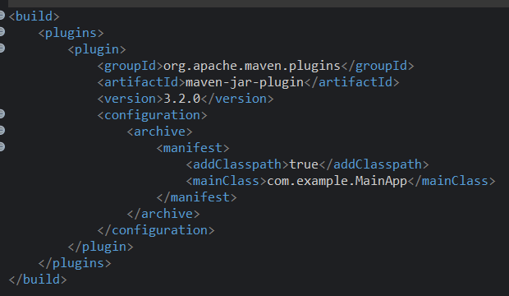
This creates a JAR file in the target directory that can be run using java -jar your-app.jar.

7. You are required to change the default build output directory from target/ to build_output/. How would you configure it?
A)To change the default build output directory from target/ to build_output/, you need to configure the build element in your pom.xml.
XML -> 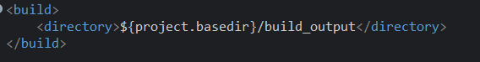
The <directory> element, within the <build> section, allows you to override the default output location for all build artifacts.
8. You want to skip tests during the Maven build. What command would you use?
A)To skip tests during a Maven build, you can use the -DskipTests command-line option.
In terminal -> mvn install -DskipTests
The surefire and failsafe plugins' test execution is entirely bypassed by this command, which runs the build lifecycle through the install stage. Using the -Dmaven.test.skip=true option, which also avoids compiling test sources, is a more popular and advised method.
9. How would you generate a site report (with test coverage, dependency analysis) for a Maven project?
A)The maven-site-plugin can be used with other reporting plugins to create a site report for a Maven project that includes test coverage and dependency analysis.
1)Add Reporting Plugins: In the section of your pom.xml file, add the maven-site-plugin and additional reporting plugins (such as the jacoco-maven-plugin for code coverage and the maven-project-info-reports-plugin for dependency analysis).
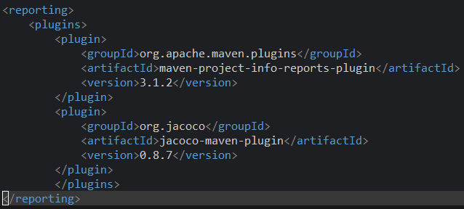
2)Run the command: Execute the following command to generate the site and all configured reports:
In Terminal - > mvn site
The generated reports will be located in the target/site directory.
10. How do you build a Java project using Maven, and what files are generated in the target/ folder after running mvn clean install?
A)The command mvn clean install is used to build a Java project using Maven.
Clean eliminates any build artifacts from the target directory.
installs the artifact into the local Maven repository (.m2) after compiling, testing, and packaging the project.
The following important files are present in the target/folder following mvn clean install:
The packaged application artifact is your-app-version.jar or.war.
classes/: Your main source code's compiled.class files (src/main/java).
test-classes/: Your test source code's compiled.class files (src/test/java).
surefire-reports/: The Surefire plugin's XML and text reports for unit tests.
maven-archiver/: The files that are used to produce the final WAR or JAR.
11. How does Maven resolve dependency conflicts when two libraries use different versions of the same dependency, and how can you view and manage the dependency tree?
A)Maven uses the "nearest definition" technique to resolve conflicts between libraries that use different versions of the same dependency. It chooses the dependency version in the dependency tree that is most similar to your project. Maven uses the dependency that shows up first in the pom.xml if two dependencies are at the same depth.
The mvn dependency:tree command can be used to view and manage the dependency tree. The output displays the complete tree, allowing you to see potential conflicts as well as the version of a dependency that is finally chosen. You can declare the most common version of the dependency in the section of your pom.xml file to explicitly manage a conflict. Maven is compelled to use that particular version everywhere as a result.
12. How do you write and run a JUnit test in a Maven project, and where are the compiled test classes and reports stored after running mvn test?
A)Writing Tests: In the src/test/java directory, write JUnit tests. Usually, the test class name should conclude with Test (MyClassTest.java, for example). @Test is used to annotate the test methods.
Executing Tests: Use the mvn test command to execute the tests. The test lifecycle phase is carried out by this command. These tests are found and executed by the maven-surefire-plugin.
Locations of Storage:
The target/test-classes/ directory contains the compiled test classes.
Test Reports: Text and XML files are kept in target/surefire-reports/.
13. How can you create an executable JAR with a main method using Maven, and which plugin helps configure this behavior?
A)You must configure the maven-jar-plugin in order to use Maven to create an executable JAR with a main method.
1)Configuring the Plugin: In the section of your pom.xml, add and configure the maven-jar-plugin.
In the <archive>'s <manifest>, specify the mainClass.
To ensure that the JAR contains a classpath pointing to its dependencies, set <addClasspath>true</addClasspath>.
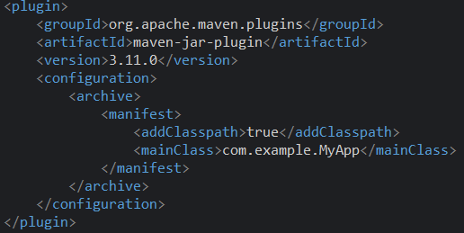
2)Building the JAR: Run mvn package to build the executable JAR, which will be created in the target/ directory.
14. How do you install and use a custom third-party JAR file in your Maven project, and how can you confirm it’s included in the build and classpath?
A)The mvn install:install-file command is used to install and utilize a custom third-party JAR in your Maven project.
1)Installation: Use the following parameters when running the command:
-Dfile: The JAR file's path.
-DartifactId, -DgroupId, -Dversion: The coordinates you wish to assign to the artifact.
-Dpackaging: Put in the jar.
In terminal ->mvn install:install-file -Dfile=/path/to/my-custom-lib.jar -DgroupId=com.example -DartifactId=my-custom-lib -Dversion=1.0 -Dpackaging=jar
2)Confirmation:
- The command installs the JAR into your local .m2 repository. You can verify its presence by checking the com/example/my-custom-lib/1.0 folder.
- Add the dependency to your pom.xml using the same coordinates.
- Run mvn dependency:tree to confirm the dependency is part of the build and classpath.

15. How do you create a Maven web project that packages into a WAR file, and what is the standard folder structure for such a project?
A)You must configure the project's packaging and adhere to a standard folder structure in order to produce a Maven web project that packages into a WAR file.
Set the element to war in pom.xml.
The maven-war-plugin manages the creation of the WAR file since it is automatically bound to the package lifecycle phase when the packaging is war.
Typical Folder Format: The following is the typical folder structure for a web project:
The Java source code is located in src/main/java.
Configuration files and additional resources are located in src/main/resources.
The important directory is src/main/webapp. It contains the web-related files.
The deployment descriptor, web.xml, and additional resources not available via the web are contained in WEB-INF/.
The location of compiled Java classes from src/main/java is WEB-INF/classes/.
WEB-INF/lib/: The location of project dependencies.
Web pages and other static content are contained in index.jsp, index.html, etc.; test classes are found in src/test/java.
16. What command do you use to build a WAR file in Maven, where is it generated, and how can you deploy it to a server like Apache Tomcat?
A)To build a WAR file, use the command mvn package.
Location
The WAR file is generated in the target/ directory.
Deployment
To deploy it to Apache Tomcat:
Manual: Copy the WAR file from target/ to Tomcat's webapps/ directory.
Automatic: Use a Maven plugin like tomcat-maven-plugin and run a command such as mvn tomcat7:deploy.
17. How do you add JSTL and servlet-api dependencies in a Maven web project, and why should the servlet API use the provided scope instead of compile?
- 1)Adding Dependencies: Add jstl and servlet-api dependencies to the <dependencies> section of your pom.xml.
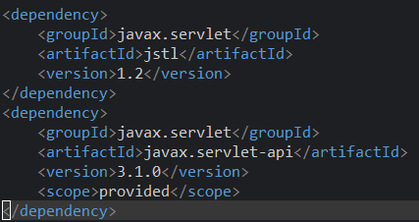
2)Why was the Servlet API scope provided? Because the web server (such as Tomcat or Jetty) already offers the Servlet API at runtime, the servlet-api dependency should make use of the scope that is supplied. Because the server also has the same classes, using the default compile scope would include the dependency in your WAR file, causing a class loading conflict. Although the dependency is not included in the final WAR, the scope provided guarantees that it is used during compilation.
18. How do you set up a multi-module Maven web project with separate modules for core logic and web interface, and how are these modules built and connected?
A)A multi-module Maven web project is structured with a parent pom.xml and separate modules for different parts of the application.
- Parent pom.xml: Create a parent pom.xml with <packaging> set to pom. It will list the modules in a <modules> section. This parent pom doesn't contain any code, just coordinates and module definitions.
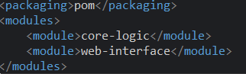
2.Core Logic Module: This module would be a standard JAR project with <packaging>jar</packaging>. It contains the business logic, services, and data access layers.
3.Web Interface Module: This module would be a WAR project with <packaging>war</packaging>. It contains the web-related files (JSPs, servlets, controllers) and declares the core logic module as a dependency.
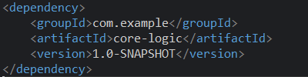
4.Building and Connecting: Building the parent project with mvn clean install will automatically build the modules in the correct order. The core-logic module is built first, its JAR is installed in the local repository, and then the web-interface module builds, using the core-logic JAR as a dependency. The final WAR file will contain the core-logic JAR inside its WEB-INF/lib folder.
19.How do you configure a Maven web project, and how do its packaging and execution differ from a traditional WAR-based application?

A)Traditional Web Project Based on WAR: Packaging: war Execution: A different application server (such as Tomcat, Jetty, or WildFly) receives the WAR file. The application is handled by the class loader on the server.
Package for the Spring Boot Web Project: jar Execution: The application code and an embedded web server (such as Tomcat) are contained in a "fat" or "uber" JAR created by the spring-boot-maven-plugin. Java -jar your-app.jar allows you to run the application directly without the need for an external application server.
Configuration: This executable JAR is created by the spring-boot-maven-plugin. The main distinction is that, unlike the conventional model, which treats the application and server as distinct entities, the application is self-contained and controls its own server.

Conclusion
Mastering Maven empowers students to structure projects efficiently, manage complex dependencies, and automate testing and packaging. By practicing real-world scenarios—such as resolving build errors, handling resource files, applying patches, and deploying to servers—students gain valuable hands-on experience aligned with professional software development workflows. Maven not only streamlines builds but also enforces standardization and reusability across projects. Through Maven, students learn efficient project management, dependency control, multi-module integration, and reproducible builds. Understanding Maven’s lifecycle, plugin system, and error handling prepares students for professional DevOps and CI/CD workflows. This lab equips students with hands-on experience in packaging, testing, resolving conflicts, and deploying real-world Java and Web applications.

