Scenario based Questions:
1.Your application is running inside Docker, but you’re not sure if the container is active.
Which command helps you check running containers?
2. You notice one of your containers is consuming high CPU and want to stop it.
How do you stop a running container named web_app?
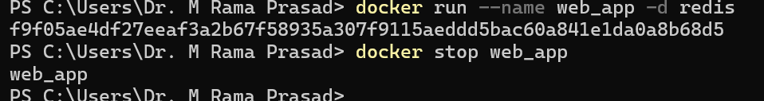
3. You’ve written a Dockerfile in your project directory and want to build an image named myapi.
What Docker CLI command do you use?
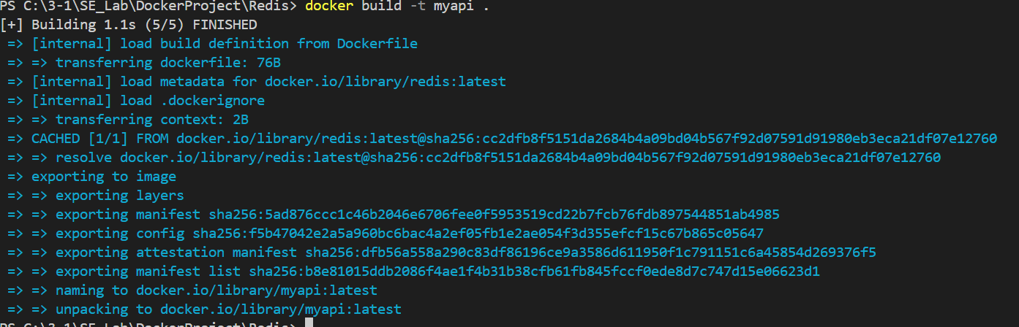
4. You want to run your web_app container and expose its internal port 5000 on host port 8080.
Which command should you use?
5. Your container is running, but you want to go inside and debug it using a shell. What CLI command helps you enter the container’s shell?
6. You’ve built a few test images and want to delete one called old_api. How would you do this?
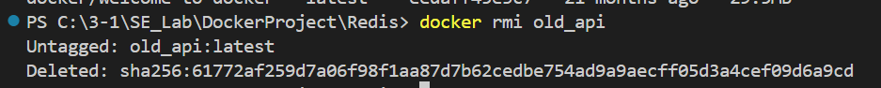
7. Your app crashed in the container. You need to check the logs. How do you check this?
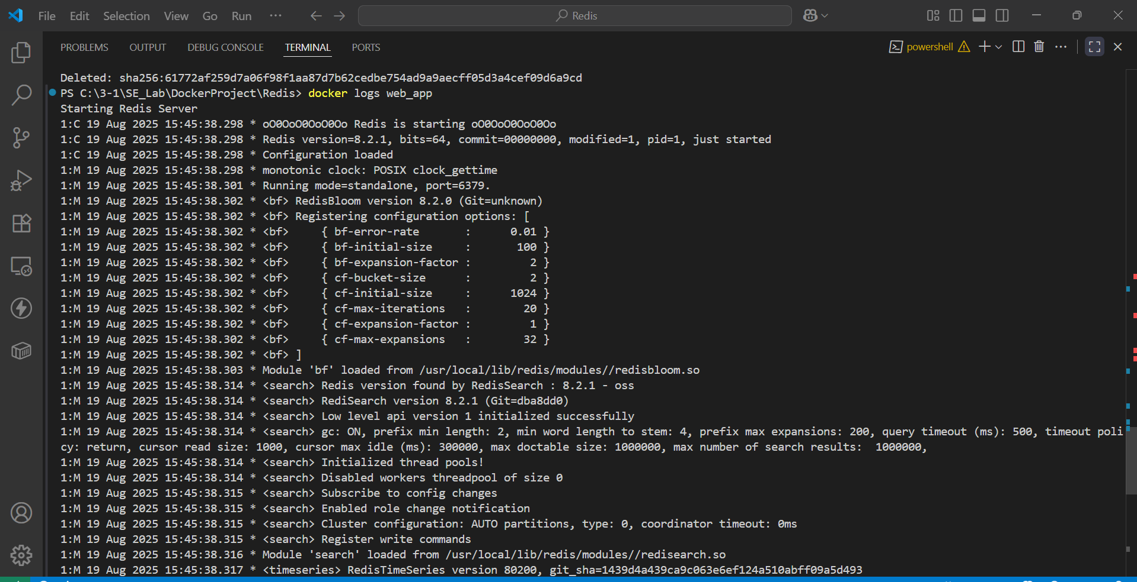8. You want to start a container and let it run in the background. Which command should you use?
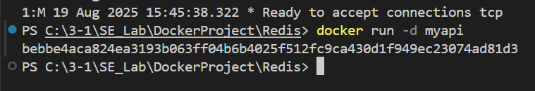
9. You're not sure which container is using port 3000. How do you check?
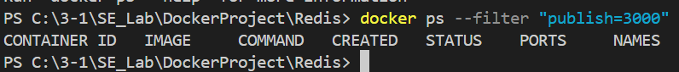
10. You built an image but forgot to tag it. How do you tag it now?
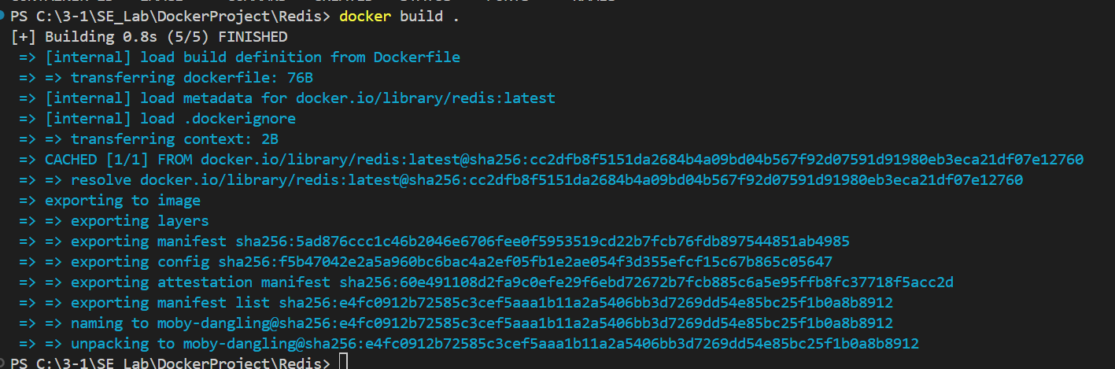
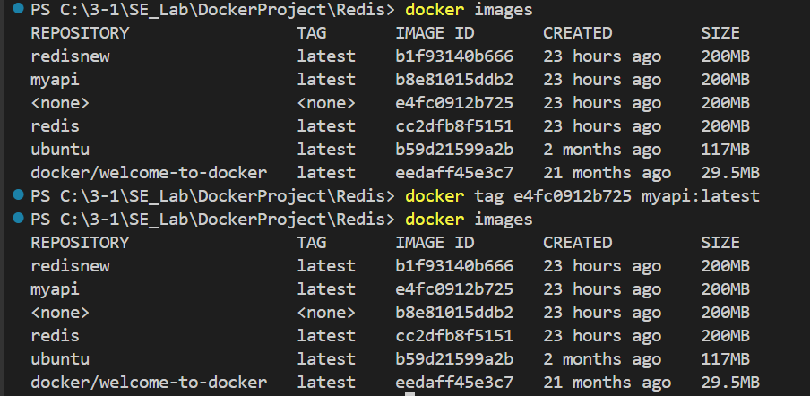
11. You want to export an image to a .tar file for offline transfer. How do you export it?
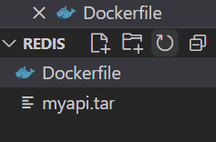
12. You want to restart a container automatically if it crashes. What Docker CLI command do you use?
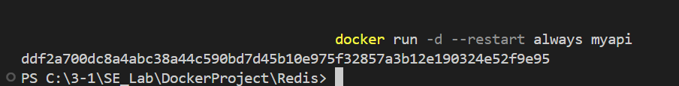
13. You want to see how much CPU/RAM each container uses. What Docker CLI command do you use? How to Control or Limit RAM in Docker? How to Measure Actual Memory Usage?
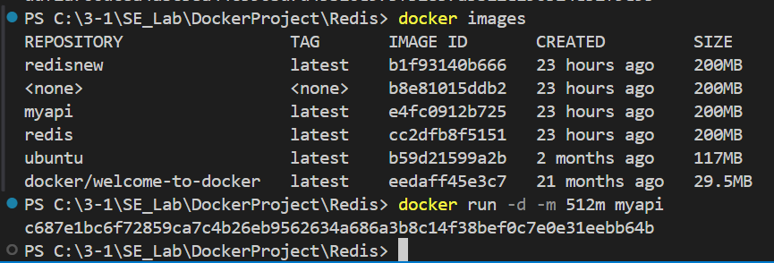
14. You want your container to run a shell command before starting the app. What do you include in docker file?
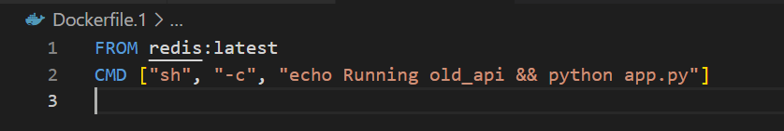
15. You want to create a custom Nginx image with your static files. What do you do?
