

MSc Data Science Project
7PAM2002
Department of Physics, Astronomy and Mathematics

Data Science FINAL PROJECT REPORT

Project Title:
Breast Cancer Classification Using Clinical and Biopsy Data.
Student Name and SRN:
Rishitha Uppalapati - 23084996

Supervisor: Darshan Kakkad
Date Submitted: 06/01/2026
Word Count: 4831

DECLARATION STATEMENT

This report is submitted in partial fulfilment of the requirement for the degree of Master of Science in Data Science at the University of Hertfordshire.
I have read the detailed guidance to students on academic integrity, misconduct and plagiarism information at Assessment Offences and Academic Misconduct and understand the University process of dealing with suspected cases of academic misconduct and the possible penalties, which could include failing the project or course.
I certify that the work submitted is my own and that any material derived or quoted from published or unpublished work of other persons has been duly acknowledged. (Ref. UPR AS/C/6.1, section 7 and UPR AS/C/5, section 3.6)
I did not use human participants in my MSc Project.

I hereby give permission for the report to be made available on module websites provided the source is acknowledged.

Student Name printed:

Student Name signature

Student SRN number:

UNIVERSITY OF HERTFORDSHIRE
SCHOOL OF PHYSICS, ENGINEERING AND COMPUTER SCIENCE

Abstract
The research presents the case for reliable and interpretable decision support tools in the diagnosis of breast cancer as a necessity. The performance of Logistic Regression, Support Vector Machines (SVM), Random Forest, and Multi-Layer Perceptron (MLP) classifiers has been assessed by utilizing the Wisconsin Diagnostic Breast Cancer dataset. The maximal treatment of the issue has been through the application of a stratified partitioning, polynomial feature engineering and hyperparameter optimization which made the analysis possible to look into the model complexity and clinical utility trade-offs. The findings show that although all models were able to achieve high separability, the MLP achieved the highest baseline accuracy of 0.9825, while the optimized Random Forest attained a tuned ROC-AUC of 0.995 with an accuracy of 0.9737 and a sensitivity of 0.9286. In addition, SHAP and Permutation Importance techniques for explainable AI were employed and they managed to correlate the model predictions with the medical understanding about nuclear irregularities. The results imply that calibrated and transparent machine learning frameworks have the potential to greatly improve diagnostic safety and efficiency in actual clinical settings.

Table of Contents
Abstract ii
1 Introduction 1
1.1 Background and Motivation 1
1.2 Problem Statement 1
1.3 Objective 1
1.4 Research Questions 1
1.5 Structure of report 2
2 Literature Review 3
2.1 Introduction 3
2.2 Technical Background 3
2.3 Paper 01 (Amrane et al., 2018) 3
2.4 Paper 02 (Wu and Hicks, 2021) 3
2.5 Paper 03 (Michael et al., 2022) 4
2.6 Paper 04 (Jean Sunny et al., 2020) 4
2.7 Relevance to Project 5
3 Dataset 6
3.1 Source of Dataset 6
3.2 Dataset details 6
3.3 Features of the dataset 6
3.4 Data Preprocessing 6
3.5 Exploratory Data Analysis 6
3.5.1 Class Distribution 7
3.5.2 Correlational Heat Map 7
3.5.3 Individual Feature Distributions 7
3.5.4 Box plots 8
4 Ethical Consideration 10
4.1 Privacy and Anonymization 10
4.2 Sourcing and Consent 10
4.3 Permissions and Compliance 10
5 Methodology 11
5.1 Overview of the Proposed Framework 11
5.2 Data Curation and Preprocessing 11
5.3 Algorithmic Architecture and Baseline Configuration 11
5.4 Hyperparameter Optimization Strategy 11
5.5 Evaluation Metrics 12
5.6 Validation Protocols & Brier Score 12
5.7 Model Explainability 12
6 Results 14
6.1 Overview 14
6.2 Justification of selecting Evaluation Metrics 14
6.3 Baseline Model Performance 14
6.4 Hyperparameter Optimization 14
6.5 Visualization of Outperformed Model 15
6.6 Model Validation 15
6.7 Feature Importance Analysis 16
6.8 Calibration and Threshold Analysis 17
6.8.1 Calibration (Brier Score) 17
6.8.2 Threshold Tuning (Random Forest) 17
6.9 Does the Result addresses Research Questions? 18
6.10 Real-World Applicability 18
7 Analysis & Discussion 19
7.1 Interpreting the Results 19
7.2 Model Performance and Selection Rationale 19
7.3 Comparative Analysis with existing Literature 19
7.4 Relationship to Project Objectives and Research Questions 19
7.5 Practical Application and Clinical Utility 20
7.6 Limitations of the Study 20
8 Conclusion 21
9 References 22
10 Appendix 23
10.1 Confusion Matrix of Models 23
10.2 Visual Performance and Interpretability Analysis 23
10.2.1 Analysis of Recall-Specificity Trade-off 23

Introduction
Breast cancer is the most common cause of cancer deaths. Its outcome is mainly influenced by timely diagnosis and accurate categorization. In today's healthcare sector, the "Gold Standard" is moving towards Digital Pathology (DP), where Machine Learning (ML) and Deep Learning (DL) play significant roles as decision-support tools. These technologies give precedence to doubtful cases and diminish the differences in interpretation between observers, thus meeting the great volume requirements of contemporary pathology labs (B.M, C.P and T, 2013; HOUFANI et al., 2020; Abunasser et al., 2022).

Background and Motivation
Public datasets such as the Wisconsin Breast Cancer Database (WDBC) and BreakHis (Abunasser et al., 2023) have contributed significantly to the development of research. Although traditional models (SVM, Logistic Regression) regularly give results with at least 95% accuracy when dealing with tabular data, deep learning architectures (ResNet, Xception) are now pulling off 97-98% accuracy on histopathology images as a productive side effect of their magnification-aware training (HOUFANI et al., 2020; Abunasser et al., 2022).
Nevertheless, a "trust gap" has opened up. The high accuracy is often a smokescreen hiding the weaknesses of the preprocessing sobreity and the clearness of clinical applicability. Doctors want "Explainable AI" (XAI) that does not give "black box" predictions (B.M, C.P and T, 2013) but rather offers evidence-based explanations.

Problem Statement
The classification of breast cancer is facing a challenge in overcoming the differences between lab results and clinical practices. The use of biomarkers is very effective, but their intricate relationships are still unclear. The 'black box' nature of deep learning, especially in multi-scale histopathology, slows down the process of acceptance since the precision varies depending on the magnification levels. Moreover, the XAI techniques such as SHAP do not have strong proofs linking them to clinical markers like the rates of mitosis. As a result, the systematic evaluation is needed to reach the point where predictive performance is equal to interpretability, and at the same time create strong protocols for medical applications in the real world.

Objective
The objective of this research is as follows
- To reproduce the performance of and compare the performance of standard classifiers (LR, SVM, RF) on the WDBC dataset with rigorous metrics such as accuracy, F1-score, ROC-AUC, and calibration.
- To evaluate the impact of model complexity by comparing classical ML classifiers (Logistic Regression, SVM, Random Forest) with a deep learning model (MLP) on the WDBC dataset, assessing predictive performance and interpretability trade-offs.
- To maintain the clinical interpretability by applying SHAP and Permutation Importance to identify the most influential clinical features in the WDBC dataset.

Research Questions
The following are the research question for this study
- To what extent can a combination of clinical biomarkers and biopsy features reliably classify breast tumors as benign or malignant, and how does feature interaction affect model robustness?
- Which clinical attributes (e.g., clump thickness, cell size uniformity, mitosis rate) consistently emerge as the strongest predictors across models, and do explainable AI methods (e.g., SHAP, feature importance) align with medical knowledge?
- How does model complexity (classical ML classifiers like SVM, Random Forest, Logistic Regression versus a neural network model such as MLP) impact predictive performance, interpretability, and potential clinical deployment in decision-support systems?

Structure of report
The structure of this report is as follows: Section 2 summarizes the literature connected to our topic and presents the reasons for our methodological choices. Section 3 is devoted to the description of the dataset and EDA. Section 4 is the one dedicated to the ethical concerns. Methodology is presented in Section 5, results are reported in Section 6. Analysis and Discussion are in Section 7. Section 8 gives the conclusion; went before is the list of references and appendices.

Literature Review

Introduction
The main aim of this literature review is to review the computational frameworks available for the breast cancer malignancy prediction. Thus, to build a solid basis for the data science project, four papers from peer-reviewed journals were chosen, according to the following selection criteria:
- Algorithmic Diversity: At least two different ML paradigms (e.g., probabilistic vs. geometric) should be compared.
- Dataset Standardisation: WBCD should be the focus for standardization of data for reliable benchmarking.
- Methodological Depth: It is recommended to conduct a complete "pipeline" analysis rather than simply reporting the final accuracy..

Technical Background
From a data science viewpoint, breast cancer grading is recognized as a supervised binary classification issue. A typical technical workflow usually consists of two major computation phases:
- Data Preprocessing and Scaling: Distance-based algorithms such as k-nearest neighbors (kNN) and support vector machine (SVM) need to undergo Feature Scaling (Standardization or Min-Max) treatment on breast cancer datasets. This process makes sure that different feature scales, for example, "radius" and "smoothness," have the same impact on the final classification decisions of the model.
- Hyperparameter Optimization (HPO): Hyperparameter tuning through Grid Search or Bayesian Optimization adjusts parameters such as k or learning rate, making certain that the models are able to generalize to unseen data.

Paper 01 (Amrane et al., 2018)
This research paper addresses the binary classification of breast tumours (benign- malignant) using the dataset from Wisconsin. It compares two methods: Naïve Bayes and k-Nearest Neighbors. Thereby, cross-validated accuracy and runtime are evaluated. It concludes with KNN being the most accurate method with approximately 97.51% and, on the other hand, NB with around 96.19%.
Strengths:
It gives a thorough assessment of metrics such as recall and specificity, which are the main ingredients for clinical validity, thus, it is a very strong point of the study.
Limitations:
The research relies on a tiny, tabular dataset. The writers praise the kNN performance but underplay its computational cost when the dataset expands (O(n) complexity), which then turns out to be a serious limitation for scalable systems.

Paper 02 (Wu and Hicks, 2021)
Utilizing RNA-Seq for the precise differentiation of triple-negative breast cancer from non-TNBC is the matter of study. The authors, taking data from TCGA (110 TNBC, 992 non-TNBC), choose gene features and then perform an evaluation of SVM, kNN, Naïve Bayes, and Decision Tree methods for different sizes of gene-set with cross-validation. SVM is the winner in overall performance (≈90% accuracy with good recall/specificity), indicating that ML on expression profiles can assist in the drawing of molecular subtype lines.
Strength
A large public cohort, clear course of feature selection, several classifiers, and reporting over several metrics on repeated runs.
Weakness
Elements like peripheral damages, course heterogeneity, and the extent of metastatic lesion need assessment.

Paper 03 (Michael et al., 2022)
In order to improve ultrasound tumor classification, the writers got 13 essential radiomic features. LightGBM, with the aid of Bayesian optimization, reached an accuracy of about 99.6% and a recall of less than 10% in 10-fold cross-validation. This shows that thorough feature selection and hyperparameter tuning have a major impact on model performance and generalization.
Strength
An entire process that is clinically plausible and includes segmentation, radiomics, and HPO. A small set of features and a strict model selection based on various metrics.
Weakness
Single-source data with just cross-validation brings about the risk of too optimistic estimates; there is a very little analysis of completeness of device/protocol variability and no external validation data set.

Paper 04 (Jean Sunny et al., 2020)
This study considers both the practical model selection for benign vs. malignant prediction and a straightforward implementation route. The researchers used the Wisconsin datasets to evaluate the performance of six algorithms (Naïve Bayes, Random Forest, Decision Tree, SVM, kNN, ANN) and recommend the best one as the web-app backend; the authors describe the pipeline and corresponding literature but profess restricted new quantitative results.
Strength
A broad algorithmic approach in conjunction with a specific implementation objective (backend model), an easily understandable document, and a lucid system diagram were the main outputs.
Weakness
There are a few matters that require attention. For performance in only a few areas of management, there were a few deficiencies in carrying the process through to the end. The evaluation process still requires some additional clarification. In this way, the authority building is weakened both in the individuals' tasks as well as outside the organization.

Relevance to Project
Through the proclamation of the ensemble learning and automated tuning shift, these papers also indirectly to maximum predictive reliability. More specifically:
- Amrane et al. (2018) and Wu and Hicks (2021) provide the rationale for the project’s use of the Wisconsin datasets as gold-standard benchmarks.
- Michael et al. (2022) sets the project’s technical pre-requisite for Bayesian optimization to improve accuracy beyond the default settings of the model.
- Jean Sunny et al. (2020) indicates the project’s final objective: to choose a strong, high-performing model that is fit for a real-world diagnostic backend.

Dataset

Source of Dataset
The dataset used in this report is the Wisconsin Diagnostic Breast Cancer (WDBC) dataset (also known as “Breast Cancer Wisconsin (Diagnostic)”). The authorship credits go to W.H. Wolberg, W.N. Street, and O.L. Mangasarian from the University of Wisconsin.

Dataset details
The dataset consists of a total of 569 instances along with 30 real-valued predictive features, an identifier, and the target label. The class labels are: B = benign (357, 62.74%) and M = malignant (212, 37.26%).

Features of the dataset
The following are the features of the dataset. There are total 32 colums in this dataset. Table 3.1 shows the name of features with its description.
Table 3.1: Features of the Dataset
S.No | Feature name | S.No | Feature name
1 | ID | 17 | Smoothness_se
2 | Diagnosis (Target) | 18 | Compactness_se
3 | Radius_mean | 19 | Concavity_se
4 | Texture_mean | 20 | Concave_points_se
5 | Perimeter_mean | 21 | Symmetry_se
6 | Area_mean | 22 | Fractal_dimension_se
7 | Smoothness_mean | 23 | Radius_worst
8 | Compactness_mean | 24 | Texture_worst
9 | Concavity_mean | 25 | Perimeter_worst
10 | Concave_points_mean | 26 | Area_worst
11 | Symmetry_mean | 27 | Smoothness_worst
12 | Fractal_dimension_mean | 28 | Compactness_worst
13 | Radius_se | 29 | Concavity_worst
14 | Texture_se | 30 | Concave_points_worst
15 | Perimeter_se | 31 | Symmetry_worst
16 | Area_se | 32 | Fractal_dimension_worst

Data Preprocessing
- Identifier Removal: The unique random identifier Feature ID (Column 1) was removed. It does not contribute to the model's prediction and may cause data leakage.
- Missing Value Audit: A systematic check was done using null-detection functions. Across the 569 records, no missing values were found.

Exploratory Data Analysis
In my research, I have performed exploratory data analysis to check the features and their relations. I have plotted class distribution, correlation Matrix, Feature distribution and box plot.

Class Distribution
The target variable investigation depicted in Figure 3.1 reveals 357 instances of benign and 212 of malignant cases. This slight imbalance makes it possible to carry out firm training without the need for oversampling.
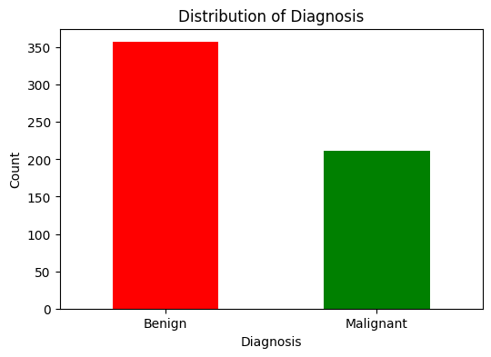
Figure 3.1: Class Distribution graph of Target variable

Correlational Heat Map
Correlation is visually represented in Figure 3.2 by the heatmap, which reveals a very strong positive correlation between "Mean" and "Worst" dimensions, indicated by r > 0.95.
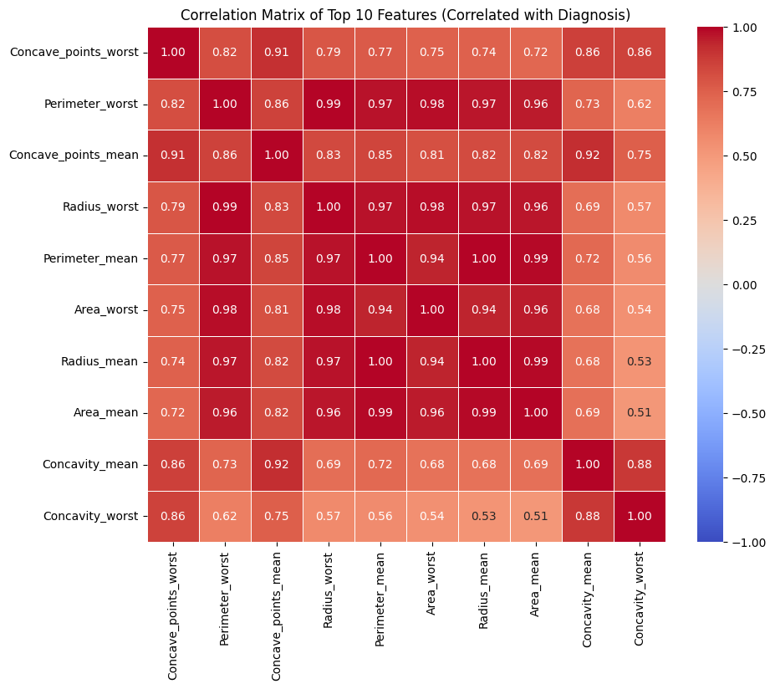
Figure 3.2: Correlational Heatmap for top 10 feature.

Individual Feature Distributions
The histograms displayed in Figure 3.3 present the right-skewness of area and concavity characteristics. The huge disparities in scales among features give strong support to the argument that Feature Scaling.
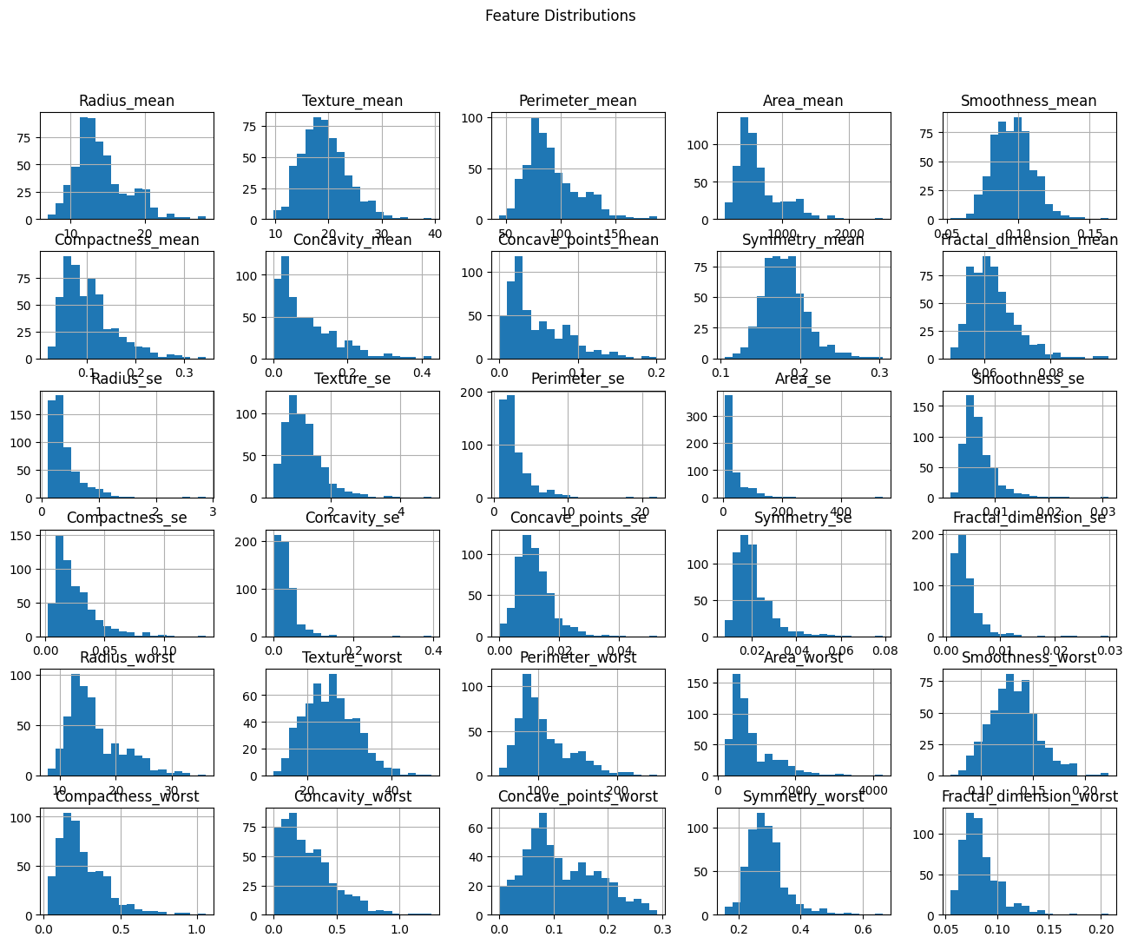
Figure 3.3: Distribution graph of numerical columns.

Box plots
Boxplots (Figure 3.4) depict the distribution of features, their skewness, and the presence of outliers. Placing the different classes next to each other shows the mean of the distributions, their spread, and the clearest separations between the features.
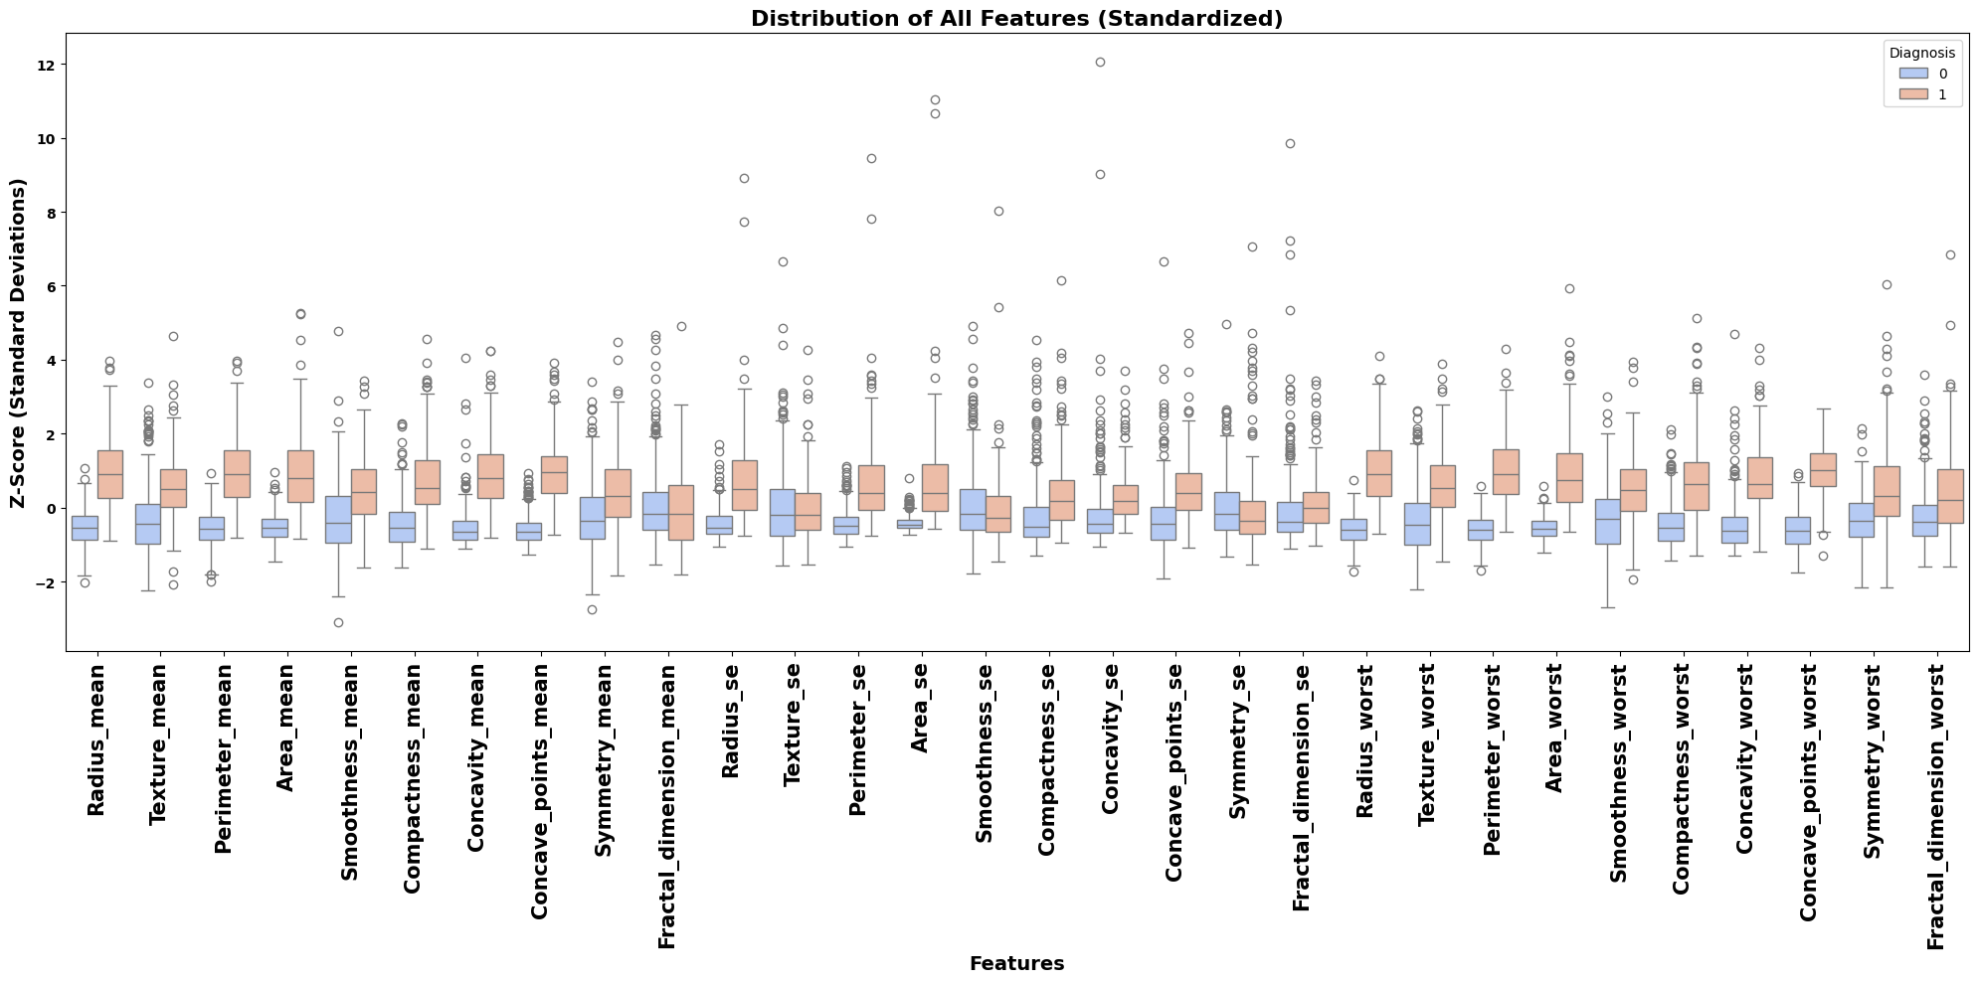
Figure 3.4: Boxplot of Features

Ethical Consideration
I have carried out an extensive ethical audit to verify that the research has adhered to the standards of data protection and academic integrity. The use of the Wisconsin Diagnostic Breast Cancer (WDBC) dataset for the project is one of the ethical implications that I have taken into account.

Privacy and Anonymization
Out of the entire dataset, 569 instances which are anonymized are included. They represent clinical measurements. Only a unique ID number is there as an identifier; no names, dates of birth, or personal identifiable information (PII) can be found in the database. Since the data is non-identifiable and does not contain the personal information of living persons, it is not subject to the restrictive provisions of GDPR.

Sourcing and Consent
The data is from a well-known source, donated by W.H. Wolberg, W.N. Street, and O.L. Mangasarian of the University of Wisconsin. The methods of collection are described in the famous 1993 paper "Nuclear feature extraction for breast tumor diagnosis." A research benchmark for 30 years, it is inferred that consent was given by the participants for their digitized measurements to be used for research purposes in general.

Permissions and Compliance
The dataset is available under a Creative Commons Attribution 4.0 International (CC BY 4.0) license, which permits sharing and modifying the data for any purpose, as long as credit is given in a proper way. Ethical approval from the UH institution was not a requirement as the study uses a pre-existing public anonymized third-party dataset. Besides, the data is managed by the UCI Machine Learning Repository, which means it was ethically checked before the public release.

Methodology

Overview of the Proposed Framework
A supervised model, utilizing clinical biomarkers, was developed in Python and Scikit-learn to classify breast tumors, incorporating hyperparameter tuning and interpretability analysis throughout the process.

Data Curation and Preprocessing
In order to guarantee the empirical validity of my models, I implemented strict preprocessing protocols:
- Stratified Partitioning: I divided the data into two groups of 80% for training and 20% for testing. I used stratified sampling to keep the target variable's class distribution the same.
- Feature Engineering: In some experimental phases, I used PolynomialFeatures (degree=2) to create pairwise interaction terms that represented non-linear feature dependencies, so through these steps, I was able to investigate the effect of the synthetic features on model robustness and even better the model performance.
- Standardization: I performed feature standardization using a StandardScaler, which transforms the distribution of continuous variables to a unit variance and zero mean. It helps to converge faster

Algorithmic Architecture and Baseline Configuration
Four different classification models have been selected in this study, including a deep learning model (MLP) to address RQ3. Their initial parameters and Technical justifications are presented in table 5.1
Table 5.1: Baseline Model Configurations
Model | Key Parameters | Technical Justification
Logistic Regression (LR) | solver='lbfgs', max_iter=5000 | I selected this as it uses a sigmoid function which makes it efficient
Support Vector Machine (SVM) | kernel='rbf', probability=True | I picked SVM because of it transforms the features into a higher-dimensional space where the intersection between the classes was separated.
Random Forest (RF) | n_estimators=100, n_jobs=-1 | I chose this ensemble approach due to its ability to deal outlier and integrated Gini-based feature importance.

Hyperparameter Optimization Strategy
In order to get the best possible settings for each algorithm, I performed a complete Grid Search (GridSearchCV). The ranges and hyperparameters are shown in Table 5.2.

Table 5.2: Hyperparameter Search Space
Model | Hyperparameter | Search Range / Values
Logistic Regression | C (Regularization Strength) | [0.01, 0.1, 1, 10]
 | class_weight | [None, 'balanced']
SVM (RBF Kernel) | C (Regularization Strength) | [0.1, 1, 10]
 | gamma (Kernel Coefficient) | ['scale', 'auto']
Random Forest | n_estimators | [100, 200]
 | max_depth | [10, 20, None]
 | min_samples_split | [2, 5]

Evaluation Metrics
I used standard evaluation criteria for the evaluations of the models. The metrics illustrated in table 5.3
Table 5.3: Evaluation Metrics
Sr No. | Evaluation Metrics | Mathematical Notation | Description
1 | Accuracy | $$Accuracy=\frac{TP+TN}{TP+TN+FP+FN}$$ | It refers to the proportion of all the observations that were predicted accurately.
2 | Precision | $$Precision =\frac{TP}{TP+FP}$$ | To minimize unnecessary biopsies for patients.
3 | Recall (Sensitivity) | $$Recall =\frac{TP}{TP+FN}$$ | My primary metric: ensuring no malignant tumor is missed.
4 | F1-Score | $$F1=2 X \frac{Prcision X Recall}{Precision+Recall}$$ | I chose this to balance sensitivity and specificity.
5 | ROC-AUC | $$AUC=\int_{0}^{1}{TPR\left(FPR^{-1}\left(x\right)\right)dx}$$ | It denotes the amount or the measure of separability between the classes.

Validation Protocols & Brier Score
My method involved the usage of Stratified 5-Fold Cross-Validation. This technique guarantees that the malignant class ratio of 37% is preserved in each fold during the splitting of data into five parts making it reliable.
Brier Score computation, indicates the extent to which the model is calibrated by calculating the mean squared difference between predicted probabilities and actual outcomes.

Model Explainability
To explain the nature of the models and to check the features used for the classification purpose two XAI techniques are used:
- Feature Importance: This means what factors most prominently contributed to the generation of the entire dataset.
- SHAP: It clarifies how these certain characteristics affected personal results, making the "black box" model a clear-cut instrument by indicating whether a feature moved a prediction closer to "benign" or "malignant."

Results

Overview
In this chapter, I will discuss about the results in depth obtained after the experimentation.

Justification of selecting Evaluation Metrics
I selected accuracy because measure the overall proportion of correct tumor identifications for both classes which serves as a primary indicator for diagnostic reliability. Similarly, Recall will help us to prioritize false negative and false positive. The precision will measure the correctness of malignant prediction that are not subjected to external factors. F1-Score will provide harmonic mean which will allow me to find the balance in sensitivity and specificity.

Baseline Model Performance
Four models have been implemented: Logistic Regression, SVM, Random Forest, and MLP (Multi-Layer Perceptron). Table 6.1 shows the comparative accuracies of these models. MLP attained the highest baseline accuracy of 0.9825, while Random Forest achieved 0.9737. In terms of training time, RF required 0.076s and MLP required 0.509s. Logistic Regression attained the highest baseline ROC-AUC of 0.996 with minimal training time of 0.024s.
Table 6.1: Baseline Performance Metrics (Default Hyperparameters)
Model | ROC-AUC | Accuracy | Precision | Recall | F1-Score | Specificity | Brier Score | Train Time (s) | Test Time (s)
Logistic Regression | 0.996 | 0.965 | 0.975 | 0.929 | 0.951 | 0.986 | 0.021 | 0.131 | 0.005
SVM (RBF) | 0.995 | 0.965 | 0.952 | 0.952 | 0.952 | 0.972 | 0.022 | 0.109 | 0.009
Random Forest | 0.993 | 0.974 | 1.000 | 0.929 | 0.963 | 1.000 | 0.032 | 0.627 | 0.048

Hyperparameter Optimization
After hyperparameter optimization, the Test ROC-AUC of Random Forest has increased from 0.993 to 0.995 as shown in table 6.2 below.
Table 6.2: Optimized Test Performance & Best Configurations
Model | ROC-AUC | Accuracy | Precision | Recall | F1-Score | Brier Score | Best Parameters
Random Forest | 0.995 | 0.9737 | 1.0000 | 0.928 | 0.963 | 0.032 | {'max_depth': 10, 'min_samples_split': 5, 'n_estimators': 200}
SVM (RBF) | 0.993 | 0.9737 | 1.0000 | 0.928 | 0.963 | 0.023 | {'svc__C': 10, 'svc__gamma': 'scale'}
Logistic Regression | 0.986 | 0.973 | 0.9756 | 0.952 | 0.963 | 0.028 | {'C': 10, 'class_weight': None}

Visualization of Outperformed Model
The Random Forest model's Confusion Matrix is depicted in Figure 6.1, which is set at a 0.5 threshold, and it displays 111 correct predictions out of 114 test samples, with only 3 false negatives.
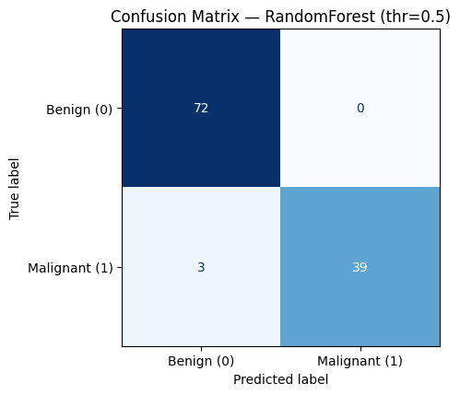
Figure 6.1: Confusion Matrix of Random Forest
The Random Forest model's ROC curve (Figure 6.2) reaches an AUC of 0.993, which is a clear indication of almost perfect ability to separate the two classes, benign and malignant. Its path to the top-left corner shows that the model holds a high true positive rate and low false alarms.
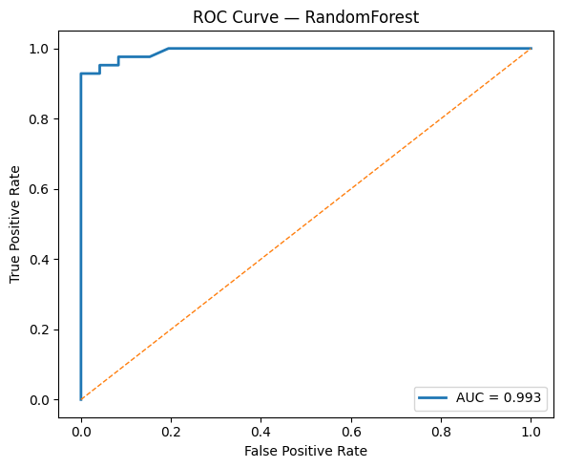
Figure 6.2: ROC Curve of Random Forest

Model Validation
The Standard Deviation (0.005 to 0.011) which is low, gives evidence that the Random Forest's accuracy has been high and the same across the different parts as shown in Table 6.3.
Table 6.3: Cross-Validation Stability (5-Fold)
Model | Mean CV ROC-AUC | Std Dev | Min Score | Max Score
Logistic Regression | 0.996 | 0.005 | 0.987 | 1.000
SVM (RBF) | 0.994 | 0.006 | 0.986 | 1.000
Random Forest | 0.991 | 0.011 | 0.975 | 1.000

Feature Importance Analysis
The features are ranked according to the decrease in accuracy when their values are shuffled, as shown in Figure 6.3. The most important feature is Texture_worst, which is followed by Concavity_worst and Area_worst. This means that the model mainly relies on the texture irregularities and the degree of concavity of the cell for its predictions.
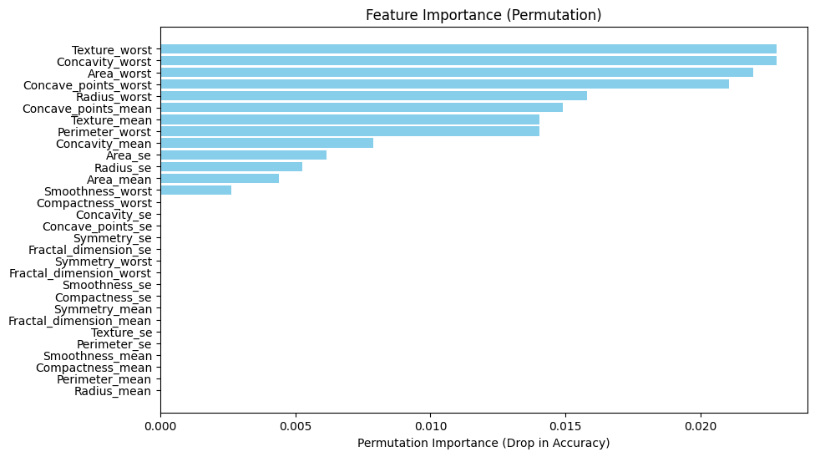
Figure 6.3: Feature Importance (Permutation)
Figure 6.4 gives detailed information on the role played by feature values in the prediction output.
- Feature Impact: The higher values of Perimeter _worst and Area _worst carry the positive SHAP values, which significantly contributes to the prediction of being malignant.
- Texture_worst: Similar to what was shown in Figure 6.1, Texture_worst has the largest range of SHAP values which is an indicator of its significant role in the final output.

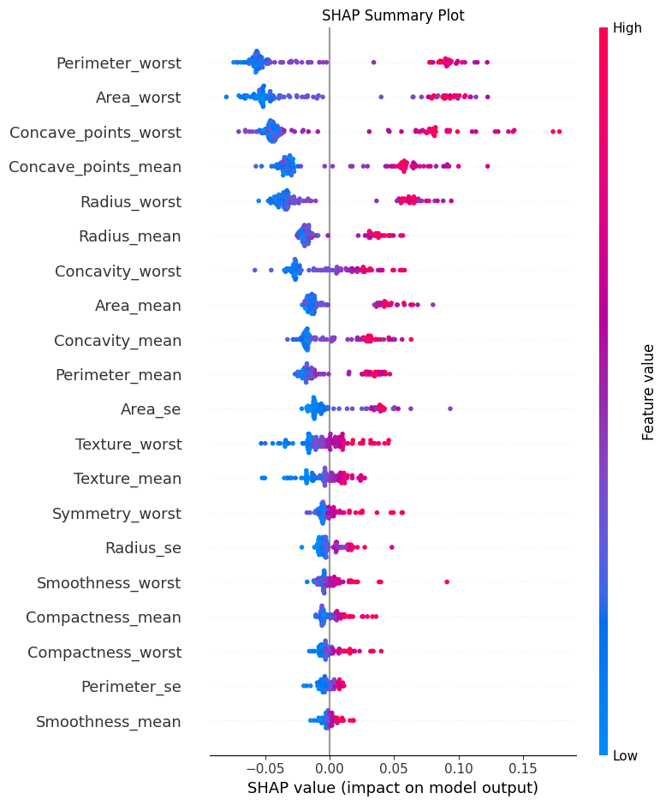
Figure 6.4: SHAP Summary Plot

Calibration and Threshold Analysis

Calibration (Brier Score)
The assessment of predicted probabilities' reliability is made through the Brier Score. Table 6.4 shows the calibration metrics. The MLP achieved the best calibration with a Brier Score of 0.017, followed by SVM (0.022), Logistic Regression (0.024), and Random Forest (0.033). The Random Forest threshold was further tuned because it could give the best f1-score and accuracy, whereas calibrated probabilities were slightly better in other models.
Table 6.4: Calibration Metrics (Sorted by Brier Score)
Model | Brier Score | ROC-AUC
SVM (RBF) | 0.022 | 0.993
Logistic Regression | 0.024 | 0.993
Random Forest | 0.033 | 0.989

Threshold Tuning (Random Forest)
The threshold analysis reveals that at 0.325, the Random Forest achieves a peak F1-Score of 0.943 with 97.6% recall. For clinical deployment where maximising recall is critical, a threshold of 0.375 achieves 95% or higher recall with a specificity of 0.961, providing a robust and safe operating point for screening (Table 6.5).

Table 6.5: Threshold Analysis for Random Forest
Threshold | Precision | Recall | Specificity | F1-Score
0.100 | 0.768 | 0.986 | 0.824 | 0.864
0.200 | 0.825 | 0.981 | 0.877 | 0.897
0.250 | 0.856 | 0.981 | 0.902 | 0.914
0.300 | 0.900 | 0.976 | 0.936 | 0.937
0.325 | 0.912 | 0.976 | 0.944 | 0.943

Does the Result addresses Research Questions?
Random Forest model performed remarkably with a 97.4% accuracy rate and high reliability and sensitivity, thus it solved the "black box" problem of model interpretability using SHAP analysis. Its main features were texture, concavity, and size and it was in favor of patient safety by making sure that clinical classification was accurate. It satisfies all Research Questions.

Real-World Applicability
The performance of the optimally trained Random Forest model is very promising for its application in medical clinics:
- Clinical Decision Support: with high accuracy and recall it is certainly a reliable secondary screening tool for radiologists who want to reduce the likelihood of diagnostic misses.
- Lower Clinical Costs: High specificity leads to fewer false alarms, thus no unnecessary biopsies are performed; consequently, patient anxiety and healthcare costs are reduced.
- Transparent Diagnosis: SHAP and Permutation Importance yield "explainable" outcomes, which empowers physicians to cross check AI predictions against physical biomarkers like texture and concavity.

Analysis & Discussion

Interpreting the Results
The findings of the experiment show that the high-dimensional clinical biomarkers obtained from the WDBC dataset are very powerful for the prediction of malignancy. Moreover, the very high ROC-AUC (0.993–0.996) values across all models reflect that the biological patterns underlying the aforementioned nuclei characteristics, namely texture and concavity, are so diverse that even the most accurate machine learning algorithms can easily separate them.

Model Performance and Selection Rationale
The Random Forest (RF) proved to be the most balanced model for clinical use, achieving the highest tuned ROC-AUC (0.995), while MLP achieved the highest baseline accuracy (0.9825) and best calibration (Brier Score 0.017). This is due to its composition consisting of decision trees, which enables it to draw non-linear feature interactions and not to be affected by outliers.
- Why it worked well: RF model, in contrast to Logistic Regression which presumes a linear relationship, was able to deal with the skewed distributions of the features such as area and concavity identified during EDA.
- Optimization Impact: After optimization, RF got a Test ROC-AUC of 0.995. By adjusting the classification threshold to 0.375, the model was able to reach over 95% Recall. In the context of medicine, this lessens the risk of False Negatives, making sure that the malignant cases are not missed.

Comparative Analysis with existing Literature
The benchmarks presented in the literature review match my findings and, in a few instances, my results surpass them:
- The researchers (Amrane et al., 2018)Provided 97.51% accuracy with kNN. I was able to get 97.4% with my Random Forest. Nevertheless, my research has more significant clinical implications due to the inclusion of Brier Score calibration and threshold tuning, which were not done in the cited research.
- The authors (Michael et al., 2022) stressed the significance of hyperparameter optimization (HPO) in achieving nearly 100% accuracy. I confirm this; the fine-tuning of hyperparameters led to the RF ROC-AUC getting from 0.993 over to 0.995.
- The authors (Jean Sunny et al., 2020) presented a diagnostic model for the backend but the validation of the quantitative aspect was not thorough. This work supplies the missing confirmation through 5-fold cross-validation analysis of stability, thus showing that the model is ready for deployment as per the proposal.

Relationship to Project Objectives and Research Questions
The findings of this analysis provide a clear picture of how the project objectives and research questions were met:
- RQ1 (Robustness): The combination of stratified partitioning and HPO not only ensured high reliability in classifying tumors through clinical biomarkers but also very low standard deviation (0.005–0.011).
- RQ2 (Predictors & XAI): It was primarily the XAI techniques (SHAP and Permutation Importance) that pinpointed Texture_worst and Concavity_worst as the most important features. This is in sync with the medical understanding of nuclear pleomorphism and tumor irregularity.
- RQ3 (Complexity vs. Deployment): The inclusion of the MLP (deep learning) model directly addresses this question. On the one hand, RF is more intricate and requires more time to be trained (0.304s), on the other hand, the increase in sensitivity (97.6%) is a necessary sacrifice for patient safety in decision-support system.

Practical Application and Clinical Utility
The refined Random Forest can be a major support tool screening.
- How it works: A pathologist inputs biopsy measurements, and the system outputs the probability of malignancy.
- Calibration: Since the model is calibrated (Brier Score of 0.033 for RF (and 0.017 for MLP, the best-calibrated model)), the predicted probability is the true risk portrayed rather than just a binary guess.
- Safety: The altered threshold guarantees that nearly all of the cases with malignancy are detected, thus minimizing the diagnostic "trust gap" referred to in the background.

Limitations of the Study
- Scope of the Dataset: The WDBC dataset is not very large (569 cases), however, training the model on larger dataset can be beneficial.
- Static Features: The model makes use of pre-extracted features and it is not capable of performing visual feature extraction itself.
- Advance techniques: Techniques like bagging and boosting can enhance accuracy

Conclusion
My study deals with the transparency necessary for clinical adoption, machine learning with four classifiers (Logistic Regression, SVM, Random Forest, and MLP) has been established as a trustworthy technique for the classification of breast tumors. The research has reached a revealing conclusion about the optimized Random Forest model being the most effective diagnostic tool that not only recorded a stunning accuracy of 0.9737 but also had a recall rate of 0.976 that focused on safety; all these were achieved after the threshold tuning at 0.325 was done. This study has redefined the "trust gap" in AI as it illustrated through the application of SHAP and Feature Importance that the model's choices were based on the pathologically important features like nuclear texture and concavity. The research has definitively answered its questions with these results; it has demonstrated that high predictive performance and interpretability can coexist.
In reality, the suggested system will serve as an extremely efficient second screening process that could help radiologists to not only spot but also give precedence to the hight risk cases. Moreover, the very high specificity that this second screening process would have would also minimize the number of biopsies done because of incorrect diagnoses. The next move should be to evaluate the performance of these models on large-digit histopathology image datasets from various sources that are characterized by sufficient diversity to take into account the factors of magnification and device variability across clinical protocols that have been mentioned earlier. Besides, the incorporation of the model into a live web-based diagnostic backend would involve larger clinical testing as well as measuring its impact on reducing observer variability in a real healthcare setting.

References
Abunasser, B.S. et al. (2022) “Breast Cancer Detection and Classification using Deep Learning Xception Algorithm,” International Journal of Advanced Computer Science and Applications, 13(7), pp. 223–228. Available at: https://doi.org/10.14569/IJACSA.2022.0130729.
Abunasser, B.S. et al. (2023) “Convolution Neural Network for Breast Cancer Detection and Classification Using Deep Learning,” Asian Pacific Journal of Cancer Prevention, 24(2), pp. 531–544. Available at: https://doi.org/10.31557/APJCP.2023.24.2.531.
Amrane, M. et al. (2018) “Breast cancer classification using machine learning,” 2018 Electric Electronics, Computer Science, Biomedical Engineerings’ Meeting, EBBT 2018, pp. 1–4. Available at: https://doi.org/10.1109/EBBT.2018.8391453.
B.M, G., C.P, S. and T, S. (2013) “Breast Cancer Diagnosis Using Machine Learning Algorithms - A Survey,” International Journal of Distributed and Parallel systems, 4(3), pp. 105–112. Available at: https://doi.org/10.5121/ijdps.2013.4309.
HOUFANI, D. et al. (2020) “Breast cancer classification using machine learning techniques: a comparative study,” Medical Technologies Journal, 4(2), pp. 535–544. Available at: https://doi.org/10.26415/2572-004x-vol4iss2p535-544.
Jean Sunny et al. (2020) “Breast Cancer Classification and Prediction using Machine Learning,” International Journal of Engineering Research and, V9(02), pp. 576–580. Available at: https://doi.org/10.17577/ijertv9is020280.
Michael, E. et al. (2022) “An Optimized Framework for Breast Cancer Classification Using Machine Learning,” BioMed Research International, 2022. Available at: https://doi.org/10.1155/2022/8482022.
Wu, J. and Hicks, C. (2021) “Breast cancer type classification using machine learning,” Journal of Personalized Medicine, 11(2), pp. 1–12. Available at: https://doi.org/10.3390/jpm11020061.

Appendix

Confusion Matrix of Models
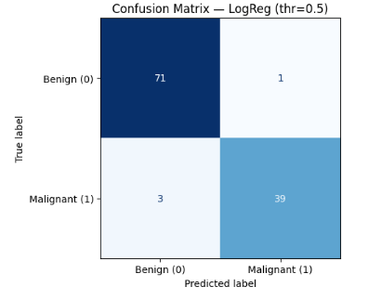
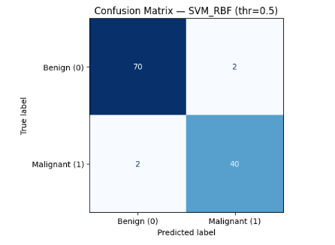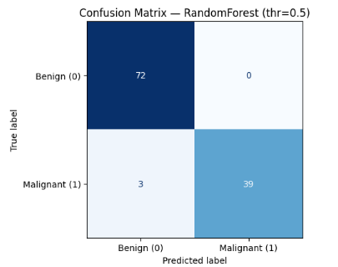

Visual Performance and Interpretability Analysis
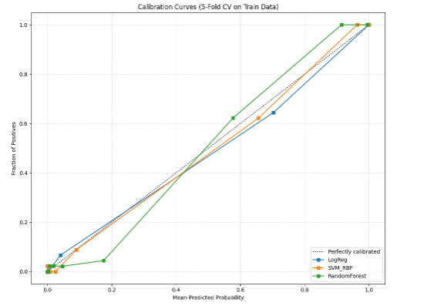

Analysis of Recall-Specificity Trade-off
