SR UNIVERSITY
School of Computer Science and Artificial Intelligence

PROJECT REPORT
E-COMMERCE CUSTOMER BEHAVIOUR
ANALYTICS DASHBOARD
Data Analytics and Visualization

Submitted by
KODHATI RISHITHA — 2503A52959
DARAVATH HUTHA SRI — 2503A52953
KAVYA ANKATHI — 2503A52938

Course: Data Analytics and Visualization (25CAI202PC201)
Academic Year: 2026–27

Submitted to SR University in partial fulfilment of the academic project requirements.

SR UNIVERSITY
School of Computer Science and Artificial Intelligence

CERTIFICATE
This is to certify that the project report entitled “E-COMMERCE CUSTOMER BEHAVIOUR ANALYTICS DASHBOARD” is a bonafide record of work carried out by the following students in partial fulfilment of the requirements for the course Data Analytics and Visualization (25CAI202PC201) at the School of Computer Science and Artificial Intelligence, SR University, Warangal, during the academic year 2026–27, under my supervision.
Student Name | Roll Number
KODHATI RISHITHA | 2503A52959
DARAVATH HUTHA SRI | 2503A52953
KAVYA ANKATHI | 2503A52938

The work presented in this report is based on the Online Shoppers Purchasing Intention dataset and the analysis performed for this project. The report does not claim predictive modelling or causal conclusions.
______________________________
Faculty Signature
Name of Faculty: ______________________________
Date: __________________ Place: Warangal

TABLE OF CONTENTS
Section | Reference page*
1. PROJECT GOAL | 1
2. DATA OVERVIEW | 2
3. DATA CLEANING PROCESS | 3
4. DATA ANALYSIS | 4
5. VISUALISATION | 5
6. FINAL CONCLUSION | 6
7. FUTURE OUTCOMES AND LIMITATIONS | 7
APPENDIX A: CODE AND PROJECT LINKS | 8
APPENDIX B: SCREENSHOTS AND EVIDENCE | 9
SUBMISSION CHECKLIST | 10

*Page references are indicative. Update them after adding screenshots or making final layout changes.

1. PROJECT GOAL

1.1 Problem Statement
E-commerce websites receive large numbers of visitor sessions. However, not every session results in a purchase. Understanding how visitors browse a website, which visitor groups convert more often, how engagement differs, and how purchase activity changes over time can help businesses evaluate their online customer experience.
The E-Commerce Customer Behaviour Analytics Dashboard uses the Online Shoppers Purchasing Intention dataset to examine session-level browsing behaviour and purchase outcomes. The project applies data cleaning, exploratory analysis and visualisation to turn the dataset into understandable summaries that can support evidence-based business decisions.

1.2 Objectives
- Collect and organize the Online Shoppers Purchasing Intention dataset in a structured format.
- Inspect the dataset and understand its columns, dimensions and data quality.
- Clean and preprocess the data for reliable analysis.
- Analyse purchase and non-purchase sessions and calculate the overall conversion rate.
- Compare conversion behaviour across visitor types, months and weekend/weekday sessions.
- Examine website engagement indicators such as product-related browsing duration, bounce rate, exit rate and page values.
- Create visualisations and prepare an interactive dashboard design for exploring customer behaviour.
- Communicate findings and practical recommendations without making unsupported causal or predictive claims.

1.3 Questions Addressed by the Analysis
- What proportion of recorded sessions resulted in a purchase?
- How does conversion rate differ among new, returning and other visitor types?
- How does purchase conversion vary across the recorded months?
- Is the observed conversion rate different for weekend and weekday sessions?
- What do product-related browsing duration and other engagement indicators show about visitor sessions?
- How can visual summaries help a business review online shopping behaviour?

2. DATA OVERVIEW

2.1 Data Source
The project uses the Online Shoppers Purchasing Intention dataset, a dataset containing session-level information about visitors to an online shopping website and whether a session resulted in revenue.
Dataset name: Online Shoppers Purchasing Intention
Dataset file used: online_shoppers_intention 2.csv
Dataset provider/source URL: [Insert the original Kaggle dataset URL used by the team]
Date accessed: [Enter actual date accessed]

2.2 Dataset Size and Coverage
Measure | Raw dataset | Cleaned dataset
Number of rows | 12,330 | 12,205
Number of columns | 18 | 18
Missing values | 0 | [Confirm from cleaning output]

The cleaned dataset contains 12,205 session records and 18 columns. The cleaning workflow reduced the row count by 125. The exact reason for each removed row should be confirmed from the executed cleaning script/output before final submission.

2.3 Important Variables and Data Types
Variable / Column | Data type | Description
Administrative | Numeric | Number of administrative pages visited.
Administrative_Duration | Numeric | Time spent on administrative pages.
Informational | Numeric | Number of informational pages visited.
Informational_Duration | Numeric | Time spent on informational pages.
ProductRelated | Numeric | Number of product-related pages visited.
ProductRelated_Duration | Numeric | Time spent on product-related pages.
BounceRates / ExitRates | Numeric | Session-level bounce and exit rate indicators.
PageValues | Numeric | Page-value measure associated with the session.
SpecialDay | Numeric | Proximity indicator for special days.
Month | Categorical | Month associated with the session.
OperatingSystems / Browser | Categorical or coded numeric | Operating system and browser identifiers.
Region / TrafficType | Categorical or coded numeric | Region and traffic-source type identifiers.
VisitorType | Categorical | Visitor classification, such as new or returning.
Weekend | Boolean | Whether the session occurred on a weekend.
Revenue | Boolean | Whether the session resulted in a purchase.

2.4 Target or Outcome Variable
Revenue is the outcome field used for purchase analysis. A value of True represents a session with a purchase, while False represents a session without a purchase. The project is descriptive and exploratory; it does not train or evaluate a machine-learning prediction model.

2.5 Sample of Raw Data
[Insert a screenshot showing 5–10 rows of the original CSV with column headings visible.]

3. DATA CLEANING PROCESS
Data cleaning was performed before analysis so that the session records could be inspected and summarized consistently. The project uses Python and Pandas for data preparation and analysis.

3.1 Cleaning Workflow
- Load the original CSV file from the project data folder.
- Inspect the dataset dimensions, column names, data types and missing-value counts.
- Apply the cleaning operations implemented in data_cleaning.py.
- Save the processed dataset as data/clean_dataset.csv.
- Use the cleaned CSV as the input for the analysis and visualisation scripts.

3.2 Data Quality Summary
Measure | Before cleaning | After cleaning
Rows | 12,330 | 12,205
Columns | 18 | 18
Rows removed | — | 125
Missing values | 0 | [Confirm after cleaning]

3.3 Notes on Cleaning Decisions
The observed row-count difference is 125 records. The precise cleaning reason (for example, duplicate removal or another filter) must be stated according to the actual implementation in data_cleaning.py. Do not describe all 125 records as duplicates unless the script confirms that.
Data types, outlier handling, category normalization and any feature transformations should be documented here only if they were performed by the submitted script. No unsupported imputation or outlier-removal procedure is claimed in this report.

3.4 Output of Cleaning
The cleaned output file is data/clean_dataset.csv. It contains 12,205 rows and 18 columns and is used by data_analysis.py and Data_visualisation.py.
[Insert a screenshot of the cleaning script execution and a preview of clean_dataset.csv.]

4. DATA ANALYSIS
The analysis summarizes purchase outcomes and compares conversion behaviour across visitor categories, months and day types. The values below are taken from the executed project analysis output.

4.1 Dataset and Purchase Summary
Metric | Result
Total sessions in cleaned dataset | 12,205
Purchase sessions | 1,908
Non-purchase sessions | 10,297
Overall conversion rate | 15.63%
Average ProductRelated_Duration | 1,206.98 seconds

Conversion rate is calculated as purchase sessions divided by total sessions, multiplied by 100.

4.2 Visitor Type Analysis
Visitor type | Total sessions | Purchases | Conversion rate
New_Visitor | 1,693 | 422 | 24.93%
Other | 81 | 16 | 19.75%
Returning_Visitor | 10,431 | 1,470 | 14.09%

Returning visitors account for the largest number of sessions and purchases. New visitors have the highest conversion rate among the listed visitor groups. This is a comparison in the dataset and does not establish why the groups behave differently.

4.3 Monthly Purchase Analysis
Month | Sessions | Purchases | Conversion rate
February | 181 | 3 | 1.66%
March | 1,860 | 192 | 10.32%
May | 3,329 | 365 | 10.96%
June | 285 | 29 | 10.18%
July | 432 | 66 | 15.28%
August | 433 | 76 | 17.55%
September | 448 | 86 | 19.20%
October | 549 | 115 | 20.95%
November | 2,982 | 760 | 25.49%
December | 1,706 | 216 | 12.66%

November has the highest monthly conversion rate in the reported results (25.49%), while February has the lowest (1.66%). The number of sessions varies substantially by month, so conversion rate and session volume should be considered separately.

4.4 Weekend vs Weekday Analysis
Session type | Total sessions | Purchases | Conversion rate
Weekday | 9,346 | 1,409 | 15.08%
Weekend | 2,859 | 499 | 17.45%

Weekend sessions show a conversion rate of 17.45%, compared with 15.08% for weekday sessions in this dataset. This is an observed difference and should not be interpreted as proof that weekends cause higher purchases.

4.5 Website Engagement
Engagement indicator | Average
Administrative_Duration | 81.65
Informational_Duration | 34.83
ProductRelated_Duration | 1,206.98
BounceRates | 0.02
ExitRates | 0.04
PageValues | 5.95

The average product-related browsing duration is 1,206.98 seconds, which is the largest of the reported average duration measures. The engagement indicators describe session behaviour and should be interpreted in the context of their definitions and units.

4.6 Key Findings
- The cleaned dataset contains 12,205 sessions, of which 1,908 resulted in a purchase; the overall conversion rate is 15.63%.
- New visitors have the highest conversion rate (24.93%), while returning visitors contribute the largest session and purchase counts.
- November records the highest monthly conversion rate (25.49%) among the months shown; February records the lowest (1.66%).
- Weekend sessions have a higher observed conversion rate (17.45%) than weekday sessions (15.08%).
- Average product-related browsing duration is 1,206.98 seconds.

5. VISUALISATION
The project uses Plotly to create interactive HTML visualisations from the cleaned dataset. The generated files are stored in data/visualisation_outputs. Each visual should be accompanied by a title, clear labels and a short interpretation.

Figure 5.1: Purchase Distribution
Chart type: Pie / doughnut chart. Suggested fields: Revenue category and session count.
Caption: Compares purchase and non-purchase sessions. The analysis reports 1,908 purchase sessions and 10,297 non-purchase sessions, corresponding to a 15.63% conversion rate.
Conclusion: Compares purchase and non-purchase sessions. The analysis reports 1,908 purchase sessions and 10,297 non-purchase sessions, corresponding to a 15.63% conversion rate.

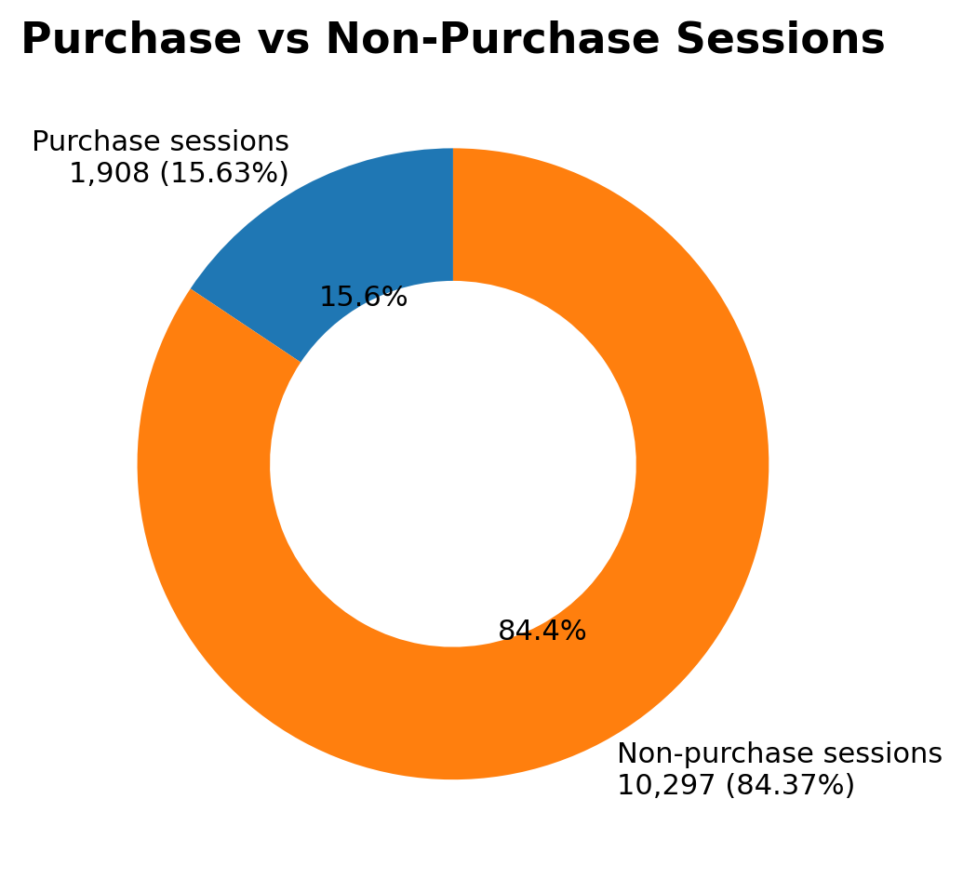
Source: Project analysis results calculated from the cleaned Online Shoppers Purchasing Intention dataset.

Figure 5.2: Conversion Rate by Visitor Type
Chart type: Bar / column chart. X-axis: VisitorType; Y-axis: Conversion rate.
Caption: New visitors show a 24.93% conversion rate, compared with 19.75% for Other and 14.09% for returning visitors. The chart highlights differences between visitor groups.
Conclusion: New visitors show a 24.93% conversion rate, compared with 19.75% for Other and 14.09% for returning visitors. The chart highlights differences between visitor groups.

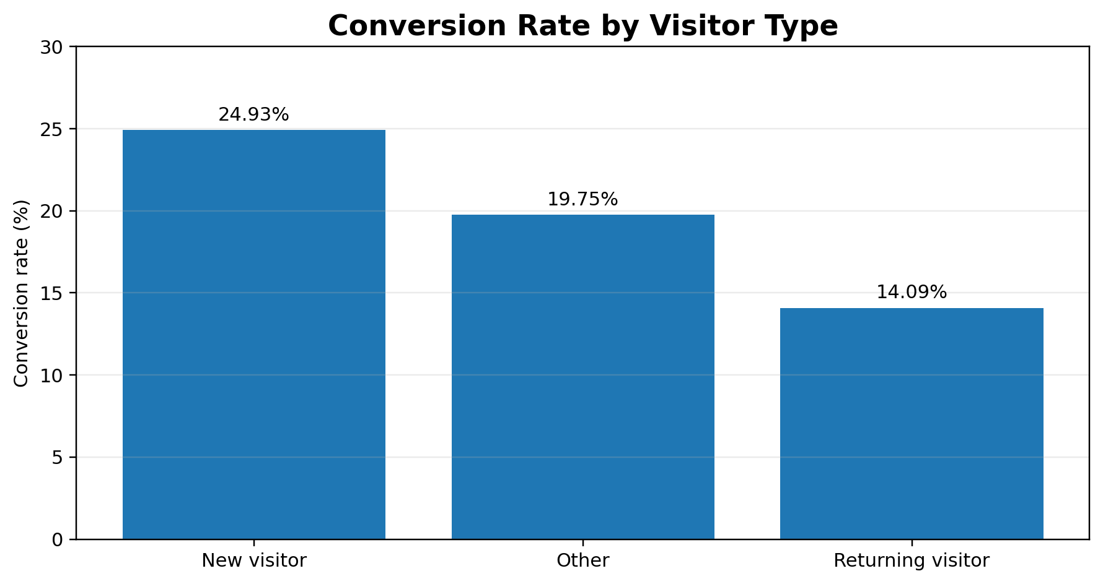
Source: Project analysis results calculated from the cleaned Online Shoppers Purchasing Intention dataset.

Figure 5.3: Monthly Conversion Trend
Chart type: Line chart. X-axis: Month; Y-axis: Conversion rate.
Caption: The reported monthly conversion rate peaks in November at 25.49% and is lowest in February at 1.66%. Month order should be chronological in the final chart.
Conclusion: The reported monthly conversion rate peaks in November at 25.49% and is lowest in February at 1.66%. Month order should be chronological in the final chart.

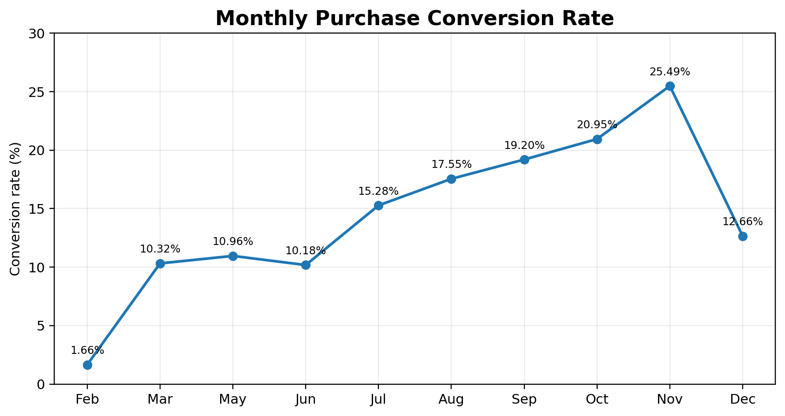
Source: Project analysis results calculated from the cleaned Online Shoppers Purchasing Intention dataset.

Figure 5.4: Weekend vs Weekday Conversion
Chart type: Column chart. X-axis: Weekend / Weekday; Y-axis: Conversion rate.
Caption: Weekend sessions have a 17.45% conversion rate, while weekday sessions have a 15.08% conversion rate in the analysed data.
Conclusion: Weekend sessions have a 17.45% conversion rate, while weekday sessions have a 15.08% conversion rate in the analysed data.

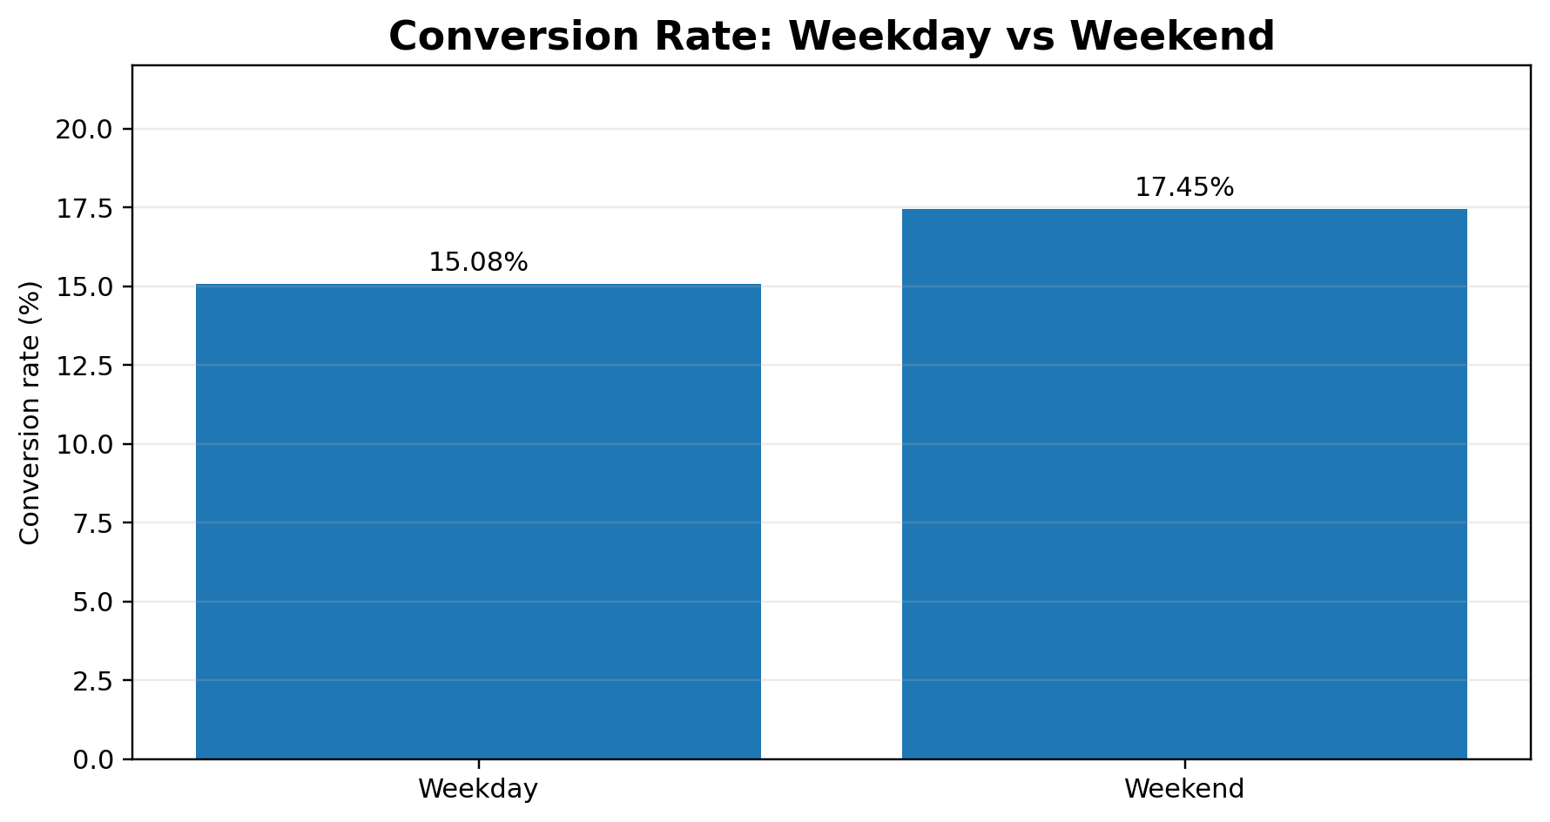
Source: Project analysis results calculated from the cleaned Online Shoppers Purchasing Intention dataset.

Figure 5.5: Product Engagement
Chart type: Engagement chart / suitable comparison visual. Use product-related duration and related session indicators.
Caption: The average ProductRelated_Duration is 1,206.98 seconds. The visual helps communicate how much session time is associated with product-related browsing.
Conclusion: The average ProductRelated_Duration is 1,206.98 seconds. The visual helps communicate how much session time is associated with product-related browsing.

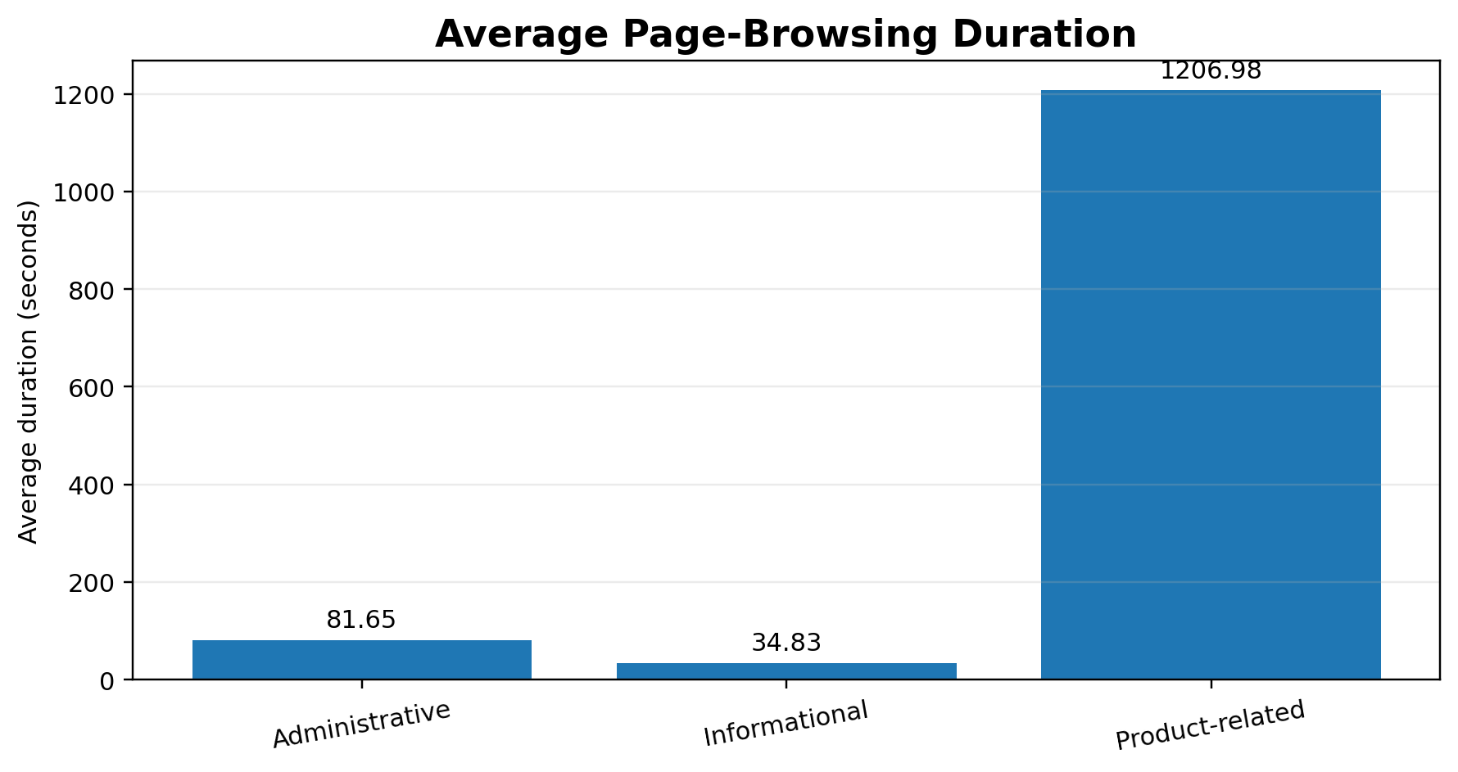
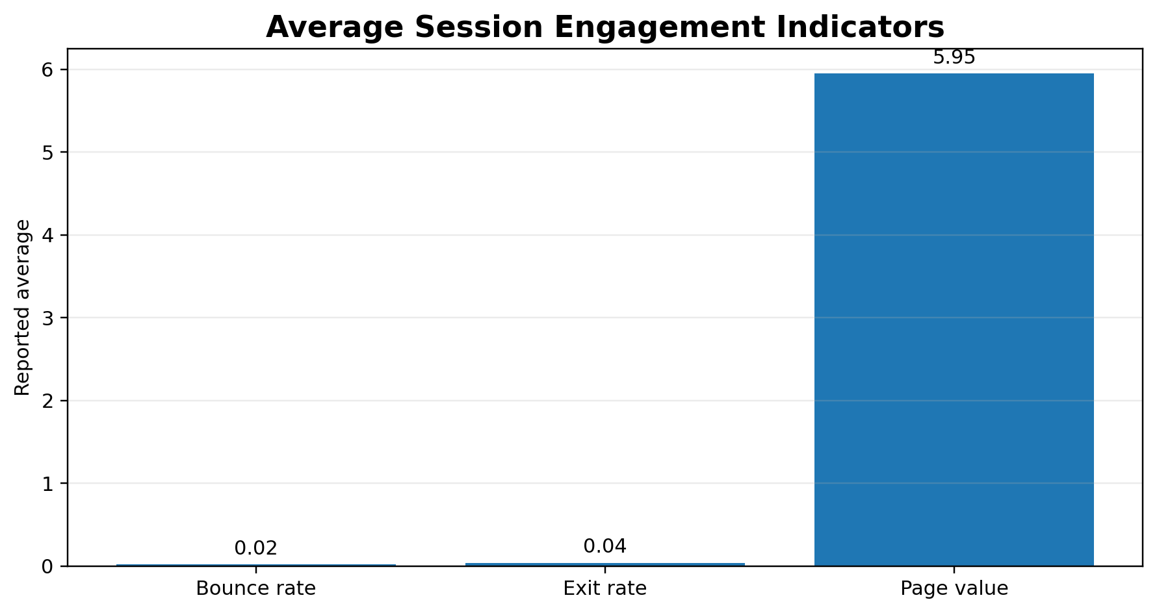
Source: Project analysis results calculated from the cleaned Online Shoppers Purchasing Intention dataset.

5.6 Final Dashboard
Planned dashboard contents:
- KPI cards for total sessions, purchase sessions, conversion rate and average product-related duration.
- Purchase versus non-purchase distribution.
- Conversion rate by visitor type.
- Monthly conversion trend.
- Weekend versus weekday conversion comparison.
- Product engagement visualisation.
- Filters/slicers for Month, VisitorType and Weekend, where supported by the final report.
Dashboard status: The Power BI Desktop report file and final dashboard screenshot have not yet been confirmed as completed. Insert the actual Power BI dashboard screenshot here after creating the report and save the final file as dashboard/Dashboard.pbix. Do not treat a planned layout or sample image as a completed dashboard.
[Insert final Power BI dashboard screenshot after completion.]

6. FINAL CONCLUSION
The E-Commerce Customer Behaviour Analytics Dashboard demonstrates how data analytics and visualisation can be applied to online shopping session data. The project workflow includes dataset inspection, data cleaning, exploratory analysis and the creation of interactive visualisations.
The cleaned dataset contains 12,205 sessions. Of these, 1,908 are purchase sessions and 10,297 are non-purchase sessions, producing an overall conversion rate of 15.63%. The analysis also shows differences across visitor types, months and weekend/weekday sessions. New visitors have the highest conversion rate among the reported visitor groups, November has the highest monthly conversion rate, and weekend sessions have a higher observed conversion rate than weekday sessions.
These results provide descriptive insights into the recorded sessions. They can help an e-commerce team identify patterns for further investigation, review the customer journey and plan more focused analysis. The results do not establish causation and do not represent predictions of future purchases.

6.1 Answers to the Project Questions
Project question | Answer based on analysis
What proportion of sessions resulted in purchase? | 1,908 of 12,205 sessions; 15.63%.
Which visitor group has the highest conversion rate? | New_Visitor at 24.93%.
Which month has the highest reported conversion rate? | November at 25.49%.
How do weekend and weekday sessions compare? | Weekend 17.45%; weekday 15.08%.
What is the average product-related browsing duration? | 1,206.98 seconds.

7. FUTURE OUTCOMES AND LIMITATIONS

7.1 Limitations
- The findings depend on the quality, scope and representativeness of the supplied dataset.
- The dataset contains session-level observations and may not describe every e-commerce platform or customer population.
- The analysis is descriptive; it does not establish causal relationships between browsing behaviour and purchases.
- The current project does not implement a validated machine-learning model for predicting purchase intention.
- Monthly comparisons may be affected by differences in session volume across months.
- The final Power BI dashboard and PBIX file must be completed and verified before they can be included as final deliverables.

7.2 Future Scope
- Complete the Power BI report with KPI cards, comparison charts and interactive slicers.
- Add additional customer, product or transaction data if available and permitted.
- Develop and evaluate a machine-learning model for purchase-intention prediction as a separate future extension.
- Explore customer segmentation and deeper engagement analysis.
- Deploy the dashboard through an appropriate sharing platform, subject to institutional and data-sharing requirements.
- Refresh the dataset periodically to examine whether observed patterns remain consistent.

7.3 Expected Outcomes if the Project Continues
With additional data and a completed interactive dashboard, the project could make session-level behaviour easier to explore and compare. A separately developed and validated predictive model could be considered in future work, but predictive performance must be tested before any prediction capability is claimed.

APPENDIX A: CODE AND PROJECT LINKS
Item | Project detail
Programming language | Python
Data processing | Pandas, NumPy
Visualisation | Plotly
Dataset | data/online_shoppers_intention 2.csv
Cleaned dataset | data/clean_dataset.csv
Cleaning script | data/data_cleaning.py
Analysis script | data/data_analysis.py
Visualisation script | data/Data_visualisation.py
Visualisation outputs | data/visualisation_outputs/
Project repository | https://github.com/rishitharao17/E-Commerce-Customer-Behaviour-Analytics-Dashboard
Power BI report | dashboard/Dashboard.pbix — pending completion/verification

A.1 Project Workflow
Raw CSV → Data inspection → Data cleaning → Cleaned CSV → Exploratory analysis → Plotly visualisations → Power BI dashboard (pending final completion).

A.2 Key Code Snippets
[Insert selected, readable snippets from data_cleaning.py, data_analysis.py and Data_visualisation.py. Include comments and ensure the snippets match the submitted source files.]

APPENDIX B: SCREENSHOTS AND EVIDENCE
Screenshot B.1: Original Online Shoppers Purchasing Intention dataset (sample rows).
[Insert screenshot here.]

Screenshot B.2: Data inspection output showing dimensions, columns and missing values.
[Insert screenshot here.]

Screenshot B.3: Python data cleaning execution and cleaned CSV preview.
[Insert screenshot here.]

Screenshot B.4: Python analysis output showing purchase, visitor-type and monthly summaries.
[Insert screenshot here.]

Screenshot B.5: Plotly visualisation outputs.
[Insert screenshot here.]

Screenshot B.6: Final Power BI dashboard screenshot (insert after dashboard completion).
[Insert screenshot here.]

Screenshot B.7: Public GitHub repository showing the submitted project files.
[Insert screenshot here.]

Submitted by: KODHATI RISHITHA (2503A52959), DARAVATH HUTHA SRI (2503A52953), KAVYA ANKATHI (2503A52938)
Faculty Signature: ______________________________

SUBMISSION CHECKLIST
- Verify the original dataset source URL and access date.
- Confirm the exact cleaning method and explain the 125-row reduction from the executed script.
- Confirm missing-value and duplicate counts after cleaning.
- Insert screenshots of raw data, cleaning output, analysis output and visualisations.
- Complete the Power BI dashboard and save the actual PBIX file as dashboard/Dashboard.pbix.
- Insert the final Power BI dashboard screenshot.
- Verify the GitHub repository contains the intended source files and excludes .venv and .env.
- Confirm the faculty name and obtain the required faculty signature.
- Update the table of contents and page references after final editing.
- Check all student names and roll numbers on the cover page and certificate.
END OF REPORT

