VISVESVARAYA TECHNOLOGICAL UNIVERSITY

“JnanaSangama”, Belgaum -590014, Karnataka.


LAB REPORT
On
ANALYSIS AND DESIGN OF ALGORITHMS (23CS4PCADA)

Submitted by

MUDDAM RISHITHA REDDY (1BF24CS181)

in partial fulfillment for the award of the degree of BACHELOR OF ENGINEERING
in
COMPUTER SCIENCE AND ENGINEERING


B.M.S. COLLEGE OF ENGINEERING
(Autonomous Institution under VTU) BENGALURU-560019
February to June 2026

CERTIFICATE
B. M. S. College of Engineering,
Bull Temple Road, Bangalore 560019
(Affiliated To Visvesvaraya Technological University, Belgaum) Department of Computer Science and Engineering



This is to certify that the Lab work entitled “ANALYSIS AND DESIGN OF ALGORITHMS” carried out by Muddam Rishitha Reddy(1BF24CS13), who is bonafide student of B. M. S. College of Engineering. It is in partial fulfillment for the award of Bachelor of Engineering in Computer Science and Engineering of the Visvesvaraya Technological University, Belgaum during the year 2025-26. The Lab report has been approved as it satisfies the academic requirements in respect of Analysis and Design of Algorithms Lab - (23CS4PCADA) work prescribed for the said degree.

Dr. Manjula S Dr. Kavitha Sooda
Assistant Professor Professor and Head
Department of CSE Department of CSE
BMSCE, Bengaluru BMSCE, Bengaluru

Index Sheet

Sl.  No. | Experiment Title | Page No.
1 | Write program to obtain the Topological ordering of vertices in a given digraph. | 4-7
2 | Implement Johnson Trotter algorithm to generate permutations. | 8-10
3 | Sort a given set of N integer elements using Merge Sort technique and  compute its time taken. Run the program for different values of N and record the time taken to sort. | 11-15
4 | Sort a given set of N integer elements using Quick Sort technique and  compute its time taken. | 16-18
5 | Sort a given set of N integer elements using Heap Sort technique and compute its time taken. | 19-21
6 | Implement 0/1 Knapsack problem using dynamic programming. (5 Marks) | 22-24
7 | Implement All Pair Shortest paths problem using Floyd’s algorithm. | 25-28
8 | - Find Minimum Cost Spanning Tree of a given undirected graph using Prim’s algorithm.  - Find Minimum Cost Spanning Tree of a given undirected graph using Kruskal’s algorithm. | 29-31  32-34
9 | Implement Fractional Knapsack using Greedy technique. | 35-37
10 | From a given vertex in a weighted connected graph, find shortest paths to other vertices using Dijkstra’s algorithm. | 38-40
11 | Implement “N-Queens Problem” using Backtracking. | 41-42

Course outcomes:

CO1 | Analyze time complexity of algorithms using asymptotic notations.
CO2 | Apply various algorithm design techniques for the given problem.
CO3 | Evaluate the appropriate algorithm/design technique for solving a given problem.
CO4 | Conduct practical experiments by applying appropriate algorithm design technique to solve problems.

Lab program 1:
Write program to obtain the Topological ordering of vertices in a given digraph.
#include <stdio.h> #define MAX 10 int main() {
int n, i, j;
int indegree[MAX] = {0}; int graph[MAX][MAX]; int order[MAX], count = 0;
printf("Enter number of vertices: "); scanf("%d", &n);
printf("Enter adjacency matrix:\n"); for(i = 0; i < n; i++) {
for(j = 0; j < n; j++) { scanf("%d", &graph[i][j]); if(graph[i][j] == 1) {
indegree[j]++;
}
}
}
while(count < n) { int found = 0;
for(i = 0; i < n; i++) { if(indegree[i] == 0) {
order[count++] = i; indegree[i] = -1;
for(j = 0; j < n; j++) { if(graph[i][j] == 1) {
indegree[j]--;

}
}
found = 1;
}
}
if(!found) break;
}
if(count < n) {
printf("No Topological Sequence (cycle detected)\n");
} else {
printf("Topological Order: "); for(i = 0; i < n; i++) {
printf("%d ", order[i]);
}
printf("\n");
}
return 0;
}

Screenshot of the output:

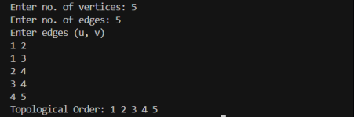

LEETCODE 207:

bool canFinish(int numCourses, int** prerequisites, int prerequisitesSize, int* prerequisitesColSize) {
int *indegree = (int *)calloc(numCourses, sizeof(int)); int **adj = (int **)malloc(numCourses * sizeof(int *)); int *adjSize = (int *)calloc(numCourses, sizeof(int)); for (int i = 0; i < numCourses; i++) {
adj[i] = (int *)malloc(prerequisitesSize * sizeof(int));
}
for (int i = 0; i < prerequisitesSize; i++) { int course = prerequisites[i][0];
int prereq = prerequisites[i][1]; adj[prereq][adjSize[prereq]++] = course; indegree[course]++;
}
int *queue = (int *)malloc(numCourses * sizeof(int)); int front = 0, rear = 0;
for (int i = 0; i < numCourses; i++) { if (indegree[i] == 0)

queue[rear++] = i;
}
int count = 0;
while (front < rear) {
int node = queue[front++]; count++;
for (int i = 0; i < adjSize[node]; i++) { int next = adj[node][i]; indegree[next]--;
if (indegree[next] == 0) queue[rear++] = next;
}
}
for (int i = 0; i < numCourses; i++) free(adj[i]);
free(adj); free(adjSize); free(indegree); free(queue);
return count == numCourses;
}

Lab program 2:
Implement Johnson Trotter algorithm to generate permutations.
#include <stdio.h> #define LEFT 0
#define RIGHT 1
void print(int a[], int dir[], int n) { for(int i = 0; i < n; i++) {
if(dir[a[i]] == LEFT) printf("%d<- ", a[i]);
else
printf("%d-> ", a[i]);
}
printf("\n");
}
int getMobile(int a[], int dir[], int n) { int mobile = 0;
for(int i = 0; i < n; i++) { if(dir[a[i]] == LEFT && i > 0) {
if(a[i] > a[i-1] && a[i] > mobile) mobile = a[i];
}
if(dir[a[i]] == RIGHT && i < n-1) { if(a[i] > a[i+1] && a[i] > mobile)
mobile = a[i];
}
}
return mobile;
}
int findPos(int a[], int n, int mobile) {

for(int i = 0; i < n; i++) { if(a[i] == mobile)
return i;
}
return -1;
}
void johnsonTrotter(int n) { int a[n], dir[n+1];
for(int i = 0; i < n; i++) { a[i] = i + 1;
dir[i+1] = LEFT;
}
print(a, dir, n); while(1) {
int mobile = getMobile(a, dir, n); if(mobile == 0)
break;
int pos = findPos(a, n, mobile); if(dir[mobile] == LEFT) {
int temp = a[pos]; a[pos] = a[pos-1]; a[pos-1] = temp; pos = pos - 1;
} else {
int temp = a[pos]; a[pos] = a[pos+1]; a[pos+1] = temp; pos = pos + 1;
}

for(int i = 1; i <= n; i++) { if(i > mobile) {
dir[i] = !dir[i];
}
}
print(a, dir, n);
}
}
int main() { int n;
printf("Enter n: ");
scanf("%d", &n); johnsonTrotter(n); return 0;
}

Screenshot of the output:
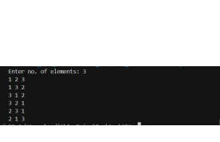

Lab program 3:
Sort a given set of N integer elements using Merge Sort technique and compute its time taken. Run the program for different values of N and record the time taken to sort.

#include <stdio.h> #include <stdlib.h> #include <time.h>
void merge(int arr[], int lb, int mid, int ub) { int n1 = mid - lb + 1;
int n2 = ub - mid; int L[n1], R[n2];
for (int i = 0; i < n1; i++) L[i] = arr[lb + i];
for (int j = 0; j < n2; j++) R[j] = arr[mid + 1 + j];
int i = 0, j = 0, k = lb; while (i < n1 && j < n2) {
if (L[i] <= R[j])
arr[k++] = L[i++]; else
arr[k++] = R[j++];
}
while (i < n1) arr[k++] = L[i++];
while (j < n2) arr[k++] = R[j++];
}
void mergeSort(int arr[], int lb, int ub) { if (lb < ub) {
int mid = (lb + ub) / 2;

mergeSort(arr, lb, mid); mergeSort(arr, mid + 1, ub); merge(arr, lb, mid, ub);
}
}
int main() { int n;
printf("Enter number of elements: "); scanf("%d", &n);
int arr[n];
printf("Enter elements:\n"); for (int i = 0; i < n; i++) {
scanf("%d", &arr[i]);
}
clock_t start = clock(); mergeSort(arr, 0, n - 1); clock_t end = clock(); double time_taken =
(double)(end - start) / CLOCKS_PER_SEC; printf("\nSorted array:\n");
for (int i = 0; i < n; i++) { printf("%d ", arr[i]);
}
printf("\n");
printf("Time taken: %.6f seconds\n", time_taken); return 0;
}

Screenshot of the output:

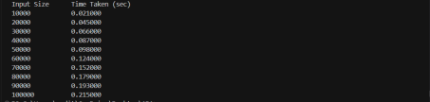

30  25  20  15  10  5  0 | Merge sort
 | 20000 40000 60000 80000 100000

LEETCODE 912:
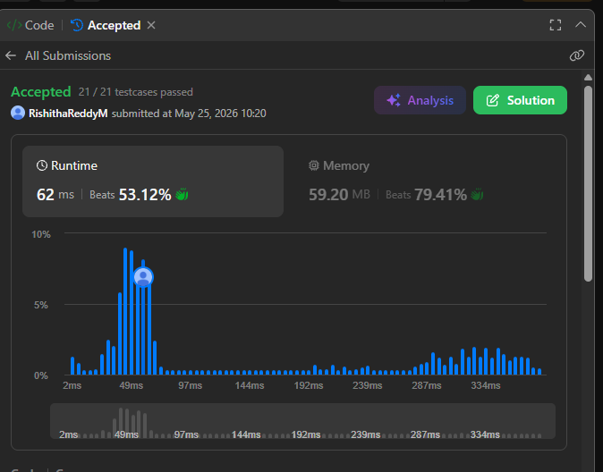
void merge(int nums[], int left, int mid, int right){ int n1 = mid - left + 1;
int n2 = right - mid; int L[n1], R[n2];
for(int i = 0; i < n1; i++) L[i] = nums[left + i]; for(int j = 0; j < n2; j++)
R[j] = nums[mid + 1 + j]; int i = 0, j = 0, k = left; while(i < n1 && j < n2)
{
if(L[i] <= R[j])
nums[k++] = L[i++]; else
nums[k++] = R[j++];
}
while(i < n1) nums[k++] = L[i++];
while(j < n2)

nums[k++] = R[j++];
}
void mergeSort(int nums[], int left, int right)
{
if(left < right)
{
int mid = left + (right - left) / 2; mergeSort(nums, left, mid); mergeSort(nums, mid + 1, right); merge(nums, left, mid, right);
}
}
int* sortArray(int* nums, int numsSize, int* returnSize)
{
mergeSort(nums, 0, numsSize - 1);
*returnSize = numsSize; return nums;
}

Lab program 4:
Sort a given set of N integer elements using Quick Sort technique and compute its time taken.
#include <stdio.h> #include <stdlib.h> #include <time.h>
void swap(int *a, int *b) { int temp = *a;
*a = *b;
*b = temp;
}
int partition(int arr[], int low, int high) {
int pivot = arr[high]; // choosing last element as pivot int i = (low - 1);
for (int j = low; j < high; j++) { if (arr[j] <= pivot) {
i++;
swap(&arr[i], &arr[j]);
}
}
swap(&arr[i + 1], &arr[high]); return (i + 1);
}
void quickSort(int arr[], int low, int high) { if (low < high) {
int pi = partition(arr, low, high); quickSort(arr, low, pi - 1); quickSort(arr, pi + 1, high);
}
}
int main() { int N;
printf("Enter number of elements: "); scanf("%d", &N);

int arr[N];
printf("Enter the elements:\n"); for (int i = 0; i < N; i++) {
scanf("%d", &arr[i]);
}
clock_t start, end; start = clock();
quickSort(arr, 0, N - 1); end = clock(); printf("Sorted array:\n"); for (int i = 0; i < N; i++) {
printf("%d ", arr[i]);
}
double time_taken = ((double)(end - start)) / CLOCKS_PER_SEC; printf("\nTime taken: %f seconds\n", time_taken);
return 0;
}

Screenshot of the output:

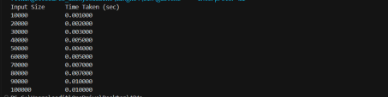

Quick sort
20

15

10

5

0
20000
40000
60000
80000
100000

LEETCODE 455:

#include <stdlib.h>
int compare(const void *a, const void *b){ return (*(int *)a - *(int *)b);}
int findContentChildren(int* g, int gSize, int* s, int sSize){ qsort(g, gSize, sizeof(int), compare);
qsort(s, sSize, sizeof(int), compare); int i = 0; // child
int j = 0; // cookie int count = 0;
while (i < gSize && j < sSize){ if (s[j] >= g[i]){
count++; i++;
j++; }
else{

j++;}
}
return count;
}

Lab program 5:
Sort a given set of N integer elements using Heap Sort technique and compute its time taken.
#include <stdio.h>
void swap(int *a, int *b) { int temp = *a;
*a = *b;
*b = temp;
}
void siftUp(int a[], int i) { while(i > 0) {
int parent = (i - 1) / 2; if(a[parent] < a[i]) {
swap(&a[parent], &a[i]); i = parent;
} else {
break;
}
}
}
void buildHeap(int a[], int n) { for(int i = 1; i < n; i++) {
siftUp(a, i);
}
}
void heapify(int a[], int n, int i) { int largest = i;
int left = 2*i + 1; int right = 2*i + 2;
if(left < n && a[left] > a[largest])

largest = left;
if(right < n && a[right] > a[largest]) largest = right;
if(largest != i) { swap(&a[i], &a[largest]); heapify(a, n, largest);
}
}
void heapSort(int a[], int n) { buildHeap(a, n);
for(int i = n-1; i > 0; i--) {
swap(&a[0], &a[i]); heapify(a, i, 0);
}
}
void print(int a[], int n) { for(int i = 0; i < n; i++)
printf("%d ", a[i]); printf("\n");
}
int main() { int n;
printf("Enter n: ");
scanf("%d", &n); int a[n];
printf("Enter elements:\n"); for(int i = 0; i < n; i++)
scanf("%d", &a[i]); heapSort(a, n);

printf("Sorted array:\n"); print(a, n);
return 0;
}

Screenshot of the output:
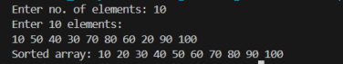

Lab program 6:
Implement 0/1 Knapsack problem using dynamic programming.
#include <stdio.h>
int knapsack(int W, int wt[], int val[], int n) { int dp[n+1][W+1];
for (int i = 0; i <= n; i++) {
for (int w = 0; w <= W; w++) { if (i == 0 || w == 0) {
dp[i][w] = 0;
}
else if (wt[i-1] <= w) {
int include = val[i-1] + dp[i-1][w - wt[i-1]]; int exclude = dp[i-1][w];
dp[i][w] = (include > exclude) ? include : exclude;
}
else {
dp[i][w] = dp[i-1][w];
}
}
}
int selected[n];
for (int i = 0; i < n; i++) selected[i] = 0;
int i = n; int w = W;
while (i > 0 && w > 0) {
if (dp[i][w] != dp[i-1][w]) { selected[i-1] = 1;
w = w - wt[i-1];

}
i--;
}
printf("\nItems included in Knapsack:\n"); for (int i = 0; i < n; i++) {
printf("%d ", selected[i]);
}
printf("\n");
return dp[n][W];
}
int main() { int n, W;
printf("Enter number of items: "); scanf("%d", &n);
int val[n], wt[n];
printf("Enter profit of items:\n"); for (int i = 0; i < n; i++) {
scanf("%d", &val[i]);
}
printf("Enter weights of items:\n"); for (int i = 0; i < n; i++) {
scanf("%d", &wt[i]);
}
printf("Enter knapsack capacity: "); scanf("%d", &W);
int result = knapsack(W, wt, val, n); printf("\nMaximum value in Knapsack = %d\n", result); return 0;
}

Screenshot of the output:
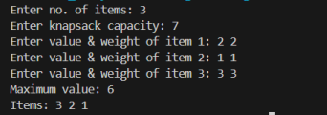

LEETCODE 70:

int climbStairs(int n){ if(n == 1)
return 1; int first = 1;
int second = 2;
for(int i = 3; i <= n; i++)
{
int third = first + second; first = second;
second = third;

}
return second;
}

Lab program 7:
Implement All Pair Shortest paths problem using Floyd’s algorithm.
#include <stdio.h> #define INF 99999
#define MAX 100
void printSolution(int dist[MAX][MAX], int V) { printf("\nShortest distance matrix:\n");
for (int i = 0; i < V; i++) { for (int j = 0; j < V; j++) {
if (dist[i][j] == INF)
printf("%7s", "INF"); else
printf("%7d", dist[i][j]);
}
printf("\n");
}
}
void floydWarshall(int graph[MAX][MAX], int V) { int dist[MAX][MAX];
for (int i = 0; i < V; i++) for (int j = 0; j < V; j++)
dist[i][j] = graph[i][j]; for (int k = 0; k < V; k++) {
for (int i = 0; i < V; i++) { for (int j = 0; j < V; j++) {
if (dist[i][k] < INF && dist[k][j] < INF && dist[i][k] + dist[k][j] < dist[i][j]) {
dist[i][j] = dist[i][k] + dist[k][j];
}

}
}
}
for (int i = 0; i < V; i++) { if (dist[i][i] < 0) {
printf("\nNegative cycle detected!\n"); return;
}
}
printSolution(dist, V);
}
int main() { int V;
int graph[MAX][MAX]; printf("Enter number of vertices: "); scanf("%d", &V);
printf("\nEnter adjacency matrix (-1 for no edge):\n"); for (int i = 0; i < V; i++) {
for (int j = 0; j < V; j++) { scanf("%d", &graph[i][j]); if (graph[i][j] == -1)
graph[i][j] = INF;
}
}
for (int i = 0; i < V; i++) graph[i][i] = 0;
floydWarshall(graph, V); return 0;}

Screenshot of the output:
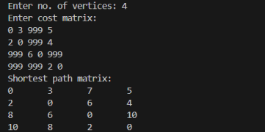

LEETCODE 821:

int* shortestToChar(char* s, char c, int* returnSize){ int n = strlen(s);
int *answer = (int*)malloc(n * sizeof(int)); int prev = -10000;
for(int i = 0; i < n; i++){ if(s[i] == c)
prev = i; answer[i] = i - prev;
}
prev = 10000;
for(int i = n - 1; i >= 0; i--)
{
if(s[i] == c) prev = i;
if(prev - i < answer[i]) answer[i] = prev - i;
}

*returnSize = n; return answer;
}

Lab program 8a:
Find Minimum Cost Spanning Tree of a given undirected graph using Prim’s algorithm.

#include <stdio.h> #include <limits.h>
int minKey(int key[], int mstSet[], int V) { int min = INT_MAX, min_index = -1; for (int v = 0; v < V; v++)
if (mstSet[v] == 0 && key[v] < min) min = key[v], min_index = v;
return min_index;
}
void primMST(int graph[50][50], int V) { int parent[V], key[V], mstSet[V];
int totalCost = 0;

for (int i = 0; i < V; i++) { key[i] = INT_MAX; mstSet[i] = 0;
}
key[0] = 0;
parent[0] = -1;
for (int count = 0; count < V - 1; count++) { int u = minKey(key, mstSet, V); mstSet[u] = 1;

for (int v = 0; v < V; v++)
if (graph[u][v] && mstSet[v] == 0 && graph[u][v] < key[v]) { parent[v] = u;
key[v] = graph[u][v];

}
}

printf("\nEdges in MST:\n"); for (int i = 1; i < V; i++) {
printf("%d - %d : %d\n", parent[i], i, graph[i][parent[i]]); totalCost += graph[i][parent[i]];
}
printf("Total cost = %d\n", totalCost);
}
int main() { int V;
int graph[50][50];
printf("Enter number of vertices: "); scanf("%d", &V);
printf("Enter adjacency matrix (enter 0 if no edge, otherwise enter cost):\n"); for (int i = 0; i < V; i++)
for (int j = 0; j < V; j++) scanf("%d", &graph[i][j]);

primMST(graph, V);

return 0;
}

Screenshot of the output:
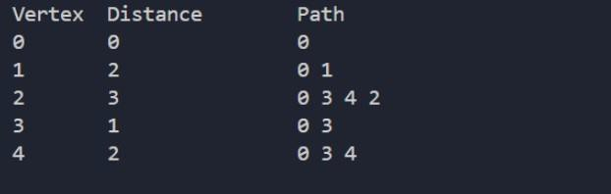

Lab program 8b:
Find Minimum Cost Spanning Tree of a given undirected graph using Kruskal’s algorithm.
#include <stdio.h> #include <stdlib.h> struct Edge {
int src,dest,weight;
};
struct Subset { int parent;
};
int find(struct Subset subsets[],int i){ while(subsets[i].parent!=i) i=subsets[i].parent;
return i;
}
void Union(struct Subset subsets[],int x,int y){ int xroot=find(subsets,x);
int yroot=find(subsets,y); subsets[xroot].parent=yroot;
}
int compare(const void *a,const void *b){
return ((struct Edge*)a)->weight-((struct Edge*)b)->weight;
}
void KruskalMST(struct Edge edges[],int V,int E){ struct Edge result[V];
struct Subset subsets[V]; qsort(edges,E,sizeof(struct Edge),compare); for(int i=0;i<V;i++)
subsets[i].parent=i;

int e=0; int i=0;
while(e<V-1&&i<E){
struct Edge next=edges[i++]; int x=find(subsets,next.src); int y=find(subsets,next.dest); if(x!=y){
result[e++]=next; Union(subsets,x,y);
}
}
printf("\nEdges in MST:\n"); int total=0;
for(i=0;i<e;i++){
printf("%d -- %d == %d\n",result[i].src,result[i].dest,result[i].weight); total+=result[i].weight;
}
printf("Total Cost = %d\n",total);
}
int main(){ int V;
printf("Enter number of vertices: "); scanf("%d",&V);
int E=V*(V-1)/2; struct Edge edges[E];
printf("Enter edges (src dest weight):\n"); for(int i=0;i<E;i++){
scanf("%d %d %d",&edges[i].src,&edges[i].dest,&edges[i].weight);
}

KruskalMST(edges,V,E); return 0;
}

Screenshot of the output:
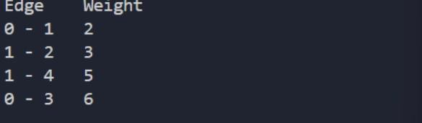

Lab program 9:
Implement Fractional Knapsack using Greedy technique
#include <stdio.h>
struct Item{int weight;int value;}; int main(){
int n,capacity;
printf("Enter number of items: "); scanf("%d",&n);
struct Item items[n]; for(int i=0;i<n;i++){
printf("Enter weight and value of item %d: ",i+1); scanf("%d %d",&items[i].weight,&items[i].value);
}
printf("Enter knapsack capacity: "); scanf("%d",&capacity);
double ratio[n];
for(int i=0;i<n;i++)ratio[i]=(double)items[i].value/items[i].weight; for(int i=0;i<n-1;i++){
for(int j=i+1;j<n;j++){ if(ratio[i]<ratio[j]){
double tempR=ratio[i];ratio[i]=ratio[j];ratio[j]=tempR; struct Item temp=items[i];items[i]=items[j];items[j]=temp;
}
}
}
double maxValue=0.0;int remaining=capacity; for(int i=0;i<n;i++){
if(items[i].weight<=remaining){ remaining-=items[i].weight;

maxValue+=items[i].value;
}else{
maxValue+=ratio[i]*remaining; break;
}
}
printf("Maximum value in Knapsack = %.2f\n",maxValue); return 0;
}

Screenshot of the output:
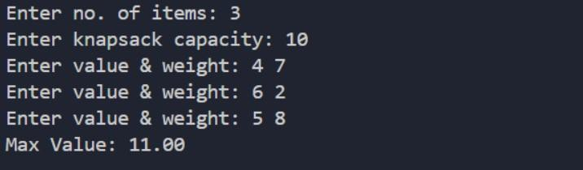

LEETCODE 1710:

int compare(const void *a, const void *b){ int *x = *(int **)a;
int *y = *(int **)b; return y[1] - x[1];}
int maximumUnits(int** boxTypes, int boxTypesSize, int* boxTypesColSize, int truckSize){
qsort(boxTypes, boxTypesSize, sizeof(int *), compare); int totalUnits = 0;
for(int i = 0; i < boxTypesSize; i++){ int boxes = boxTypes[i][0];
int units = boxTypes[i][1]; if(truckSize >= boxes){
totalUnits += boxes * units; truckSize -= boxes;}
else{
totalUnits += truckSize * units; break;

}}
return totalUnits;
}

Lab program 10:
From a given vertex in a weighted connected graph, find shortest paths to other vertices using Dijkstra’s algorithm.
#include <stdio.h> #include <limits.h>
#define V 10 // maximum number of vertices
int minDistance(int dist[], int sptSet[], int vertices) { int min = INT_MAX, min_index;
for (int v = 0; v < vertices; v++) {
if (sptSet[v] == 0 && dist[v] <= min) { min = dist[v];
min_index = v;
}
}
return min_index;
}
void printSolution(int dist[], int vertices, int src) { printf("Vertex \t Distance from Source %d\n", src); for (int i = 0; i < vertices; i++) {
printf("%d \t %d\n", i, dist[i]);
}
}
void dijkstra(int graph[V][V], int src, int vertices) { int dist[vertices]; // shortest distance from src
int sptSet[vertices]; // whether vertex is included in shortest path tree for (int i = 0; i < vertices; i++) {
dist[i] = INT_MAX; sptSet[i] = 0;
}
dist[src] = 0;

for (int count = 0; count < vertices - 1; count++) { int u = minDistance(dist, sptSet, vertices); sptSet[u] = 1;
for (int v = 0; v < vertices; v++) {
if (!sptSet[v] && graph[u][v] && dist[u] != INT_MAX && dist[u] + graph[u][v] < dist[v]) {
dist[v] = dist[u] + graph[u][v];
}
}
}
printSolution(dist, vertices, src);
}
int main() { int vertices;
printf("Enter number of vertices: "); scanf("%d", &vertices)
int graph[V][V];
printf("Enter adjacency matrix (0 if no edge):\n"); for (int i = 0; i < vertices; i++) {
for (int j = 0; j < vertices; j++) { scanf("%d", &graph[i][j]);
}
}
int src;
printf("Enter source vertex: "); scanf("%d", &src); dijkstra(graph, src, vertices); return 0;
}

Screenshot of the output:
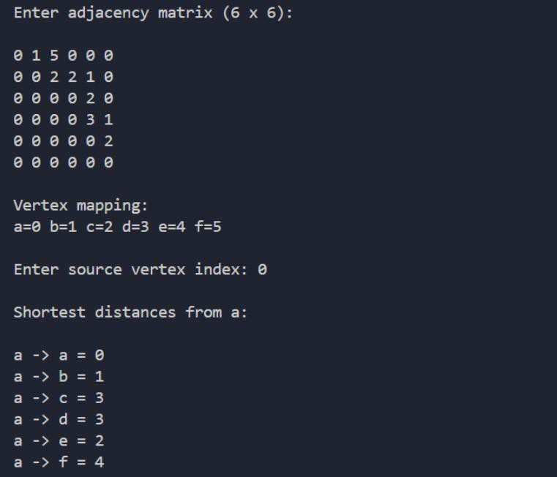

Lab program 11:
Implement “N-Queens Problem” using Backtracking.
#include <stdio.h> #include <stdbool.h> #define MAX 20
int N;
int board[MAX][MAX]; bool isSafe(int row,int col){
for(int i=0;i<row;i++){ if(board[i][col])return false;
if(col-(row-i)>=0&&board[i][col-(row-i)])return false; if(col+(row-i)<N&&board[i][col+(row-i)])return false;
}
return true;
}
void printBoard(){ for(int i=0;i<N;i++){
for(int j=0;j<N;j++)printf("%c ",board[i][j]?'Q':'.'); printf("\n");
}
printf("\n");
}
void solve(int row){ if(row==N){
printBoard(); return;
}
for(int col=0;col<N;col++){ if(isSafe(row,col)){

board[row][col]=1; solve(row+1); board[row][col]=0;
}
}
}
int main(){
printf("Enter the size of the board (N): "); scanf("%d",&N);
if(N>MAX||N<1){
printf("Invalid board size. Please enter between 1 and %d.\n",MAX); return 1;
}
solve(0); return 0;
}

Screenshot of the output:
