**Spring boot application- Hello World!**

**Pre-Requisites:**

Java 1.8 +

Docker

**Download Eclipse:**

<https://www.eclipse.org/downloads/>

**Creating a Project:**

1. Go to new project -> select Maven Project from maven drop down
2. Give a Group id(Rishitha) and artifact id(springbootHelloworld) and name your project(springbootHelloworld).
3. Click finish.
4. Editing the pom.xml

Include the spring boot dependencies

<parent>

<groupId>org.springframework.boot</groupId>

<artifactId>spring-boot-starter-parent</artifactId>

<version>2.3.2.RELEASE</version>

</parent>

<dependencies>

<dependency>

<groupId>org.springframework.boot</groupId>

<artifactId>spring-boot-starter-web</artifactId>

</dependency>

</dependencies>

1. Create a “*Class*” in the project and name the Class (HelloWorld)
2. Insert the code to the Hello World application program.
3. Give a default file name for “*.jar*” that will be generated by including in pom.xml

<build>

<finalName>springbootHelloWorld</finalName>

</build>

1. Run the project.
2. “*springbootHelloWorld.jar*” is created in the target folder.
3. Browse <https://localhost:8080>

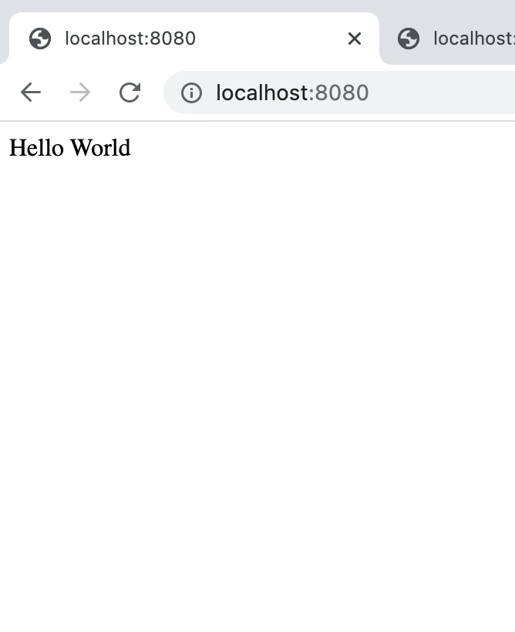

**Dockerizing the application:**

1. Create a “*File*” and name it “*Dockerfile”.*
2. Taking java as a base image and copy the “jar” file and start the application

FROM openjdk:latest

EXPOSE 8080

ADD target/springbootHelloWorld.jar springbootHelloWorld.jar

ENTRYPOINT ["java", "-jar", "springbootHelloWorld.jar"]

1. Open terminal : move to the location of the “Dockerfile”
2. Build the File to get an image

$docker build -t [image name] .

$docker build -t helloworld .

1. Run the image by binding the port to the host

$docker run -p [hostport]:[containerport] --name [container name] [imagename]

$docker run -p 8081:8080 --name helloworldcontainer helloworld

1. Browse <https://localhost:8081>

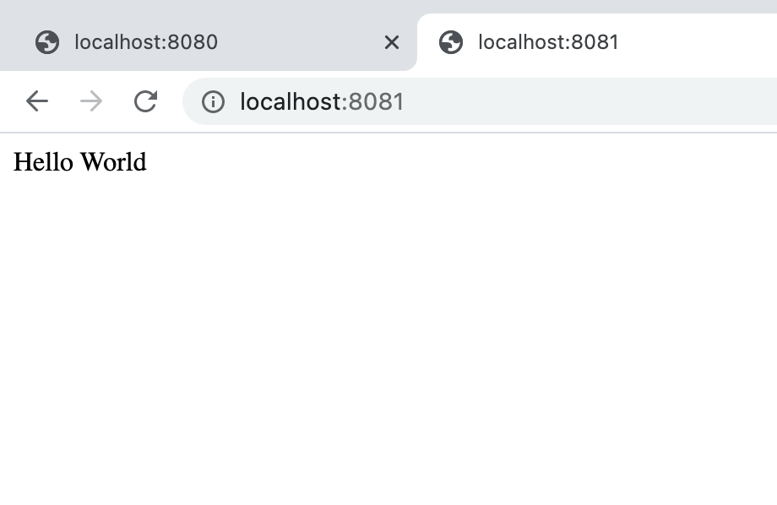

**Issues**:

While running the docker container:

no main manifest attribute, in jar Error in Spring Boot



Solution:

Include the plugin to repackage the application while building. As the manifest file indicates the entrypoint main method for the application. And which main method should be indicated in the manifest file.

<plugins>

<plugin>

<groupId>org.springframework.boot</groupId>

<artifactId>spring-boot-maven-plugin</artifactId>

<version>2.1.5.RELEASE</version>

<executions>

<execution>

<goals>

<goal>repackage</goal>

</goals>

</execution>

</executions>

</plugin>

</plugins>