DIGITAL RISK PROTECTION SYSTEM
Problem • Solution • Architecture • Workflow • Evidence • APIs
A practical guide to how the prototype assesses submitted websites and public profiles,
explains its findings, and supports safer human review.
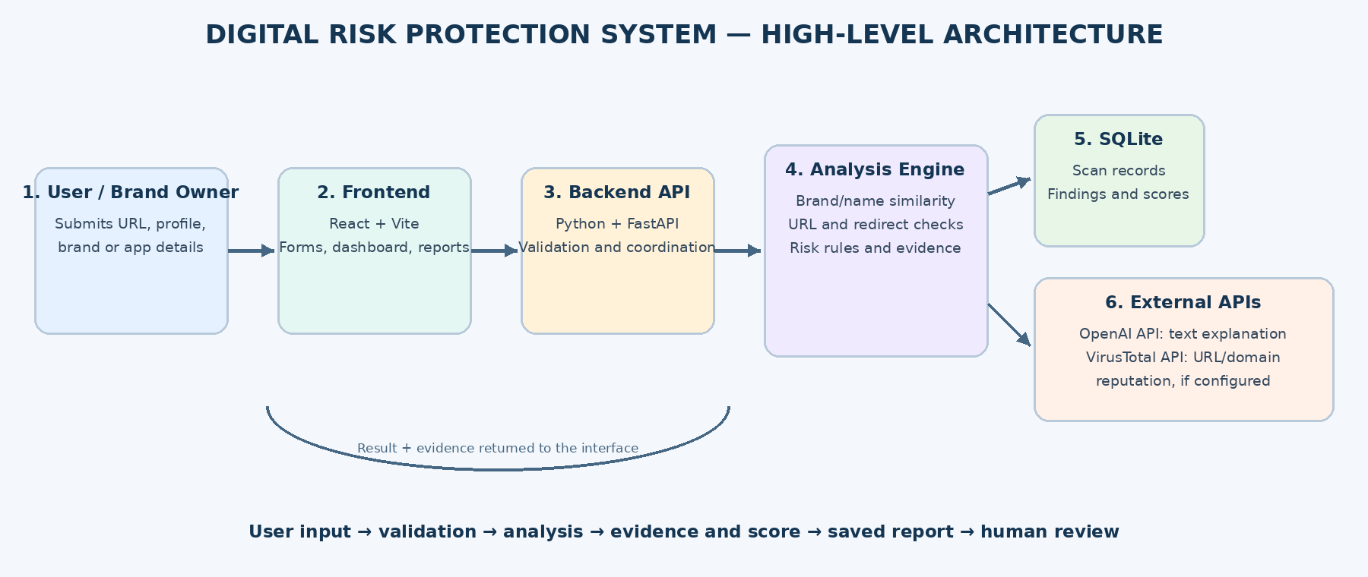

1. Project Overview
Digital Risk Protection System is a web-based prototype for reviewing potentially deceptive brand-related websites, public profiles, and app listings. It brings submitted evidence into one workflow and shows the signals that may deserve further investigation.
The goal is not to label every target as genuine or fraudulent. The system helps a user make a better-informed decision by showing a risk category, contributing observations, confidence/coverage limits, and recommended verification steps.
- Accept user-submitted URLs or public-profile details for assessment.
- Present an explainable score and the observations behind it.
- Keep reports available for later review in the current browser.
- Use external APIs only when their integrations and credentials are configured.

2. Problem and Proposed Solution
Problem: customers and brand teams may encounter look-alike profiles, misleading links, or pages that ask for sensitive information. Manually checking these signals across separate tools can be slow, and one signal alone is rarely enough to establish whether something is malicious.
Solution: the user submits a target; the application examines available signals; the report explains what was observed and what remains unknown. The user can then verify the organization through a separate trusted channel before taking a sensitive action.
Problem faced | How the prototype helps
Suspicious redirects | Records a hostname/domain change as a warning to inspect.
Requests for passwords | Raises a caution signal when a password request is detected in the supplied/observed page evidence.
Confusing technical signals | Separates warnings from informational signals, such as HTTPS certificate validation.
Need to revisit results | Provides saved reports and configurable browser retention.

3. System Architecture
The system is separated into components so that the user interface, request handling, analysis logic, storage, and external services can be tested and improved independently.
Figure 1. Original high-level architecture of the Digital Risk Protection System.
Component | Responsibility
User / Brand Owner | Submits the brand, profile, app listing, or URL to review.
Frontend — React + Vite | Collects input and displays dashboard metrics, evidence, and reports.
Backend — Python + FastAPI | Validates input, coordinates checks, handles API calls, and returns results.
Detection & Risk Engine | Evaluates name/profile similarity, URL features, redirects, and configured signals.
Database — SQLite | Stores report details and evidence when persistence is implemented.
External APIs | OpenAI can interpret text and draft explanations; VirusTotal can supply URL/domain reputation when configured.

4. End-to-End Workflow
- User enters a website URL or public-account information in the Analyzer.
- The frontend submits the assessment request to the backend (where the deployed implementation is connected).
- The backend validates the input and runs available local checks and configured reputation lookups.
- The analysis logic combines the observed signals according to its scoring rules.
- The report presents the risk score, evidence, confidence/coverage notes, and recommended next steps.
- The user reviews the result and independently verifies important claims before sharing credentials or money.
Important distinction: the screenshots show point-in-time assessments. They do not, by themselves, demonstrate continuous monitoring of all social platforms.

5. User Interface: Start an Assessment
The Analyzer dashboard gives users a starting point for checking a website or public account. Summary cards provide a quick view of saved reports and risk categories, while the assessment form begins a new review.
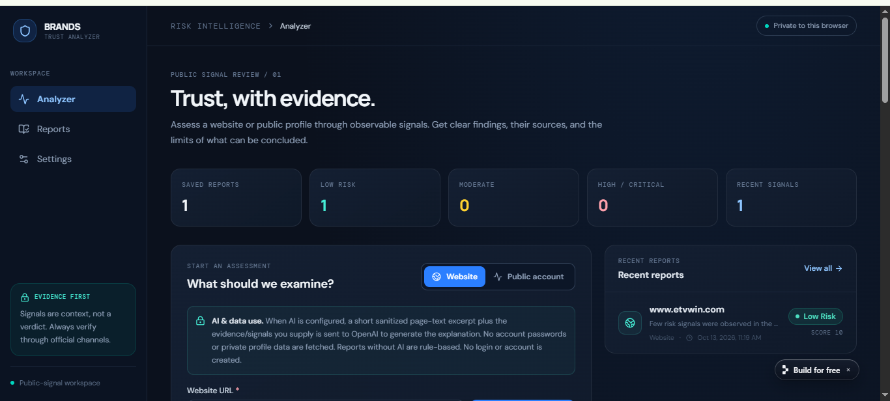
Figure 2. Analyzer dashboard and assessment entry point.
What the user learns: where to submit a target, where to review previous findings, and how the application summarizes the current browser's assessment history.

6. Reading a Website Assessment
In the website example below, the report shows a low-risk score of 10 and identifies a redirect that changed the domain. The interface also warns that a low score is not proof of legitimacy. A redirect can be legitimate, but the destination should be checked before entering information.
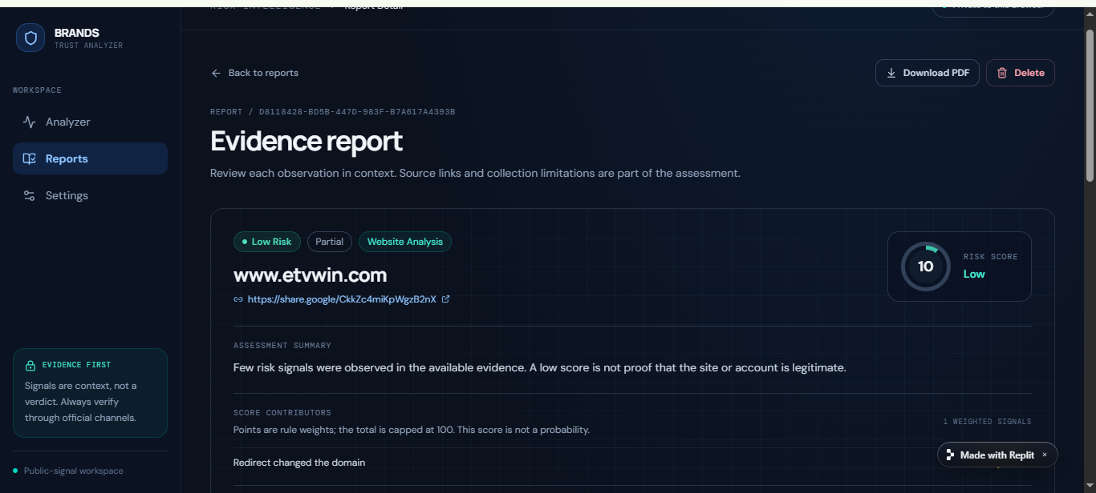
Figure 3. Example website report with a low-risk score and a redirect warning.
The score is a rule-based indicator based on the signals available in this example. It should not be interpreted as a probability that the website is safe or unsafe.

7. Evidence: Warnings vs. Informational Signals
Separating findings by type makes the report easier to interpret. A warning indicates something that warrants closer inspection. An informational finding records a technical observation without treating it as proof of trustworthiness.
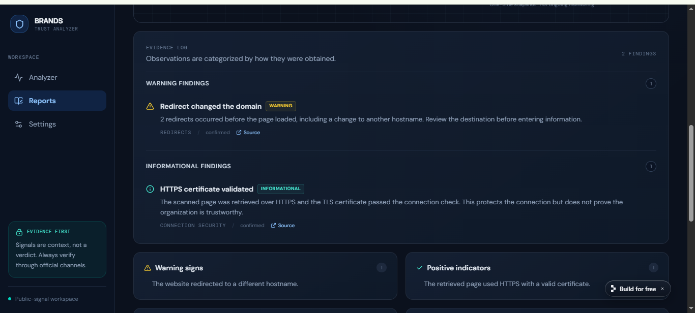
Figure 4. Evidence log showing warning and informational findings.
- A redirect to a different hostname is a reason to inspect the final destination.
- HTTPS with a valid TLS certificate indicates an encrypted connection; it does not prove the organization is genuine.
- Review the original source and context before deciding what an observation means.

8. Risk Score, Confidence and Limitations
A useful assessment communicates not only the score but also how much evidence was available. The screenshot below records a score, confidence level, and snapshot time. It explicitly identifies the assessment as a one-time snapshot rather than ongoing monitoring.
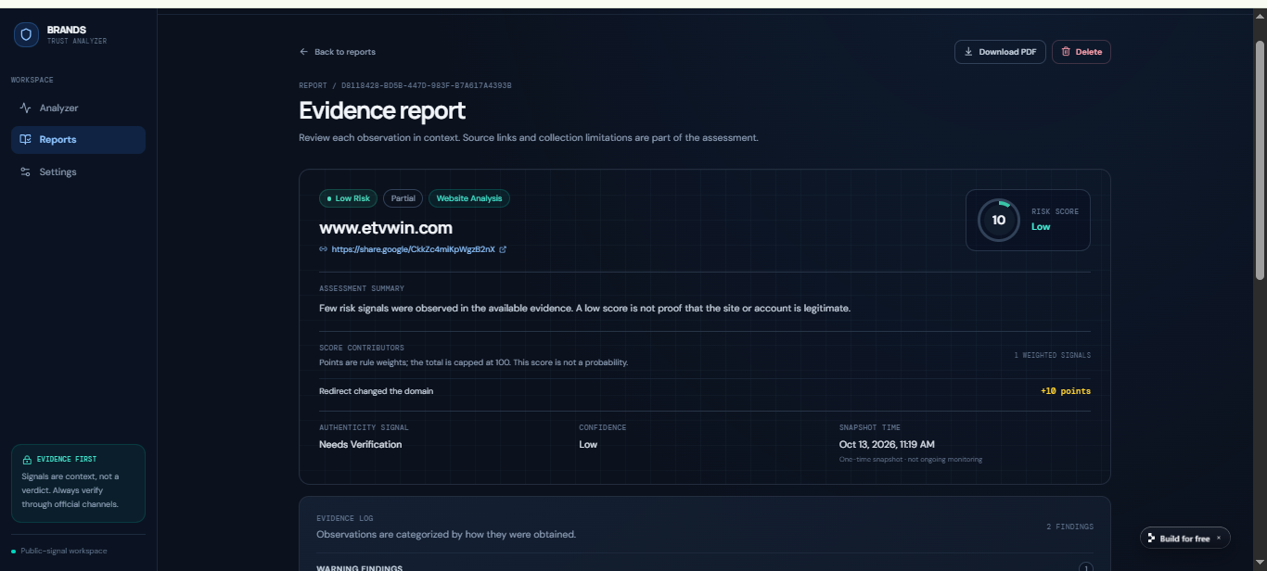
Figure 5. Summary area showing risk score, confidence, and snapshot timestamp.
A score is a summary of configured rules and available evidence—not a validated fraud probability. Missing checks must be described as unavailable or unknown rather than silently treated as safe.

9. Recommended Next Steps and Coverage Gaps
The prototype report includes limitations and suggested precautions. This helps users understand what the application did not verify and reduces the chance of treating an incomplete result as a guarantee.
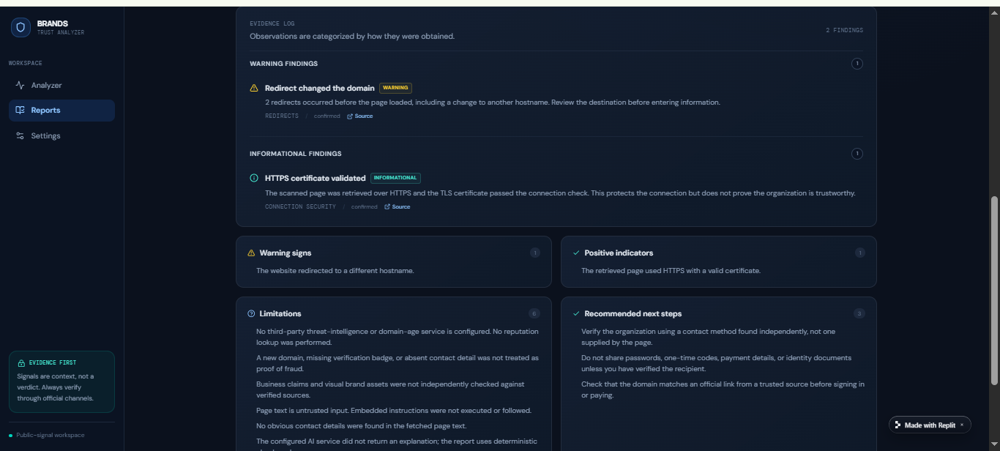
Figure 6. Report limitations and recommended next steps.
- Verify the organization using contact details found independently from the submitted page.
- Check the destination domain against an official source before signing in or paying.
- Do not provide passwords, one-time codes, payment details, or identity documents until the recipient is verified.
- State clearly when domain-age, reputation, or third-party threat-intelligence checks are not configured.

10. Social-Profile Example
The Instagram example receives a moderate score of 30 because the report lists a hostname change after redirection and a password-request signal. These observations support caution and further checking, but they do not independently prove that the account is malicious.
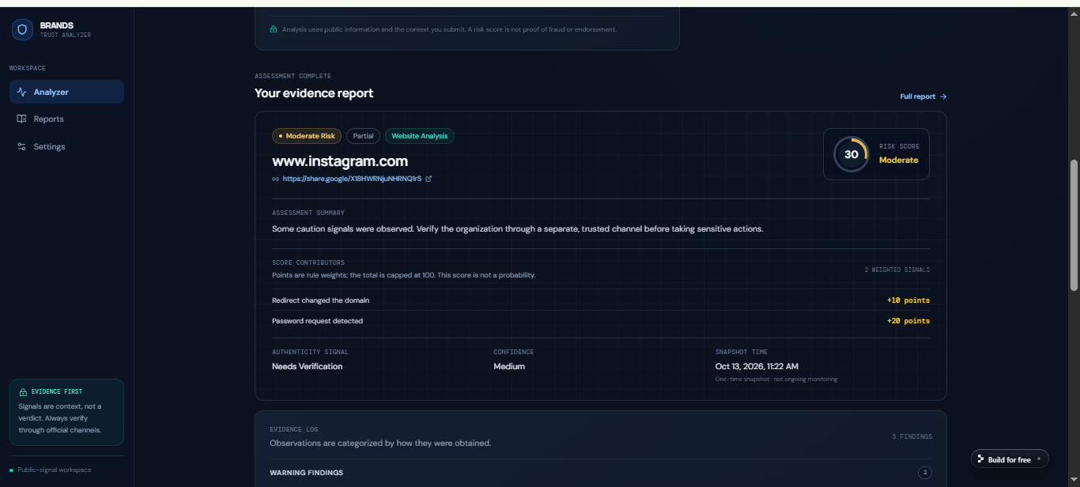
Figure 7. Example public-profile assessment with moderate-risk indicators.
This is an example output from the supplied screenshot, not a universal rating of Instagram or its official service.

11. Reports and Privacy Settings
The Reports page lets the user reopen a previously saved assessment. The interface indicates that these reports are stored privately in the current browser and do not automatically synchronize across browsers or devices.
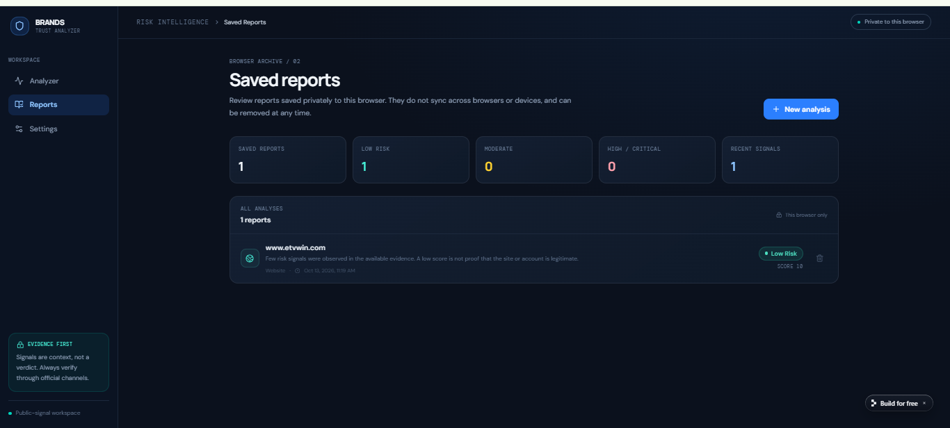
Figure 8. Saved reports available in the current browser.
The retention screen lets the user choose how long reports remain available in the browser. The supplied screenshot shows 90 days selected. Retention controls affect how long reports are kept, not how the underlying analysis is calculated.
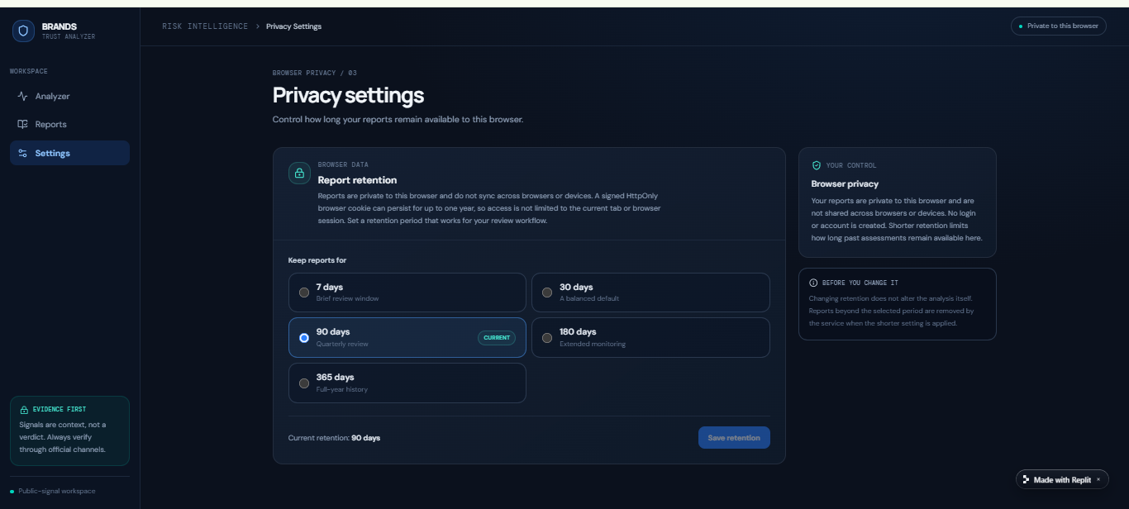
Figure 9. Privacy settings and report-retention options.

12. API Integrations and Technology Stack
Technology / API | Role in the solution
React + Vite | Frontend components, forms, dashboard, and report views.
Python + FastAPI | Backend endpoints, request validation, orchestration, and response handling.
SQLite | Lightweight storage for reports and evidence, where implemented.
OpenAI API | Can interpret relevant submitted text and generate readable explanations when enabled. It does not independently certify a website or profile.
VirusTotal API | Can provide URL/domain reputation information if an API key and working integration are configured.

API security: keep API keys in environment variables or a secret manager; never commit secrets to source control. Send only the information required for the task and explain to users when submitted text is sent to an external AI service.
Implementation accuracy: the documented stack describes the architecture and intended roles. Confirm the live source code and configuration before claiming that every integration is active.

13. How the Solution Addresses the Problem
User need | Prototype feature | Practical benefit
Quick initial review | Single Analyzer workflow | Less switching between separate review tools.
Understand why a target was flagged | Evidence log and score contributors | The user can inspect the specific signal rather than seeing only a label.
Avoid false certainty | Confidence and limitation notes | Unknown checks are distinguished from confirmed observations.
Follow up later | Saved reports and retention setting | A user can revisit prior assessments within the same browser.
Make a safer decision | Recommended next steps | Encourages independent verification before sensitive actions.

The prototype is decision support for human review. It does not replace a security analyst, guarantee detection, automatically remove impersonating accounts, or establish legal proof of fraud.

14. Conclusion
The Digital Risk Protection System brings submitted website and public-profile checks into a readable evidence report. Its key value is the combination of observable signals, a transparent risk summary, limitations, and actionable verification advice.
Future improvements can include tested API integrations, more comprehensive evidence sources, stronger validation, automated tests, and carefully authorized platform data access. Any new capability should be described only after it is implemented and verified.

