NAME: Tirkala Rishitha
Class: CSE-AI-B
Roll-no: 160724754067

Date: 03/02/2026

- Create an account in github and link the repository with the google colab
https://github.com/rishithatirkala-byte/RishithaTirkala-ai-2025-2026-Even-AI-DS-4067.git

- Write the code to implement the following data structures
  - List
  - Tuples
  - Sets and
  - Dictionaries
#implementation of list
fruits=["apple","banana","cherry"]
print(fruits)
fruits.append("orange")
fruits.insert(1,"mango")
print(fruits)
fruits.remove("banana")
print(fruits)
print(fruits[0])
print("Total fruits:",len(fruits))

OUTPUT:

['apple', 'banana', 'cherry']
['apple', 'mango', 'banana', 'cherry', 'orange']
['apple', 'mango', 'cherry', 'orange']
apple
Total fruits: 4
---------------------------------------------------------
#implementation of tuples
fruits=("apple","banana","cherry",1,5)
print(fruits)
print(fruits[0])
print(fruits[2])
print(fruits[-1])
print("Total fruits:",len(fruits))

OUTPUT:

('apple', 'banana', 'cherry', 1, 5)
apple
cherry
5
Total fruits: 5
---------------------------------------------------
#implementation of sets
fruits={"apple","banana","cherry"}
print(fruits)
fruits.add("orange")
fruits.update(["mango","grapes"])
fruits.remove("banana")
print(fruits)
print("Total fruits:", len(fruits))
set1={1,2,3,4,5}
set2={4,5,6,7,8}
#union
print("Union:",set1|set2)
#intersection
print("Intersection:",set1&set2)
#difference
print("Difference:",set1-set2)
#symmetric difference
print("Symmetric Difference:",set1^set2)

OUTPUT:

{'apple', 'cherry', 'banana'}
{'cherry', 'mango', 'orange', 'grapes', 'apple'}
Total fruits: 5
Union: {1, 2, 3, 4, 5, 6, 7, 8}
Intersection: {4, 5}
Difference: {1, 2, 3}
Symmetric Difference: {1, 2, 3, 6, 7, 8}
--------------------------------------------------------------------------
#implementation of dictionaries
student={"Name":"Sara","RollNo":42,"Course":"DS"}
print("Dictionary items:")
for key,value in student.items():
print(key,":",value)
print("Total keys:",len(student))

OUTPUT:

Dictionary items:
Name : Sara
RollNo : 42
Course : DS
Total keys: 3

- Write the code to download, save and transform the data sets from the URL
# Download and save the dataset to local drive
import pandas as pd

# Correct URL of dataset (sample CSV dataset)
url = "https://raw.githubusercontent.com/mwaskom/seaborn-data/master/iris.csv"

# Read dataset from URL
df = pd.read_csv(url)

# Display first few rows
print(df.head())

# Save dataset to local drive
df.to_csv("iris.csv", index=False)

print("Dataset saved successfully")

sepal_length sepal_width petal_length petal_width species
0 5.1 3.5 1.4 0.2 setosa
1 4.9 3.0 1.4 0.2 setosa
2 4.7 3.2 1.3 0.2 setosa
3 4.6 3.1 1.5 0.2 setosa
4 5.0 3.6 1.4 0.2 setosa
Dataset saved successfully

Date: 10/02/2026
- Write the code to implement the following searching algorithms
  - Linear search
  - Binary search
n = int(input("Enter number of elements: "))
arr = []

# input elements
for i in range(n):
arr.append(int(input(f"Enter element {i+1}: ")))

key = int(input("Enter element to search: "))

found = False

# linear search
for i in range(n):
if arr[i] == key:
print(f"{key} found at index {i}")
found = True
break

if not found:
print("Element not found")

OUTPUT:

Enter number of elements: 6
Enter element 1: 12
Enter element 2: 23
Enter element 3: 34
Enter element 4: 5
Enter element 5: 1
Enter element 6: 3
Enter element to search: 5
5 found at index 3
# binary search
n = int(input("Enter number of elements: "))
arr = []

for i in range(n):
arr.append(int(input(f"Enter element {i+1}: ")))

arr.sort()
print("\nSorted list:", arr)

key = int(input("Enter the key: "))

low = 0
high = n - 1
found = False

while low <= high:
mid = (low + high) // 2

if arr[mid] == key:
print(f"Element {key} found at index {mid}")
found = True
break
elif key < arr[mid]:
high = mid - 1
else:
low = mid + 1

if not found:
print("Element not found")

Enter number of elements: 5
Enter element 1: 6
Enter element 2: 8
Enter element 3: 4
Enter element 4: 4
Enter element 5: 8

Sorted list: [4, 4, 6, 8, 8]
Enter the key: 8
Element 8 found at index 3

- Write the code to implement the following sorting algorithms
  - Bubble sort
  - Selection sort
  - Insertion sort
# Bubble sort
n = int(input("Enter number of elements: "))
arr = []

for i in range(n):
arr.append(int(input(f"Enter element {i+1}: ")))

print("\nOriginal array:", arr)

#bubble sort logic
for i in range(n-1):
for j in range (n-1-1):
if arr[j] > arr[j+1]:
arr[j], arr[j+1]= arr[j+1], arr[j]
print("sorted array:", arr)

Enter number of elements: 5
Enter element 1: 56
Enter element 2: 34
Enter element 3: 76
Enter element 4: 88
Enter element 5: 45

Original array: [56, 34, 76, 88, 45]
sorted array: [34, 56, 76, 88, 45]

# selection sort
n = int(input("Enter number of elements: "))
arr = []

for i in range(n):
arr.append(int(input(f"Enter element {i+1}: ")))

print("\nOriginal array:", arr)

# selection sort logic
for i in range(n - 1):
min_index = i
for j in range(i + 1, n):
if arr[j] < arr[min_index]:
min_index = j

# swap after finding minimum
arr[i], arr[min_index] = arr[min_index], arr[i]

print("Sorted array:", arr)

Enter number of elements: 5
Enter element 1: 66
Enter element 2: 88
Enter element 3: 886
Enter element 4: 12
Enter element 5: 6

Original array: [66, 88, 886, 12, 6]
Sorted array: [6, 12, 66, 88, 886]
- Perform the data filtering operations any data frame using logical operators and condition based
# filtering data
import pandas as pd

data = {
"ID": [101, 102, 103],
"Name": ["Alice", "Bob", "Charlie"]
}

df = pd.DataFrame(data)

print("Original DataFrame")
print(df)

print(df[df["Name"] == "Alice"])
print(df[df["Name"] == "Charlie"])

OUTPUT:

Original DataFrame
ID Name
0 101 Alice
1 102 Bob
2 103 Charlie
ID Name
0 101 Alice
ID Name
- 103 Charlie
- Perform the following data manipulation operations
  - Adding columns
  - Updating the values
  - Conditional updates
  - Renaming columns
import pandas as pd

# data manipulation operations
data = {
"Name": ['A', 'B', 'C'],
"Age": [20, 21, 22],
"Marks": [70, 80, 90]
}

df = pd.DataFrame(data)

print("Original Data:")
print(df)

# adding a new column
df["Bonus"] = 5
print("\nAfter adding bonus:")
print(df)

# increase marks
df["Marks"] = df["Marks"] + 2
print("\nAfter increasing marks:")
print(df)

# create new column from existing columns
df["Total"] = df["Marks"] + df["Bonus"]
print("\nAfter adding total:")
print(df)

# change value
df.loc[0, "Age"] = 21
print("\nAfter changing Age of first student:")
print(df)

# rename column
df.rename(columns={"Total": "Final"}, inplace=True)
print("\nAfter renaming Total to Final:")
print(df)

# remove a column
df.drop("Bonus", axis=1, inplace=True)
print("\nAfter removing Bonus column:")
print(df)

OUTPUT:

Original Data:
Name Age Marks
0 A 20 70
1 B 21 80
2 C 22 90

After adding bonus:
Name Age Marks Bonus
0 A 20 70 5
1 B 21 80 5
2 C 22 90 5

After increasing marks:
Name Age Marks Bonus
0 A 20 72 5
1 B 21 82 5
2 C 22 92 5

After adding total:
Name Age Marks Bonus Total
0 A 20 72 5 77
1 B 21 82 5 87
2 C 22 92 5 97

After changing Age of first student:
Name Age Marks Bonus Total
0 A 21 72 5 77
1 B 21 82 5 87
2 C 22 92 5 97

After renaming Total to Final:
Name Age Marks Bonus Final
0 A 21 72 5 77
1 B 21 82 5 87
2 C 22 92 5 97

After removing Bonus column:
Name Age Marks Final
0 A 21 72 77
1 B 21 82 87
2 C 22 92 97

import pandas as pd

data = {
"ID": [101, 102, 103],
"Name": ['abc', 'xyz', 'pqr']
}

df = pd.DataFrame(data)

print(df)
print(df[["Name"]])
print("location 0\n", df.iloc[0])
print("location to 3\n", df.iloc[0:3, 1:2])

OUTPUT:

ID Name
0 101 abc
1 102 xyz
2 103 pqr
Name
0 abc
1 xyz
2 pqr
location 0
ID 101
Name abc
Name: 0, dtype: object
location to 3
Name
0 abc
1 xyz
- pqr

- Perform the grouping operations on any of the data frames

# Grouping
import pandas as pd

# Simple Dataframe
data = {
"Department": ["IT", "IT", "HR", "HR", "Finance"],
"Name": ["A", "B", "C", "D", "E"],
"Marks": [80, 85, 75, 90, 88]
}

df = pd.DataFrame(data)

print("Original Data:")
print(df)

print("\n Average Marks by department:")
print(df.groupby("Department")["Marks"].mean())

print("\nTotal marks by department:")
print(df.groupby("Department")["Marks"].sum())

OUTPUT:

Original Data:
Department Name Marks
0 IT A 80
1 IT B 85
2 HR C 75
3 HR D 90
4 Finance E 88

Average Marks by department:
Department
Finance 88.0
HR 82.5
IT 82.5
Name: Marks, dtype: float64

Total marks by department:
Department
Finance 88
HR 165
IT 165
Name: Marks, dtype: int64

# Rearrange

import pandas as pd

data = {
"Name": ["A", "B", "C"],
"Age": [22, 21, 23],
"Marks": [85, 90, 80]
}

df = pd.DataFrame(data)

print("Original DataFrame:")
print(df)

# Rearranging rows by Marks (ascending)
df_sorted = df.sort_values(by="Marks")

print("\nAfter rearranging rows by marks (ascending):")
print(df_sorted)

# Rearranging rows by Marks (descending)
df_sorted_desc = df.sort_values(by="Marks", ascending=False)

print("\nAfter rearranging rows by marks (descending):")
print(df_sorted_desc)

# Rearranging columns
df_rearranged_cols = df[["Marks", "Name", "Age"]]

print("\nAfter rearranging columns:")
print(df_rearranged_cols)

OUTPUT:

Original DataFrame:
Name Age Marks
0 A 22 85
1 B 21 90
2 C 23 80

After rearranging rows by marks (ascending):
Name Age Marks
2 C 23 80
0 A 22 85
1 B 21 90

After rearranging rows by marks (descending):
Name Age Marks
1 B 21 90
0 A 22 85
2 C 23 80

After rearranging columns:
Marks Name Age
0 85 A 22
1 90 B 21
2 80 C 23

# Plotting

import matplotlib.pyplot as plt

x = [1, 2, 3, 4, 5]
y = [2, 4, 6, 8, 10]

plt.plot(x, y)
plt.xlabel("X values")
plt.ylabel("Y values")
plt.title("X-Y Graph")
plt.show()

OUTPUT:
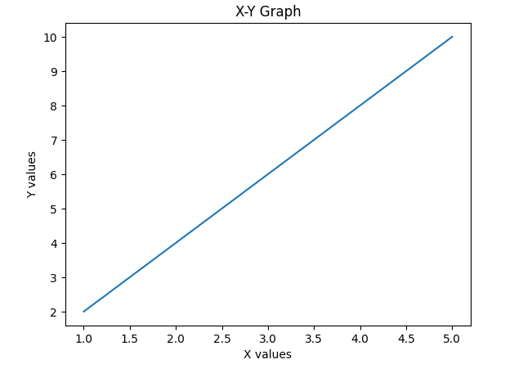--------------------------------------------------------------------------------------------------------------------------------------

Week 3 : 17.02.2026
12. Write the code to implement the following operations on any data set reading from URL
  - Data filtering
  - Data Manipulation
  - Data ranking

# Import libraries
import pandas as pd
import numpy as np
import matplotlib.pyplot as plt

# Load Iris dataset (working public CSV link)
url = "https://raw.githubusercontent.com/mwaskom/seaborn-data/master/iris.csv"
df = pd.read_csv(url)

print("Dataset (first 10 rows):")
print(df.head(10))

# Select the sepal length column
data = df["sepal_length"]

print("\nSummary Statistics:")
print(data.describe())

print("\nVariance:", np.var(data))
print("Standard Deviation:", np.std(data))

# Plot histogram
plt.figure(figsize=(8,5))
plt.hist(data, bins=10, color='skyblue', edgecolor='black')

# Mean line
plt.axvline(np.mean(data), color='red', linestyle='dashed',
linewidth=2, label=f"Mean: {np.mean(data):.2f}")

# Median line
plt.axvline(np.median(data), color='green', linestyle='dashed',
linewidth=2, label=f"Median: {np.median(data):.2f}")
plt.xlabel("Sepal Length (cm)")
plt.ylabel("Frequency")
plt.title("Distribution of Sepal Length")
plt.legend()
plt.show()

# Skewness inference
mean_value = np.mean(data)
median_value = np.median(data)

print("\nInference:")
print("Mean value:", mean_value)
print("Median value:", median_value)

if mean_value > median_value:
print("Data is slightly right-skewed")
elif mean_value < median_value:
print("Data is slightly left-skewed")
else:
print("Data is symmetric")

OUTPUT:

Dataset (first 10 rows):
sepal_length sepal_width petal_length petal_width species
0 5.1 3.5 1.4 0.2 setosa
1 4.9 3.0 1.4 0.2 setosa
2 4.7 3.2 1.3 0.2 setosa
3 4.6 3.1 1.5 0.2 setosa
4 5.0 3.6 1.4 0.2 setosa
5 5.4 3.9 1.7 0.4 setosa
6 4.6 3.4 1.4 0.3 setosa
7 5.0 3.4 1.5 0.2 setosa
8 4.4 2.9 1.4 0.2 setosa
9 4.9 3.1 1.5 0.1 setosa

Summary Statistics:
count 150.000000
mean 5.843333
std 0.828066
min 4.300000
25% 5.100000
50% 5.800000
75% 6.400000
max 7.900000
Name: sepal_length, dtype: float64

Variance: 0.6811222222222222
Standard Deviation: 0.8253012917851409
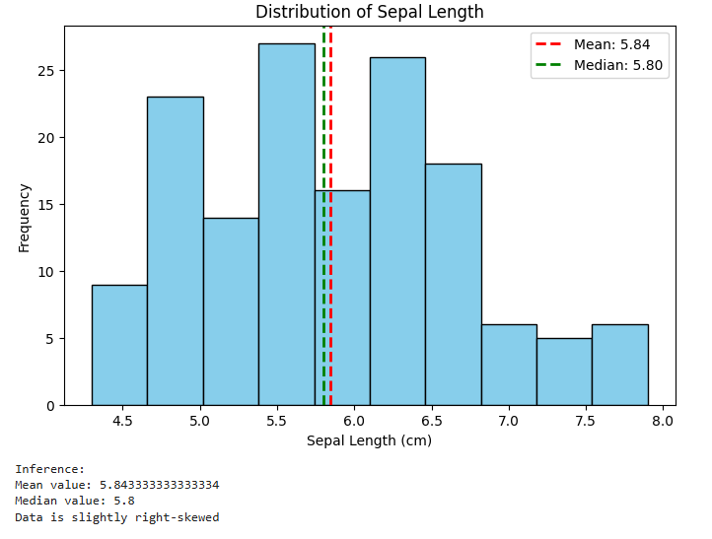

import pandas as pd
import numpy as np
import matplotlib.pyplot as plt

# Create data
data = [10, 12, 15, 18, 20, 22, 25, 30, 35, 40]

# Create DataFrame
df = pd.DataFrame(data, columns=["Values"])

print("Dataset:")
print(df)

print("\nSummary Statistics:")
print(df.describe())

print("\nVariance:", np.var(data))
print("Standard Deviation:", np.std(data))

# Plot histogram
plt.hist(data, bins=5, color='skyblue', edgecolor='black')
plt.xlabel("Values")
plt.ylabel("Frequency")
plt.title("Data Distribution")
plt.show()

# Calculate mean and median
mean_value = np.mean(data)
median_value = np.median(data)
print("\nInference")
print("Mean Value:", mean_value)
print("Median Value:", median_value)
if mean_value > median_value:
print("Data is slightly right-skewed")

elif mean_value < median_value:
print("Data is slightly left-skewed")

else:
print("Data is symmetric")

OUTPUT:

Dataset:
Values
0 10
1 12
2 15
3 18
4 20
5 22
6 25
7 30
8 35
9 40

Summary Statistics:
Values
count 10.000000
mean 22.700000
std 9.855061
min 10.000000
25% 15.750000
50% 21.000000
75% 28.750000
max 40.000000

Variance: 87.41
Standard Deviation: 9.34933152690608

