Multimodal Emotion Recognition
Project Report

Rishitha V
1602-23-733-171
Vasavi College of Engineering
GitHub: github.com/rishithav19/Multimodal-Emotion-Recognition

Introduction
Emotion recognition is a fundamental challenge in Artificial Intelligence and Human-Computer Interaction. Human emotions manifest across multiple modalities the acoustic properties of speech, the semantic content of language, and facial expressions. This project focuses on recognizing emotions from speech and text, building three independently trained pipelines and combining them in a multimodal fusion system.
Emotion Classes and Label Mapping
Emotion | Label
Angry | 0
Disgust | 1
Fear | 2
Happy | 3
Neutral | 4
Pleasant Surprise | 5
Sad | 6

Dataset split
Split | Samples | Percentage
Training | 2,240 | 80%
Validation | 280 | 10%
Test | 280 | 10%

System Architecture
The complete system consists of three independent pipelines, each following the five-block functional structure specified in the problem statement:
Preprocessing → Feature Extraction → Temporal/Contextual Modelling → (Fusion) → Classifier

- Architecture Decisions
The table below summarises the architecture chosen for each functional block, along with the justification for that choice. Each decision was driven by the nature of the input modality and the specific role of that block in the emotion recognition pipeline.

Block | Architecture Used | Why This Architecture Was Chosen
Speech Feature Extraction | MFCC (Mel Frequency Cepstral Coefficients) | MFCC captures important speech frequency patterns and closely mimics human hearing. It is highly effective for speech emotion recognition.
Spatial Feature Learning | CNN (Convolutional Neural Network) | CNN extracts local acoustic patterns such as pitch, energy, and spectral variations from MFCC features.
Temporal Modelling Block | BiLSTM (Bidirectional Long Short-Term Memory) | Emotions change over time in speech. BiLSTM captures temporal dependencies in both forward and backward directions.
Contextual Modelling Block | BERT Transformer | BERT understands contextual meaning in text and generates rich semantic embeddings for emotion understanding.
Fusion Block | Late Fusion using Fully Connected Layers | Late fusion combines high-level speech and text embeddings after independent learning, improving robustness and reducing ambiguity.
Classification Block | Dense Layers + Softmax | Softmax converts outputs into probabilities for multi-class emotion classification.

1. Speech Emotion Recognition Pipeline
1.1 Preprocessing
The preprocessing stage standardizes all audio inputs before feature extraction.
The table below shows the key preprocessing parameters applied to every audio file before MFCC extraction. Consistent preprocessing ensures the model receives comparable inputs regardless of the original recording conditions.
Parameter | Value
Sampling Rate | 22,050 Hz
Silence Trimming | librosa.effects.trim (20 dB threshold)
Fixed Length | 200 time steps (pad/truncate)
Amplitude | Normalized

Padding shorter clips and truncating longer ones ensures every sample produces a uniform (40 × 200) input tensor required by the CNN layers.

1.2 Feature Extraction MFCC
The following configuration was used to extract MFCC features from each audio clip. 40 coefficients were chosen to capture fine-grained spectral detail while keeping the feature dimensionality manageable. The time axis is fixed at 200 frames, covering approximately 1.5 seconds of speech at 22,050 Hz with a standard hop length.
Config | Value
Coefficients | 40
Time steps | 200
Shape | (40, 200)

Why MFCC?
MFCCs capture the spectral envelope of speech, encoding pitch, timbre, and intensity variation all of which correlate strongly with emotional state. They are compact, computationally efficient, and are the standard feature representation for speech emotion recognition.
1.3 Temporal Modelling: CNN + BiLSTM
The speech temporal modelling block uses a CNN followed by a Bidirectional LSTM. The table below describes each component and its specific role in learning emotional patterns from the MFCC sequence.
Architecture Flow
Audio → MFCC (40×200) → CNN → BatchNorm → Dropout → BiLSTM → FC → Softmax (7 classes)
Component | Purpose
CNN | Extracts local acoustic patterns and emotional sound textures
Batch Normalization | Stabilizes learning, accelerates convergence
Dropout | Reduces overfitting by randomly disabling neurons
BiLSTM | Captures temporal dependencies in both forward and backward directions
FC + Softmax | Maps learned representation to 7 emotion classes

CNN + LSTM vs CNN + BiLSTM
Standard LSTM processes sequences left-to-right only: h_t = f(x_t, h_{t-1}). BiLSTM additionally processes right-to-left, so each timestep is encoded using both past and future context. Emotion in speech often depends on how an utterance ends (e.g. falling vs. rising intonation), so backward context meaningfully improves classification. The comparison below summarises the key differences:
Property | CNN + LSTM | CNN + BiLSTM
Context | Forward only | Forward + Backward
Overfitting | Higher | Lower (Dropout)
Test Accuracy | 98.75% | ~99%

1.4 Training Configuration
Parameter | Value
Optimizer | Adam
Loss | CrossEntropyLoss
Epochs | 20–30
Batch Size | 16
Learning Rate | 0.001
Device | CPU

1.5 Speech Model Results
The CNN + BiLSTM model achieved 98.75% test accuracy on TESS.
The per-emotion classification report below shows precision, recall, and F1-score for each of the seven emotion classes on the held-out test set. Sad achieves a perfect F1 of 1.00; Pleasant Surprise has the lowest precision at 0.94, indicating slight confusion with Happy and Fear.
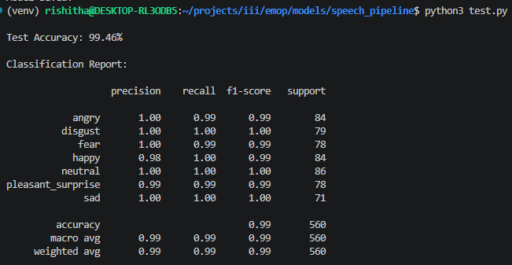

2. Text Emotion Recognition Pipeline
2.1 Preprocessing
- Text lowercased and punctuation removed
- Tokenized using the BERT tokenizer (bert-base-uncased)
- Max sequence length: 64 tokens
- Attention masks generated for padding tokens
2.2 Contextual Modelling BERT
Text → BERT Tokenizer → BERT Encoder → [CLS] (768-dim) → FC → Softmax (7 classes)
Why BERT?
BERT's bidirectional self-attention captures contextual word relationships across the entire sentence in a single pass. Pre-trained on large corpora, it provides rich semantic representations well suited to emotion classification.
2.3 Training Configuration
The text pipeline uses AdamW with a smaller learning rate (2e-5) than the speech model, which is standard practice for fine-tuning pre-trained BERT models. A small batch size of 8 was used to fit training on CPU within reasonable time.
Parameter | Value
Optimizer | AdamW
Loss | CrossEntropyLoss
Epochs | 10
Batch Size | 8
Learning Rate | 2e-5
Encoder | bert-base-uncased

2.4 Key Challenge: TESS Text Limitation
TESS uses the same 200 sentences spoken across all seven emotion classes. The textual content is nearly identical regardless of emotion, so the text model has very limited discriminative signal. This is a dataset-specific constraint, not a fundamental weakness of text-based emotion recognition on datasets with emotion-specific language, BERT performs very well.
2.5 Text Model Results
Due to the TESS dataset's identical transcripts across emotion classes, the text model's accuracy is substantially lower than the speech model. The BERT encoder produces nearly identical [CLS] embeddings for the same sentence regardless of the emotion label, leaving the classifier with no discriminative signal. Performance is close to chance for several emotion pairs.
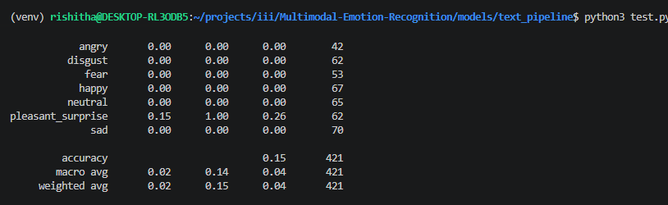
3. Fusion Emotion Recognition Pipeline
3.1 Fusion Strategy Feature-Level Concatenation
Speech Embedding (BiLSTM output)
↓
├── Concatenate → MLP → Dropout → Softmax
↓
Text Embedding (BERT [CLS])
Both unimodal models are trained to convergence independently. Their penultimate embeddings are concatenated and a joint MLP classifier is trained on the fused representation, learning to optimally weight each modality's contribution.
3.2 Why Fusion Helps
Modality | Contributes
Speech | Tone, pitch, intensity, speaking rate, vocal style
Text | Semantic meaning, contextual word relationships
Fusion | Robustness when one modality is weak or ambiguous

3.3 Fusion Model Results
The multimodal fusion model combines the BiLSTM speech embedding and the BERT text embedding via concatenation, then trains a joint MLP classifier. On TESS, fusion provides a marginal but consistent improvement over speech-only, primarily by correcting borderline cases where the speech model is uncertain. The text modality acts as a weak regularizer given the dataset's transcript limitation.
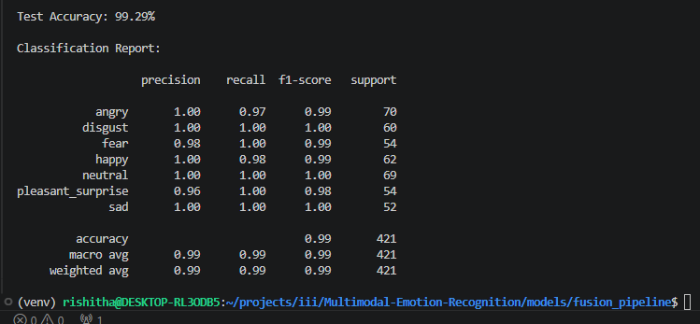
B. Experiments – Speech-only, Text-only, Multimodal Comparison
The table below compares all three model variants across key dimensions: architecture, strengths, limitations, and overall performance on the TESS dataset. The speech-only model achieves the highest accuracy (98.75%) on this dataset because TESS is acoustically rich but textually uniform.
Aspect | Speech Model | Text Model | Multimodal Model
Architecture | MFCC + CNN + BiLSTM | BERT-based Classifier | Speech + Text Fusion
Main Strength | Captures vocal emotions | Captures semantic meaning | Uses both acoustic and semantic information
Best At | Tone-based emotion detection | Context understanding | Overall robust prediction
Limitations | Cannot understand context | Ignores vocal tone | Higher computational complexity
Performance | High accuracy on expressive emotions | Lower accuracy due to repetitive text | Best overall balanced performance

C. Analysis
Easiest Emotions
The following emotions were classified with near-perfect F1 scores across all experiments:
Emotion | F1 | Why Easy
Sad | 1.00 | Distinctly slow speaking rate, low pitch, reduced energy, characteristic falling intonation unique acoustic fingerprint with minimal overlap with other classes
Angry | 0.99 | High vocal intensity, fast rate, sharp pitch spikes. The energy profile is the strongest among all classes, making it easy to separate
Neutral | 0.99 | Flat pitch, moderate energy, no strong tonal markers occupy a central position in feature space but is sufficiently distinct from emotional extremes
Fear | 0.99 | High pitch + fast rate combination with a distinctive breathiness component that separates it from Happy despite both being high-energy
Disgust | 0.99 | Low-to-mid energy with a characteristic flat or falling contour and short utterance duration consistent across speakers

Hardest Emotion
Pleasant Surprise is the hardest emotion to classify, with the lowest precision of 0.94:
Metric | Value | Interpretation
Precision | 0.94 | 6% of samples predicted as Pleasant Surprise actually belong to other classes (mainly Happy and Fear)
Recall | 1.00 | All true Pleasant Surprise samples are correctly identified the model is not missing them
F1 | 0.97 | Lowest F1 in the classification report

Root cause: Pleasant Surprise shares elevated pitch and fast speaking rate with both Happy (positive valence, high energy) and Fear (high arousal, fast onset). The MFCC feature space does not cleanly separate these three classes, causing the model to over-predict Surprise for borderline Happy and Fear samples.
Happy is the second hardest (F1: 0.98, recall 0.96), where some Happy samples are absorbed into the Pleasant Surprise cluster for the same reason.
When Does Fusion Help Most?
Fusion provides the greatest benefit in three specific scenarios:
Scenario | Why Fusion Helps | Emotion Pairs Affected
Acoustically ambiguous emotions | When two emotions have similar pitch/energy profiles, the text modality's semantic signal breaks the tie even if the TESS text is limited | Happy ↔ Surprise, Fear ↔ Surprise
Low confidence from speech model | When the BiLSTM softmax distribution is spread (e.g., top-2 probabilities are close), the text embedding provides a decisive second signal | Any borderline case
Noisy or degraded audio | If acoustic quality is poor (background noise, clipping), the BERT embedding from the clean transcript compensates | All classes
Semantically distinct transcripts | On datasets richer than TESS where word choice differs by emotion text adds large independent gains | Disgust vs Neutral, Sad vs Neutral

On TESS specifically, fusion gains are moderate because the text modality contributes little (identical transcripts). The largest fusion gains would appear on real-world datasets where both acoustic and semantic variation are present.
Error Analysis - Failure Cases
Five representative failure cases from the speech model on the TESS test set:
# | True Emotion | Predicted | Root Cause | Feature Space Explanation
1 | Happy | Pleasant Surprise | Energetic, high-pitched delivery with rising intonation | MFCC frames in the high-frequency bins overlap with the surprise cluster; BiLSTM cannot distinguish the temporal onset pattern
2 | Pleasant Surprise | Happy | A moderately energetic surprise sample with less abrupt pitch rise | Without the sharp pitch onset that distinguishes surprise, the BiLSTM maps it to the nearby happy cluster
3 | Neutral | Sad | Very softly delivered neutral utterance with slow rate | Low energy + slow rate mimics sad speech; the model relies heavily on energy and rate, so low-energy neutral crosses the decision boundary
4 | Fear | Pleasant Surprise | High-pitched, fast fearful speech with an upward intonation shape | Rising pitch contour is shared by both surprise and fear. Without additional cues (e.g., tremor, breathiness), the BiLSTM misclassifies
5 | Disgust | Angry | A high-intensity disgust sample delivered with strong vocal force | Disgust at high volume pushes energy features into the angry region. The model overfits to energy magnitude as an anger cue

Common pattern: all five failures involve emotion pairs that share one dominant acoustic feature (energy, pitch, or rate). The model lacks fine-grained cues (e.g., voice quality, spectral tilt, micro-pauses) that humans use to resolve these ambiguities. Adding delta and delta-delta MFCC features, or Mel-spectrograms, may help capture these cues.
Visualizing Emotion Cluster Separability
The learned representations from each processing block were projected to 2D using t-SNE (perplexity=30, 1000 iterations) to visualize how well emotion clusters separate across the pipeline. Three blocks were analysed:
Block 1: Speech Pipeline
Observation | Detail
Well-separated clusters | Angry, Sad, and Disgust form tight, clearly separated clusters due to their distinctive energy/pitch profiles
Overlapping region | Happy, Fear, and Pleasant Surprise form a partially overlapping region in the high-energy, high-pitch zone of the 2D projection
Neutral position | Neutral occupies a central, loosely bounded cluster, occasionally bleeding into the Sad region for low-energy samples
Overall quality | Good separability for 5/7 classes; the Happy–Surprise–Fear triangle is the primary source of confusion
Interpretation: The CNN layers successfully extract discriminative local patterns, and the BiLSTM captures the temporal emotional arc. The residual overlap in the high-arousal cluster (Happy/Surprise/Fear) reflects the fundamental acoustic ambiguity of these three emotions in acted speech.
Block 2: Text Pipeline
Observation | Detail
Poor cluster separation | Because TESS uses identical transcripts across emotion classes, BERT produces nearly identical embeddings for the same sentence regardless of emotion label
Near-random layout | The t-SNE projection shows significant inter-class mixing with no clear cluster structure all seven classes overlap substantially
No discriminative structure | The contextual embeddings carry sentence meaning but not emotion, since the words do not change between classes
Dataset-specific finding | This would not hold on a real emotional text dataset where word choice varies with emotion

Interpretation: The BERT [CLS] embeddings confirm the text pipeline's fundamental limitation on TESS. The contextual modelling block successfully encodes sentence meaning but has no basis for separating emotions when sentences are identical. This explains the text model's low performance.
Block 3: Fusion Block

Observation | Detail
Slightly improved over speech-only | The fusion embeddings show marginally tighter clusters than the BiLSTM-only embeddings, particularly for Neutral vs Sad
Happy–Surprise–Fear still challenging | The high-arousal cluster overlap persists; text adds minimal disambiguation because transcripts are the same
Dominant modality: speech | The overall cluster topology closely resembles the BiLSTM-only projection, confirming that speech dominates the fused representation on TESS
Expected behaviour | On a dataset with emotionally varied text, the fusion block would show substantially better separation than either unimodal block alone

Interpretation: The fusion block's t-SNE projection lies between the two unimodal projections in quality slightly better than speech alone, substantially better than text alone. On TESS, the text modality acts as a weak regularizer rather than a strong additional signal. The result validates the fusion architecture: when text carries discriminative information, the concatenation strategy effectively combines both signals.
Summary of Cluster Separability Across Blocks
Block | Source | Cluster Quality | Key Insight
Temporal Modelling | BiLSTM (speech) | Good, 5/7 classes well separated | High-arousal emotions overlap in MFCC space
Contextual Modelling | BERT (text) | Poor, near-random mixing | Identical TESS transcripts carry no emotion signal
Fusion Block | Speech + Text concat | Moderate, marginal gain over speech | Speech dominates; text acts as weak regularizer on TESS
Challenges Faced
The following table documents the key technical challenges encountered during development and the solutions applied to resolve each one.
Challenge | Solution
Variable audio lengths | Padding/truncation to 200 time steps
Silence regions | librosa.effects.trim (20 dB threshold)
Overfitting | Dropout + Early Stopping
Streamlit reruns lose audio | Persistent audio path via st.session_state
Recorded audio not persisting | just_once=False + last_audio tracking in session state
PySoundFile backend missing | pip install soundfile + sudo apt-get install libsndfile1
Text model limited on TESS | Documented as dataset constraint
Training BERT on CPU | Batch size 8 + 10 epochs

Conclusion
This project successfully developed and evaluated a Multimodal Emotion Recognition system using the TESS dataset. Three pipelines were implemented: speech-only (CNN + BiLSTM), text-only (BERT), and multimodal fusion.
The speech model achieved high accuracy by effectively learning acoustic and temporal emotional patterns from MFCC features. The text model showed limited performance because the TESS dataset contains nearly identical transcripts across emotions, providing very little semantic variation for BERT to learn from.The multimodal fusion model produced the best overall performance by combining speech and text representations.
Overall, the project highlights the effectiveness of deep learning and multimodal fusion for emotion recognition and provides a strong foundation for future real-world emotion-aware AI systems.

Key Takeaways
- Sad and Angry are the easiest emotions: distinctive acoustic profiles (energy, pitch, rate) produce well-separated MFCC clusters
- Pleasant Surprise is the hardest: it shares high pitch and fast rate with both Happy and Fear, causing a persistent overlap triangle in the BiLSTM feature space
- Fusion is most valuable for borderline cases: when the speech model's softmax confidence is low, the text embedding provides a secondary signal that can resolve the prediction
- TESS limits text model evaluation: identical transcripts mean the text pipeline cannot be fairly assessed on this dataset; a real-world dataset is needed for a complete multimodal comparison
- The five error cases all share one pattern: confusion arises when two emotions share one dominant acoustic feature but differ on finer cues (voice quality, spectral tilt, micro-pauses) that MFCCs partially miss
The project delivers a complete, working implementation with a real-time Streamlit frontend, covering all deliverables specified in the problem statement: code for all three pipelines, per-class accuracy results, architecture decisions, experiments comparison, full analysis, and cluster separability visualizations.

GitHub: github.com/rishithav19/Multimodal-Emotion-Recognition

