**1)Vowels Counter**

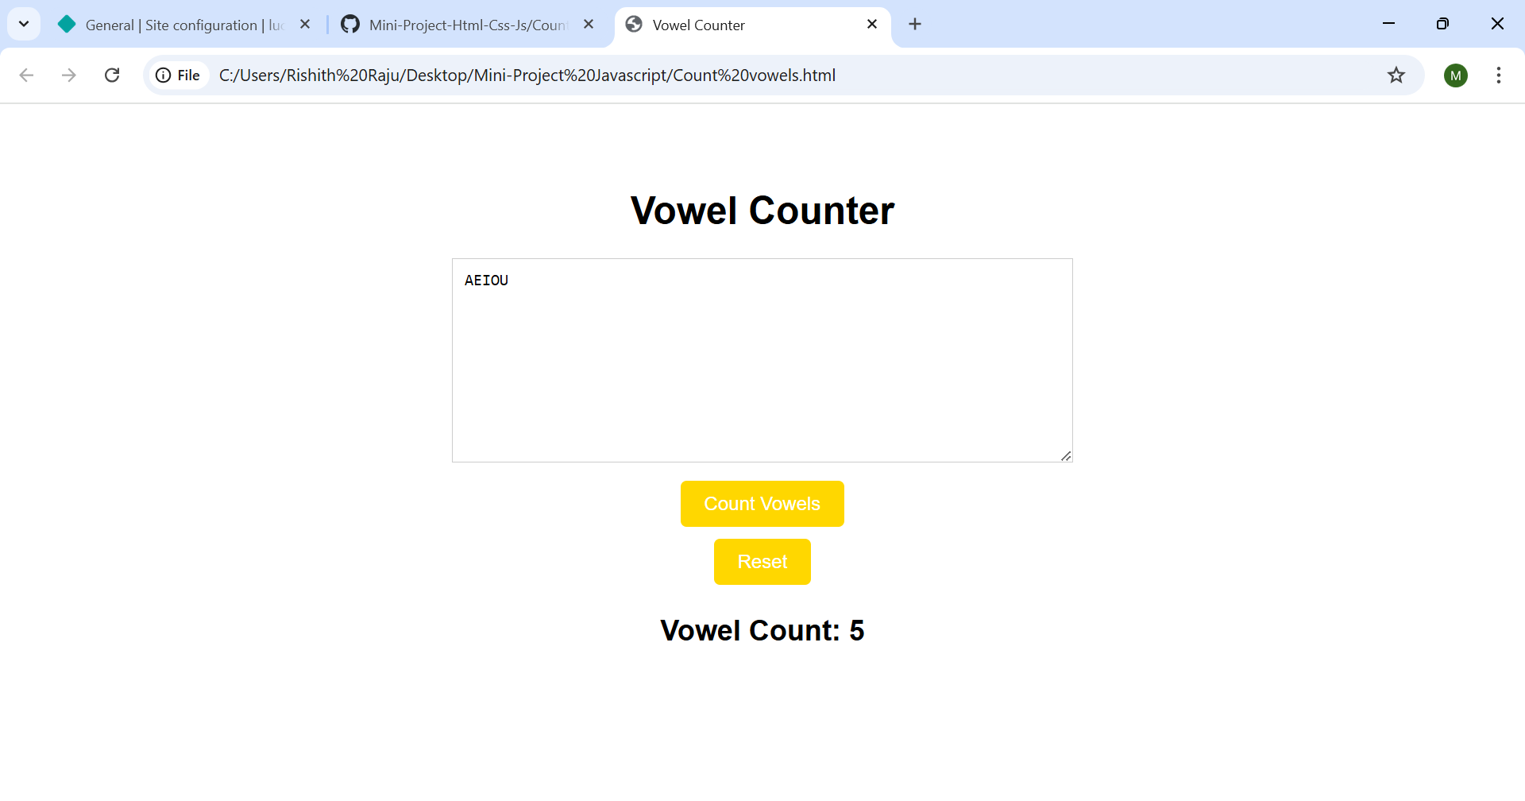

**2.)12- Hours Digital Clock**

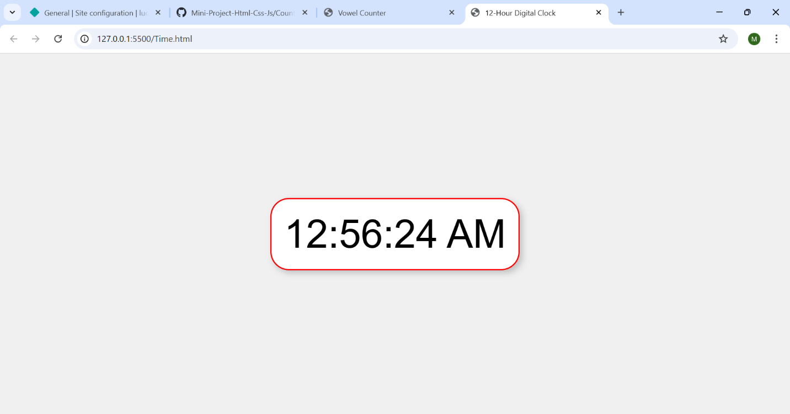

**Git Hub Repo:** [**https://github.com/rishithraju/Mini-Project-Html-Css-Js.git**](https://github.com/rishithraju/Mini-Project-Html-Css-Js.git)