LAB 1: REQUIREMENTS ENGINEERING & UML USE-CASE MODELLING
Problem Statement #29: Municipal Infrastructure Damage Reporting App
NAME: RISHIT V N S
SRN: PES1UG24AM225
Requirements Table :
ID | Type | Description | Priority | Acceptance Criteria | Rationale
FR-001 | Functional | The system shall allow a Citizen Reporter to select an infrastructure damage category such as pothole, broken streetlight, or water pipeline leak and enter a description of the issue. | High | Pass: The citizen can select one valid damage category and enter the issue description before proceeding. Fail: The system allows submission without selecting a damage category. | Categorizing the issue helps the municipality understand the nature of the problem and process it appropriately.
FR-002 | Functional | The system shall allow a Citizen Reporter to upload one or more photographs as evidence of the reported infrastructure damage. | High | Pass: Valid image files are uploaded and attached to the corresponding report. Fail: The system accepts unsupported or corrupted files as evidence. | Photographic evidence helps Municipal Engineers verify the reported damage and assess its severity.
FR-003 | Functional | The system shall extract GPS location information from geotagged photographs and associate the coordinates with the submitted damage report. | High | Pass: The submitted report contains valid latitude and longitude coordinates and displays the incident location on the map. Fail: The system records an invalid or unrelated location. | Accurate location information enables municipal teams to identify the exact site requiring attention.
FR-004 | Functional | The system shall automatically assign submitted damage reports to the appropriate Municipal Engineering division based on the reported damage category and location. | High | Pass: A report is assigned to the appropriate municipal division and the assignment is recorded. Fail: A valid report remains unassigned or is assigned to an unrelated division. | Automatic assignment reduces processing time and ensures that complaints reach the responsible department.
FR-005 | Functional | The system shall allow a Municipal Engineer to review assigned reports and update their status and resolution details. | Medium | Pass: An authorized engineer can review an assigned report and update its status and resolution information. Fail: An unauthorized user can modify the report or the status update is not saved. | This provides an organized workflow for resolving infrastructure complaints and maintaining accountability.
NFR-001 | Non-Functional — Performance & Security | The system shall save an incomplete or completed damage report locally when network connectivity is unavailable and synchronize the stored report automatically when connectivity is restored. | High | Pass: A report created without network connectivity is preserved and automatically synchronized after the connection returns. Fail: The report or its attached information is lost during synchronization. | Citizens may need to report infrastructure problems in locations with poor or unavailable mobile connectivity.
NFR-002 | Non-Functional — Security | The system shall protect user accounts, uploaded photographs, GPS information, and report data through authenticated access and secure data transmission. | High | Pass: Only authenticated users can access authorized reports and transmitted report data is protected. Fail: An unauthenticated or unauthorized user can access restricted report information. | Reports may contain location information, photographs, and user data that must be protected from unauthorized access.

UML Use-Case Diagram: (using draw.io)

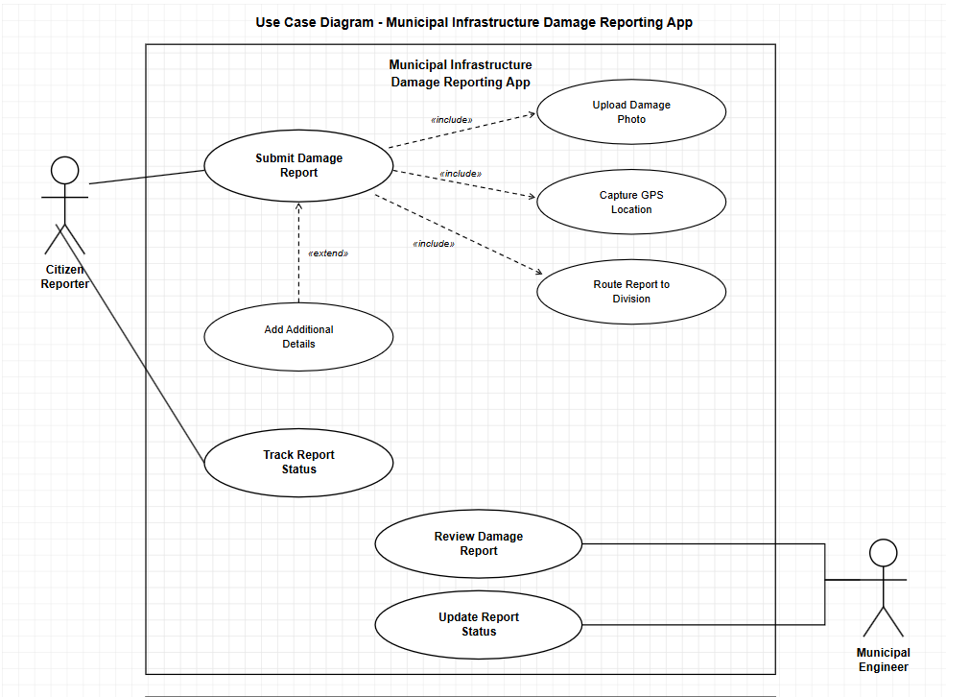

«include» relationship
Represents mandatory, reusable behaviour — the included use case always executes as part of the base use case, every single time.

«extend» relationship
Represents optional or conditional behaviour — the extending use case runs only under certain circumstances, not every time.

USE-CASE FLOW SPECIFICATION:

Field | Specification
Use Case ID | UC-001
Use Case Name | Submit Damage Report
Primary Actor | Citizen Reporter
Supporting System/Actor | Municipal Infrastructure Damage Reporting App
Goal | Allow a citizen to report municipal infrastructure damage with photographic evidence and location information.

Main Success Scenario
- The Citizen Reporter opens the Submit Damage Report function.
- The system displays the available infrastructure damage categories.
- The Citizen Reporter selects the appropriate damage category and enters a description of the issue.
- The Citizen Reporter uploads one or more photographs showing the infrastructure damage.
- The system validates and attaches the uploaded photographs to the report.
- The system captures the GPS location of the reported damage.
- The system associates the GPS coordinates with the damage report.
- The system creates the damage report with the entered details, photographs, and location.
- The system automatically routes the report to the appropriate municipal engineering division.
- The system confirms successful submission and provides a report status for tracking.

Alternate Flow – Invalid/Unsupported Photo
A1. At Step 5, the system detects that the uploaded image is invalid, unsupported, or corrupted.
A2. The system displays an error message asking the Citizen Reporter to upload a valid image.
A3. The Citizen Reporter uploads a valid photograph.
A4. The system validates the photograph and continues with Step 6 of the Main Success Scenario.

Preconditions :
- The Citizen Reporter has access to the Municipal Infrastructure Damage Reporting App.
- The Citizen Reporter has identified a municipal infrastructure problem such as a pothole, broken streetlight, or water pipeline leak.
- The device has access to location services for capturing GPS coordinates.

Postconditions :
- The damage report is successfully stored in the system.
- The uploaded damage photo and GPS location are associated with the report.
- The report is routed to the appropriate municipal engineering division.
- A report status is created so that the Citizen Reporter can track the complaint.

