Lab 2: Agile Backlog Creation G Sprint Simulation in Jira NAME: RISHIT V N S
SRN: PES1UG24AM225

PROBLEM STATEMENT 29:
MUNICIPAL INFRASTRUCTURE DAMAGE REPORTING APP

Epic ID | Epic Name | Epic Priority | Story ID | User Story Title | User Story | Story Priority
MIDRA-1 | Damage Reporting | Medium | MIDRA-6 | Report Infrastructure Damage | As a citizen, I want to report municipal infrastructure damage such as potholes, broken streetlights, and water pipeline leaks so that the responsible municipal authorities can take appropriate action. | High
MIDRA-1 | Damage Reporting | Medium | MIDRA-7 | Select Damage Category | As a citizen, I want to select the category of infrastructure damage so that the municipality can correctly identify and route the reported issue. | Medium
MIDRA-1 | Damage Reporting | Medium | MIDRA-8 | Submit Damage Report | As a citizen, I want to submit my completed damage report so that the reported municipal infrastructure issue can be recorded and reviewed by the responsible authorities. | High
MIDRA-2 | Photo and Location Capture | Medium | MIDRA-9 | Capture Damage Photo | As a citizen, I want to capture and upload photos of the infrastructure damage so that municipal authorities can visually assess the issue. | High
MIDRA-2 | Photo and Location Capture | Medium | MIDRA-10 | Capture Current Location | As a citizen, I want to automatically capture my current location so that the municipal authorities can accurately identify where the damage occurred. | High
MIDRA-2 | Photo and Location Capture | Medium | MIDRA-11 | Verify Photo and Location Details | As a citizen, I want to review and verify the uploaded photo and location details before submitting the report so that the information provided is accurate. | Medium
MIDRA-3 | Damage Verification and Classification | High | MIDRA-12 | Verify Submitted Damage Report | As a municipal authority, I want to verify submitted infrastructure damage reports so that inaccurate, duplicate, or incomplete reports can be identified before further action is taken. | High
MIDRA-3 | Damage Verification and Classification | High | MIDRA-13 | Classify Damage Severity | As a municipal authority, I want to classify reported infrastructure damage based on severity so that critical issues can be prioritized for faster resolution. | High
MIDRA-3 | Damage Verification and Classification | High | MIDRA-14 | Detect Duplicate Damage Reports | As a municipal authority, I want to identify duplicate damage reports so that the same infrastructure issue is not processed multiple times. | Medium
MIDRA-4 | Issue Tracking and Status Updates | Medium | MIDRA-15 | View Report Status | As a citizen, I want to view the current status of my reported infrastructure issue so that I can know the progress of its resolution. | Medium
MIDRA-4 | Issue Tracking and Status Updates | Medium | MIDRA-16 | Receive Status Updates | As a citizen, I want to receive updates when the status of my reported infrastructure issue changes so that I can stay informed about the progress of its resolution. | Medium
MIDRA-4 | Issue Tracking and Status Updates | Medium | MIDRA-17 | View Resolution Details | As a citizen, I want to view the resolution details of my reported infrastructure issue so that I can understand what action was taken by the municipal authorities. | Low
MIDRA-5 | Department Dispatch and Resolution | Low | MIDRA-18 | Route Report to Appropriate Department | As a municipal authority, I want the system to route verified infrastructure damage reports to the appropriate department so that each issue can be handled by the responsible team. | High
MIDRA-5 | Department Dispatch and Resolution | Low | MIDRA-19 | Assign Issue to Resolution Team | As a municipal authority, I want to assign a reported infrastructure issue to a responsible resolution team so that the issue can be addressed efficiently. | Medium
MIDRA-5 | Department Dispatch and Resolution | Low | MIDRA-20 | Mark Issue as Resolved | As a municipal authority, I want to mark a completed infrastructure issue as resolved so that citizens can see that appropriate action has been taken. | Medium

SCRUM PROJECT CREATED :
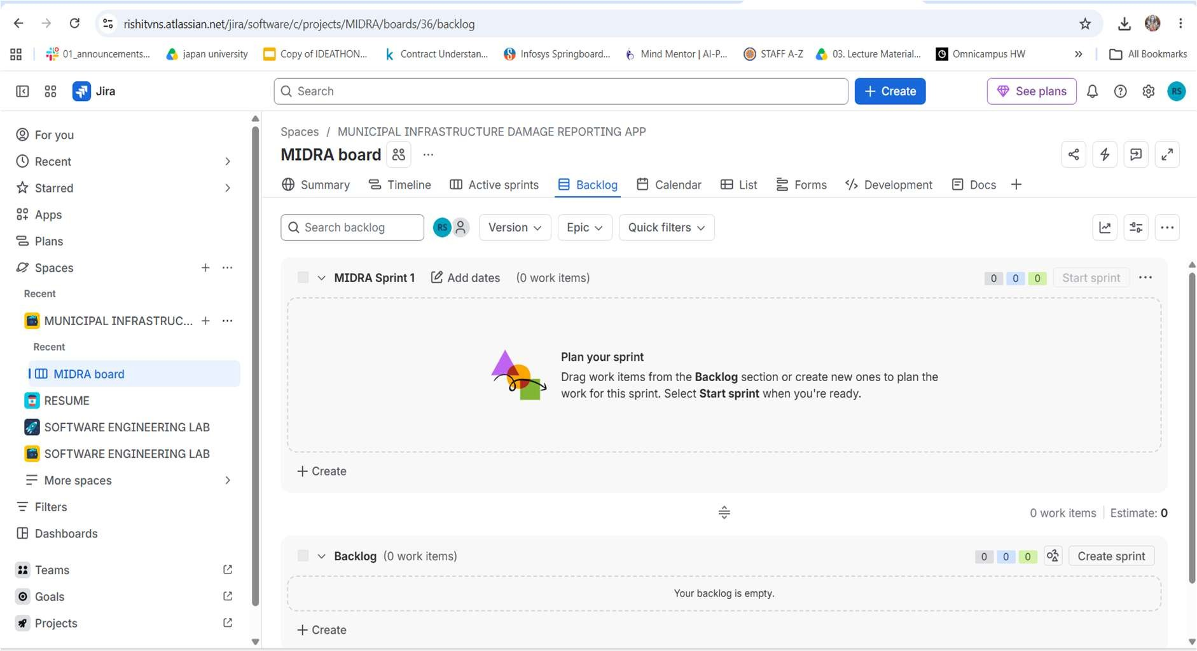

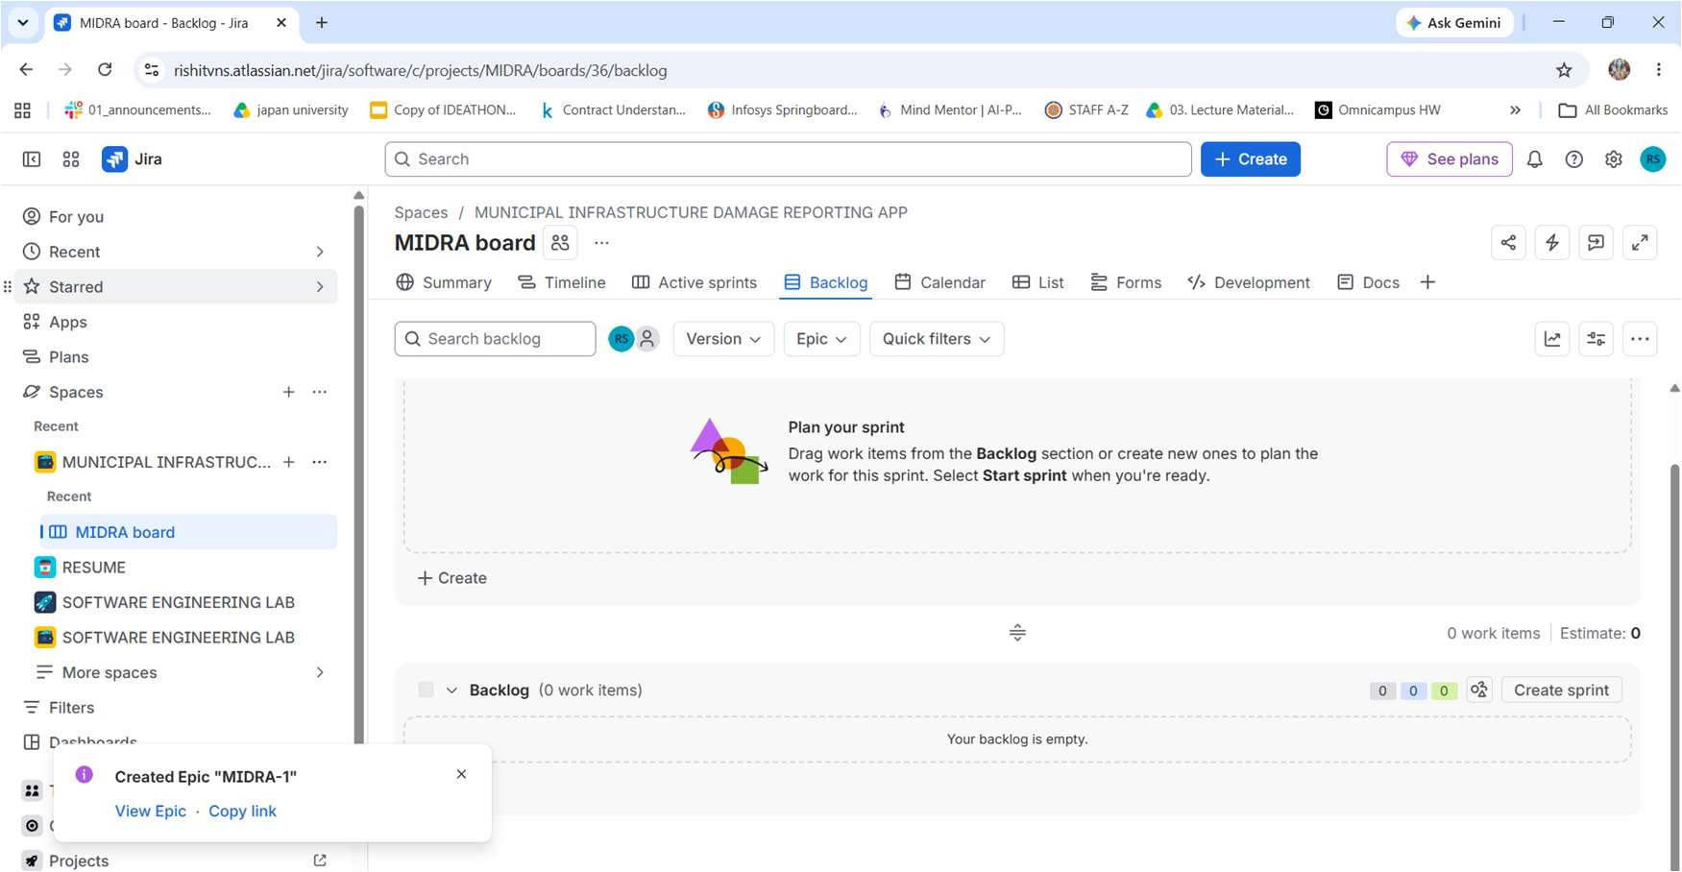

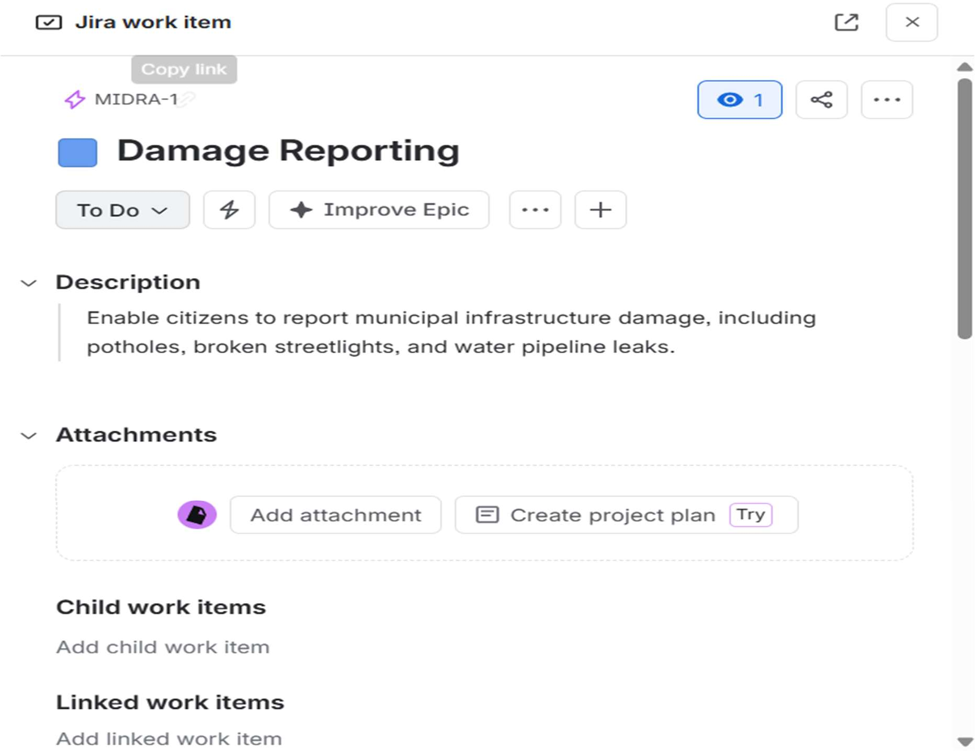

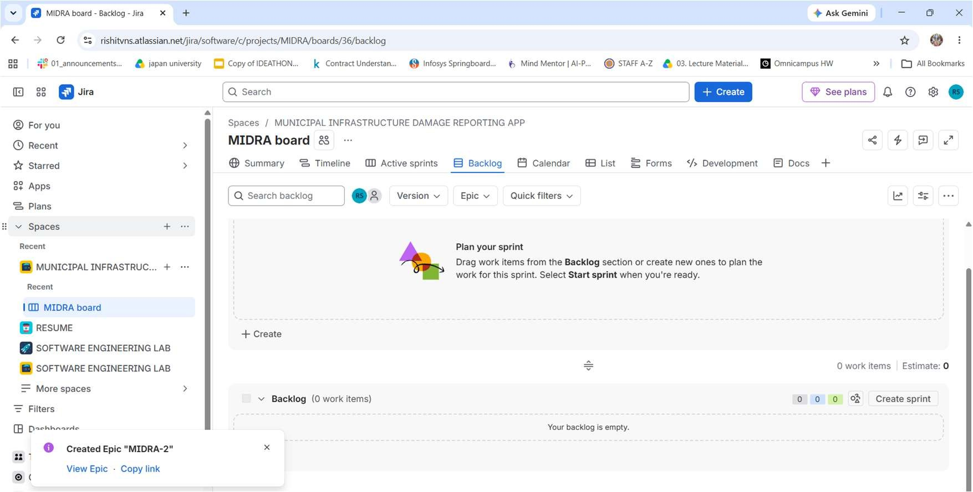

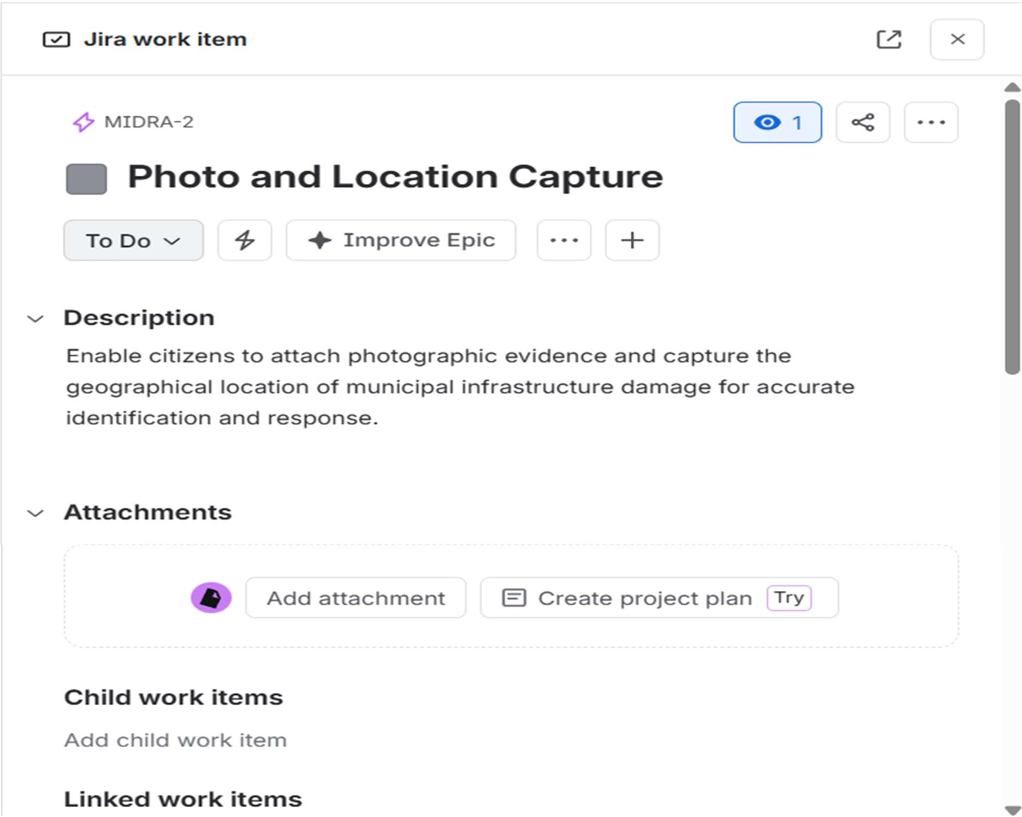

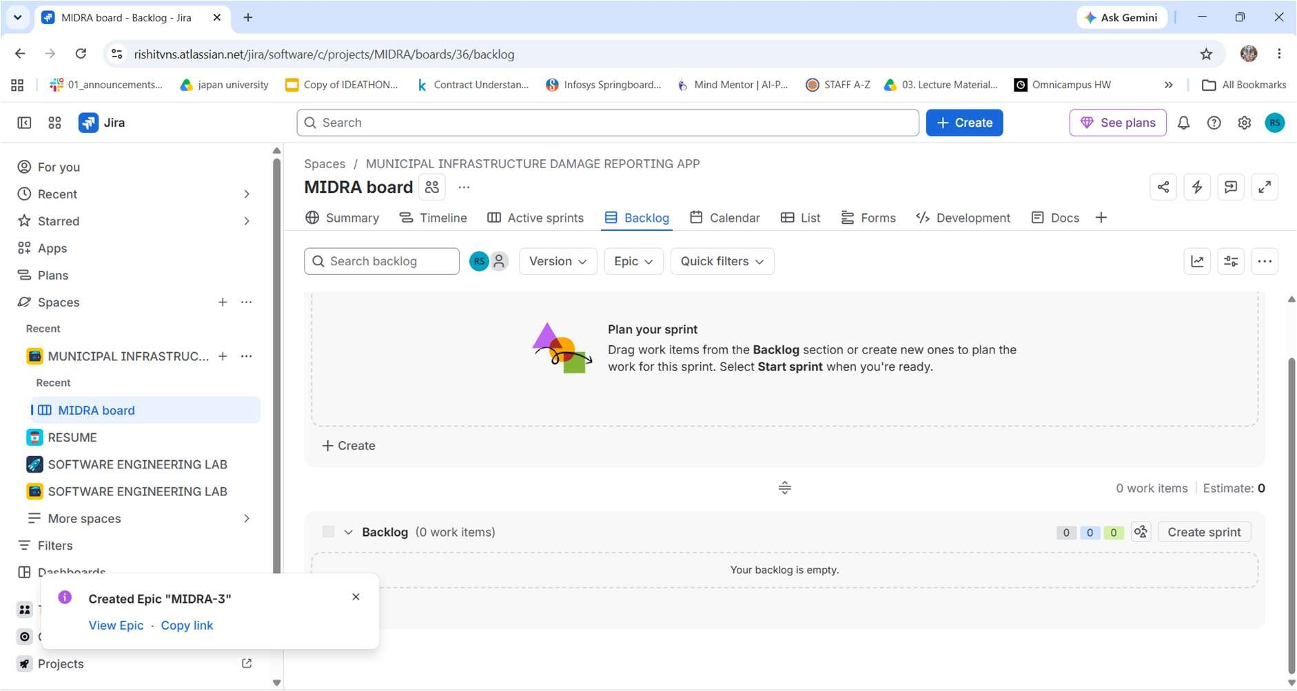

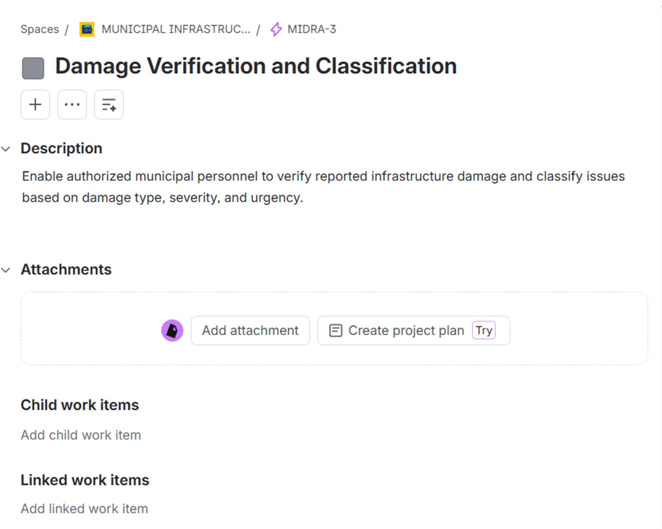

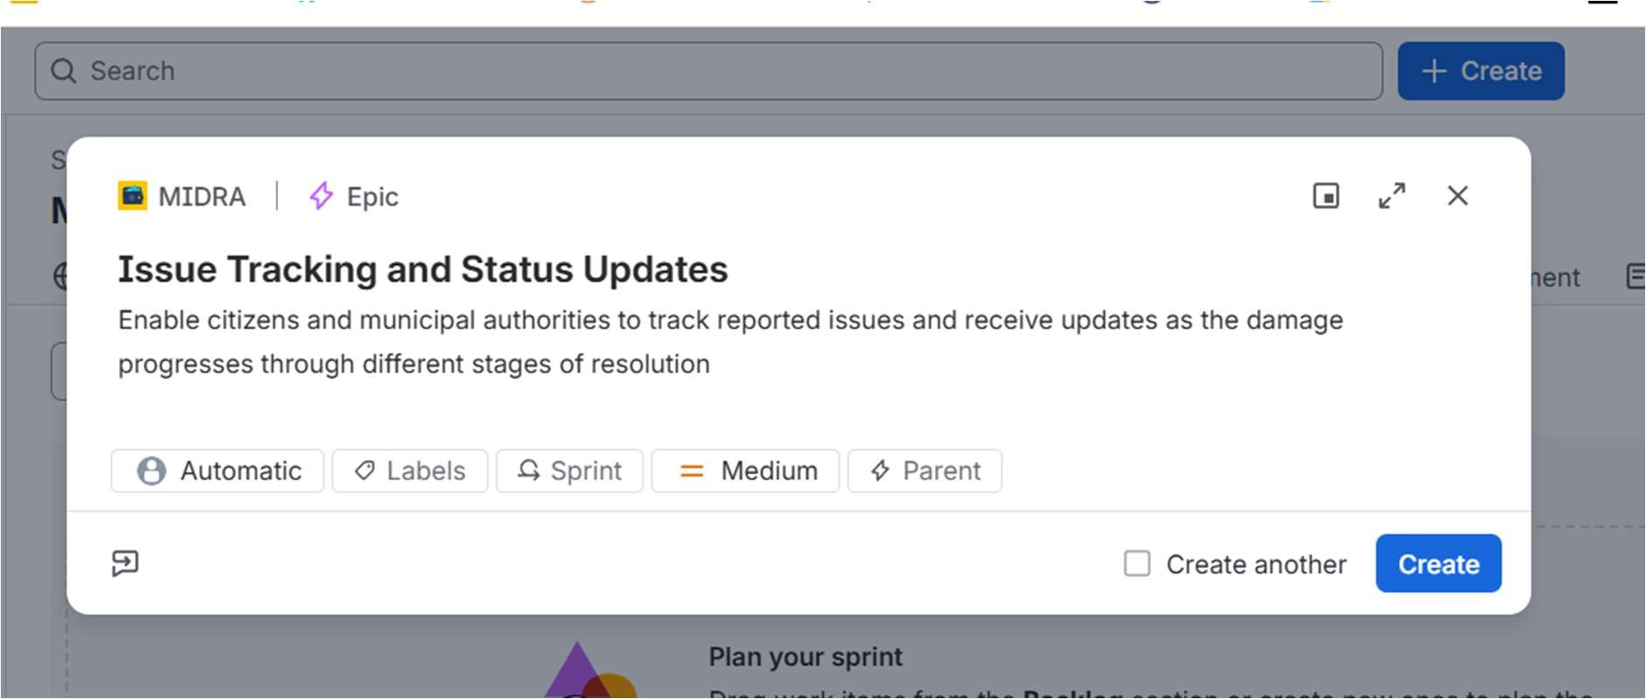
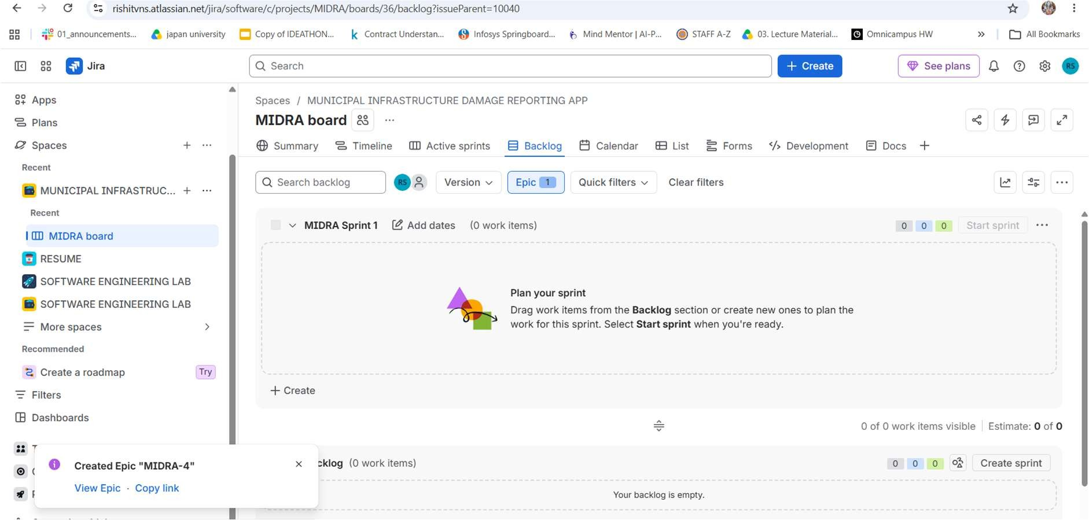
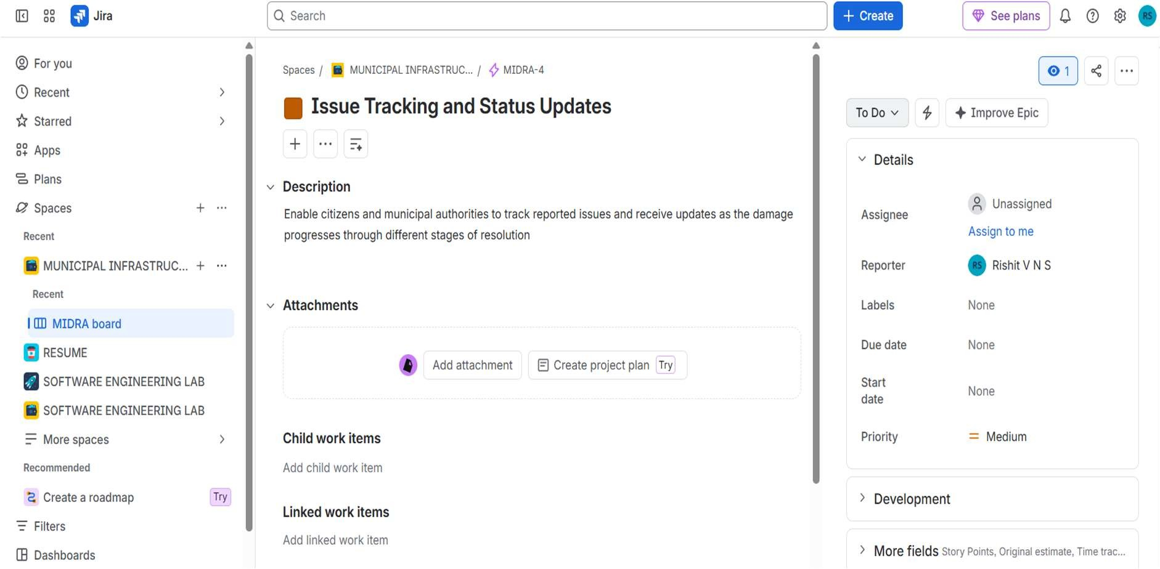

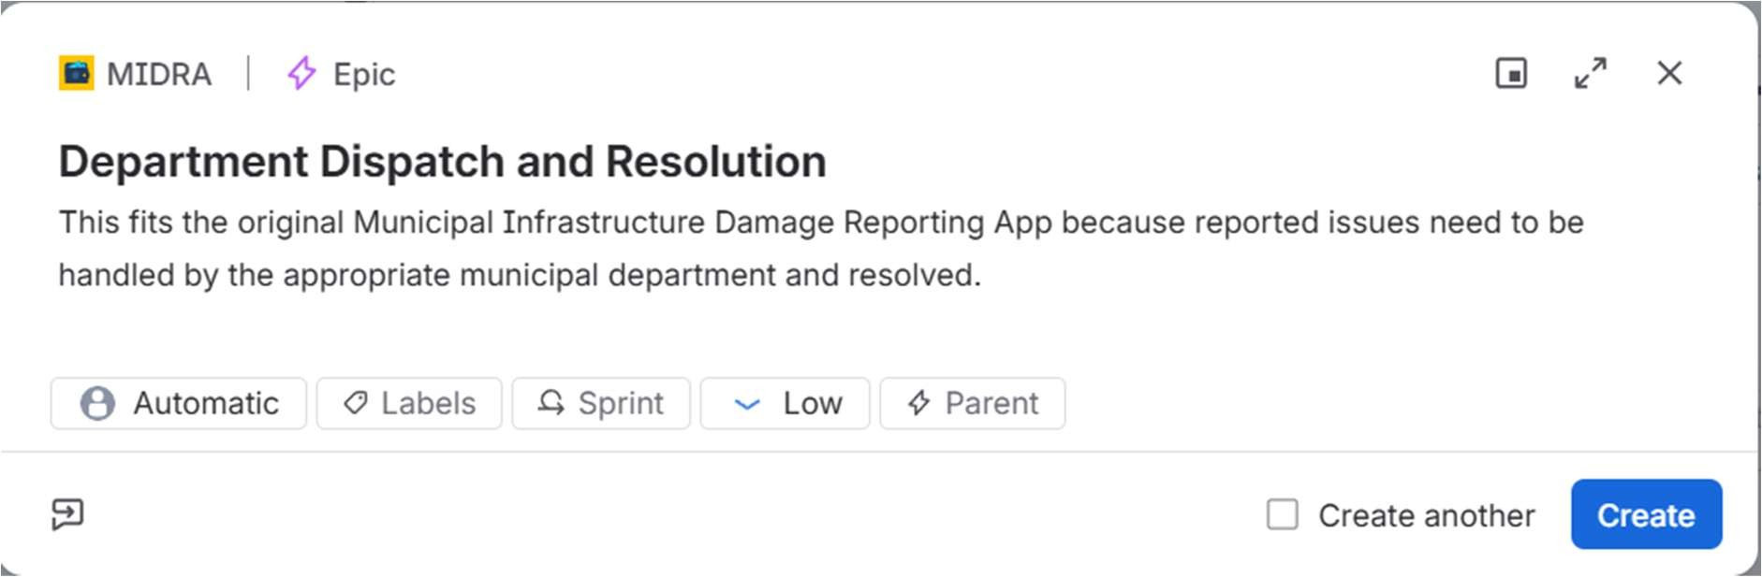
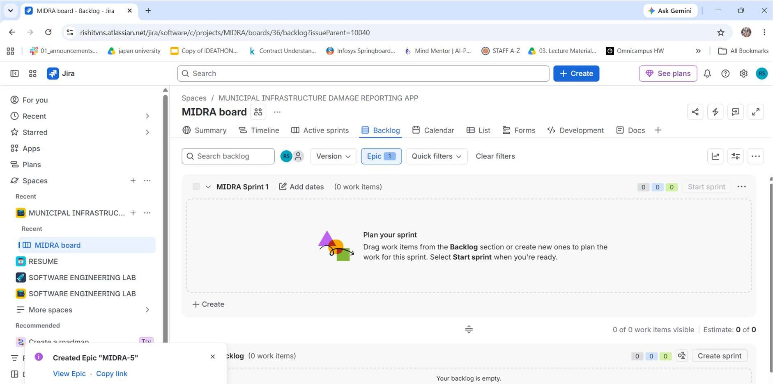
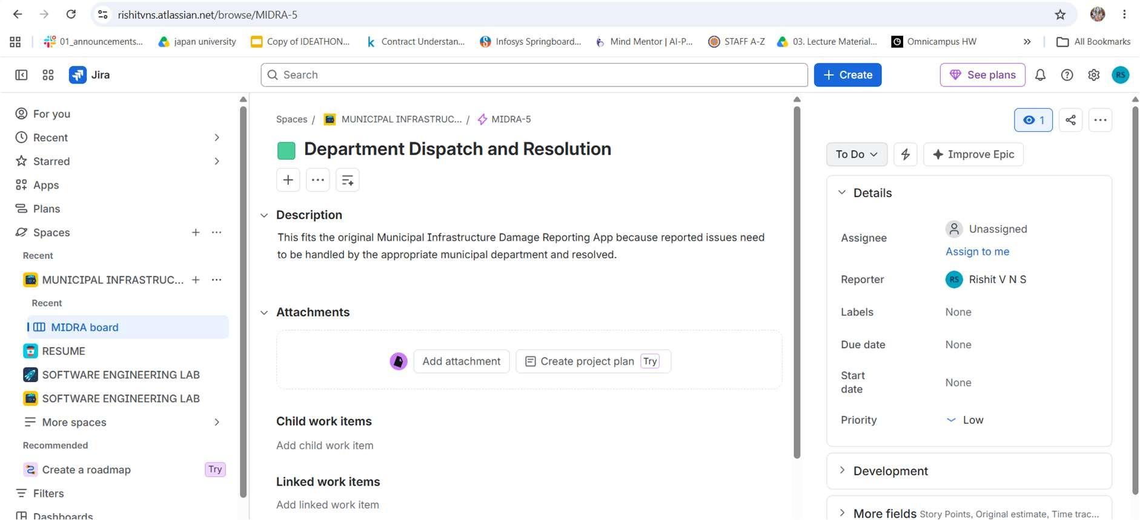

5 EPICS CREATED:
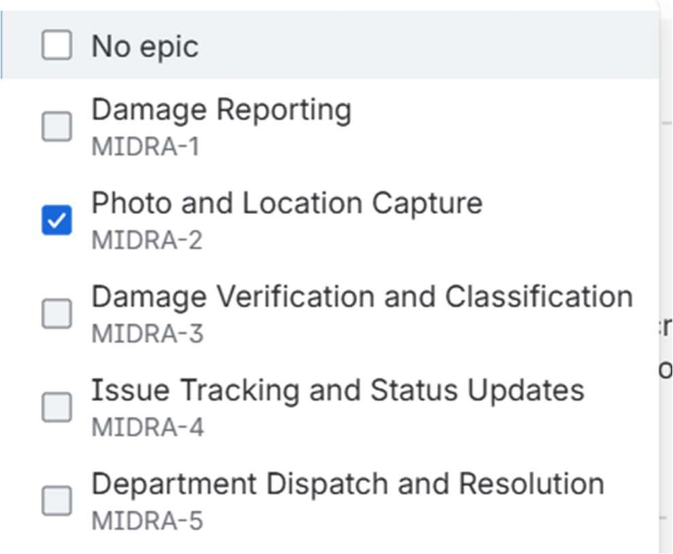

For epic 1:
Story 1.1:
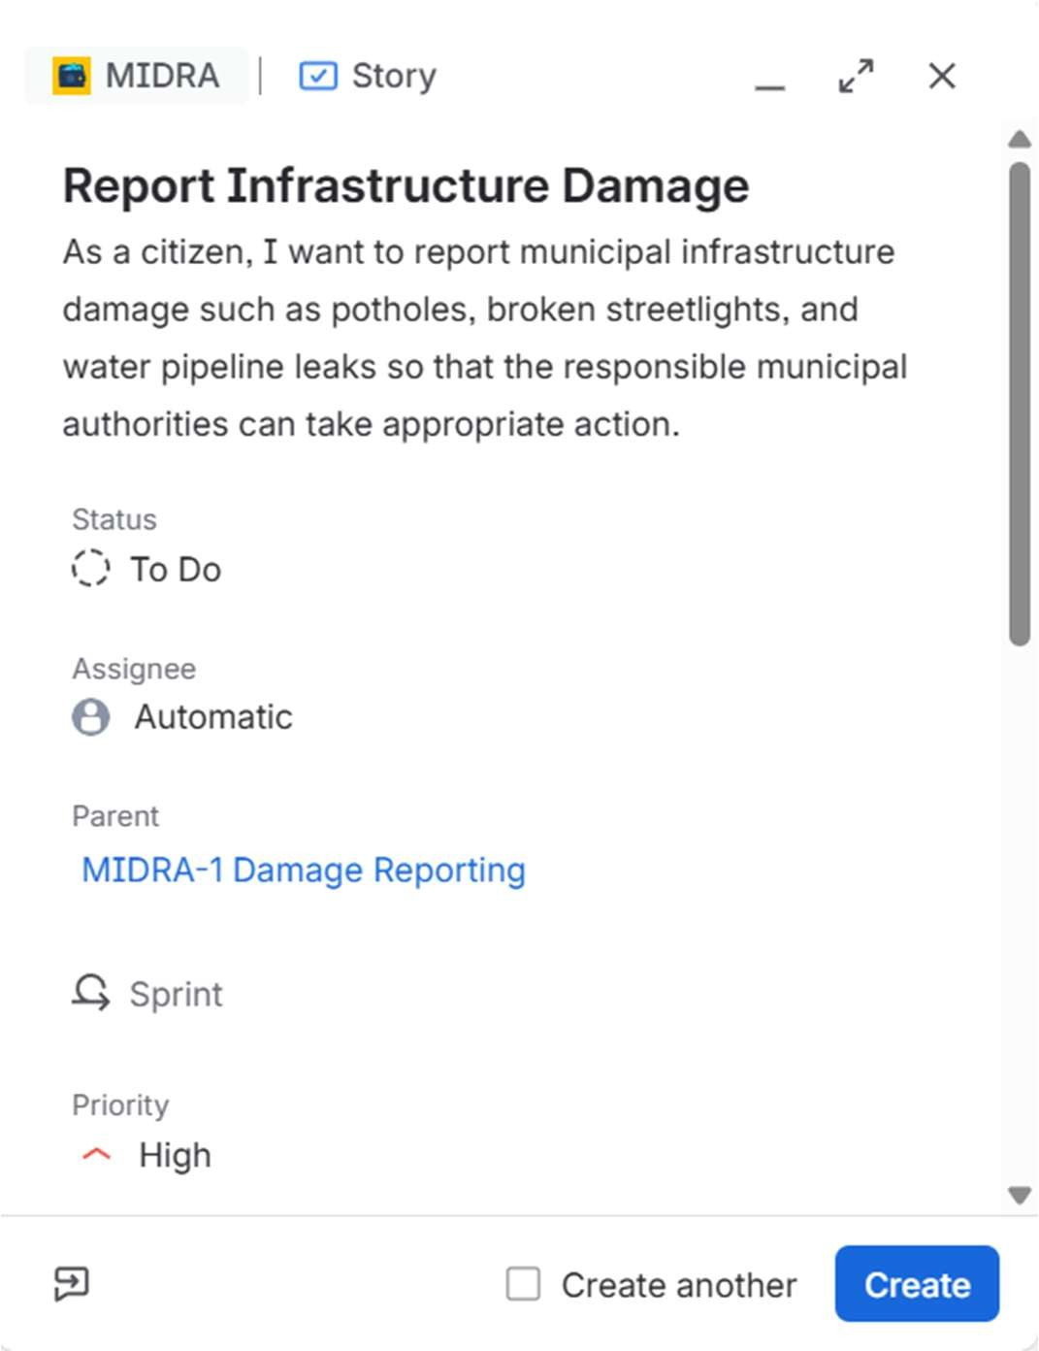

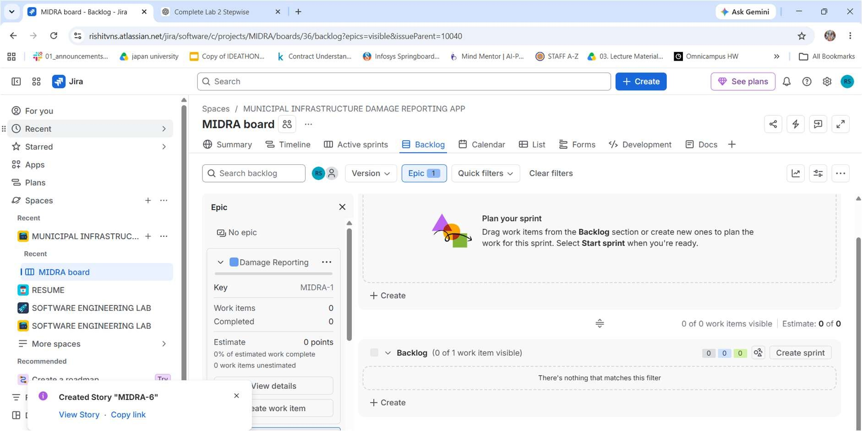
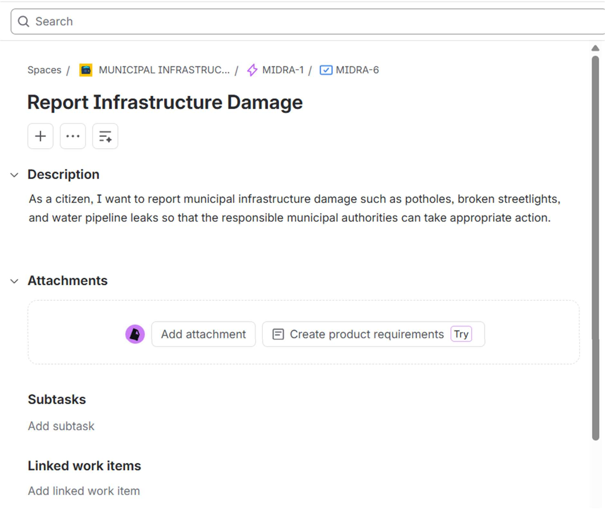

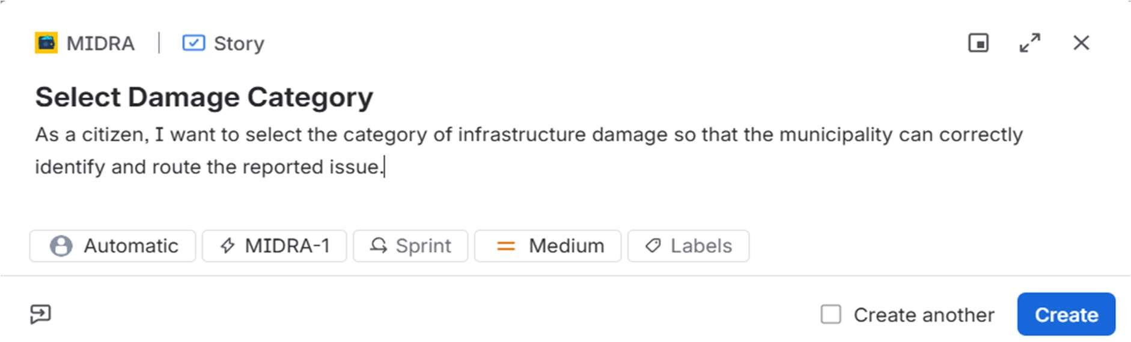
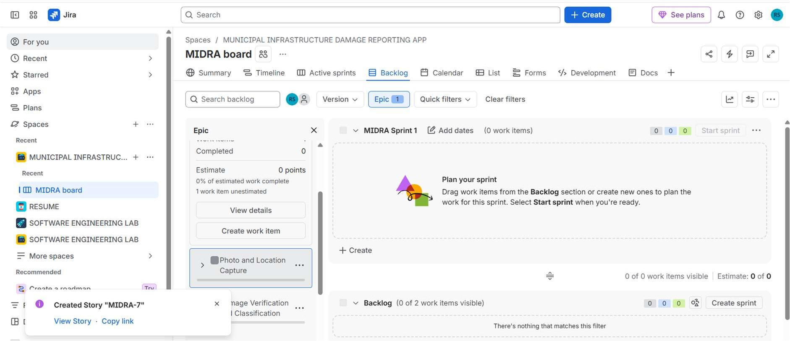
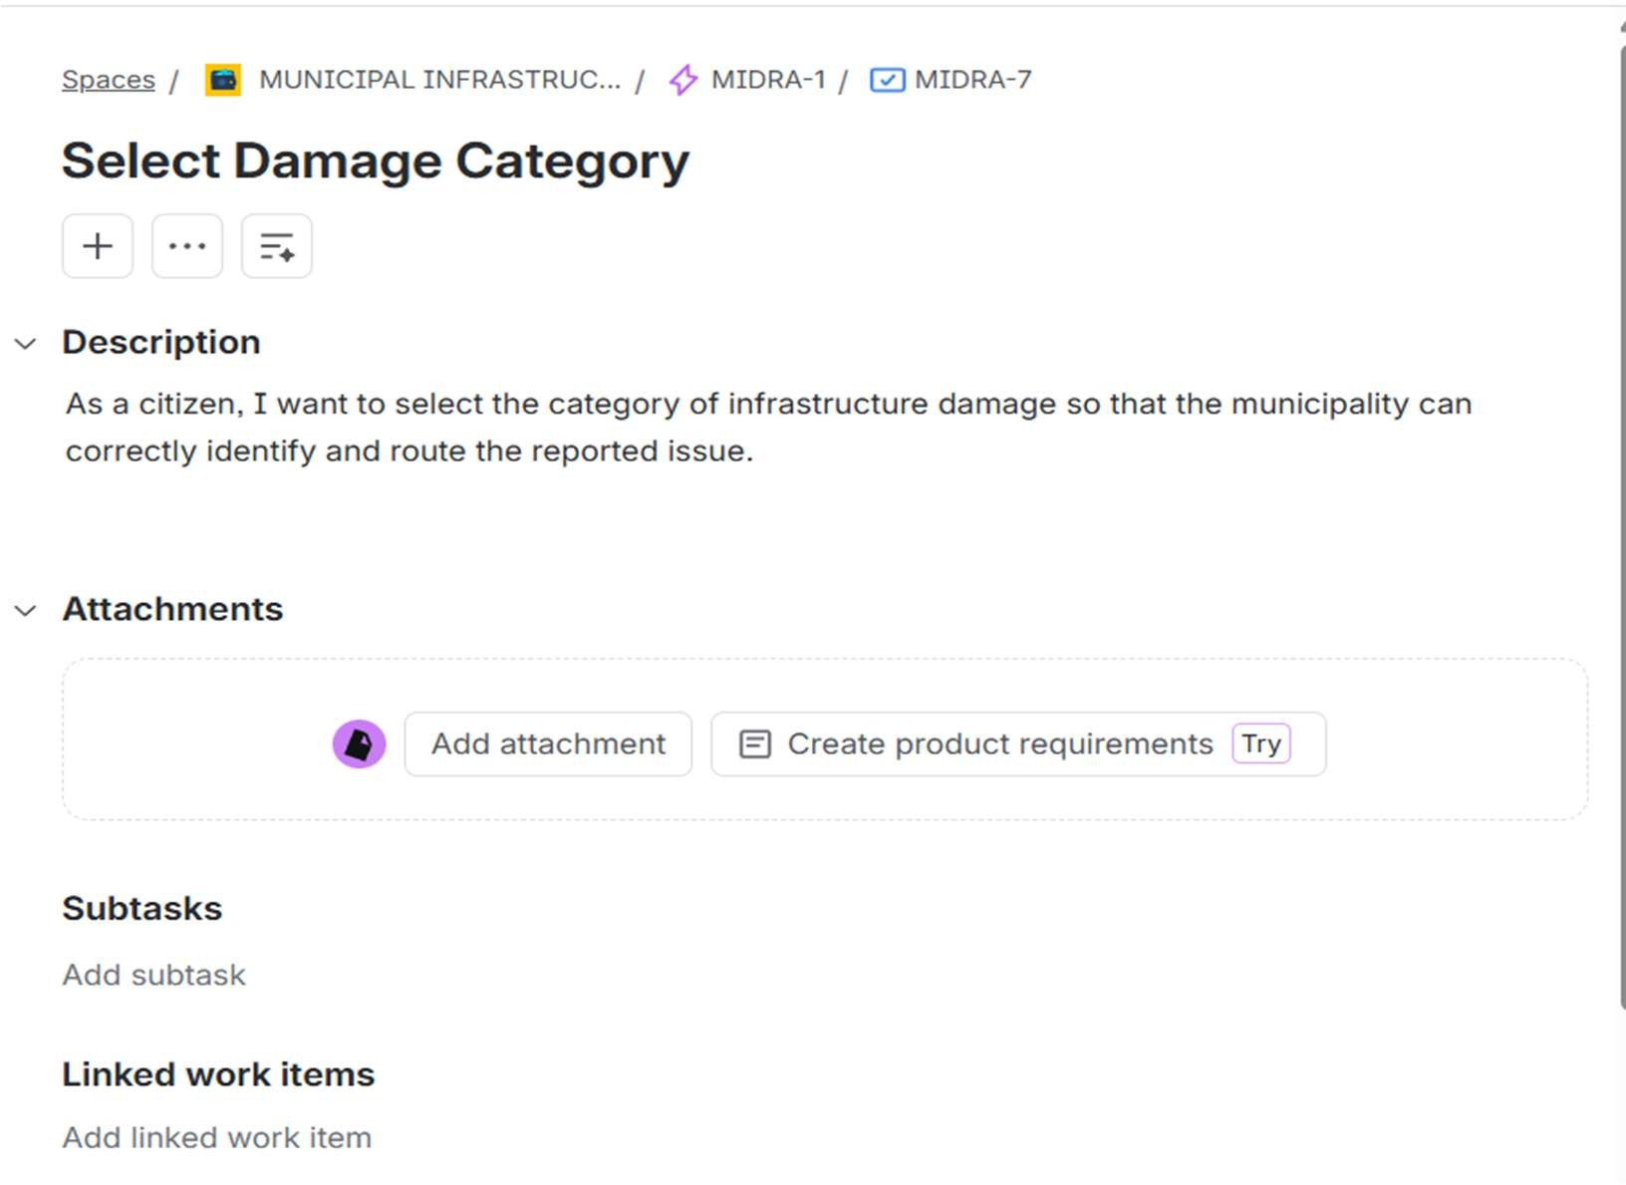

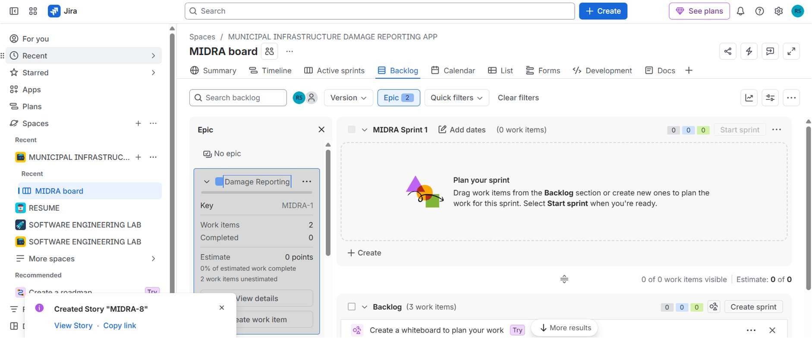

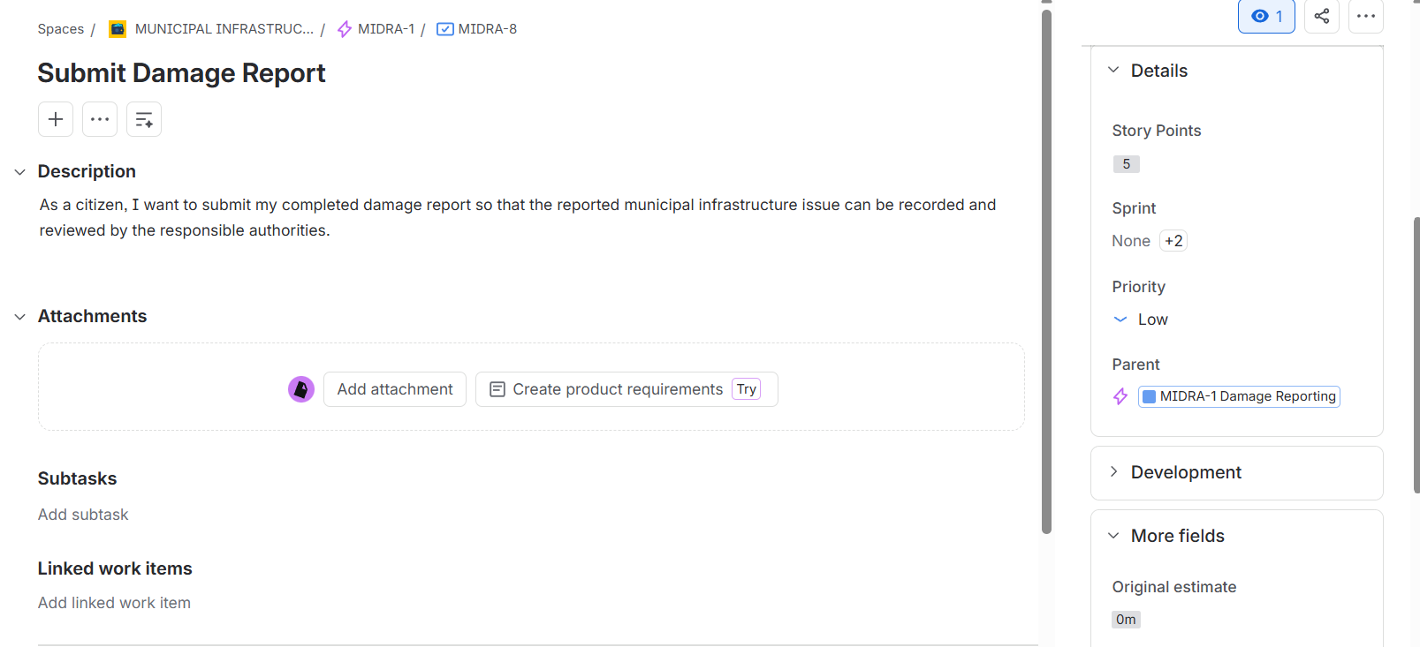

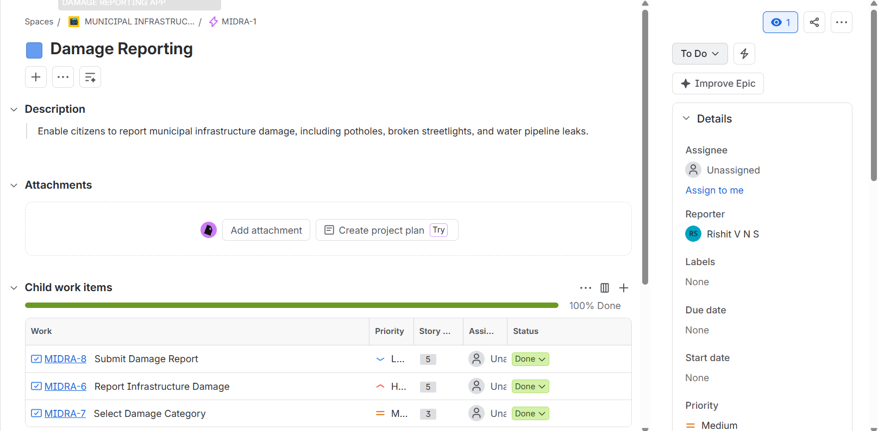

STORIES FOR EPIC 2: story 2.1:
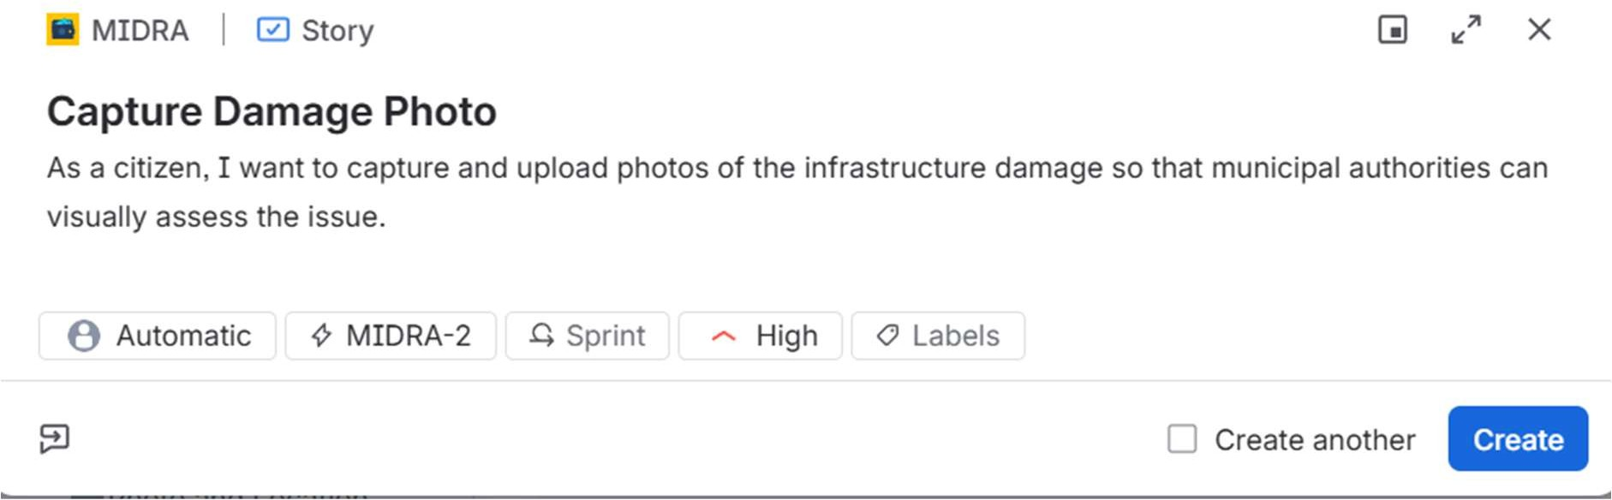
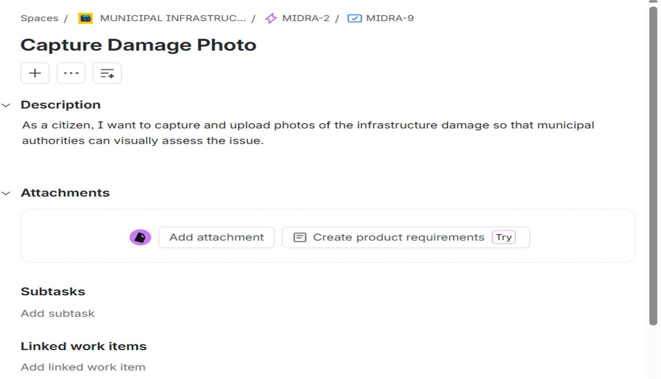

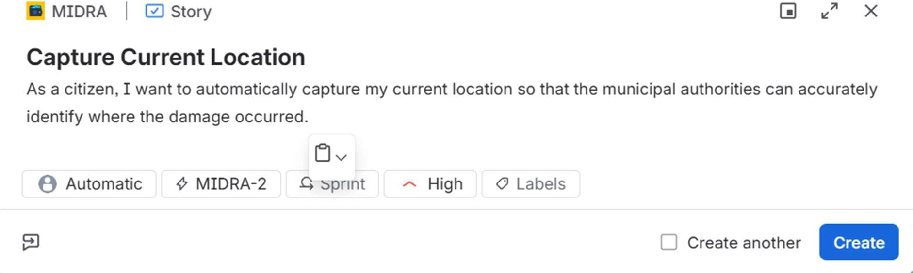
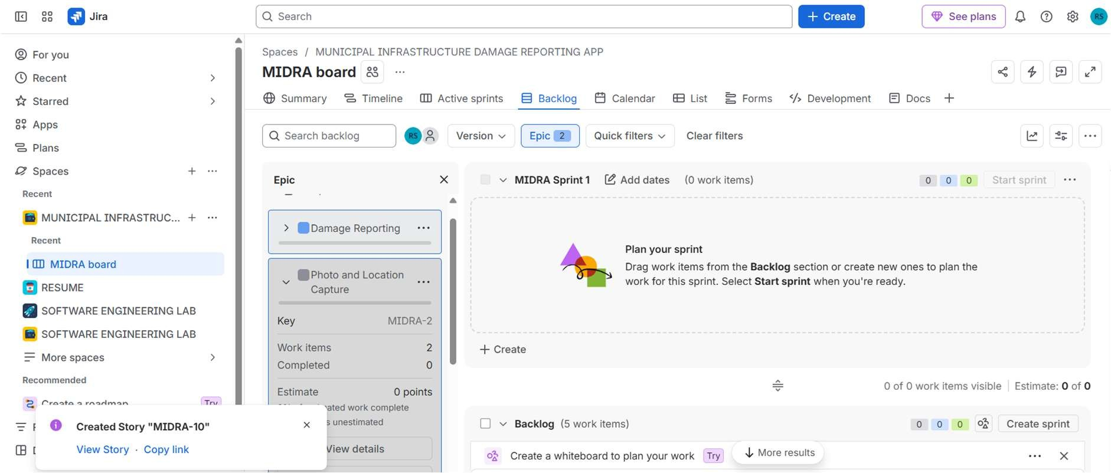

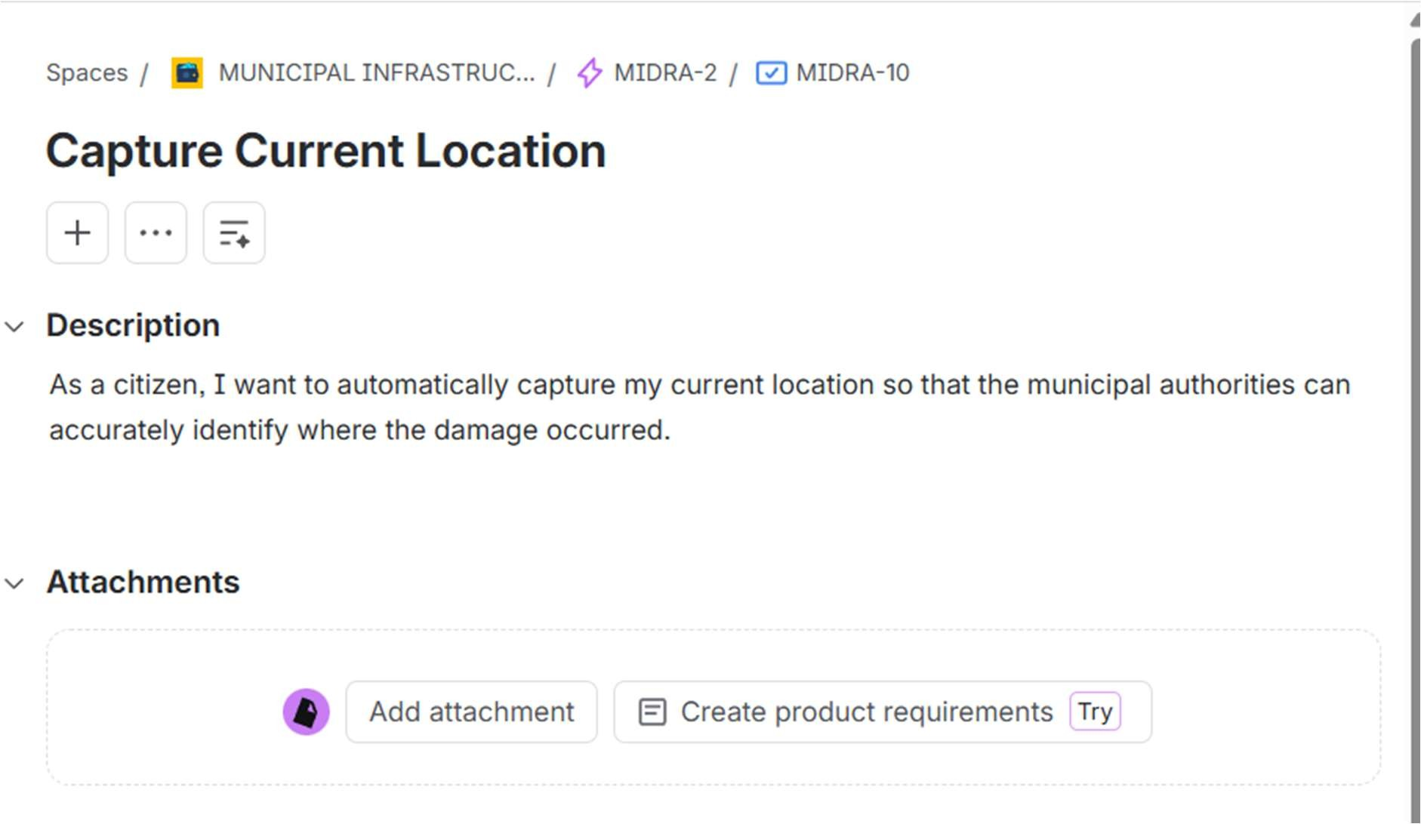

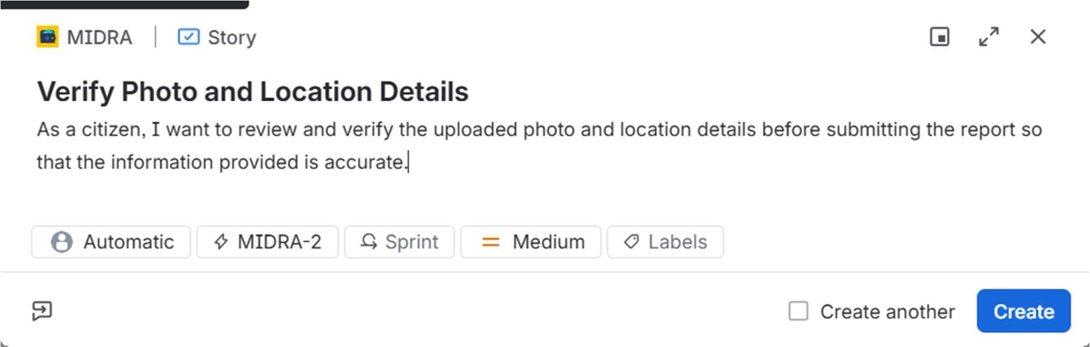
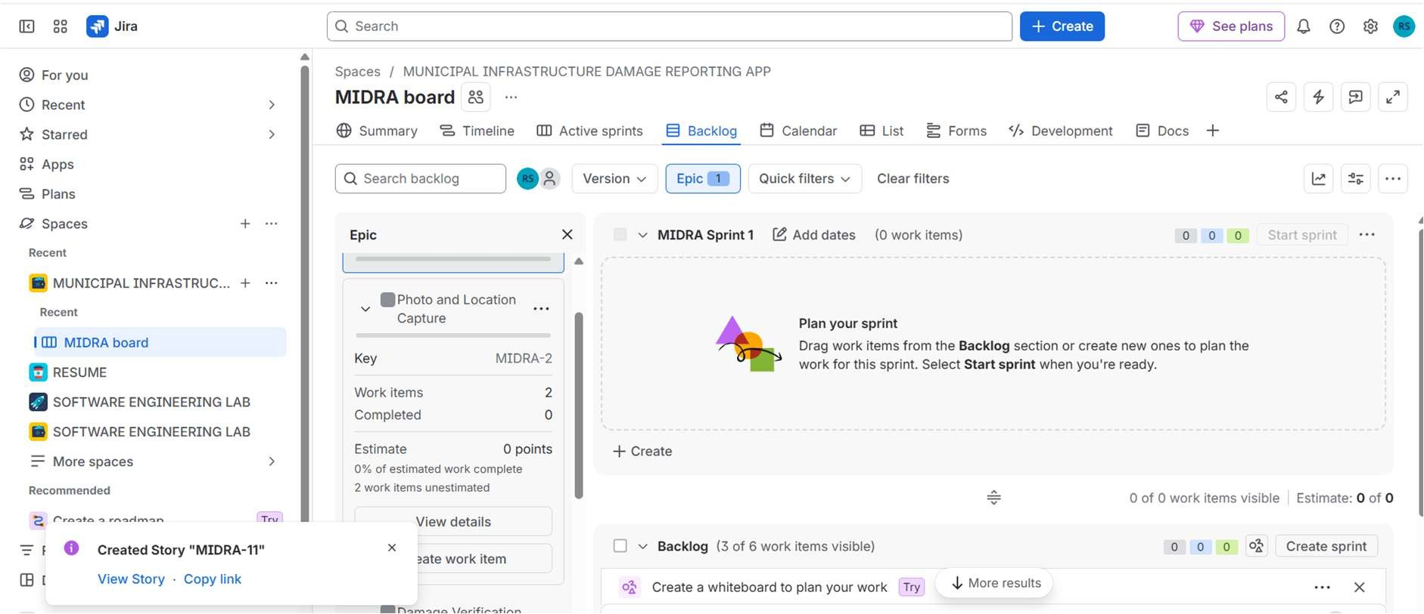

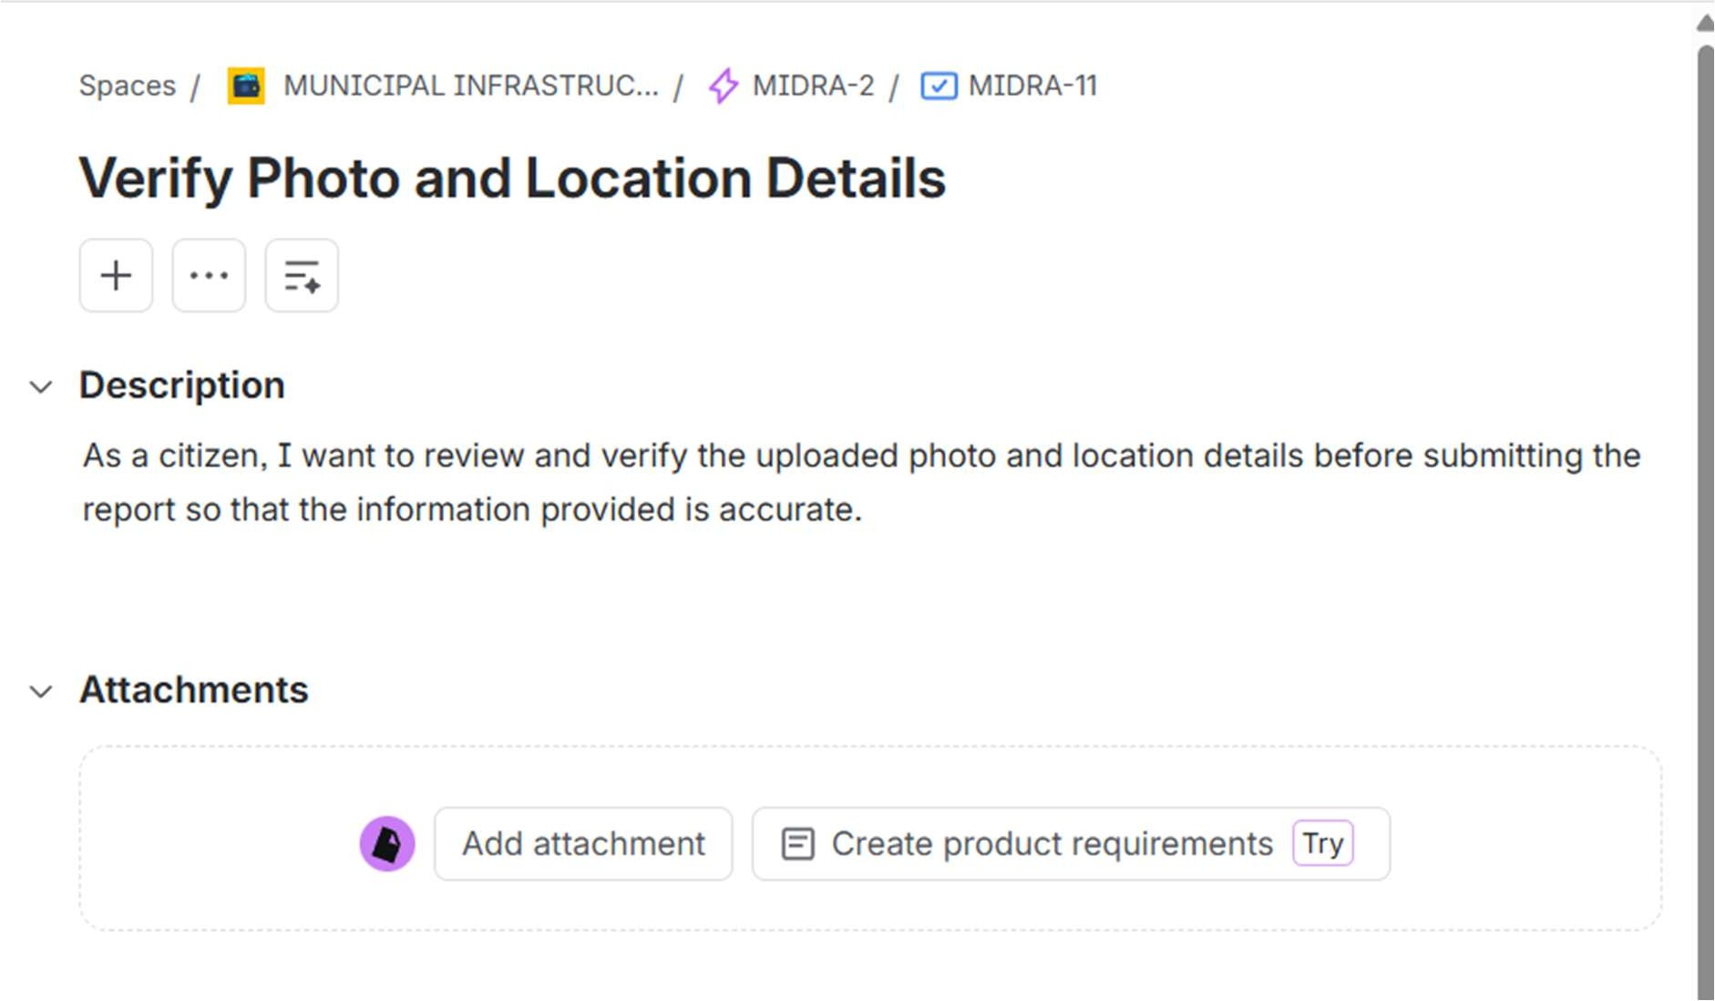

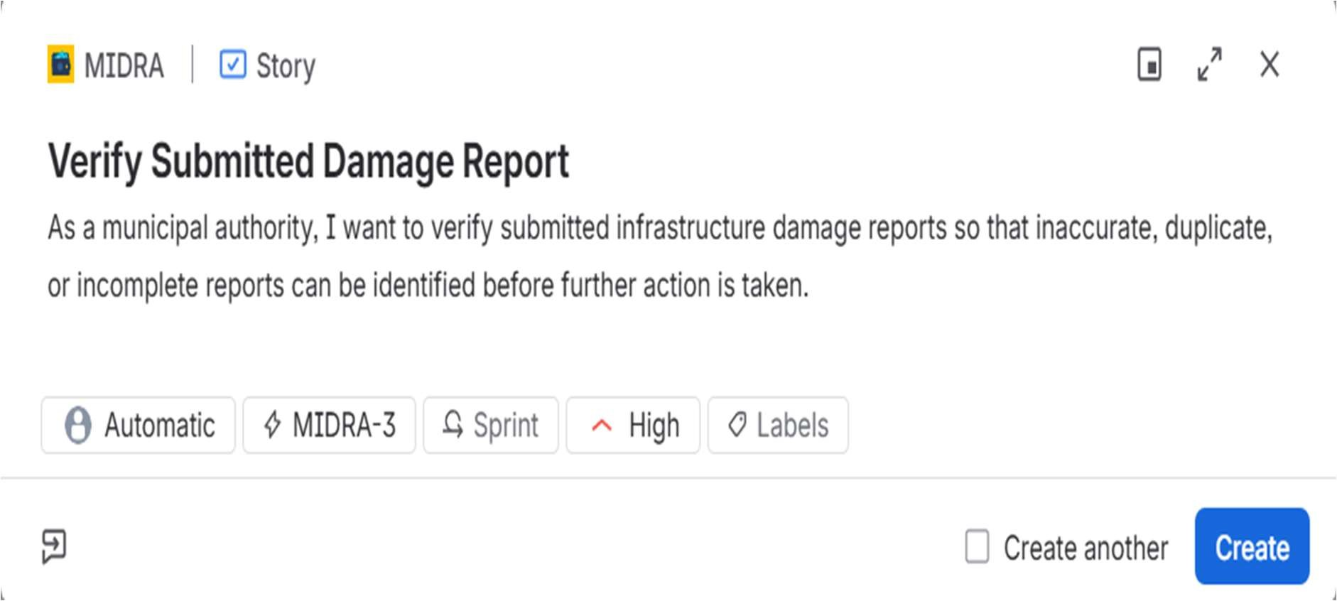

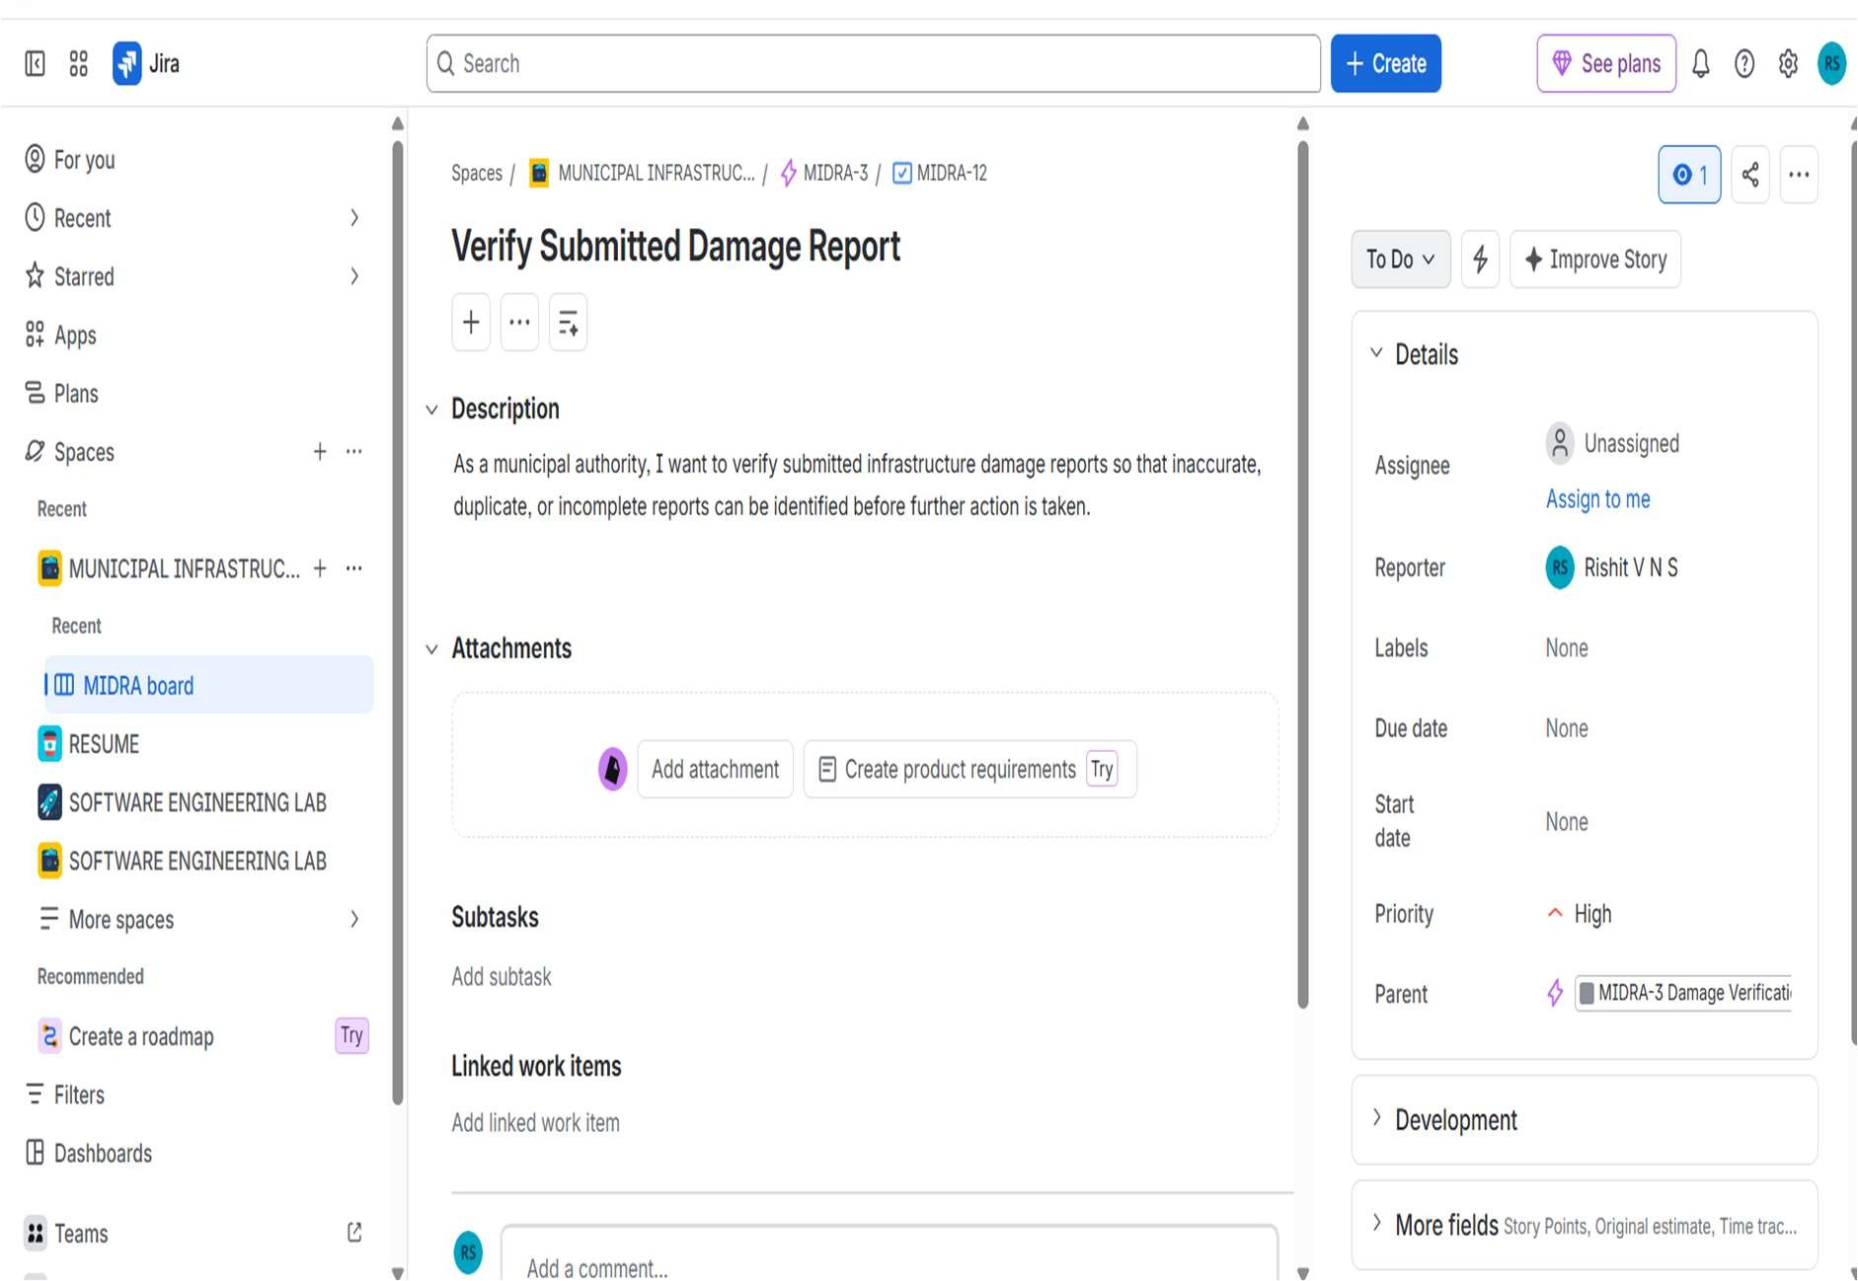

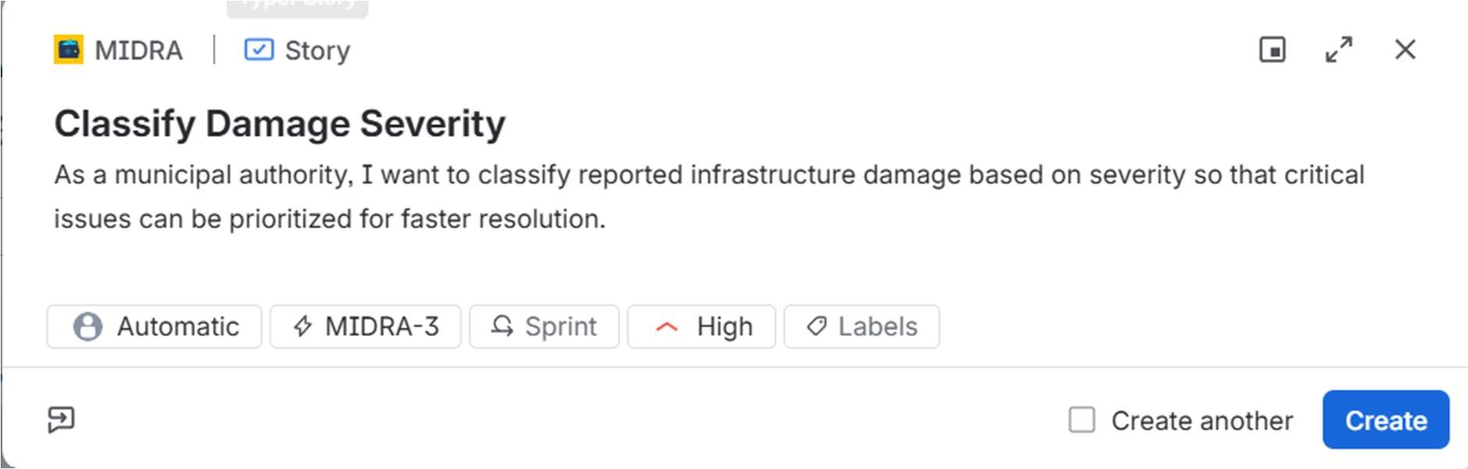

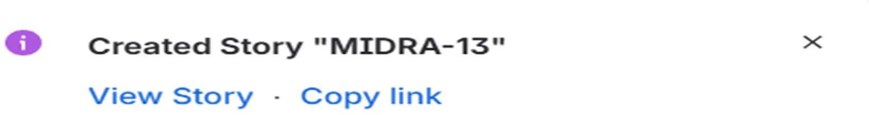

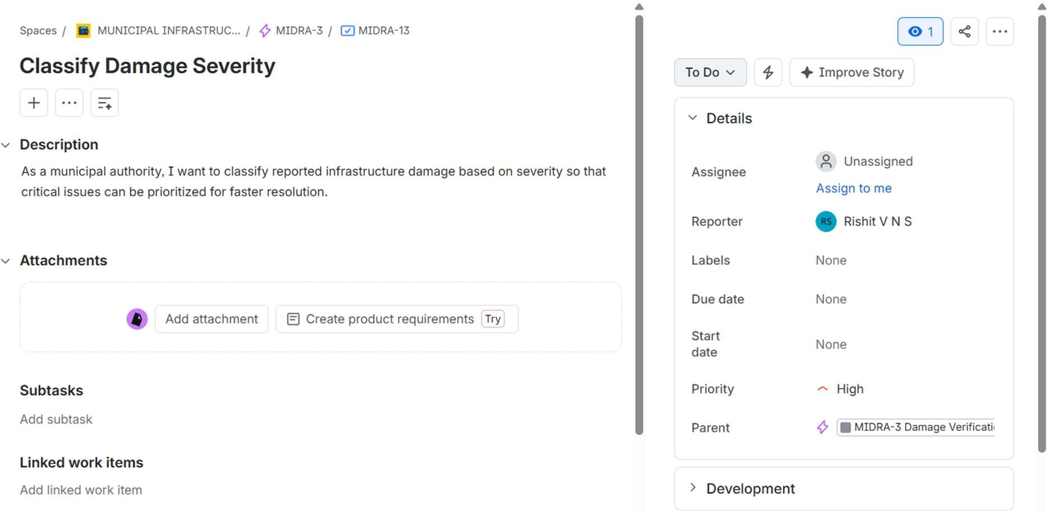

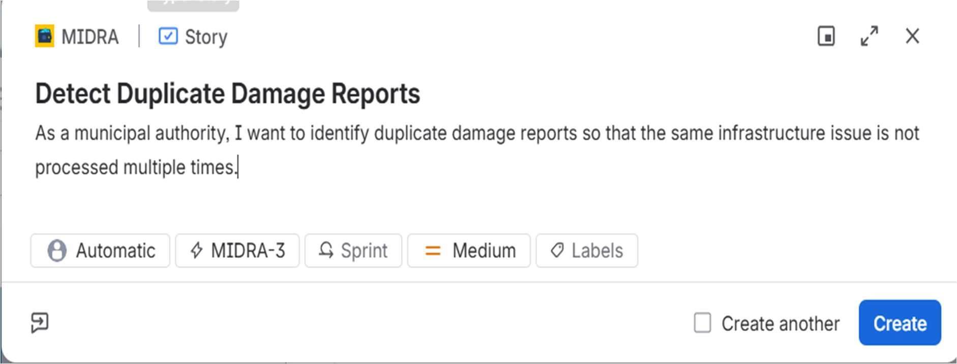

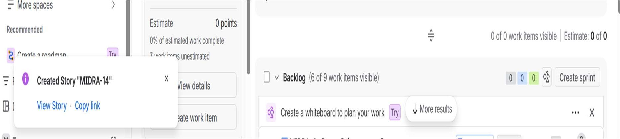

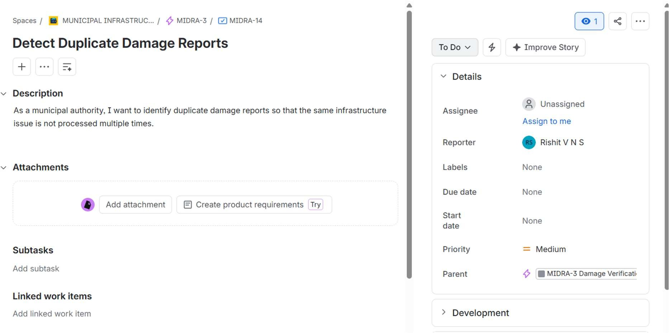

STORY 4.1:
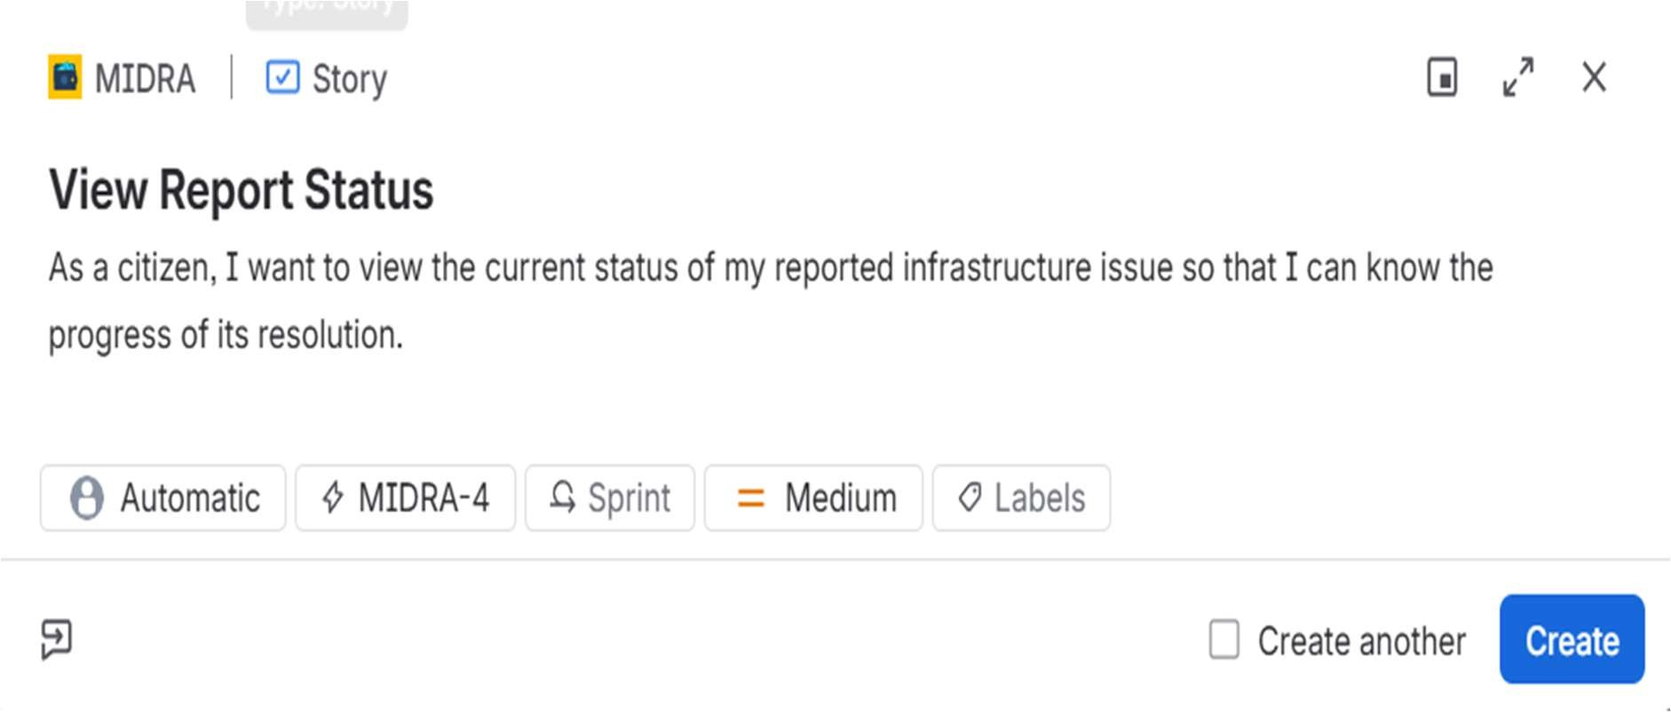

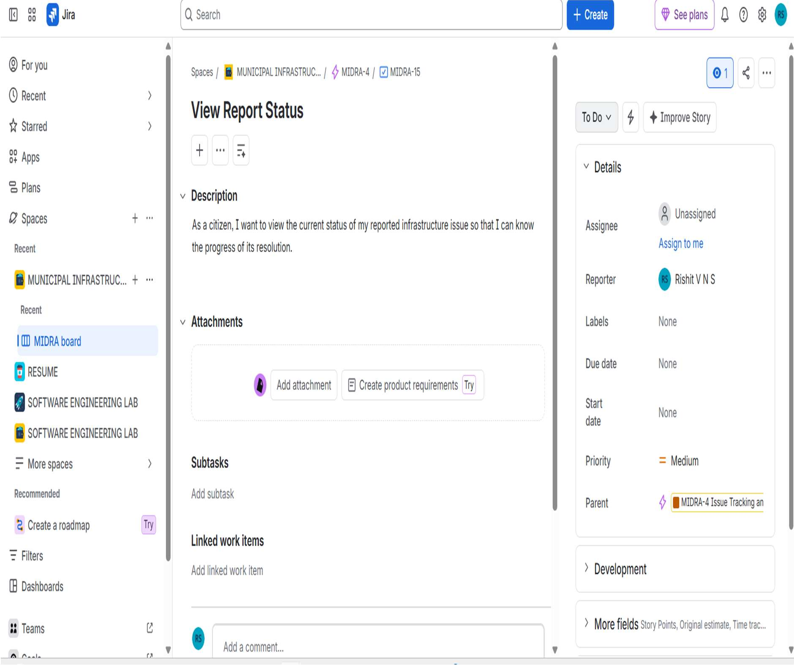

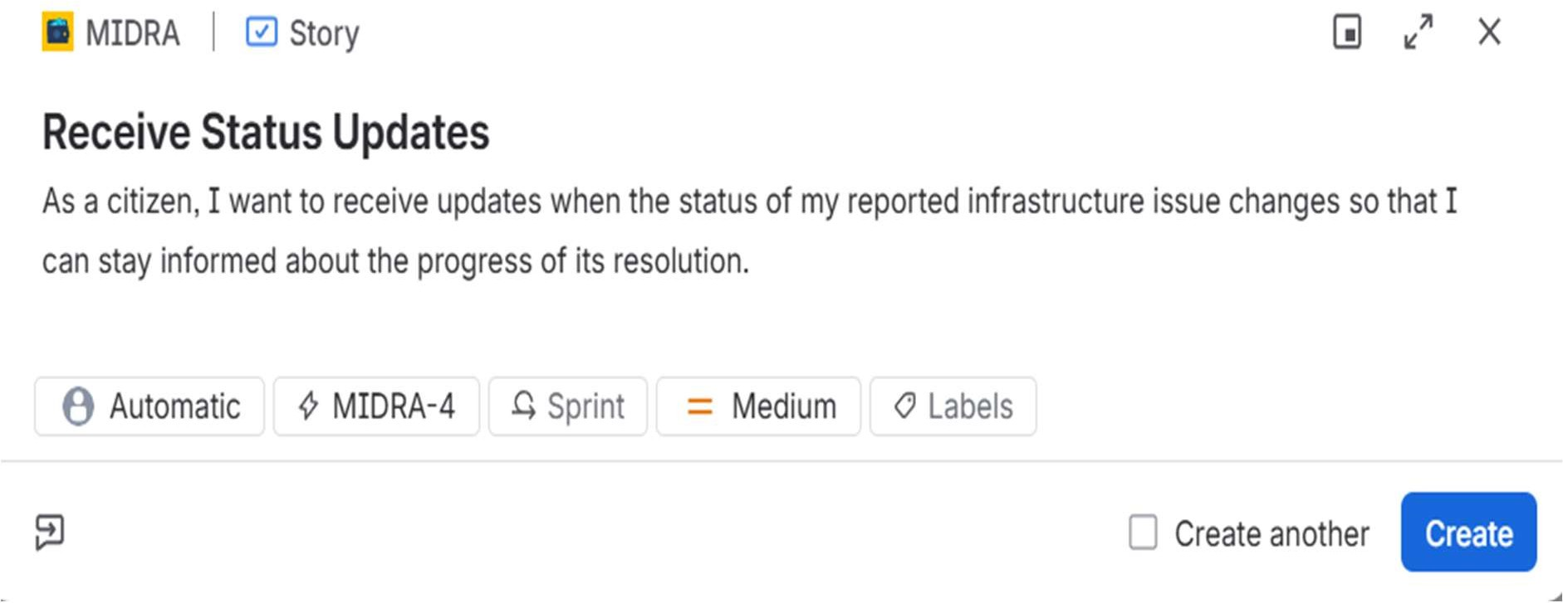

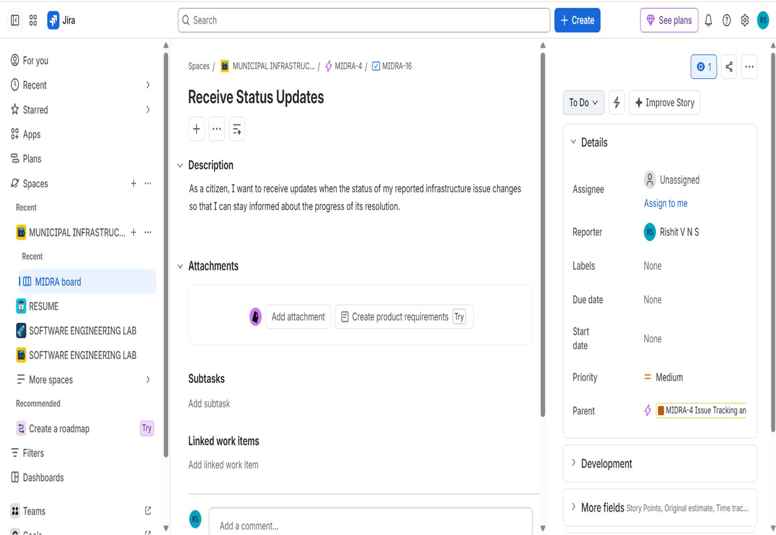

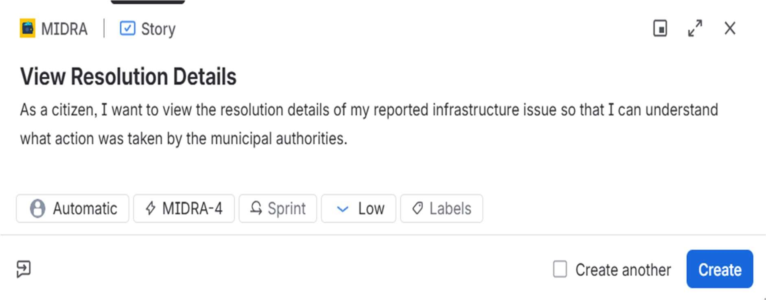

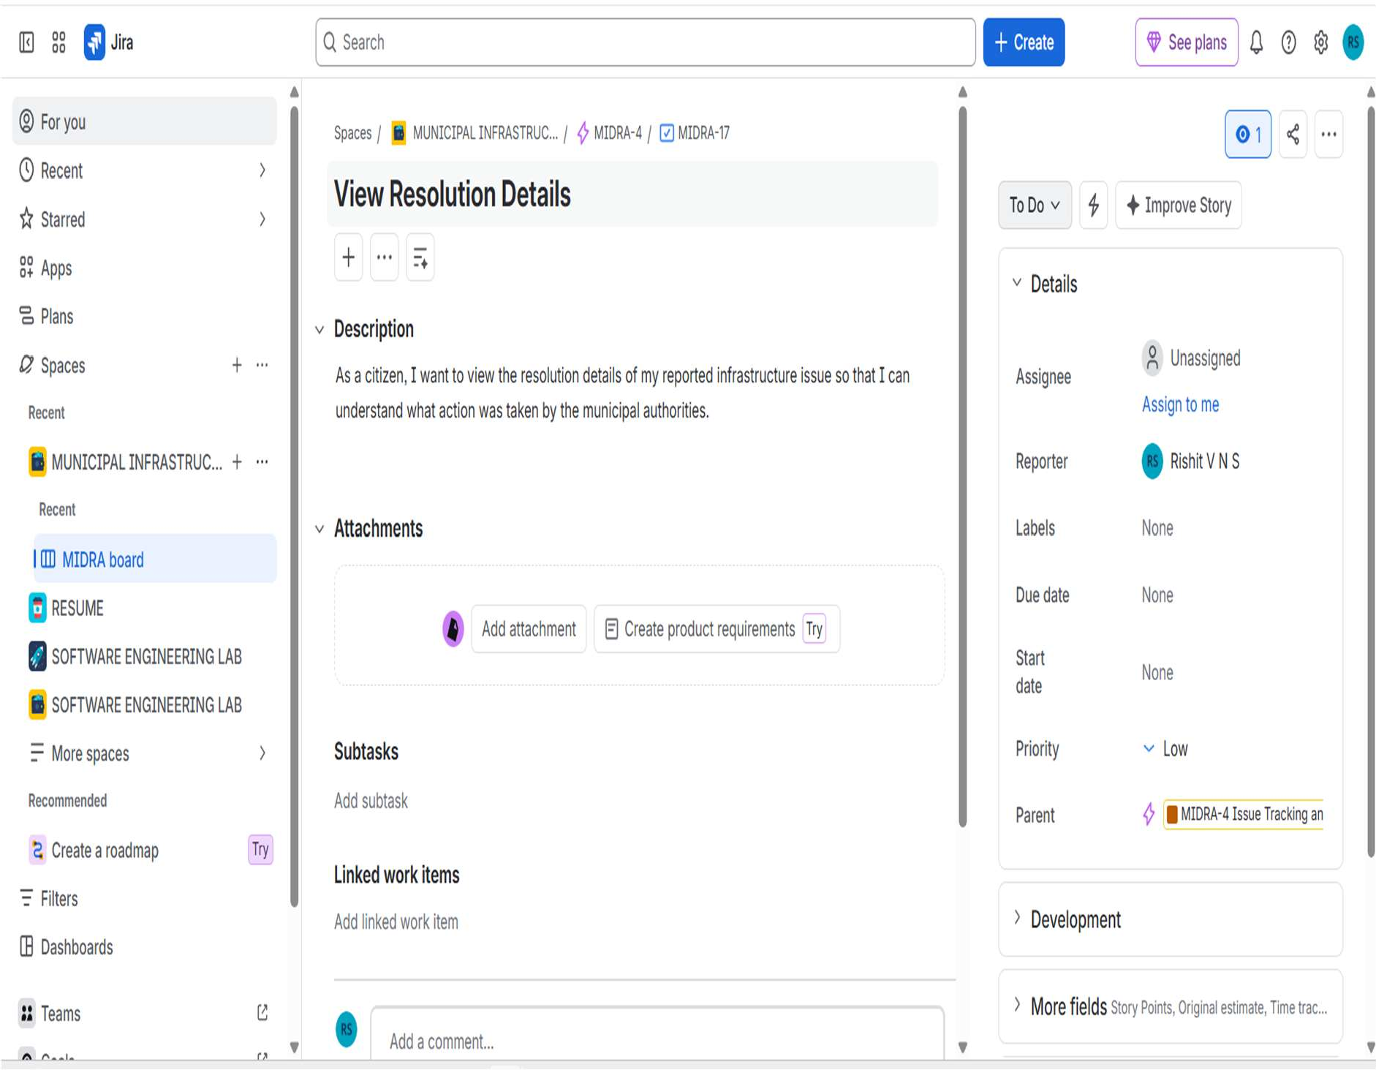

STORY 5.1:
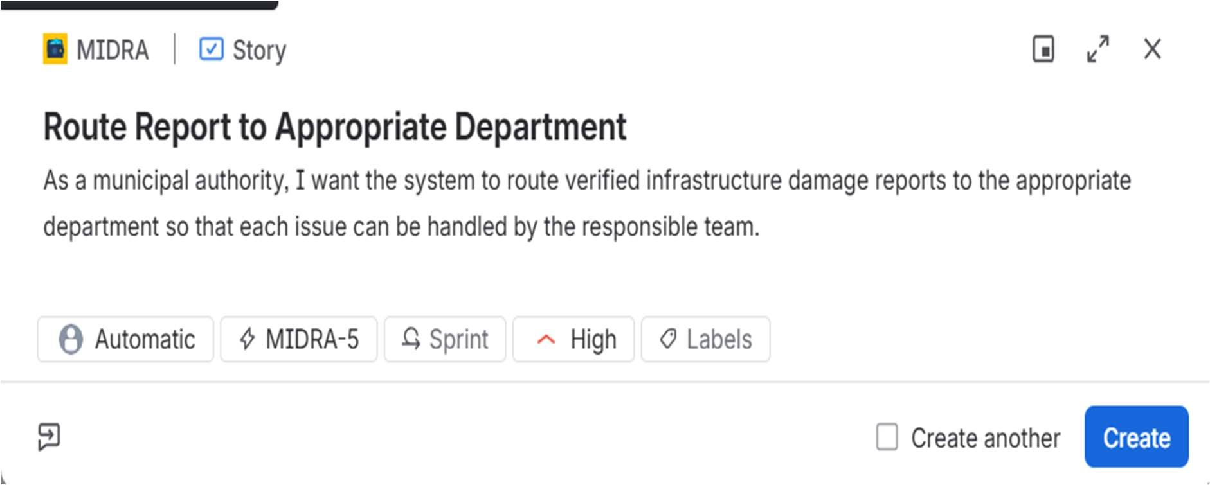

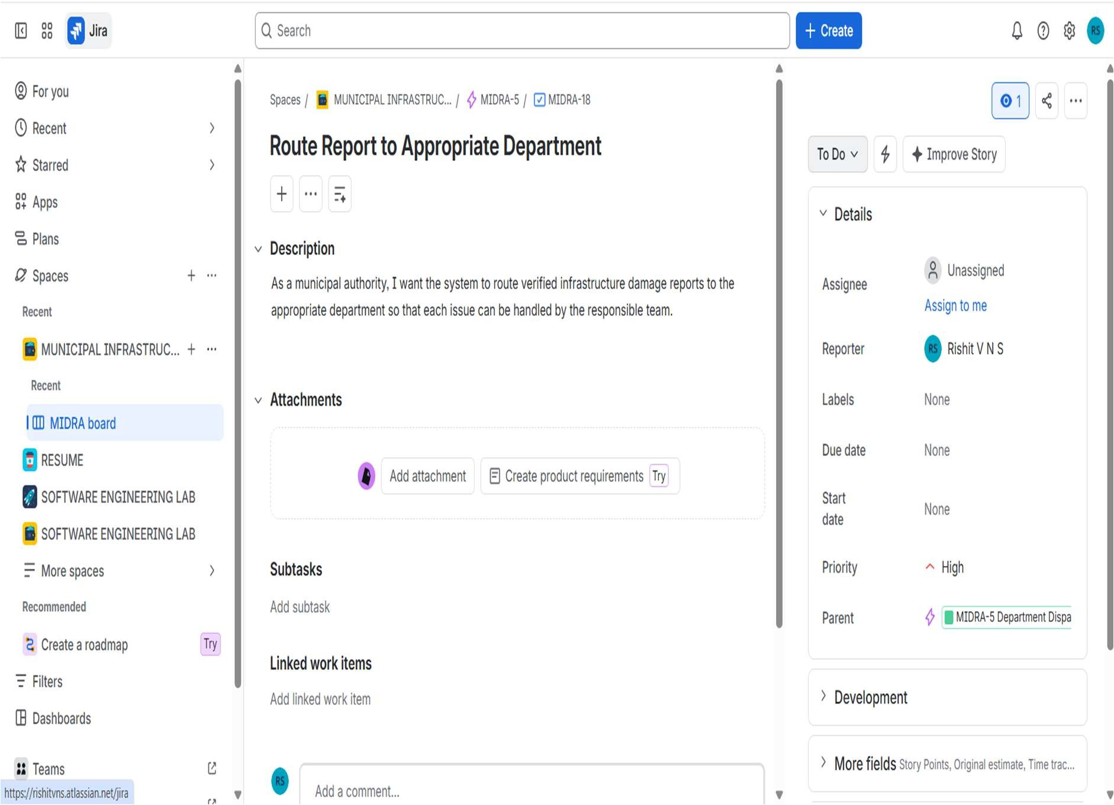

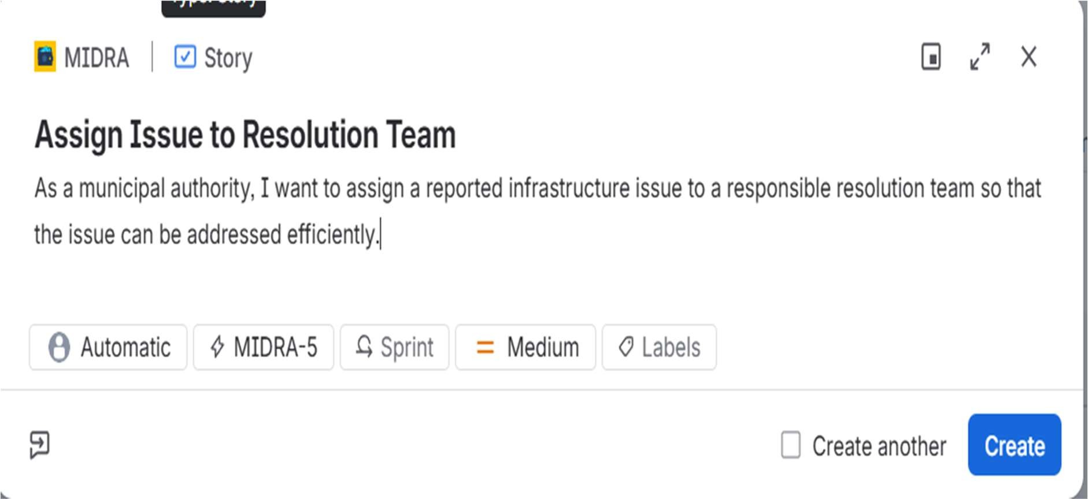

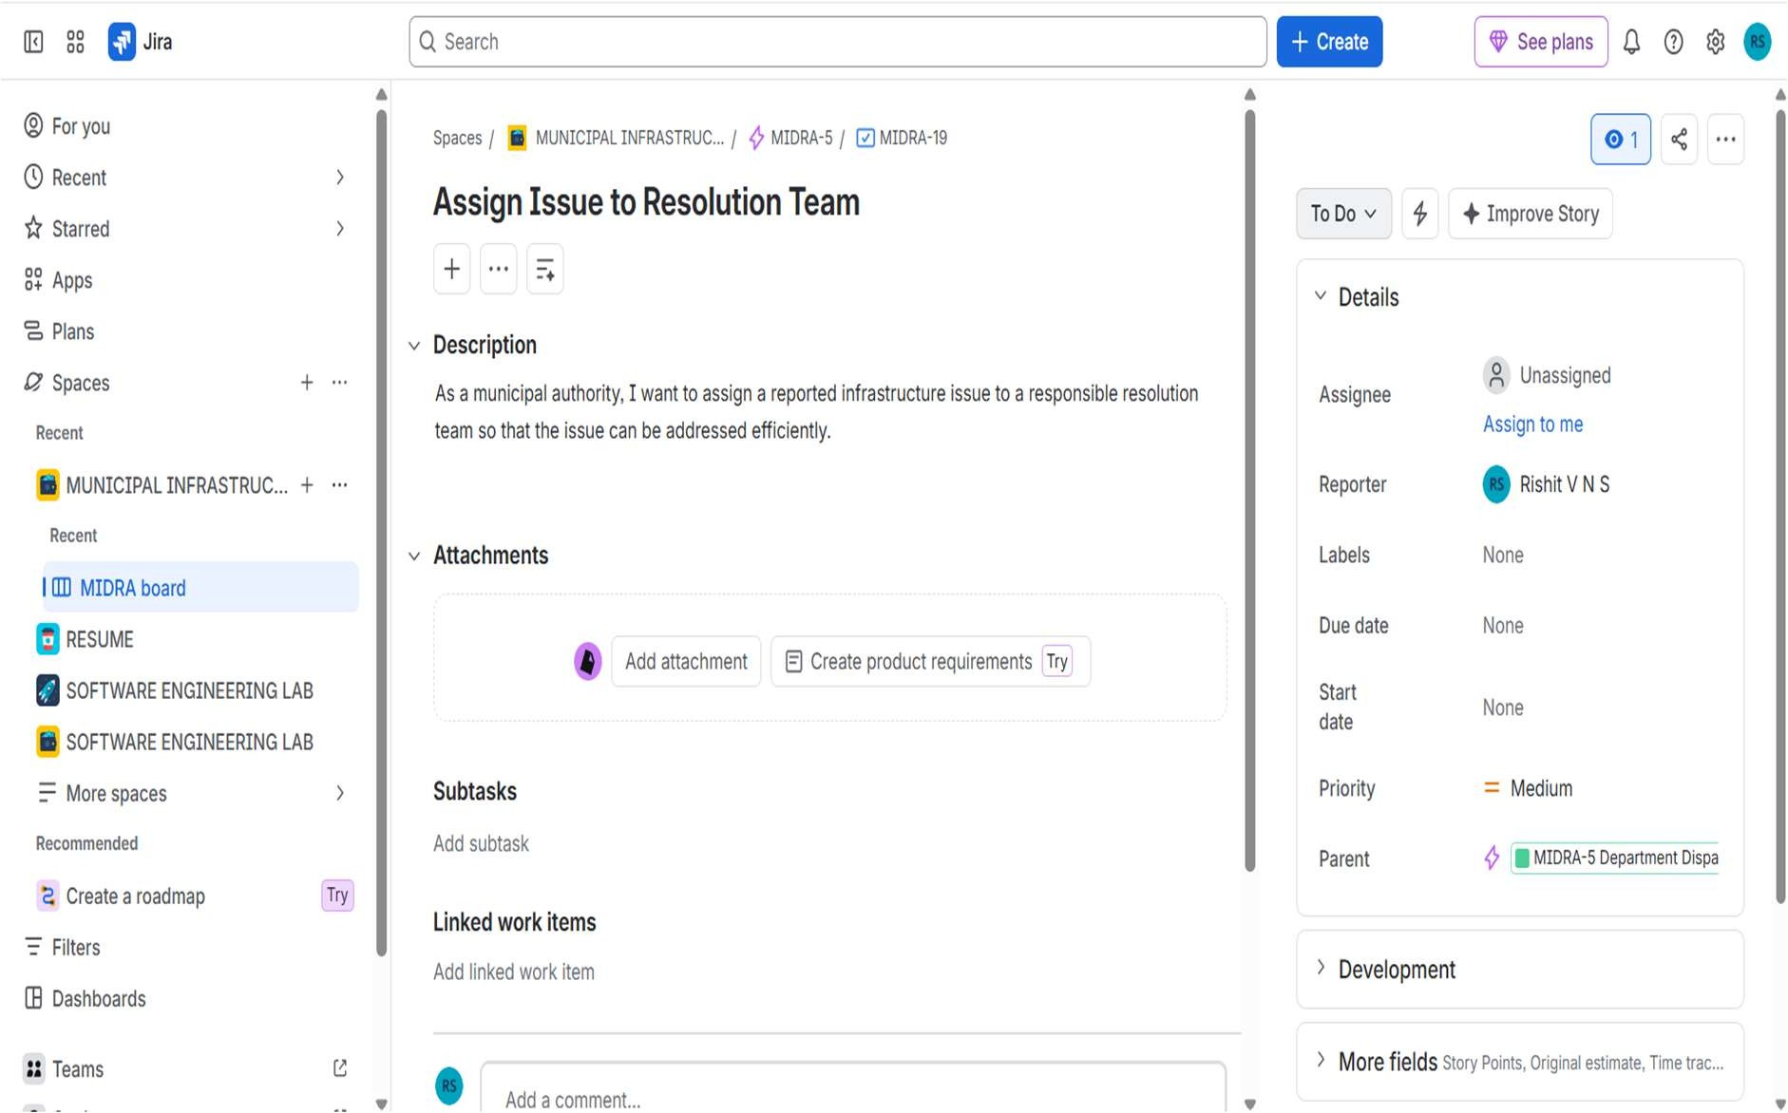

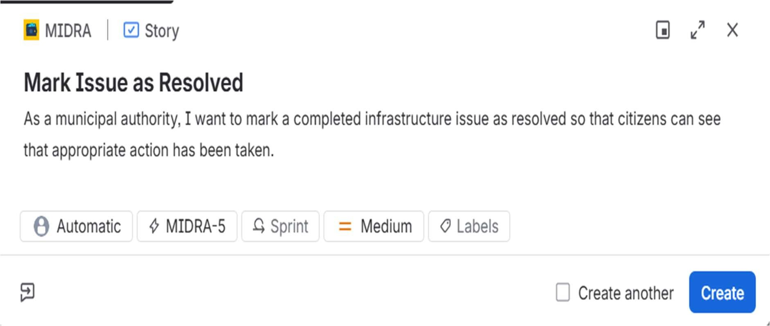

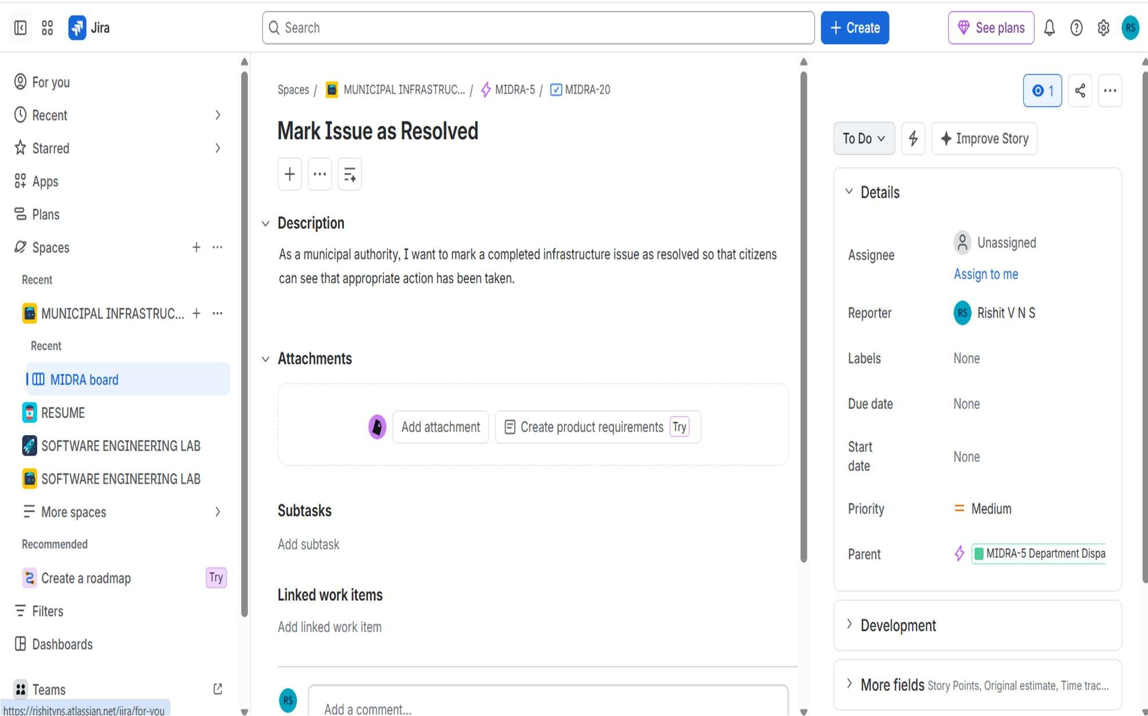

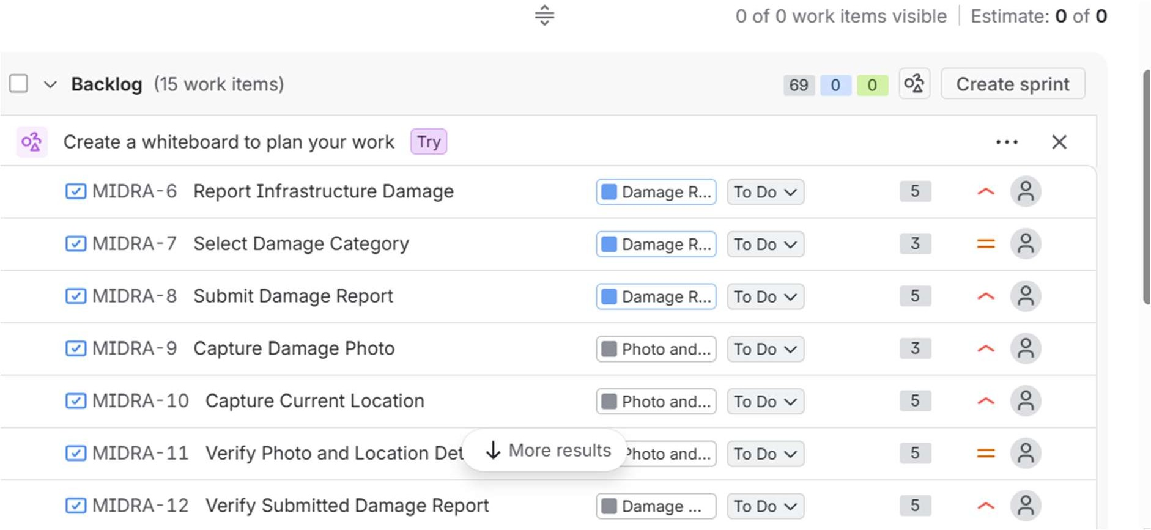

PLANNING POKER:
Story points were estimated using the Planning Poker technique. Each user story was evaluated based on effort, complexity, risk, and uncertainty. Fibonacci sequence values were used to assign relative estimates to the user stories.

REORDERING BACKLOG:
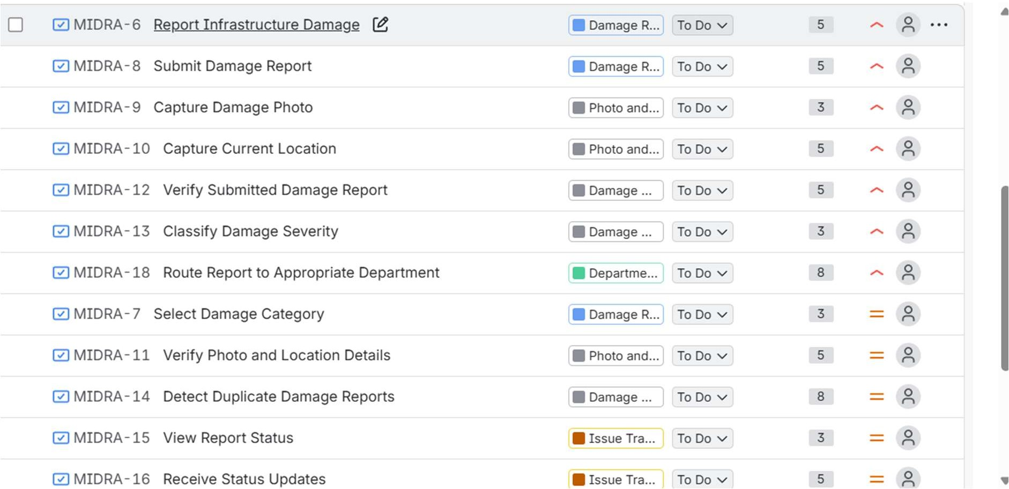
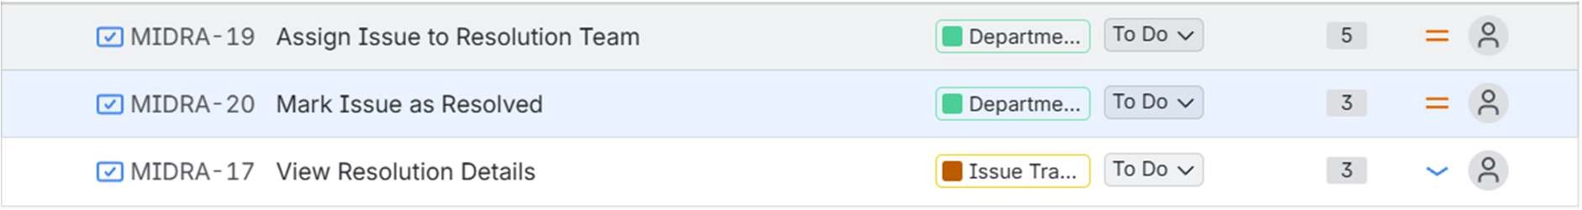

The product backlog was prioritized and reordered based on story importance. High-priority user stories were placed at the top, followed by Medium-priority stories, and finally Low-priority stories.

Running a Mock Sprint:(SPRINT 1)

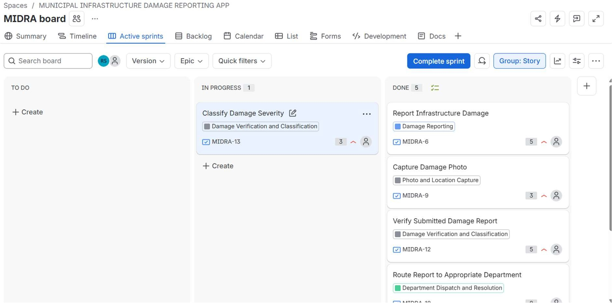
MOVED EPICS FROM TODO TO INPROGRESS TO DONE: SIMULATING PROGRESS:

ADDING COMMENT TO INPROGRESS EPIC:

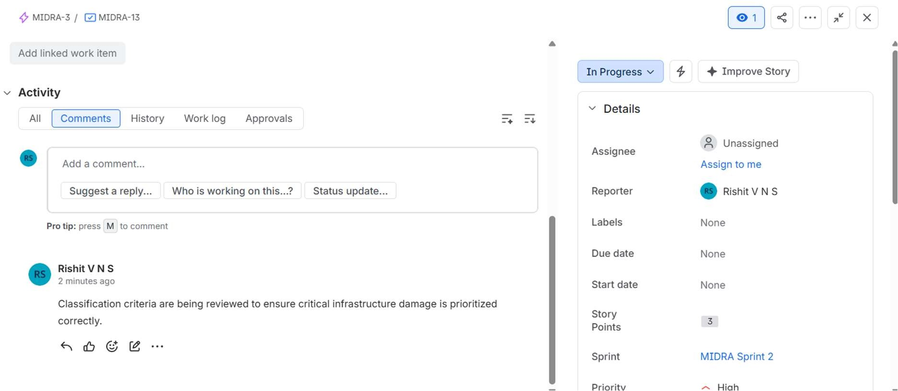

COMPLETED SPRINT PROGRESS:
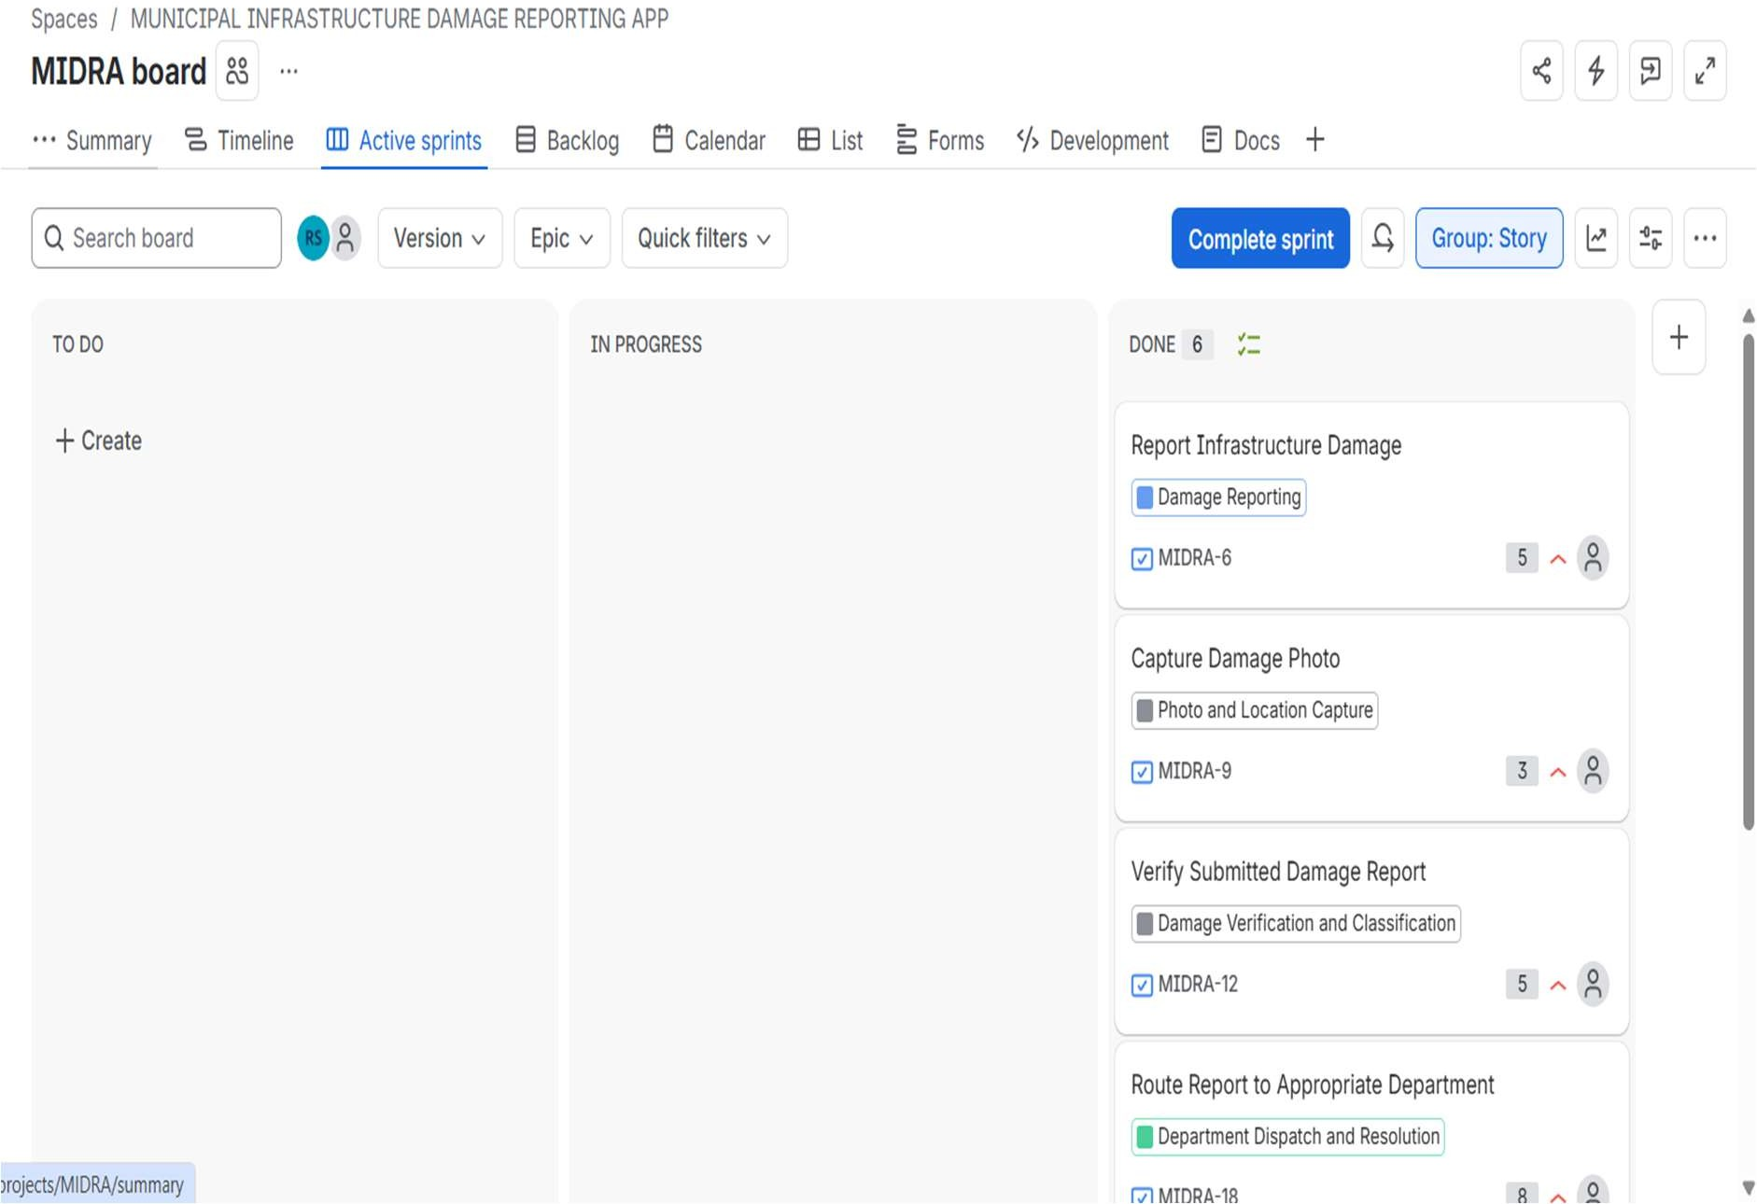
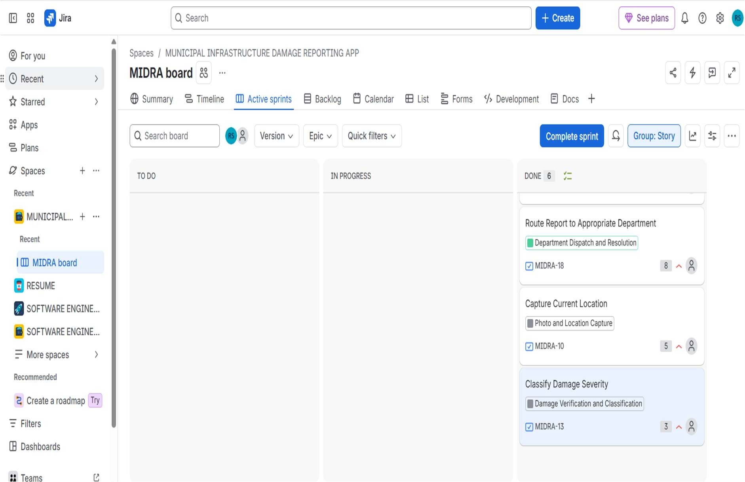

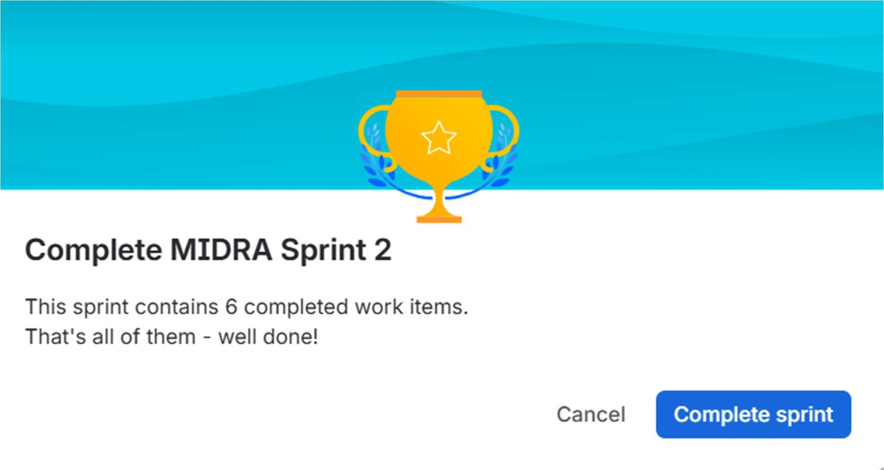
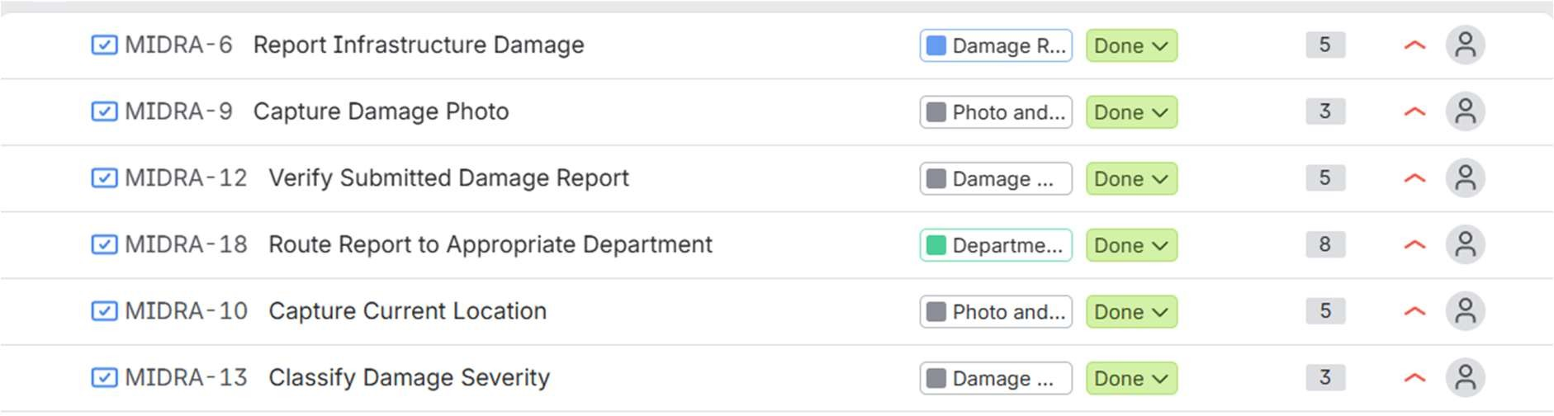

SPRINT FOR MEDIUM PRIORITY:
Moved select damage category to inprogress:
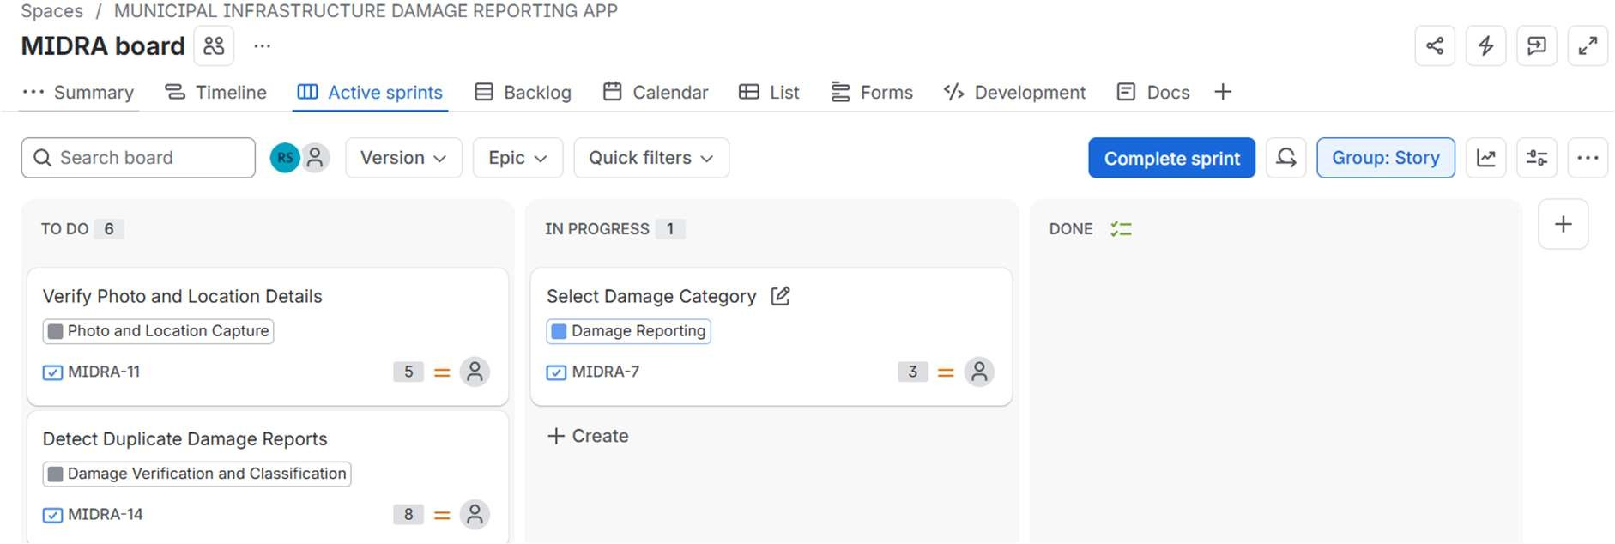

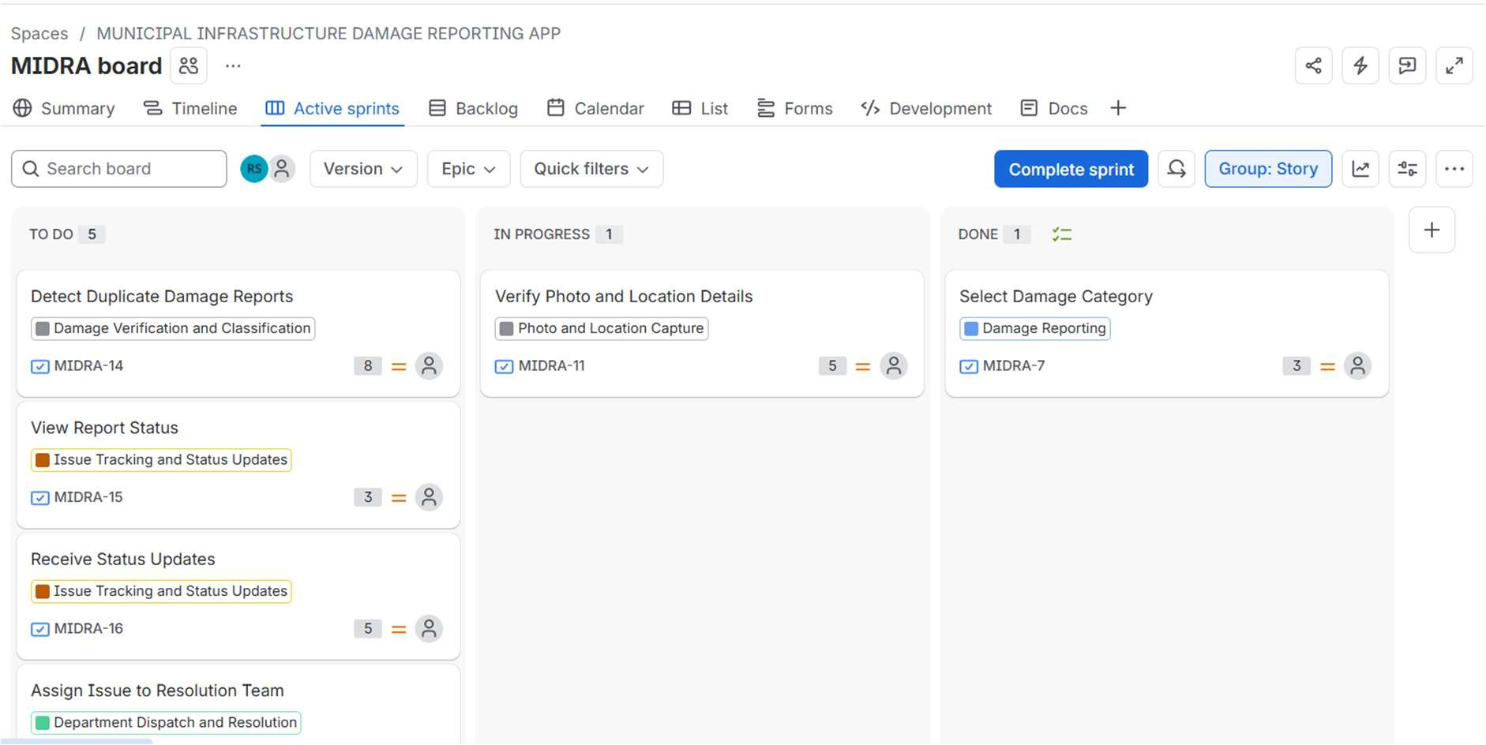
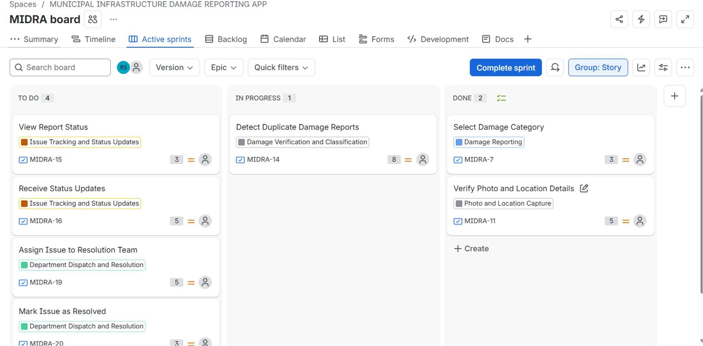
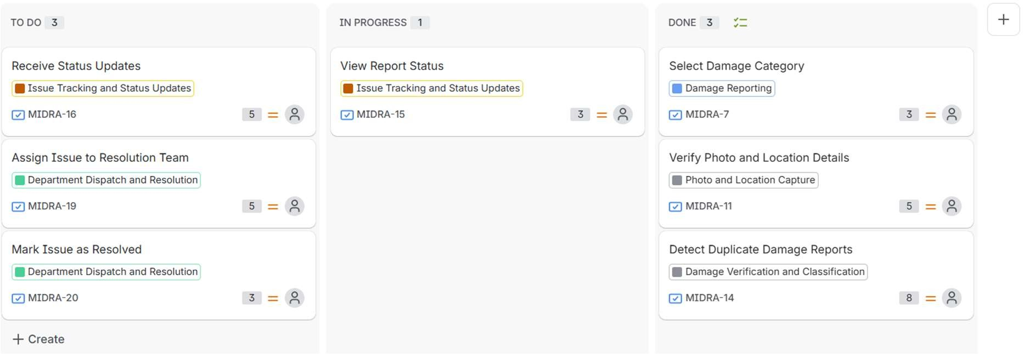

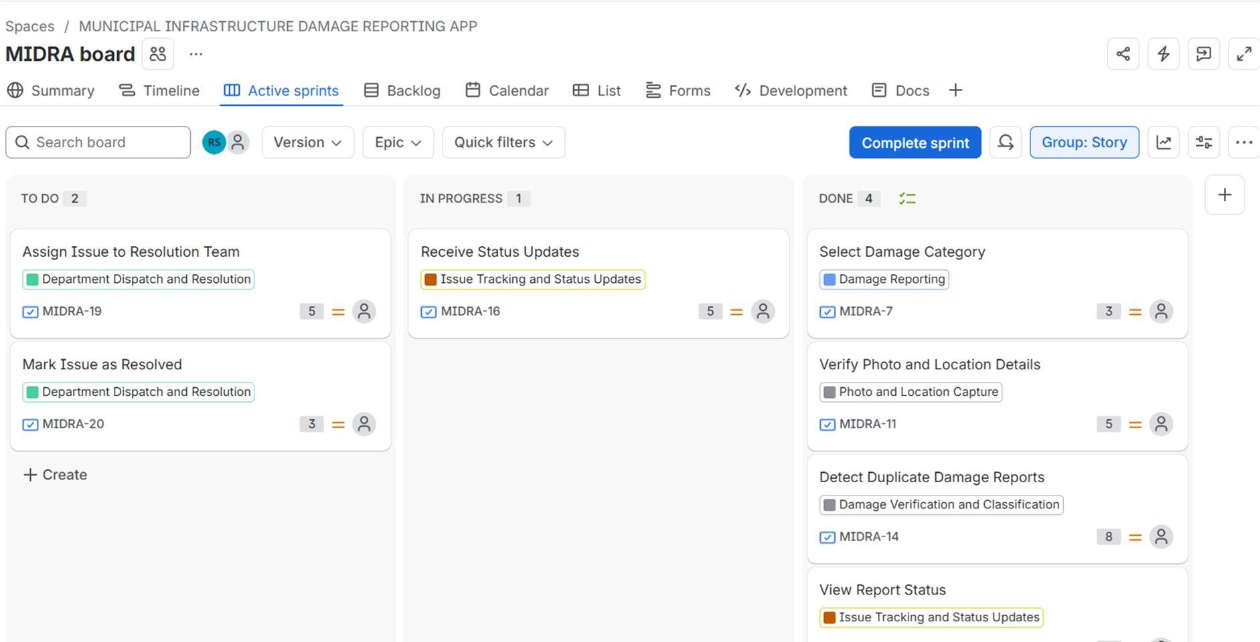

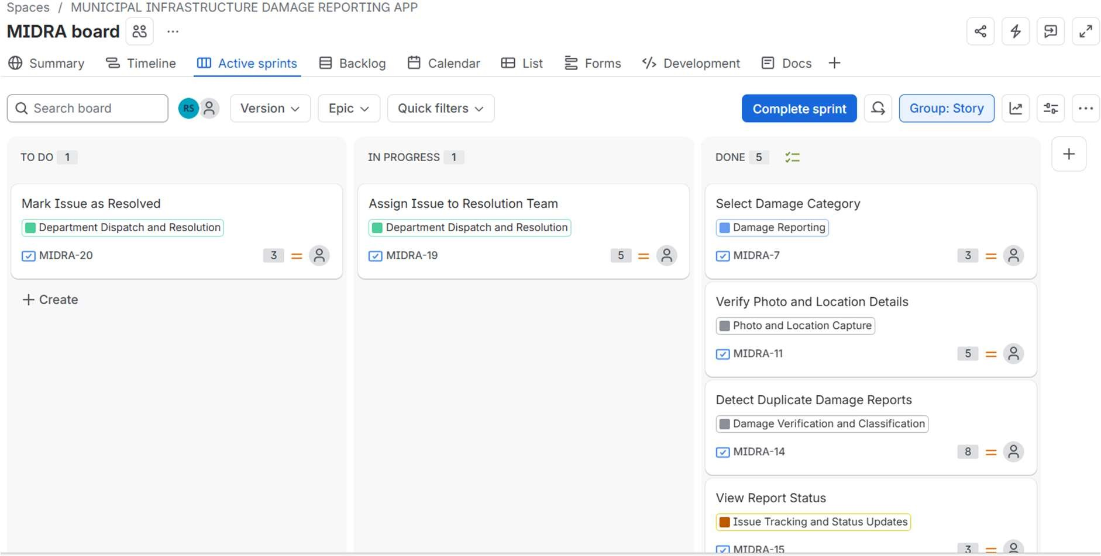

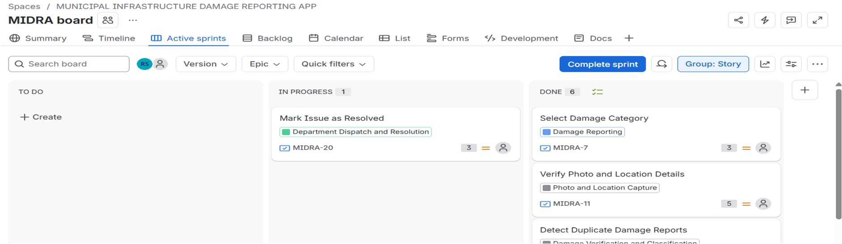

ADDING COMMENT:
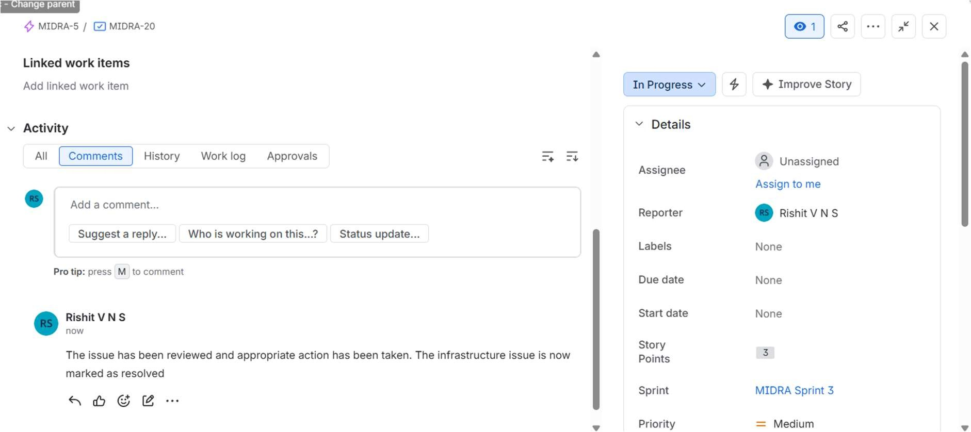

All epics done:

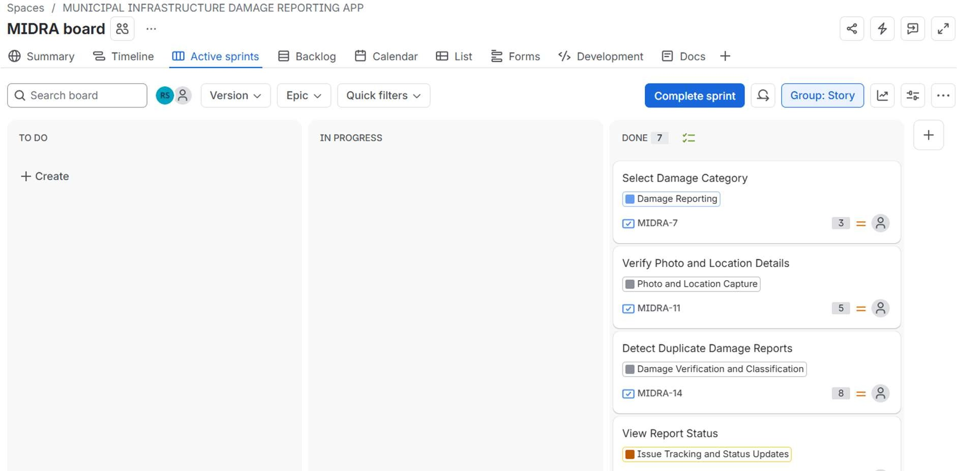

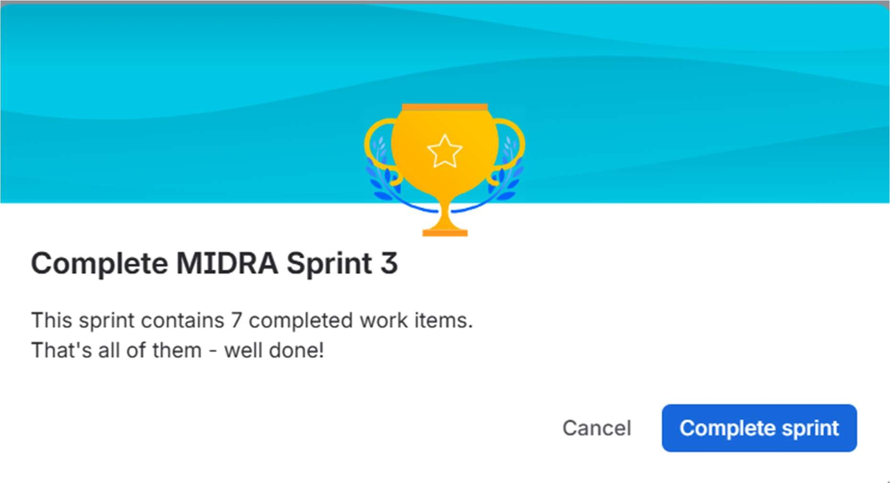
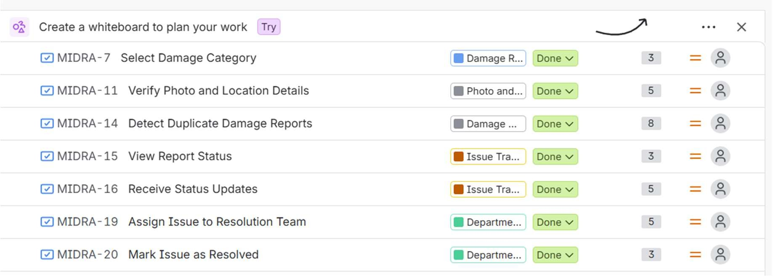

SPRINT FOR LOW PRIORITY:
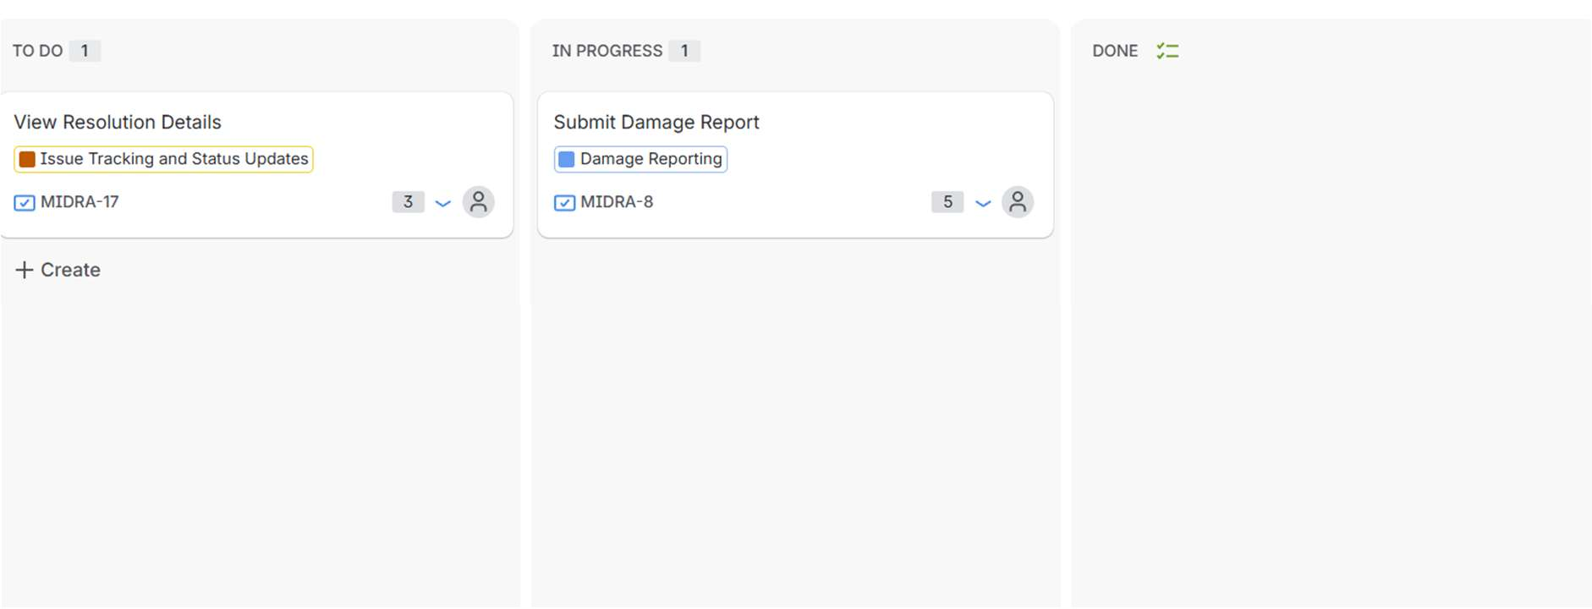

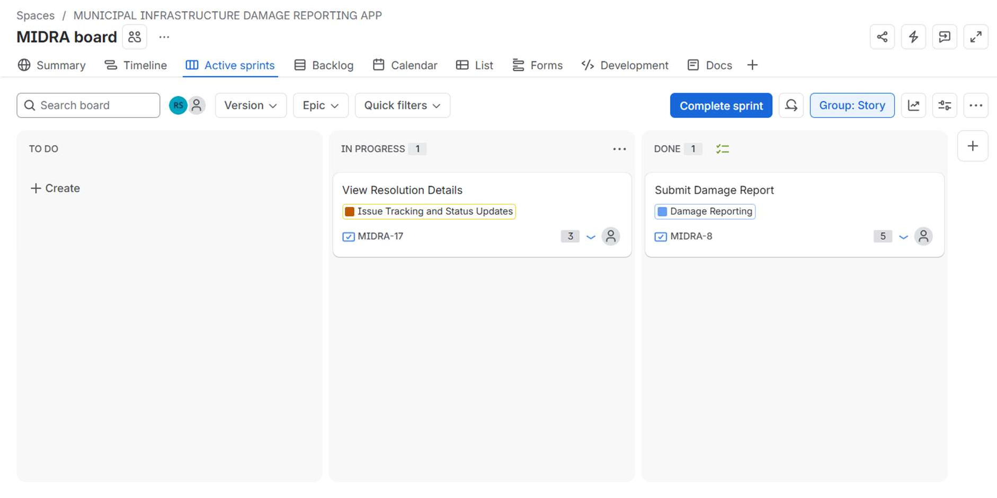

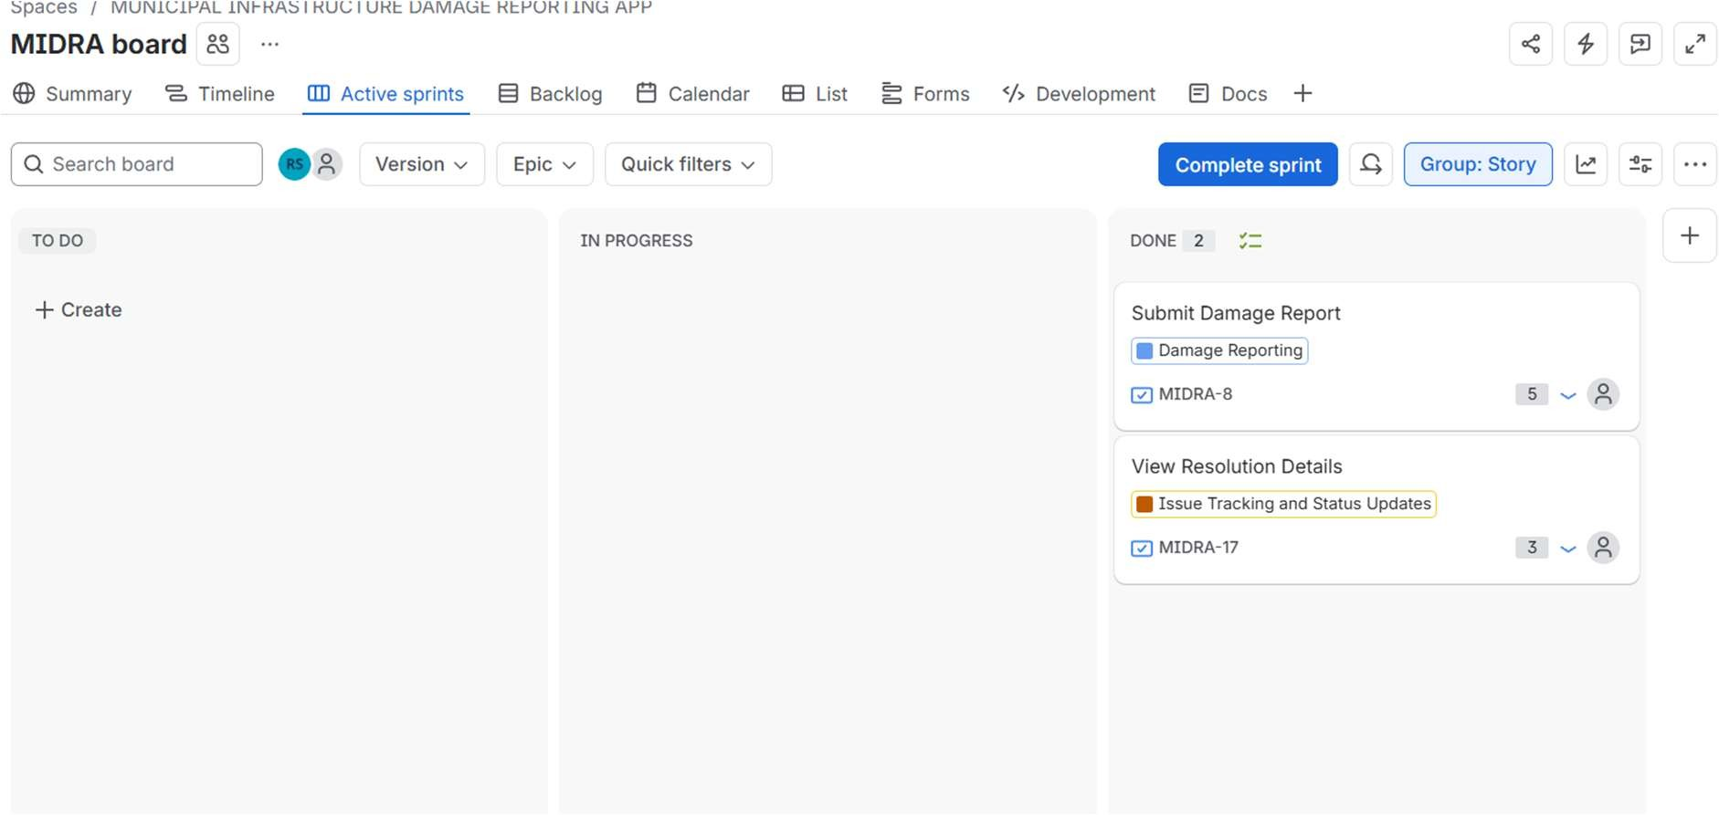
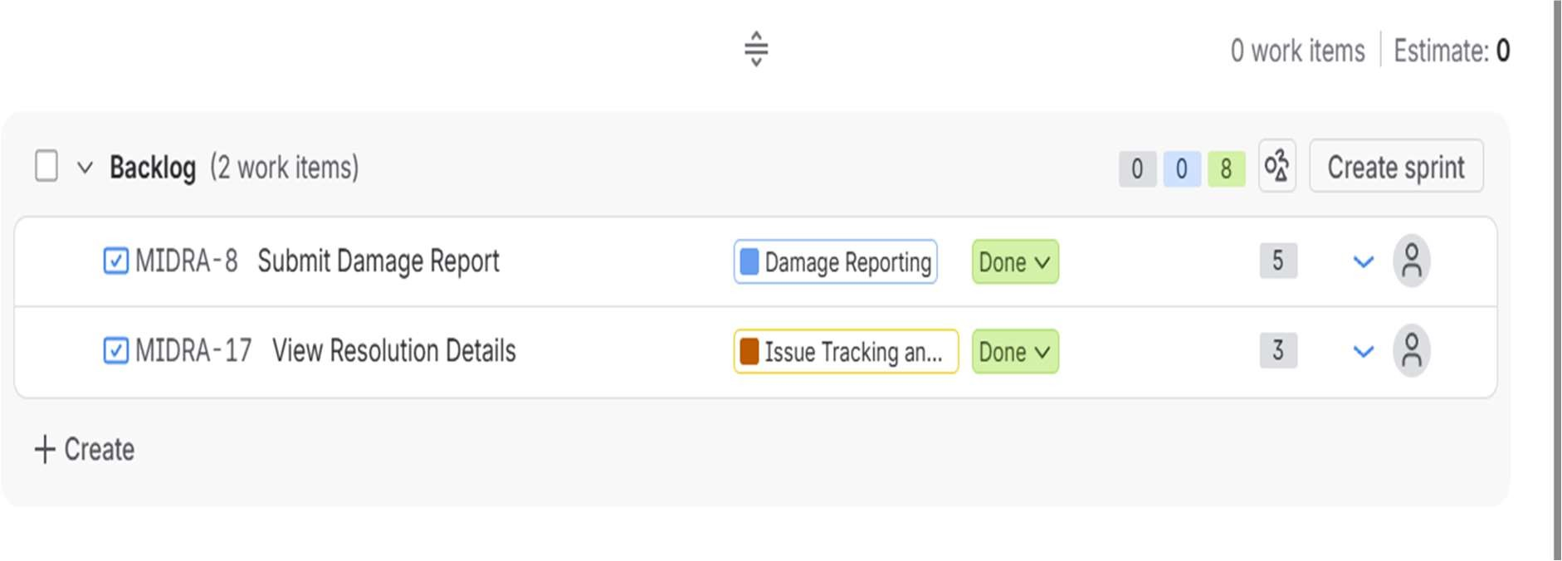

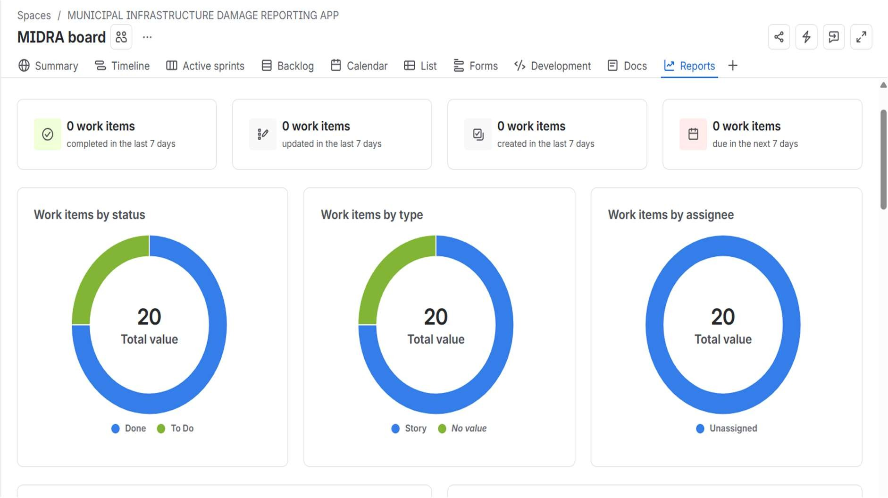

BURNDOWN CHART: SPRINT 2:
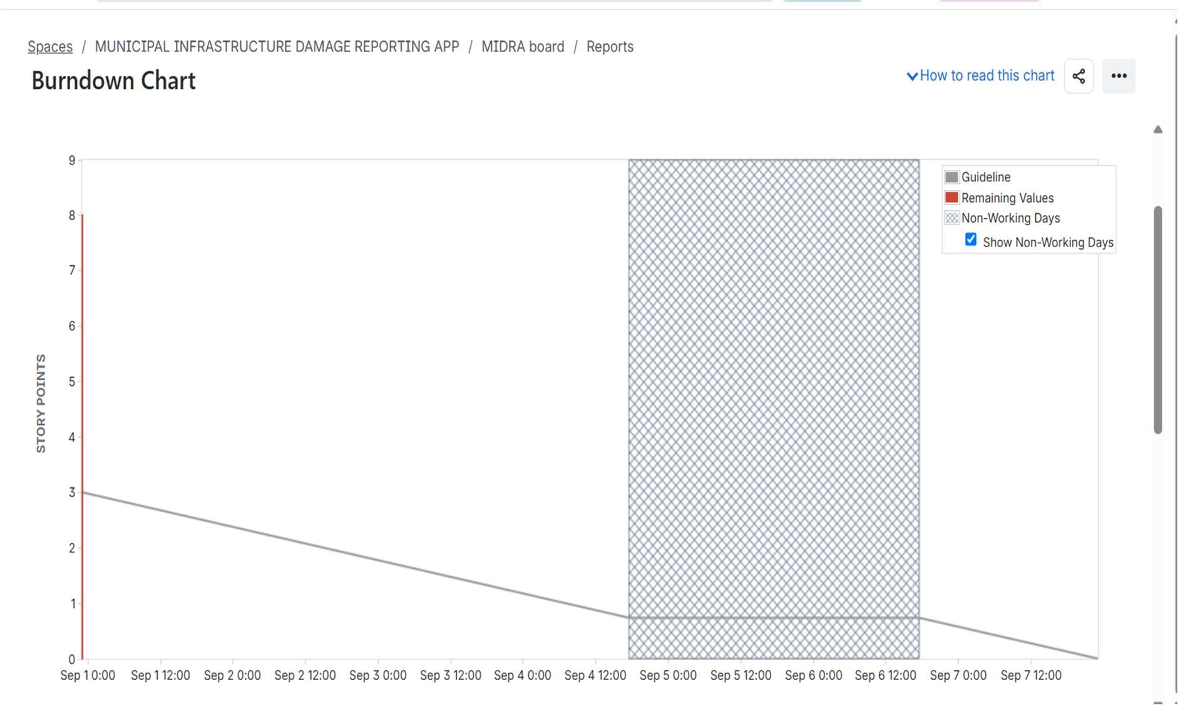

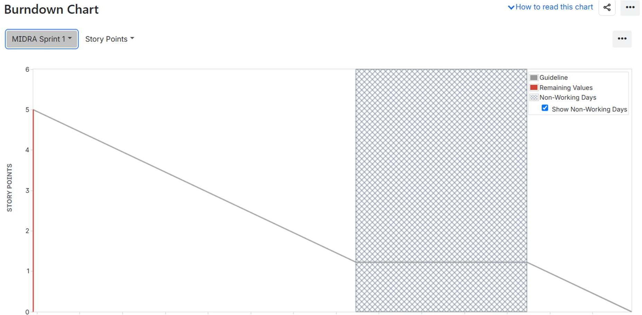

SPRINT 3:
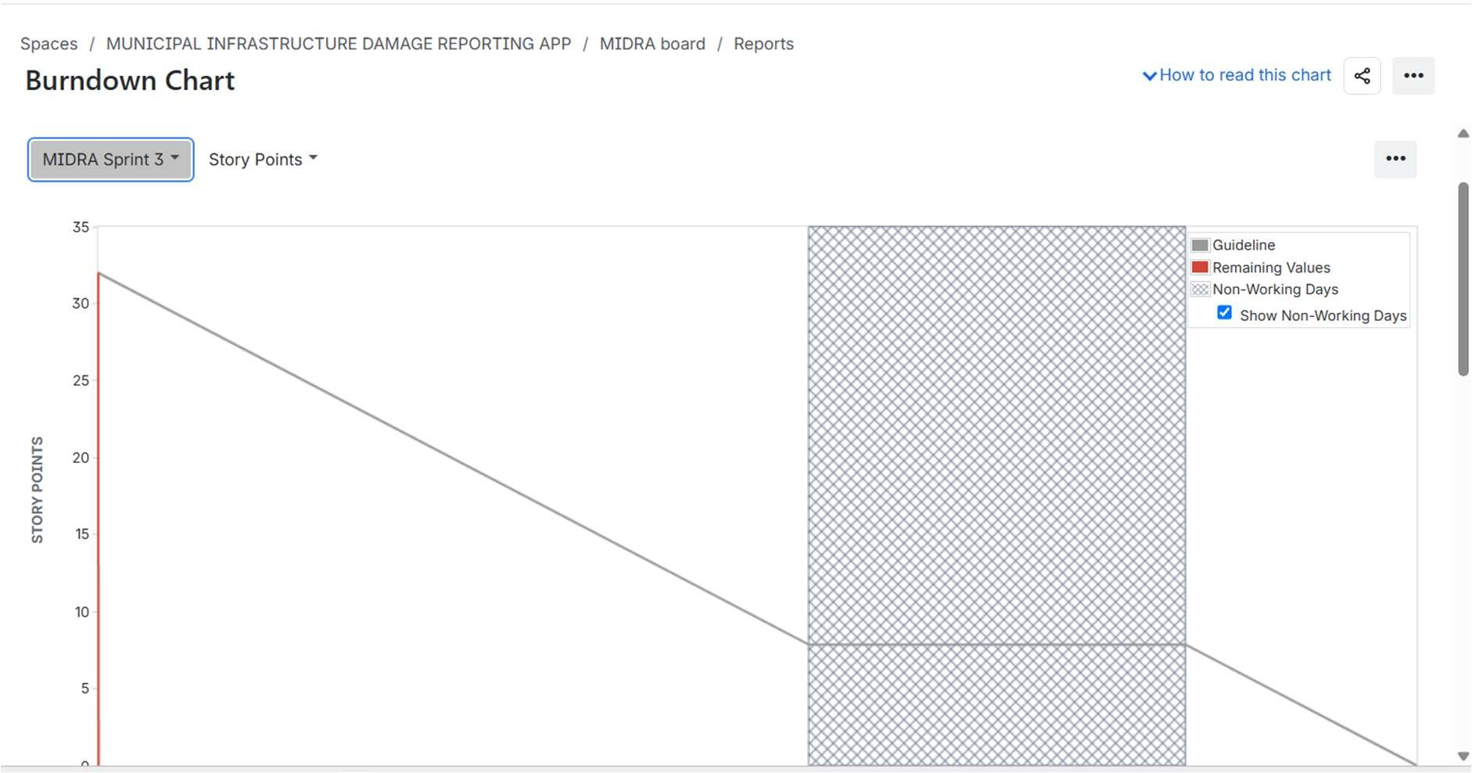

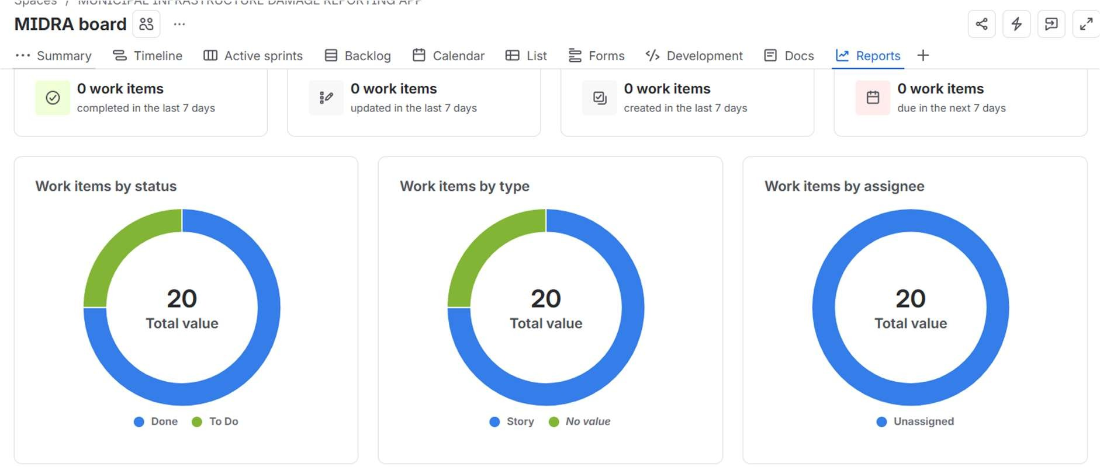

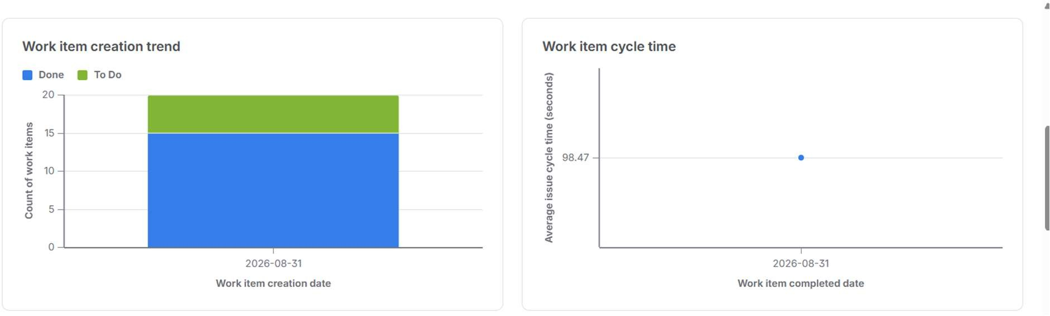

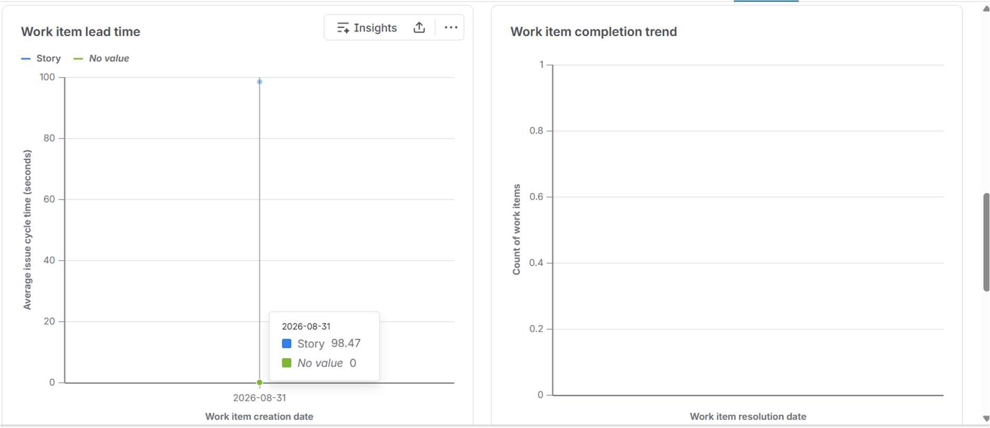

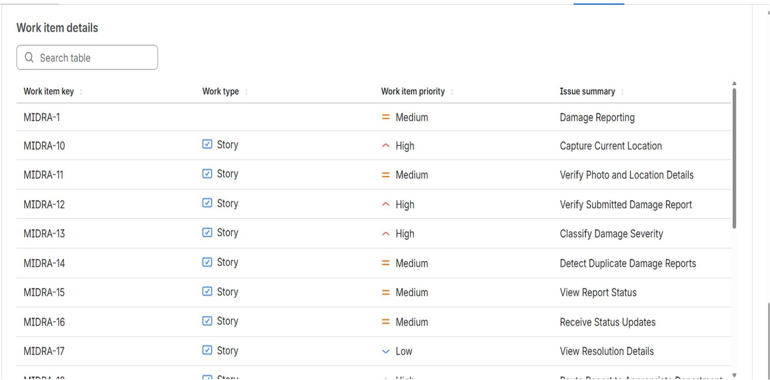
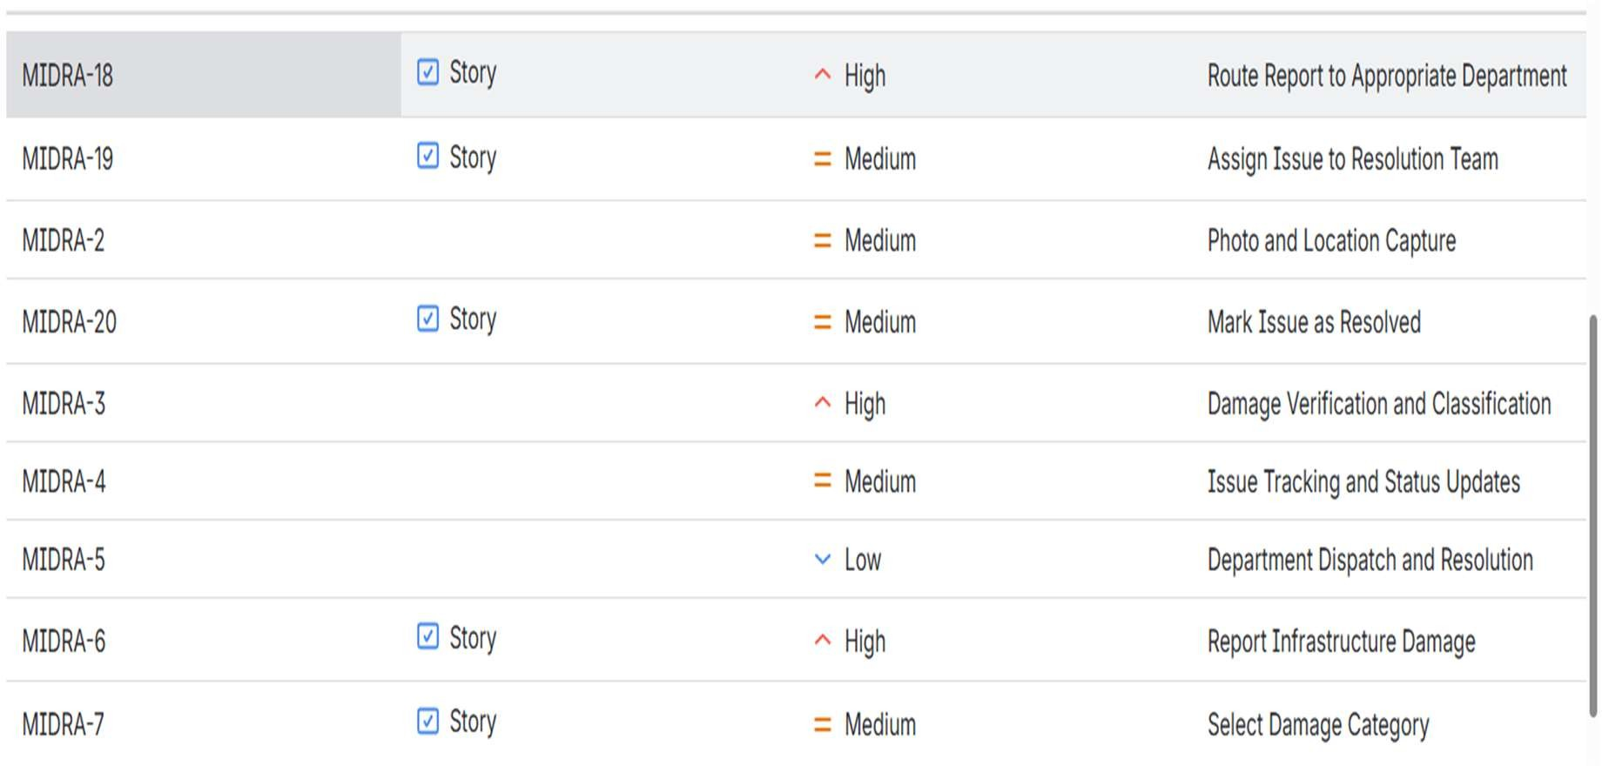
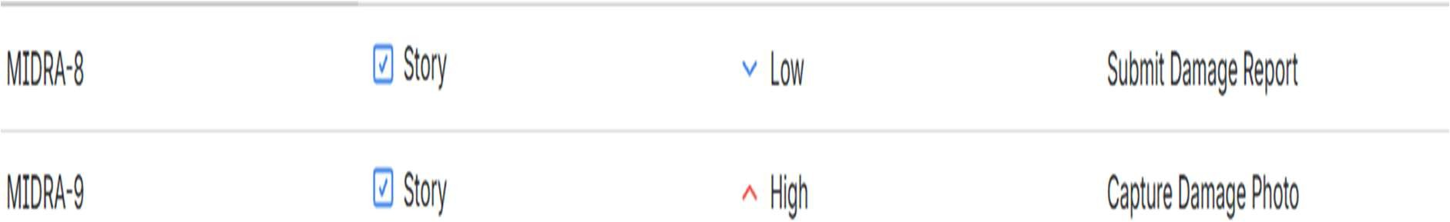

6. Group Reflection
Working on the MiDRA application was a valuable learning experience that helped me understand how Agile and Scrum practices can be applied in a real-world project environmen. Throughout the project, we worked collaboratively to plan, organize, prioritize, and track different work items related to the development of the application.
One of the most important lessons we learned was the value of effective teamwork and communication. Each team member contributed to different aspects of the project, while regular discussions helped us maintain a common understanding of the project goals and requirements. By dividing the work into manageable user stories and prioritizing tasks based on their importance, we were able to approach the project in a more organized and systematic manner.
The use of Jira for Agile project management gave us practical experience in managing a software project through sprints. We created and organized work items, assigned priorities, estimated story points, and moved tasks through different stages such as To Do, In Progress, and Done. This allowed us to clearly visualize the progress of the project and understand how Agile teams continuously track and manage their work.
Sprint planning was particularly useful because it helped us understand the importance of selecting achievable tasks for a specific sprint. By grouping work items according to their priority and completing them systematically, we gained experience in managing workload and maintaining focus on the most important requirements. The use of the Burndown Chart also helped us understand how completed work can be compared with planned work and how progress can be monitored throughout a sprint.
We also learned that not every aspect of a project goes perfectly according to the initial plan. During the process, there were situations where we needed to review work items, update task status, and make adjustments to ensure that the project remained properly organized. These experiences helped us understand that Agile development is flexible and iterative, allowing teams to continuously improve their workflow instead of strictly following a fixed plan.
Another important takeaway was the significance of prioritization. High-priority tasks were addressed first because they had a greater impact on the core functionality of the MiDRA application. Medium- and low-priority tasks were then planned and managed accordingly. This approach helped us understand how software teams make decisions when resources and time are limited.
Overall, this project provided our group with a strong practical understanding of Agile methodology, Scrum concepts, sprint management, teamwork, task prioritization, and project tracking. Beyond the technical aspects of the application, we developed

important professional skills such as collaboration, communication, planning, responsibility, and problem-solving.
In conclusion, the MiDRA project was a highly valuable learning experience for our group. It demonstrated that successful software development depends not only on developing the final application but also on effective planning, continuous monitoring, collaboration, and adaptation. The knowledge and experience gained from this project will be useful in future academic projects as well as in real-world software development environments.

