// 01 • HERO SHOWCASE | [ 01 / 08 ]
FixGrid Probe™: The Complete Ecosystem
A Live Web Platform (fixgrid.vytron.me) & A Frugal Handheld Diagnostic Wand Championing Sustainable Repair Across All 21+ Categories
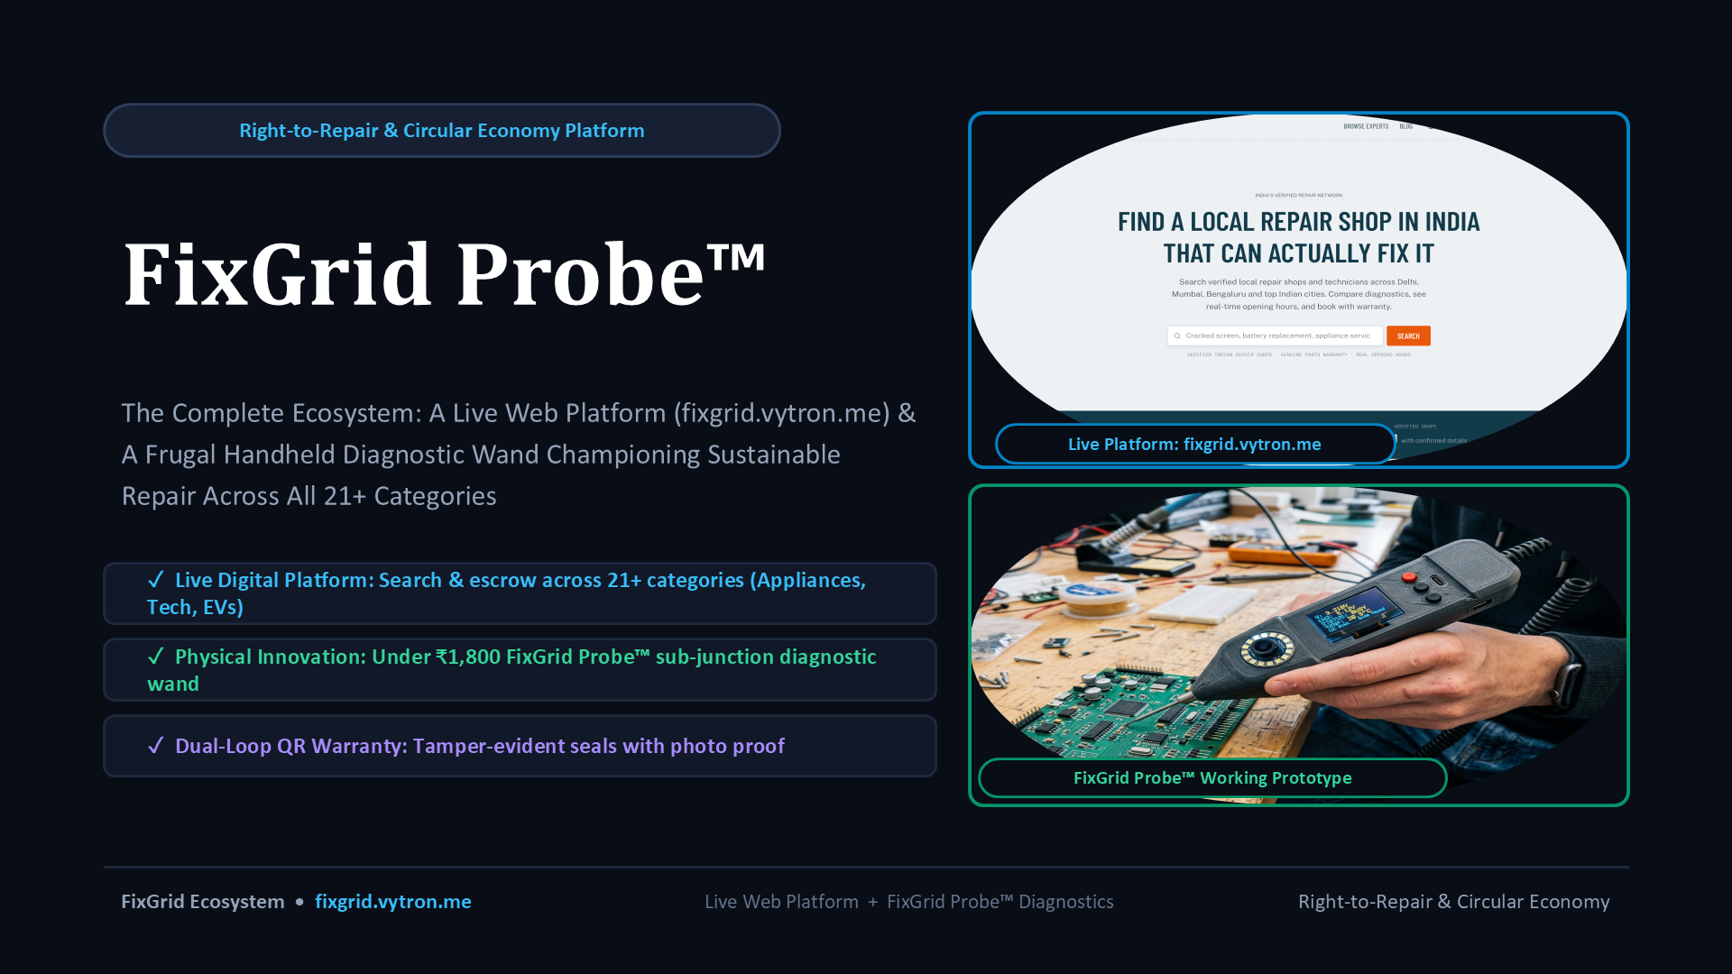
KEY TAKEAWAYS & SLIDE CONTENT
✓ Live Digital Platform: Search & escrow across 21+ categories (Appliances, Tech, EVs)
✓ Physical Innovation: Under ₹1,800 FixGrid Probe™ sub-junction diagnostic wand
✓ Dual-Loop QR Warranty: Tamper-evident seals with photo proof

🎙️ PRESENTER SCRIPT & TALKING POINTS
"Welcome. FixGrid Probe unites a live web marketplace with a low-cost physical diagnostic wand, solving both the digital trust void and the technical hardware diagnostic barrier."

FixGrid Ecosystem • fixgrid.vytron.me | SLIDE 01 OF 08

// 02 • PROBLEM STATEMENT | [ 02 / 08 ]
Problem Statement: The Throwaway Culture & Climate Paradox
Why 78% of repairable gadgets end up in landfills while local artisans lose their livelihoods
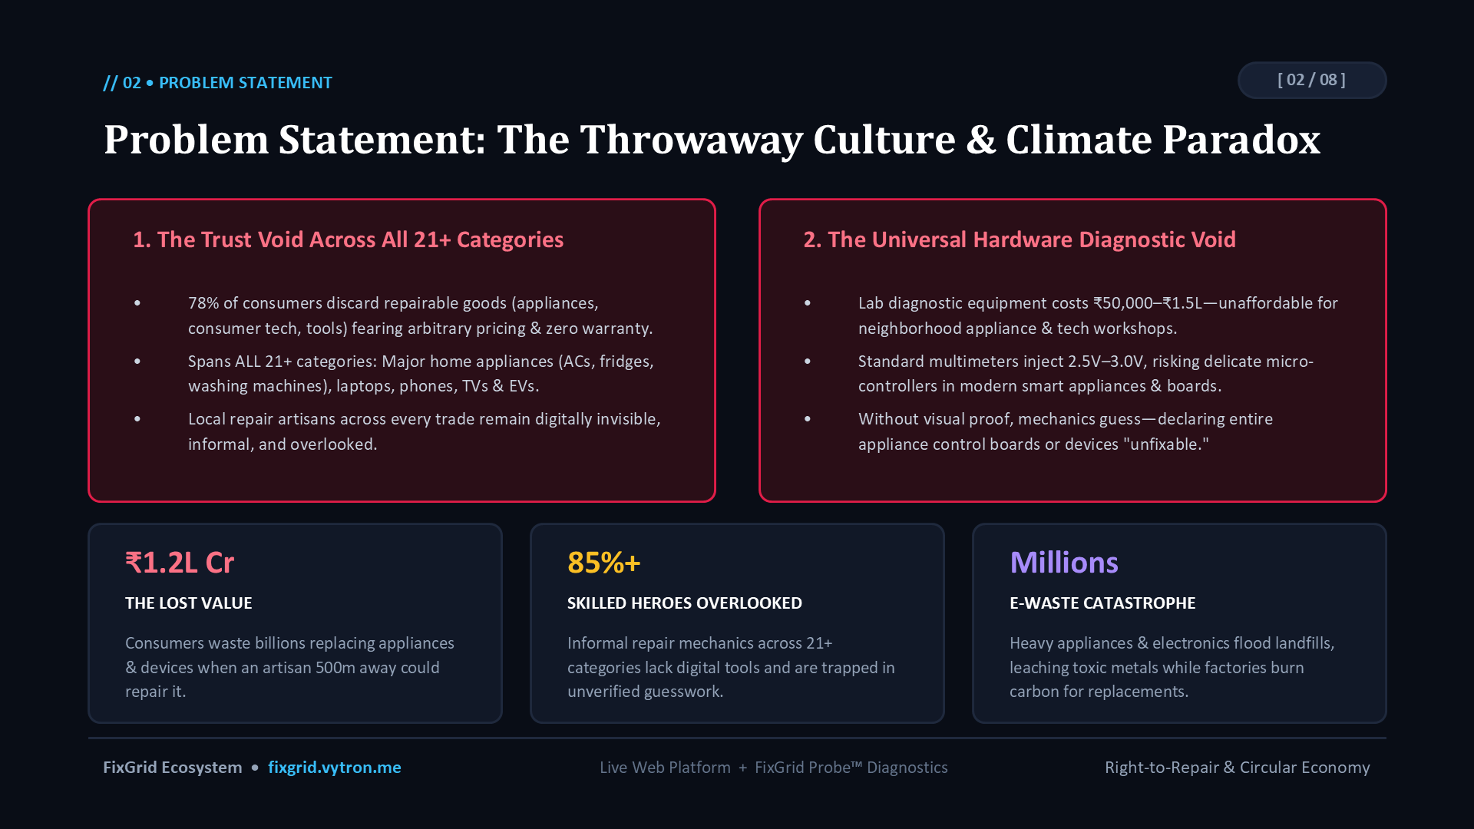
KEY TAKEAWAYS & SLIDE CONTENT
✓ The $15.2B Repair Economy is Broken: 78% of consumers discard repairable smartphones, laptops, and appliances into landfills due to fear of arbitrary pricing and technician fraud.
✓ Hardware Diagnostic Barrier: Informal mechanics lack ₹1,50,000 lab oscilloscopes. Trial-and-error multimeters fry delicate microchips, misdiagnosing ₹10 capacitors as dead boards.
✓ Mounting E-Waste Crisis: Millions of tons of toxic e-waste generated annually, leaching lead and cadmium into groundwater while new manufacturing burns carbon.

🎙️ PRESENTER SCRIPT & TALKING POINTS
"Every day, thousands of repairable phones and appliances are thrown away. A ₹50 blown capacitor is declared a dead motherboard because roadside mechanics lack diagnostic tools. FixGrid ends this cycle."

FixGrid Ecosystem • fixgrid.vytron.me | SLIDE 02 OF 08

// 03 • SOLUTION OVERVIEW | [ 03 / 08 ]
A Two-Pillar Solution: Digital Marketplace + Smart Hardware
Unifying web discovery and escrow governance with hardware circuit precision
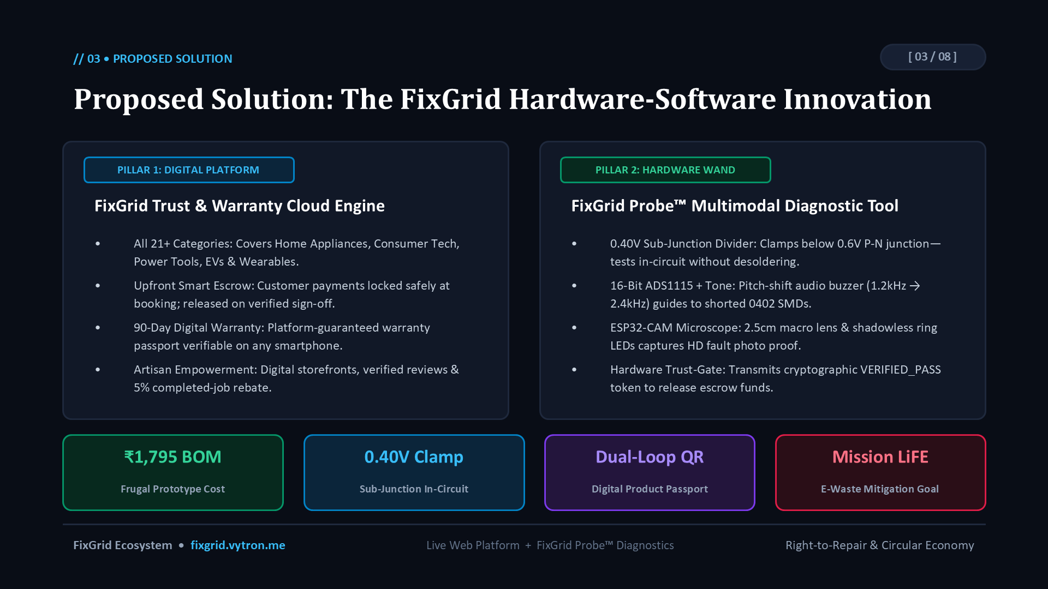
KEY TAKEAWAYS & SLIDE CONTENT
✓ Pillar 1 — Live Web Platform (fixgrid.vytron.me): 21+ repair categories, upfront transparent pricing, safe escrow lock, and verified shop credentials.
✓ Pillar 2 — FixGrid Probe™ Multimodal Diagnostic Tool: 0.40V sub-junction divider testing in-circuit without desoldering, 16-bit ADS1115 audio tone buzzer, and ESP32-CAM microscope.
✓ Key Innovation Metrics: ₹1,795 BOM prototype cost, 0.40V safe voltage clamp, Dual-Loop QR digital product passport, supporting Mission LiFE.

🎙️ PRESENTER SCRIPT & TALKING POINTS
"FixGrid Probe merges physics and digital governance. It tests in-circuit at 0.40V without desoldering, snaps macro photos of 0402 SMDs, links to a Dual-Loop QR warranty seal, and acts as a hardware trust-gate releasing escrow."

FixGrid Ecosystem • fixgrid.vytron.me | SLIDE 03 OF 08

// 04 • HARDWARE INNOVATION | [ 04 / 08 ]
FixGrid Probe™: Lab Diagnostics in a Handheld Wand
Sub-junction in-circuit fault detection with 5MP macro photo evidence under ₹1,800 BOM
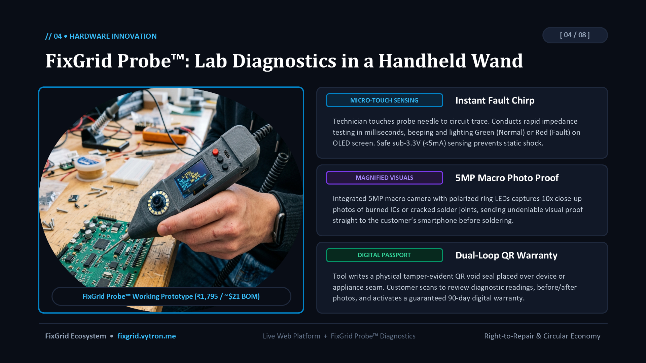
KEY TAKEAWAYS & SLIDE CONTENT
✓ Instant Fault Chirp (Micro-Touch Sensing): Rapid impedance testing in milliseconds; beeps and glows Green (Normal) or Red (Fault) on OLED screen without desoldering.
✓ 5MP Macro Photo Proof (Magnified Visuals): Integrated macro camera with polarized ring LEDs captures 10x close-up photos of burned ICs or cracked joints, beaming undeniable proof straight to the customer's phone.
✓ Dual-Loop QR Warranty (Digital Passport): Writes a physical tamper-evident holographic QR void seal over the chassis seam, locking in a guaranteed 90-day digital warranty.

🎙️ PRESENTER SCRIPT & TALKING POINTS
"FixGrid Probe provides three capabilities in one wand: micro-touch fault sensing with instant beeps, macro photo proof sent to the phone, and a tamper-evident digital warranty seal."

FixGrid Ecosystem • fixgrid.vytron.me | SLIDE 04 OF 08

// 05 • LIVE WEB PLATFORM | [ 05 / 08 ]
fixgrid.vytron.me: Consumer Marketplace & Trust Engine
Connecting device owners to verified neighborhood repair artisans with escrow safety
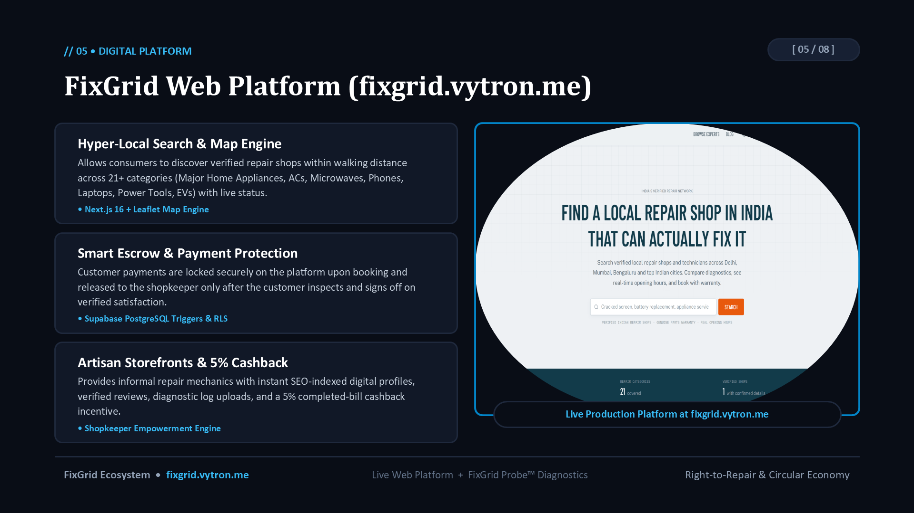
KEY TAKEAWAYS & SLIDE CONTENT
✓ 21+ Repair Categories: Smartphones, laptops, home appliances, microwaves, smartwatches, and clean-tech EV battery chargers.
✓ Smart Escrow Safety: 100% upfront payment held securely; released to technician only after hardware test pass and customer sign-off.
✓ Verified Local Directory: Interactive Leaflet map engine finding skilled artisans within 500m to 5km with genuine storefront audits.

🎙️ PRESENTER SCRIPT & TALKING POINTS
"Our live web platform fixgrid.vytron.me is operational with interactive maps, verified expert profiles, upfront pricing, and smart escrow protection across 21 categories."

FixGrid Ecosystem • fixgrid.vytron.me | SLIDE 05 OF 08

// 06 • VERIFICATION WORKFLOW | [ 06 / 08 ]
Physical & Digital Synergy: The Dual-Loop Warranty
How hardware diagnostics, physical seals, and cloud telemetry ensure 100% accountability
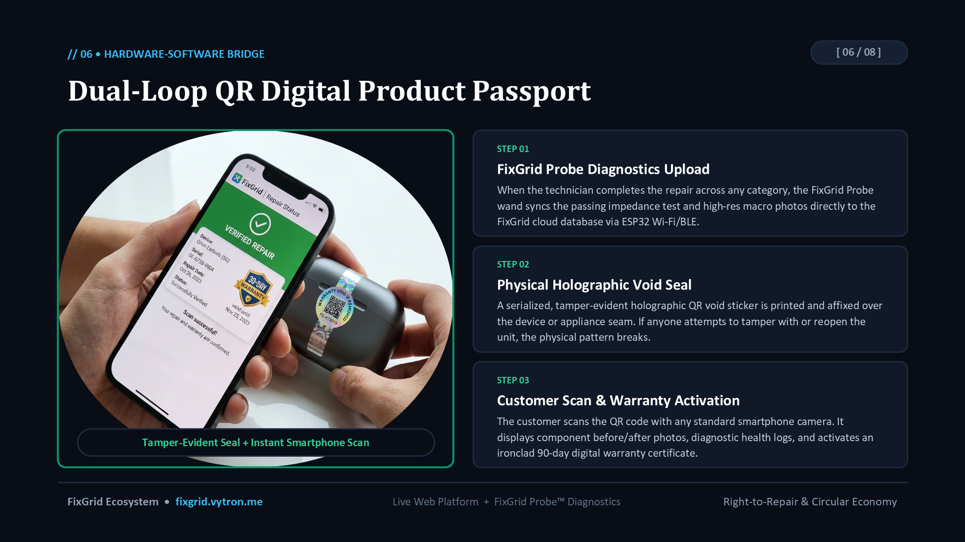
KEY TAKEAWAYS & SLIDE CONTENT
✓ Step 01 — FixGrid Probe Diagnostics Upload: Technician finishes repair; wand syncs passing impedance telemetry and macro photos directly to FixGrid cloud via ESP32 Wi-Fi/BLE.
✓ Step 02 — Physical Holographic Void Seal: Serialized tamper-evident QR void sticker is affixed over the device seam. If tampered with, the pattern breaks.
✓ Step 03 — Customer Smartphone Scan & Warranty Activation: Customer scans QR with any phone camera to view before/after photos and activate an ironclad 90-day warranty certificate.

🎙️ PRESENTER SCRIPT & TALKING POINTS
"This is where the magic happens: the FixGrid Probe hardware records the repair, generates a tamper-evident holographic QR seal, and the customer scans it on their phone to see verified before-and-after photos and activate their warranty."

FixGrid Ecosystem • fixgrid.vytron.me | SLIDE 06 OF 08

// 07 • IMPACT & SCALABILITY | [ 07 / 08 ]
Tapping the $15.2B Repair Economy
Sustainable monetization that aligns consumer savings, artisan livelihoods, and e-waste reduction
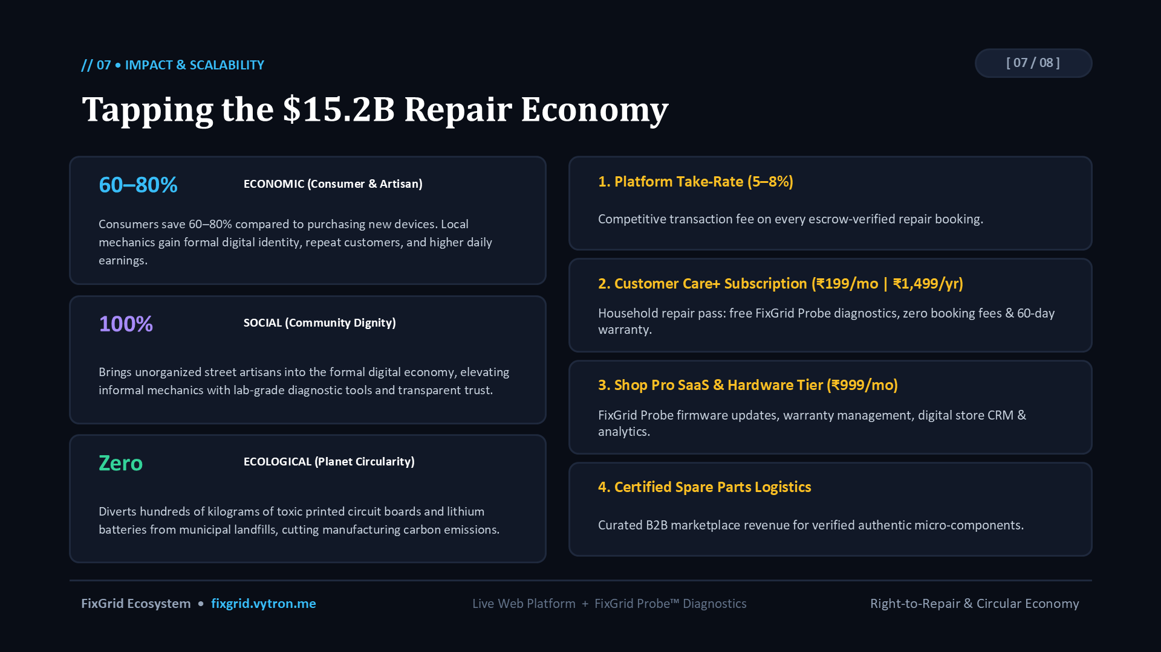
KEY TAKEAWAYS & SLIDE CONTENT
✓ Triple Bottom Line: Consumers save 60–80% vs buying new; local artisans gain respected digital identity; tons of hazardous e-waste prevented at the source.
✓ Stream 1 — Platform Take-Rate: Competitive 5–8% transaction fee on every escrow-verified repair booking.
✓ Stream 2 — Customer Care+ Pass: ₹199/month household subscription with free FixGrid Probe diagnostics & zero booking fees.
✓ Stream 3 — Shop Pro SaaS: ₹999/month repair shop tier for firmware updates, warranty management, and digital CRM.
✓ Stream 4 — B2B Spare Parts: Curated marketplace logistics for verified authentic micro-components.

🎙️ PRESENTER SCRIPT & TALKING POINTS
"Our model creates value for everyone: consumers save money, informal mechanics earn reliable livelihoods, and FixGrid monetizes through transaction fees and subscriptions."

FixGrid Ecosystem • fixgrid.vytron.me | SLIDE 07 OF 08

// 08 • THE FUTURE ROADMAP | [ 08 / 08 ]
A Movement Towards a Sustainable Repair Economy
Phased scaling from neighborhood repair clusters to nationwide municipal partnerships
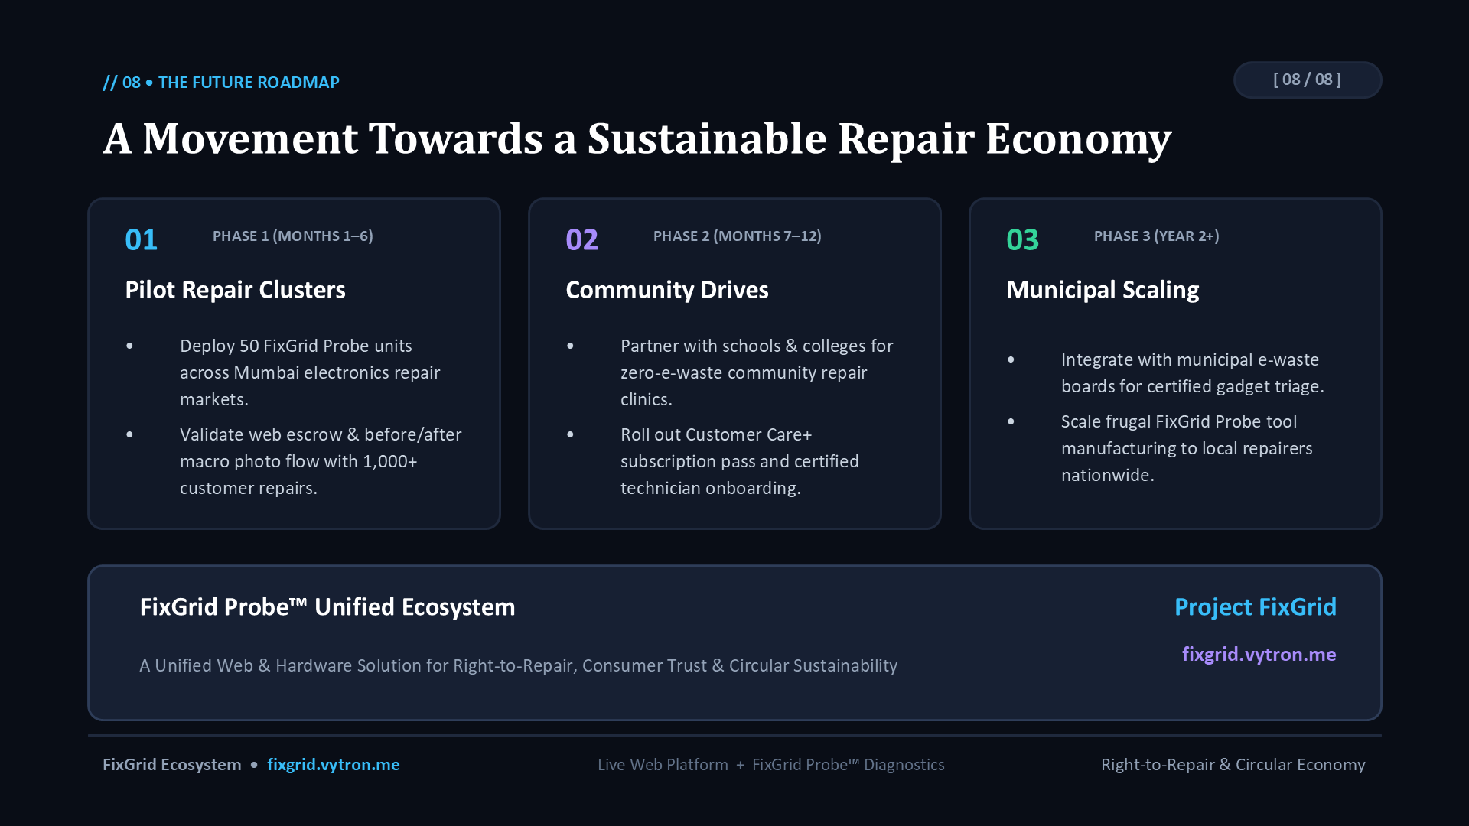
KEY TAKEAWAYS & SLIDE CONTENT
✓ Phase 1 (Months 1–6) — Pilot Repair Clusters: Deploy 50 FixGrid Probe units across Mumbai electronics markets; validate web escrow with 1,000+ customer repairs.
✓ Phase 2 (Months 7–12) — Community Drives: Partner with schools and colleges for zero-e-waste community repair clinics; expand Care+ subscription.
✓ Phase 3 (Year 2+) — Municipal Scaling: Integrate with municipal e-waste recycling boards for certified gadget triage; scale frugal hardware tool manufacturing nationwide.
✓ Unified Vision: A world where repair is as trusted, easy, and respected as buying new.

🎙️ PRESENTER SCRIPT & TALKING POINTS
"Thank you. FixGrid and FixGrid Probe demonstrate that with frugal engineering and digital trust, we can empower local artisans, save consumers money, and protect our environment from toxic e-waste."

FixGrid Ecosystem • fixgrid.vytron.me | SLIDE 08 OF 08

