VISVESVARAYA TECHNOLOGICAL UNIVERSITY

“JnanaSangama”, Belgaum -590014, Karnataka.

LAB RECORD

Bio Inspired Systems (23CS5BSBIS)
Submitted by
MAKADIA RISHIT DILIPBHAI (1BM23CS177)
in partial fulfillment for the award of the degree of

BACHELOR OF ENGINEERING
in
COMPUTER SCIENCE AND ENGINEERING



B.M.S. COLLEGE OF ENGINEERING
(Autonomous Institution under VTU)
BENGALURU-560019
Aug-2025 to Dec-2025

B.M.S. College of Engineering,
Bull Temple Road, Bangalore 560019
(Affiliated To Visvesvaraya Technological University, Belgaum)

Department of Computer Science and Engineering


CERTIFICATE
This is to certify that the Lab work entitled “ Bio Inspired Systems (23CS5BSBIS)” carried out by MAKADIA RISHIT DILIPBHAI (1BM23CS177), who is a bonafide student of B.M.S. College of Engineering. It is in partial fulfillment for the award of Bachelor of Engineering in Computer Science and Engineering of the Visvesvaraya Technological University, Belgaum. The Lab report has been approved as it satisfies the academic requirements of the above mentioned subject and the work prescribed for the said degree.

Radhika A.D.  Assistant Professor  Department of CSE, BMSCE | Dr. Kavitha Sooda  Professor & HOD  Department of CSE, BMSCE

Index

Sl.  No. | Date | Experiment Title | Page No.
1 | 18/8/25 | Genetic Algorithm (Lab_1) | 2
2 | 1/9/25 | Particle Swarm Optimisation (Lab_2) | 7
3 | 8/9/25 | Ant Colony Optimisation (Lab_3) | 10
4 | 15/9/25 | Cuckoo Search Optimisation (Lab_4) | 14
5 | 29/9/25 | Grey Wolf Optimisation (Lab_5) | 18
6 | 13/10/25 | Parallel Cellular Algorithm (Lab_6) | 23
7 | 25/8/25 | Gene Expression Algorithm (Lab_7) | 29

Github Link:

https://github.com/rishitmakadia/1BM23CS177_BIS_5

Program 1

Implement a Genetic Algorithm in Python to find the maximum value of a simple function

f(x) = x^2.
Algorithm:

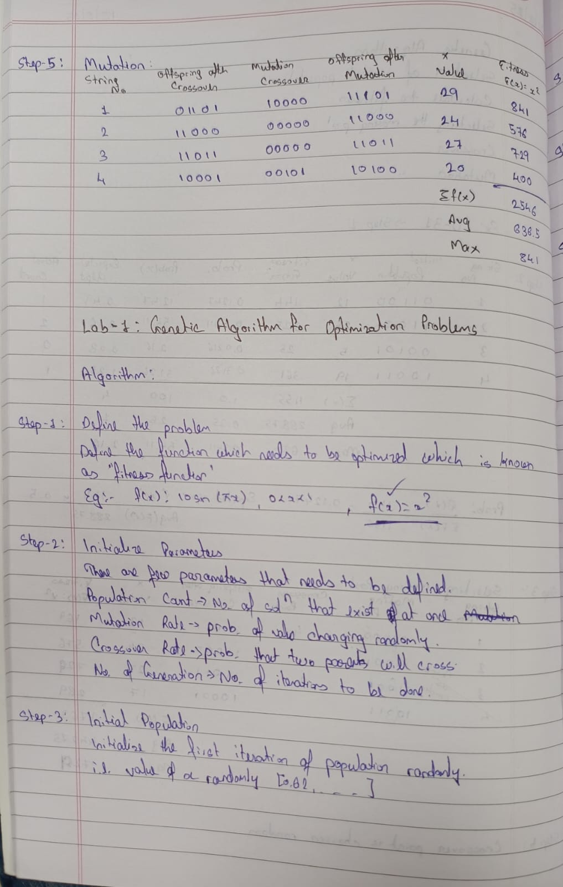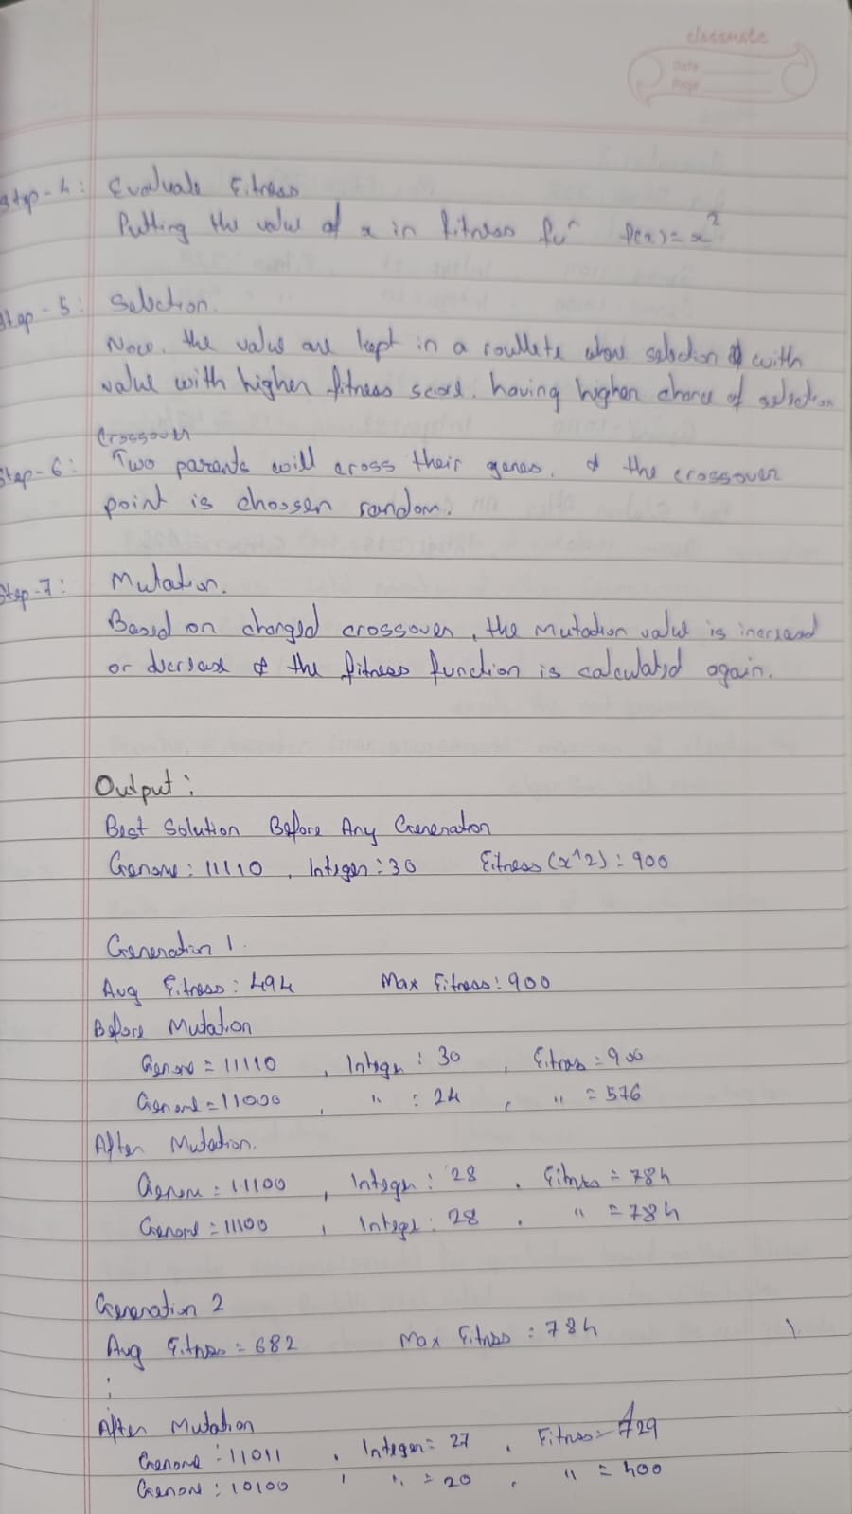

Code:

import random
import numpy as np
# pip install numpy

# 1. Define the Problem
def fitness_function(x):
return x**2

# 2. Initialize Parameters
POPULATION_SIZE = 4
GENOME_LENGTH = 5 #bits
# 1 = Every pair of parents will definitely crossover.
CROSSOVER_RATE = 0.5
# 1 = Every bit of every child genome will flip.
MUTATION_RATE = 1
GENERATIONS = 3

# Decode to integer
def decode(genome):
return int(genome, 2)

# random 10110 type once
def generate_genome():
return ''.join(random.choice('01') for _ in range(GENOME_LENGTH))

# random 10110 type for entire population_size
def create_population():
return [generate_genome() for _ in range(POPULATION_SIZE)]

def evaluate(population):
# Evaluate fitness on decoded integer (x) evaluates fitness function
return [fitness_function(decode(ind)) for ind in population]

# selects two individuals (parents) based on their fitness probabilities
def select(population, fitnesses):
total_fit = sum(fitnesses)
probs = [f / total_fit for f in fitnesses]
return random.choices(population, weights=probs, k=2)

# Combines two parent genomes (p1 and p2) to create two offspring by exchanging genetic material at a random crossover point.
def crossover(p1, p2):
if random.random() < CROSSOVER_RATE:
point = random.randint(1, GENOME_LENGTH - 1)
return p1[:point] + p2[point:], p2[:point] + p1[point:]
else:
return p1, p2

def mutate(genome):
# Flip exactly 1 bit at a random position
pos = random.randint(0, GENOME_LENGTH - 1)
bit_list = list(genome)
bit_list[pos] = '1' if bit_list[pos] == '0' else '0'
return ''.join(bit_list)

def genetic_algorithm():
population = create_population()

# Show the best individual before any generation or mutation
fitnesses = evaluate(population)
best_initial = max(zip(population, fitnesses), key=lambda x: x[1])
best_initial_genome, best_initial_fit = best_initial
best_initial_x = decode(best_initial_genome)
print("\n=== Best Solution Before Any Generation ===")
print(f"Genome: {best_initial_genome}")
print(f"Decoded Integer: {best_initial_x}")
print(f"Fitness (x^2): {best_initial_fit:.4f}\n")

for generation in range(1, GENERATIONS + 1):
fitnesses = evaluate(population)

# Sort population by fitness descending
pop_fit = list(zip(population, fitnesses))
pop_fit.sort(key=lambda x: x[1], reverse=True)

# Calculate avg and max fitness
avg_fitness = sum(fitnesses) / len(fitnesses)
max_fitness = max(fitnesses)

print(f"\n--- Generation {generation} ---")
print(f"Average Fitness: {avg_fitness:.4f}")
print(f"Max Fitness: {max_fitness:.4f}")

# Show top 2 individuals BEFORE mutation
print("Top 2 individuals BEFORE mutation:")
for i, (genome, fit) in enumerate(pop_fit[:2], 1):
decoded = decode(genome)
print(f" Rank {i}: Genome={genome} | Decoded Integer={decoded} | Fitness={fit:.4f}")

new_population = []

while len(new_population) < POPULATION_SIZE:
parent1, parent2 = select(population, fitnesses)
child1, child2 = crossover(parent1, parent2)

# Mutate children with exactly 1 bit flip
mutated_child1 = mutate(child1)
mutated_child2 = mutate(child2)

new_population.extend([mutated_child1, mutated_child2])

population = new_population[:POPULATION_SIZE]

# Evaluate new population after mutation
new_fitnesses = evaluate(population)

# Sort new population by fitness descending
new_pop_fit = list(zip(population, new_fitnesses))
new_pop_fit.sort(key=lambda x: x[1], reverse=True)

# Show top 2 individuals AFTER mutation
print("Top 2 individuals AFTER mutation:")
for i, (genome, fit) in enumerate(new_pop_fit[:2], 1):
decoded = decode(genome)
print(f" Rank {i}: Genome={genome} | Decoded Integer={decoded} | Fitness={fit:.4f}")

# After all generations, output overall best
overall_best = max(new_pop_fit, key=lambda x: x[1])
best_genome, best_fit = overall_best
best_x = decode(best_genome)
print("\n=== Best Solution Found After All Generations ===")
print(f"Genome: {best_genome}")
print(f"Decoded Integer: {best_x}")
print(f"Fitness (x^2): {best_fit}")

genetic_algorithm()

Program 2
Implement the Particle Swarm Optimization (PSO) algorithm to minimize the De Jong function:
f (x, y) = x^2 + y^2

Algorithm:

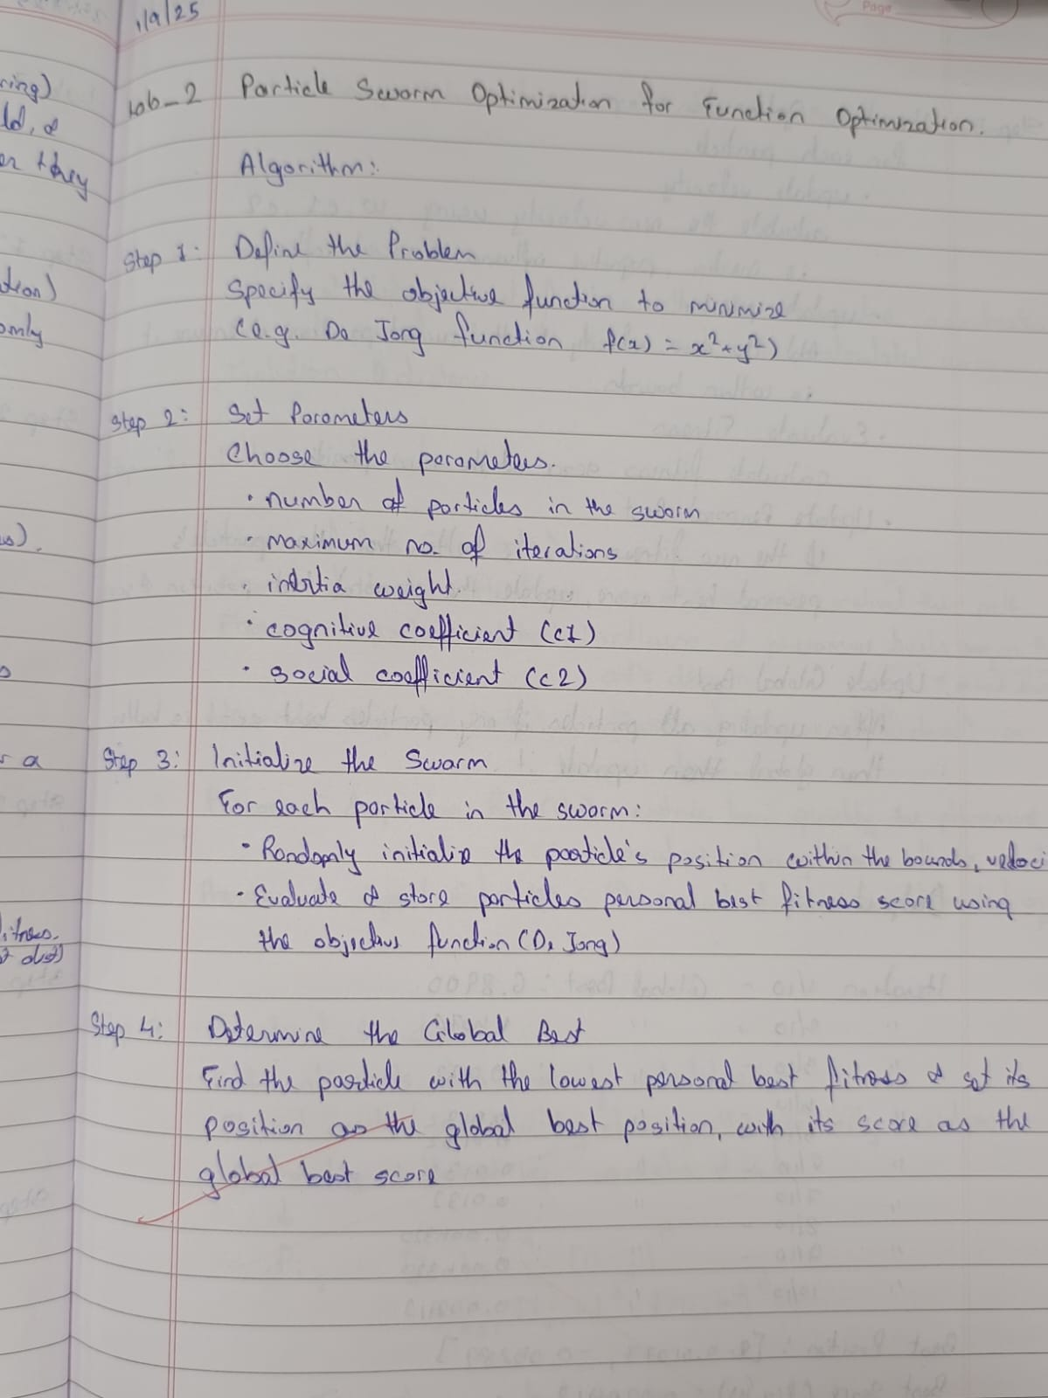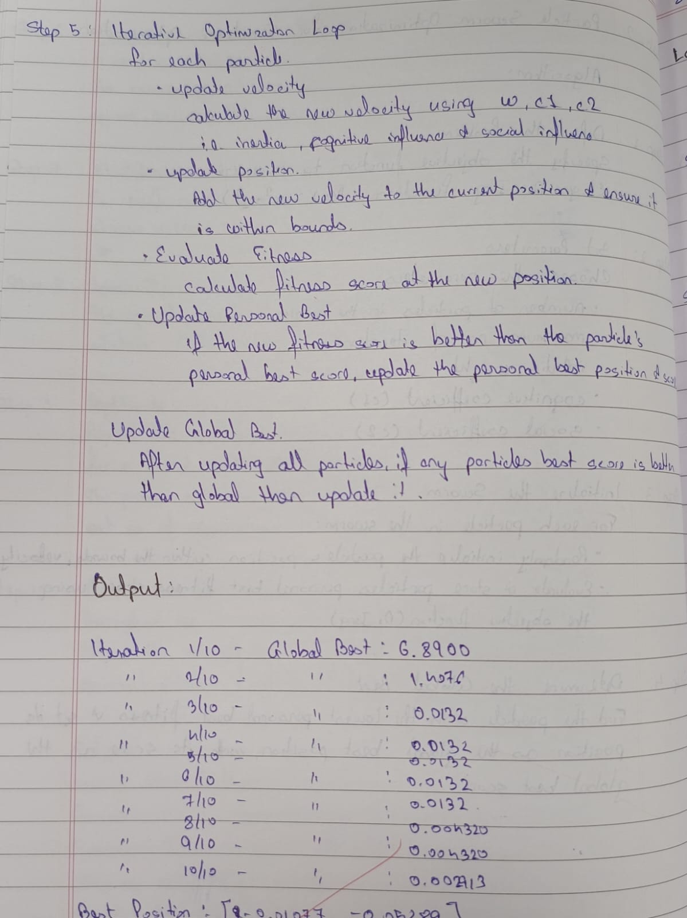

Code:
import random

# Step 1: Define the De Jong fitness function
def de_jong(position):
x, y = position
return x**2 + y**2

# Step 2: Particle class
class Particle:
def __init__(self, bounds):
self.position = [random.uniform(low, high) for low, high in bounds]
self.velocity = [random.uniform(-1, 1) for _ in bounds]
self.best_position = list(self.position)
self.best_score = de_jong(self.position)

def update_velocity(self, global_best_position, w, c1, c2):
for i in range(len(self.velocity)):
r1 = random.random()
r2 = random.random()
cognitive = c1 * r1 * (self.best_position[i] - self.position[i])
social = c2 * r2 * (global_best_position[i] - self.position[i])
self.velocity[i] = w * self.velocity[i] + cognitive + social

def update_position(self, bounds):
for i in range(len(self.position)):
self.position[i] += self.velocity[i]
# Clamp to bounds
self.position[i] = max(bounds[i][0], min(self.position[i], bounds[i][1]))

current_score = de_jong(self.position)
if current_score < self.best_score:
self.best_score = current_score
self.best_position = list(self.position)

# Step 3: PSO Algorithm
def pso(
function,
bounds=[(-10, 10), (-10, 10)],
num_particles=30,
max_iter=10,
w=0.5, # inertia weight
c1=1.5, # personal influence | Cognitive Coefficient
c2=1.5 # best influence | Social Coefficient
):
# Initialize particles
swarm = [Particle(bounds) for _ in range(num_particles)]

# Initialize global best
global_best_position = min(swarm, key=lambda p: p.best_score).best_position
global_best_score = function(global_best_position)

# Main loop
for iteration in range(max_iter):
for particle in swarm:
particle.update_velocity(global_best_position, w, c1, c2)
particle.update_position(bounds)

# Update global best
for particle in swarm:
if particle.best_score < global_best_score:
global_best_score = particle.best_score
global_best_position = list(particle.best_position)

print(f"Iteration {iteration+1}/{max_iter} - Global Best: {global_best_score:.6f}")

print("\n✅ Optimization Complete!")
print(f"Best Position: {global_best_position}")
print(f"Best Score (f(x,y)): {global_best_score:.6f}")
return global_best_position, global_best_score

# Step 4: Run the PSO
if __name__ == "__main__":
pso(de_jong)

Program 3
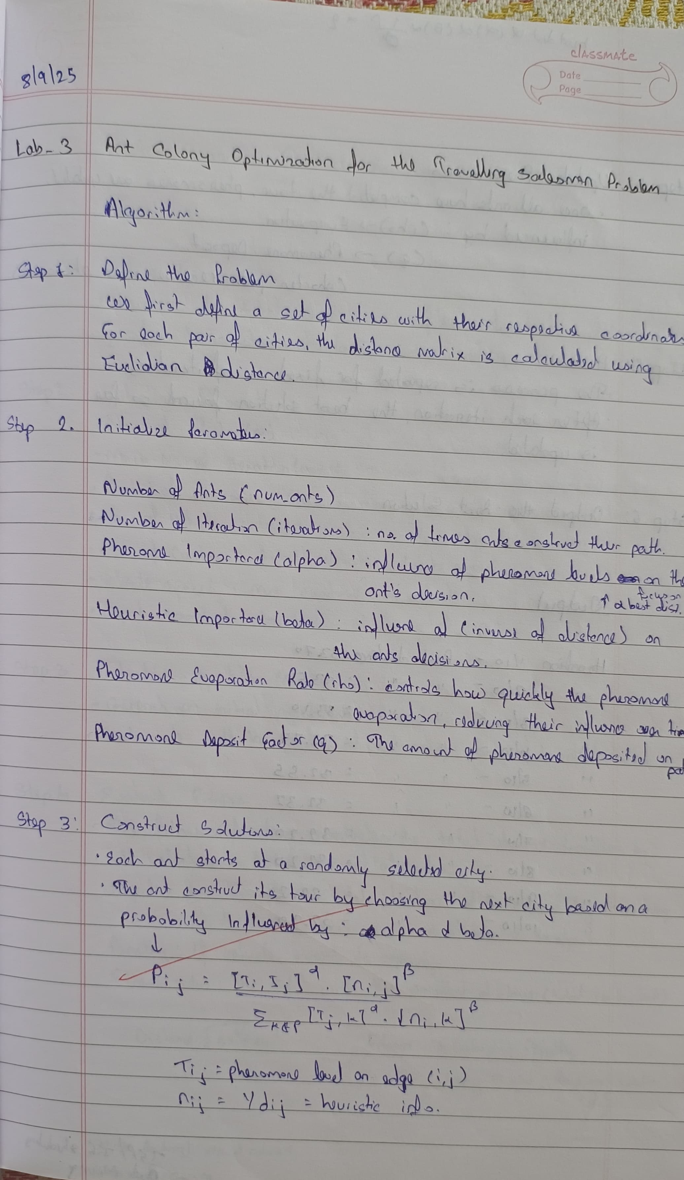
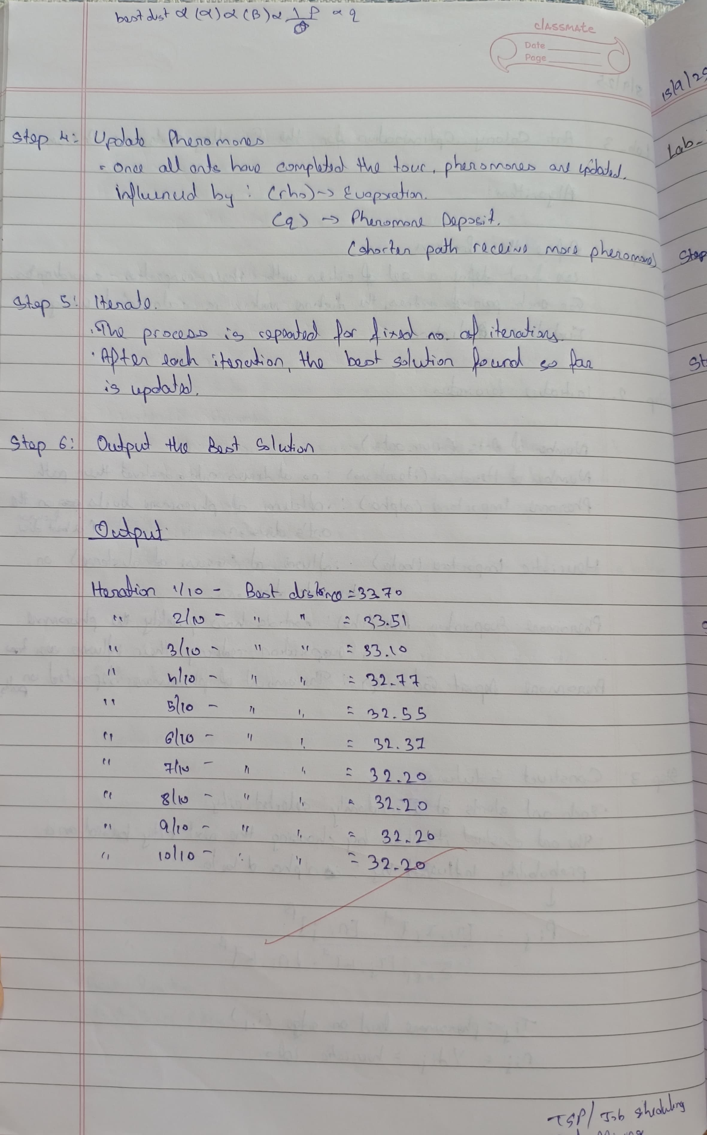
Implement the Ant Colony Optimization (ACO) algorithm to find the shortest possible route that visits a set of cities exactly once and returns to the starting city — i.e., solve the Travelling Salesman Problem (TSP).
Algorithm:

Code:

import numpy as np
import random

# Define number of cities and their coordinates
cities = [ [0, 0], [1, 5], [5, 2], [3, 8], [7, 7],
[9, 0], [6, 5], [4, 6], [8, 3], [2, 1]]

# Number of ants, iterations, pheromone parameters
num_ants = 5000
iterations = 10
alpha = 1 # Pheromone importance (increased a little)
beta = 1 # Heuristic importance (1/distance)
rho = 0.1 # Pheromone evaporation rate (moderate value)
q = 10 # Pheromone deposit factor (increased for stronger influence)
# Number of cities
num_cities = len(cities)

# Create distance matrix
distances = np.zeros((num_cities, num_cities))
for i in range(num_cities):
for j in range(num_cities):
if i != j:
distances[i][j] = np.linalg.norm(np.array(cities[i]) - np.array(cities[j]))

# Initialize pheromone matrix with a small constant value (not too high)
pheromone = np.ones((num_cities, num_cities)) * 0.1 # Lower initial pheromone values

# Precompute heuristic (inverse of distance)
heuristic = 1 / (distances + np.eye(num_cities)) # Avoid division by zero on diagonal
np.fill_diagonal(heuristic, 0)

# Function to construct a solution (tour) for each ant
def construct_solution():
path = []
visited = set()

# Randomly choose a starting city
current_city = random.randint(0, num_cities - 1)
path.append(current_city)
visited.add(current_city)

while len(path) < num_cities:
probabilities = calculate_transition_probabilities(current_city, visited)
next_city = np.random.choice(range(num_cities), p=probabilities)
path.append(next_city)
visited.add(next_city)
current_city = next_city

return path

# Function to calculate transition probabilities for the ants
def calculate_transition_probabilities(current_city, visited):
probabilities = np.zeros(num_cities)
pheromone_strength = pheromone[current_city]
heuristic_info = heuristic[current_city]

# Calculate probability for each city based on pheromone and heuristic
for city in range(num_cities):
if city not in visited:
probabilities[city] = (pheromone_strength[city] ** alpha) * (heuristic_info[city] ** beta)

total_prob = np.sum(probabilities)
if total_prob == 0:
unvisited = [city for city in range(num_cities) if city not in visited]
for city in unvisited:
probabilities[city] = 1.0
total_prob = len(unvisited)

return probabilities / total_prob

# Function to calculate the total distance of a given path
def calculate_distance(path):
distance = 0
for i in range(len(path)):
from_city = path[i]
to_city = path[(i + 1) % num_cities] # wrap around to start
distance += distances[from_city][to_city]
return distance

# Function to update pheromone levels based on solutions
def update_pheromones(all_paths, all_distances):
global pheromone
pheromone *= (1 - rho) # Evaporate pheromone

# Update pheromones for each path based on its quality (distance)
for path, distance in zip(all_paths, all_distances):
pheromone_deposit = q / distance
for i in range(len(path)):
from_city = path[i]
to_city = path[(i + 1) % num_cities]
pheromone[from_city][to_city] += pheromone_deposit
pheromone[to_city][from_city] += pheromone_deposit # symmetric update

# Normalize pheromone levels and add slight randomness to prevent stagnation
pheromone = pheromone / np.sum(pheromone) # Normalize to avoid infinite growth
pheromone += np.random.rand(num_cities, num_cities) * 0.01 # Small noise for exploration

# Main loop to run the Ant Colony Optimization
best_distance = float('inf')
best_path = None

for iteration in range(iterations):
all_paths = []
all_distances = []

# Each ant constructs a solution
for ant in range(num_ants):
path = construct_solution()
distance = calculate_distance(path)
all_paths.append(path)
all_distances.append(distance)

if distance < best_distance:
best_distance = distance
best_path = path

# Update pheromones based on solutions found by ants
update_pheromones(all_paths, all_distances)

# Output the best distance at this iteration
print(f"Iteration {iteration + 1}/{iterations} - Best distance: {best_distance:.2f}")

# Output the best path and its distance
print("\nBest path found:", best_path)
print("Best path distance:", round(best_distance, 2))

Program 4
Implement the Cuckoo Search Optimization Algorithm (CSO) to find the minimum of the Sphere function, defined as:
f(x)=∑x^2 ​
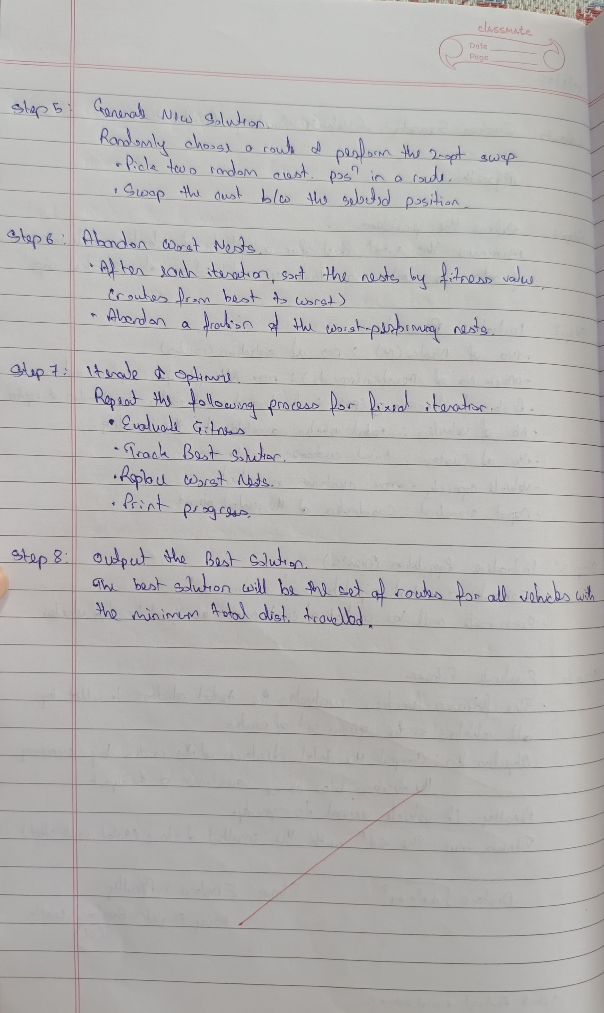
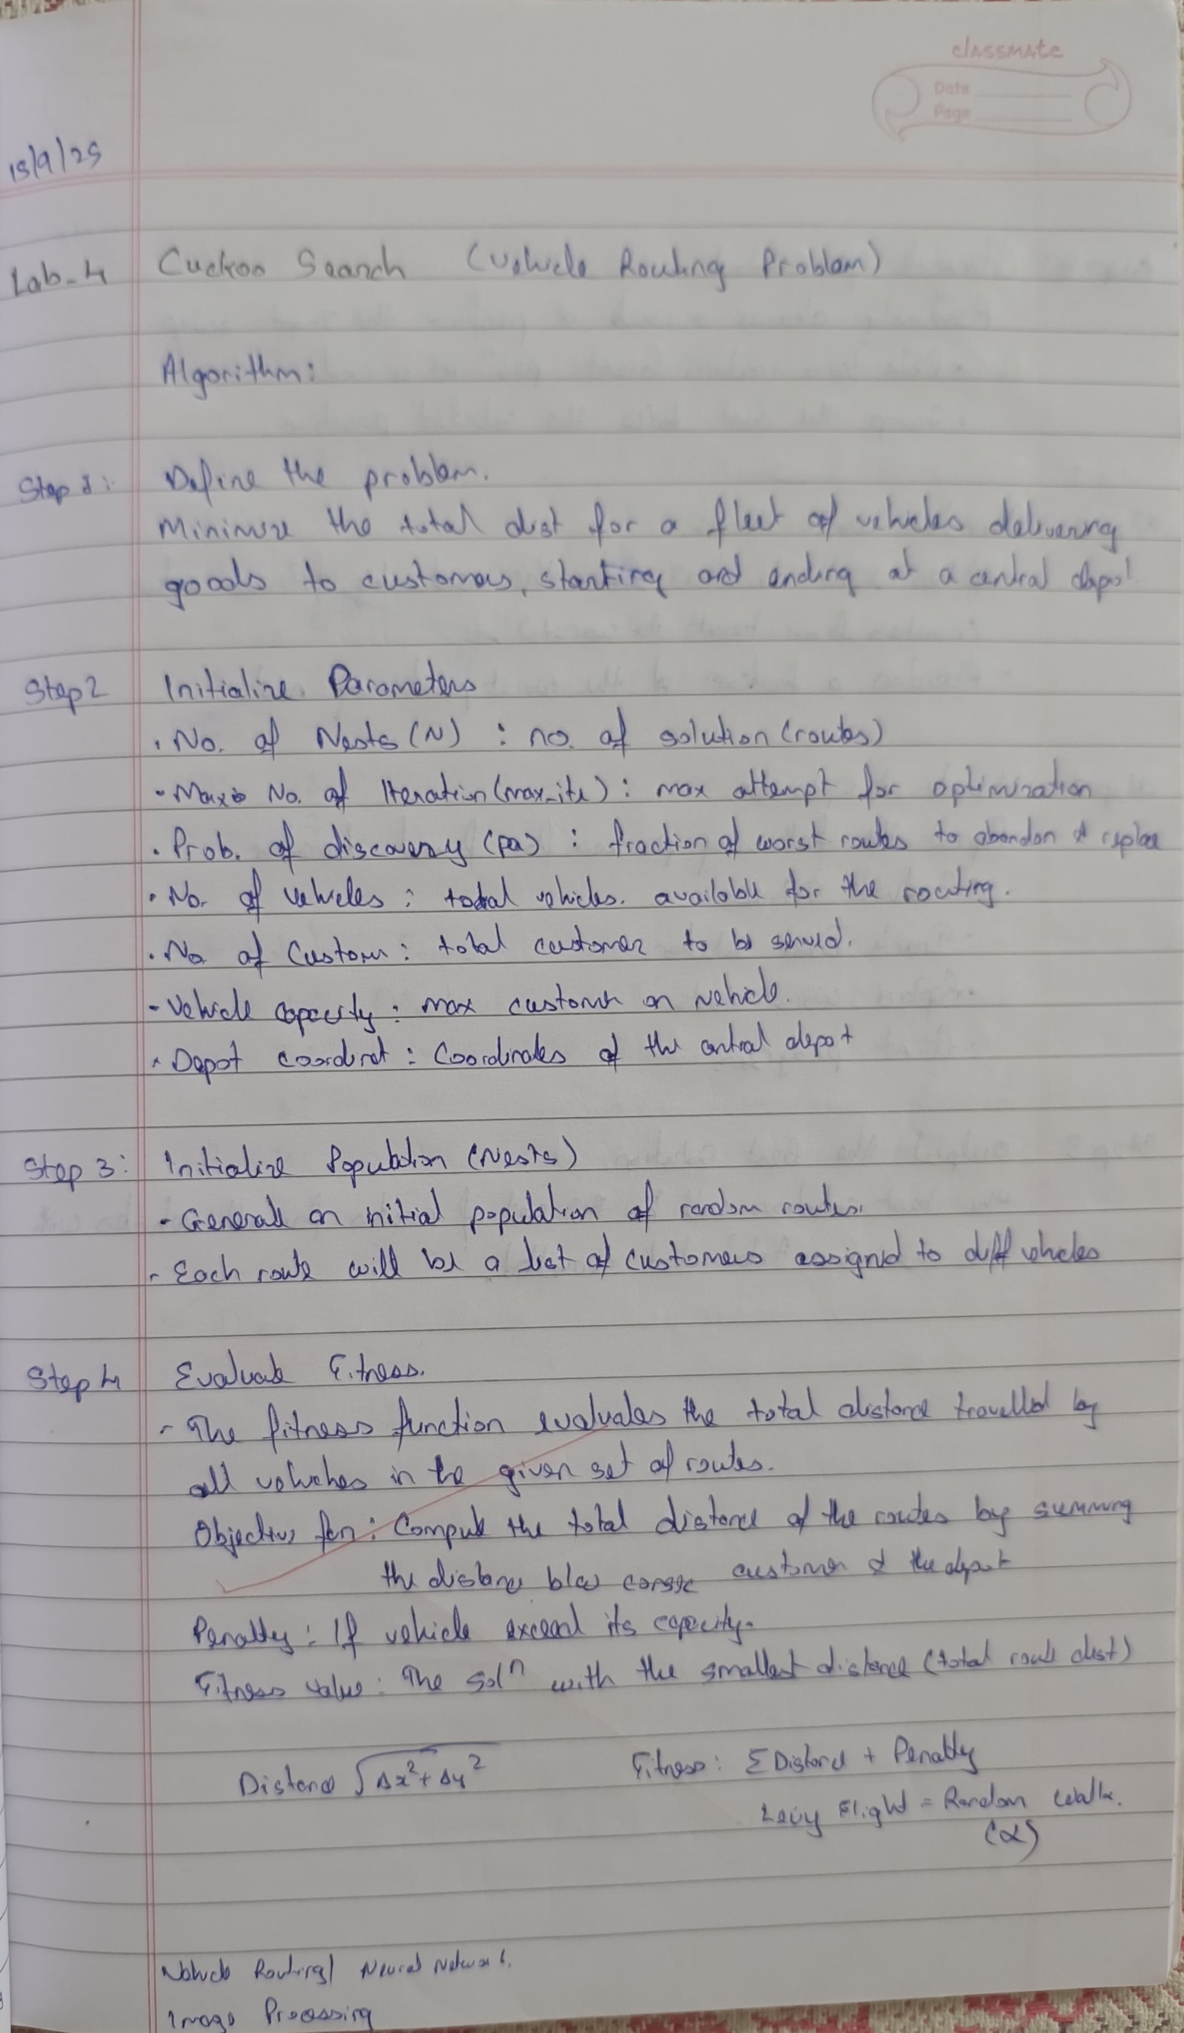
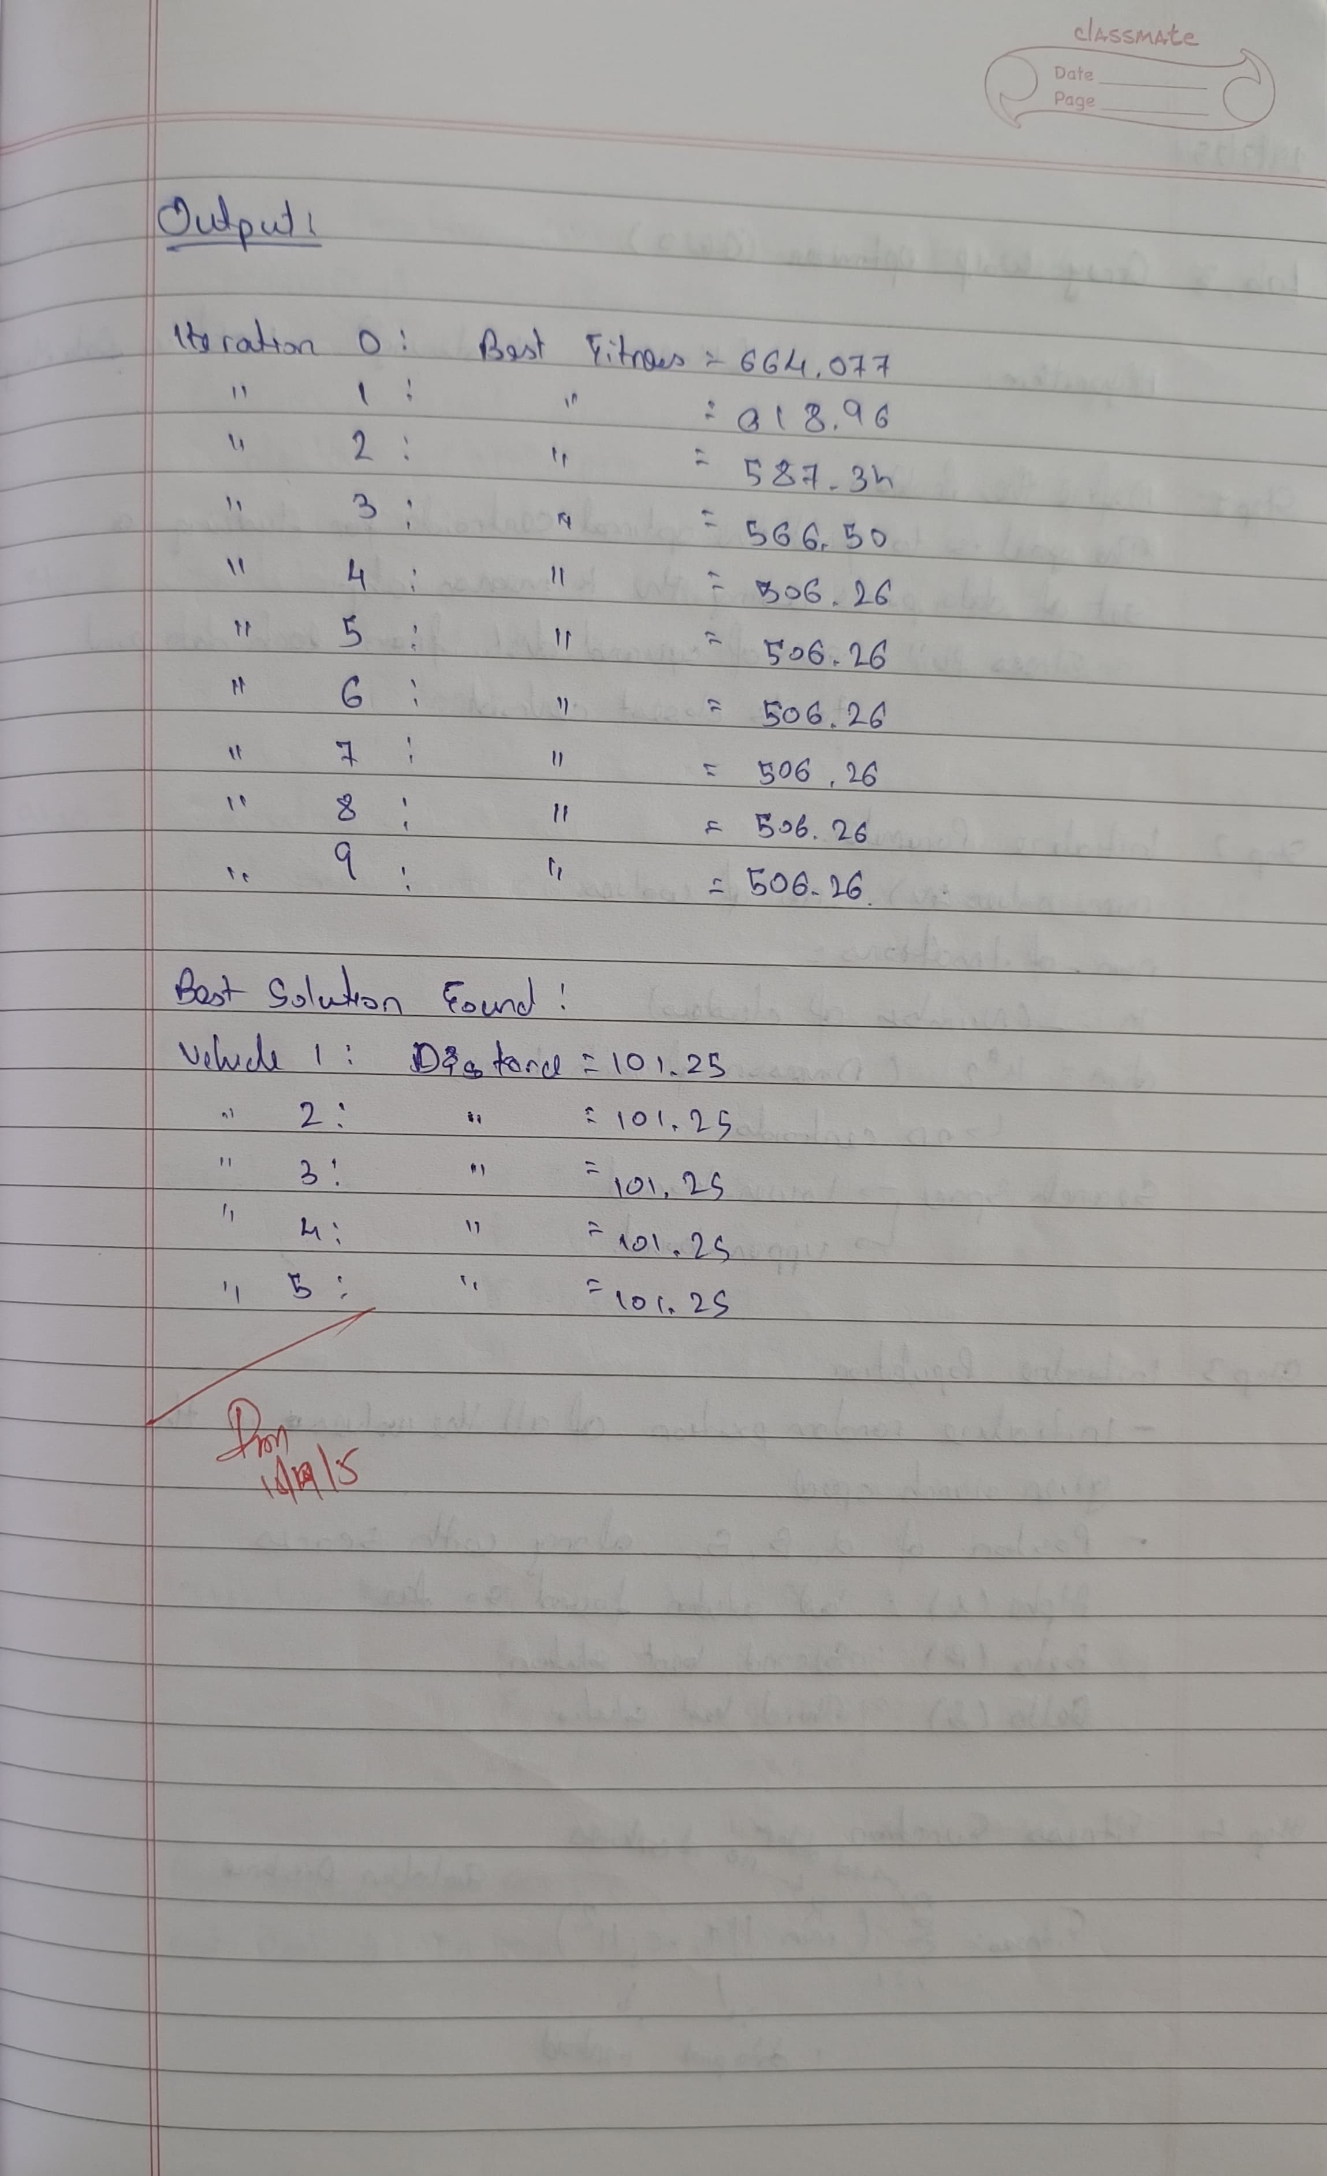
Algorithm:

Code:
import numpy as np
import random

# Step 1: Define the objective function (for optimization)
def objective_function(x):
# Example: Sphere function (minimization)
return np.sum(x**2)

# Step 2: Initialize parameters
n_nests = 50 # Number of nests
max_iter = 100 # Maximum number of iterations
pa = 0.25 # Probability of discovery (egg being discovered by host)
n_dim = 10 # Number of dimensions (problem size)
alpha = 1.5 # Scaling factor for Lévy flights

# Step 3: Initialize population (random positions)
nests = np.random.uniform(-10, 10, (n_nests, n_dim))

# Step 4: Evaluate fitness (objective function value for each nest)
fitness = np.apply_along_axis(objective_function, 1, nests)

# Step 5: Lévy flight approximation (using a simplified version without external dependencies)
def levy_flight(n_dim, alpha=1.5):
# Simplified Lévy flight step using a random walk with a power law
# We use a normal distribution for this approximation, though it's less accurate than the original Levy distribution
u = np.random.normal(0, 1, n_dim)
v = np.random.normal(0, 1, n_dim)
step = u / np.power(np.abs(v), 1 / alpha)
return step

# Step 6: Abandon worst nests and replace them with new ones
def replace_worst_nests(nests, fitness, pa, max_iter):
# Sort nests based on fitness values
sorted_indices = np.argsort(fitness)
best_nests = nests[sorted_indices[:n_nests // 2]]
worst_nests = nests[sorted_indices[n_nests // 2:]]

# Abandon the worst nests and replace them
for i in range(n_nests // 2):
if random.random() < pa:
# Generate a new nest using Lévy flight
step = levy_flight(n_dim, alpha)
new_nest = best_nests[i] + step
new_nest = np.clip(new_nest, -10, 10) # Ensure within bounds
nests[sorted_indices[n_nests // 2 + i]] = new_nest
return nests

# Step 7: Iterate and perform optimization
best_solution = None
best_fitness = float('inf')

for iteration in range(max_iter):
# Evaluate fitness of each nest
fitness = np.apply_along_axis(objective_function, 1, nests)

# Find the best solution
min_fitness_idx = np.argmin(fitness)
min_fitness_value = fitness[min_fitness_idx]
if min_fitness_value < best_fitness:
best_fitness = min_fitness_value
best_solution = nests[min_fitness_idx]

# Replace worst nests with new solutions
nests = replace_worst_nests(nests, fitness, pa, max_iter)

# Print progress (every 10 iterations)
# if iteration % 10 == 0:
print(f"Iteration {iteration}: Best Fitness = {best_fitness}")

# Step 8: Output the best solution
print("\nBest Solution Found:")
print(f"Position: {best_solution}")
print(f"Fitness: {best_fitness}")

Program 5
Implement the Grey Wolf Optimizer (GWO) algorithm to perform clustering on a set of 2D data points.
The algorithm should optimize the positions of cluster centroids such that the sum of squared distances between data points and their nearest centroids is minimized (similar to K-Means).
Algorithm:
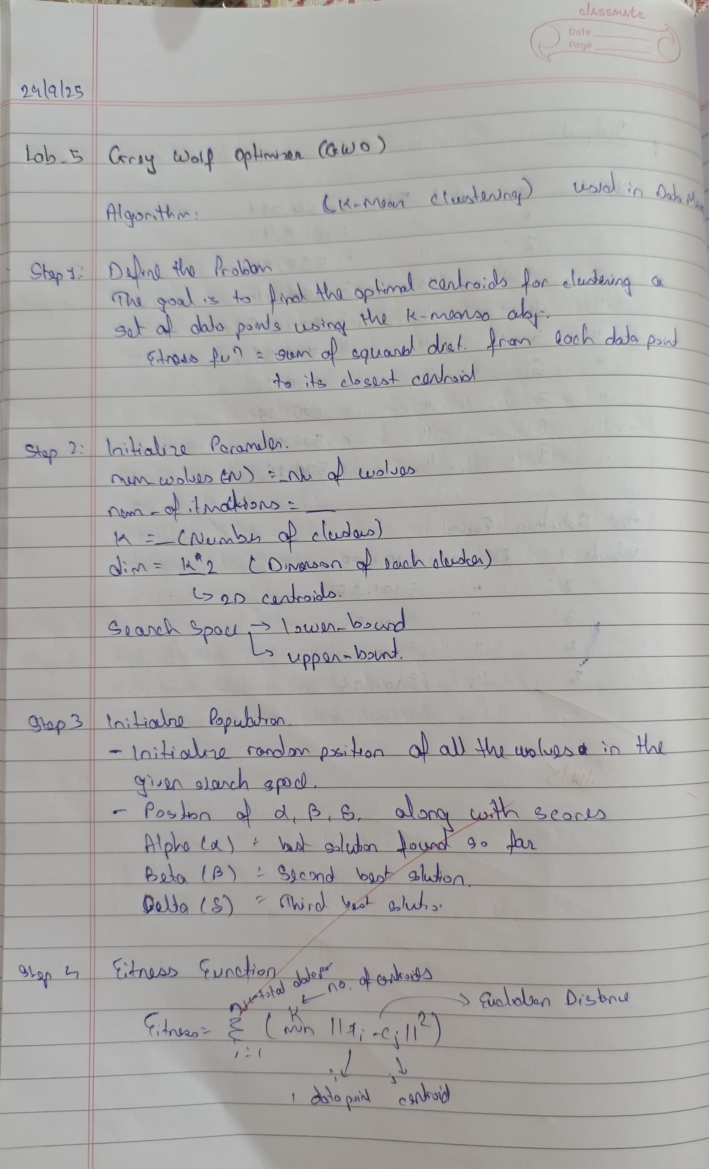
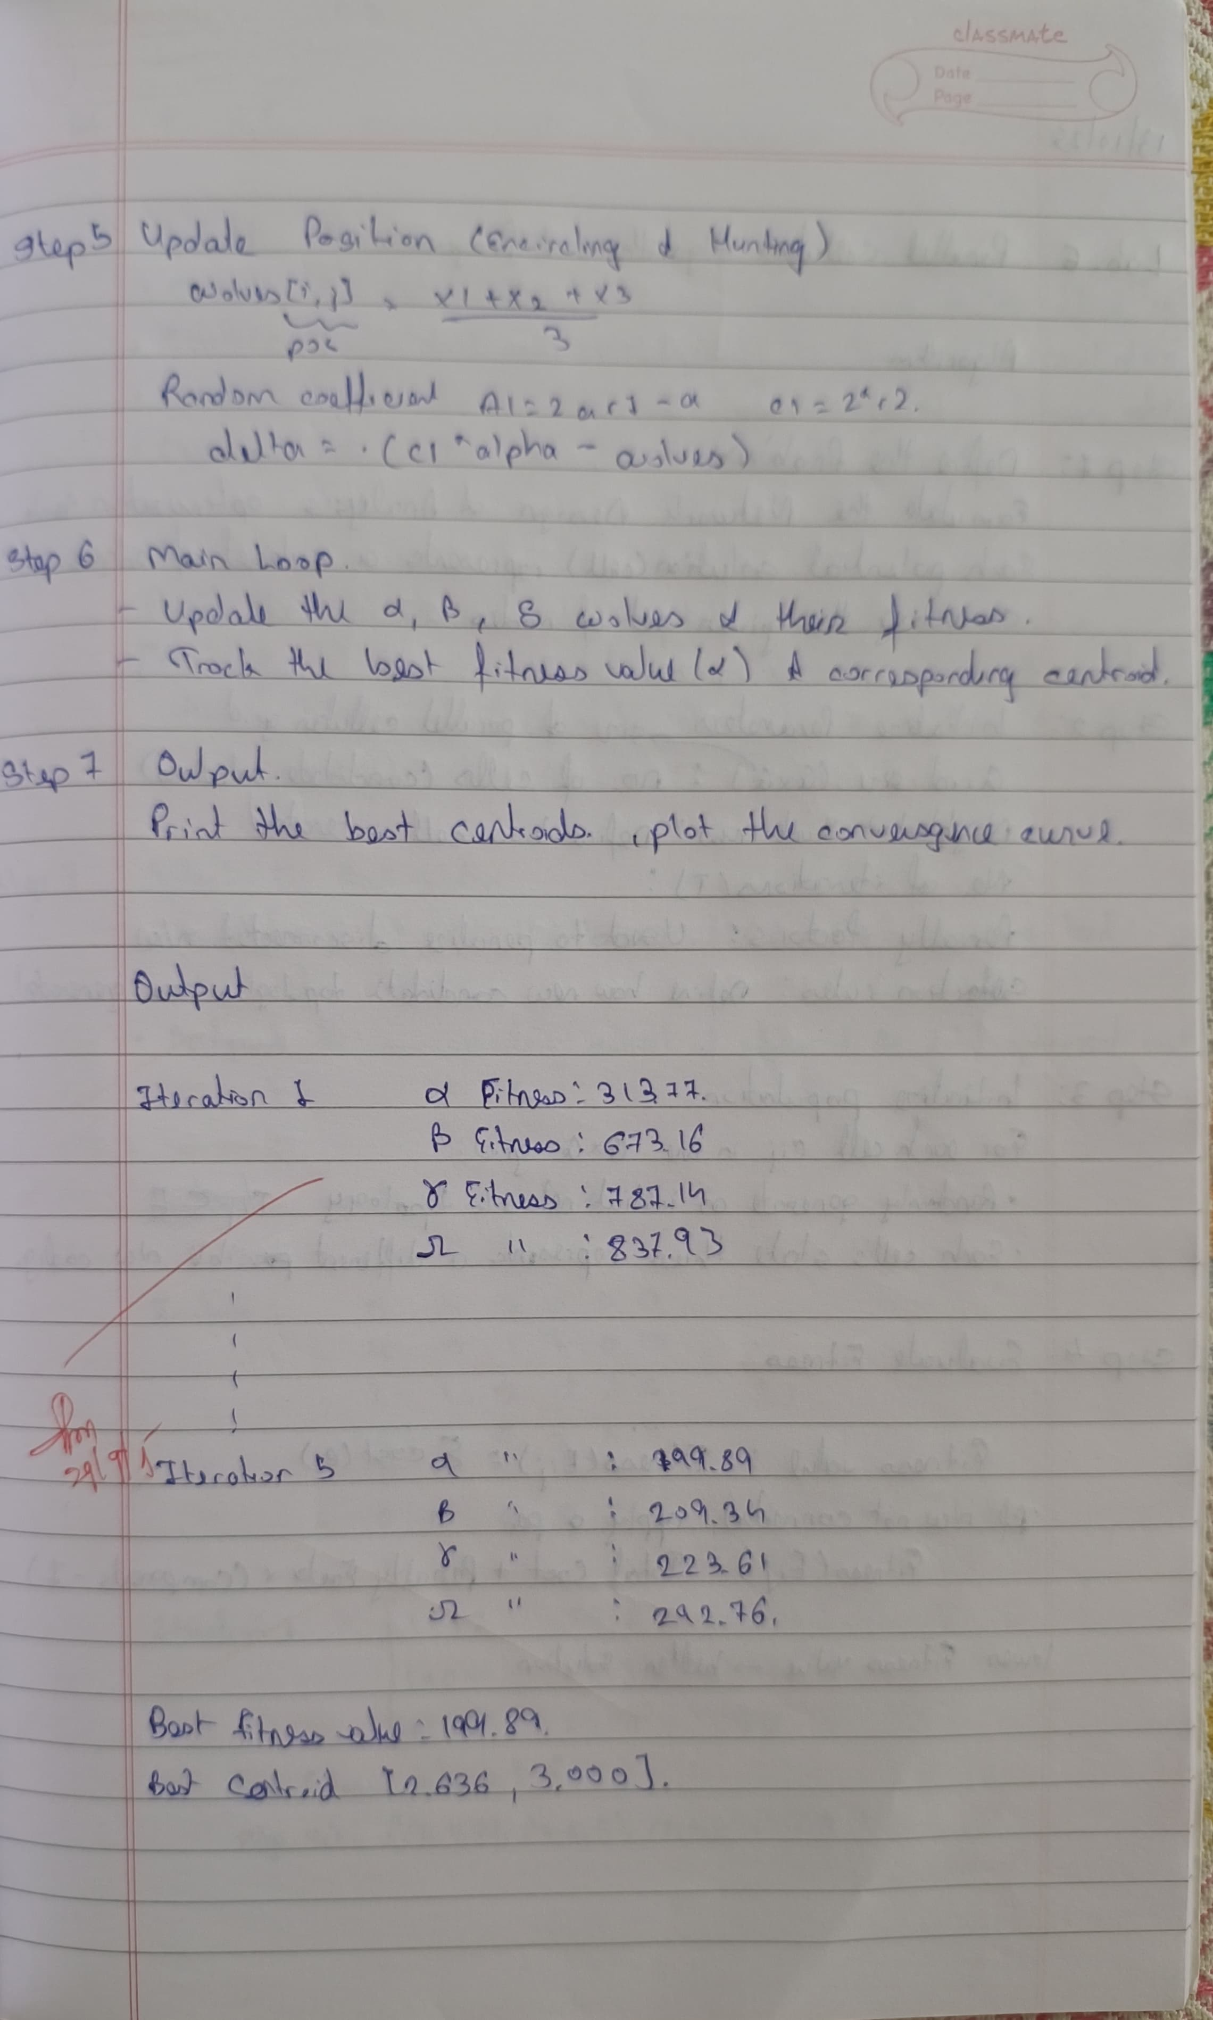

Code:
import numpy as np
import matplotlib.pyplot as plt

# Generate random data points
np.random.seed(42)
num_points = 100
X = np.vstack([
np.random.normal(loc=[3, 3], size=(num_points//2, 2)), # Cluster 1
np.random.normal(loc=[7, 7], size=(num_points//2, 2)) # Cluster 2
])

# Number of clusters (K)
K = 2

# GWO Parameters
num_wolves = 30
num_iterations = 5
dim = K * 2 # Each centroid has 2 coordinates (x, y)

# Search space boundaries
lower_bound = 0
upper_bound = 10

# Initialize wolves' positions (randomly within the search space)
wolves = np.random.uniform(lower_bound, upper_bound, (num_wolves, dim))

# Initialize alpha, beta, delta, omega wolves
alpha_pos = np.zeros(dim)
alpha_score = float('inf')

beta_pos = np.zeros(dim)
beta_score = float('inf')

delta_pos = np.zeros(dim)
delta_score = float('inf')

omega_pos = np.zeros(dim)
omega_score = float('inf')

# To track fitness over iterations (for convergence curve)
fitness_curve = []

# Euclidean distance function
def euclidean_distance(x1, x2):
return np.linalg.norm(x1 - x2)

# Fitness function (K-means objective: sum of squared distances to centroids)
def fitness(wolves, X, K):
wolf_centroids = wolves.reshape((K, 2))
total_distance = 0
for point in X:
# Calculate the distance to the closest centroid
distances = [euclidean_distance(point, centroid) for centroid in wolf_centroids]
total_distance += min(distances)**2 # Sum of squared distances
return total_distance

# Clip wolf positions to remain within boundaries
def clip_positions(wolves, lb, ub):
np.clip(wolves, lb, ub, out=wolves)

# Main GWO loop
for iter in range(num_iterations):
for i in range(num_wolves):
# Calculate the fitness of each wolf (position)
fit = fitness(wolves[i], X, K)

# Update alpha, beta, delta, omega positions based on fitness
if fit < alpha_score:
alpha_score = fit
alpha_pos = wolves[i].copy()
elif fit < beta_score:
beta_score = fit
beta_pos = wolves[i].copy()
elif fit < delta_score:
delta_score = fit
delta_pos = wolves[i].copy()
elif fit < omega_score:
omega_score = fit
omega_pos = wolves[i].copy()

# Calculate "a" for the hunting equation (linearly decreasing from 2 to 0)
a = 2 - iter * (2 / num_iterations)

# Update the positions of all wolves based on the encircling and hunting equations
for i in range(num_wolves):
for j in range(dim):
r1 = np.random.rand()
r2 = np.random.rand()

# Encircling & Hunting Equations
A1 = 2 * a * r1 - a
C1 = 2 * r2
D_alpha = np.abs(C1 * alpha_pos[j] - wolves[i, j])
X1 = alpha_pos[j] - A1 * D_alpha

r1 = np.random.rand()
r2 = np.random.rand()

A2 = 2 * a * r1 - a
C2 = 2 * r2
D_beta = np.abs(C2 * beta_pos[j] - wolves[i, j])
X2 = beta_pos[j] - A2 * D_beta

r1 = np.random.rand()
r2 = np.random.rand()

A3 = 2 * a * r1 - a
C3 = 2 * r2
D_delta = np.abs(C3 * delta_pos[j] - wolves[i, j])
X3 = delta_pos[j] - A3 * D_delta

# Update wolf's position based on the three best wolves
wolves[i, j] = (X1 + X2 + X3) / 3

# Clip wolf positions to ensure they remain within the defined boundaries
clip_positions(wolves, lower_bound, upper_bound)

# Record the best fitness value (for convergence curve)
fitness_curve.append(alpha_score)

# Print positions of Alpha, Beta, Delta, Omega wolves at each iteration
print(f"Iteration {iter + 1}:")
print(f" Alpha Wolf Position: {alpha_pos} | Fitness: {alpha_score}")
print(f" Beta Wolf Position: {beta_pos} | Fitness: {beta_score}")
print(f" Delta Wolf Position: {delta_pos} | Fitness: {delta_score}")
print(f" Omega Wolf Position: {omega_pos} | Fitness: {omega_score}")
print("-" * 50)

# Final solution (best centroids) is the position of the alpha wolf
print(f"Best solution found with fitness value: {alpha_score}")
alpha_pos = alpha_pos.reshape((K, 2))
print("Best centroids (Alpha Wolf):")
for idx, centroid in enumerate(alpha_pos):
print(f"Centroid {idx + 1}: {centroid}")

# Plotting the final result of clustering with the best centroids
plt.figure(figsize=(8, 8))

# Plot data points
plt.scatter(X[:, 0], X[:, 1], c='blue', label='Data Points', alpha=0.6)

# Plot the centroids
for idx, centroid in enumerate(alpha_pos):
plt.scatter(centroid[0], centroid[1], color='red', s=100, label=f'Centroid {idx + 1}')

plt.xlabel('X')
plt.ylabel('Y')
plt.title('Clustering Result with Grey Wolf Optimizer')
plt.legend()
plt.grid(True)
plt.show()

Program 6
Implement a Parallel Cellular Algorithm for Network Design and Analysis.
The objective is to find an optimal subset of network edges that connects all nodes with minimum total cost, while maintaining connectivity.
Disconnected networks are penalized in the fitness function.

Algorithm:

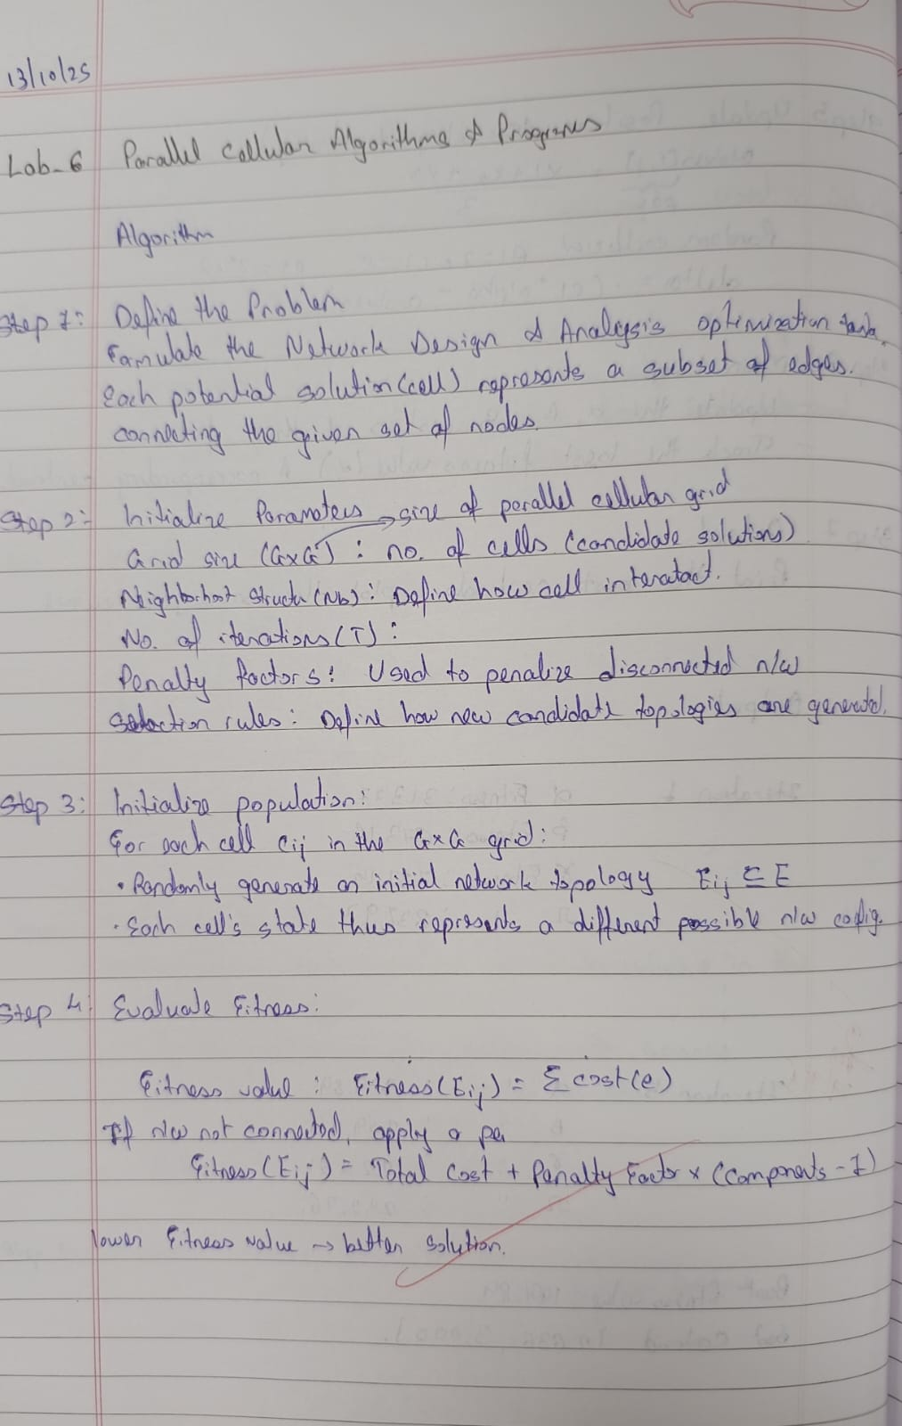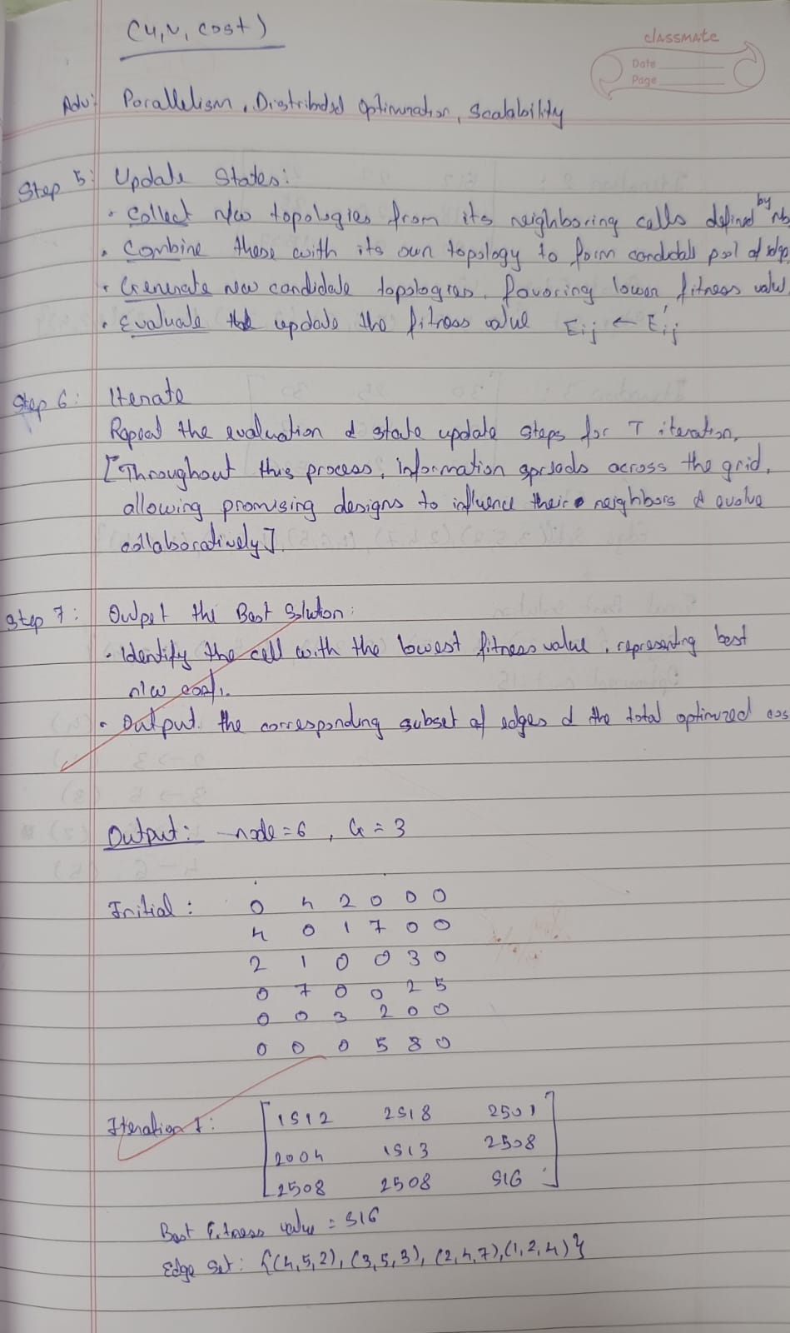
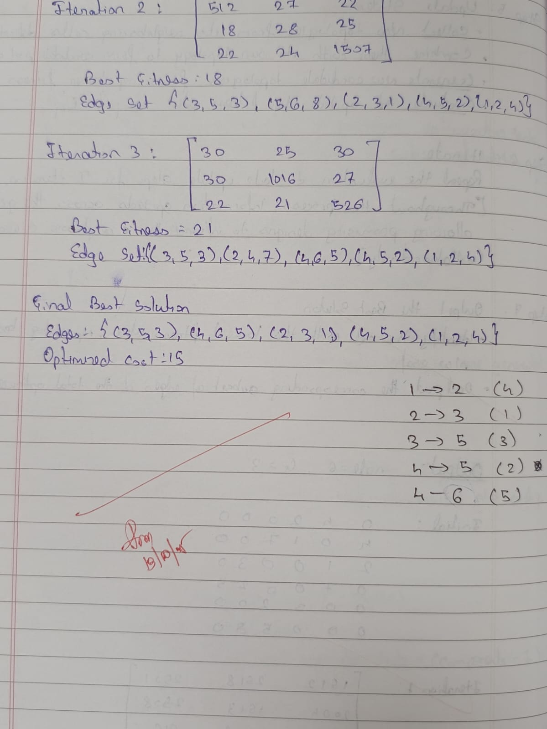
Code:
import random
import math
from collections import defaultdict, deque

# -----------------------------
# Helper Functions
# -----------------------------

def is_connected(nodes, edges):
"""Check if the given edges connect all nodes (using BFS)."""
if not edges:
return False, len(nodes)
adj = defaultdict(list)
for u, v, _ in edges:
adj[u].append(v)
adj[v].append(u)

visited = set()
q = deque([nodes[0]])
while q:
n = q.popleft()
if n not in visited:
visited.add(n)
for nei in adj[n]:
if nei not in visited:
q.append(nei)
components = len(nodes) - len(visited) + 1
return len(visited) == len(nodes), components

def fitness(nodes, edges, penalty_factor=1000):
"""Compute total cost with penalty for disconnected networks."""
total_cost = sum(c for _, _, c in edges)
connected, components = is_connected(nodes, edges)
if not connected:
total_cost += penalty_factor * (components - 1)
return total_cost

def von_neumann_neighbors(i, j, G, wrap=True):
"""Return von Neumann neighbors of cell (i,j)."""
neighbors = []
directions = [(-1, 0), (1, 0), (0, -1), (0, 1)]
for di, dj in directions:
ni, nj = i + di, j + dj
if wrap:
ni %= G
nj %= G
if 0 <= ni < G and 0 <= nj < G:
neighbors.append((ni, nj))
return neighbors

# -----------------------------
# Main Algorithm
# -----------------------------

def parallel_cellular_network_design(nodes, edges, G=4, T=10, penalty_factor=1000):
"""
Parallel Cellular Algorithm for Network Design and Analysis.
Displays grid state, fitness values, and best solution at each iteration.
"""
# Initialize random population
grid = [[set(random.sample(edges, random.randint(1, len(edges)//2)))
for _ in range(G)] for _ in range(G)]

for t in range(T):
fitness_grid = [[0]*G for _ in range(G)]

# Evaluate fitness
for i in range(G):
for j in range(G):
f = fitness(nodes, grid[i][j], penalty_factor)
fitness_grid[i][j] = f

# Find best fitness & corresponding edge in this iteration
best_iter_fit = math.inf
best_iter_edges = None
for i in range(G):
for j in range(G):
if fitness_grid[i][j] < best_iter_fit:
best_iter_fit = fitness_grid[i][j]
best_iter_edges = grid[i][j]

# Display iteration info
print(f"\n===== Iteration {t+1} =====")
print("Fitness Matrix:")
for row in fitness_grid:
print(["{:.1f}".format(x) for x in row])

print(f"\nBest Fitness This Iteration: {best_iter_fit:.2f}")
print(f"Best Edge Set: {best_iter_edges}")

# Update states (in parallel logic)
new_grid = [[set() for _ in range(G)] for _ in range(G)]
for i in range(G):
for j in range(G):
# Gather neighbors
neighbors = von_neumann_neighbors(i, j, G)
candidate_pool = set(grid[i][j])
for ni, nj in neighbors:
candidate_pool.update(grid[ni][nj])

candidate_list = list(candidate_pool)
if not candidate_list:
new_grid[i][j] = set()
continue

# Generate multiple candidates from the pool
candidates = []
for _ in range(5): # sample 5 new candidates
k = random.randint(1, len(candidate_list))
subset = random.sample(candidate_list, k)
candidates.append(set(subset))

# Choose best candidate
best_edges = min(candidates, key=lambda e: fitness(nodes, e, penalty_factor))
new_grid[i][j] = best_edges

grid = new_grid

# Final best solution after all iterations
best_edges = None
best_fit = math.inf
for i in range(G):
for j in range(G):
f = fitness(nodes, grid[i][j], penalty_factor)
if f < best_fit:
best_fit = f
best_edges = grid[i][j]

print("\n===== Final Best Solution =====")
print("Edges:", best_edges)
print("Optimized Cost:", best_fit)

# -----------------------------
# Example Usage
# -----------------------------

if __name__ == "__main__":
# Example network with 6 nodes and edges with costs
nodes = [1, 2, 3, 4, 5, 6]
edges = [
(1, 2, 4), (1, 3, 2), (2, 3, 1),
(2, 4, 7), (3, 5, 3), (4, 5, 2),
(4, 6, 5), (5, 6, 8)
]

parallel_cellular_network_design(nodes, edges, G=3, T=3, penalty_factor=500)

Program 7
Optimize the search efficiency of multiple drones exploring a grid by coordinating their positions based on neighbors' success using a Parallel Cellular Algorithm to maximize the total searched area.

Algorithm:

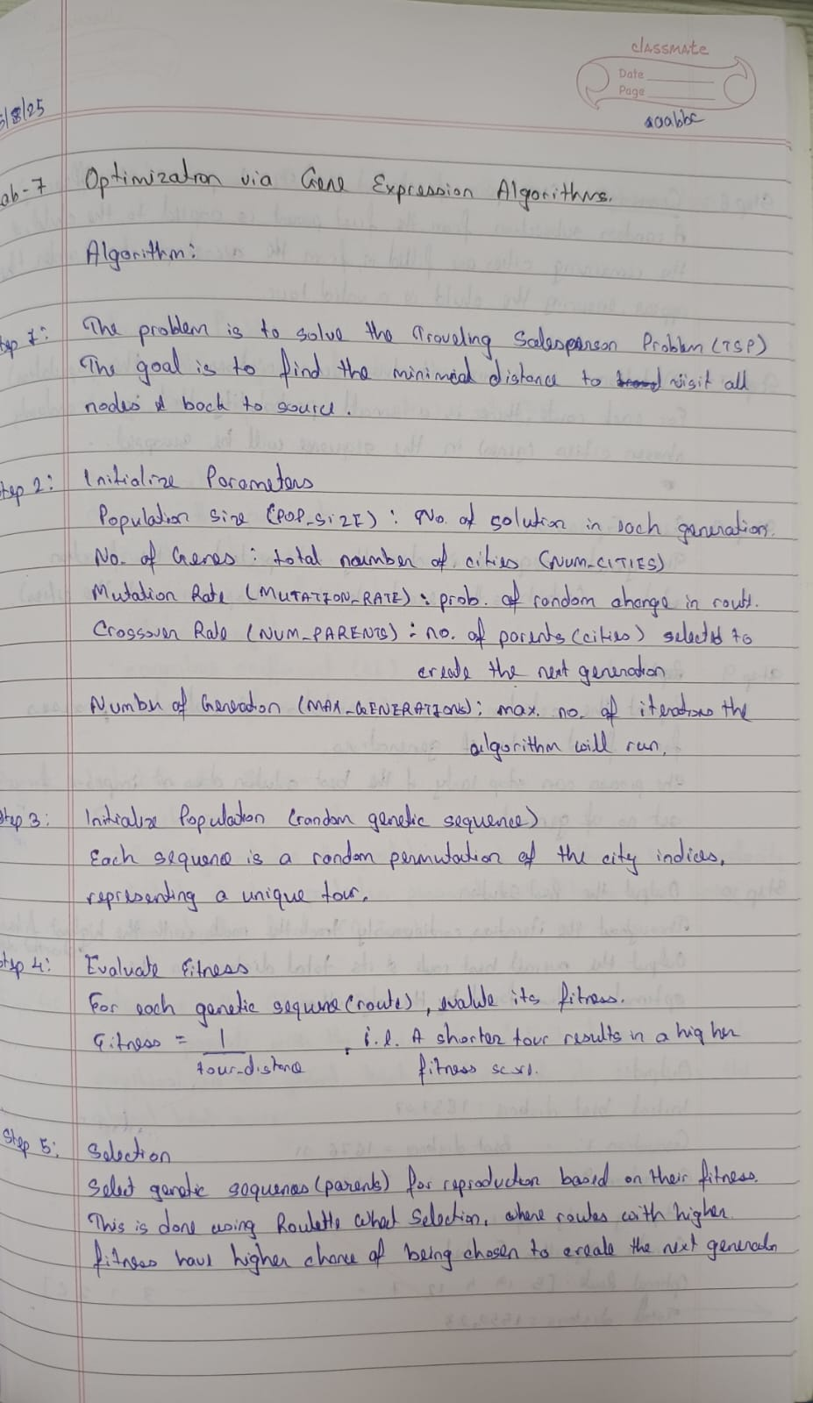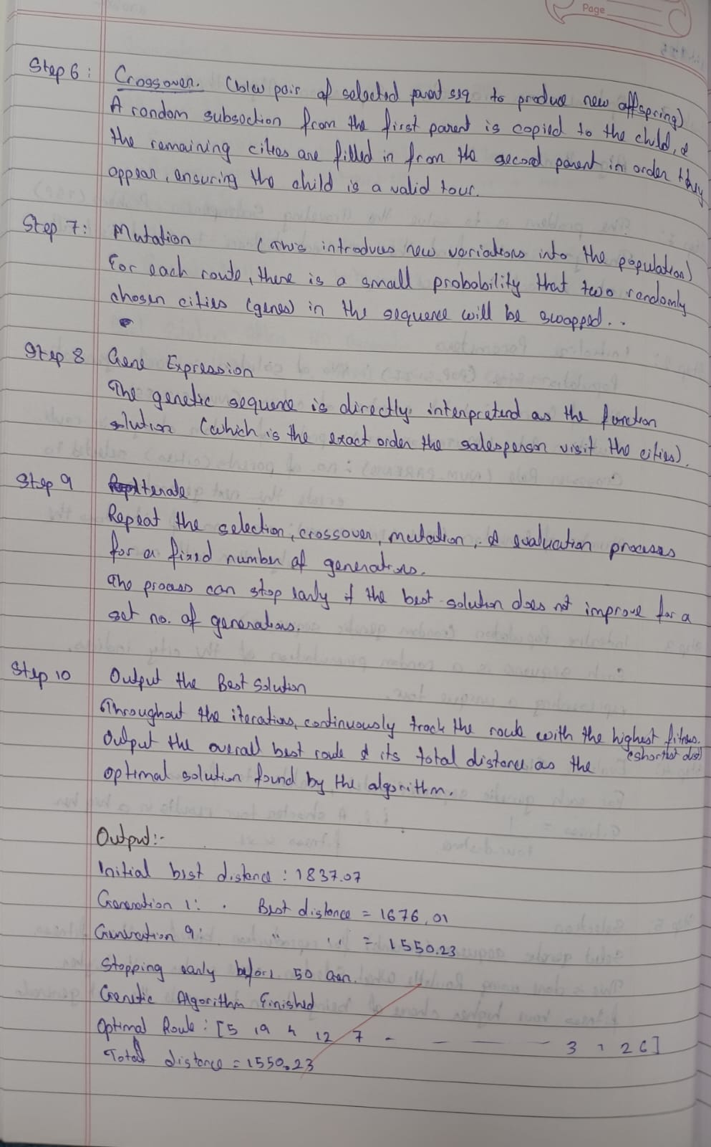
Code:

import random
import math

# --- 1. Define cities with (x, y) coordinates ---
# For demonstration, we'll create some random cities.
# In a real application, you would load these from a file.
NUM_CITIES = 20
CITIES = [(random.randint(0, 200), random.randint(0, 200)) for _ in range(NUM_CITIES)]

# --- Helper Function: distance ---
def distance(city1, city2):
"""Return Euclidean distance between city1 and city2."""
return math.sqrt((city1[0] - city2[0])**2 + (city1[1] - city2[1])**2)

# --- Helper Function: tourDistance ---
def tour_distance(route):
"""
Calculate the total distance of a tour.
A route is a list of city indices, e.g., [0, 3, 1, 2, ...].
"""
total_dist = 0
num_cities = len(route)
for i in range(num_cities):
# Get the distance between the current city and the next city
from_city = CITIES[route[i]]
# If it's the last city, the next city is the starting city
to_city = CITIES[route[(i + 1) % num_cities]]
total_dist += distance(from_city, to_city)
return total_dist

# --- Helper Function: fitness ---
def fitness(route):
"""
Calculate the fitness of a route. Fitness is the inverse of the tour distance.
A shorter distance means a higher fitness.
"""
return 1 / tour_distance(route)

# --- GA Function: initializePopulation ---
def initialize_population(pop_size, num_cities):
"""Create 'popSize' random routes, each visiting all cities exactly once."""
population = []
base_route = list(range(num_cities))
for _ in range(pop_size):
route = random.sample(base_route, len(base_route)) # Create a random permutation
population.append(route)
return population

# --- GA Function: calculateFitness (for the whole population) ---
def calculate_all_fitness(population):
"""For each route in the population, compute its fitness."""
return [fitness(route) for route in population]

# --- GA Function: selectMatingPool ---
def select_mating_pool(population, fitness_scores, num_parents):
"""Use roulette wheel selection to pick 'numParents' routes."""
# random.choices allows for weighted selection with replacement
parents = random.choices(
population=population,
weights=fitness_scores,
k=num_parents
)
return parents

# --- GA Function: crossover ---
def crossover(parent1, parent2):
"""
Create a child route using Ordered Crossover (OX1).
A random slice is taken from parent1, and the rest is filled from parent2.
"""
child = [None] * len(parent1)

# Choose a random slice from parent1
start, end = sorted(random.sample(range(len(parent1)), 2))

# Copy the slice from parent1 to the child
child[start:end] = parent1[start:end]

# Fill the remaining cities from parent2
parent2_pointer = 0
for i in range(len(child)):
if child[i] is None:
while parent2[parent2_pointer] in child:
parent2_pointer += 1
child[i] = parent2[parent2_pointer]
parent2_pointer += 1

return child

# --- GA Function: crossoverPopulation ---
def crossover_population(parents, offspring_size):
"""Create 'offspringSize' children using crossover."""
offspring = []
# Ensure there are always enough parents for the next crossover operation
num_parents = len(parents)
for i in range(offspring_size):
# Pick two distinct parents for crossover
parent1 = parents[i % num_parents]
parent2 = parents[(i + 1) % num_parents]
offspring.append(crossover(parent1, parent2))
return offspring

# --- GA Function: mutatePopulation ---
def mutate_population(population, mutation_rate):
"""
For each route, with a given probability, swap two random cities.
This is known as Swap Mutation.
"""
mutated_pop = []
for route in population:
mutated_route = route[:] # Create a copy
if random.random() < mutation_rate:
# Select two random indices to swap
idx1, idx2 = random.sample(range(len(mutated_route)), 2)
# Swap the cities
mutated_route[idx1], mutated_route[idx2] = mutated_route[idx2], mutated_route[idx1]
mutated_pop.append(mutated_route)
return mutated_pop

# --- Main GA Function: geneticAlgorithm ---
def genetic_algorithm(pop_size, max_generations, num_parents, mutation_rate, patience):
"""The main function to run the genetic algorithm for TSP."""

# Initialize population and evaluate its fitness
population = initialize_population(pop_size, NUM_CITIES)
fitness_scores = calculate_all_fitness(population)

# Track the best route found so far
best_fitness_idx = fitness_scores.index(max(fitness_scores))
best_route = population[best_fitness_idx]
best_distance = tour_distance(best_route)

unchanged_generations = 0

print(f"Initial best distance: {best_distance:.2f}")

for gen in range(max_generations):
# Select parents
parents = select_mating_pool(population, fitness_scores, num_parents)

# Create offspring via crossover
offspring_size = pop_size - len(parents)
offspring = crossover_population(parents, offspring_size)

# Mutate the offspring
mutated_offspring = mutate_population(offspring, mutation_rate)

# The new population is a combination of the best parents (elitism) and the new offspring
population = parents + mutated_offspring

# Evaluate fitness of the new population
fitness_scores = calculate_all_fitness(population)

# Find the best route in the current generation
current_best_idx = fitness_scores.index(max(fitness_scores))
current_best_route = population[current_best_idx]
current_best_distance = tour_distance(current_best_route)

# Update the overall best route if the current one is better
if current_best_distance < best_distance:
best_distance = current_best_distance
best_route = current_best_route
unchanged_generations = 0
print(f"Generation {gen + 1}: New best distance = {best_distance:.2f}")
else:
unchanged_generations += 1

# Stop if the solution hasn't improved for many generations
if unchanged_generations >= patience:
print(f"\nStopping early after {patience} generations without improvement.")
break

return best_route, best_distance

if __name__ == "__main__":
# GA Hyperparameters
POP_SIZE = 100
MAX_GENERATIONS = 500
NUM_PARENTS = 20
MUTATION_RATE = 0.02
PATIENCE = 50 # For early stopping

# Run the algorithm
final_route, final_distance = genetic_algorithm(
pop_size=POP_SIZE,
max_generations=MAX_GENERATIONS,
num_parents=NUM_PARENTS,
mutation_rate=MUTATION_RATE,
patience=PATIENCE
)
print("\n" + "="*40)
print("Genetic Algorithm Finished!")
print(f"Optimal route found: {final_route}")
print(f"Total distance: {final_distance:.2f}" print(“="*40)3535

