Project Curious
Architecture & Technical Specification
Classess Platform — Evaluation Engine

1. Overview
Curious is a standalone evaluation engine that reads handwritten student assignments via camera, evaluates them against teacher-provided or auto-generated rubrics using Google Gemini Vision AI, and returns scored results. It operates as an independent service with its own APIs, designed to be embedded into the Classess platform.

Users
- Teacher — Creates assignments, provides/approves expected answers, receives evaluation reports
- Student — Scans handwritten pages, views results with feedback, submits for teacher review

2. System Architecture
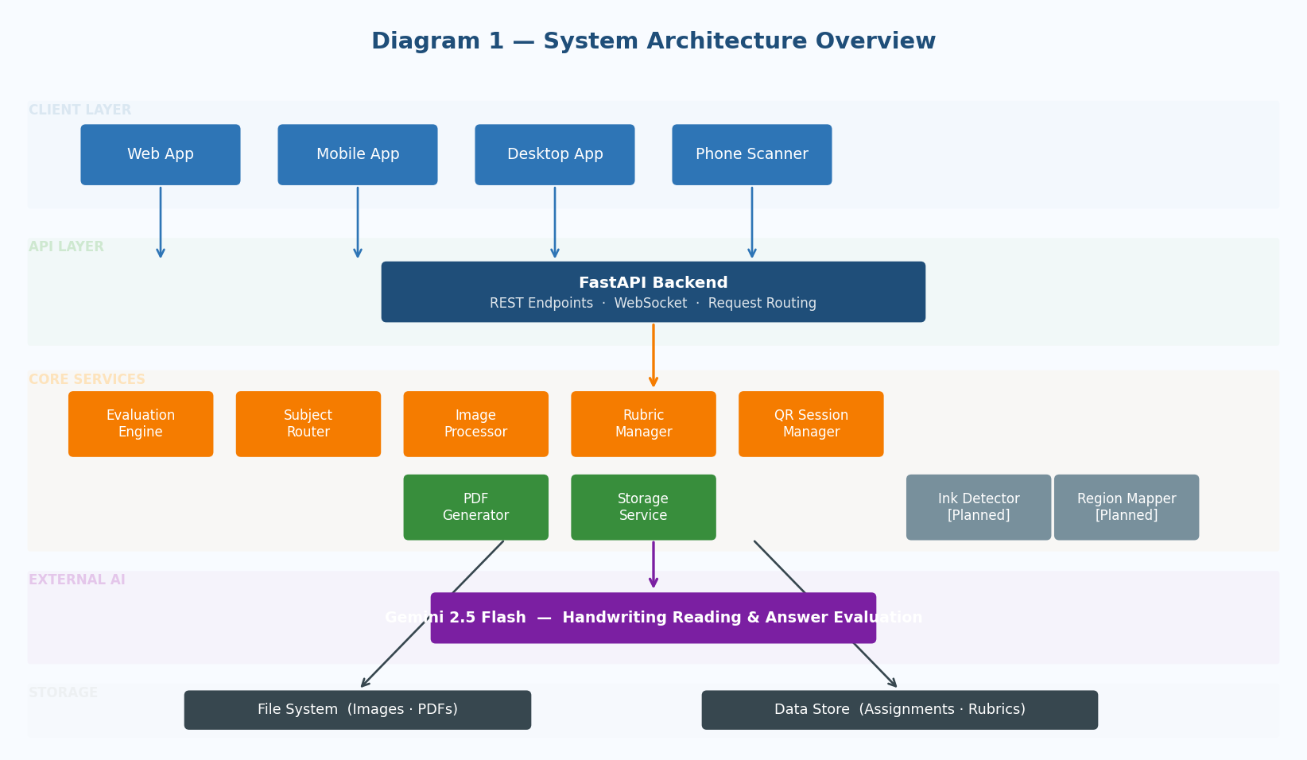
Diagram 1 — System Architecture Overview

2.1 Layer Breakdown
Layer | Components | Responsibility
Client | Web App, Mobile App, Desktop App, Phone Scanner | UI, camera access, results display
API | FastAPI Backend | REST endpoints, WebSocket, request routing
Core Services | Evaluation Engine, Subject Router, Image Processor, Ink Detector (Planned), Rubric Manager, QR Session Manager, PDF Generator, Storage Service | All business logic
External AI | Gemini 2.5 Flash | Handwriting reading and answer evaluation
Storage | File System, Data Store | Images, PDFs, assignments, rubrics

2.2 Tech Stack
Component | Technology
Frontend | React 18+, TypeScript, Vite
Backend | Python 3.10, FastAPI, Uvicorn
AI Models | Gemini 2.5 Flash
Image Processing | OpenCV (cleanup), NumPy + Pillow (ink detection)
PDF Generation | ReportLab or WeasyPrint
Real-time | WebSocket (native FastAPI)
Storage | Local filesystem (swappable via abstraction)
Data | JSON files (swappable to database via abstraction)

3. User Flows

3.1 Teacher: Assignment Creation
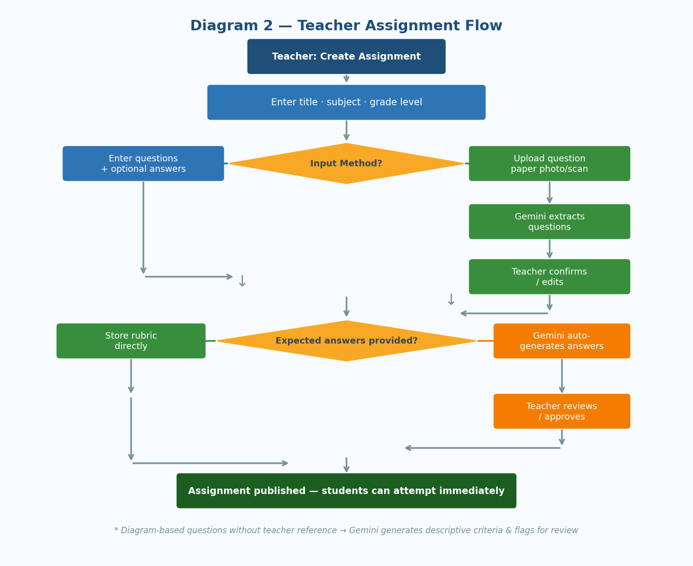
Diagram 2 — Teacher Assignment Flow
Flow:
- Teacher opens "Create Assignment" — enters title, subject, grade level
- Teacher chooses input method:
  - Type questions: Enters questions as text, optionally with expected answers
  - Upload image: Uploads photo/scan of question paper → Gemini extracts questions → Teacher confirms/edits extracted questions
- System checks if expected answers are provided:
  - Yes: Rubric stored directly, assignment is ready
  - No: Gemini auto-generates expected answers → Teacher reviews
- For diagram-based questions without teacher reference, system generates descriptive evaluation criteria and flags as "teacher review recommended"
- Teacher approves, edits, or leaves for later review
- Assignment becomes available to students immediately (students can attempt while teacher reviews auto-generated answers; final teacher evaluation happens after submission)

3.2 Student: Scanning & Evaluation
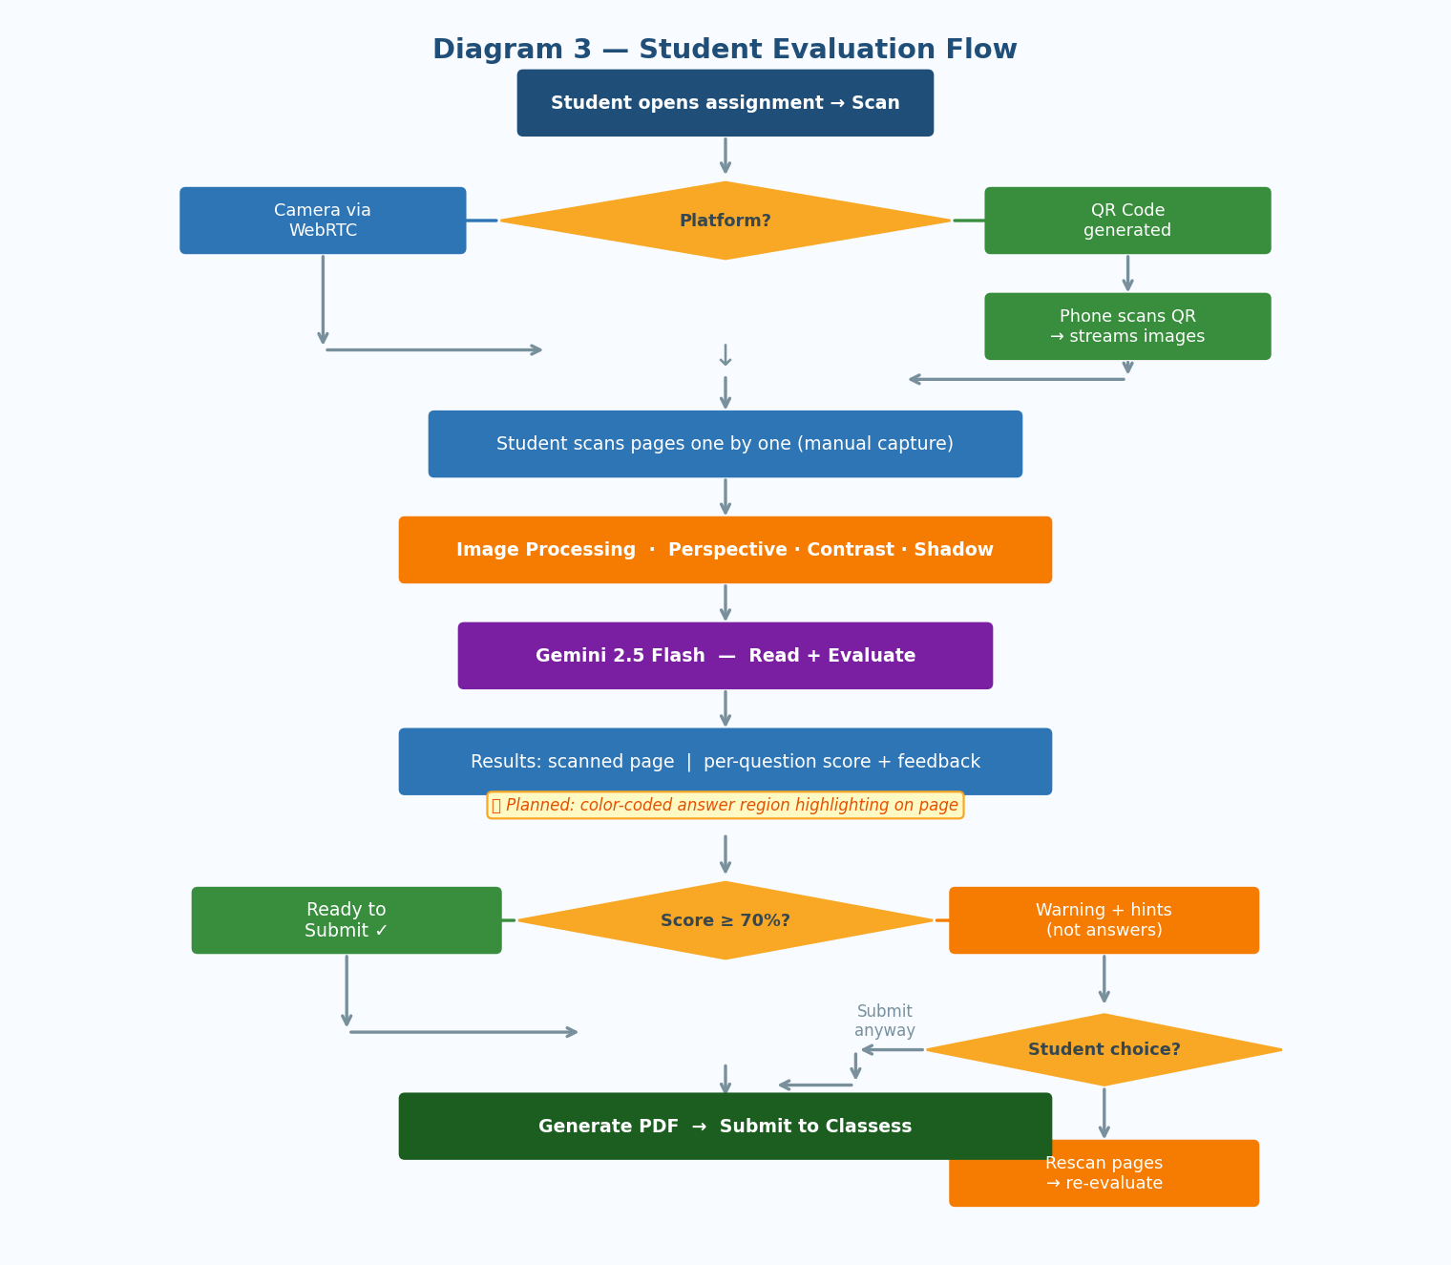
Diagram 3 — Student Evaluation Flow
Flow:
- Student opens assignment, clicks "Scan"
- Platform detection:
  - Mobile: Camera opens directly via WebRTC
  - Desktop: QR code generated → Student scans with phone → Phone acts as camera only, images stream to desktop via WebSocket
- Student scans pages one by one (manual capture per page)
- On completion, all page images are processed:
  - Image cleanup: Perspective correction, contrast enhancement, shadow removal (OpenCV)
  - Store: Both raw and cleaned images saved
- Evaluation runs (see Pipeline Design §4.1)
- Results displayed in split view:
  - Left: Scanned page
  - Right: Per-question breakdown — extracted answer, score, feedback
  - Mobile: Stacked layout instead of side-by-side
- Score check against 70% threshold:
  - ≥ 70%: "Ready to submit" — smooth submission flow
  - < 70%: Warning with areas to improve + subtle hints (not exact answers) → Student can rescan specific pages or full rescan, or submit anyway (allowed, but warned)
- On submission: Generate PDF (cleaned pages + evaluation overlay + summary) → Submit to Classess

Planned Feature — Bounding Box Highlighting: Answer regions on scanned pages will be color-coded (green/orange/red) based on score. This feature is designed but not yet active in the current build.

3.3 QR Code Scanning Flow
Participants: Desktop Browser, Backend Server, Phone Browser

- Desktop requests QR session → Backend creates session with unique ID and expiry
- Desktop displays QR code containing session URL
- Student scans QR with phone → Opens lightweight scanning page
- Phone connects to backend via WebSocket using session ID
- Desktop receives "phone connected" notification
- For each page: Phone captures image → Sends via WebSocket → Backend stores and forwards thumbnail to desktop
- Phone signals "scanning complete" → Desktop receives all images → Evaluation begins
- Results displayed on desktop only. Phone shows "Scanning complete, view results on your computer"

4. Core Pipeline Design

4.1 Evaluation Pipeline
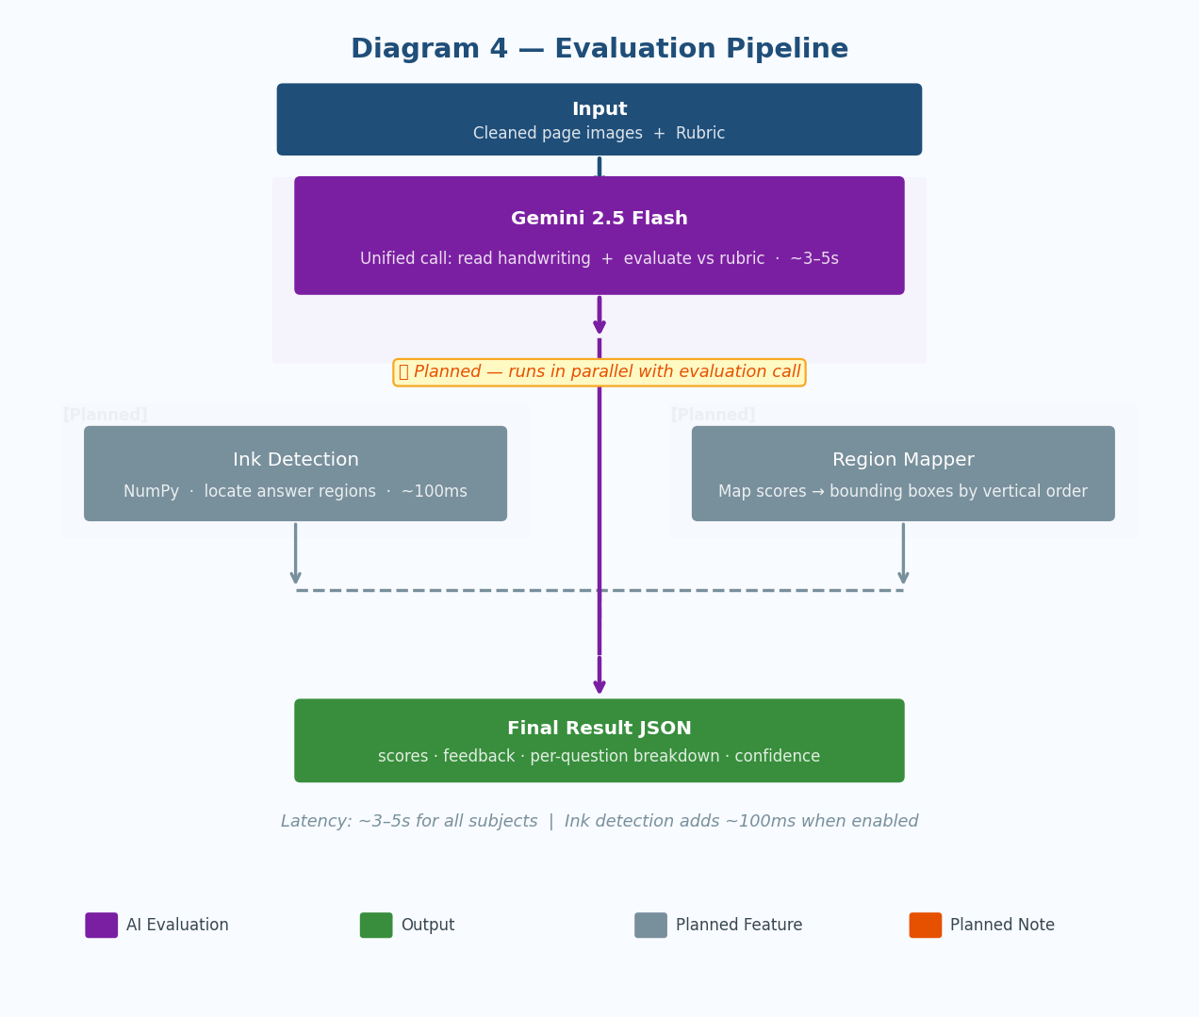
Diagram 4 — Evaluation Pipeline
The pipeline uses a single Gemini 2.5 Flash call per page — reading handwriting and evaluating against the rubric in one unified call, for both text and math subjects.

Input: Cleaned page images + Rubric
|
v
+---------------------------+
| Gemini 2.5 Flash |
| Single unified call: |
| Read handwriting + |
| Evaluate vs rubric |
| ~3-5s |
+-------------+-------------+
|
v
Final Result JSON

Latency
- All subjects: ~3–5 seconds per page

Planned Feature — Ink Detection & Bounding Boxes: A parallel ink detection pass (NumPy-based, ~100ms) will run alongside evaluation to locate answer regions on the page. Scores will then be mapped to bounding boxes by vertical order for visual highlighting. This is designed but not yet active.

4.2 Image Processing Pipeline
Runs on every captured page before evaluation.

Step | Operation | Library
1 | Convert to grayscale | OpenCV
2 | Edge detection → find paper boundary | OpenCV (Canny)
3 | Perspective correction → warp to rectangle | OpenCV (warpPerspective)
4 | Adaptive contrast enhancement | OpenCV (CLAHE)
5 | Shadow removal via local illumination normalization | OpenCV
6 | Resize to standard dimensions | OpenCV
7 | Save cleaned image | Pillow

- Input: Raw camera photo (possibly angled, shadowed, uneven lighting)
- Output: Clean, flat, high-contrast document image

4.3 Ink Detection Pipeline
Planned Feature — This pipeline is designed but not yet active in the current build. It will run in parallel with Gemini evaluation to find WHERE answers are on the page without reading them.

Step | Operation
1 | Convert cleaned image to grayscale
2 | Gaussian blur to estimate local background
3 | Subtract: pixels significantly darker than background = ink
4 | Calculate row-by-row ink density
5 | Smooth density curve, apply dynamic threshold
6 | Find contiguous ink regions (answer bands)
7 | Merge nearby regions, filter noise
8 | Find horizontal extent per region
9 | Output bounding boxes (normalized coordinates)

- Input: Cleaned page image + expected number of answers
- Output: List of bounding boxes, one per answer region

4.4 PDF Generation
Generated on submission for teacher review.

Page | Content
Cover | Student name, assignment title, date, total score
Per scanned page | Cleaned image (with colored bounding box overlays showing scores — Planned Feature)
Summary | Per-question table: question text, extracted answer, score, feedback
Metadata | Prompt version, model used, evaluation timestamp, confidence

5. API Specification

5.1 Assignment Management
POST /api/v1/assignments
Body: { title, subject, grade_level, subject_type, questions[] }
Response: { id, status: "created" }

POST /api/v1/assignments/extract-questions
Body: multipart { image }
Response: { extracted_questions[], source_image_ref }

GET /api/v1/assignments
Response: { assignments[] }

GET /api/v1/assignments/{id}
Response: { full assignment with questions and answers }

PUT /api/v1/assignments/{id}
Body: { updated fields }

DELETE /api/v1/assignments/{id}

POST /api/v1/assignments/{id}/generate-answers
Response: { generated_answers[], status: "pending_approval" }

POST /api/v1/assignments/{id}/approve-answers
Body: { answers[] with optional edits }
Response: { status: "approved" }

5.2 Evaluation
POST /api/v1/prepare
Body: { assignment_id, student_id }
Response: { status, title, total_questions, total_marks, answers_approved }

POST /api/v1/evaluate
Body: multipart { assignment_id, student_id, images[] (one per page) }
Response: {
pages: [{
page_number,
cleaned_image_url,
is_readable,
is_relevant,
questions: [{
q_number,
extracted_answer,
score,
max_marks,
feedback,
bounding_box: [y_min, x_min, y_max, x_max], // Planned Feature
hints: (only if score < threshold)
}]
}],
total_score, max_score, percentage, meets_threshold,
overall_feedback, prompt_version, model_used, confidence
}

POST /api/v1/evaluate/rescan
Body: multipart { assignment_id, student_id,
submission_id, page_numbers[], images[] }
Response: { updated evaluation result (same schema) }

5.3 QR Session
POST /api/v1/qr-session
Body: { assignment_id, student_id }
Response: { session_id, qr_data, ws_url, expires_at }

GET /api/v1/qr-session/{session_id}
Response: { status, pages_received }

WebSocket /ws/scan/{session_id}
Phone sends: { type: "image", data: base64, page_num }
Phone sends: { type: "complete" }

WebSocket /ws/desktop/{session_id}
Receives: { type: "phone_connected" }
Receives: { type: "page_received", page_num, thumbnail }
Receives: { type: "scanning_complete", total_pages }

5.4 Submission
POST /api/v1/submissions
Body: { assignment_id, student_id, evaluation_id }
Response: { submission_id, pdf_url, submitted_at }

GET /api/v1/submissions/{id}
Response: { full submission details }

GET /api/v1/submissions/{id}/pdf
Response: PDF file download

5.5 Health
GET /api/v1/health
Response: { status, gemini_reachable, storage_ok, version }

6. Data Models

6.1 Assignment
Assignment {
id: string (uuid)
title: string
subject: string
grade_level: integer
subject_type: enum ["text", "math"]
question_source: enum ["typed", "extracted_from_image"]
source_image_ref: string? (if uploaded image)
created_by: string (teacher_id)
created_at: datetime
updated_at: datetime
}

6.2 Question
Question {
id: string (uuid)
assignment_id: string (FK)
q_number: integer
text: string
max_marks: integer
has_diagram: boolean
diagram_description: string?
diagram_ref: string?
}

6.3 Expected Answer
ExpectedAnswer {
id: string (uuid)
question_id: string (FK)
answer_text: string
is_auto_generated: boolean
approved_by_teacher: boolean
approved_at: datetime?
teacher_notes: string?
}

6.4 Evaluation
Evaluation {
id: string (uuid)
assignment_id: string (FK)
student_id: string
pages: PageScan[]
results: QuestionResult[]
total_score: float
max_score: float
percentage: float
meets_threshold: boolean
overall_feedback: string
model_used: string
prompt_version: string
confidence: float
evaluated_at: datetime
}

6.5 Page Scan
PageScan {
page_number: integer
raw_image_ref: string
cleaned_image_ref: string
is_readable: boolean
is_relevant: boolean
}

6.6 Question Result
QuestionResult {
q_number: integer
page_number: integer
extracted_answer: string
score: float
max_marks: float
feedback: string
hints: string?
bounding_box: [int, int, int, int]? // Planned Feature
mapping_confidence: float // Planned Feature
}

6.7 QR Session
QRSession {
session_id: string (uuid)
assignment_id: string
student_id: string
status: enum ["waiting", "connected", "scanning", "complete", "expired"]
pages_received: integer
page_images: string[] (refs)
created_at: datetime
expires_at: datetime (created_at + 10 minutes)
}

6.8 Submission
Submission {
id: string (uuid)
evaluation_id: string (FK)
assignment_id: string (FK)
student_id: string
pdf_ref: string
total_score: float
max_score: float
percentage: float
submitted_at: datetime
}

7. Component Architecture

7.1 Backend
app/
├── main.py FastAPI app, CORS, lifespan
├── config.py Environment-based configuration
│
├── api/
│ ├── routes/
│ │ ├── health.py GET /health
│ │ ├── assignments.py CRUD + extract + approve
│ │ ├── evaluate.py POST /prepare, /evaluate, /evaluate/rescan
│ │ ├── qr_session.py POST /qr-session, GET status
│ │ ├── submissions.py POST /submit, GET, GET /pdf
│ │ └── websocket.py WS /ws/scan/{id}, /ws/desktop/{id}
│ └── dependencies.py Shared deps (auth, services)
│
├── core/
│ ├── evaluator.py Orchestrates full evaluation pipeline
│ ├── subject_router.py Routes text vs math subjects
│ ├── gemini_evaluator.py Unified Gemini 2.5 Flash call (read + evaluate)
│ ├── rubric.py Rubric generation + caching
│ ├── ink_detector.py [Planned] Adaptive ink detection (NumPy)
│ ├── region_mapper.py [Planned] Maps scores → bounding boxes
│ ├── image_processor.py OpenCV cleanup pipeline
│ ├── question_extractor.py Extract questions from image (Gemini)
│ └── prompts/
│ ├── eval_v1.py Unified eval prompt (text + math)
│ ├── rubric_gen_v1.py Prompt for answer generation
│ └── question_extract_v1.py Prompt for question extraction
│
├── services/
│ ├── qr_session.py QR session lifecycle management
│ ├── pdf_generator.py PDF creation from evaluation results
│ └── submission.py Submission creation and management
│
├── data/
│ ├── source.py AssignmentDataSource protocol
│ ├── local_source.py JSON file implementation
│ └── classess_source.py Classess API implementation (stub)
│
├── storage/
│ ├── base.py StorageService protocol
│ └── local.py Filesystem implementation
│
└── models/
├── assignment.py Assignment, Question, ExpectedAnswer
├── evaluation.py Evaluation, QuestionResult, PageScan
├── submission.py Submission
├── qr_session.py QRSession
└── common.py Shared types, enums

7.2 Frontend
src/
├── App.tsx Root: state machine (flow controller)
├── pages/
│ ├── StudentFlow.tsx Student scanning + evaluation flow
│ └── TeacherFlow.tsx Assignment creation + review flow
│
├── components/
│ ├── Scanner/
│ │ ├── CameraFeed.tsx WebRTC camera + manual capture
│ │ ├── PageThumbnails.tsx Preview of captured pages
│ │ └── ScanControls.tsx Capture, retake, done buttons
│ │
│ ├── QRScanner/
│ │ ├── QRDisplay.tsx Shows QR code on desktop
│ │ ├── PhoneScanPage.tsx Lightweight page opened on phone
│ │ └── ConnectionStatus.tsx
│ │
│ ├── Results/
│ │ ├── SplitView.tsx Left: image, Right: score breakdown
│ │ ├── PageViewer.tsx Scanned page (+ highlights — Planned)
│ │ ├── ScoreBreakdown.tsx Per-question score + feedback
│ │ ├── ScoreWarning.tsx Below threshold warning + hints
│ │ └── SubmitButton.tsx Submit with confirmation
│ │
│ ├── Teacher/
│ │ ├── AssignmentForm.tsx
│ │ ├── QuestionEditor.tsx
│ │ ├── AnswerReview.tsx
│ │ └── ImageUpload.tsx
│ │
│ └── Common/
│ ├── Loading.tsx
│ └── ErrorBoundary.tsx
│
├── hooks/
│ ├── useCamera.ts
│ ├── useWebSocket.ts
│ ├── useEvaluation.ts
│ └── useQRSession.ts
│
├── services/
│ └── api.ts
├── types/
│ └── index.ts
└── utils/
└── postMessage.ts

8. Error Handling Strategy
Scenario | Detection | Handling | User Sees
Gemini API timeout | Request exceeds 30s | Retry once, then fail gracefully | "Evaluation taking longer than expected. Retry?"
Gemini returns invalid JSON | JSON parse fails | Retry once with same image | "Evaluation unclear. Retrying..."
Image too dark/blurry | Gemini flags is_readable: false | Return immediately, no evaluation | "Image is unclear. Please rescan this page."
Wrong assignment content | Gemini flags is_relevant: false | Return immediately | "This doesn't match the assignment."
Ink detection finds 0 regions | No regions returned | Show results without highlighting | Results shown normally [Planned Feature]
Image cleanup fails | OpenCV exception | Skip cleanup, use raw image | Evaluation proceeds (may be less accurate)
QR session expired | Timestamp check | Close session, prompt new QR | "Session expired. Generate a new QR code."
Phone disconnects | WebSocket close event | Desktop notified | "Phone disconnected. Generate new QR."
Low confidence result | Low confidence from Gemini | Flag in results | "Some answers unclear. Teacher will review."
PDF generation fails | Exception in generator | Store evaluation without PDF | "Results saved. PDF available shortly."

Principle: Never crash. Never lose data. Always show something useful. Bounding boxes are an enhancement, not a requirement.

9. Configuration
# -- AI Models --
GEMINI_API_KEY=xxx
EVAL_MODEL=gemini-2.5-flash
MODEL_TEMPERATURE=0
MAX_OUTPUT_TOKENS=4096

# -- Thresholds --
SCORE_THRESHOLD_PERCENT=70
INK_SENSITIVITY=25 # Planned Feature
MIN_REGION_HEIGHT_RATIO=0.03 # Planned Feature

# -- Storage --
STORAGE_TYPE=local
STORAGE_PATH=./data/images
DATA_SOURCE=local
DATA_PATH=./data/assignments

# -- QR Sessions --
QR_SESSION_EXPIRY_MINUTES=10

# -- Server --
HOST=0.0.0.0
PORT=8000
CORS_ORIGINS=["http://localhost:3000"]

# -- Feature Flags --
ENABLE_IMAGE_CLEANUP=true
ENABLE_QR_SCANNING=true
ENABLE_BOUNDING_BOXES=false # Planned Feature -- not yet active

