CS313, Lab – 3

Rishit Saiya, 180010027

September 19, 2020

**Q.5]**

1. Query:

SELECT * FROM part, supplier, shipment WHERE part.colour = 'red' AND part.part_no = shipment.part_no AND supplier.supplier_no = shipment.supplier_no;

Output:

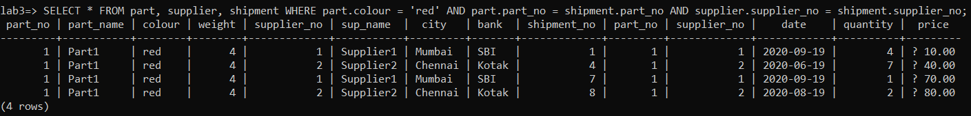

2. Query:

SELECT SUM(shipment.price), supplier.supplier_no FROM part, supplier, shipment WHERE shipment.supplier_no = supplier.supplier_no AND part.part_no = shipment.part_no group by supplier.supplier_no;

Output:



3. Query:

SELECT supplier.supplier_no FROM part, supplier, shipment WHERE shipment.supplier_no = supplier.supplier_no AND part.part_no = shipment.part_no group by supplier.supplier_no having COUNT (DISTINCT part.part_no) = (SELECT COUNT (DISTINCT part_no) FROM part);

Output:

