CS313, Lab – 6

Rishit Saiya, 180010027

October 10, 2020

**Q.1]**

***Code Screenshot:***

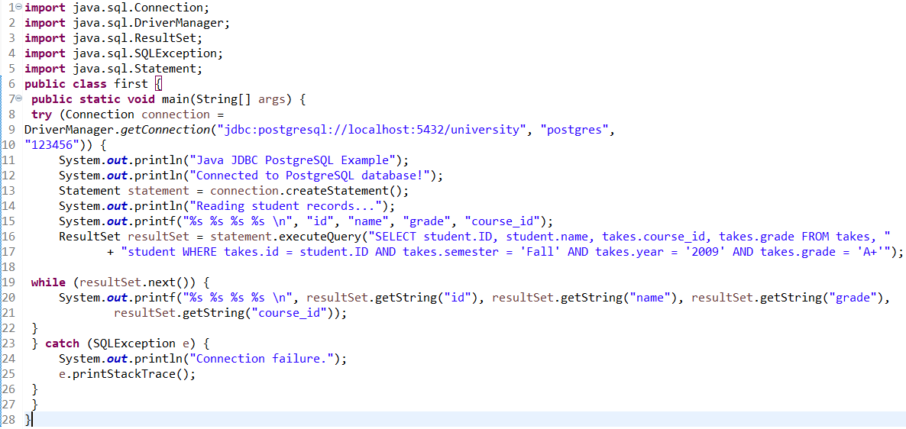

***Output:***

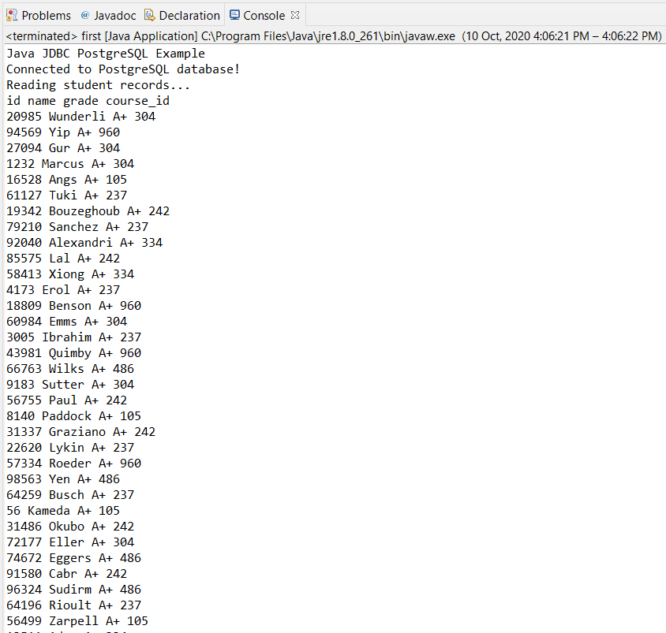

**Q.2]**

***Code Screenshot:***

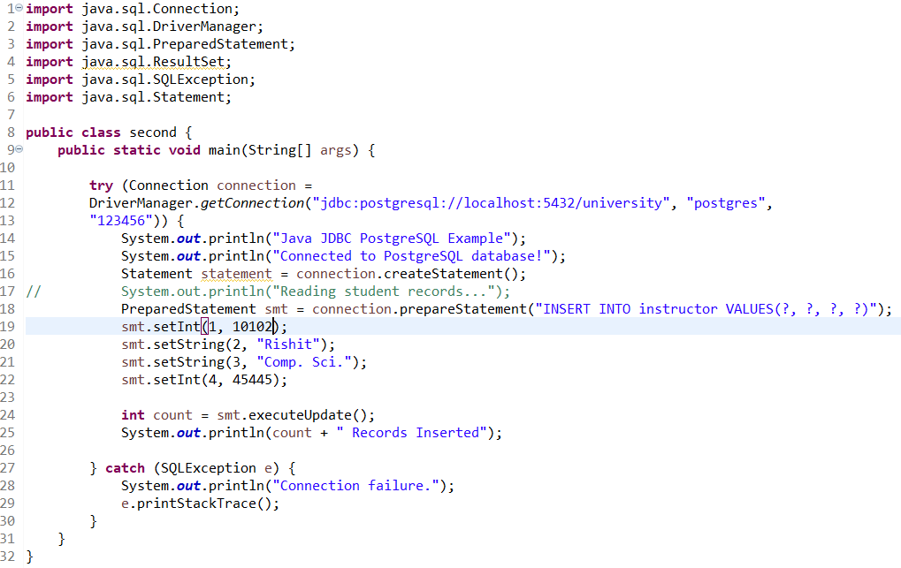

***Output:***

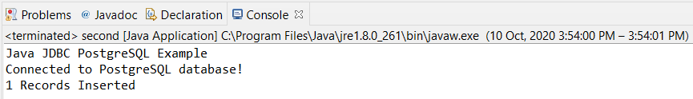

**Q.3]**

***Code Screenshot:***

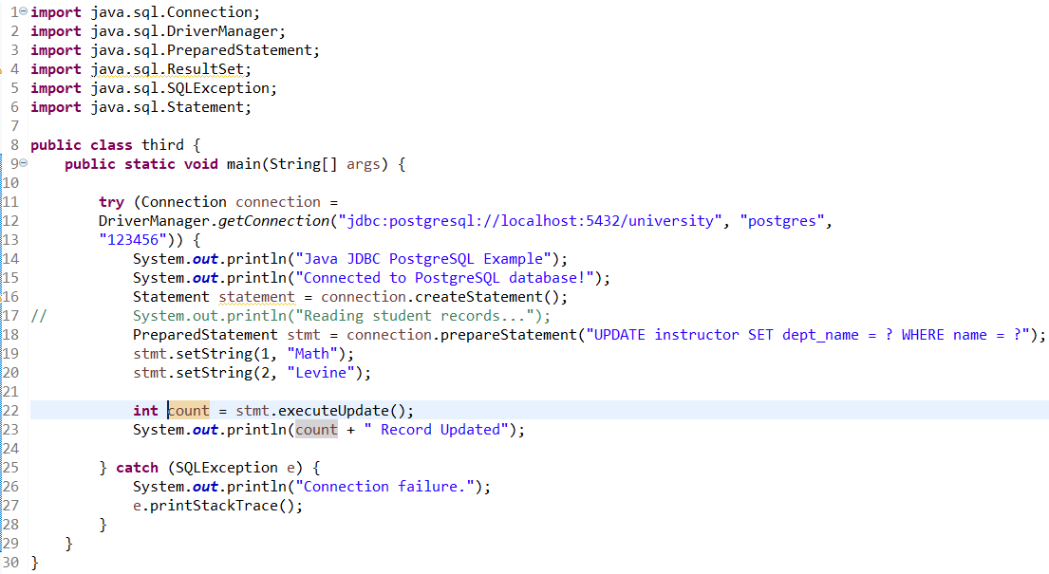

**Output:**

