DSCI-519 Homework 3

This is an INDIVIDUAL assignment. You may discuss it with other students, but each student must submit their own work. Prepare a report in PDF format with a font size of 10 points, single-spaced, single column Submit the report on the D2L.

Note: some of the problems in this assignment are quite open-ended, there can be more than one right answer Make any relevant reasonable assumptions as you need to, just make sure to state your assumptions in your report.

Problem 1 (20 points)
Alice and Bob are financial consultants. Let CD_{X}, CD_{Y}, CD_{U}, and CD_{V} be company data sets of companies X, Y, U and V. Suppose, X and Y are information technology and U and Y are oil companies. Consider two conflict of interest sets COI₁ = {X, Y} and COI₂ = {U, V}.
Show all the possible assignments that are allowed and prohibited by the Chinese wall policy - consider read only assignments as well as read and write.
Consider the following scenarios:
- Only read accesses need to be provided to CDs
- Both read and write accesses need to be provided together to any CD.
- Both read/write required for CD_{X}, and CD_{V}, and read-only to remaining CDs.
Note that Alice and Bob may not be able to cover all the CDs – for that you can assume there are consultants who can take on the assignment. You need to only consider Alice and Bob.

Problem 2 RBAC/ABAC (55 points)
Task 1. (5 points)
Consider the following highly simplified healthcare environment. A hospital personnel consists of doctors, nurses, and hospital staff. The hospital’s IT system maintains the following types of information: general hospital information (location, list of specialists, services provided, etc.), internal hospital information (hospital inventory, scheduling, etc.), patient information (diagnosis, treatment, lab tests, etc.),

Deliverable: develop a high-level access control policy using MAC. In particular, define the following:

- Types of users (subjects) and protected information (objects)
- MAC labels (access classes) that contain only hierarchical levels
  - Show the dominance relationship for your access classes
- Classifications and clearances for the objects and subjects
  - I.e., assign the labels to specific types of users and types of information to express the policy you want to enforce

Task 2. (30 points)
Consider a health monitoring infrastructure that uses sensors to collect vital parameters (e.g., blood pressure, blood sugar, and heart rate) from patients. For each patient the IT system maintains two types of log files: “normal” (the parameters are within the normal range) and “abnormal” (the parameters indicate some abnormality that needs to be examined). This information can be shared with healthcare professionals including doctors, nurses, and emergency responders.
Once this data is collected from each monitored patient, a trusted device classifies it as “normal” or “abnormal” and sends the classified data securely to a secure trusted data storage facility. The received data are written into “normal’ or “abnormal” log files.

The high-level system access control policies are as follows:

- An authorized healthcare professional should be able to examine both logs and determine whether the situation is critical and remedial actions are required. When the readings from both logs lead to an emergency situation, an “emergency” log is created by this person.
- Physicians should be able to access all three types of logs of their patients at any time. Nurses should be able to access all three types of logs belonging to their patients only during working hours.
- Emergency responders should get access to the “emergency” logs of all patients. Once the emergency is resolved, the authorization given to the responders will be automatically revoked.
- The system is maintained by sysadmins who should be able to manage the access permissions.

- Deliverable: (15 points) develop a RBAC-3 access control policy that captures the above requirements. In particular, define the following:
- Protected objects
- Operations on protected objects
  - These should include administrative (access control management) and non-administrative operations (access to protected objects)
- Permissions: objects to operations assignments
- Roles
- Role to permission assignments
- Constraints

- Deliverable (15 points): develop an ABAC access control policy that captures the above requirements. In particular, define the following:

- Resource attributes
- Subject attributes
- Action attributes
- Environment attributes
- Access control rules based on the attributes of resources, subjects, actions and environment

Task 3. (20 points)

Express your RBAC and ABAC policies that you developed for task 2 using Azure RBAC and ABAC. Provide screenshots of your solution.

Step 1. Sign up for a free student account: https://azure.microsoft.com/en-us/free/students/

Step 2. Use the following tutorials to familiarize yourself with Azure RBAC and ABAC

https://github.com/MicrosoftLearning/AZ-500-Azure-Security/blob/master/Instructions/Labs/Module_1/LAB_06_RBAC.md

https://docs.microsoft.com/en-us/azure/role-based-access-control/conditions-overview

Below are some tips.

Steps for creating a new user
Navigate to the users in the domain to be created and click on new user.
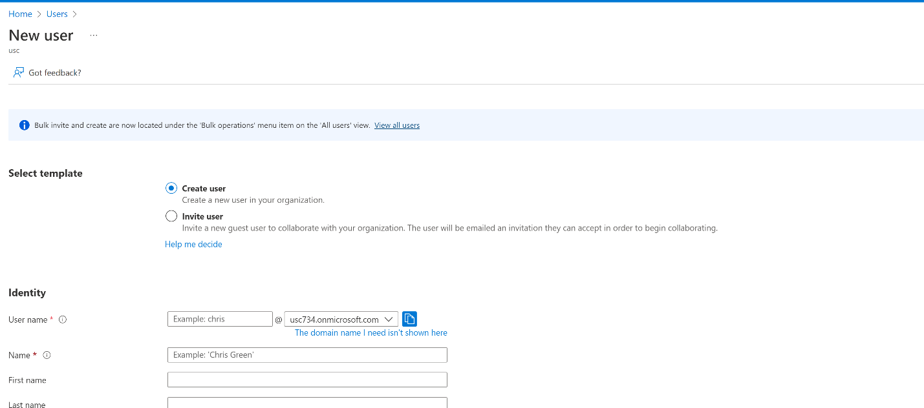
After filling out the details click create user.
Steps for creating a resource to be managed
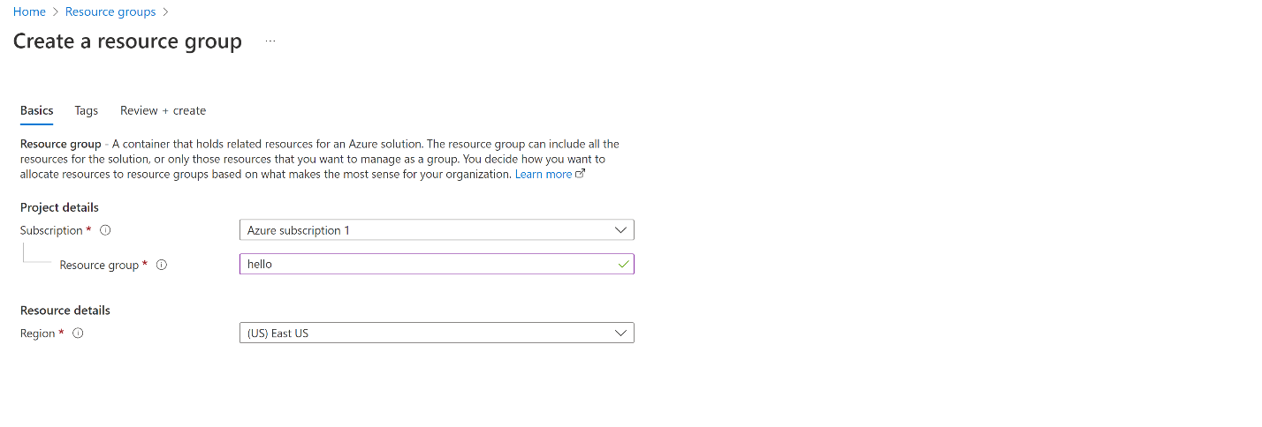
The subscription type and the resource name is to be defined and click create.

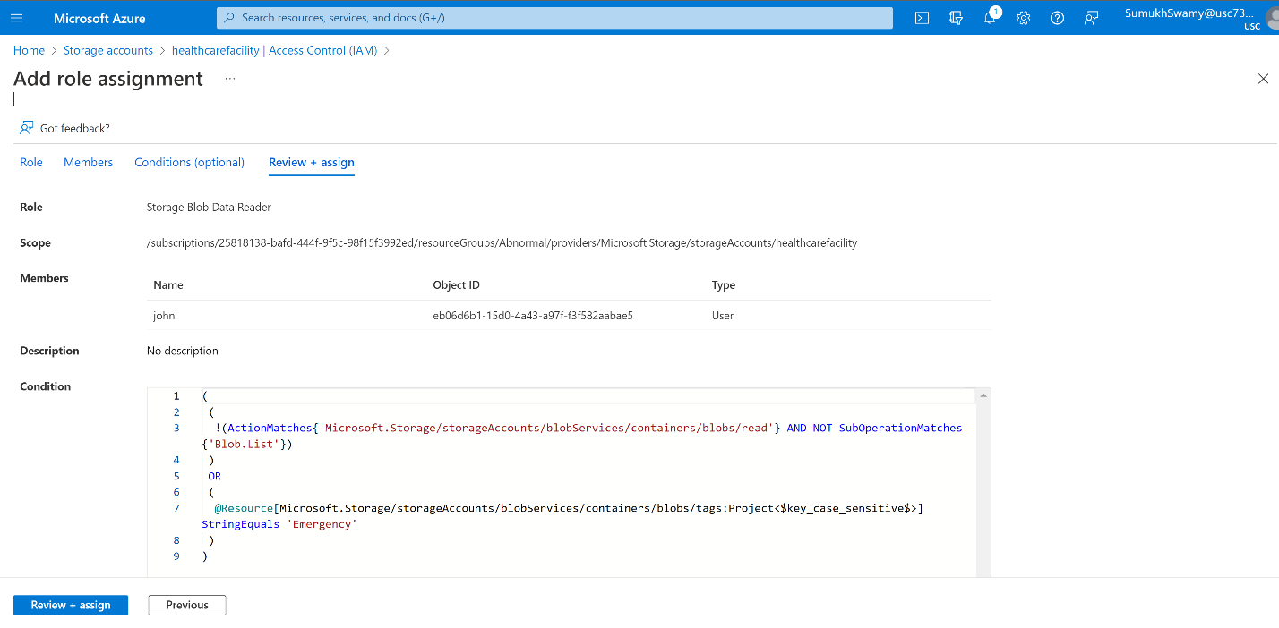

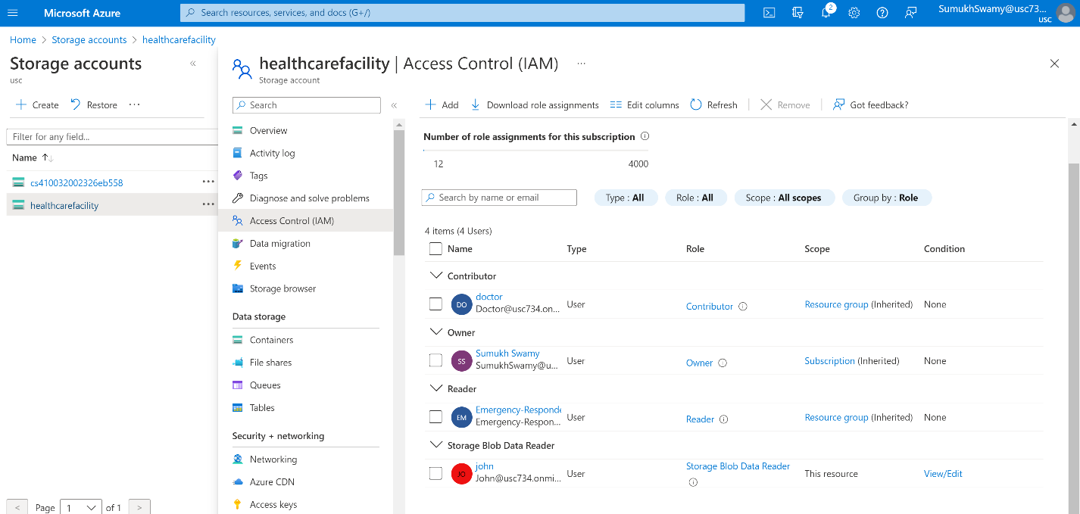
John a new user who only has access to the storage blob which contains the emergency file.
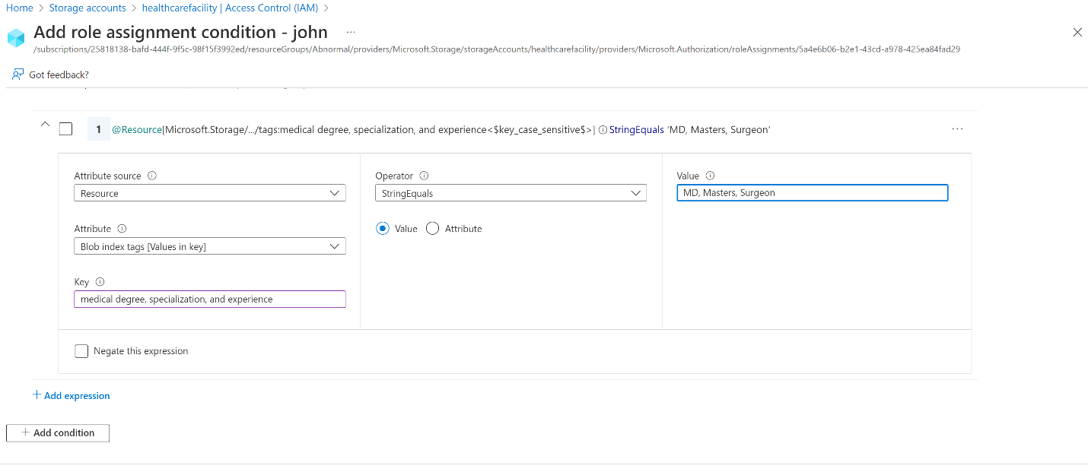
One of the conditions for authorization and authentication is that of credentials which the file uploaded with the above info can possess. In this situation the credential of the user is verified and is then access provided.
Creation of storage account with the resources to be managed by ABAC
First, we have to navigate to the storage account.
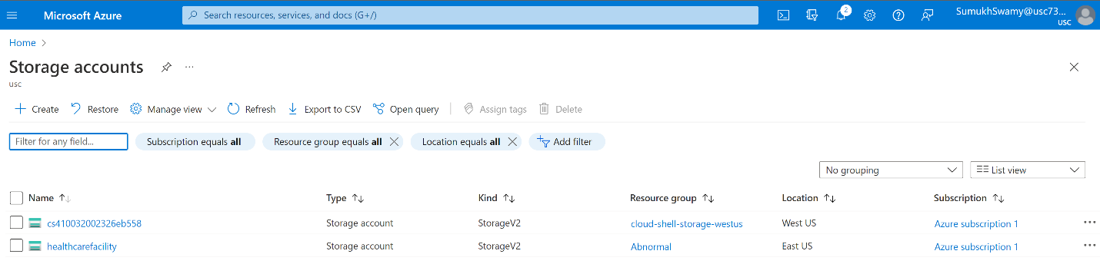
Upload the doc and set the values in advanced for authentication.
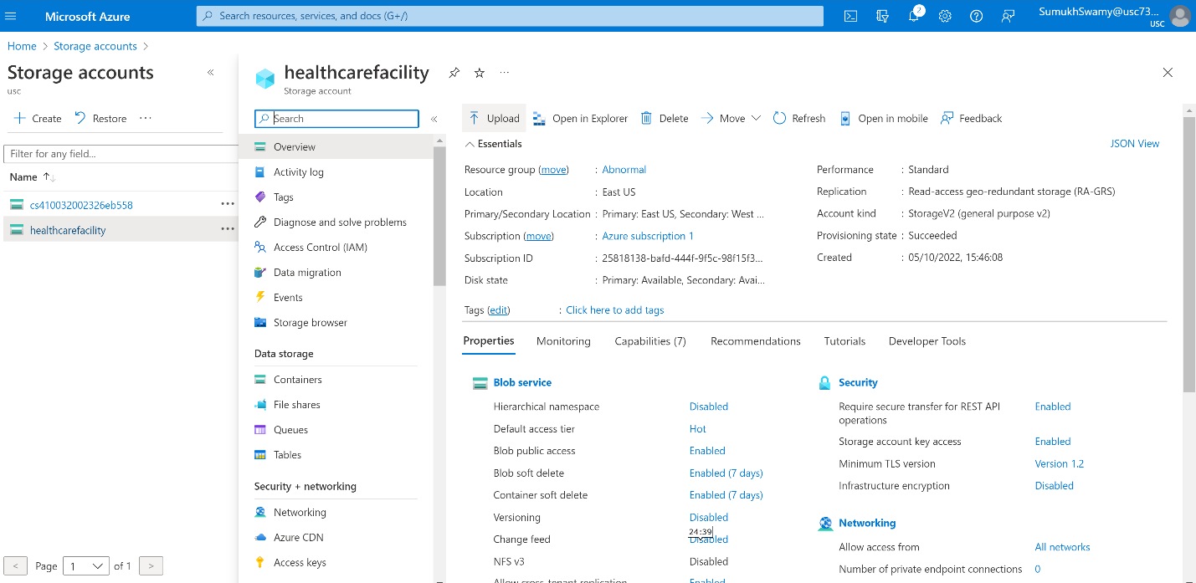
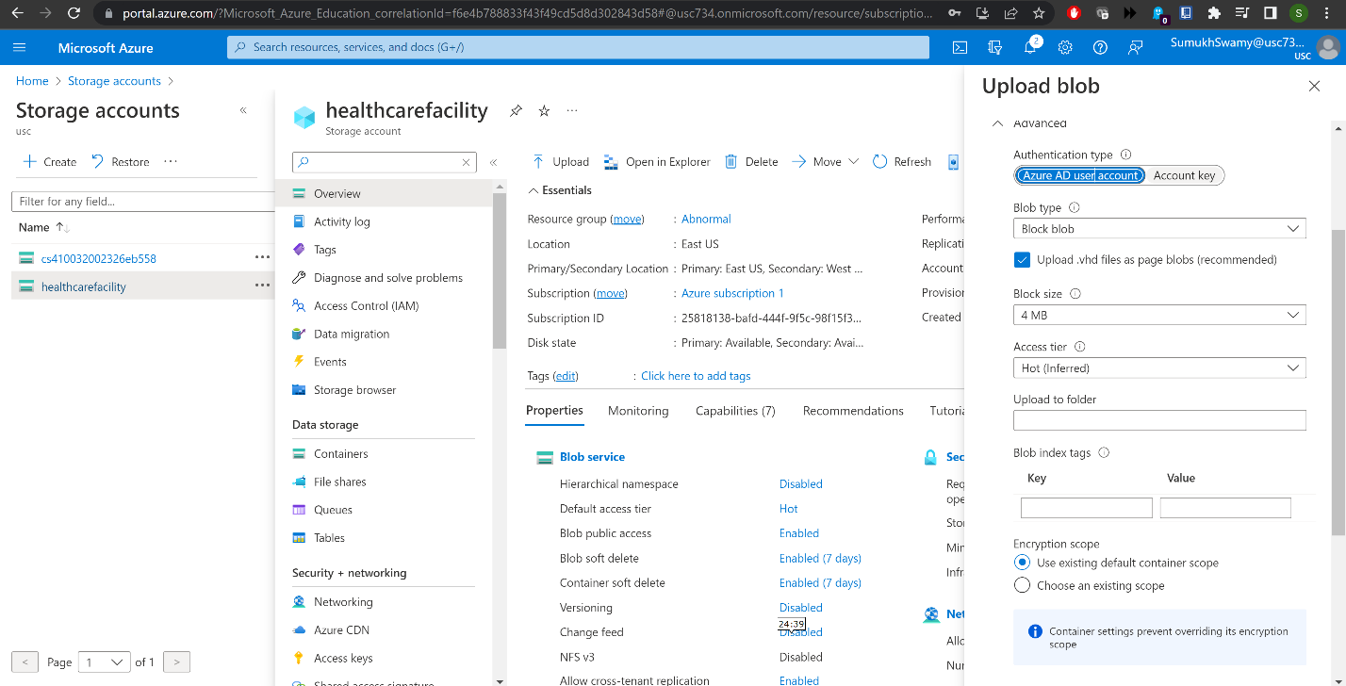
Steps for adding roles for storage ABAC
In the storage account navigate to the IAM.
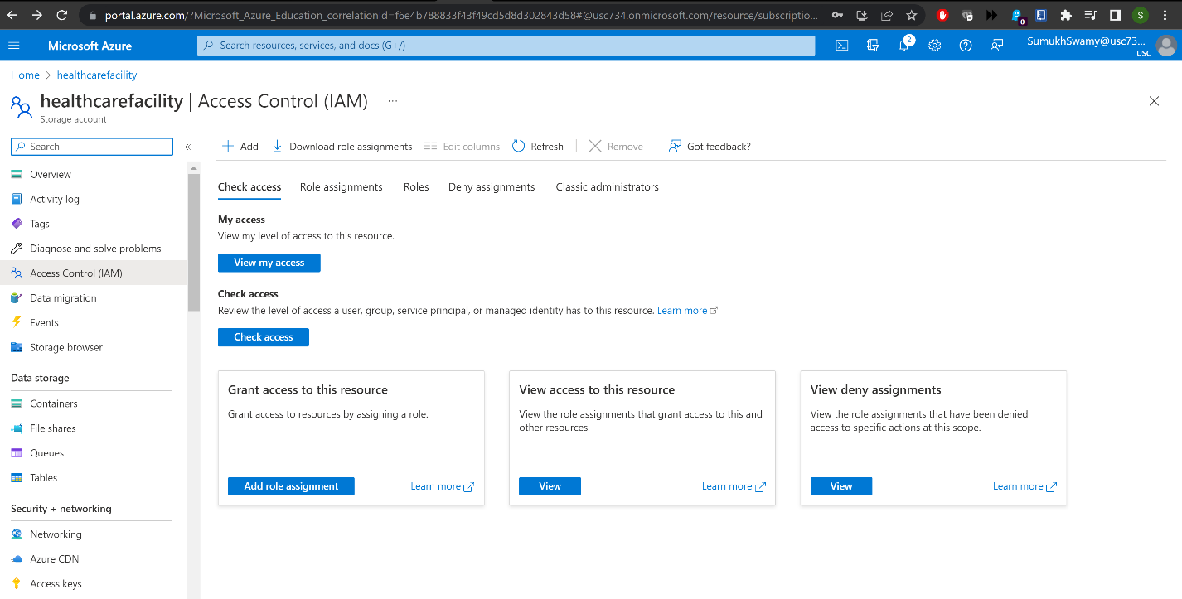
Click add and role assignment in this search for storage blob reader.
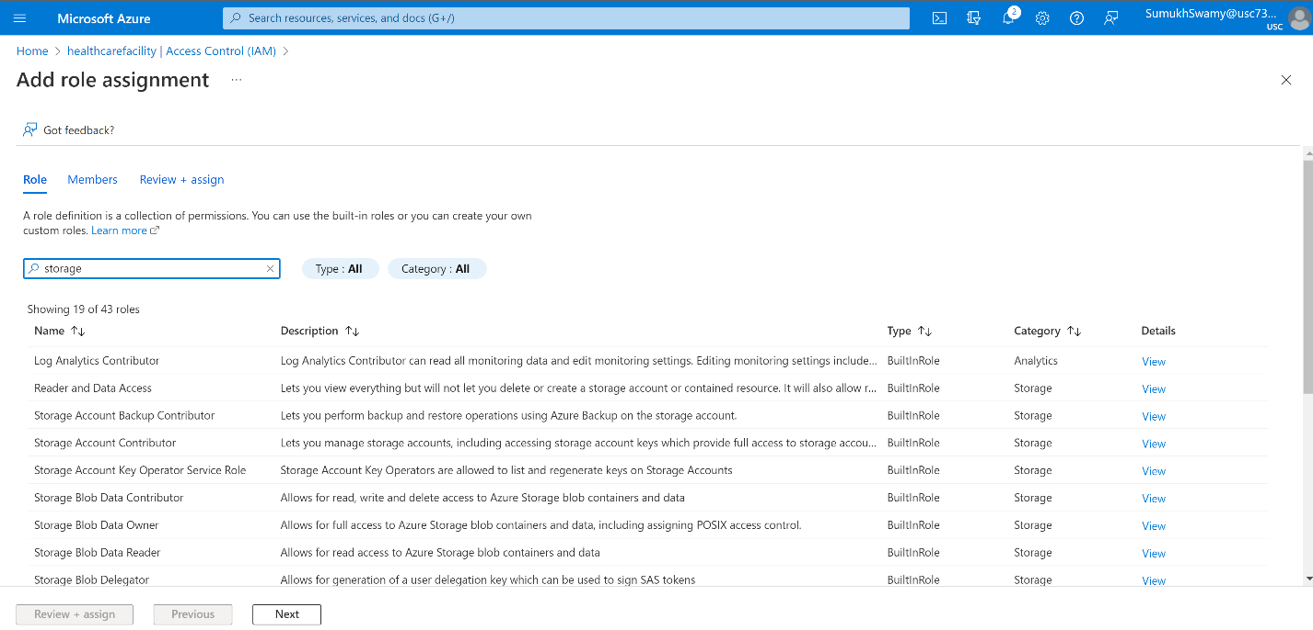
Select the member to provide the attribute access to.
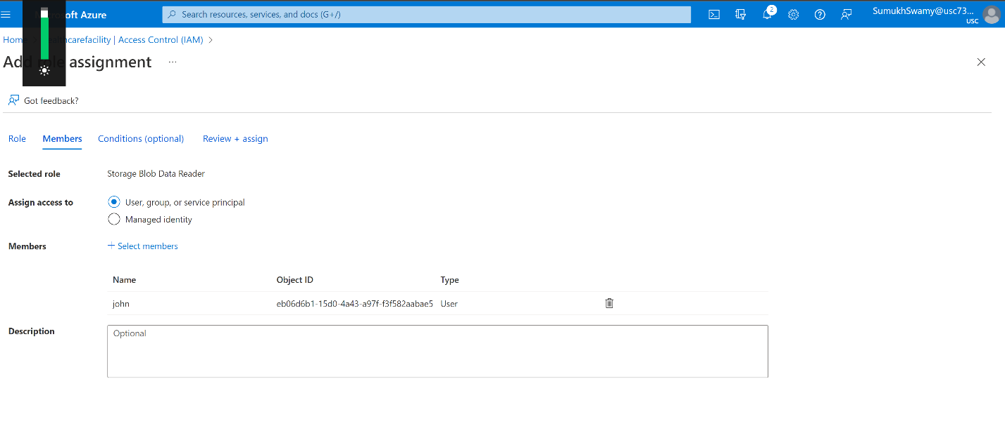
In the next section click on role assignment condition and specify the blob read action.
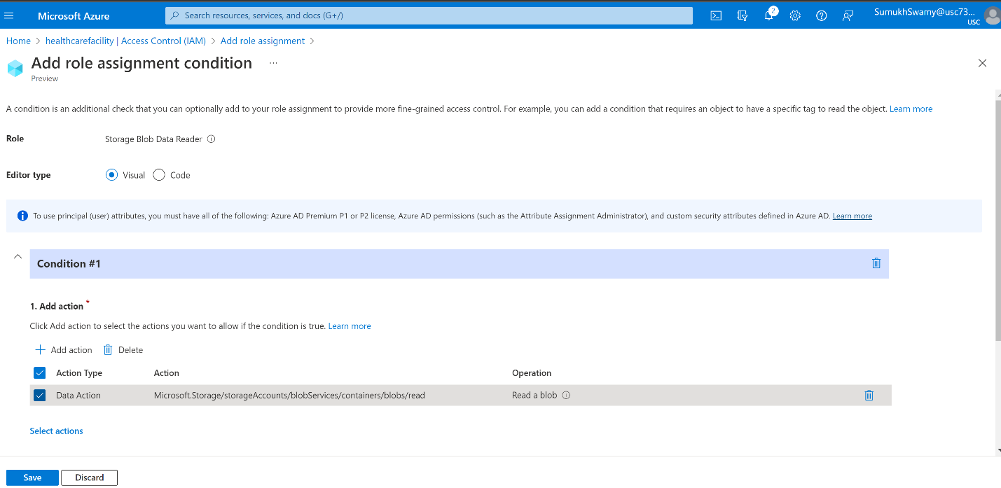
Select the expression the authentication values needed.
Finally finish and create the rule for ABAC policy.

Problem 3 (15 points)

We have studied two concepts, which are used in a “divide and conquer” strategy for security policy.

- [4 points] Briefly describe the concept that primarily focuses on a single computer.

- [4 points] Briefly describe the concept that focuses more on a loosely-coupled network of computers.

- [7 points] Briefly describe two similarities and two differences between these two concepts.

Problem 4 (10 points)
TCB subsets are said to leverage purely hierarchical domains ordered by privilege.

- [3 points] Explain the relation between these domains and protection rings.

- [3 points] How does the concept of ordered domains help in the “incremental evaluation” of a system composed of TCB subsets?

- [4 points] How can the “Reference Monitor” concept be applied as part of the above-mentioned incremental evaluation?

