**COL-334/CSL-374/CSL-672: Assignment 3, Semester 2014-2015 I**

1. We have the following topology: a sender communicating to a receiver via a series of two routers. Packets are of size s, the transit links have a transmission rate of r, while the access link operates at half the rate of the transit links. The round trip propagation delay is 4s/r, hence within an RTT of 8s/r the access link can just about support a window size of 4 packets. Ignore acknowledgement sizes.

Sender

Receiver

Access link

Transit link

2s/r

s/r

8s/r

Transit link

s/r

Consider the following packet trace at the sender using a transport protocol similar to TCP. The y-axis indicates sequence numbers in bytes – long vertical rectangles are packets and each packet is 100 bytes long, thus the first packet contains data from sequence number 0 to 99, the second packet from sequence number 100 to 199, etc. The x-axis indicates time in units of s/r. The small stubs are acknowledgement numbers – thus, the stub at time 9 (after one RTT) is the cumulative acknowledgement for the first packet with sequence number 0 to 99, the stub at time unit 11 is the cumulative acknowledgement for the second packet, etc.

Assume the congestion window size to be fixed and greater than 4 packets – this implies that the sender will try to push out a packet every 2 time units, which is the maximum transmission rate its access link allows.

Also assume for simplicity that no acknowledgements are lost and no reordering occurs.

Now explain the packet trace below.

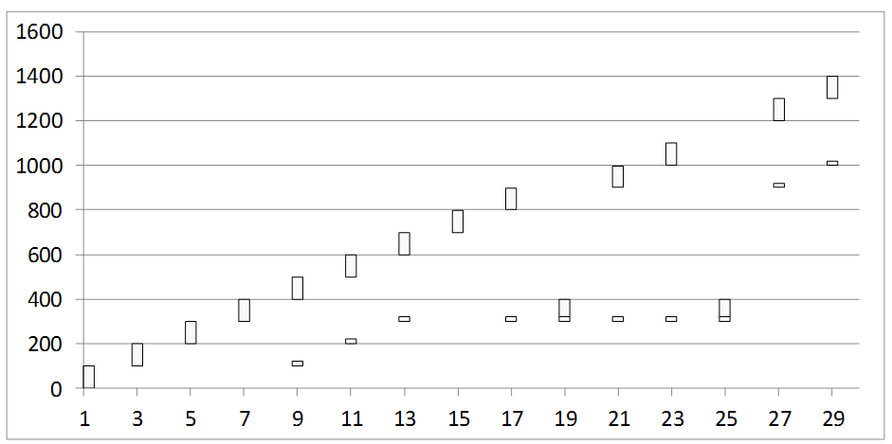

* + 1. Packet 300-399 seems to have been lost. What triggers the retransmission of the lost packet?

**Ans:** Retransmission has happened because the sender has received 3 duplicate acknowledgements referring to the 4th packet (300-399) at time 13,17,19 from the receiver.

* + 1. The acknowledgement received at time 21 was generated at the receipt of which packet at the receiver?

**Ans:** It was generated by the 7th packet (600-699).

* + 1. Why is the acknowledgement at time 21 still referring to the lost packet even though it has been retransmitted?

**Ans:** The lost packet which has been retransmitted at time 19 hasn’t reached the receiver before the receiver sends the acknowledgement of the 7th packet referring to the lost packet.

* + 1. Why the lost packet is again retransmitted at time 25?

**Ans:** Upon receiving the three duplicate acknowledgment packet referring to the lost packet at time 21, 23, 25, the sender retransmits the lost packet again at time 25.It seems that the lost packet which was retransmitted at time 19 hasn’t reached the receiver yet.

* + 1. Why is there a sudden jump in the acknowledgement number at time 27? The acknowledgement was generated at the receipt of which packet?

**Ans:** There is a sudden jump indicating that the receiver has received everything upto 9th packet (800-899) and is expecting the next packet with sequence number starting from 900. This also indicates that the lost packet which was retransmitted at time 19 has reached the receiver.