**COL-334/CSL-374/CSL-672: Assignment 3, Semester 2014-2015 I**

1. In another variant, the initial congestion window size is started at 4 packets, and the window is incremented fractionally by (1 / int (current window size)) upon receiving an acknowledgement. Thus, a window size of 4 will increment to 5 after having received 4 acknowledgements (4.25 after the first ack, 4.5 after the second ack, 4.75 after the third, and 5 after the fourth ack). Note that packets are dispatched only if they can be accommodated fully within the window, i.e. even with a window of 4.75 only four outstanding packets will be allowed.

The window size also reduces to half upon receiving triple duplicate acknowledgements which is seen as an evidence of packet loss. Note that receipt of the third dup ack will not increment the window, i.e. if the window is 5 when the third dup ack arrives, it will just be reduced to 2.5, and not add another 1 / int (2.5) increment for this ack as is done for other acks. Also note that the event of a triple dup ack is also interpreted as a loss, and hence the number of outstanding packets will be assumed to be one less than what was it estimated to be earlier. This is almost identical to TCP operations in the congestion avoidance phase.

Answer the following questions. Hint: Mentally maintain two variables for congestion window and the outstanding data to understand what is happening.

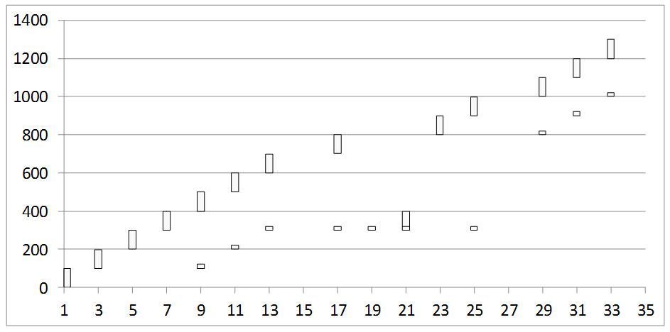

* + 1. What is the window size at time 17?

**Ans:** Window size at time 17 is 5.

* + 1. What is the window size at time 19? Why is no packet pushed out at time 19? What is the window size at time 21? What is the outstanding data estimated by the sender at time 21?

**Ans:** Window size at time 19 is 2.5 .At time 19, the number of outstanding packet in the network is 2 and since the window size is 2.5, the new packet cannot be fully accommodated in the window, therefore leading to no push out of packets at time 19.

Window size at time 21 is 3 .At time 21, the outstanding data is the lost packet which is being retransmitted having the sequence number 300 - 399.

* + 1. Why is a packet pushed out at time 23 even though no ack is received at that time?

**Ans:** At time 23, the window size is 3 and the number of packets in the network is 2. Therefore, one more packet can be pushed into the network as that can be fully accommodated in the congestion window. That’s the reason why a packet is pushed out at time 23 even though no ack is received at that time.

* + 1. What is the window size at time 31?

**Ans:** Window size at time 31 is 3.99