**COL-334/CSL-374/CSL-672: Assignment 3, Semester 2014-2015**

1. Now consider a different scenario where the access link is very fast but the next link is slower.

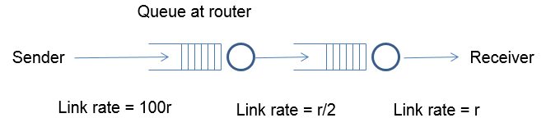

Assume an initial window size of 8 this time. As in the previous question, the window size is reduced to half upon receiving triple duplicate acknowledgements, and it is incremented by 1 / int (congestion window) upon receiving an acknowledgment. A timeout occurs if the last unacked packet goes unacknowledged for more than 25 time units. The buffer size at the first router is limited, and it follows a drop-tail policy. Assume that all packet losses happen due to buffer overflow at the first router. Answer the following questions:

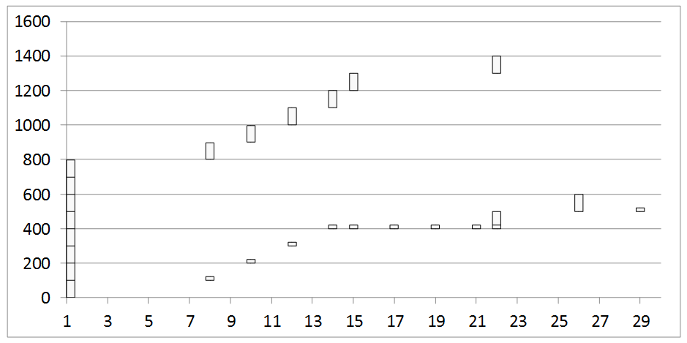

* + 1. What is the RTT in this case?

Ans: 7

* + 1. Can you infer the buffer size at the first router? How?

Ans: Buffer Size is 4. Since the router follows the tail drop policy and 5th packet has been dropped after seeing three duplicate ack and also 6th packet has been dropped after seeing it’s timeout at time26, it suggests that the buffer size of the router is 4.

* + 1. Why is there no retransmission at time 17 despite a triple dup ack? Why does this retransmission happen later at time 22? Why do two packets get fired off at time 22?

Ans: No retransmission happens at time 17, because on receiving 3 dup ack, the window size became 4.312 and at that moment there were 7 packets in the network. For the packet to be transmitted, the number of the packets in the network must be less than the congestion window size, which is not the case at time 17.

* + 1. When did a timeout occur? Which packet gets timed out?

Ans: The timeout occurs at time 26. Packet number 6 (500 – 599) gets timed out.