**COL-334/CSL-374/CSL-672: Assignment 3, Semester 2014-2015**

1. Consider now a scenario where the buffer size at the first router is very large so that no drops occur. Answer the following questions:

5th 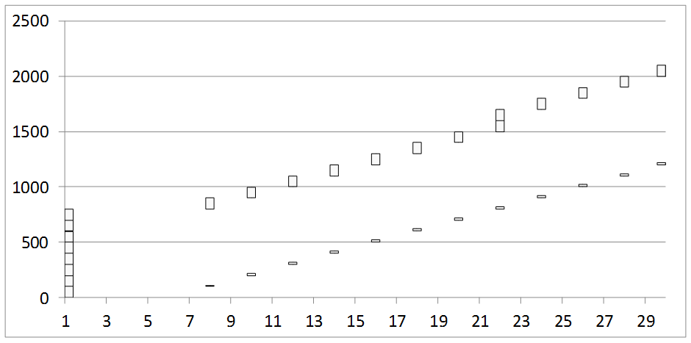

* + 1. What is the round trip time clocked for the first packet? For the fifth packet? For the eighth packet?

Ans: RTT for 1st packet is 7, 5th packet is 15, 8th packet is 21.

* + 1. When is the window size increased to 9?

Ans: Window size is increased to 9 at time 22.

* + 1. Since the buffers are assumed to be large enough, there will be no drops and the window size will keep increasing each time a complete round of acknowledgments for the current window are received. What is the problem with such a scenario?
    2. Suggest a method to trigger a window size reduction in such a scenario, without witnessing any loss events.