**COL-334/CSL-374/CSL-672: Assignment 3, Semester 2014-2015**

1. Show that in a steady state TCP connection working in the congestion avoidance phase, the throughput ~ 1.22 x MSS /(RTT x sqrt(L), where RTT is the round trip time, MSS is the maximum segment size, and L is the loss rate

Note that in the congestion avoidance phase, all losses are assumed to be detected through fast retransmits and not timeouts, hence the congestion window rises additively and falls to half its value in a saw-tooth pattern.

Hint: If N packets are sent between two consecutive packet loss events, assume that the events happen due to the loss of only one packet in each event, hence the loss rate can be written as 1/N.

Solution:

At steady state, **the congestion window grows linearly one packet (1 MSS) per RTT** and when there is a loss event, **congestion window is set to half its previous value.**

We can see this TCP behaviour from the diagram below where STT is the saw tooth time(s), W is the congestion window size.

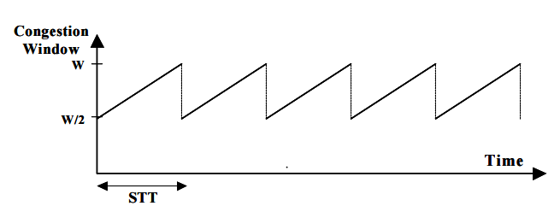

In one STT, we see that the congestion window has gone from W/2 to W. To calculate STT, we would need the slope of the increase in congestion window. Also noting that for TCP, the congestion window is increased by 1 MSS every RTT, we get STT = RTT * (w/2) 🡪 (Eq. 1).

Next we should look into the amount of data which is sent in one STT, which is nothing but the data which is sent in one RTT and in one RTT, the data worth of one congestion window is sent. Average size of the congestion window is 3W/4, so the amount of data sent in one STT is (W/2) * (3W/4) *MSS. 🡪 (Eq. 2)

Average throughput T = (Amt. of the data sent in one STT) / STT

= ((W/2) * (3W/4) *MSS)/ (RTT * (w/2)) = 3W/4 * (MSS/RTT) 🡪 (Eq. 3)

Average packet loss rate (L) is basically how many losses occur per STT. As per the given information, L = 1 / (number of packets sent in STT) = 1 / ((W/2) * (3W/4)). On solving for W, we get W = sqrt (8/3L) 🡪 (Eq.4).

Now substitute W from equation 4 to equation 3. We get average throughput T as a function of MSS, RTT and L i.e.; = 1.22 * MSS / (RTT * sqrt (L)