Software Requirements Specification

Electronics Store Inventory Management System

Field | Entry
Project Title | Electronics Store Inventory Management System
Group Number | Team 8
Project ID | Team 8
Technology Stack | Python (Django), PostgreSQL
Development Methodology | Agile
Version | 1.0 (Approved)
Date Created | 6/09/2026

Team details:
1) Samiksha B N – PES1UG24CS413
2) Roopa Sreedhar A- PES1UG24CS386
3) Rishitth G R – PES1UG24CS376
4) Sakthevel Saravanan – PES1UG24CS405

Table of Contents
Table of Contents 2
Revision History 4
1. Introduction 4
1.1 Purpose 4
1.2 Intended Audience and Reading Suggestions 4
1.3 Product Scope 4
1.4 References 5
2. Overall Description 5
2.1 Product Perspective 5
2.2 Product Functions 5
2.3 User Classes and Characteristics 5
2.4 Operating Environment 6
2.5 Design and Implementation Constraints 6
2.6 Assumptions and Dependencies 6
3. External Interface Requirements 6
3.1 User Interfaces 6
3.2 Software Interfaces 6
3.3 Communications Interfaces 7
4. Analysis Models 7
4.1 Validation Specification – Initial Planning 8
4.2 Project Plan 9
4.3 Tool Stack 9
5. System Features 10
5.1 User Authentication & Role Management (Owner: Member 1) 10
5.1.1 Description and Priority 10
5.1.2 Stimulus/Response Sequences 10
5.1.3 Functional Requirements 10
5.2 Product & Inventory Catalog Management (Owner: Member 2) 10
5.2.1 Description and Priority 10
5.2.2 Stimulus/Response Sequences 10
5.2.3 Functional Requirements 10
5.3 Purchase & Sales Order Handling – Stock In/Out (Owner: Member 3) 11
5.3.1 Description and Priority 11
5.3.2 Stimulus/Response Sequences 11
5.3.3 Functional Requirements 11
5.4 Supplier Management & Reporting (Owner: Member 4) 12
5.4.1 Description and Priority 12
5.4.2 Stimulus/Response Sequences 12
5.4.3 Functional Requirements 12
6. Other Nonfunctional Requirements 12
6.1 Performance Requirements 12
6.2 Safety Requirements 13
6.3 Security Requirements 13
6.4 Software Quality Attributes 13
6.5 Business Rules 13
7. Other Requirements 14
Appendix A: Glossary 14
Appendix B: Field Layouts 14
Appendix C: Requirement Traceability Matrix 15

Revision History
Name | Date | Reason For Changes | Version
Team 8 | 6/09/2026 | Initial draft | 1.0

1. Introduction

1.1 Purpose
This Software Requirements Specification (SRS) defines the functional and non-functional requirements for the Electronics Store Inventory Management System (ESIMS), Version 1.0. The system digitizes stock tracking, purchase and sales recording, supplier management and low-stock alerting for a retail electronics store. This document covers the complete system as a single deliverable; no subsystem is scoped separately.

1.2 Intended Audience and Reading Suggestions
This document is intended for the development team (all four members), the course faculty/evaluators, and any reviewer assessing the project's requirements coverage. Developers should read Sections 3–6 closely before implementation; evaluators may use Section 5 (System Features) and Appendix C (Traceability Matrix) to verify coverage. The document is organized following the standard SRS structure: overall description, interfaces, analysis models, system features, non-functional requirements, and appendices.

1.3 Product Scope
Electronics stores handle a large number of SKUs across categories such as mobiles, accessories, appliances and components, and struggle to track stock levels manually. This leads to overselling, stockouts, delayed reordering, and no visibility into which products are moving fastest. ESIMS provides a digital platform for managing the product catalog, recording purchase (stock-in) and sales (stock-out) transactions, tracking supplier information, generating low-stock alerts, and producing basic operational reports for store staff and administrators.
In Scope / Out of Scope
In Scope | Out of Scope
Staff / Admin login and role-based access | Barcode / QR hardware scanner integration
Product and category management | Multi-store / warehouse transfer management
Stock-in (purchase) recording | Point-of-sale hardware integration
Stock-out (sales) recording | Online customer-facing storefront
Low-stock threshold alerts | Payment gateway integration
Supplier management | Accounting / ERP system integration
Inventory and sales reporting | AI-based demand forecasting
Search and filter inventory | Multi-currency / multi-branch enterprise deployment

1.4 References
• PES University – Jackfruit Mini-Project: Software Engineering Project Guidelines 2026 (UE24CS341A).
• PES University – SE Level 3 Mini-Project Student Submission Guide (Coffee Kiosk Exemplar).
• Approved Project Synopsis – Electronics Store Inventory Management System, v1.0.

2. Overall Description

2.1 Product Perspective
ESIMS is a new, self-contained web application; it does not replace an existing system. It is a single Django-based application with a server-rendered (or API-backed) frontend, a relational database, and role-based access for two internal user classes: Staff and Administrator. The system does not integrate with any external e-commerce or payment platform in this version.

2.2 Product Functions
• User authentication and role-based access control (Staff / Administrator).
• Product and category catalog management (create, edit, disable).
• Stock-in (purchase entry) and stock-out (sales entry) transaction recording.
• Automatic low-stock alert generation based on a configurable reorder threshold.
• Supplier record management.
• Inventory and sales reporting (stock value, top-selling items, low-stock list).
• Search and filter across the product catalog.

2.3 User Classes and Characteristics
User Class | Privileges | Characteristics
Staff | Login; browse/search catalog; record stock-in and stock-out transactions; view low-stock alerts | Non-technical to moderately technical; frequent daily use during business hours
Administrator | All Staff privileges, plus: manage products/categories, manage suppliers, manage staff accounts, view reports | Higher privilege; trained user; less frequent but higher-impact use

2.4 Operating Environment
The system runs as a Django web application deployed on a Linux server, backed by a PostgreSQL database. It is accessed through a standard modern web browser (Chrome, Edge, Firefox) on desktop devices used at the store counter/back office. No native mobile application is planned for this version.

2.5 Design and Implementation Constraints
• Must be implemented using Python (Django) with a relational database (PostgreSQL/SQLite).
• Must follow Agile methodology with sprint-wise delivery, tracked via GitHub Projects.
• Must use Git/GitHub for version control with individual, attributable commits per member.
• Must include automated unit tests and a CI pipeline (GitHub Actions).
• Passwords must be hashed; plaintext storage of credentials is not permitted.

2.6 Assumptions and Dependencies
• It is assumed the store has a single physical location (no multi-branch stock transfer in v1.0).
• It is assumed Staff and Administrator accounts are created internally; there is no public self-registration.
• The system depends on Django's built-in authentication framework for session/user management.
• It is assumed reorder thresholds are set per product by an Administrator and do not change automatically.

3. External Interface Requirements

3.1 User Interfaces
The system provides a web-based interface with two role-driven views: a Staff view (catalog browsing, stock-in/stock-out forms, alerts) and an Administrator view (all Staff screens plus product/category/supplier/user management and reports). Standard elements include a persistent navigation bar, a dashboard summarizing low-stock items, form validation messages, and confirmation dialogs for destructive actions (e.g., disabling a product).

3.2 Software Interfaces
Component | Version / Type | Purpose
Django | 5.x | Backend web framework, ORM, authentication
PostgreSQL | 15.x | Primary relational data store
Django Templates + Bootstrap | Bootstrap 5 | Server-rendered UI
Django REST Framework (optional) | 3.x | API layer if a decoupled frontend is used

3.3 Communications Interfaces
All client-server communication occurs over HTTPS. The system uses standard HTTP request/response cycles for form submissions and page loads; if a REST API is used, JSON is the data-interchange format. No email/SMS notification channel is included in this version; low-stock alerts are surfaced in-app only.

4. Analysis Models
The primary analysis model at this stage is the use case model below, covering all actors and major interactions. An Entity-Relationship model (Product, Category, Supplier, StockTransaction, User) will be developed in the Design phase and referenced from the Requirement Traceability Matrix (Appendix C).
Use Case ID | Use Case | Primary Actor | Precondition | Outcome
UC-01 | Login | Staff / Admin | Valid account exists | Authenticated session
UC-02 | Manage Product Catalog | Administrator | Admin authenticated | Product created/updated/disabled
UC-03 | Manage Categories | Administrator | Admin authenticated | Category created/updated
UC-04 | Record Stock-In (Purchase) | Staff | Logged in; valid supplier | Stock quantity increased
UC-05 | Record Stock-Out (Sale) | Staff | Logged in; sufficient stock | Stock quantity decreased
UC-06 | Search / Browse Inventory | Staff / Admin | Logged in | Matching products displayed
UC-07 | View Low-Stock Alerts | Staff / Admin | Logged in | Alert list displayed
UC-08 | Manage Suppliers | Administrator | Admin authenticated | Supplier created/updated/removed
UC-09 | Generate Reports | Administrator | Admin authenticated | Report displayed/exported
UC-10 | Manage Staff Accounts | Administrator | Admin authenticated | Staff account created/deactivated

Use Case Diagram
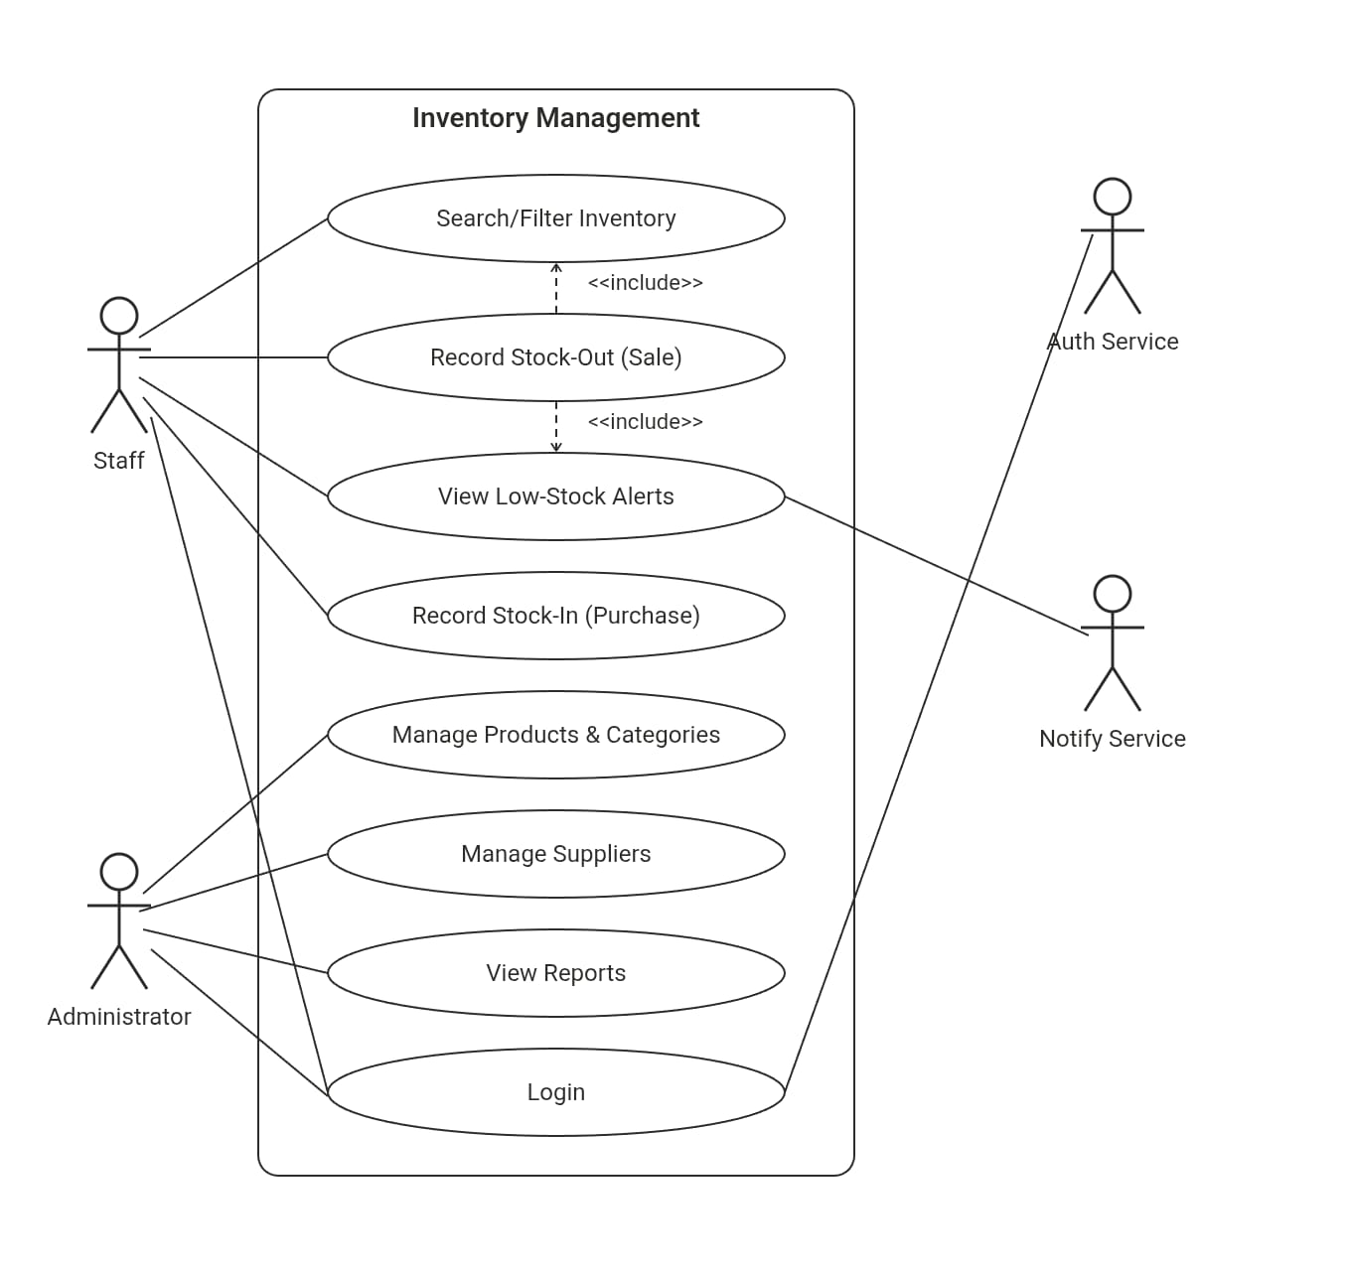

4.1 Validation Specification – Initial Planning
At the requirements stage, the validation specification is planning-focused. It explains how functional, security and non-functional requirements will eventually be validated, including planned penetration/security testing. This stage is not the final test report.
Requirement Category | Planned Validation | Example
Functional | Black-box functional tests | Valid/invalid stock-out transaction
Security | Authentication/authorization + security testing | Staff account attempts an admin-only endpoint
Performance | Load/response-time test | Concurrent catalog search requests
Usability | Task-based walkthrough | Staff completes a stock-in transaction in ≤4 steps
Reliability | Failure/retry scenarios | Duplicate stock-out on form double-submission
Unit | Automated unit tests + coverage | Stock quantity and low-stock threshold calculation

4.2 Project Plan
The project plan identifies and justifies the lifecycle, identifies tools, classifies reuse/build components, and breaks work down into a detailed work breakdown structure (WBS) with effort estimates per member.
Work Package | Tasks | Owner | Estimated Effort (person-days) | Output
WP1 | Requirements + use cases | All | 4 | SRS
WP2 | Architecture + UML | M1/M2 | 4 | Architecture/Design
WP3 | Auth & Role Management module | M1 | 6 | Working feature
WP4 | Product & Inventory Catalog module | M2 | 6 | Working feature
WP5 | Stock In/Out module | M3 | 7 | Working feature
WP6 | Supplier Management & Reporting module | M4 | 7 | Working feature
WP7 | Testing + CI/CD + security | All | 6 | Test/validation evidence
WP8 | Final validation + report | All | 4 | Final report

4.3 Tool Stack
The following tools are used across the project lifecycle for version control, Agile planning, CI/CD, containerization, testing and design.
Activity | Recommended/Example Tool | Evidence to Submit
Version control | Git + GitHub | Repository URL, commit history
Agile planning | Jira / GitHub Projects | Backlog, user stories, sprint board
CI/CD | GitHub Actions | Pipeline screenshot/log
Containerization | Docker | Dockerfile + build/run evidence
Testing | Django test framework / pytest | Test results
Static analysis | SonarQube or similar | Analysis report
API testing | Postman / similar | Collection/results
Design | Draw.io / StarUML / PlantUML | UML diagrams

5. System Features
Features are organized by module, each corresponding to one team member's functional ownership as defined in the project Synopsis.

5.1 User Authentication & Role Management (Owner: Member 1- Roopa Sreedhar A)

5.1.1 Description and Priority
Provides secure login and role-based access control distinguishing Staff from Administrator users. Priority: High.

5.1.2 Stimulus/Response Sequences
User submits login credentials → system validates and creates a session, or returns an error. User navigates to a restricted page → system checks role and grants or denies access.

5.1.3 Functional Requirements
ID | Requirement | Priority | Verification
FR-001 | The system shall allow a user to log in using a unique username/email and password. | High | Functional test
FR-002 | The system shall restrict access to each feature based on the user's assigned role (Staff or Administrator). | High | Authorization test
FR-003 | The system shall allow an Administrator to create, edit, and deactivate Staff accounts. | High | Functional test
FR-004 | The system shall terminate a user's session after a configurable period of inactivity. | Medium | Security test

5.2 Product & Inventory Catalog Management (Owner: Member 2- Sakthevel Saravanan )

5.2.1 Description and Priority
Allows authorized users to maintain the product catalog and view live stock levels. Priority: High.

5.2.2 Stimulus/Response Sequences
Admin submits a new product form → system validates and creates the product record. User enters a search term → system returns matching products with current stock.

5.2.3 Functional Requirements
ID | Requirement | Priority | Verification
FR-005 | The system shall allow an authorized user to add a new product with name, category, SKU, price and initial stock quantity. | High | Functional test
FR-006 | The system shall allow an authorized user to edit product details including price and category. | High | Functional test
FR-007 | The system shall allow an Administrator to disable a product without deleting its historical transaction records. | Medium | Functional test
FR-008 | The system shall allow users to search and filter products by name, category, or SKU. | High | Functional test
FR-009 | The system shall display the current stock quantity for each product in real time. | High | System test

5.3 Purchase & Sales Order Handling – Stock In/Out (Owner: Member 3 – Samiksha B N)

5.3.1 Description and Priority
Core transactional module: records purchases (stock-in) and sales (stock-out), keeping stock counts accurate and consistent. Priority: High.

5.3.2 Stimulus/Response Sequences
Staff submits a stock-in form against a supplier → system increases stock and logs the transaction. Staff submits a stock-out form → system validates available quantity, decreases stock, and logs the transaction, or rejects it if insufficient stock is available.

5.3.3 Functional Requirements
ID | Requirement | Priority | Verification
FR-010 | The system shall allow a Staff member to record a stock-in (purchase) transaction against a registered supplier, increasing product stock. | High | Functional test
FR-011 | The system shall allow a Staff member to record a stock-out (sale) transaction, decreasing product stock. | High | Functional test
FR-012 | The system shall reject a stock-out transaction that would reduce stock below zero. | High | Negative test
FR-013 | The system shall assign a unique transaction ID to every stock-in and stock-out record. | High | Integration test
FR-014 | The system shall maintain an audit trail (user, timestamp, quantity) for every stock transaction. | High | System test

5.4 Supplier Management & Reporting (Owner: Member 4- Rishitth G R)

5.4.1 Description and Priority
Maintains supplier records, generates low-stock alerts, and produces operational reports for the Administrator. Priority: Medium-High.

5.4.2 Stimulus/Response Sequences
Stock level drops below reorder threshold → system generates a low-stock alert automatically. Admin requests a report for a date range → system computes and displays aggregated stock/sales data.

5.4.3 Functional Requirements
ID | Requirement | Priority | Verification
FR-015 | The system shall allow an Administrator to add, edit, and remove supplier records. | Medium | Functional test
FR-016 | The system shall associate each stock-in transaction with a registered supplier. | High | Integration test
FR-017 | The system shall generate a low-stock alert when a product's quantity falls below its configured reorder threshold. | High | System test
FR-018 | The system shall generate a stock/sales report for a specified date range. | Medium | Functional test
FR-019 | The system shall display the top-selling products based on recorded sales transactions. | Low | Functional test

6. Other Nonfunctional Requirements

6.1 Performance Requirements
ID | Category | Measurable Requirement | Verification
NFR-001 | Performance | 95% of catalog search requests shall receive a response within 2 seconds under normal load. | Performance test
NFR-002 | Availability | The application shall be available at least 99% during defined business hours, excluding planned maintenance. | Operational review
NFR-003 | Usability | A Staff member shall be able to complete a stock-in or stock-out transaction in no more than 4 screens/steps. | Usability walkthrough
NFR-004 | Reliability | A stock transaction shall not be recorded twice if a user double-submits the same form. | Negative/integration test
NFR-005 | Maintainability | Business logic shall be separated into distinct Django apps/modules with automated unit tests. | Code review
NFR-006 | Testability | Core services (stock calculation, alert generation) shall be testable independent of the UI layer. | Unit/integration test

6.2 Safety Requirements
As ESIMS is an internal business application with no physical or life-safety impact, no dedicated safety certifications apply. The primary safety-adjacent concern is data integrity: the system shall never allow stock counts to become negative or transactions to be silently lost.

6.3 Security Requirements
ID | Security Requirement | Validation Approach
SEC-001 | Passwords shall not be stored in plaintext (hashed using Django's default password hasher). | Code/configuration review
SEC-002 | Role-based access shall prevent Staff accounts from accessing Administrator-only functions. | Authorization tests
SEC-003 | The system shall validate and sanitize all user-supplied input before processing (e.g., stock quantity fields). | Negative/security tests
SEC-004 | Authenticated sessions shall expire after a defined period of inactivity. | Security test
SEC-005 | Sensitive supplier and pricing data shall not be exposed to unauthenticated users. | Design review
SEC-006 | Security-relevant events (failed logins, unauthorized access attempts) shall be logged. | System test

6.4 Software Quality Attributes
• Maintainability: modules (auth, catalog, transactions, suppliers/reports) shall be loosely coupled Django apps.
• Reusability: stock calculation logic shall be implemented as reusable service functions, not duplicated across views.
• Robustness: the system shall handle invalid or missing form input gracefully with clear error messages.
• Usability: the interface shall favor consistency – the same layout and action patterns across catalog, stock, and supplier screens.

6.5 Business Rules
• Only products marked "active" can be included in a new stock-out (sale) transaction.
• A stock-out transaction cannot exceed the currently available stock quantity for a product.
• Only Administrators can add, edit, or remove suppliers and categories.
• Only Administrators can deactivate a product or a Staff account.
• Every stock transaction must be linked to a valid, active product.
• A low-stock alert is generated automatically and cannot be manually suppressed by Staff.

7. Other Requirements
• Database requirements: all stock transactions must be retained indefinitely for audit purposes (no hard deletes); products are soft-deleted (disabled) rather than removed.
• Legal/compliance: no personally identifiable customer data is collected in this version, limiting data-protection scope to staff account credentials.
• Reuse objectives: Django's built-in admin, auth, and ORM are reused wherever possible instead of custom-built equivalents.
• Localization: currency is assumed to be INR (₹) for this version; no multi-currency support is required.

Appendix A: Glossary
Term | Definition
SKU | Stock Keeping Unit – a unique identifier for a distinct product/variant.
Stock-in | A transaction that increases a product's recorded stock quantity (a purchase from a supplier).
Stock-out | A transaction that decreases a product's recorded stock quantity (a sale).
Reorder threshold | The minimum stock quantity below which a low-stock alert is triggered.
RBAC | Role-Based Access Control – restricting system functions based on a user's assigned role.
Administrator | A user role with full privileges, including catalog, supplier and staff-account management.
Staff | A user role limited to day-to-day catalog viewing and stock transaction recording.

Appendix B: Field Layouts
Sample field layout for the Product entity:
Field | Length | Data Type | Description | Mandatory
product_id | 36 | UUID/String | Unique product identifier | Y
sku | 50 | String | Stock Keeping Unit code | Y
product_name | 150 | String | Display name of the product | Y
category_id | 36 | UUID/String | Reference to product category | Y
price | 10,2 | Decimal | Current selling price | Y
quantity_in_stock | 10 | Integer | Current available stock quantity | Y
reorder_threshold | 10 | Integer | Minimum quantity before a low-stock alert fires | Y
supplier_id | 36 | UUID/String | Reference to the associated supplier | N
status | 20 | Enum/String | active / disabled | Y

Sample report field requirements:
Stock Report | Sales Report
Product Name | Transaction Reference Number
SKU | Product Name
Category | Quantity Sold
Current Stock | Sale Amount
Reorder Threshold | Transaction Date
Stock Value (Qty × Price) | Staff Member

Appendix C: Requirement Traceability Matrix
Architecture and design references will be finalized during the Design phase (Deliverable 3); the entries below show the planned mapping to be completed once modules are implemented.
Req ID | Brief Description | Architecture Ref | Design Ref | Code/File Ref | Test Case ID | System Test ID
FR-001 | User login | AUTH-01 | TBD | auth_service.* | UT-AUTH-01 | ST-AUTH-01
FR-005 | Add product | CATALOG-01 | TBD | catalog_service.* | UT-CAT-01 | ST-CAT-01
FR-010 | Record stock-in | STOCK-01 | TBD | stock_service.* | IT-STOCK-01 | ST-STOCK-01
FR-012 | Reject over-sale | STOCK-02 | TBD | stock_service.* | UT-STOCK-02 | ST-STOCK-02
FR-017 | Low-stock alert | REPORT-01 | TBD | alert_service.* | UT-ALERT-01 | ST-ALERT-01
SEC-002 | Role-based access | AUTH-02 | TBD | middleware/auth.* | UT-SEC-01 | ST-SEC-01
NFR-001 | Search response time | API layer | TBD | deployment config | PERF-01 | ST-PERF-01

