PES UNIVERSITY, BANGALORE
Department of Computer Science and Engineering
Software Engineering (UE24CS341A) - Phase 3: Testing and Validation
Code and Branch Coverage Report
Line and branch coverage of the authentication module
Project | Electronics Store Inventory Management System (ESIMS)
Group / Project ID | Team 8
Module covered | Authentication, security and project setup (stories ESIMS-01 to ESIMS-09)
Prepared by | Roopa Sreedhar A(Member 1, Authentication) – SRN:PES1UG24CS386
Date | 06-11-2026
Version | 1.0
Repository / version tested | SE_ESIMS_Project_2026, main branch (after the Sprint 2 merge)

1. Purpose
Code (line) coverage shows which statements of the module were executed by the automated tests. Branch coverage shows how many decision outcomes (for example both the true and the false side of an if) were executed. A line can be covered while one of its branches is never taken, so both measures are reported together.

2. Tool, scope and commands
- Tool: coverage.py with branch measurement enabled (--branch).
- Included: accounts/* and esims/validation.py. Excluded: test files, migrations, and the catalog, suppliers, transactions and reports modules (covered by their owners).
- Tests run: 144 (accounts module), all passed.
coverage erase
coverage run --branch --include="accounts/*,esims/validation.py" --omit="accounts/test*,accounts/migrations/*" manage.py test accounts
coverage report -m
coverage html -d docs\reports\coverage_html
coverage json -o docs\reports\coverage.json

3. Summary
Measure | Value
Total statements / missed | 365 / 10
Line coverage | 97.3 %
Total branches / partially covered | 62 / 7
Branch coverage | 88.7 %
Combined line + branch coverage (coverage report TOTAL) | 96 %
Line % = (statements - missed) / statements. Branch % = covered branches / total branches (55 of 62). The combined figure is the TOTAL line of coverage report -m.

4. Coverage by file
File | Stmts | Miss | Line % | Branches | Partial | Branch % | Combined
accounts/admin.py | 20 | 3 | 85.0 | 0 | 0 | n/a | 85 %
accounts/apps.py | 6 | 0 | 100.0 | 0 | 0 | n/a | 100 %
accounts/backends.py | 16 | 2 | 87.5 | 8 | 2 | 75.0 | 83 %
accounts/forms.py | 53 | 1 | 98.1 | 10 | 2 | 80.0 | 95 %
accounts/management/commands/seed_demo_users.py | 44 | 0 | 100.0 | 12 | 0 | 100.0 | 100 %
accounts/mixins.py | 4 | 0 | 100.0 | 0 | 0 | n/a | 100 %
accounts/models.py | 36 | 0 | 100.0 | 2 | 0 | 100.0 | 100 %
accounts/security.py | 22 | 1 | 95.5 | 4 | 1 | 75.0 | 92 %
accounts/signals.py | 14 | 0 | 100.0 | 2 | 1 | 50.0 | 94 %
accounts/urls.py | 5 | 0 | 100.0 | 0 | 0 | n/a | 100 %
accounts/views.py | 90 | 1 | 98.9 | 6 | 1 | 83.3 | 98 %
esims/validation.py | 55 | 2 | 96.4 | 18 | 0 | 100.0 | 97 %
TOTAL | 365 | 10 | 97.3 | 62 | 7 | 88.7 | 96 %
Per-file branch % assumes one missing exit for each partially covered branch point; coverage.json and the HTML report give the exact values. The combined column is rounded like the TOTAL column of coverage report -m.

5. Evidence
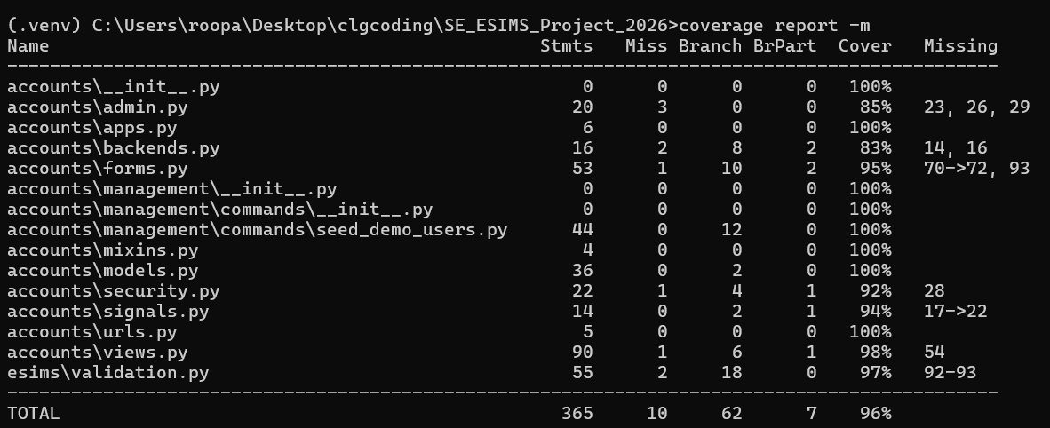
Figure 2: Terminal output of coverage report -m showing the TOTAL of 96 %
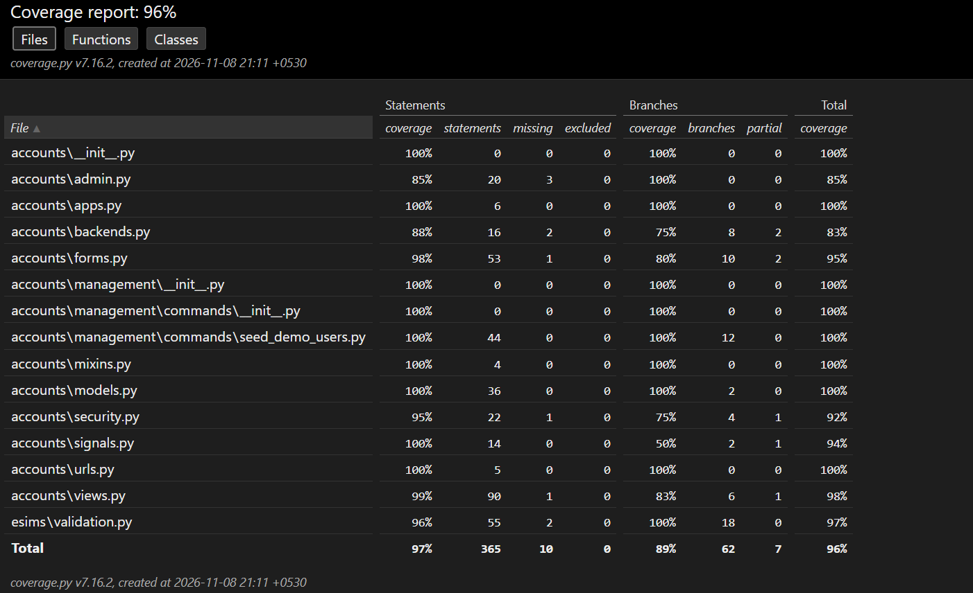
Figure 3: Coverage HTML report (index.html) listing coverage per file
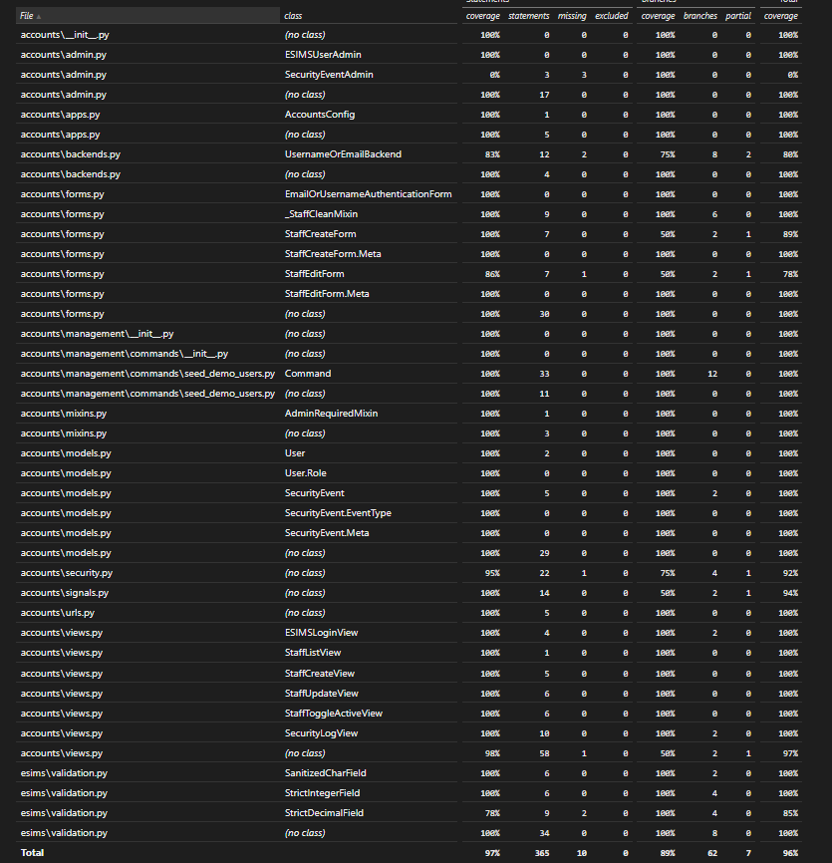
Figure 4: Coverage HTML report with the Branch and Partial columns shown

6. Analysis of uncovered code
File | Not covered | Reason
accounts/admin.py | Lines 23, 26, 29 | Read-only permission methods of the Security Event admin page, never called by the tests
accounts/backends.py | Lines 14, 16 | Fallback when no username is passed and the empty-input early return; the login form never sends these
accounts/forms.py | Line 93; branch 70->72 | Duplicate-username error on the edit form; save(commit=False) on the create form
accounts/security.py | Line 28 | Defensive branch for a user object with no saved id
accounts/signals.py | Branch 17->22 | Failed-login signal with an empty username; the form blocks blank usernames earlier
accounts/views.py | Line 54 | 403 handler for an anonymous visitor (anonymous users are normally redirected to login)
esims/validation.py | Lines 92-93 | Defensive InvalidOperation handler that the digit check makes unreachable

All uncovered lines and branches are defensive or error-handling paths that normal use and the form validation prevent from happening. No functional requirement depends on them.

7. Conclusion
The authentication module reached 97.3 % line coverage and 88.7 % branch coverage (96 % combined) with 144 passing tests. Every requirement FR-001 to FR-004 and SEC-001 to SEC-006 has tests exercising its main and failure paths, and the uncovered paths are limited to defensive code.

