PES UNIVERSITY, BANGALORE
Department of Computer Science and Engineering
Software Engineering (UE24CS341A) - Phase 3: Testing and Validation
System Validation Report
Authentication, security and project setup module
Project | Electronics Store Inventory Management System (ESIMS)
Group / Project ID | Team 8
Module covered | Authentication, security and project setup (stories ESIMS-01 to ESIMS-09)
Prepared by | Roopa (Member 1, Authentication) - SRN: PES1UG24CS386
Date | 06-11-2026
Version | 1.0
Repository / version tested | SE_ESIMS_Project_2026, main branch (after the Sprint 2 merge)

1. Introduction
This report records the system-level validation of the Authentication, security and project setup module against the Software Requirements Specification (FR-001 to FR-004, SEC-001 to SEC-006) and the Software Test Plan v1.0. It covers functional and black-box testing through the web interface, white-box evidence (coverage), security validation, and non-functional checks.

2. Validation environment
Operating system | Windows 11
Python version | 3.12.4
Django version | 5.2.18
Database | PostgreSQL 16 (application / manual tests). The automated test run used Django's in-memory SQLite test database (see the test log).
Test runner | Django test runner (python manage.py test)
Coverage tool | coverage.py, branch measurement on (--branch)
Browser (manual tests) | Chrome
Execution date | 06-11-2026
Test data: demo users created with python manage.py seed_demo_users (admin, manager, staff1, staff2, inactive_staff; see docs/SEED_USERS.md).

3. Validation summary
Validation area | Activity | Result | Evidence
Functional | Execute all critical use cases: login, role access, staff management, session timeout | Pass. All critical use cases executed; defects found earlier were fixed and retested (section 9). | Section 4; Figs 6-16
Black-box | Test through the user interface with valid, invalid and boundary input | Pass. Actual matched expected in all 11 manual cases. | Section 4
White-box | Run the automated suite with line and branch coverage | Line 97.3 %, branch 88.7 % (96 % combined) | Section 5; Figs 2-4
Security | Authentication, authorization, input validation, session expiry, logging | Pass. No open findings; two input-handling defects fixed (BUG-01, BUG-02). | Section 6; Fig 5
Performance | No login response-time requirement in the SRS (NFR-001 covers catalog search, owned by the catalog module) | Not applicable to this module | Section 7
Usability | Login and staff-account creation each need a single form | Pass | Section 7; Figs 6, 8
Reliability | Session expiry, logging failure handling, deactivated user with open session | Pass (IT-SEC-19, IT-AUTH-41, ST-AUTH-02) | Section 7

4. Functional and black-box validation (manual system tests)
Each case from the Test Case Document was executed on 06-11-2026 and one screenshot was taken per case (figure numbers below).
Test ID / Req | Steps / test data | Expected result | Actual result | Result | Fig.
ST-AUTH-03  FR-001 | Seed users created (python manage.py seed_demo_users); server running  1) log in as staff1 / Staff@12345 2) log out, log in as staff1@esims.local 3) log in with wrong password | 1) dashboard 2) dashboard 3) red error message, stays on login page | As expected | Pass | 6
ST-AUTH-01  FR-002 / SEC-002 | Seed users created; logged in as staff1  Open /staff/ then /security-log/ in the address bar | Access-denied (403) page for both; admin links not visible in menu/dashboard | As expected | Pass | 7
ST-AUTH-04  FR-003 | Logged in as manager / Admin@12345  Manage Staff > + New Staff (fill form) > Edit > Deactivate > try login as that user > Activate > login again | Each step succeeds; deactivated user is refused; reactivated user can log in | As expected | Pass | 8
ST-AUTH-02  FR-004 / SEC-004 | Server started with SESSION_TIMEOUT_SECONDS=20 set in the same terminal; logged in  Log in, wait 20+ seconds, click any link | Redirected to login page; must log in again | As expected | Pass | 9
ST-SEC-04  SEC-004 | As ST-AUTH-02  After timeout, press browser Back / reload an old page, try /staff/ as admin | Every request asks for login again; no data shown from the expired session | As expected | Pass | 10
ST-SEC-01  SEC-001 | Seed users created  Run: python manage.py shell -c "from accounts.models import User; print(User.objects.first().password[:25])" | Output starts with pbkdf2_sha256$ (hash, not plaintext) | As expected | Pass | 11
ST-SEC-02  SEC-002 | Logged in as staff1  Open /staff/new/, /staff/<id>/edit/, /security-log/ directly in the address bar | 403 for each; each attempt appears in /security-log/ (as admin) | As expected | Pass | 12
ST-SEC-03  SEC-003 | Logged in as manager; also stock forms as staff1  Staff create form: <script> as username, <b>x</b> as first name, duplicate email in different case. Stock-out form: quantity -5, abc, 1e3 | Username rejected; first name saved without tags; duplicate rejected; bad quantities rejected; no stock change | As expected | Pass | 13
ST-SEC-05  SEC-005 | Logged out  Open /, /staff/, /security-log/, /transactions/ directly | Each redirects to the login page; no protected data visible | As expected | Pass | 14
ST-SEC-06  SEC-006 | Seed users created  1) 3 wrong passwords for staff1 2) as staff1 open /staff/ 3) log in as manager, open /security-log/ | Log shows 3 Failed login rows and 1 Unauthorized access row with user, IP and time; no password visible | As expected | Pass | 15
ST-AUTH-05  Dev utility (supports FR-001) | Seed run; server running  Log in as admin, manager, staff1, staff2, inactive_staff using the passwords in docs/SEED_USERS.md | admin, manager, staff1, staff2 succeed; inactive_staff refused | As expected | Pass | 16

5. White-box validation
The automated suite was run with coverage.py and branch measurement. Details are in the Code and Branch Coverage Report.
Measure | Value
Automated tests executed / passed | 144 / 144
Line coverage (accounts + esims/validation.py) | 97.3 % (355 of 365 statements)
Branch coverage | 88.7 % (55 of 62 branches); 96 % combined
Code review findings | None blocking; uncovered code is defensive error handling

6. Security validation
Req | Validation activity | Test cases | Result | Findings / remediation
SEC-001 | Stored passwords are hashes, never plaintext | UT-SEC-01..03, IT-SEC-01, ST-SEC-01 | Pass | None. Django PBKDF2 hasher in use.
SEC-002 | Staff blocked from every admin-only URL and action | IT-AUTH-10, 13, 18, IT-SEC-03/04, ST-SEC-02, ST-AUTH-01 | Pass | None. A guard test fails if a new URL is not classified.
SEC-003 | Invalid, oversized and malformed input rejected or sanitized | UT-SEC-04..16, IT-SEC-05..07, ST-SEC-03 | Pass | BUG-01 (case-insensitive duplicates) fixed.
SEC-004 | Idle sessions expire; expired session needs login | UT-AUTH-08..10, IT-AUTH-46..49, ST-AUTH-02, ST-SEC-04 | Pass | BUG-03 (.env not read) documented.
SEC-005 | Protected pages inaccessible without login | IT-SEC-08, IT-AUTH-14, ST-SEC-05 | Pass | None.
SEC-006 | Failed logins and unauthorized access logged with user, IP, time | IT-SEC-09..34, ST-SEC-06 | Pass | BUG-02 (form-rejected logins not logged) fixed.

Static security scan
bandit -r accounts esims -ll -f txt -o docs\reports\security_scan_bandit.txt
Severity (medium and above) | Issues found | Open | Comment
High | 0 | 0 | None reported
Medium | 0 | 0 | None reported

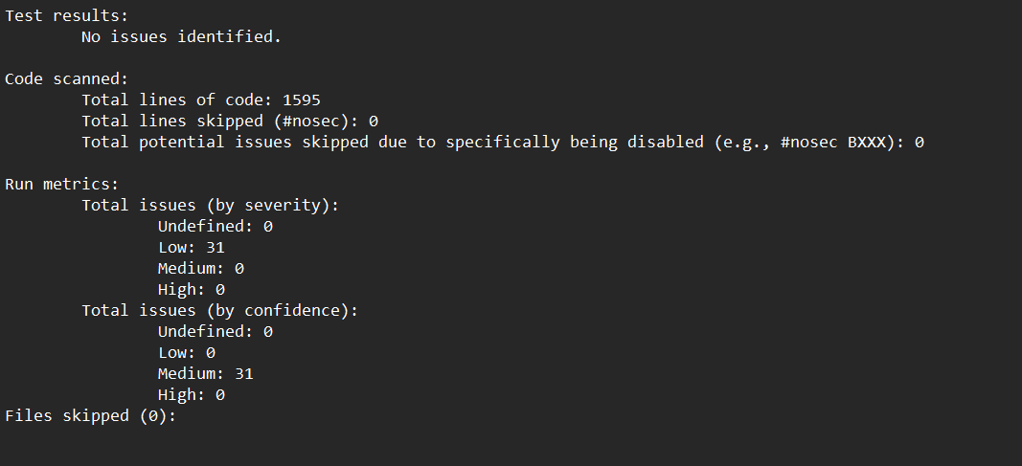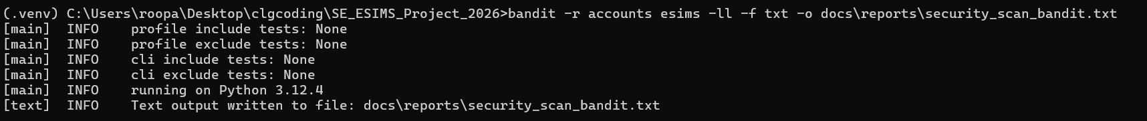
Figure 5: Output of the static security scan (bandit)

7. Non-functional validation
Req | Requirement | Verification | Result | Evidence
NFR-005 | Business logic separated into distinct Django apps with automated unit tests | Code review: apps accounts, catalog, suppliers, transactions, reports; 144 automated tests in accounts | Pass | Unit Test Report
NFR-006 | Core services testable independent of the UI | Unit tests call forms, backend, validators and services without a browser | Pass | Unit Test Report
FR-004 | Session timeout configurable | Set SESSION_TIMEOUT_SECONDS=20, observe logout (ST-AUTH-02) | Pass | Fig. 9
Perf. | No login response-time requirement in the SRS (NFR-001 is catalog search) | Not applicable to this module | N/A | -
Usability | No usability requirement for authentication (NFR-003 covers stock transactions) | Login and staff creation each use a single form | Pass | Figs 6, 8
Reliability | Logging failure never breaks the login page; deactivation ends open sessions | IT-SEC-19, IT-AUTH-41 | Pass | Unit Test Report

8. Final requirements traceability
Req | Description | Test case IDs | System tests | Verified
FR-001 | User login with username/email + password | UT-AUTH-01..04, IT-AUTH-01..08 | ST-AUTH-03, ST-AUTH-05 | Yes
FR-002 | Features restricted by role (Staff / Administrator) | UT-AUTH-05..07, IT-AUTH-09..22 | ST-AUTH-01 | Yes
FR-003 | Administrator creates, edits, deactivates Staff accounts (UC-10) | IT-AUTH-23..44 | ST-AUTH-04 | Yes
FR-004 | Session ends after configurable inactivity | UT-AUTH-08..13, IT-AUTH-45..49 | ST-AUTH-02 | Yes
SEC-001 | Passwords hashed, never plaintext | UT-SEC-01..03, IT-SEC-01, IT-SEC-02, IT-AUTH-23, IT-AUTH-30 | ST-SEC-01 | Yes
SEC-002 | Staff cannot use Administrator functions | IT-AUTH-10, IT-AUTH-13, IT-AUTH-18, IT-AUTH-25, IT-SEC-03, IT-SEC-04, IT-SEC-33 | ST-SEC-02, ST-AUTH-01 | Yes
SEC-003 | User input validated and sanitized | UT-SEC-04..16, IT-SEC-05..07, IT-AUTH-06..08 | ST-SEC-03 | Yes
SEC-004 | Authenticated sessions expire after inactivity | UT-AUTH-08..10, IT-AUTH-46..49 | ST-AUTH-02, ST-SEC-04 | Yes
SEC-005 | Sensitive data not exposed to unauthenticated users | IT-SEC-08, IT-AUTH-14, IT-AUTH-17 | ST-SEC-05 | Yes
SEC-006 | Failed logins and unauthorized access attempts logged | IT-SEC-09..34, UT-SEC-17..19 | ST-SEC-06 | Yes

9. Defect summary
Defect ID | Severity | Description | Root cause | Fix | Retest
BUG-01 | Medium | Two Staff accounts could differ only in the case of the email or username (Bob@x.com and bob@x.com). Login looks both up case-insensitively, so login was ambiguous. | Database uniqueness is case-sensitive. | Case-insensitive duplicate checks added to the staff create and edit forms (IT-AUTH-27, 28, 35). | Pass
BUG-02 | Medium | Login attempts rejected by the form before authentication (null bytes, over-long usernames) were not written to the security log. | The failed-login signal only fires after authenticate() runs. | LoginView.form_invalid now logs these attempts as LOGIN_FAILED (IT-SEC-16). | Pass
BUG-03 | Low | SESSION_TIMEOUT_SECONDS set in a .env file had no effect, so the first session-timeout manual test did not log the user out. | Django does not read .env files; the value comes from the process environment. | Documented: set the variable in the terminal before runserver. ST-AUTH-02 re-run. | Pass

10. Screenshot index
Figure | What it shows | Related test / report
1 | Unit test run summary | Unit Test Report
2 | coverage report -m in the terminal | Code and Branch Coverage Report
3 | Coverage HTML report index | Code and Branch Coverage Report
4 | Coverage HTML report with branch columns | Code and Branch Coverage Report
5 | bandit security scan | Section 6
6 | Browser login: username, email, wrong password | ST-AUTH-03
7 | Browser: Staff opens admin pages | ST-AUTH-01
8 | Browser: create, edit, deactivate, reactivate Staff | ST-AUTH-04
9 | Browser: idle timeout | ST-AUTH-02
10 | Browser: reuse of an expired session | ST-SEC-04
11 | Inspect stored credential | ST-SEC-01
12 | Staff attempts admin-only functions | ST-SEC-02
13 | Browser: malformed input | ST-SEC-03
14 | Browser: unauthenticated access | ST-SEC-05
15 | Browser: failed logins and 403s are logged | ST-SEC-06
16 | Browser: every seeded login | ST-AUTH-05

11. Conclusion and sign-off
All 11 manual system tests and all 144 automated tests passed. FR-001 to FR-004 and SEC-001 to SEC-006 are verified for the authentication module, the traceability matrix is complete, and no defects are open. Line coverage is 97.3 % and branch coverage 88.7 %.
Role | Name | Signature | Date
Test owner (Authentication) | Roopa |  | 06-11-2026
Faculty / reviewer

