ADB CHAPTER 6
Q.1 Define Data Mining [3]
Ans:
- The process of discovering patterns, correlations, and insights from large sets of data.
- The primary goal is to extract useful information that can aid in decision-making.
- Involves applying algorithms and techniques to find hidden patterns or trends in the data.
- It includes tasks like classification, clustering, association, and prediction.
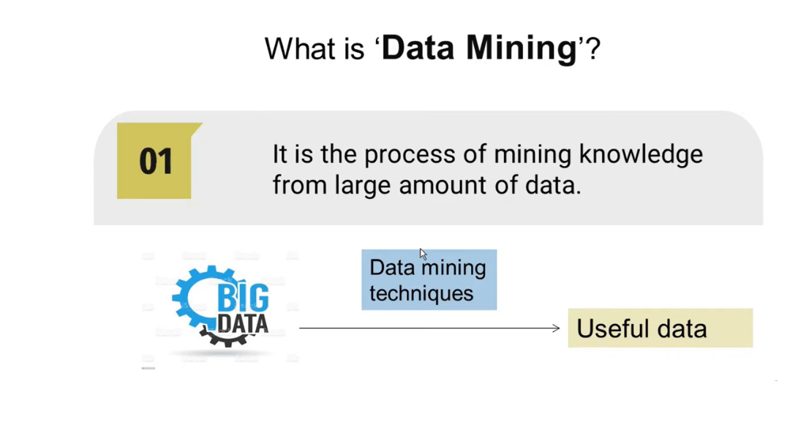
Q.2 Explain KDD process [4/6]
Ans:
THE KDD PROCESS
Step 1: Define Business Objectives.
- This step is similar to any information system project. First of all, determine whether you really need a data mining solution. State your objectives. Are you looking to improve your direct marketing campaigns? Do you want to detect fraud in credit card usage? Are you looking for associations between products that sell together?
- In this step, define expectations.
- Express how the final results will be presented and used in the operational systems
Step 2: Prepare Data.
This step consists of data selection, preprocessing of data, and data transformation.
a) Data Selection: Select the data to be extracted from the data warehouse. Use the business objectives to determine what data has to be selected. Include appropriate metadata about the selected data.
b) Preprocessing: Preprocessing is meant to improve the quality of selected data. When you select from the data warehouse, it is assumed that the data is already cleansed. Preprocessing could also involve enriching the selected data with external data. In the preprocessing substep, remove noisy data, that is, data clearly out of range. Also ensure that there are no missing values.
c) Data transformation: if the data for mining is selected from the data warehouse, it is again assumed that all the necessary data transformations have already been completed
Step 3: Perform Data Mining.
- this is the crucial step. The knowledge discovery engine applies the selected algorithm to the prepared data.
- The output from this step is a set of relationships or patterns. However, this step and the next step of evaluation may be performed in an iterative manner.
- After an initial evaluation, you may adjust the data and redo this step. The duration and intensity of this step depend on the type of data mining application.
- If you are segmenting the database, not too many iterations are needed. If you are creating a predictive model, the models are repeatedly set up and tested with sample data before testing with the real database
Step 4: Evaluate Results.
- You are actually seeking interesting patterns or relationships. These help you in the understanding of your customers, products, profits, and markets.
- In the selected data, there are potentially many patterns or relationships. In this step, you examine all the resulting patterns.
- You will apply a filtering mechanism and select only the promising patterns to be presented and applied.
- Again, this step also depends on the specific kind of data mining algorithm applied
Step 5: Present Discoveries.
- Presentation of knowledge discoveries may be in the form of visual navigation, charts, graphs, or free-form texts.
- Presentation also includes storing of interesting discoveries in the knowledge base for repeated use.
Step 6: Incorporate Usage of Discoveries.
- The goal of any data mining operation is to understand the business, discover new patterns and possibilities, and also turn this understanding into actions.
- This step is for using the results to create actionable items in the business. You assemble the results of the discovery in the best way so that they can be exploited to improve the quality of the business.

Q.3 Compare data mining and data warehouse [3/4/6]
Ans:

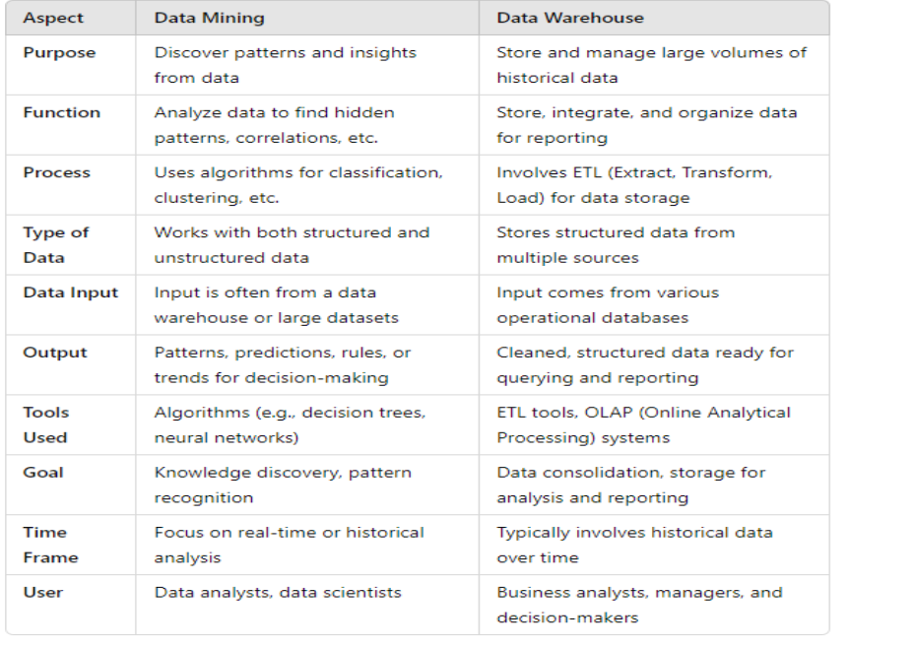
Q.4 Compare various data mining technique [4/6]
Ans:
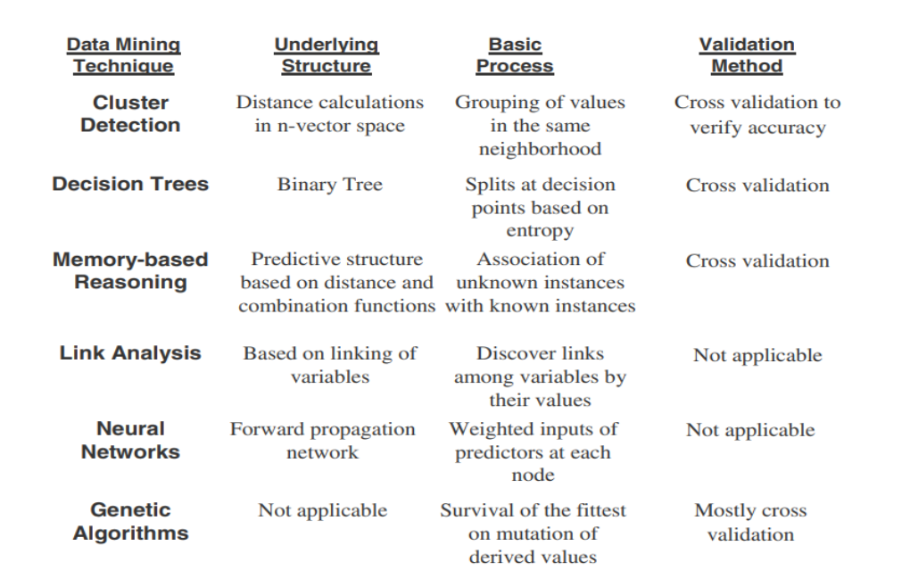

Q.5 Describe major techniques in data mining [4/6/8]
Ans:
MAJOR TECHNIQUES IN DATA MINING:
- Cluster Detection:
- Decision Trees:
- Memory-Based Reasoning (MBR):
- Link Analysis:
- Association Discovery:
- Data Visualization:
- Neural Networks:
- Genetic Algorithms:
1. Cluster Detection:
- Cluster detection groups similar data points based on certain features or characteristics without prior knowledge of categories.
- It identifies patterns and structures in large datasets by finding clusters where data points in the same group are more similar to each other than to those in other groups.
Example:
- In market segmentation, a retail company might use clustering to divide customers into groups based on purchasing habits.
- For instance, one group might contain high-spending customers who purchase luxury items, while another group consists of low-spending customers who focus on discounted items.
- Techniques like k-means clustering help identify these groups.
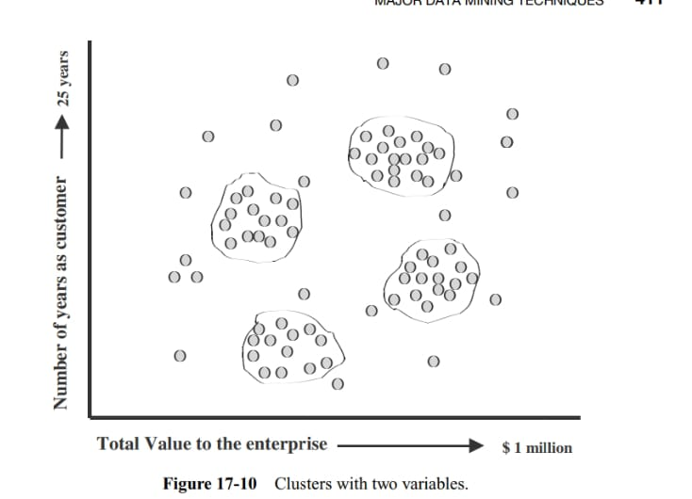
2. Decision Trees:
- Decision trees are a supervised learning technique used for classification and regression tasks.
- It breaks down a dataset into smaller subsets while developing a tree structure.
- At each node, a decision is made based on a feature's value, eventually leading to a final decision or prediction at the leaves.
Example:
- Imagine you're trying to predict whether a student will pass or fail based on hours studied and attendance.
- The decision tree might ask, "Did the student attend more than 80% of classes?" If yes, "Did they study more than 10 hours?"
- These decisions lead to either a "pass" or "fail" outcome.
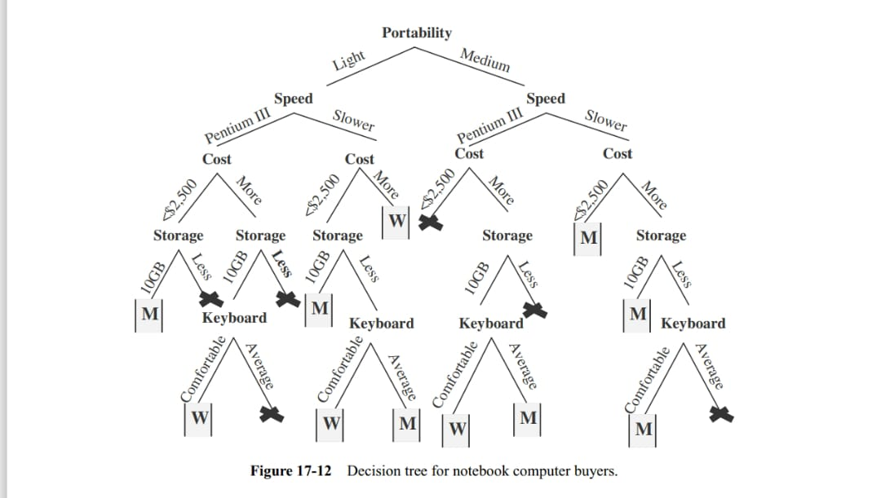
(ISME YEH ABOVE EXAMPLE PASS FAIL KA DECISION TREE BANALENA)
3. Memory-Based Reasoning (MBR):
- Also known as instance-based learning, memory-based reasoning uses specific past examples or instances to make predictions for new data.
- Instead of creating a model, it compares new cases to historical examples.
- The k-nearest neighbor (KNN) algorithm is a classic method here.
Example:
- In a recommendation system for movies, if a user has watched certain genres, MBR might suggest movies based on what similar users have watched.
- For instance, if User A and User B have similar tastes, and User B likes a particular movie that User A hasn't seen, that movie might be recommended to User A.
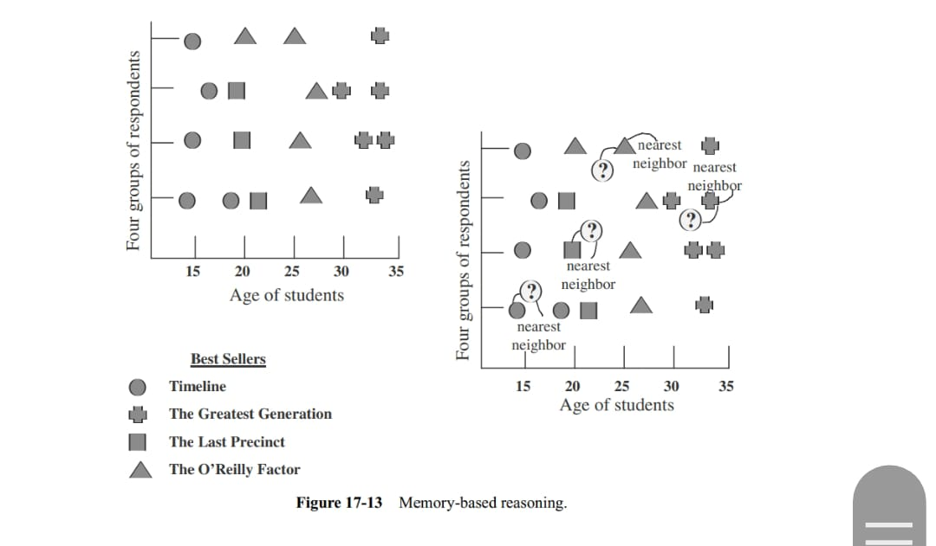
4. Link Analysis:
- Link analysis examines relationships and connections between data points, often represented as a network or graph.
- It’s widely used in web search algorithms, social networks, and fraud detection to identify patterns or strong relationships between entities.
Example:
- In social networks like Facebook, link analysis can be used to detect communities or clusters of users who frequently interact with each other.
- It’s also applied in PageRank, the algorithm Google uses to rank web pages based on their links to one another.
5. Association Discovery:
- Association discovery finds relationships between variables in large datasets.
- It is primarily used to find frequent itemsets or associations in transactional datasets, such as market baskets.
- Apriori and FP-Growth (Frequent Pattern) are commonly used algorithms.
Example:
- In retail, a supermarket may use association rule mining to discover that customers who buy bread are likely to also buy butter.
- The rule might be: "If bread is purchased, there's a 60% chance butter will also be purchased."
- This insight can help with product placement and promotions.
6. Data Visualization:
- Data visualization involves representing data in graphical form to make it easier to understand patterns, trends, and insights.
- Common tools include bar charts, pie charts, scatter plots, and heatmaps.
Example:
- In a sales report, a bar chart might be used to compare the monthly revenue for different products, helping managers easily see which product performs the best over time.
7. Neural Networks:
- Neural networks are inspired by the human brain and are used in deep learning for tasks such as classification, regression, and pattern recognition.
- They consist of layers of interconnected nodes (neurons) that process input data to produce outputs.
Example:
- Neural networks are widely used in image recognition.
- For instance, a neural network trained on thousands of labeled images can learn to recognize whether an image contains a cat by adjusting weights and biases between neurons until it predicts the correct label with high accuracy.
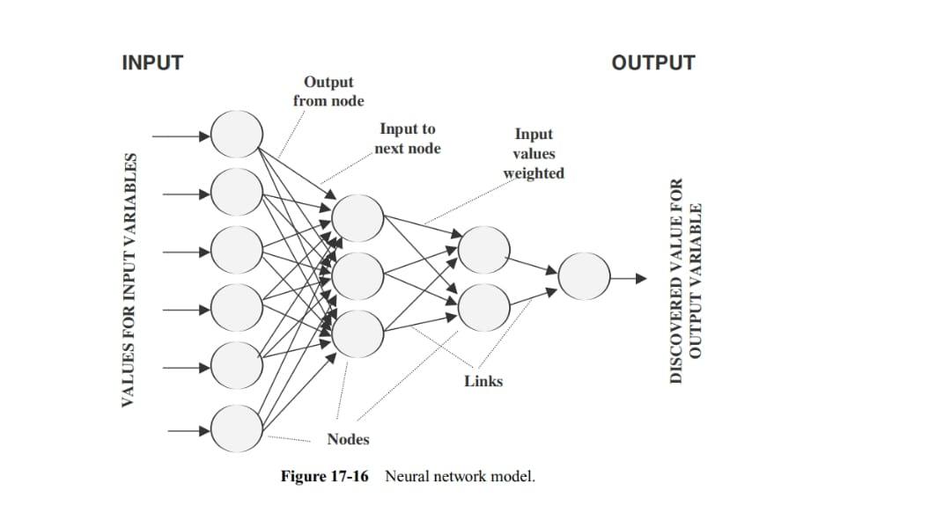
8. Genetic Algorithms:
- Genetic algorithms (GA) are optimization techniques based on the principles of natural selection and genetics.
- They iteratively evolve a population of solutions by applying selection, crossover, and mutation to find the best solutions.
Example:
- In engineering design, a genetic algorithm might be used to optimize the design of an aircraft wing by testing various configurations, evolving the best ones, and finally producing the most efficient design based on aerodynamic performance.
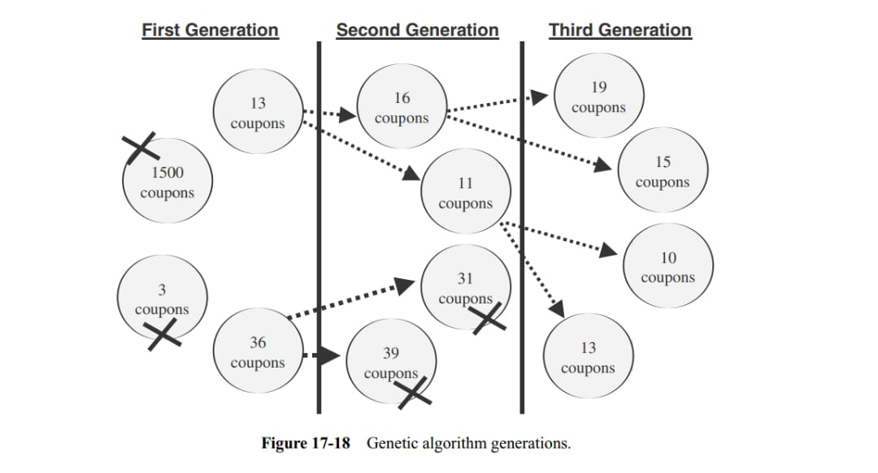
Q.6 Describe issues in data mining [4/6/8]
Ans:
1. Data Access:
- The data mining tool must be able to access data sources such as the data warehouse and quickly bring over the required datasets to its environment.
- On many occasions you may need data from other sources to augment the data extracted from the data warehouse.
- The tool must be capable of reading other data sources and input formats.
2. Data Selection:
- While selecting and extracting data for mining, the tool must be able to perform its operations according to a variety of criteria.
- Selection abilities must include filtering out of unwanted data and deriving new data items from existing ones.
3. Sensitivity to Data Quality:
- Because of its importance, data quality is worth mentioning again.
- The data mining tool must be sensitive to the quality of the data it mines.
- The tool must be able to recognize missing or incomplete data and compensate for the problem.
- The tool must also be able to produce error reports.
4. Data Visualization:
- Data mining techniques process substantial data volumes and produce a wide range of results.
- Inability to display results graphically and diagrammatically diminishes the value of the tool severely.
- Select tools with good data visualization capabilities
5.Extensibility:
- The tool architecture must be able to integrate with the data warehouse administration and other functions such as data extraction and metadata management.
6.Performance:
- The tool must provide consistent performance irrespective of the amount of data to be mined, the specific algorithm applied, the number of variables specified, and the level of accuracy demanded.
7. Scalability:
- Data mining needs to work with large volumes of data to discover meaningful and useful patterns and relationships.
- Therefore, ensure that the tool scales up to handle huge data volumes.
8. Suite of Algorithms:
- Select a tool that provides a few different algorithms rather than one that supports only a single data mining algorithm.
9. Openness:
- This is a desirable feature. Openness refers to being able to integrate with the environment and other types of tools.
- Look for the ability of the tool to connect to external applications where users could gain access to data mining algorithms from other applications.
- The tool must be able to share the output with desktop tools such as graphical displays, spreadsheets, and database utilities.
- The feature of openness must also include availability of the tool on leading server platforms.

Q.7 Applications of data mining [individually 3/4]
Ans:
i) Applications in Retail industry
In the retail industry, data mining plays a crucial role in improving operations and decision-making. Key applications include:
- Customer Segmentation: Data mining tools cluster customers based on purchasing behavior, helping retailers target specific segments with personalized promotions and direct marketing.
- Market Basket Analysis: Link analysis identifies product affinities, allowing retailers to optimize product placements and promote items that frequently sell together.
- Inventory Management: Predictive algorithms help retailers manage stock by analyzing demand patterns, reducing overstock and stockouts.
- Sales Forecasting: Data mining predicts sales trends, factoring in seasonal fluctuations, holidays, and weekends, enabling better manpower and promotional planning.
ii) Applications in telecommunication industry
In the telecommunications industry, data mining is used to address critical challenges and enhance competitiveness. Key applications include:
- Customer Churn Prediction: Identifying customers likely to leave and targeting them with retention strategies to reduce churn.
- Fraud Detection: Predictive algorithms help detect and prevent fraudulent activities, particularly in cellular services.
- Customer Behavior Analysis: Analyzing data to predict future line usage and promote relevant service packages to maximize customer satisfaction.
- Network Monitoring: Data visualization tools detect network issues, allowing timely intervention to prevent service disruptions and customer loss.
iii) Applications in banking and finance
In the banking and finance industry, data mining is widely used for several critical functions:
- Fraud Detection: Algorithms analyze transaction patterns to detect and prevent fraudulent activities.
- Risk Assessment: Data mining helps assess the creditworthiness of potential customers by analyzing their financial history.
- Trend Analysis: Banks use data mining to identify customer trends and predict financial market behaviors.
- Forecasting: Neural networks and predictive models are used to forecast stock prices, commodity trends, and potential financial risks, aiding in portfolio management and trading decisions.

Q.8 Social impacts of data mining [3/4]
Ans:
The social impacts of data mining are both positive and negative, as the technology influences privacy, fairness, and societal efficiency. Key social impacts include:
- Privacy Concerns: Data mining often involves analyzing personal data, raising significant privacy issues. Misuse of sensitive information, such as financial or health data, can lead to breaches of confidentiality and trust.
- Bias and Discrimination: Algorithms can unintentionally perpetuate or exacerbate biases present in the data, leading to unfair outcomes in areas like hiring, lending, or law enforcement. Discriminatory patterns can reinforce existing societal inequalities.
- Enhanced Personalization: Data mining enables personalized experiences, such as tailored advertisements, recommendations, or services, improving consumer satisfaction but also raising concerns about manipulation and intrusion

- Economic Efficiency: By identifying patterns and trends, data mining can improve business decision-making, leading to more efficient resource allocation, cost savings, and innovation in industries like healthcare, retail, and finance.

- Surveillance and Security: Governments and organizations use data mining for surveillance, monitoring behavior to prevent crime or terrorism. While this improves security, it can also infringe on individual freedoms and lead to surveillance overreach.

- Employment Impacts: Automation and decision-making driven by data mining can reduce human oversight in certain jobs, potentially leading to job displacement, but it can also create new opportunities in data-related fields, impacting labor markets.

