Shri Vile Parle Kelavani Mandal’s
SHRI BHAGUBHAI MAFATLAL POLYTECHNIC

Program : Computer Engineering (CSE) Semester : V-A /B
Course : Advanced DBMS Course Code : ADB220812

ADB PT 1 QUESTION BANK

CHAPTER NO 1 : Data Manipulation using NoSQL { 10 MARKS } (CO1)

4 Mark Questions
- Explain the differences between a document store and a key-value store in NoSQL databases.
Ans: PPT Page No 7
Document Store
Structure: Non-relational database using documents instead of rows and columns.
Data Format: Stores data in JSON, BSON (Binary JSON), or XML documents.
Flexibility: Less translation needed between data objects in applications and stored data.
Access: Elements can be accessed using an index value for faster querying.
Collections: Groups of documents with similar contents, although flexible schema allows different structures within the same collection.
Key-Value Store
Structure: Simplest form of NoSQL database, storing data in key-value pairs.
Data Format: Values can be simple data types (strings, numbers) or complex objects.
Access: Data is retrieved using a unique key allotted to each element.
Comparison to RDBMS: Similar to a relational database with only two columns: key and value.


- Describe how does schema flexibility in NoSQL databases benefit developers?
Ans:
Schema flexibility in NoSQL databases offers several key benefits to developers:
- Adaptability to Changes: Developers can modify the data model as application requirements evolve without needing to perform complex schema migrations. This means new fields, data types, or structures can be introduced seamlessly.
- Handling Diverse Data Types: NoSQL databases can store various types of data—unstructured, semi-structured, and structured—within the same database. This flexibility allows developers to work with different formats like JSON or XML without predefined schemas.
- Reduced Overhead: The lack of a fixed schema reduces the need for extensive schema management and normalization, simplifying development and maintenance. Developers can focus on application logic rather than managing the database structure.
- Faster Development Cycles: Developers can quickly prototype and deploy applications, making iterative changes as needed. This accelerates the development process and supports agile practices by removing constraints associated with rigid schema designs.
- Compare SQL and NoSQL databases.
Ans: 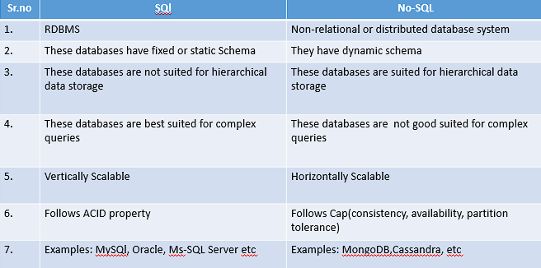
- Outline the basic steps to start and stop a NoSQL database.
Ans: In MongoDB, starting and stopping the database typically refers to starting and stopping the MongoDB server itself, which hosts one or more databases.
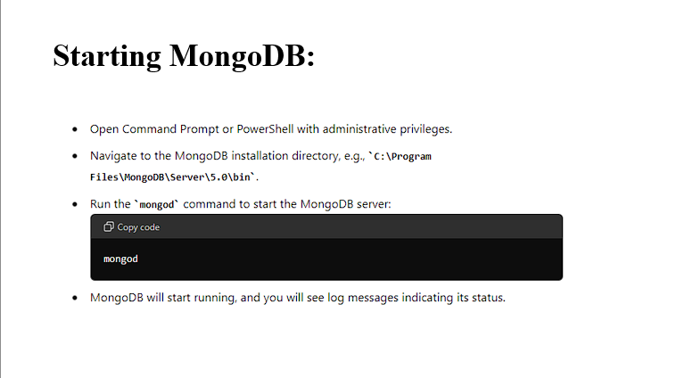
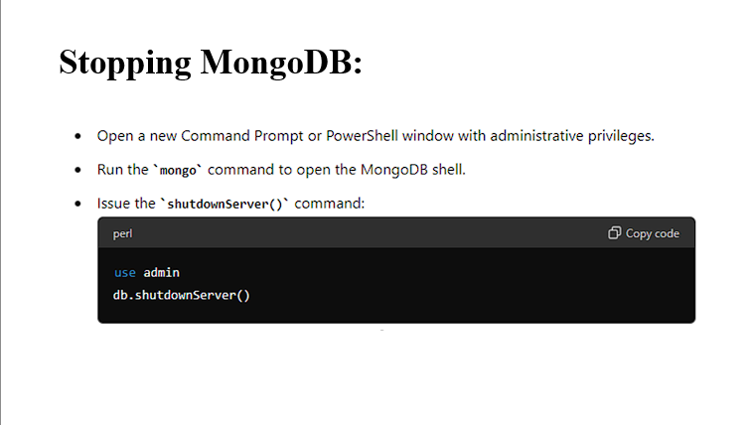
- Describe the main data types supported by a typical NoSQL database.
Ans:
- NoSQL databases support various data types, and the specific types available can vary depending on the database system. Here are some common data types often supported in NoSQL databases:
  - String: Represents text data.
  - Integer: Represents whole numbers.
  - Float/Double: Represents floating-point numbers with decimal precision.
  - Boolean: Represents true or false values.
  - Date/Time: Represents date and time values.
  - Array/List: Represents an ordered collection of elements.
  - Object/Document: Represents structured data in a key-value format, often similar to JSON objects. This is particularly common in document-oriented databases like MongoDB.
  - Binary/BLOB (Binary Large Object): Represents binary data, such as images, audio, or video files.
  - Set: Represents a collection of unique elements.
  - Map/Dictionary/Hash: Represents an unordered collection of key-value pairs.
  - Timestamp: Represents a point in time, often used for tracking when data was created or modified.
- Provide an example of a CRUD operation in a NoSQL database shell
Ans:
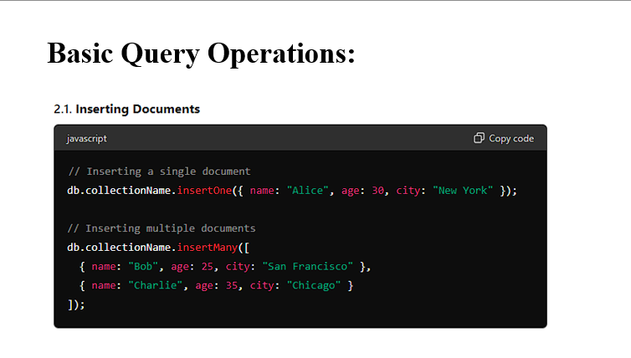
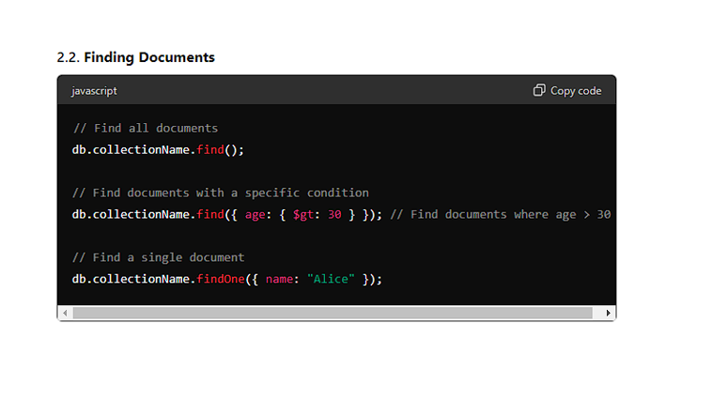 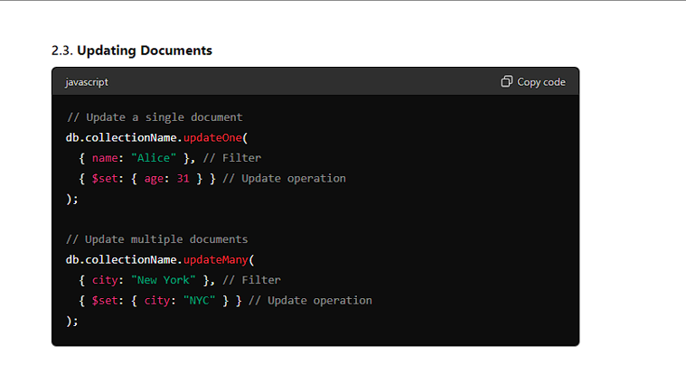 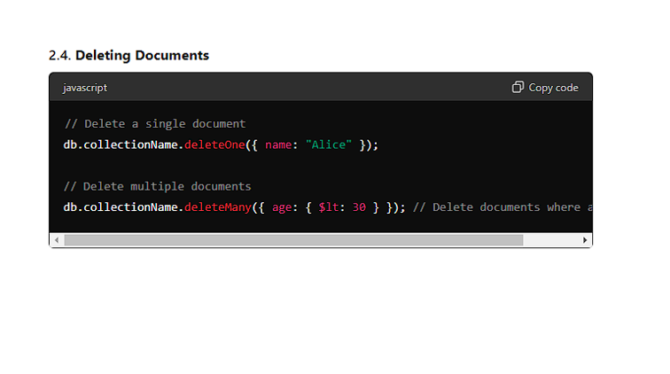

6 Mark Questions
- Illustrate with an example how to perform a query in a NoSQL database.
Ans: OWN
- Discuss the importance of database design in NoSQL databases
Ans:
- Optimized Performance
- Query Efficiency: Proper database design ensures that queries are efficient and performant. For example, in document stores, designing the schema to match the query patterns can reduce the need for complex joins and improve retrieval times.
- Indexing: Effective indexing strategies are critical in NoSQL databases to accelerate data access and search operations. Designing indexes based on common query patterns enhances performance.
2. Scalability
- Horizontal Scaling: NoSQL databases often scale horizontally by distributing data across multiple nodes. Good design practices ensure that data is partitioned and distributed efficiently, balancing the load and maintaining performance as the database grows.
- Sharding: Designing the data model to facilitate effective sharding (partitioning data across different servers) can prevent hotspots and ensure even distribution of data and queries.
3. Data Integrity and Consistency
- Data Modeling: In NoSQL databases, where consistency models may vary (e.g., eventual consistency), careful design is needed to manage data integrity and ensure that applications function correctly despite potential delays in data propagation.
- Denormalization: Many NoSQL databases use denormalized data models to optimize read performance. Proper design ensures that data duplication is managed efficiently and updates are synchronized across different parts of the database.
4. Flexibility and Adaptability
- Schema Evolution: NoSQL databases often support flexible schemas, allowing for changes in data structures over time. Well-thought-out design accommodates evolving data requirements without significant disruption to existing data and queries.
- Handling Diverse Data Types: NoSQL databases can store various data types (e.g., JSON, XML). Effective design practices enable the handling of diverse data formats and structures, supporting a wide range of use cases.
5. Efficient Data Retrieval
- Data Aggregation: Proper design helps in organizing and aggregating data to support efficient retrieval. For instance, designing document schemas in a way that groups related data together can reduce the number of reads required.
- Query Patterns: Anticipating common query patterns and structuring data accordingly ensures that queries are efficient and do not require extensive processing.
6. Reduced Operational Complexity
- Maintenance: A well-designed NoSQL database can simplify maintenance tasks such as backups, replication, and scaling. Proper design reduces the complexity involved in managing the database over time.
- Troubleshooting: Clear data modeling and indexing strategies help in diagnosing and resolving issues more effectively, reducing downtime and operational disruptions.
7. Application Requirements Alignment
- Use Case Fit: Aligning the database design with the specific needs of the application ensures that the database can support required features and performance characteristics. For example, a time-series database might be designed differently from a key-value store.

- Describe the functions and capabilities of a NoSQL database shell, including querying and managing data.
Ans:
- In MongoDB, the MongoDB Shell, also known as mongo, is a powerful command-line interface that allows you to interact with MongoDB instances.
- It's a JavaScript-based interface that enables administrators and developers to perform various operations on MongoDB databases.
- The MongoDB Shell is essential for managing MongoDB databases efficiently, whether for development, administration, or automation tasks.

- Basic Commands:
- show dbs: Lists all databases on the connected MongoDB instance.
- use <database>: Switches to a specific database.
- show collections: Lists all collections in the current database.
- db.<collection>.find(): Retrieves documents from a collection.
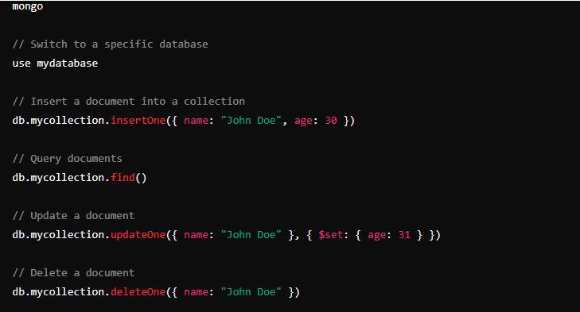
- Querying NoSQL:
In MongoDB, querying NoSQL data involves using the MongoDB Query Language (MQL), which is designed to handle the unique structures of NoSQL documents stored in collections.
MongoDB's flexible schema allows documents in a collection to have varying fields, making querying a bit different from traditional SQL databases.
CRUD OPERATIONS
- Explain MongoDB and key points about collections and documents in it.
Ans: MongoDB is an open source NoSQL database management program. NoSQL (Not only SQL) is used as an alternative to traditional relational databases.
NoSQL databases are quite useful for working with large sets of distributed data. MongoDB is a tool that can manage document-oriented information, store or retrieve information.
Instead of using tables and rows as in relational databases, as a NoSQL database, the MongoDB architecture is made up of collections and documents.
MongoDB's basic unit of data. Collections, the equivalent of SQL tables, contain document sets. MongoDB offers support for many programming languages, such as C, C++, C#, Go, Java, Python, Ruby and Swift.
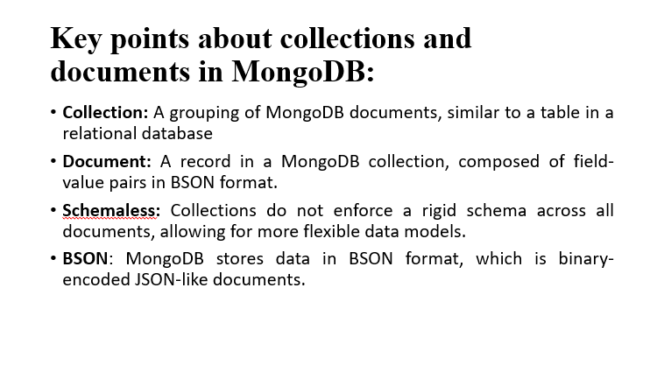
- Explain any 6 functions with example in NOSQL
Ans:
• insertOne:
- Description: Inserts a single document into a collection.
- Example:
db.collection('users').insertOne({
name: 'John Doe',
age: 28,
email: 'johndoe@example.com'
});
This command inserts a single document with the specified fields into the users collection.
• insertMany:
- Description: Inserts multiple documents into a collection.
- Example:
db.collection('users').insertMany([
{ name: 'Alice Smith', age: 30, email: 'alice@example.com' },
{ name: 'Bob Brown', age: 25, email: 'bob@example.com' }
]);
This command inserts two documents into the users collection in a single operation.
• find:
- Description: Retrieves documents from a collection that match a query.
- Example:
db.collection('users').find({ age: { $gt: 25 } });
This command retrieves all documents from the users collection where the age is greater than 25.
• findOne:
- Description: Retrieves a single document from a collection that matches a query.
- Example:
db.collection('users').findOne({ email: 'alice@example.com' });
This command retrieves the first document from the users collection where the email is alice@example.com.
• updateOne:
- Description: Updates a single document that matches a query.
- Example:
db.collection('users').updateOne(
{ name: 'John Doe' },
{ $set: { age: 29 } }
);
This command updates the age field to 29 for the first document in the users collection where the name is John Doe.
• updateMany:
- Description: Updates multiple documents that match a query.
- Example:
db.collection('users').updateMany(
{ age: { $lt: 30 } },
{ $set: { status: 'active' } }
);

CHAPTER NO 2: Introduction to Data Warehouse { 10 MARKS } (CO2)

4 Mark Questions
- List and explain different features of Data Warehousing.
Ans: 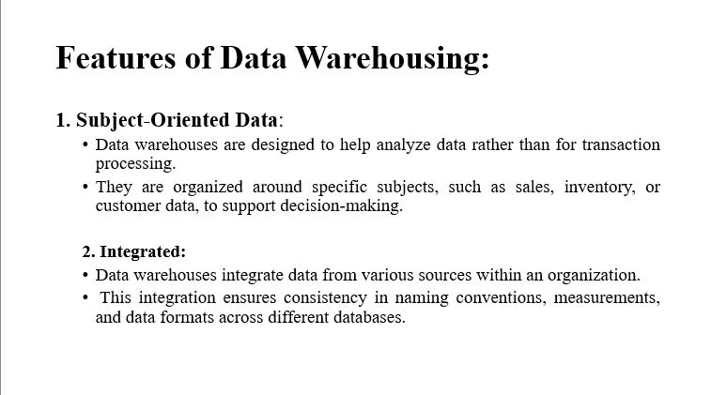
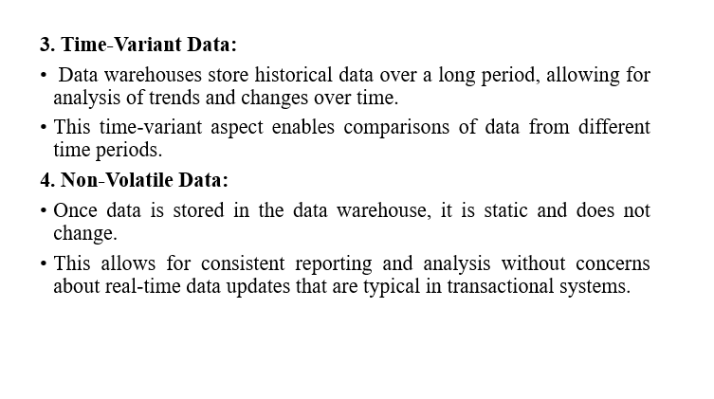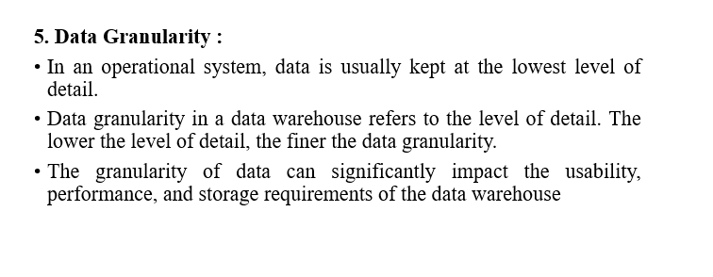
- Compare Data Warehouses and Data Marts with the help of an example.
Ans:
Data warehouse: A data warehouse is a centralized repository that stores integrated, historical data from multiple sources across an entire organization.
Example: A large retail chain stores data from all its stores, including sales, inventory, and customer data, in a data warehouse. This allows corporate analysts to perform enterprise-wide analysis to understand sales trends, optimize inventory management, and segment customers for marketing campaigns.
Data Mart: A data mart is a subset of a data warehouse that is focused on a specific department, function, or business unit within an organization.
Example: The marketing department of the retail chain might have a data mart that focuses specifically on marketing campaign performance. This data mart would contain relevant data such as campaign effectiveness, customer responses, and demographics.
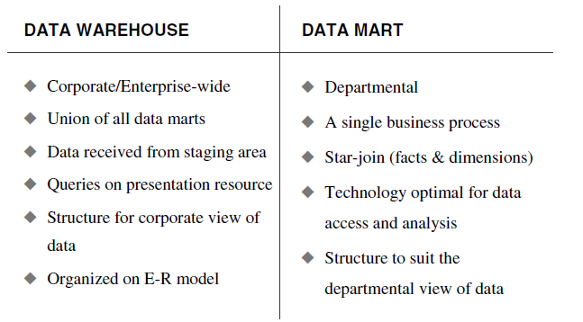
- Explain the difference between Data Warehouses and Data Lakes.
Ans:
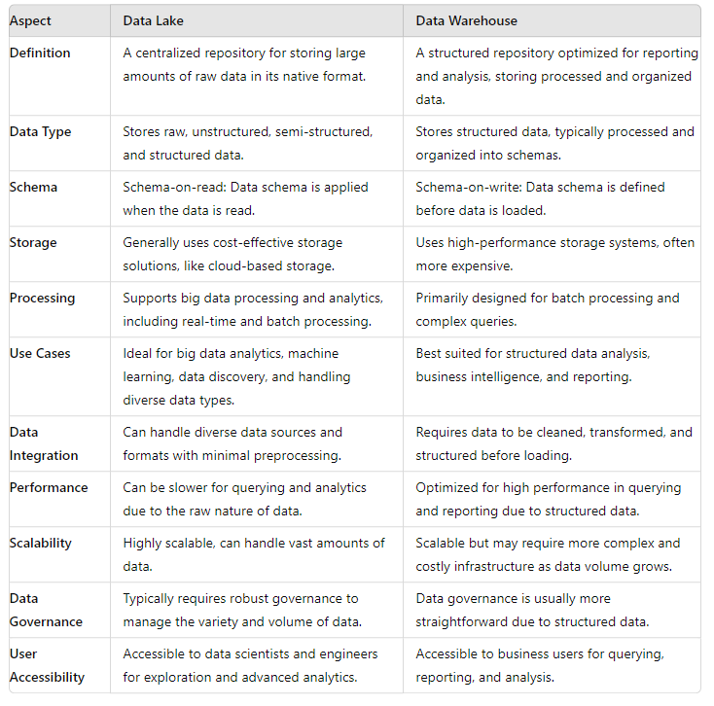
- Explain the difference between the Top-Down and Bottom-Up approaches in Data Warehousing.
Ans:
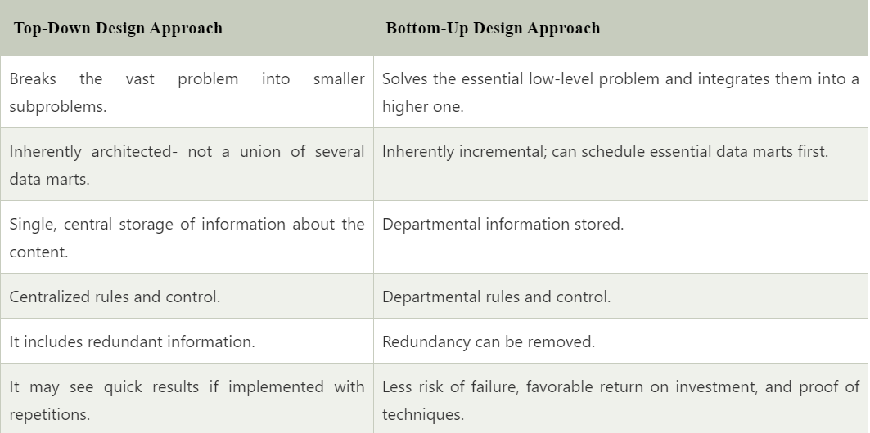

- Discuss the advantages and disadvantages of the Top-Down approach.
Ans:
Top-Down Approach
  - The advantages of this approach are:
    - A truly corporate effort, an enterprise view of data
    - Inherently architected—not a union of disparate data marts
    - Single, central storage of data about the content
    - Centralized rules and control
    - May see quick results if implemented with iterations
  - The disadvantages are:
    - Takes longer to build even with an iterative method
    - High exposure/risk to failure
    - Needs high level of cross-functional skills
    - High outlay without proof of concept
- Discuss the advantages and disadvantages of the Bottom-Up approach.
Ans:
Bottom-Up Approach
- The advantages of this approach are:
  - Faster and easier implementation of manageable pieces
  - Favorable return on investment and proof of concept
  - Less risk of failure
  - Inherently incremental
  - can schedule important data marts first
  - Allows project team to learn and grow
- The disadvantages are:
  - Each data mart has its own narrow view of data
  - Permeates redundant data in every data mart
  - Perpetuates inconsistent and irreconcilable data
  - Proliferates unmanageable interfaces
- Describe the role of the Data Storage Component in a Data Warehouse.
Ans:
- The data storage component of a data warehouse is the backbone of the system, responsible for holding all the integrated data from various sources. It is designed to store vast amounts of historical data in a way that supports efficient querying and analysis. This component ensures data is structured and organized, facilitating easy retrieval for business intelligence, reporting, and decision-making processes.

Roles:
- Data Integration: Stores data from multiple sources, ensuring it's combined and consistent.
- Historical Data Management: Retains large volumes of historical data for trend analysis and reporting.
- Data Organization: Structures data to support efficient querying and analysis.
- Performance Optimization: Optimizes storage for quick data retrieval and processing.
- Data Availability: Ensures data is always accessible to users for reporting and analysis.
- Data Consistency: Maintains data integrity and consistency across the data warehouse.
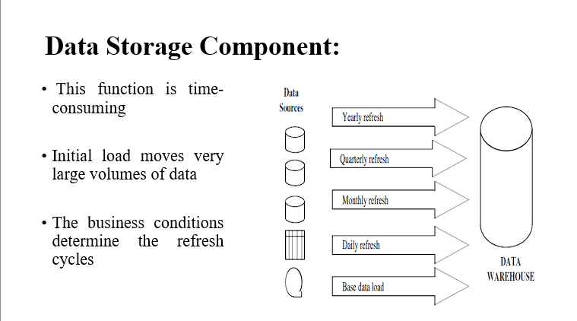
- Explain Information Delivery Component in a Data Warehouse.
Ans:
- The information delivery component in a data warehouse is responsible for providing users with access to the data stored in the warehouse.
- It acts as the interface between the data warehouse and the end-users, enabling them to retrieve, analyse, and report on the data according to their needs.

- Delivery Methods:
- These are the ways in which information is accessed and delivered to end-users. Each method is linked to a specific type of analysis or reporting:
- Online:
  - Ad hoc reports: Customized reports generated as needed.
  - Complex queries: Advanced querying capabilities for detailed data analysis.
- Intranet:
  - MD Analysis: Multi-Dimensional Analysis, likely involving OLAP (Online Analytical Processing) for examining data from multiple perspectives.
- Internet:
  - Statistical Analysis: Conducting statistical evaluations and analyses over the internet.
  - EIS feed: Executive Information Systems feed, providing essential information for executives.
- E-Mail:
- Data Mining: Automated processes to discover patterns and insights from large datasets.

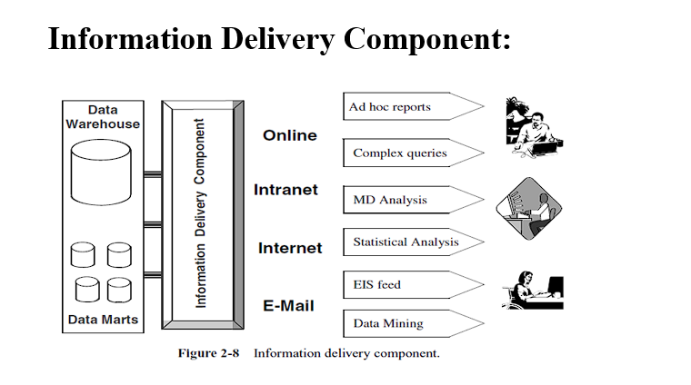
- Describe the Top-Down and bottom up approach in Data Warehousing
Ans:

Top-Down Approach
- Concept: The Top-Down approach, focuses on creating a comprehensive, enterprise-wide data warehouse. It emphasizes a centralized data warehouse that integrates data from various sources before it is analyzed.
- Process:
  - Design: Begin with a high-level design of the data warehouse architecture. This includes defining the overall structure, data integration methods, and data flow.
  - Enterprise Data Warehouse (EDW): Develop the EDW, which serves as the central repository for all data. This involves creating a normalized data model to ensure data consistency and integrity.
  - Data Marts: Once the EDW is in place, create data marts that cater to specific business areas or departments. These are usually designed using denormalized schemas (e.g., star schema or snowflake schema) for optimized querying and reporting.
- Advantages:
  - Integrated View: Provides a unified view of data across the entire organization.
  - Consistency: Ensures data consistency and integrity through centralized management.
  - Scalability: Easier to scale and integrate additional data sources as needed.
- Disadvantages:
  - Longer Implementation Time: Can take longer to develop and deploy due to its comprehensive nature.
  - Higher Initial Costs: Typically requires a significant upfront investment in time and resources
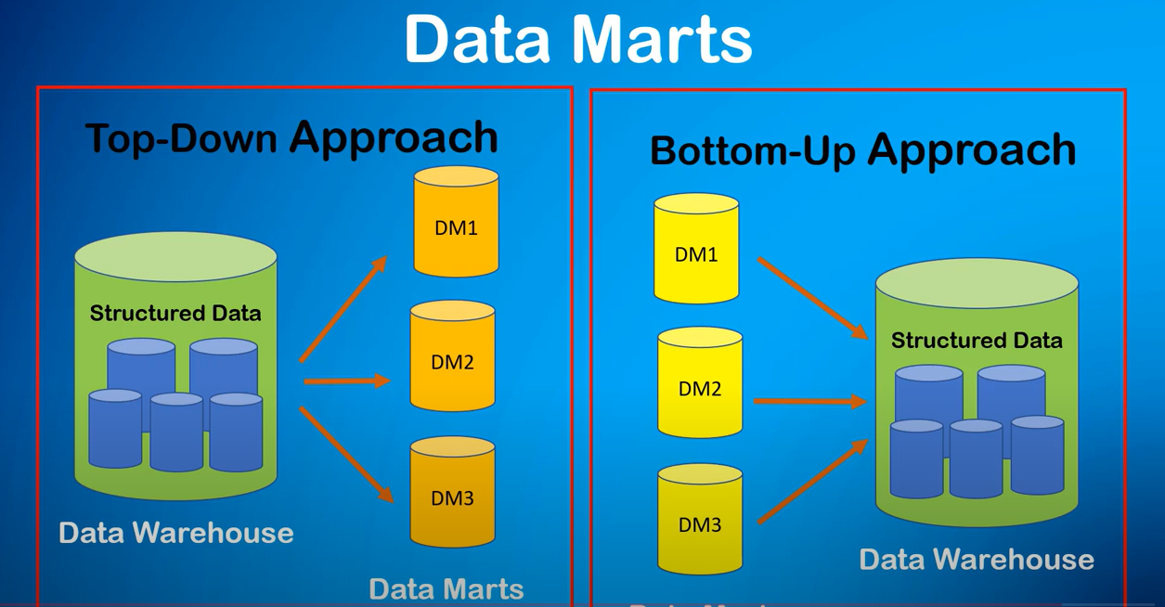

Bottom-Up Approach
- Concept: The Bottom-Up approach, starts with the creation of data marts tailored to specific business needs or departments. These data marts are then integrated to form a more comprehensive data warehouse over time.
- Process:
  - Data Marts: Begin by developing data marts that address immediate business requirements. These marts are built using denormalized schemas and are designed for efficient querying and reporting.
  - Integration: Gradually integrate these data marts into a larger, unified data warehouse. This involves creating a data warehouse architecture that consolidates the individual data marts.
  - Enterprise Data Warehouse (EDW): The EDW is developed incrementally as more data marts are created and integrated.
- Advantages:
  - Faster Implementation: Allows for quicker deployment of data marts and faster delivery of valuable insights.
  - Lower Initial Costs: Typically requires lower initial investment as it starts with smaller, focused projects.
  - Flexibility: Easier to adapt to changing business requirements and priorities.
- Disadvantages:
  - Integration Challenges: Integrating data marts into a cohesive EDW can be complex and require additional effort.
  - Data Redundancy: Potential for data duplication and inconsistencies across different data marts.


6 Mark Questions
- Draw and explain a diagram of the building blocks or components of a Data Warehouse.
Ans:
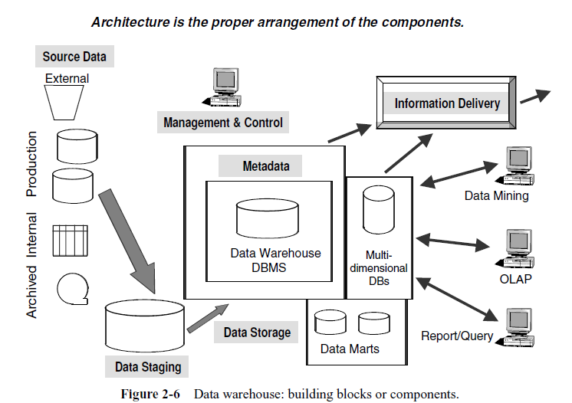
1. Source Data Component: Source data is the foundation of any data warehouse. It refers to the raw data collected from various operational systems, external sources, or other databases that will be transformed and loaded into the data warehouse for analysis.
Types of Source Data Components:
- Production Data
- Internal Data
- Archived Data
- External Data

- Data Staging Component: The "Data Staging Component" in a data warehouse context typically refers to the intermediary storage area and processes where data is cleansed, transformed, and prepared before it is loaded into the data warehouse.
The three major functions that take place in the staging area.
    - Data Extraction.
    - Data Transformation.
    - Data Loading.
- Data Storage Component: The data storage component of a data warehouse is the backbone of the system, responsible for holding all the integrated data from various sources. It is designed to store vast amounts of historical data in a way that supports efficient querying and analysis. This component ensures data is structured and organized, facilitating easy retrieval.
- Information Delivery: The information delivery component in a data warehouse is responsible for providing users with access to the data stored in the warehouse. It acts as the interface between the data warehouse and the end-users, enabling them to retrieve, analyse, and report on the data according to their needs.

- Management and Control Component: This component of the data warehouse architecture sits on top of all the other components. The management and control component coordinates the services and activities within the data warehouse. This component controls the data transformation and the data transfer into the data warehouse storage.
- Metadata Component: Metadata in a data warehouse is similar to the data dictionary or the data catalog in a database management system. In the data dictionary, you keep the information about the logical data structures, the information about the files and addresses, the information about the indexes, and so on. The data dictionary contains data about the data in the database.

- Explain the Source Data Components of a Data Warehouse (PDF PG NO 52)
Ans:
Source data is the foundation of any data warehouse. It refers to the raw data collected from various operational systems, external sources, or other databases that will be transformed and loaded into the data warehouse for analysis. Source data coming into the data warehouse may be grouped into four broad categories, as discussed here.
1. Production Data: This type of data is often disparate, meaning it comes from various sources and formats, which can make it challenging to integrate.
Examples: Transactional data from operational systems like sales, inventory, and customer interactions.
2. Internal Data: This data includes private and often department-specific information.
Examples: Spreadsheets, documents, customer profiles, and databases managed within departments.
3. Archived Data: Data that has been stored for long-term retention, typically historical data no longer in active use but valuable for trend analysis.
Examples: Historical sales records, old transaction logs, and previous customer data.
4. External Data: Data that originates from outside the organization, often used to benchmark and compare performance.
Examples: Market research reports, financial indicators, industry benchmarks, and third-party datasets.
- Explain the Data Staging Component and its three major functions in detail.
Ans:
  - The "Data Staging Component" in a data warehouse context typically refers to the intermediary storage area and processes where data is cleansed, transformed, and prepared before it is loaded into the data warehouse.
  - The three major functions that take place in the staging area.
- Data Extraction.
- Data Transformation.
- Data Loading.
- Data Extraction: Data is extracted from various source systems, which could include production data, internal data, archived data, and external data.
- Data Transformation: Extracted data is then cleaned and transformed to ensure it is in a consistent format. This involves data cleansing, de-duplication, and ensuring data quality. Transformation processes may also include data aggregation, filtering, sorting, and other data manipulation tasks to make the data suitable for analysis.
- Data Loading: The cleansed and transformed data is then loaded into the data warehouse. This step may involve loading the data into different tables, schemas, or partitions within the data warehouse.
- Extract:
- Objective: Gather data from various sources.
- Sources: The company collects data from different systems, such as:
  - Sales System: Contains sales transactions from each branch.
  - Customer Relationship Management (CRM) System: Holds customer information and interactions.
  - Inventory Management System: Provides stock levels and inventory data.
- Example Extract Process:
- Extract sales records from the Sales System’s database, which may be stored in SQL Server.
- Extract customer data from the CRM system, which might be stored in Salesforce.
- Extract inventory data from the Inventory Management System’s files or database.
- Transform:
- Objective: Process and convert the extracted data into a consistent format suitable for analysis.
- Tasks:
- Data Cleaning: Remove duplicates and correct errors (e.g., inconsistent customer names or incorrect dates).
- Data Integration: Combine data from different sources into a unified format. For example, merging sales records with customer data to provide insights into purchasing behavior.
- Data Transformation: Convert data into a format compatible with the target system. This might involve changing data types, aggregating data (e.g., summing up sales per branch), or creating new calculated fields (e.g., total sales per region).
- Example Transform Process:
- Clean up the sales data to ensure all entries have valid and consistent formats for dates and amounts.
- Join sales records with customer information to include customer demographics in the dataset.
- Aggregate sales data by month and branch to prepare for trend analysis.
- 3.Load:
- Objective: Load the transformed data into the target system where it will be available for reporting and analysis.
- Target System: A data warehouse or data mart that stores historical and consolidated data for querying and reporting.
- Example Load Process:
- Load the cleaned and transformed data into a data warehouse.
- Ensure data is correctly inserted into relevant tables (e.g., Sales_Facts, Customer_Dimension, Inventory_Dimension).
- Perform checks to verify that data has been correctly loaded and is available for business intelligence tools.

- Describe the Management and Control Component in a Data Warehouse. (4M)
Ans:
- This component of the data warehouse architecture sits on top of all the other components.
- The management and control component coordinates the services and activities within the data warehouse.
- This component controls the data transformation and the data transfer into the data warehouse storage.
- On the other hand, it moderates the information delivery to the users.
- It works with the database management systems and enables data to be properly stored in the repositories.
- It monitors the movement of data into the staging area and from there into the data warehouse storage itself.
- The management and control component interacts with the metadata component to perform the management and control functions.
- As the metadata component contains information about the data warehouse itself, the metadata is the source of information for the management module.

- Discuss the Metadata Component of a Data Warehouse and also explain the different types of Metadata with examples, including Operational Metadata, Extraction and Transformation Metadata, and End-User Metadata.
Ans:
Metadata Component:
- Metadata in a data warehouse is similar to the data dictionary or the data catalog in a database management system.
- In the data dictionary, you keep the information about the logical data structures, the information about the files and addresses, the information about the indexes, and so on.
- The data dictionary contains data about the data in the database.
- Similarly, the metadata component is the data about the data in the data warehouse.
- Metadata in a data warehouse is similar to a data dictionary, but much more than a data dictionary.
- Metadata as one of the components of the data warehouse architecture.
Types of Metadata:
- Metadata in a data warehouse fall into three major categories:
- Operational Metadata
- Extraction and Transformation Metadata
- End-User Metadata
-1) Operational Metadata
- Operational metadata is a type of administrative metadata that provides information on the processes and operations involved in handling and managing data.
- This includes details about how data is created, processed, stored, and accessed within an organization.
- It is essential for ensuring the efficient and effective use of data in various operational processes.
- Consider a scenario in a retail data warehouse where the operational metadata is used to manage and monitor the ETL (Extract, Transform, Load) process
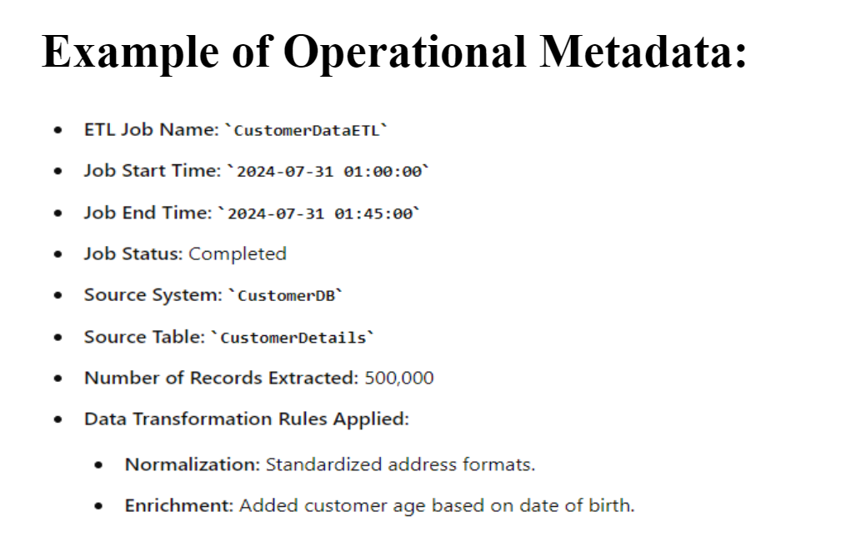
-2) Extraction and Transformation Metadata
- Extraction and transformation metadata contain data about the extraction of data from the source systems, namely, the extraction frequencies, extraction methods, and business rules for the data extraction.
- Also, this category of metadata contains information about all the data transformations that take place in the data staging area
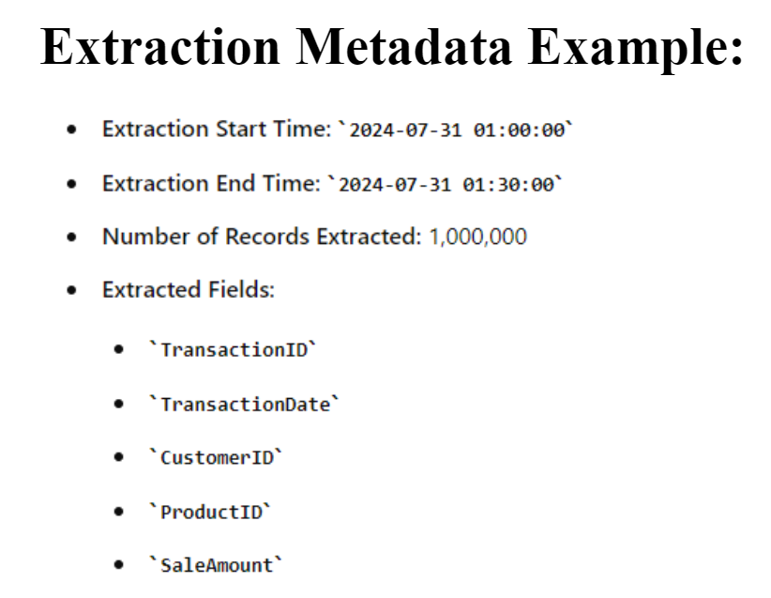
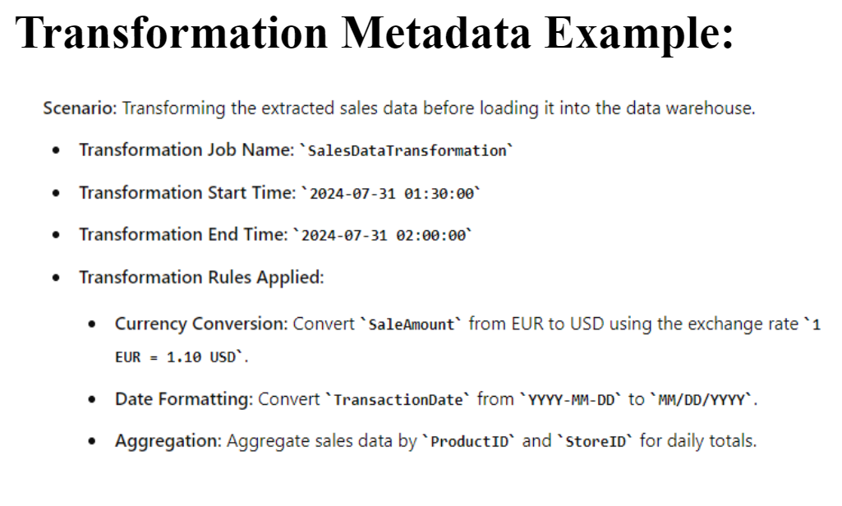
-3) End-User Metadata:
- The end-user metadata is the navigational map of the data warehouse.
- It enables the end-users to find information from the data warehouse.
- The end-user metadata allows the end-users to use their own business terminology and look for information in those ways in which they normally think of the business.
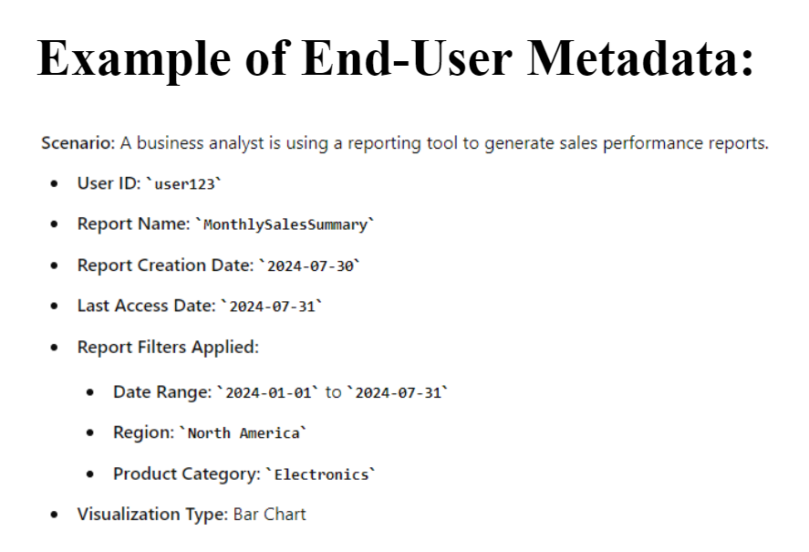

- List and explain the benefits of Data Warehousing.
Ans:
1. Improved Data Quality and Consistency
- Ensures data is accurate and reliable by consolidating and cleaning data from various sources, providing consistent data across the organization.
2. Enhanced Business Intelligence and Decision Making
- Provides a centralized repository for comprehensive analysis, enabling informed and faster decision-making.
3. Improved Performance and Efficiency
- Optimizes data retrieval and offloads intensive queries from operational systems, improving overall system efficiency.
4. Scalability
- Easily expands to handle increasing data volumes without compromising performance, making it adaptable to future growth.
5. Enhanced Data Integration
- Integrates data from multiple sources, providing a unified view that supports more comprehensive and insightful analysis.
6. Improved Data Security
- Implements strong security measures, ensuring that only authorized users have access to sensitive data, thus protecting it from breaches.
7. Cost Savings
- Reduces long-term costs by improving data management efficiency and enabling better, data-driven decision-making.

CHAPTER NO 3: Data Extraction, Transformation, and Loading { 12 MARKS }(C03)

4 Mark Questions
- Explain the extract phase of the ETL process with an example.
Ans:
1. Extract:
- Definition: The process of retrieving data from various sources. These sources can be databases, flat files, APIs, or other data repositories.
- Key Activities:
  - Data Extraction: Pulling data from source systems in a raw form.
  - Handling Different Formats: Managing different data formats and structures (e.g., SQL databases, CSV files, XML, JSON).
  - Dealing with Heterogeneous Sources: Extracting data from multiple and diverse data sources.
- Objective: Gather data from various sources.
- Sources: The company collects data from different systems, such as:
  - Sales System: Contains sales transactions from each branch.
  - Customer Relationship Management (CRM) System: Holds customer information and interactions.
  - Inventory Management System: Provides stock levels and inventory data.
Example Extract Process:
- Extract sales records from the Sales System’s database, which may be stored in SQL Server.
- Extract customer data from the CRM system, which might be stored in Salesforce.
- Extract inventory data from the Inventory Management System’s files or database.
- Describe the transform phase and mention at least two common transformation tasks.
Ans:
2. Transform
- Definition: The process of converting extracted data into a suitable format or structure for analysis and reporting.
- Key Activities:
  - Data Cleaning: Removing inconsistencies, duplicates, and errors.
  - Data Mapping: Aligning data fields from source systems to the destination schema.
  - Data Enrichment: Enhancing data quality by adding necessary information (e.g., deriving new metrics).
  - Data Aggregation: Summarizing data for analysis (e.g., calculating averages, totals).
  - Data Standardization: Converting data into a consistent format (e.g., date formats, measurement units).
WE CAN WRITE ANY 2 TASKS OUT OF 5
1.Selection.
- This takes place at the beginning of the whole process of data transformation. You select either whole records or parts of several records from the source systems. The task of selection usually forms part of the extraction function itself.
- However, in some cases, the composition of the source structure may not be willing to selection of the necessary parts during data extraction.
- In these cases, it is prudent to extract the whole record and then do the selection as part of the transformation function.
2.Splitting/joining.
- This task includes the types of data manipulation you need to perform on the selected parts of source records.
- Sometimes (uncommonly), you will be splitting the selected parts even further during data transformation.
- Joining of parts selected from many source systems is more widespread in the data warehouse environment
- Discuss the source identification process in data extraction. (SAME AS 6M QUESTION BOOK PG NO 263)
- List and briefly explain options available for data extraction techniques.
Ans:
To summarize, the following options are available for data extraction:
- Capture of static data
- Capture through transaction logs
- Capture through database triggers
- Capture in source applications
- Capture based on date and time stamp
- Capture by comparing files
Capture of Static Data
This technique involves extracting data that does not change frequently. It is typically used for historical data or reference data. Static data capture ensures consistency and accuracy, making it ideal for analytical and reporting purposes.

Capture through Transaction Logs
This method utilizes transaction logs to capture data changes. Transaction logs record all changes made to the database, enabling the capture of incremental updates. It is useful for real-time data integration and ensuring data consistency in disaster recovery scenarios.

Capture through Database Triggers
Database triggers are automated procedures that are executed in response to specific events on a particular table or view. When a data change event (like INSERT, UPDATE, DELETE) occurs, the trigger captures and processes the data. This method ensures real-time data capture and can enforce business rules.

Capture in Source Applications
Data is captured directly from the source applications where it is generated. This approach ensures the accuracy and timeliness of the data, as it is extracted at the point of origin. It is particularly useful for capturing transactional data and integrating it into centralized data systems.

Capture based on Date and Time Stamp
This technique captures data based on the date and time stamps associated with the records. It involves extracting records that have been created or modified within a specific time frame. This method is efficient for batch processing and incremental data extraction.

Capture by Comparing Files
This method involves comparing two versions of a file to identify changes. By examining differences between the files, data changes can be extracted and processed. It is useful for scenarios where direct database access is not available or when working with flat files and other file-based data sources.

- Describe the tasks involved in the data transformation process: selection and conversion.
Ans:
1.Selection.
- This takes place at the beginning of the whole process of data transformation. You select either whole records or parts of several records from the source systems. The task of selection usually forms part of the extraction function itself.
- However, in some cases, the composition of the source structure may not be willing to selection of the necessary parts during data extraction.
- In these cases, it is prudent to extract the whole record and then do the selection as part of the transformation function.
3.Conversion.
- This is an all-inclusive task. It includes a large variety of basic conversions of single fields for two primary reasons—one to standardize among the data extractions from disparate source systems, and the other to make the fields usable and understandable to the users.

- What are the major challenges in the data extraction process?
Ans:
Data Quality and Accuracy:
- Inconsistencies: Data may come from disparate sources with varying formats, leading to inconsistencies and inaccuracies that need to be resolved.
- Incomplete Data: Extracted data might be missing crucial information, impacting the quality and reliability of the analysis.
· Data Integration:
- Format Differences: Integrating data from multiple sources often involves dealing with different formats, structures, and schemas, complicating the extraction process.
- Transformation Needs: Data may need significant transformation and cleaning to align with the target system's requirements.
· Scalability:
- Volume of Data: Handling large volumes of data efficiently can be challenging, requiring robust infrastructure and optimized extraction processes to manage high data loads.
- Performance: Ensuring that the extraction process remains performant as data size and complexity grow is crucial for maintaining efficiency.
· Security and Compliance:
- Sensitive Data: Extracting data that includes sensitive or personal information requires stringent security measures to protect against breaches and ensure compliance with data protection regulations (e.g., GDPR, HIPAA).
- Access Control: Managing permissions and ensuring that only authorized users can access or extract data adds another layer of complexity.
· Real-Time Data Extraction:
- Timeliness: For applications requiring real-time or near-real-time data, ensuring that extraction processes keep up with the speed of data generation can be challenging.
· Source System Limitations:
- System Performance: The performance and stability of source systems can affect extraction, especially if they are not optimized for handling large-scale data extraction operations.
- Connectivity Issues: Network or connectivity problems can disrupt data extraction processes, leading to delays or incomplete data.

- Explain the differences between data refresh and data update with the help of a graph. (282)
Ans:
The Two Ways to Update Data:
- Refresh: This means replacing all the data in the warehouse with new data at specific times.
- Update: This means only changing the parts of the data that have been updated or changed.

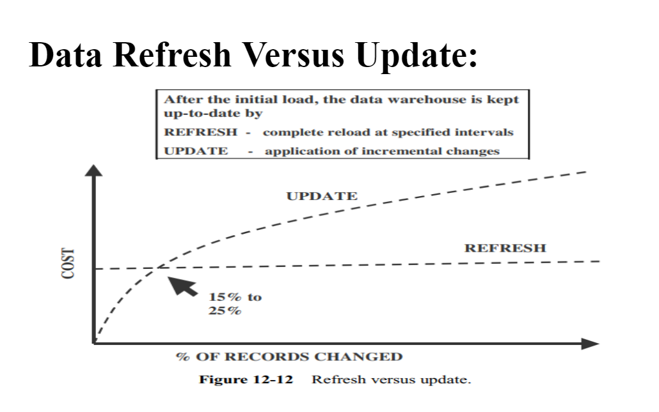
The Graph:
- Cost (Y-axis): This shows how much it costs to keep the data up-to-date. Higher up means it's more expensive.
- % of Records Changed (X-axis): This shows how much of the data needs to be updated. More to the right means more data is changed.
What the Lines Mean:
- Refresh Line (dashed): The cost stays the same no matter how much data is changed. Whether you change a little or a lot, it costs the same.
- Update Line (dotted): The cost increases as more data is changed. If you only change a little bit, it costs less. If you change a lot, it costs more.
- Describe various methods of data extraction and their applications.

6 Mark Questions
- Explain the ETL process in detail, including the extract, transform, and load phases.
Ans:
1. Extract:
- Definition: The process of retrieving data from various sources. These sources can be databases, flat files, APIs, or other data repositories.
- Key Activities:
  - Data Extraction: Pulling data from source systems in a raw form.
  - Handling Different Formats: Managing different data formats and structures (e.g., SQL databases, CSV files, XML, JSON).
  - Dealing with Heterogeneous Sources: Extracting data from multiple and diverse data sources.
Example Extract Process:
- Extract sales records from the Sales System’s database, which may be stored in SQL Server.
- Extract customer data from the CRM system, which might be stored in Salesforce.
- Extract inventory data from the Inventory Management System’s files or database.
2. Transform
- Definition: The process of converting extracted data into a suitable format or structure for analysis and reporting.
- Key Activities:
  - Data Cleaning: Removing inconsistencies, duplicates, and errors.
  - Data Mapping: Aligning data fields from source systems to the destination schema.
  - Data Enrichment: Enhancing data quality by adding necessary information (e.g., deriving new metrics).
  - Data Aggregation: Summarizing data for analysis (e.g., calculating averages, totals).
  - Data Standardization: Converting data into a consistent format (e.g., date formats, measurement units).
Example Transform Process:
- Clean up the sales data to ensure all entries have valid and consistent formats for dates and amounts.
- Join sales records with customer information to include customer demographics in the dataset.
- Aggregate sales data by month and branch to prepare for trend analysis.
3. Load
- Definition: The process of inserting transformed data into the target data warehouse or database.
- Key Activities:
  - Initial Load: The first load of all historical data into the data warehouse.
  - Incremental Load: Loading only the data that has changed since the last ETL run (also known as delta loading).
  - Full Refresh: Reloading the entire dataset, replacing the old data with the new data.
  - Data Validation: Ensuring the data has been loaded correctly and completely.
Example Load Process:
- Load the cleaned and transformed data into a data warehouse.
- Ensure data is correctly inserted into relevant tables (e.g., Sales_Facts, Customer_Dimension, Inventory_Dimension).
- Perform checks to verify that data has been correctly loaded and is available for business intelligence tools.
- Illustrate the source identification process with the help of a diagram and explain its importance. (263)
Ans:
Source Identification:
- Source identification is not as simple a process as it may sound.
- It is a critical first process in the data extraction function.
- You need to go through the source identification process for every piece of information you have to store in the data warehouse.
- As you might have already figured out, source identification needs thoroughness, lots of time, and exhaustive analysis.
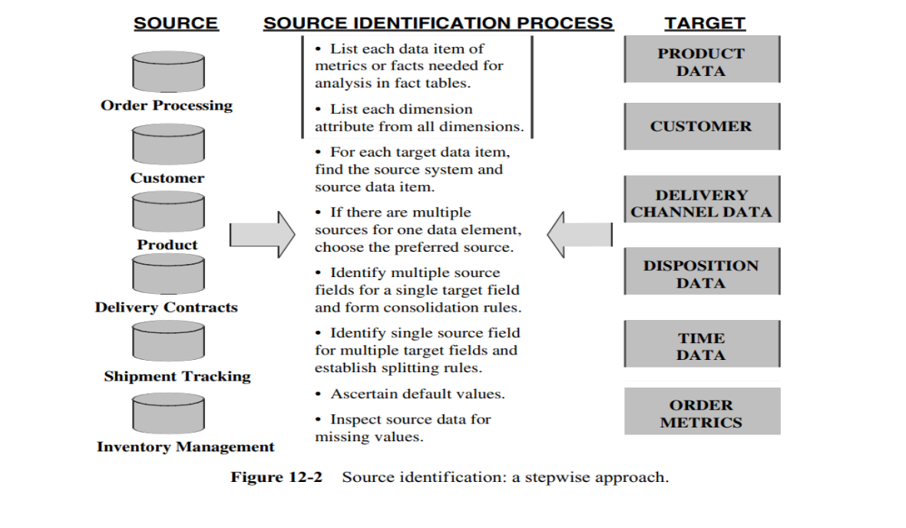
IMPORTANCE
1. Data Accuracy and Integrity
Ensures that the correct and relevant data is extracted from the right sources, which is essential for maintaining the accuracy and integrity of the data throughout the ETL process.
2. Consistency in Data Integration
Identifying the sources properly ensures that data from different sources can be consistently integrated, avoiding conflicts and inconsistencies when combining data.
3. Data Quality Management
Knowing the source allows for proper data quality checks, including validation, cleansing, and enrichment based on the characteristics and reliability of the source.
4. Performance Optimization
Proper identification of sources helps optimize the extraction process by allowing tailored extraction strategies that suit the specific data source, reducing time and resource consumption.
5. Auditability and Compliance
Source identification enables traceability, making it easier to audit data flow and ensure compliance with data governance policies, regulations, and standards.
6. Error Handling and Troubleshooting
Facilitates better error handling and troubleshooting by allowing ETL processes to identify and address issues at the source level.
7. Resource Management
Helps in managing and allocating resources effectively by understanding the complexity and volume of data coming from each source, ensuring that the ETL process is efficient and scalable.
- Describe data extraction techniques using replication technology and deferred data extraction options.
Ans:
PAGE NO 266
DOUBT WHAT WO WRITE FOR DET AND WHICH DIAGRAM TO DRAW EITHER ONE OR BOTH AND ITS EXPLANATION
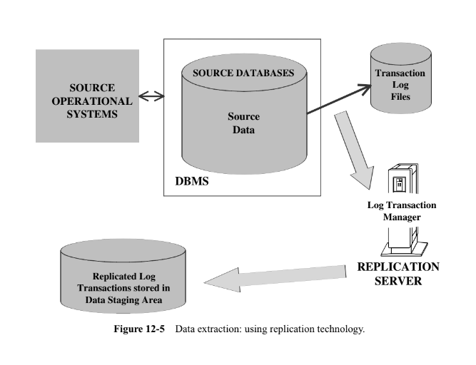
Replication technology involves copying and maintaining database objects, like tables, from one database to another, ensuring consistency between them. Here's a breakdown based on the diagram:
- Source Operational Systems and Databases:
  - The source operational systems feed data into the source databases managed by a DBMS (Database Management System).
- Transaction Log Files:
  - These logs capture all changes (inserts, updates, deletes) made to the source database.
- Replication Server:
  - The transaction logs are read by a Log Transaction Manager within the Replication Server.
  - The server processes the logs and ensures that the changes made in the source database are replicated to a target system, storing them in the Data Staging Area.
This method is real-time or near-real-time, ensuring that the data is consistently replicated, making it suitable for applications requiring high availability and disaster recovery.

Deferred Data Extraction (FORMATTED BY GPT)
Deferred data extraction refers to capturing data changes after the transactions have occurred in the source operational systems. Unlike immediate or real-time data capture, deferred extraction happens later.
Diagram Explanation:
The diagram shows two options for deferred data extraction:
- Capture Based on Date and Time Stamp:
- Every time a source record is created or updated, it may be marked with a date and time stamp. The extraction occurs later, based on these timestamps. For example, if the extraction program runs at midnight, it will extract only those records with a date and time stamp later than midnight of the previous day. This technique captures the latest state of the source data but does not detect deletions unless special logic is added to the source applications.
- Capture by Comparing Files (Snapshot Differential Technique):
- This technique compares two snapshots of the source data to detect changes. For example, while performing today's data extraction, you compare today’s copy of the product data with yesterday’s copy. You also compare the record keys to find inserts and deletes, capturing any changes between the two copies. Though simple, this method can be inefficient for large files and requires keeping prior copies of the source data.
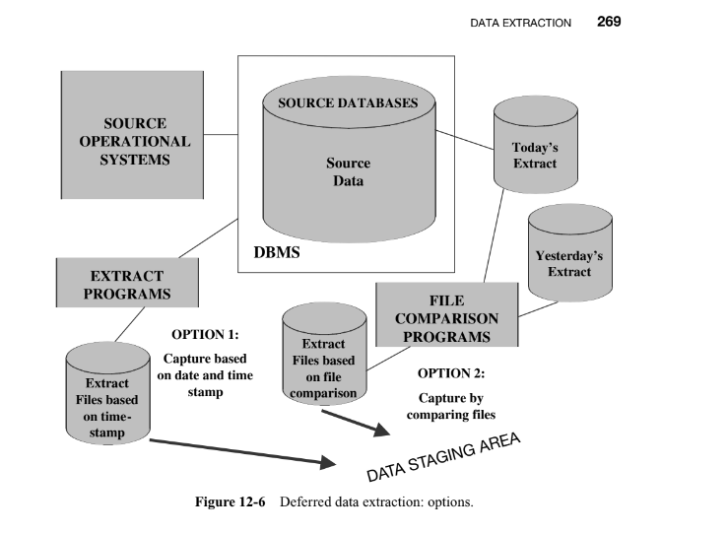
- Explain the basic tasks in data transformation: selection, splitting/joining, conversion, summarization, and enrichment.
Ans:
Data Transformation: Basic Tasks
- Irrespective of the variety and complexity of the source operational systems, and regardless of the extent of your data warehouse, you will find that most of your data transformation functions break down into a few basic tasks.
- Let us go over these basic tasks so that you can view data transformation from a fundamental perspective.
- Here is the set of basic tasks:
1.Selection.
- This takes place at the beginning of the whole process of data transformation. You select either whole records or parts of several records from the source systems. The task of selection usually forms part of the extraction function itself.
- However, in some cases, the composition of the source structure may not be willing to selection of the necessary parts during data extraction.
- In these cases, it is prudent to extract the whole record and then do the selection as part of the transformation function.
2.Splitting/joining.
- This task includes the types of data manipulation you need to perform on the selected parts of source records.
- Sometimes (uncommonly), you will be splitting the selected parts even further during data transformation.
- Joining of parts selected from many source systems is more widespread in the data warehouse environment
3.Conversion.
- This is an all-inclusive task. It includes a large variety of basic conversions of single fields for two primary reasons—one to standardize among the data extractions from disparate source systems, and the other to make the fields usable and understandable to the users.
4.Summarization.
- Sometimes you may find that it is not feasible to keep data at the lowest level of detail in your data warehouse. It may be that none of your users ever need data at the lowest details for analysis or querying.
- For example, for a grocery chain, sales data at the lowest level of detail for every transaction at the checkout may not be needed. Storing sales by product by store by day in the data warehouse may be quite adequate.
- So, in this case, the data transformation function includes summarization of daily sales by product and by store.
5.Enrichment.
- Enrichment means making data more meaningful.
- This task is the rearrangement and simplification of individual fields to make them more useful for the data warehouse environment.
- You may use one or more fields from the same input record to create a better view of the data for the data warehouse.
- This principle is extended when one or more fields originate from multiple records, resulting in a single field for the data warehouse.
- List and explain the major types of data transformation.
Ans:
Major Transformation Types
- When you consider a particular set of extracted data structures, you will find that the transformation functions you need to perform on this set may done by doing a combination of the basic tasks discussed.
- These are the most common transformation types:
1.Format Revisions.
- You will come across these quite often. These revisions include changes to the data types and lengths of individual fields.
- In your source systems, product package types may be indicated by codes and names in which the fields are numeric and text data types. Again, the lengths of the package types may vary among the different source systems.
- It is wise to standardize and change the data type to text to provide values meaningful to the users.
2.Decoding of Fields.
- This is also a common type of data transformation. When you deal with multiple source systems, you are bound to have the same data items described by a plethora of field values.
- The classic example is the coding for gender, with one source system using 1 and 2 for male and female and another system using M and F. Also, many legacy systems are notorious for using cryptic codes to represent business values.
- What do the codes AC, IN, RE, and SU mean in a customer file? You need to decode all such cryptic codes and change these into values that make sense to the users.
- Change the codes to Active, Inactive, Regular, and Suspended.
3.Calculated and Derived Values.
- What if you want to keep profit margin along with sales and cost amounts in your data warehouse tables? The extracted data from the sales system contains sales amounts, sales units, and operating cost estimates by product.
- You will have to calculate the total cost and the profit margin before data can be stored in the data warehouse. Average daily balances and operating ratios are examples of derived fields.
4.Splitting of Single Fields.
- Earlier legacy systems stored names and addresses of customers and employees in large text fields. The first name, middle initials, and last name were stored as a large text in a single field.
- Similarly, some earlier systems stored city, state, and Zip Code data together in a single field.
- You need to store individual components of names and addresses in separate fields in your data warehouse for two reasons.
- First, you may improve the operating performance by indexing on individual components.
- Second, your users may need to perform analysis by using individual components such as city, state, and Zip Code.
5.Merging of Information.
- This is not quite the opposite of splitting of single fields. This type of data transformation does not literally mean the merging of several fields to create a single field of data.
- For example, information about a product may come from different data sources. The product code and description may come from one data source.
- The relevant package types may be found in another data source. The cost data may be from yet another source.
- In this case, merging of information denotes the combination of the product code, description, package types, and cost into a single entity.
6.Character Set Conversion.
- This type of data transformation relates to the conversion of character sets to an agreed standard character set for textual data in the data warehouse.
- If you have mainframe legacy systems as source systems, the source data from these systems will be in EBCDIC characters.
- If PC-based architecture is the choice for your data warehouse, then you must convert the mainframe EBCDIC format to the ASCII format. When your source data is on other types of hardware and operating systems, you are faced with similar character set conversions.
7.Conversion of Units of Measurements.
- Many companies today have global branches. Measurements in many European countries are in metric units.
- If your company has overseas operations, you may have to convert the metrics so that the numbers may all be in one standard unit of measurement. Date/Time Conversion. This type relates to representation of date and time in standard formats.
- For example, the American and the British date formats may be standardized to an international format.
- The date of October 11, 2000 is written as 10/11/2000 in the U.S. format and as 11/10/2000 in the British format. This date may be standardized to be written as 11 OCT 2000
8.Summarization.
- This type of transformation is the creating of summaries to be loaded in the data warehouse instead of loading the most granular level of data.
- For example, for a credit card company to analyze sales patterns, it may not be necessary to store in the data warehouse every single transaction on each credit card.
- Instead, you may want to summarize the daily transactions for each credit card and store the summary data instead of storing the most granular data by individual transactions.
9.Key Restructuring.
- While extracting data from your input sources, look at the primary keys of the extracted records. You will have to come up with keys for the fact and dimension tables based on the keys in the extracted records.
- Please see Figure 12-8.
- In the example shown in the figure, the product code in this organization is structured to have inherent meaning. If you use this product code as the primary key, there would be problems.
- If the product is moved to another warehouse, the warehouse part of the product key will have to be changed.
- This is a typical problem with legacy systems. When choosing keys for your data warehouse database tables, avoid such keys with built-in meanings.
- Transform such keys into generic keys generated by the system itself. This is called key restructuring.
10.Deduplication.
- In many companies, the customer files have several records for the same customer. Mostly, the duplicates are the result of creating additional records by mistake.
- In your data warehouse, you want to keep a single record for one customer and link all the duplicates in the source systems to this single record.
- This process is called deduplication of the customer file. Employee files and, sometimes, product master files have this kind of duplication problem
- Explain data integration and consolidation with the help of a diagram. (275)
Ans:
- The real challenge of ETL functions is the pulling together of all the source data from many disparate, dissimilar source systems.
- As of today, most the data warehouses get data extracted from a combination of legacy mainframe systems, old minicomputer applications, and some newer client/server systems.
- Most of these source systems do not conform to the same set of business rules. Very often they follow different naming conventions and varied standards for data representation.
- Integrating the data is the combining of all the relevant operational data into coherent data structures to be made ready for loading into the data warehouse.
- Data integration and consolidation should be considered as a crucial preprocessing step before applying major transformation routines.
- This involves standardizing names and data representations, as well as resolving discrepancies in how the same data is represented across different source systems.
- Although these tasks can be time-consuming, they are manageable with the right approach.
EXPLAIN DIAGRAM ON YOUR OWN
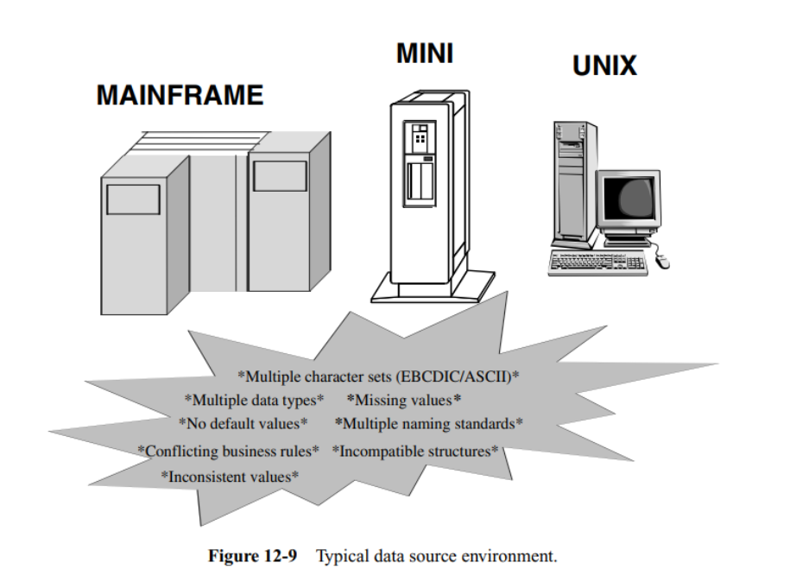
- Discuss different techniques and processes of applying data with the help of a diagram.
Ans:
BOOK PAGE NO 280
ALL THE CONTENT RELATED TO THIS TOPIC MENTIONED IN THE PPT IS DISPLAYED HERE
FOR MORE REFER BOOK
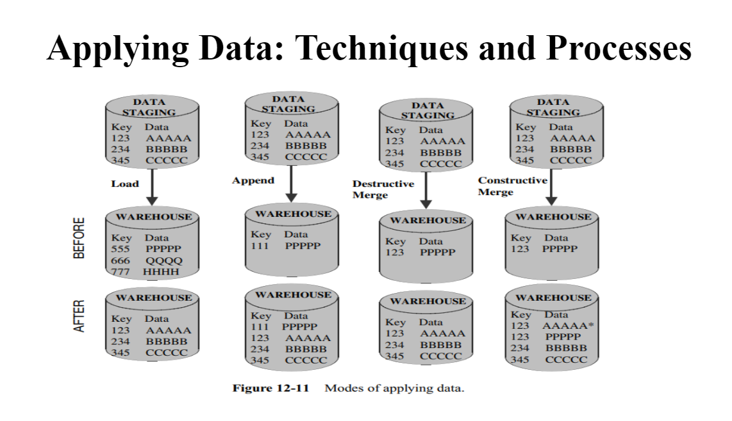
- Load: Just add new data to the empty spots.
- Append: Add new data next to the old data.
- Destructive Merge: Replace old data with new data if they have the same key.
- Constructive Merge: Keep both old and new data if they have the same key.
Understanding the Parts
- Data Staging: This is where new data is temporarily stored before it goes to the main storage. Think of it like a waiting room where new data waits.
- Warehouse: This is the main storage where data is kept for a long time. Think of it like a big library where all the books (data) are stored.
Load
- Before: The warehouse has three items of data with keys 555, 666, and 777.
- Action: We move the data from the Data Staging to the Warehouse.
- After: The new data with keys 123, 234, and 345 is added to the warehouse.
Append
- Before: The warehouse has one item of data with key 111.
- Action: We add the new data from the Data Staging to the existing data in the Warehouse.
- After: The new data with keys 123, 234, and 345 is added alongside the existing data.
Destructive Merge
- Before: The warehouse has one item of data with key 123.
- Action: The new data from the Data Staging replaces the existing data with the same keys in the Warehouse.
- After: The data with key 123 is replaced by new data, and other new data is added.
Constructive Merge
- Before: The warehouse has one item of data with key 123.
- Action: The new data from the Data Staging is combined with the existing data, so both old and new data with the same key are kept.
- After: The warehouse has both the old and new data with key 123, along with the other new data.
Load: You put new books on an empty shelf.
Append: You add new books next to the ones already there.
Destructive Merge: You replace old books with new editions.
Constructive Merge: You keep both the old and new editions of the books.

