DC Characteristics of an n-Channel MOS Transistor (MOSFET)
Two-Dimensional Device Simulation Using the Semiconductor Module of COMSOL Multiphysics® 6.2
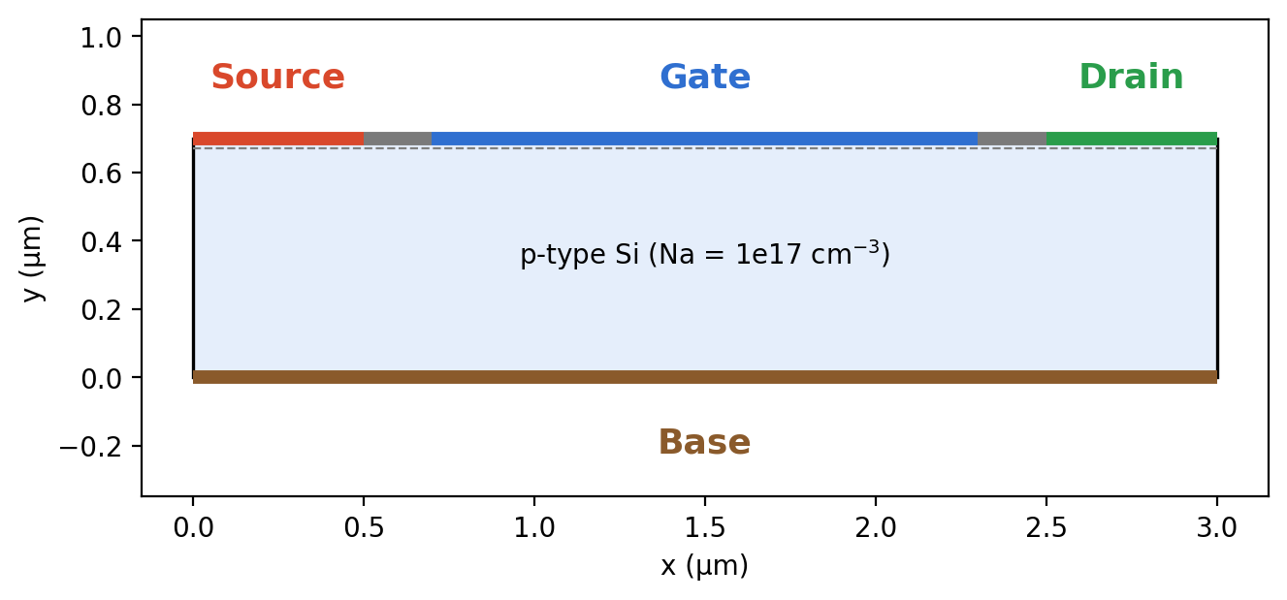
Simulated device cross-section: source, gate, drain and base contacts on a p-type silicon substrate

Table of Contents
Abstract 3
1. Introduction 4
1.1 Background 4
1.2 Objectives 4
1.3 Scope of the Work 4
2. Theoretical Background 5
2.1 Operating Regions of a MOSFET 5
2.2 Threshold Voltage 5
2.3 Equilibrium Carrier Densities 5
2.4 Current–Voltage Relations and Small-Signal Parameters 6
3. Model Definition and Simulation Methodology 7
3.1 Model Wizard and Global Parameters 7
3.2 Geometry 7
3.3 Material and Physics Settings 8
3.4 Doping Profiles 8
3.5 Boundary Conditions 8
3.6 Mesh 9
3.7 Studies 9
4. Results and Discussion 10
4.1 Doping Distribution 10
4.2 Transfer Characteristic and Threshold Voltage 11
4.3 Output Characteristics 11
4.4 Channel Formation and Pinch-off 13
4.5 Small-Signal Parameters 14
4.6 Summary of Results 14
5. Limitations and Sources of Error 15
6. Conclusions 16
7. Future Scope 17
References 18
Appendix : Modelling Workflow Summary 19

Abstract
This project investigates the direct-current (DC) behaviour of an n-channel metal-oxide-semiconductor field-effect transistor (MOSFET) using two-dimensional numerical device simulation in COMSOL Multiphysics® 6.2 with the Semiconductor Module. The device is a 3 µm × 0.7 µm p-type silicon structure (background acceptor concentration N_{a} = 10¹⁷ cm⁻³) with Gaussian-profiled n⁺ source and drain implants (peak donor concentration N_{d} = 10²⁰ cm⁻³), a 30 nm gate insulator of relative permittivity 4.5, and grounded source and substrate contacts. Fermi–Dirac statistics, Jain–Roulston band-gap narrowing and Shockley–Read–Hall recombination were included.
Two stationary studies were performed. In the first, the drain voltage was fixed at 10 mV and the gate voltage was swept from 0 to 4 V, giving a threshold voltage of approximately 1.2 V, in close agreement with the analytical estimate of 1.18 V. In the second, the drain voltage was swept from 0 to 5 V at gate voltages of 2, 3 and 4 V, reproducing the linear, non-linear and saturation regions of the output characteristic. The saturation current rises from about 25 µA at V_{G} = 2 V to about 140 µA at 3 V and about 350–370 µA at 4 V, consistent with square-law behaviour, and a slight positive slope in saturation reveals the onset of short-channel effects. Electron-concentration and potential maps at V_{D} = 0, 1 and 5 V visualise the inversion channel and its pinch-off near the drain. Small-signal parameters, including output conductance and output resistance, were extracted from the simulated curves.
Keywords: MOSFET, COMSOL Multiphysics, semiconductor device simulation, threshold voltage, output characteristics, pinch-off, short-channel effect.

1. Introduction

1.1 Background
The MOSFET is by far the most widely used semiconductor device and is the primary building block of processors, memories and digital integrated circuits. Since the first microprocessors appeared roughly four decades ago, the device has undergone tremendous development, and it is now manufactured with feature sizes of 22 nm and below.
A MOSFET is essentially a miniaturised switch. In the structure studied here, the source and drain are ohmic contacts to heavily doped n-type regions formed in a p-type substrate. The gate electrode lies above the p-type region, slightly overlapping the two n-type regions, and is separated from the semiconductor by a thin insulating layer so that the gate and the underlying semiconductor form a capacitor. Applying a voltage to the gate alters the local band structure beneath it through the field effect. A sufficiently high gate voltage inverts a thin layer of the semiconductor from p-type to n-type; this inversion layer, or channel, connects the source and drain regions and has a much lower resistance than the back-to-back n⁺p / pn⁺ junctions that isolate them when the gate voltage is low. The gate voltage at which significant current begins to flow is called the threshold or turn-on voltage.
Numerical simulation is invaluable for studying such devices because it exposes internal quantities (carrier densities, potential, fields) that cannot be measured directly, and allows geometry, doping and bias to be varied rapidly and at no fabrication cost.

1.2 Objectives
- To build a two-dimensional physical model of an n-channel MOSFET in COMSOL Multiphysics® 6.2, including geometry, doping, contacts, gate insulator and mesh.
- To obtain the transfer characteristic (I_{D} versus V_{G}) at a small drain bias and to determine the threshold voltage, comparing it with an analytical estimate.
- To obtain the output characteristics (I_{D} versus V_{D}) for several gate voltages and identify the linear, non-linear and saturation regions.
- To visualise the electron concentration and electric potential inside the device and to explain current saturation through the pinch-off mechanism.
- To extract small-signal quantities (output conductance and resistance) from the simulated characteristics.

1.3 Scope of the Work
The study is restricted to DC (stationary) analysis of a single long-to-moderate channel device (gate length 1.6 µm) in two dimensions. Transient, small-signal AC, temperature-dependent and reliability effects are outside the scope of this work. The simulation follows the structure and procedure of the COMSOL Application Library model DC Characteristics of a MOS Transistor , with modifications to the geometry parameters and mesh settings described in Section 3.

2. Theoretical Background

2.1 Operating Regions of a MOSFET
For a gate voltage above threshold, the drain current of an n-channel MOSFET passes through three regimes as the drain voltage is increased:
- Linear (ohmic) region – at small V_{D} the channel behaves as a gate-controlled resistor and I_{D} increases almost linearly with V_{D}.
- Non-linear region – at intermediate V_{D} the potential drop along the channel reduces the local gate-to-channel voltage toward the drain, narrowing the channel and causing the I_{D}–V_{D} curve to bend over.
- Saturation region – when the channel is pinched off at the drain end, further increases in V_{D} produce little additional current, and the device behaves approximately as a voltage-controlled constant-current source.
Pinch-off occurs because the voltage between the gate and the channel varies with position: as current flows, the potential along the channel rises from the source toward the drain, so the inversion-layer width is no longer constant. A larger gate voltage yields a wider channel, lower resistance for a given drain voltage and a higher saturation current.

2.2 Threshold Voltage
The threshold voltage of a MOS structure may be approximated (Sze and Ng, 2007) by
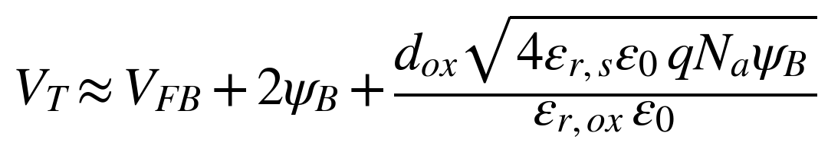 (1)
where d_{ox} is the oxide thickness, ε_{r,ox} and ε_{r,s} are the relative permittivities of the oxide and semiconductor, ε₀ is the permittivity of free space, q is the elementary charge and N_{a} is the acceptor concentration under the gate. The flat-band voltage V_{FB} and the potential difference between the intrinsic level and the Fermi level, ψ_{B}, are
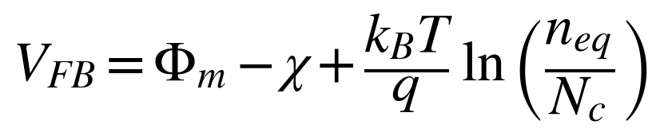 (2)
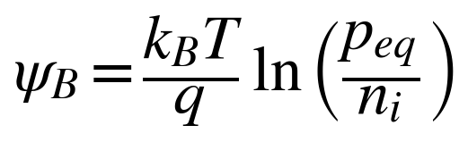 (3)
Here Φ_{m} is the work function of the metal contact, χ is the semiconductor electron affinity, k_{B} is Boltzmann’s constant, T is the absolute temperature, N_{c} is the effective density of states in the conduction band and n_{i} is the intrinsic carrier density.

2.3 Equilibrium Carrier Densities
Assuming complete ionisation and Maxwell–Boltzmann statistics (reasonable under the gate), the equilibrium electron and hole densities are
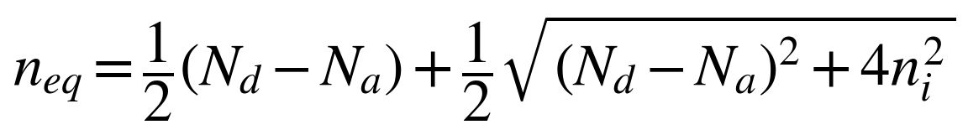 (4)
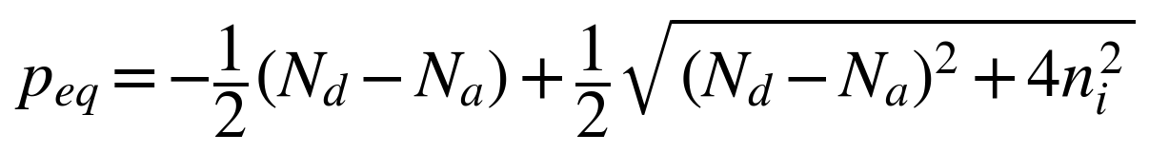 (5)
with N_{d} the donor concentration under the gate. For the substrate used here (N_{a} = 10¹⁷ cm⁻³, N_{d} ≈ 0), these relations give ψ_{B} ≈ 0.42 V for n_{i} ≈ 10¹⁰ cm⁻³ at 300 K, so strong inversion begins when the surface potential reaches about 2ψ_{B} ≈ 0.83 V. Together with the depletion-charge term of Eq. (1) (≈ 1.25 V for a 30 nm oxide of permittivity 4.5), this indicates that the threshold voltage is dominated by the oxide and doping parameters, while the flat-band voltage (which depends on the contact work function) shifts it by an additional negative offset. The reference model reports an analytical value of V_{T} = 1.18 V.

2.4 Current–Voltage Relations and Small-Signal Parameters
For a long-channel device, the classical gradual-channel approximation gives, in the linear region and in saturation respectively,
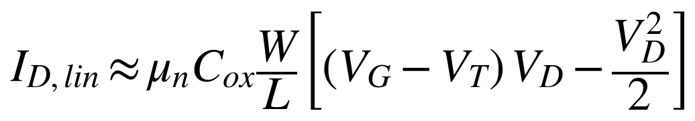 (6)
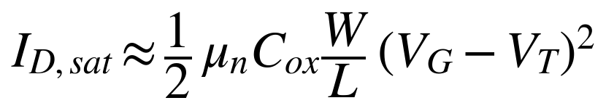 (7)
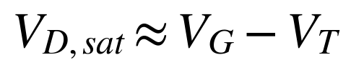 (8)
where μ_{n} is the electron mobility, C_{ox} the oxide capacitance per unit area and W/L the width-to-length ratio. Equation (7) predicts that the saturation current scales with the square of the gate overdrive (V_{G} − V_{T}), and Eq. (8) gives the saturation voltage. Real short-channel devices deviate from these expressions; nonetheless they remain a useful benchmark. The small-signal parameters of interest are
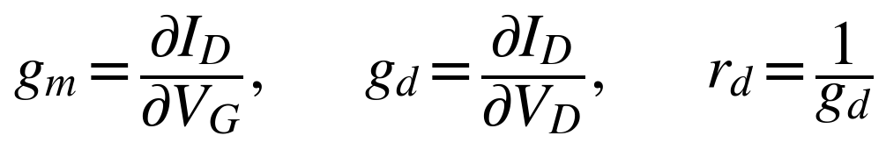 (9)
where g_{m} is the transconductance (slope of the transfer characteristic), g_{d} is the output conductance (slope of the output characteristic) and r_{d} is the output resistance. In an ideal long-channel device g_{d} → 0 in saturation and r_{d} → ∞; a finite r_{d} is a signature of channel-length modulation and other short-channel effects.
Internally, COMSOL solves the Poisson equation for the electrostatic potential together with the electron and hole continuity (drift–diffusion) equations, with the doping profile, recombination and boundary conditions supplying the source terms and constraints.

3. Model Definition and Simulation Methodology
This section documents the complete simulation set-up so that the study can be reproduced. The device is connected as shown in Fig. 1: both the source and the base (substrate) are grounded, while the drain and gate voltages are varied.
Figure 1: Model geometry with the source, gate, drain and base terminals and the p-type silicon substrate (N_{a} = 10¹⁷ cm⁻³).

3.1 Model Wizard and Global Parameters
A 2D model was created with the Semiconductor (semi) physics interface and a Stationary study, since a stationary solution is required to analyse the steady-state electric potential and current. Two global parameters were defined for later parametric sweeps:
Table 1: Global parameters
Name | Expression | Value | Description
V_{d} | 10[mV] | 0.01 V | Drain voltage
V_{g} | 2[V] | 2 V | Gate voltage

3.2 Geometry
The geometry was defined in micrometres. A rectangle of width 3 µm and height 0.7 µm represents the silicon substrate (a rectangular, two-dimensional cross-section of length L and thickness b). A closed-curve polygon was then added on top of the rectangle to define the split points for the source, gate and drain contacts, together with a line at y = 0.67 µm that assists mesh generation. Its coordinates are given in Table 2.
Table 2: Polygon vertices (closed curve)
Vertex | 1 | 2 | 3 | 4 | 5 | 6 | 7 | 8
x (µm) | 0 | 0 | 0.5 | 0.7 | 2.3 | 2.5 | 3 | 3
y (µm) | 0.67 | 0.7 | 0.7 | 0.7 | 0.7 | 0.7 | 0.7 | 0.67

Mesh Control Edges were used to control the size and distribution of the mesh by virtually removing selected geometric entities. Boundary numbering is shown in Fig. 2 and the role of each boundary is listed in Table 4.
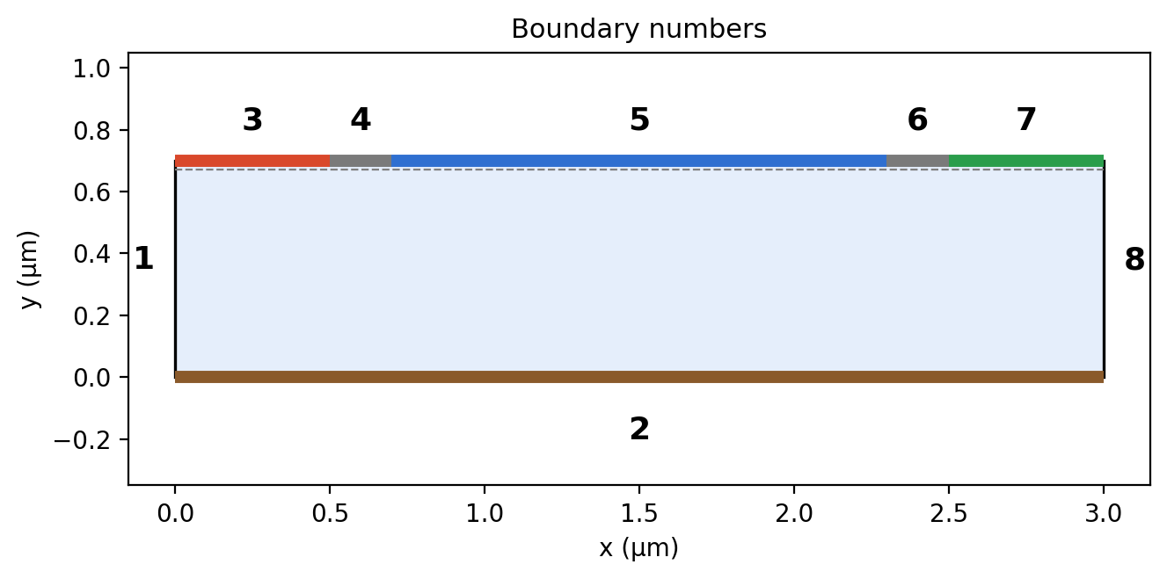
Figure 2: Boundary numbering of the geometry (boundaries 1–8).

3.3 Material and Physics Settings
Material. Silicon (Semiconductors > Si – Silicon) from the COMSOL material library was assigned to the domain. Carrier statistics. Fermi–Dirac statistics were selected in the Semiconductor interface, which remains accurate in the very heavily doped source and drain regions. Band-gap narrowing. The Jain–Roulston model was activated in the Semiconductor Material Model to account for the reduction of the band gap at high doping. Recombination. Trap-assisted (Shockley–Read–Hall) recombination with the default parameters was applied on all domains, so that carrier recombination and generation are considered throughout the geometry.

3.4 Doping Profiles
Three Analytic Doping Model features were used, all applied to all domains:
Table 3: Analytic doping models
Feature | Type / role | Key settings | Profile
Model 1 | Uniform acceptor background | N_{A0} = 1×10¹⁷ cm⁻³ | Constant
Model 2 | Source n⁺ implant (box distribution) | r₀ = (0, 0.6) µm; W = 0.6 µm; D = 0.1 µm; N_{D0} = 1×10²⁰ cm⁻³ | Gaussian, d_{j} = (0.2, 0.25) µm
Model 3 | Drain n⁺ implant (duplicate of Model 2) | r₀ = (2.4, 0.6) µm; other settings as Model 2 | Gaussian, d_{j} = (0.2, 0.25) µm

For the box distribution, a rectangular region of constant doping is defined and the Gaussian fall-off occurs away from its edges. Because the implant is doped into a background of opposite type, the length scale d_{j} specifies the junction depth; different scales were used in the lateral (x = 0.2 µm) and vertical (y = 0.25 µm) directions. The background acceptor concentration was selected in the N_{b} list for the Gaussian profile.

3.5 Boundary Conditions
Table 4: Boundary assignments
Boundary | Location | Boundary condition | Setting
1, 8 | Left / right walls | Insulation (default) | –
2 | Bottom (base) | Metal contact, ideal ohmic | 0 V (grounded)
3 | x = 0 – 0.5 µm | Metal contact 1 (source), ideal ohmic | 0 V (default terminal)
4, 6 | Gaps between terminals | Insulation (default) | –
5 | x = 0.7 – 2.3 µm | Thin insulator gate | V₀ = V_{g}; ε_{ins} = 4.5; d_{ins} = 30 nm
7 | x = 2.5 – 3 µm | Metal contact 2 (drain), ideal ohmic | V₀ = V_{d}

The Metal Contact feature is a terminal-type boundary condition; by default it applies a fixed potential of 0 V, which is appropriate for the grounded source and base. The gate dielectric is not represented explicitly: the Thin Insulator Gate condition models both the gate contact and the thin oxide layer through its permittivity and thickness. Its charge setting refers to charge on the conductor and not to trapped charge at the oxide–semiconductor interface.

3.6 Mesh
A user-controlled mesh was used, combining an edge mesh along the contact boundaries (where the surface channel forms and gradients are steepest), a mapped mesh in the substrate with a graded boundary-layer distribution, and free triangular elements elsewhere. The maximum element growth rate was set to 1.05. Table 5 lists the settings, including those that were changed relative to the reference model.
Table 5: Mesh settings
Setting | Value used | Comment
Sequence type | User-controlled | –
Maximum element growth rate | 1.05 | Smooth size transition
Edge mesh: boundaries | 3 – 7 | Contact and gap boundaries
Edge mesh: max. element size | 0.08 µm | Modified (reference: 0.03 µm)
Mapped mesh: domain | Domain 2 | Adjust edge mesh enabled
Distribution: elements | 10 | Modified (reference: 8)
Distribution: element ratio | 10 | Modified (reference: 9)
Growth / direction | Exponential, reversed | Fine near the surface

3.7 Studies
Study 1 – transfer characteristic. A stationary study with an auxiliary sweep (all combinations) was defined with V_{d} = 0.01 V fixed and V_{g} = range(0, 0.2, 1.4), 2, 3, 4 V. The gate voltage is swept with uneven steps to reduce computation time and file size; continuation on V_{g} uses the previous solution as the initial guess and lets the solver insert intermediate steps if necessary.
Study 2 – output characteristics. A second stationary study swept V_{d} from 0 to 5 V for V_{g} = 2, 3 and 4 V. Results were post-processed with 1D plot groups of the terminal current (semi.IO_2, in µA) and with 2D surface plots of the electron concentration and the electric potential.

4. Results and Discussion

4.1 Doping Distribution
Fig. 3 shows the donor concentration of the source implant (Analytic Doping Model 2): a plateau of 10²⁰ cm⁻³ in the box region (x ≤ 0.6 µm, y ≥ 0.6 µm) with a Gaussian roll-off beyond its edges. Duplicating the feature at x = 2.4 µm produces the drain implant, and the signed dopant concentration N_{d} − N_{a} (Fig. 4) shows both n⁺ regions embedded in the p-type substrate.
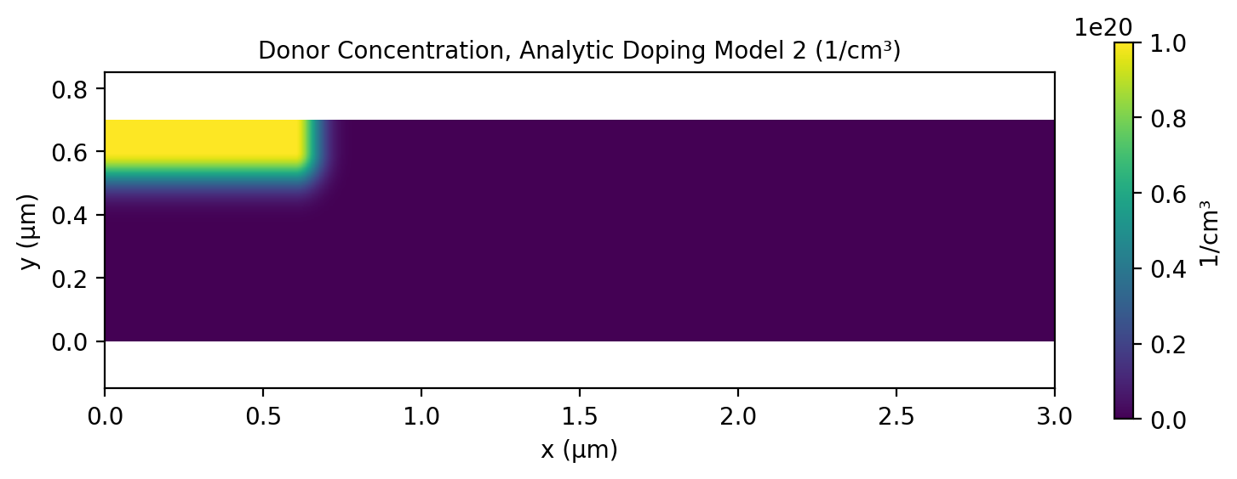
Figure 3: Donor concentration of Analytic Doping Model 2 (source implant).
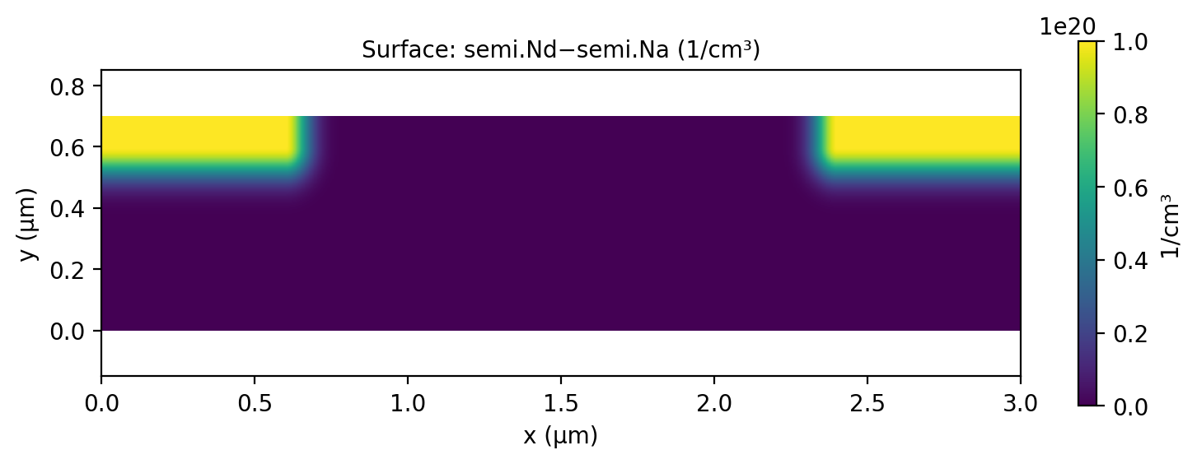
Figure 4: Signed dopant concentration N_{d} − N_{a} showing the source and drain regions.
The net doping plot (Fig. 5) uses a red scale for p-type and a blue scale for n-type material on a logarithmic axis. The metallurgical junctions lie at a depth of roughly 0.35 µm below the top surface (y ≈ 0.35 µm), and the lateral diffusion under the gate edges produces the required overlap between the n⁺ regions and the gate. The n⁺ regions extend to about x ≈ 0.8 µm on the source side and start at about x ≈ 2.2 µm on the drain side, so the metallurgical channel length is approximately 1.4 µm, slightly shorter than the 1.6 µm gate.
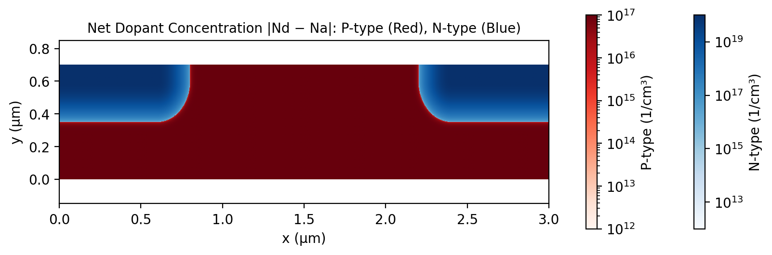
Figure 5: Net dopant concentration |N_{d} − N_{a}| – p-type (red) and n-type (blue).

4.2 Transfer Characteristic and Threshold Voltage
Fig. 6 shows the drain current as a function of gate voltage for V_{D} = 10 mV. For V_{G} below about 1 V the current remains at its very low off-state level, then rises sharply as the inversion layer forms, and beyond about 1.5 V increases almost linearly with V_{G}, as expected for a device operating in the linear region with a small drain bias. The threshold voltage read from the curve is V_{T} ≈ 1.2 V.
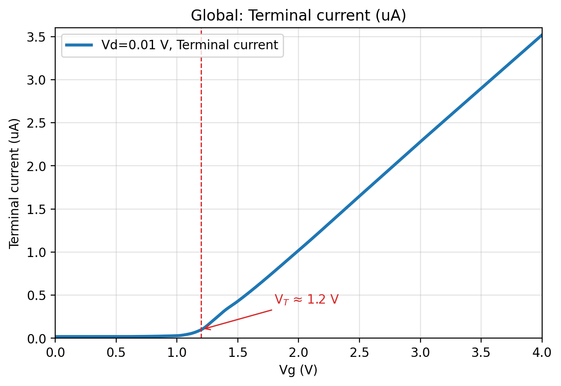
Figure 6: Drain current versus gate voltage for V_{D} = 10 mV; threshold voltage V_{T} ≈ 1.2 V.
As a cross-check, extrapolating the linear portion of the curve (about 1.0 µA at V_{G} = 2 V and 3.5 µA at 4 V, giving a slope of ≈ 1.25 µS) back to zero current yields an intercept of approximately 1.18 V, which agrees with the simulated value and with the analytical estimate of 1.18 V obtained from Eq. (1) in the reference model. The small discrepancy between analytical and numerical thresholds is expected, because the analytical expression assumes complete ionisation, Maxwell–Boltzmann statistics and a one-dimensional, long-channel structure. Between the off state (≈ 0.02 µA) and V_{G} = 4 V (≈ 3.5 µA) the current changes by more than two orders of magnitude at V_{D} = 10 mV, confirming that the gate effectively switches the device from a high-resistance to a low-resistance state.

4.3 Output Characteristics
Fig. 7 presents I_{D} versus V_{D} for V_{G} = 2, 3 and 4 V. All three curves display the classical three regions: a linear region at low V_{D}, a non-linear region at intermediate voltages, and an approximately constant-current saturation region at higher V_{D}. The current level increases strongly with gate voltage, since a larger V_{G} produces a wider, more conductive channel.
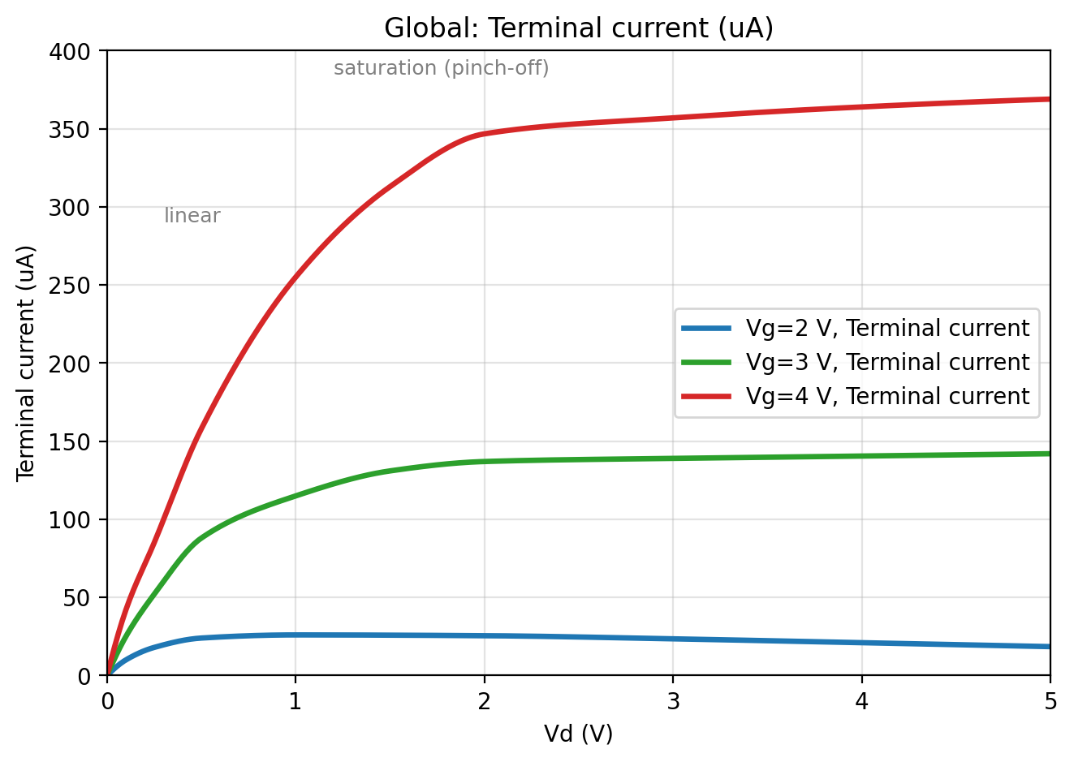
Figure 7: Drain current versus drain voltage for V_{G} = 2, 3 and 4 V.
Table 6: Output-characteristic summary (values read from Fig. 7)
V_{G} (V) | Overdrive V_{G} − V_{T} (V) | Approx. knee (saturation onset) V_{D} (V) | Saturation current I_{D,sat} (µA) | K = 2I_{D,sat}/(V_{G} − V_{T})² (µA/V²)
2 | 0.8 | ≈ 0.5 | ≈ 25 | ≈ 78
3 | 1.8 | ≈ 2 | ≈ 137 – 142 | ≈ 85
4 | 2.8 | ≈ 2 | ≈ 347 – 369 | ≈ 89

The last column tests the square-law relation of Eq. (7): if the device followed it, K = μ_{n}C_{ox}W/L would be independent of V_{G}. The computed values fall within about ±7 % of a mean of ≈ 84 µA/V², confirming that the saturation current scales approximately with (V_{G} − V_{T})². The remaining deviations are attributed to mobility degradation and short-channel effects.
Two features deserve comment. First, at V_{G} = 3 V the knee occurs near V_{D} ≈ 2 V, close to the long-channel prediction V_{D,sat} = V_{G} − V_{T} ≈ 1.8 V, whereas at V_{G} = 4 V the observed knee (≈ 2 V) is well below the predicted 2.8 V. Saturation therefore sets in earlier than the simple theory predicts at high overdrive, a typical signature of velocity saturation and short-channel behaviour. Second, the curves are not perfectly flat in saturation: at V_{G} = 4 V the current creeps from about 347 µA at 2 V to about 369 µA at 5 V. This slight gradient is due to the onset of short-channel effects, which mean that the standard analytic expressions for saturation voltage and current are inaccurate, although the predicted saturation voltages are of a similar magnitude.
At V_{G} = 2 V, which is only 0.8 V above threshold, the current is small (≈ 25 µA) and decreases slightly at large V_{D} (to ≈ 18 µA at 5 V). In this low-overdrive case the channel is very thin and strongly influenced by the drain field, and the gate control near the drain end is weakened as V_{D} grows; the decrease is thus a second-order effect of the short-channel geometry and the drain-induced potential redistribution rather than a failure of saturation.

4.4 Channel Formation and Pinch-off
Fig. 8 shows the electron concentration (left) and electric potential (right) at V_{G} = 4 V for V_{D} = 5 V, 1 V and 0 V. The electron concentration spans more than fifteen orders of magnitude, from about 10⁴ cm⁻³ in the depleted substrate to about 10²⁰ cm⁻³ in the n⁺ source and drain.
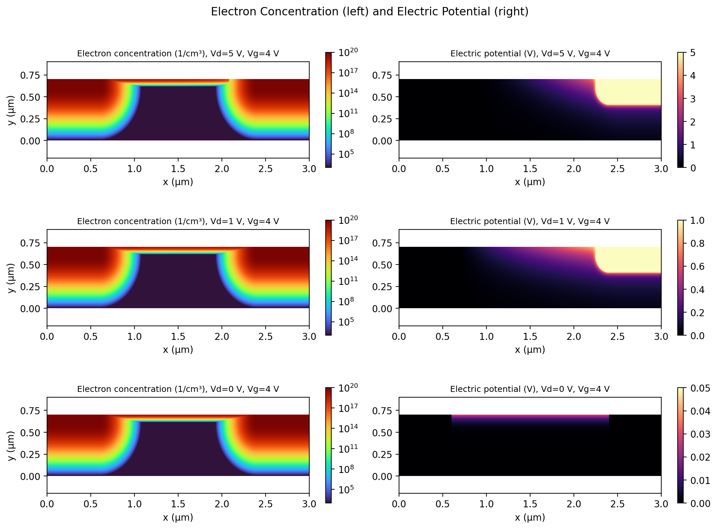
Figure 8: Electron concentration (left) and electric potential (right) at V_{G} = 4 V for V_{D} = 5 V (top), 1 V (middle) and 0 V (bottom).
- V_{D} = 0 V (equilibrium in the channel). A thin, uniform electron layer just below the gate oxide (of the order of tens of nanometres thick) connects the source and drain n⁺ regions: this is the inversion channel. The potential is essentially zero everywhere apart from small variations (< 0.05 V) beneath the gate, and no current flows because there is no lateral field.
- V_{D} = 1 V. The channel remains continuous, but a potential gradient now exists along it. The drain-side potential rises along the channel and the gate-to-channel voltage falls toward the drain; at this bias the thinning of the electron layer is still slight, corresponding to the non-linear part of the I–V curve.
- V_{D} = 5 V. The potential in the drain region is 5 V and the potential near the surface rises steeply towards the drain end of the channel. The gate-to-channel voltage is reduced there, so the inversion layer at the drain end is markedly thinner than at the source end. This is the pinch-off condition: the channel narrows at one end because of the field parallel to the surface, and the current saturates.
This picture explains why the drain current is nearly independent of V_{D} in saturation: once the channel is pinched off, additional drain voltage is dropped across the narrow pinched region between the channel end and the drain, while the voltage along the conducting channel stays approximately fixed at V_{G} − V_{T}. Carriers reaching the pinched-off region are swept into the drain by the high field.

4.5 Small-Signal Parameters
The slope of the V_{G} = 4 V output characteristic between V_{D} = 1 V (y₁ = 255.09 µA) and V_{D} = 2 V (y₂ = 346.77 µA) was calculated from the simulated data:
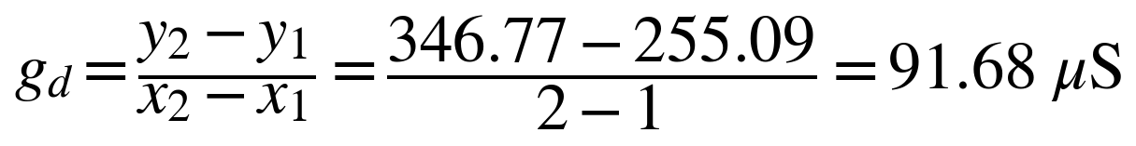 (10)
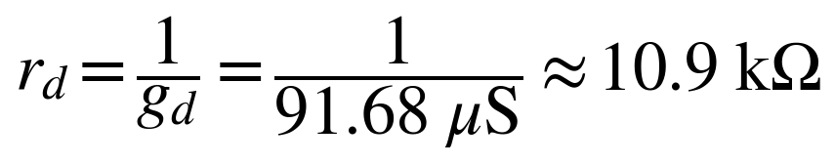 (11)
Because this is the slope of I_{D} with respect to V_{D}, it is the output conductance g_{d} and the corresponding output resistance r_{d} (≈ 0.0109 MΩ). It applies to the pre-saturation, non-linear part of the curve and is therefore relatively large. In true saturation (V_{D} from 2 V to 5 V) the same calculation gives a slope of only (369 − 347)/3 ≈ 7 µS, i.e. r_{d} ≈ 135 kΩ – an order of magnitude higher, illustrating that the device approaches an ideal current source in saturation, with the finite r_{d} caused by short-channel effects.
The transconductance g_{m} = ∂I_{D}/∂V_{G} can be obtained from the transfer characteristic: at V_{D} = 10 mV, the linear region of Fig. 6 gives g_{m} ≈ 1.25 µS. From the output curves at V_{D} = 5 V, the current increases from about 142 µA at V_{G} = 3 V to about 369 µA at 4 V, giving a saturation transconductance g_{m} ≈ 227 µS. The corresponding intrinsic voltage gain g_{m}/g_{d} is therefore of the order of 30, demonstrating the amplifying capability of the device in saturation.

4.6 Summary of Results
Table 7: Key results
Quantity | Value | Reference / comment
Threshold voltage (simulation) | ≈ 1.2 V | V_{D} = 10 mV
Threshold voltage (analytical) | 1.18 V | Eq. (1), reference model
Saturation current, V_{G} = 2 V | ≈ 25 µA | Low overdrive
Saturation current, V_{G} = 3 V | ≈ 137 – 142 µA | –
Saturation current, V_{G} = 4 V | ≈ 347 – 369 µA | Slight slope: short-channel effect
Output conductance g_{d} (V_{D} = 1 – 2 V, V_{G} = 4 V) | 91.68 µS | r_{d} ≈ 10.9 kΩ
Output conductance in saturation (2 – 5 V) | ≈ 7 µS | r_{d} ≈ 135 kΩ
Saturation transconductance g_{m} (V_{D} = 5 V, V_{G} = 3 – 4 V) | ≈ 227 µS | Read from Fig. 7

5. Limitations and Sources of Error
- Two-dimensional model. The simulation is 2D, so the terminal current is expressed per unit out-of-plane depth as set in the model (the default was retained). Absolute current levels should be interpreted qualitatively and compared with other results only in relative terms.
- Mesh resolution. The maximum edge element size of 0.08 µm is coarser than the 0.03 µm of the reference model, and the boundary-layer distribution was altered. Small differences in the curves relative to the reference are therefore expected; a mesh-convergence study would quantify them.
- Graph-derived values. Several quantities in Tables 6 and 7 were read from the plots and are approximate (typically ± 3–5 %).
- Simplified gate stack. The oxide is modelled through the Thin Insulator Gate condition, so interface traps, fixed oxide charge, quantum confinement and gate leakage are not included.
- Physical models. Default mobility and SRH parameters were used, no self-heating or temperature dependence was studied, and the analytical threshold comparison relies on complete ionisation and Maxwell–Boltzmann statistics.
- Threshold definition. The threshold voltage was determined graphically and by linear extrapolation; other definitions (constant-current, maximum transconductance) could give slightly different values.

6. Conclusions
A two-dimensional n-channel MOSFET was modelled in COMSOL Multiphysics® 6.2 and its DC characteristics were successfully simulated. The main conclusions are:
- The threshold voltage of the device is approximately 1.2 V, in good agreement with the analytical value of 1.18 V and with the extrapolated linear-region intercept.
- The output characteristics exhibit linear, non-linear and saturation regions; the saturation current increases from about 25 µA to about 140 µA and about 350–370 µA as V_{G} is raised from 2 V to 3 V and 4 V, scaling approximately with the square of the gate overdrive (K ≈ 84 µA/V²).
- Electron-concentration and potential maps confirm the formation of an inversion channel under the gate and its pinch-off at the drain end for high V_{D}, which is the physical origin of current saturation. In saturation the device behaves approximately as a constant-current source.
- The slight rise of current in saturation and the earlier-than-predicted onset of saturation at high V_{G} show the influence of short-channel effects, which make the simple long-channel expressions only approximately valid.
- The output conductance is about 92 µS (r_{d} ≈ 10.9 kΩ) in the non-linear region and only about 7 µS (r_{d} ≈ 135 kΩ) in saturation, and the intrinsic gain in saturation is of order 30.
Overall, the study demonstrates that finite-element device simulation reproduces the essential physics of MOSFET operation and provides insight into internal quantities that are inaccessible experimentally.

7. Future Scope
- Perform a mesh-convergence study and compare the 0.08 µm and 0.03 µm edge meshes quantitatively.
- Vary the gate length, oxide thickness, substrate doping and junction depth to study their influence on threshold voltage, saturation current and short-channel effects (drain-induced barrier lowering, channel-length modulation).
- Study the sub-threshold region on a logarithmic current scale to extract the sub-threshold swing and on/off ratio.
- Investigate other semiconductor materials (for example germanium or III–V channels) and high-k gate dielectrics.
- Add a small-signal (frequency-domain) analysis to determine capacitances and cut-off frequency, and a transient study for switching behaviour.
- Include temperature dependence and interface-trap models to assess reliability and variability.

References
[1] S. M. Sze and K. K. Ng, Physics of Semiconductor Devices, 3rd ed., John Wiley & Sons, 2007, pp. 305–306.
[2] COMSOL AB, DC Characteristics of a MOS Transistor (MOSFET), Application Library model, Semiconductor_Module/Transistors/mosfet, COMSOL Multiphysics® version 6.2.
[3] COMSOL AB, Semiconductor Module User’s Guide, COMSOL Multiphysics® version 6.2.
[4] Y. Taur and T. H. Ning, Fundamentals of Modern VLSI Devices, 3rd ed., Cambridge University Press, 2021.
[5] S. C. Jain and D. J. Roulston, “A simple expression for band gap narrowing (BGN) in heavily doped Si, Ge, GaAs and Ge_{x}Si_{1−x} strained layers,” Solid-State Electronics, vol. 34, no. 5, pp. 453–465, 1991.
[6] W. Shockley and W. T. Read, “Statistics of the recombinations of holes and electrons,” Physical Review, vol. 87, no. 5, pp. 835–842, 1952.

Appendix : Modelling Workflow Summary
The sequence of steps followed in COMSOL Multiphysics® 6.2 is summarised below.
Step | Stage | Main actions
1 | Model Wizard | New > Model Wizard > 2D > Semiconductor (semi) > Study > Stationary
2 | Global definitions | Parameters: V_{d} = 10[mV], V_{g} = 2[V]
3 | Geometry | Units µm; rectangle 3 × 0.7; closed polygon (Table 2); mesh control edges; remove boundary 4 of the “fin”
4 | Materials | Add Silicon to the component
5 | Semiconductor | Fermi–Dirac statistics; Analytic Doping Models 1–3
6 | Boundary conditions | Metal contacts (source B3, drain B7, base B2); Thin Insulator Gate B5 (ε = 4.5, 30 nm)
7 | Recombination / BGN | Trap-assisted recombination on all domains; Jain–Roulston band-gap narrowing
8 | Mesh | User-controlled: edge mesh (0.08 µm), mapped mesh with distribution, free triangular
9 | Plots | Signed dopant concentration (semi.Nd − semi.Na)
10 | Study 1 | V_{d} = 0.01 V; V_{g} = range(0, 0.2, 1.4), 2, 3, 4 V; plot semi.IO_2 (I_{D}–V_{G})
11 | Study 2 | V_{d} sweep 0 – 5 V at V_{g} = 2, 3, 4 V; plot semi.IO_2 (I_{D}–V_{D})
12 | Post-processing | Electron concentration and electric potential at V_{d} = 5, 1, 0 V (V_{g} = 4 V)

