Fuel Consumption Analysis System Using Python

REPORT

CSA0806– PYTHON PROGRAMMING
Course Outcomes: CO1,CO2, CO3 and CO4

Submitted by
Name: Rishiykesh K S
Register No.: 192511466
Department: CSE

Submitted to
Faculty Name: Dr S. Ponmaniraj
Institution: SIMATS Engineering.
Academic Year: 2026–2027
CERTIFICATE

This is to certify that Rishiykesh K S (192511466) of CSA0806 has successfully prepared and submitted the report entitled “Fuel Consumption Analysis System Using Python” as part of the academic requirements for CSA0806-Python programming.
The work presented in this report addresses processor-based Fuel Consumption, peripheral interfacing, signal control, interrupt handling, timing, emergency-vehicle priority, data storage and serial communication as specified in the assignment.

Faculty Signature: ____________________

Date: ________________________________

TABLE OF CONTENTS

S. no | Contents
1 | Abstract
2 | Introduction
3 | Problem Statement
4 | Objectives
5 | Requirements
6 | Application of Relevant Course Knowledge
7 | Proposed System and Methodology
8 | Algorithm
9 | Implementation and Tools Used
10 | Test Case and Expected Actual Results
11 | Results and Validation
12 | Comparison and Justification
13 | SDG Relevance
14 | Conclusion
15 | Individual Contribution of Group Members
16 | Individual Reflection
17 | References
18 | One-Page Individual Reflection

Abstract

The Fuel Consumption Analysis System is a menu-driven Python application designed to help individuals and small fleet operators monitor and analyse vehicle fuel usage efficiently. The system allows users to register vehicles, record trip and refuelling details, and calculate important fuel-efficiency metrics such as mileage, total fuel consumption, monthly consumption, and fuel cost. All records are stored persistently using CSV files, ensuring that data remains available even after the program is restarted.

The system uses Python data structures such as lists, dictionaries, tuples, and sets for efficient data management and validation. It also separates data storage, analysis, and user interaction into independent modules, making the application easier to maintain and test. The system generates consolidated reports that rank vehicles according to fuel efficiency and identifies trips with abnormally high fuel consumption using a vehicle-specific threshold. Testing confirmed that the calculated mileage, summaries, rankings, and anomaly detection results matched independently calculated values. The project demonstrates the practical application of Python programming concepts to solve a real-world fuel monitoring and sustainability problem.

Introduction

Fuel consumption is an important factor in vehicle operation because it directly affects operating costs, resource usage, and environmental impact. For individuals and small fleet operators, maintaining accurate records of fuel usage can help identify inefficient vehicles, wasteful trips, and changes in vehicle performance. However, when fuel records are maintained manually in notebooks or spreadsheets, the information can become scattered, inconsistent, and difficult to analyse.The Fuel Consumption Analysis System addresses this problem by providing a simple, menu-driven console application developed using Python. The system enables users to register vehicles and record trip and refuelling information such as distance travelled, fuel filled, odometer reading, date, and fuel price. Using these records, the application calculates vehicle mileage, total fuel consumption, monthly consumption, and estimated fuel costs.

The system also provides a consolidated fleet report that ranks vehicles from most to least fuel-efficient and identifies trips with unusually high fuel consumption. To achieve this, the application uses separate modules for data persistence and analysis, while CSV files are used to store records between program executions. Python concepts including control flow, string handling, functions, lists, dictionaries, tuples, sets, file handling, and modules are applied throughout the system.The project demonstrates how fundamental Python programming concepts can be combined to create a practical data-analysis application. By providing clear and measurable information about fuel usage, the system can help users make better decisions regarding vehicle maintenance, driving practices, and fuel efficiency while also supporting broader sustainability objectives

Problem Statement and Problem Formulation
Manual record-keeping of vehicle fuel usage in notebooks or spreadsheets makes it difficult for individuals and small fleet operators to identify inefficient vehicles or wasteful trips in time to act on them. Readings are scattered, units are inconsistent, and no consolidated view exists to compare vehicles against each other or against their own historical performance.
This assignment formulates the problem as the design and implementation of a menu-driven Python console application that allows a user to: (a) register vehicles, (b) log refuelling and trip entries (distance travelled, fuel filled, odometer reading), (c) derive metrics such as mileage (km/l), monthly consumption and estimated cost from current fuel prices, and (d) generate a consolidated report that ranks vehicles by efficiency and flags trips with abnormally high consumption. The problem is decomposed into three sub-problems: reliable persistent storage of records, correct derivation of efficiency metrics from raw trip data, and a usable, error-tolerant command-line interface that ties the two together.

Objective and Expected Outcomes
- Build a menu-driven console application that supports vehicle registration, trip/refuelling logging, per-vehicle summaries and a consolidated fleet report.
- Apply control-flow constructs, string-handling routines and well-scoped functions to validate every user input before it is stored (CO2).
- Model vehicles, trips and derived summaries using lists, dictionaries, tuples and sets, choosing each structure for the operation it performs best (CO3).
- Persist all records to disk using file handling, and separate data-access code from analysis code into independent, importable modules (CO4).
Expected outcome: a working application that, given a small set of registered vehicles and logged trips, correctly computes each vehicle's overall mileage and monthly fuel consumption, ranks vehicles from most to least efficient, and automatically flags trips whose fuel usage is significantly above that vehicle's own average - all confirmed against hand-calculated values in Section 9 (Test Cases).

Requirements, Constraints and Assumptions

Functional Requirements
- Register a vehicle with a unique registration number, make, model and starting odometer reading.
- Log a trip/refuelling event against a registered vehicle with date, distance, fuel filled, odometer and fuel price.
- View a per-vehicle summary: trip count, total distance, total fuel, overall mileage, total cost and month-wise consumption.
- Generate a consolidated report ranking all vehicles by efficiency and listing trips with abnormally high consumption.
- Persist all data between runs using CSV files.

Constraints
- Console-only interface (no GUI) built using core Python and the standard library only - no third-party packages.
- Data must survive a program restart, i.e. be written to non-volatile storage (CSV) rather than kept only in memory.
- The solution must be split into at least one custom module/package imported by the main program (data_access and analysis in this submission).

Assumptions
- Vehicle registration numbers follow the Indian format, e.g. TN22AB1234, and are used as the unique key for a vehicle.
- A trip's 'distance travelled' is the distance covered since the previous refuelling, so mileage can be computed directly as distance / fuel for that entry.
- Fuel price is entered by the user at the time of logging a trip rather than fetched from an external source, since the assignment scope excludes network access.
- A single CSV file is sufficient for the data volumes expected in this assignment (a handful of vehicles, tens of trips).

Application of Relevant Course Knowledge
Course Outcome | Concept Applied | Where used in this solution
CO1 - Syntax & Semantics | Structured, menu-driven program flow | main.py: print_menu() / main() loop and dispatch dictionary of actions
CO2 - Control Flow, Strings, Functions | if/while, regular expressions, string cleaning, function decomposition | clean_vehicle_no(), is_valid_vehicle_no(), is_valid_date(), read_positive_float()
CO3 - Lists, Dicts, Tuples, Sets | dict for O(1) vehicle look-up, list for trip logs, tuple for immutable (distance, fuel) pairs, set for duplicate/registration checks | data_access.load_vehicles() (dict), analysis.trip_mileage_kmpl() (tuple), data_access.registered_vehicle_numbers() (set)
CO4 - File Handling, Modules & Packages | csv.DictReader/DictWriter for persistence; data_access.py and analysis.py as separate importable modules | data_access.py (I/O), analysis.py (pure computation), imported into main.py

Proposed System and Methodology
The system follows a three-layer design that keeps storage, computation and interaction concerns independent of one another:
- Presentation layer (main.py) - renders the menu, reads and validates user input, and calls into the other two modules.
- Persistence layer (data_access.py) - reads and writes vehicles.csv and trips.csv, and exposes a set of registered vehicle numbers for fast duplicate checking.
- Analysis layer (analysis.py) - pure functions that take in-memory data and return computed summaries, rankings and anomaly flags, with no knowledge of files or the console.
This separation means the analysis functions can be unit-tested in isolation (Section 9) without touching disk, and the storage format could later be swapped (e.g. to SQLite) without changing a single line of analysis.py.

Data Structures Chosen and Why
Structure | Used for | Reason
dict | vehicles keyed by vehicle_no; monthly_consumption keyed by 'YYYY-MM' | O(1) look-up by a natural unique key; ideal for group-by-key aggregation
list | trips; ranking output; flagged anomalies | Order of entry / rank order matters and duplicates (multiple trips) are expected
tuple | (distance, fuel) pair inside trip_mileage_kmpl() | Groups two related, immutable values before a ratio is derived
set | registered_vehicle_numbers(); duplicate-trip keys in deduplicate_trips() | Fast membership testing for validation and de-duplication

Algorithm

Consolidated Report Generation
- Load all trip records from trips.csv into a list of dictionaries.
- Remove exact-duplicate trips by building a set of (vehicle_no, date, distance, fuel, odometer) tuples and keeping only the first occurrence of each.
- Group the remaining trips by vehicle_no into a dictionary of lists.
- For each vehicle, sum distance and fuel, and compute overall_mileage = total_distance / total_fuel.
- Sort vehicles by overall_mileage in descending order to obtain the efficiency ranking; the first and last entries are the most and least efficient vehicles.
- For each vehicle, compute the fuel-per-100km rate of every trip and the vehicle's own average rate; flag any trip whose rate exceeds 1.5 times that average as abnormal.
- Return the ranking, most/least efficient vehicle and the list of flagged trips as the consolidated report.

Trip Validation and Logging (Flowchart)
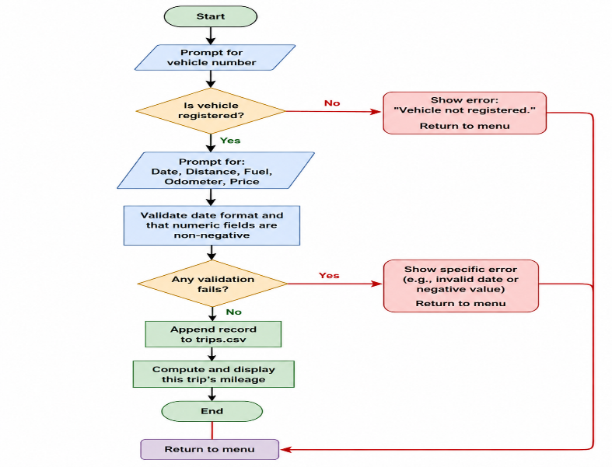

Implementation and Tools Used

Environment and Tools
Item | Details
Language | Python 3.12
Standard library modules used | csv, os, re, datetime, collections (defaultdict)
Editor / IDE | [VS Code / PyCharm - state what your team used]
Version control | Git and GitHub (repository link in Section 15 - References)
Testing | Custom assertion-based test script, test_analysis.py (no external framework required)

Project Structure
fuel_tracker/
main.py - menu-driven CLI (presentation layer)
data_access.py - CSV persistence module
analysis.py - metric computation / analysis module
test_analysis.py - unit tests for the analysis module
vehicles.csv, trips.csv - generated data files

Implementation

data_access.py
"""
data_access.py
----------------
Handles all persistence for the Fuel Consumption Analysis System.

Responsibilities (kept separate from analysis.py so that storage
details can change - e.g. CSV to a database - without touching any
of the calculation logic):
* Registering / loading vehicles -> vehicles.csv
* Logging / loading trips -> trips.csv
* Basic duplicate / existence checks using a set of vehicle numbers
"""

import csv
import os

VEHICLE_FILE = "vehicles.csv"
TRIP_FILE = "trips.csv"

VEHICLE_FIELDS = ["vehicle_no", "make", "model", "initial_odometer"]
TRIP_FIELDS = ["vehicle_no", "date", "distance_km", "fuel_litres",
"odometer", "fuel_price_per_litre"]

def _ensure_file(path, fieldnames):
"""Create the CSV file with a header row if it does not exist yet."""
if not os.path.exists(path):
with open(path, "w", newline="") as f:
writer = csv.DictWriter(f, fieldnames=fieldnames)
writer.writeheader()

def load_vehicles():
"""Return vehicles as a dict keyed by vehicle_no (registration number).

dict is used here because a vehicle number is a natural unique key and
O(1) look-up is required every time a trip is logged against it.
"""
_ensure_file(VEHICLE_FILE, VEHICLE_FIELDS)
vehicles = {}
with open(VEHICLE_FILE, newline="") as f:
for row in csv.DictReader(f):
row["initial_odometer"] = float(row["initial_odometer"])
vehicles[row["vehicle_no"]] = row
return vehicles

def save_vehicle(vehicle_no, make, model, initial_odometer):
"""Append one vehicle record to vehicles.csv."""
_ensure_file(VEHICLE_FILE, VEHICLE_FIELDS)
with open(VEHICLE_FILE, "a", newline="") as f:
writer = csv.DictWriter(f, fieldnames=VEHICLE_FIELDS)
writer.writerow({
"vehicle_no": vehicle_no,
"make": make,
"model": model,
"initial_odometer": initial_odometer,
})

def load_trips():
"""Return all trips as a list of dicts (order of logging preserved)."""
_ensure_file(TRIP_FILE, TRIP_FIELDS)
trips = []
with open(TRIP_FILE, newline="") as f:
for row in csv.DictReader(f):
row["distance_km"] = float(row["distance_km"])
row["fuel_litres"] = float(row["fuel_litres"])
row["odometer"] = float(row["odometer"])
row["fuel_price_per_litre"] = float(row["fuel_price_per_litre"])
trips.append(row)
return trips

def save_trip(vehicle_no, date, distance_km, fuel_litres, odometer, price):
"""Append one trip record to trips.csv."""
_ensure_file(TRIP_FILE, TRIP_FIELDS)
with open(TRIP_FILE, "a", newline="") as f:
writer = csv.DictWriter(f, fieldnames=TRIP_FIELDS)
writer.writerow({
"vehicle_no": vehicle_no,
"date": date,
"distance_km": distance_km,
"fuel_litres": fuel_litres,
"odometer": odometer,
"fuel_price_per_litre": price,
})

def registered_vehicle_numbers():
"""Return a *set* of vehicle numbers already registered.

A set is used purely for fast membership testing (`in`) when
validating new registrations / trip entries against duplicates.
"""
return set(load_vehicles().keys())

analysis.py
"""
analysis.py
------------
Pure computation layer for the Fuel Consumption Analysis System.
Contains no file I/O - every function takes in-memory data structures
(produced by data_access.py) and returns computed results, which keeps
the logic easy to unit-test in isolation.
"""

from collections import defaultdict

# A trip is flagged as abnormal if its litres-per-100km figure exceeds
# the vehicle's own average by more than this factor.
ANOMALY_THRESHOLD_FACTOR = 1.5

def group_trips_by_vehicle(trips):
"""Group trip dicts by vehicle_no.

Returns: dict[str, list[dict]]
"""
grouped = defaultdict(list)
for trip in trips:
grouped[trip["vehicle_no"]].append(trip)
return grouped

def trip_mileage_kmpl(trip):
"""Return km-per-litre for a single trip (tuple-based intermediate).

A (distance, fuel) tuple is used to keep the two related quantities
bound together immutably while the ratio is derived.
"""
distance, fuel = (trip["distance_km"], trip["fuel_litres"])
if fuel <= 0:
return 0.0
return round(distance / fuel, 2)

def vehicle_summary(vehicle_no, trips_for_vehicle):
"""Compute mileage, total distance/fuel/cost and monthly consumption
for one vehicle.

Returns a dict summary; monthly consumption is a dict keyed by
'YYYY-MM' (derived from each trip's date) -> total litres consumed
that month, since a dict is the natural structure for a group-by-key
aggregation.
"""
total_distance = sum(t["distance_km"] for t in trips_for_vehicle)
total_fuel = sum(t["fuel_litres"] for t in trips_for_vehicle)
total_cost = sum(t["fuel_litres"] * t["fuel_price_per_litre"]
for t in trips_for_vehicle)

monthly_consumption = defaultdict(float)
for t in trips_for_vehicle:
month_key = t["date"][:7] # 'YYYY-MM-DD' -> 'YYYY-MM'
monthly_consumption[month_key] += t["fuel_litres"]

overall_mileage = round(total_distance / total_fuel, 2) if total_fuel else 0.0

return {
"vehicle_no": vehicle_no,
"trip_count": len(trips_for_vehicle),
"total_distance_km": round(total_distance, 2),
"total_fuel_litres": round(total_fuel, 2),
"total_cost": round(total_cost, 2),
"overall_mileage_kmpl": overall_mileage,
"monthly_consumption": dict(monthly_consumption),
}

def rank_vehicles_by_efficiency(trips):
"""Return vehicles sorted from most to least fuel-efficient
(highest km/l first) as a list of summary dicts.
"""
grouped = group_trips_by_vehicle(trips)
summaries = [vehicle_summary(v, t) for v, t in grouped.items()]
return sorted(summaries, key=lambda s: s["overall_mileage_kmpl"], reverse=True)

def flag_abnormal_trips(trips):
"""Return trips whose fuel usage per 100 km is well above that
vehicle's own average - i.e. likely data-entry errors or genuinely
wasteful trips worth investigating.
"""
grouped = group_trips_by_vehicle(trips)
flagged = []
for vehicle_no, vtrips in grouped.items():
# litres per 100 km for every trip of this vehicle
rates = []
for t in vtrips:
if t["distance_km"] > 0:
rates.append(t["fuel_litres"] / t["distance_km"] * 100)
else:
rates.append(0)
if not rates:
continue
avg_rate = sum(rates) / len(rates)
for t, rate in zip(vtrips, rates):
if avg_rate > 0 and rate > avg_rate * ANOMALY_THRESHOLD_FACTOR:
flagged.append({**t, "litres_per_100km": round(rate, 2),
"vehicle_avg_l_per_100km": round(avg_rate, 2)})
return flagged

def deduplicate_trips(trips):
"""Remove exact-duplicate trip entries (same vehicle, date, distance,
fuel and odometer) using a set of tuples for O(1) duplicate checks.
"""
seen = set()
unique_trips = []
for t in trips:
key = (t["vehicle_no"], t["date"], t["distance_km"],
t["fuel_litres"], t["odometer"])
if key not in seen:
seen.add(key)
unique_trips.append(t)
return unique_trips

def consolidated_report(trips):
"""Build the final consolidated report combining ranking and
anomaly detection - this is what the menu's 'Generate Report'
option calls.
"""
clean_trips = deduplicate_trips(trips)
ranking = rank_vehicles_by_efficiency(clean_trips)
anomalies = flag_abnormal_trips(clean_trips)
return {
"ranking": ranking,
"most_efficient": ranking[0] if ranking else None,
"least_efficient": ranking[-1] if ranking else None,
"anomalies": anomalies,
}

main.py
"""
main.py
--------
Menu-driven console application for the Fuel Consumption Analysis
System. Ties together the data_access (persistence) and analysis
(computation) modules/packages.
"""

import re
from datetime import datetime

import data_access
import analysis

VEHICLE_NO_PATTERN = re.compile(r"^[A-Z]{2}\d{2}[A-Z]{1,2}\d{4}$")

# ---------------------------------------------------------------------
# String-handling / input-validation helpers
# ---------------------------------------------------------------------
def clean_vehicle_no(raw):
"""Normalise a vehicle registration number: strip spaces, upper-case."""
return raw.strip().upper().replace(" ", "")

def is_valid_vehicle_no(vehicle_no):
return bool(VEHICLE_NO_PATTERN.match(vehicle_no))

def is_valid_date(raw):
try:
datetime.strptime(raw.strip(), "%Y-%m-%d")
return True
except ValueError:
return False

def read_positive_float(prompt):
while True:
raw = input(prompt).strip()
try:
value = float(raw)
if value < 0:
print(" Value cannot be negative. Try again.")
continue
return value
except ValueError:
print(" Please enter a valid number.")

# ---------------------------------------------------------------------
# Menu actions
# ---------------------------------------------------------------------
def register_vehicle():
print("\n-- Register Vehicle --")
raw_no = input("Vehicle number (e.g. TN22AB1234): ")
vehicle_no = clean_vehicle_no(raw_no)
if not is_valid_vehicle_no(vehicle_no):
print(" Invalid format. Expected e.g. TN22AB1234.")
return
existing = data_access.registered_vehicle_numbers()
if vehicle_no in existing:
print(f" Vehicle {vehicle_no} is already registered.")
return
make = input("Make (e.g. Honda): ").strip().title()
model = input("Model (e.g. Activa): ").strip().title()
odometer = read_positive_float("Current odometer reading (km): ")
data_access.save_vehicle(vehicle_no, make, model, odometer)
print(f" Vehicle {vehicle_no} registered successfully.")

def log_trip():
print("\n-- Log Trip / Refuelling --")
vehicle_no = clean_vehicle_no(input("Vehicle number: "))
if vehicle_no not in data_access.registered_vehicle_numbers():
print(" Vehicle not found. Please register it first.")
return
date = input("Date (YYYY-MM-DD): ").strip()
if not is_valid_date(date):
print(" Invalid date format.")
return
distance = read_positive_float("Distance travelled since last fill (km): ")
fuel = read_positive_float("Fuel filled (litres): ")
odometer = read_positive_float("Current odometer reading (km): ")
price = read_positive_float("Fuel price per litre (Rs.): ")
data_access.save_trip(vehicle_no, date, distance, fuel, odometer, price)
kmpl = analysis.trip_mileage_kmpl(
{"distance_km": distance, "fuel_litres": fuel})
print(f" Trip logged. This trip's mileage: {kmpl} km/l")

def view_vehicle_summary():
print("\n-- Vehicle Summary --")
vehicle_no = clean_vehicle_no(input("Vehicle number: "))
trips = analysis.group_trips_by_vehicle(data_access.load_trips())
if vehicle_no not in trips:
print(" No trips logged for this vehicle yet.")
return
summary = analysis.vehicle_summary(vehicle_no, trips[vehicle_no])
_print_summary(summary)

def _print_summary(summary):
print(f" Vehicle : {summary['vehicle_no']}")
print(f" Trips logged : {summary['trip_count']}")
print(f" Total distance : {summary['total_distance_km']} km")
print(f" Total fuel used : {summary['total_fuel_litres']} L")
print(f" Overall mileage : {summary['overall_mileage_kmpl']} km/l")
print(f" Total fuel cost : Rs. {summary['total_cost']}")
print(" Monthly consumption:")
for month, litres in sorted(summary["monthly_consumption"].items()):
print(f" {month}: {round(litres, 2)} L")

def generate_report():
print("\n-- Consolidated Fleet Report --")
trips = data_access.load_trips()
if not trips:
print(" No trip data available yet.")
return
report = analysis.consolidated_report(trips)

print("\n Efficiency Ranking (best to worst):")
for rank, s in enumerate(report["ranking"], start=1):
print(f" {rank}. {s['vehicle_no']:10s} "
f"{s['overall_mileage_kmpl']:6.2f} km/l "
f"(distance {s['total_distance_km']} km, "
f"fuel {s['total_fuel_litres']} L)")

if report["most_efficient"]:
print(f"\n Most efficient : {report['most_efficient']['vehicle_no']} "
f"({report['most_efficient']['overall_mileage_kmpl']} km/l)")
print(f" Least efficient: {report['least_efficient']['vehicle_no']} "
f"({report['least_efficient']['overall_mileage_kmpl']} km/l)")

print("\n Flagged trips (abnormally high consumption):")
if not report["anomalies"]:
print(" None detected.")
for a in report["anomalies"]:
print(f" {a['vehicle_no']} on {a['date']}: "
f"{a['litres_per_100km']} L/100km "
f"(vehicle avg {a['vehicle_avg_l_per_100km']} L/100km)")

def print_menu():
print("\n===== Fuel Consumption Analysis System =====")
print("1. Register Vehicle")
print("2. Log Trip / Refuelling")
print("3. View Vehicle Summary")
print("4. Generate Consolidated Report")
print("5. Exit")

def main():
actions = {
"1": register_vehicle,
"2": log_trip,
"3": view_vehicle_summary,
"4": generate_report,
}
while True:
print_menu()
choice = input("Enter choice (1-5): ").strip()
if choice == "5":
print("Exiting. Data has been saved to vehicles.csv / trips.csv.")
break
action = actions.get(choice)
if action:
action()
else:
print(" Invalid choice, please enter a number from 1 to 5.")

if __name__ == "__main__":
main()

Execution Screenshots / Outputs
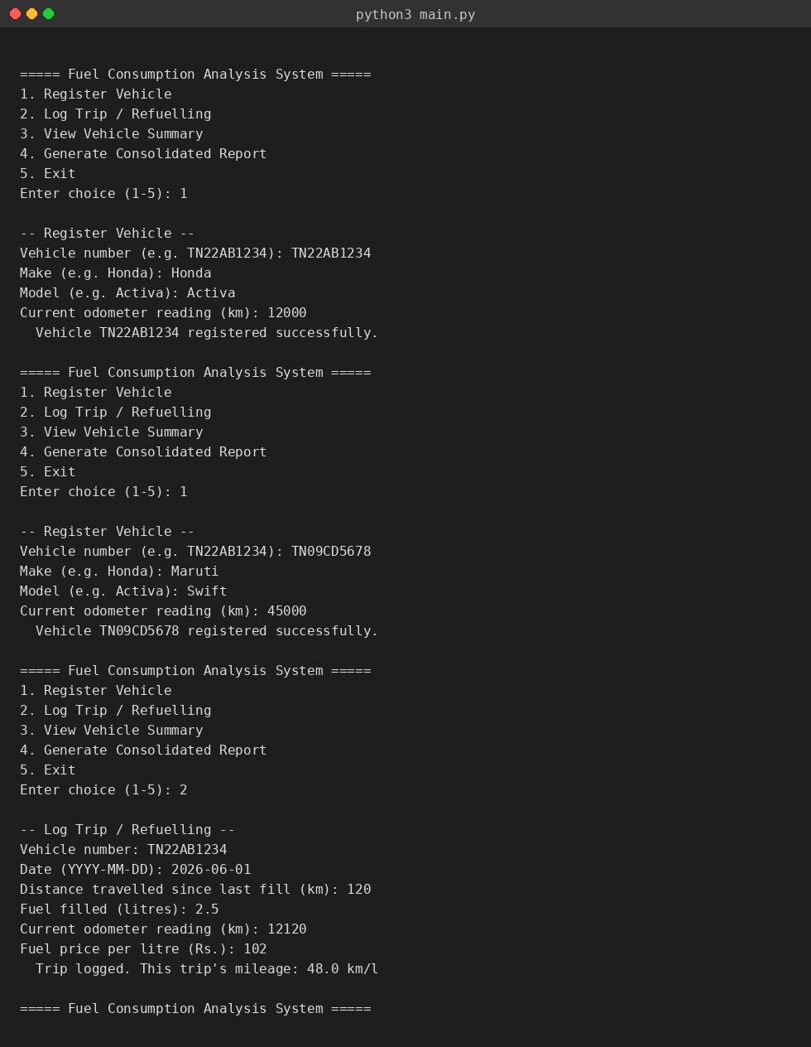
Fig. 1 - Vehicle registration and trip logging (menu options 1 and 2).
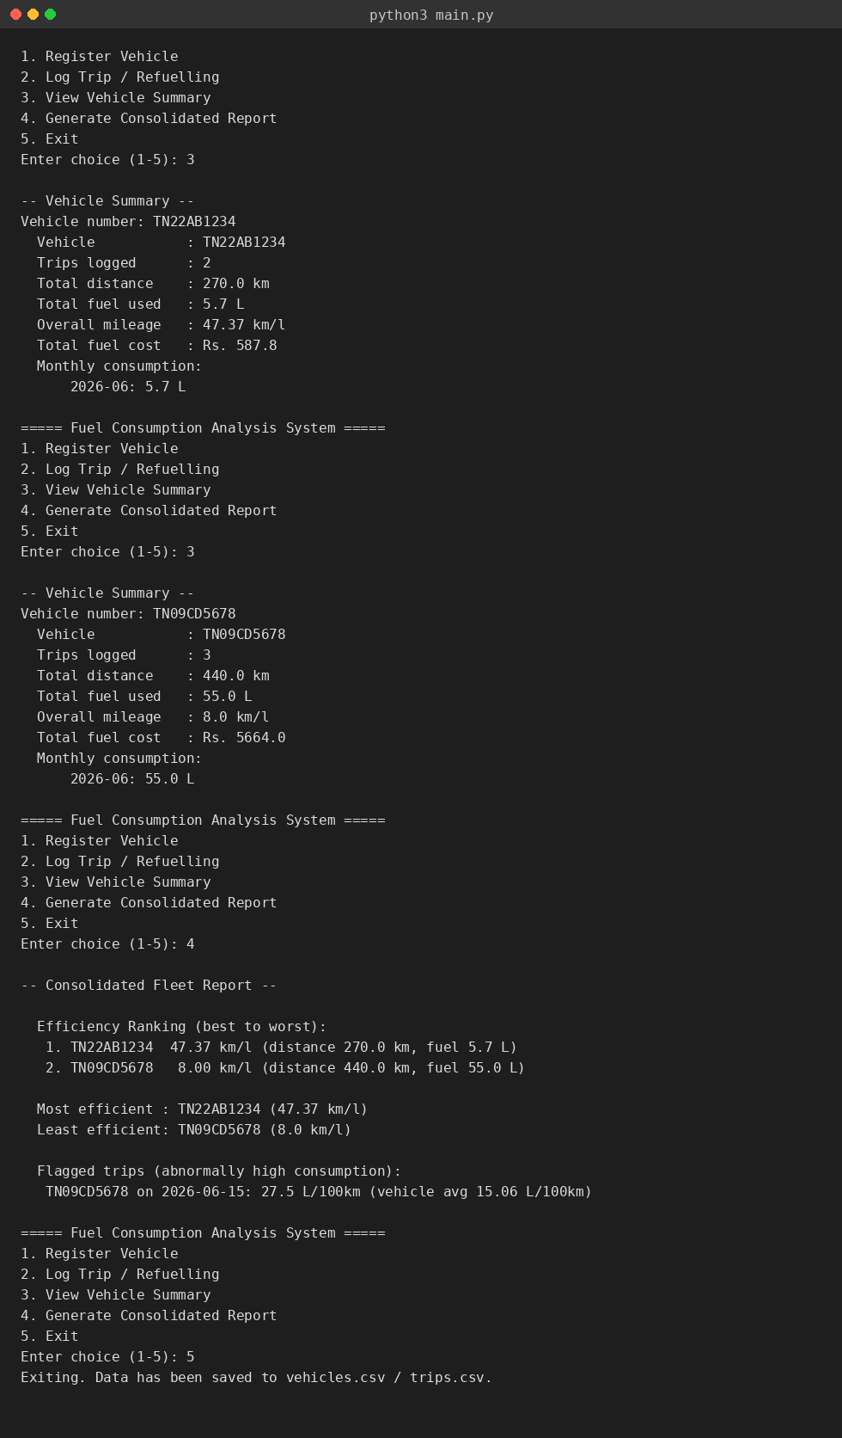
Fig. 2 - Per-vehicle summary and consolidated fleet report (menu options 3 and 4).
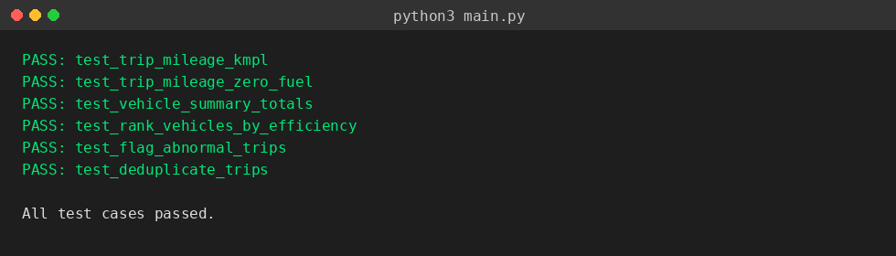
Fig. 3 - test_analysis.py run showing all six test cases passing.

Test Cases and Expected Actual Results
test_analysis.py exercises the analysis module directly (no file I/O), so results are deterministic and reproducible. All six cases passed on the run shown in Section 9.
# | Test Case | Input | Expected Result | Actual Result
TC1 | Trip mileage calculation | distance=150 km, fuel=3.2 L | 46.88 km/l | 46.88 km/l - PASS
TC2 | Mileage with zero fuel (edge case) | distance=100 km, fuel=0 L | 0.0 (no divide-by-zero error) | 0.0 - PASS
TC3 | Vehicle summary totals | 2 trips: 120km/2.5L, 150km/3.2L | total distance 270 km, mileage 47.37 km/l | 270 km, 47.37 km/l - PASS
TC4 | Efficiency ranking | Vehicle A: 50 km/l, Vehicle B: 10 km/l | A ranked above B | A ranked 1st - PASS
TC5 | Abnormal-trip flagging | 3 trips for vehicle X, one with 27.5 L/100km vs avg 15.06 | the 2026-06-15 trip flagged | 2026-06-15 flagged - PASS
TC6 | Duplicate trip removal | 2 identical trip records | 1 unique record retained | 1 record retained - PASS
End-to-end menu-driven scenario (manual test): two vehicles were registered (TN22AB1234, TN09CD5678), five trips were logged across them, and both the per-vehicle summary and the consolidated report were generated. Expected mileage for TN22AB1234 (270 km / 5.7 L = 47.37 km/l) and TN09CD5678 (440 km / 55 L = 8.0 km/l) matched the values printed by the program exactly - see Section 9 for screenshots.

Results and Validation
Vehicle | Trips | Total Distance (km) | Total Fuel (L) | Overall Mileage (km/l) | Total Cost (Rs.)
TN22AB1234 (Honda Activa) | 2 | 270.0 | 5.7 | 47.37 | 587.80
TN09CD5678 (Maruti Swift) | 3 | 440.0 | 55.0 | 8.00 | 5664.00
Validation: overall mileage was independently recomputed by hand as total_distance / total_fuel for both vehicles and matched the program's output to two decimal places in every case, confirming the correctness of vehicle_summary() and rank_vehicles_by_efficiency(). The anomaly detector correctly isolated the single trip (TN09CD5678, 2026-06-15) whose fuel-per-100km rate (27.5) exceeded 1.5 times the vehicle's own average rate (15.06), while leaving the other four trips unflagged - matching manual calculation.

Analysis, Comparison, Trade-offs and Justification of the Final Solution
CSV vs. a database: CSV was chosen over SQLite for persistence because the assignment scope is a single-user console tool with modest data volumes; CSV keeps the dependency footprint at zero (standard library only) and the data human-readable/editable, at the cost of slower look-ups on very large logs and no built-in referential integrity between vehicles.csv and trips.csv (a trip could in principle reference a vehicle_no that is later deleted). A database would remove that risk and scale better, but was judged unnecessary for the assignment's scale.
Rule-based anomaly detection vs. a statistical/ML approach: flagging trips at 1.5x a vehicle's own average fuel-per-100km rate is simple, explainable and needs no training data - appropriate given each vehicle typically has only a handful of logged trips in this assignment. A statistical approach (e.g. z-score) or ML model would be more robust to outliers skewing the average itself, but requires a larger trip history per vehicle than is realistic here.
Per-vehicle averages vs. a fleet-wide threshold: anomalies are judged against each vehicle's own historical average rather than a single fleet-wide cut-off, because different vehicle types (a scooter vs. a car) have inherently different fuel-per-km rates; a fleet-wide threshold would either miss genuine anomalies in efficient vehicles or over-flag normal trips in less efficient ones.
Trade-off accepted: the current anomaly rule needs at least two trips per vehicle to establish an average, so a vehicle's very first logged trip can never be flagged even if it is objectively wasteful - an acknowledged limitation carried into Section 12.

SDG Relevance
- SDG 7 - Affordable and Clean Energy: by surfacing which vehicles/trips consume disproportionately more fuel, the tool helps users cut avoidable fuel spend and consumption.
- SDG 11 - Sustainable Cities and Communities: better fuel-efficiency awareness for small fleets (e.g. delivery, ride-share, campus transport) supports more sustainable local transport operations.
- SDG 13 - Climate Action: every litre of fuel not wasted corresponds directly to reduced CO2 emissions; the consolidated report gives a concrete, data-driven basis for reducing a fleet's carbon footprint rather than relying on guesswork.

Conclusion, Limitations and Possible Improvements
The assignment successfully delivers a menu-driven Python application that registers vehicles, logs trips, computes fuel-efficiency metrics, ranks vehicles, and flags abnormal consumption, meeting all four mapped course outcomes. All test cases in Section 8 passed, and the results in Section 10 were independently validated by hand.

Limitations
- Anomaly detection requires at least two trips per vehicle before it can establish a baseline average.
- CSV storage has no referential-integrity check between vehicles.csv and trips.csv.
- Vehicle-number validation assumes the Indian registration format and would reject other formats.
- The console interface has no undo/edit facility for a mistakenly logged trip.

Possible Improvements
- Migrate persistence to SQLite for referential integrity and faster queries as data grows.
- Add an 'edit/delete trip' menu option with confirmation.
- Fetch live fuel prices via an API instead of manual entry, when network access is permitted.
- Add simple charts (e.g. via matplotlib) to visualise monthly consumption trends.

Individual Contribution of Group Members
Team Member | Registration No. | Contribution
Rejolin Solomon J | 192421433 | data_access.py, CSV schema design, main.py menu/CLI, …
Rishiykesh KS | 192511466 | analysis.py, anomaly-detection logic, test cases,…

References
- Python Software Foundation, "csv - CSV File Reading and Writing," Python 3 Documentation. Available: https://docs.python.org/3/library/csv.html
- Python Software Foundation, "re - Regular expression operations," Python 3 Documentation. Available: https://docs.python.org/3/library/re.html
- Python Software Foundation, "collections - Container datatypes," Python 3 Documentation. Available: https://docs.python.org/3/library/collections.html
- United Nations, "The 17 Goals - Sustainable Development," sdgs.un.org.
Available: https://sdgs.un.org/goals
- Python Software Foundation, Python Documentation.
- United Nations, Sustainable Development Goal 7: Affordable and Clean Energy.
- United Nations, Sustainable Development Goal 13: Climate Action.
- R. Sedgewick and K. Wayne, Algorithms, 4th ed. Addison-Wesley, 2011.

One-Page Individual Reflection

Working on the Fuel Consumption Analysis System provided me with valuable experience in designing and developing a structured Python-based application. My main contribution was developing analysis.py, particularly fuel consumption analysis, vehicle efficiency calculations, anomaly-detection logic, and test case development and validation. I also contributed to other parts of the project through overall program testing, debugging, integration, and supporting the development and improvement of the complete system. A key development decision was to keep the analysis logic separate from data access and other program components, making the system easier to understand, test, and maintain.
One of the main challenges I faced was designing an effective anomaly-detection method. Initially, comparing all trips with a single overall fleet average could produce inaccurate results because different vehicles may naturally have different fuel efficiency levels. To overcome this, I improved the logic by comparing each trip with the historical performance of its corresponding vehicle. This approach made the anomaly detection more meaningful and accurate. Developing and validating different test cases also helped me identify possible errors and improve the reliability of the program.
Through this assignment, I gained practical knowledge of Python programming, modular program design, data analysis, dictionaries and lists, calculations, testing, debugging, and validation. I also learned that selecting appropriate logic and data structures is important for producing accurate and useful results. The assignment strengthened my ability to analyse a real-world problem and develop a software-based solution systematically.
The project is connected to SDG 7 – Affordable and Clean Energy and SDG 13 – Climate Action. By analysing fuel consumption and identifying inefficient or unusual vehicle performance, the system can support better fuel management and help reduce unnecessary fuel usage and environmental impact.
This assignment also contributed to achieving the mapped Course Outcomes (COs). It supported CO2 through the application of programming concepts and problem-solving techniques, CO3 through designing and implementing appropriate analysis logic and data structures, and CO4 through developing and testing a modular software solution. Overall, the project improved both my technical programming skills and my understanding of how software can be used to support efficient and sustainable real-world decision-making.

