What a knowledge graph can do for a central bank economist
Worked examples from ten years of Bank of England research on market-based finance · October 2026

Summary

Link: https://rishkum-boe-mbf-knowledge-graph.share.connect.posit.cloud
I turned 245 Bank of England staff publications on market-based finance (MBF), published since 2015, into a knowledge graph. The graph holds 1,214 dated causal claims. Each claim links to its publication and to a quote from the source, and a shared vocabulary of 57 concepts ties most of them together.
Below I work through six tasks that would otherwise take days of reading. Each comes with a real result.
- Grade the evidence. The research firmly establishes the core financial-stability spiral, in which price falls trigger margin calls, margin calls force sales and forced sales push prices down further. Some links in it, though, rest mainly on models or on a handful of studies (section 2).
- Audit foresight. Bank staff had published each core link of the spiral at least five times before the September 2022 liability-driven investment (LDI) episode. Yet only two publications had looked at pension schemes or LDI alongside leverage, margin or repo. Fourteen did so afterwards (section 3).
- Know when a finding holds. A language model compared 374 pairs of claims that point in opposite directions and judged none to be a genuine contradiction. In 342 pairs the answer depends on the market, institution or conditions; the other 32 say the same thing in different words (section 4).
- Trace a scenario. The path from a US Treasury sell-off to UK markets rests on one or two publications at most steps, which points to a research gap (section 5).
- Brief yourself in minutes. The graph produces a one-page pack on private credit that covers what the Bank has established, what it argues, open questions, gaps and what to read first (section 6).
- Track the agenda. Research output peaked about two years after each of the last two stress episodes. LDI and pension schemes grew from 8% of MBF work in 2015–2022 to 27% in 2023–2026, while private credit and stablecoins still get little attention (section 7).

1. The knowledge graph in brief
A knowledge graph stores what a body of research says as a network of linked facts, so you can query it instead of reading one document after another. Here the basic unit is a causal claim with a driver, a direction and an outcome, such as “margin calls increase forced sales”. Each claim also carries its channel, conditions, type of evidence, how firmly the authors state it, its date and a supporting quote. The graph also links each publication to the events it analyses, the publications it cites and the questions it leaves open (Figure 1).
A fixed vocabulary of 57 concepts with synonyms (47 topics, 6 events and 4 methods) ties the claims together, so “margin call” in a 2016 working paper and “collateral call” in a 2025 blog post count as the same idea. Where no concept fitted, the model proposed a new one, and 12% of claims use one of these.
I collected 1,657 Staff Working Papers, Quarterly Bulletin articles and Bank Overground, Bank Underground and Bank Insights posts published since 2015 from the Bank’s websites. A keyword and embedding screen picked out 333 candidates, and a language model (Claude Haiku 4.5) read each candidate in a single pass, set aside 88 as not substantially about MBF and extracted the claims from the remaining 245. A script then matched every quote against the source text. 86% match it, ignoring punctuation and spacing; for all but one of the rest, the script substituted the closest source sentence. The same language model then judged each pair of opposing claims: a genuine disagreement, a difference of context or the same claim in other words. Model fees came to about $3, estimated from token counts.
Copilot and ChatGPT find a few relevant passages and summarise them. That works for a question about one paper, but not one that depends on the whole literature: “How many Bank papers say margin calls cause fire sales, and has that changed over time?” Answering requires reading all 245 publications and counting every relevant claim. An assistant samples only a handful, so a confident answer may be incomplete. The knowledge graph instead reads everything once, in advance, and records each claim in a fixed format.
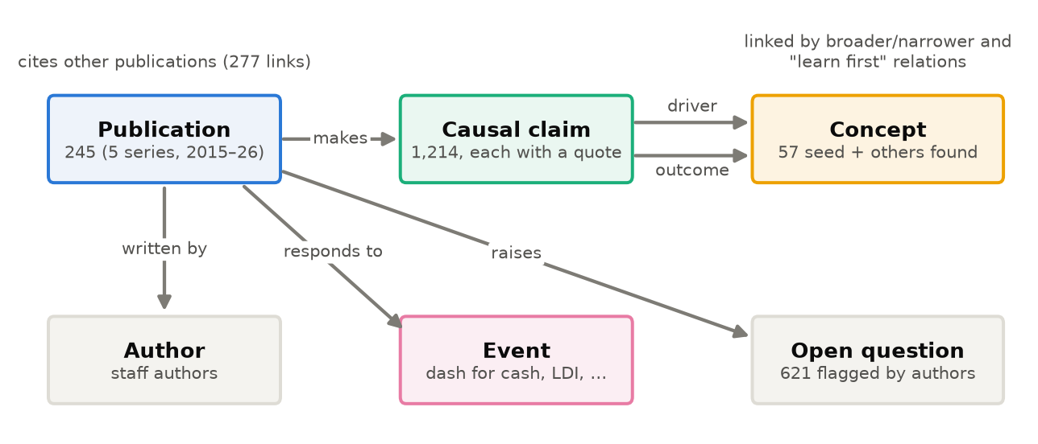
Figure 1. What the knowledge graph records: the kinds of element (boxes) and the relationships between them (arrows).
Taken together, the claims form a causal map of the field (Figure 2). The map shows the 45 links that at least five publications make, between 23 concepts. Sectors and vulnerabilities sit on the right, markets and market outcomes on the left. Of the 22 arrows that cross between the two sides, 19 run from right to left, from who is exposed and how to what then happens in markets. Asset prices (13 links), central bank backstops (9) and market liquidity (8) are the busiest concepts. Each section below puts one question to this map.
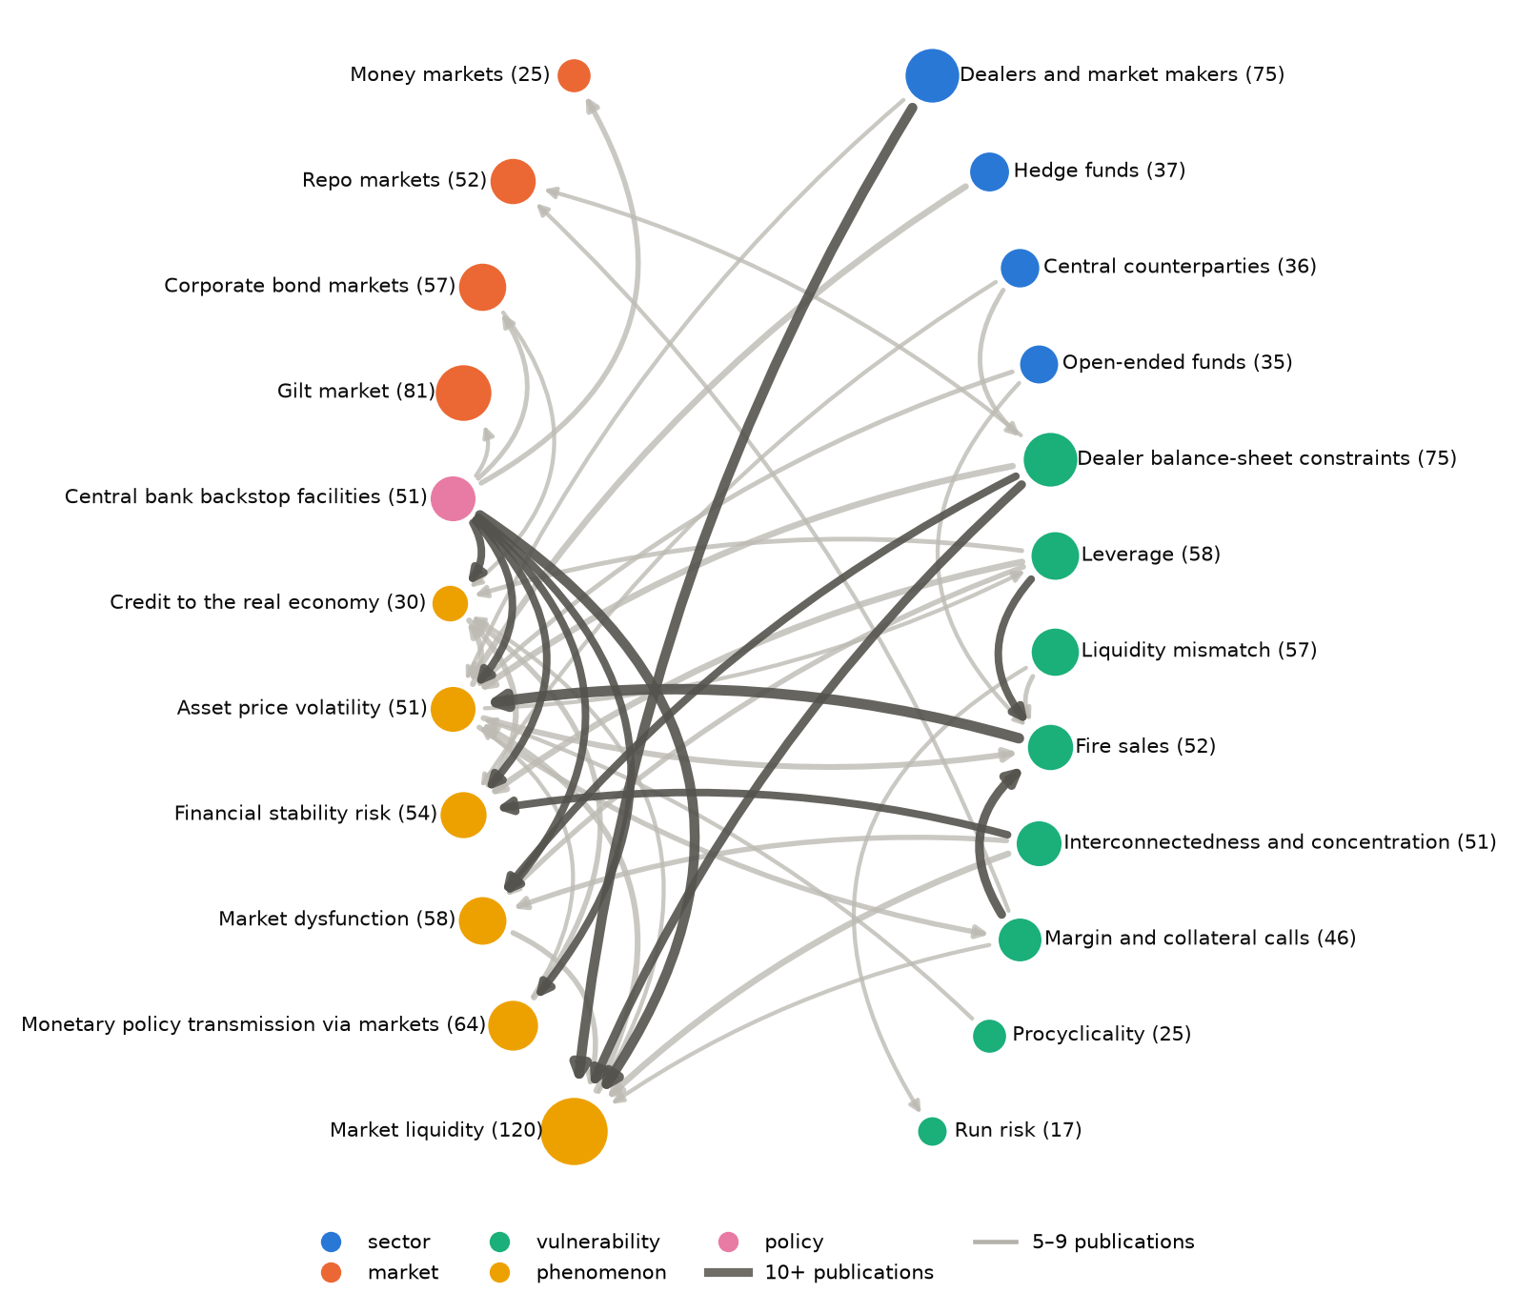
Figure 2. The causal map: links between concepts that five or more Bank MBF publications make. Each arrow runs from driver to outcome, and dark arrows have ten or more publications behind them. The number after each concept counts the publications that analyse it or treat it as central. The map counts exact concept pairs, so some counts are lower than in Table 1, which also includes narrower concepts.

2. Grade the evidence before a briefing
Example question: “I need to tell the Committee how confident we are that collateral calls can trigger fire sales in UK markets. What does our research actually show, and how solid is it?”
The graph assembles the mechanism from claims spread across many publications (Figure 3). It grades each link on four things: how many publications support it, over what period, how the authors measured it and how firmly they state it (Table 1).
Three links stand on solid ground. Seventeen publications find that margin calls lead to forced sales, 16 that forced sales push prices further and 10 that dealer balance-sheet limits turn selling into dysfunction. The weak spots show up just as clearly. The link from liquidity mismatch to forced sales rests mainly on models, and only three publications, mostly model-based, look at how central clearing affects dealer capacity. A briefing can then report how strong the evidence is at each step, as well as what it says.
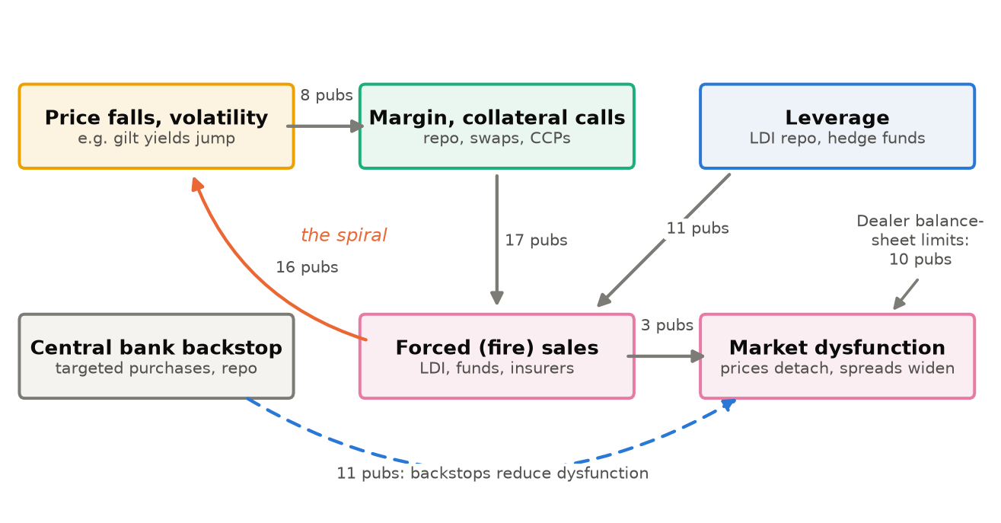
Figure 3. The collateral and leverage spiral in Bank MBF publications. The numbers show how many publications make each causal claim. The orange arrow closes the loop; the dashed blue arrow shows central bank backstops reducing dysfunction.
Table 1. Evidence behind each link of the spiral
Causal link | Publications | Years | Measured in data | Stated firmly | Reading of the evidence
Price falls, volatility → bigger margin calls | 8 | 2018–25 | 82% | 100% | Few studies, but measured in data and stated firmly
Margin and collateral calls → forced sales | 17 | 2018–26 | 39% | 94% | Well established: data, models and case studies agree
Forced sales → further price falls, volatility | 16 | 2016–25 | 47% | 100% | Well established
Leverage → forced sales | 11 | 2019–26 | 25% | 75% | Widely stated, less often measured
Dealer balance-sheet limits → market dysfunction | 10 | 2016–26 | 58% | 67% | Established, with some hedging
Liquidity mismatch → forced sales | 6 | 2019–24 | 29% | 100% | Thin and mostly models (a)
Central bank backstops → less dysfunction | 11 | 2016–24 | 31% | 77% | Mix of case studies, data and models
Central clearing → dealer capacity | 6 | 2018–26 | 33% | 78% | Thin and mostly models (b)
“Measured in data” is the share of claims backed by data analysis, and “stated firmly” the share the authors state without hedging. The counts include narrower concepts: procyclical margin under margin calls, basis trades under leverage and market-maker-of-last-resort under backstops. Five links count only claims in the stated direction. The other three count all claims, because authors word the outcome both ways for forced sales → prices and for clearing (“lower prices”, “higher volatility”), and all liquidity mismatch claims point the same way anyway. (a) Models produce 5 of the 7 claims. Only two concern fund redemptions; the rest cover bank funding shocks, derivative margin and LDI recapitalisation. (b) Only 3 of the 6 publications deal with clearing. Mostly using models, they find that wider clearing would expand repo netting, with one hedged caveat for March 2020.
The graph also pulls together numbers that sit in different publications. Bank monitoring put collateral calls on non-banks in the January 2025 gilt sell-off at about £7 billion and found no sign of forced sales. In the 2022 LDI episode, repo calls on pension schemes and LDI funds alone reached £53 billion (Table 2).
Table 2. Collateral calls on non-banks active in UK markets, by episode
Episode | Repo | Swaps | Repo and swaps
March 2020 dash for cash | n/a | £12 billion (a) | n/a
Autumn 2022 LDI episode | £53 billion (b) | £13 billion (b) | n/a
System-wide exploratory scenario (hypothetical) | n/a | n/a | £86 billion (c)
January 2025 gilt sell-off (net) | £4 billion | £3 billion | £7 billion
Source: Bank Overground, “Monitoring collateral calls” (March 2025), Table A. n/a: not reported in that table. (a) Includes FX swaps. (b) Pension schemes and LDI funds only. (c) Variation margin calls, part of about £94 billion of total margin calls in the scenario.

3. Audit foresight: what did Bank research know before the LDI episode?
Example question: “With hindsight, had our research identified the vulnerability that crystallised in September 2022?”
Every claim carries a date, so the graph can be viewed as it stood on any day. Viewed as of 22 September 2022, it gives a clear answer (Figure 4).
The spiral was already in print. Each core link had at least five publications behind it: margin calls leading to forced sales (8), leverage leading to forced sales (5), price falls raising margin calls (5) and forced sales pushing prices further (7). The links to wider market dysfunction had less support. Four publications showed dealer limits turning selling into dysfunction, and none showed forced sales causing dysfunction directly.
The closest precursor was a December 2021 working paper, An unintended consequence of holding dollar assets. Its authors showed that in March 2020 UK insurers and pension funds sold gilts to meet margin calls on their currency hedges, which added to the spike in yields. (The paper and its 2022 blog summary count as two publications in the margin-calls count, and the blog also appears in two other counts.)
Nobody had joined this up with LDI. Staff research described pension schemes as investors that buy bonds when yields fall, a source of procyclical demand. A 2018 working paper expected that if rates rose materially, pension funds would support bond market liquidity by buying as prices fell. Only two publications analysed pension schemes or LDI together with leverage, margin or repo, and on closer reading only one of them, the dollar-assets paper, did so in substance. After the episode, fourteen did. An AI-assisted search of the pre-episode text found no publication in these series that set out what a sharp rise in yields would do to leveraged LDI funds. The pieces sat in separate publications, and the graph puts them side by side.
Two cautions. I covered published staff research only, not Financial Stability Reports, Financial Policy Committee (FPC) records or supervisory work. And it is easier to spot a chain after the fact than before it. The query is more useful looking forward. Run today on other pairings of sector and mechanism, it would show where the building blocks of the next episode already sit in Bank research, still unconnected.
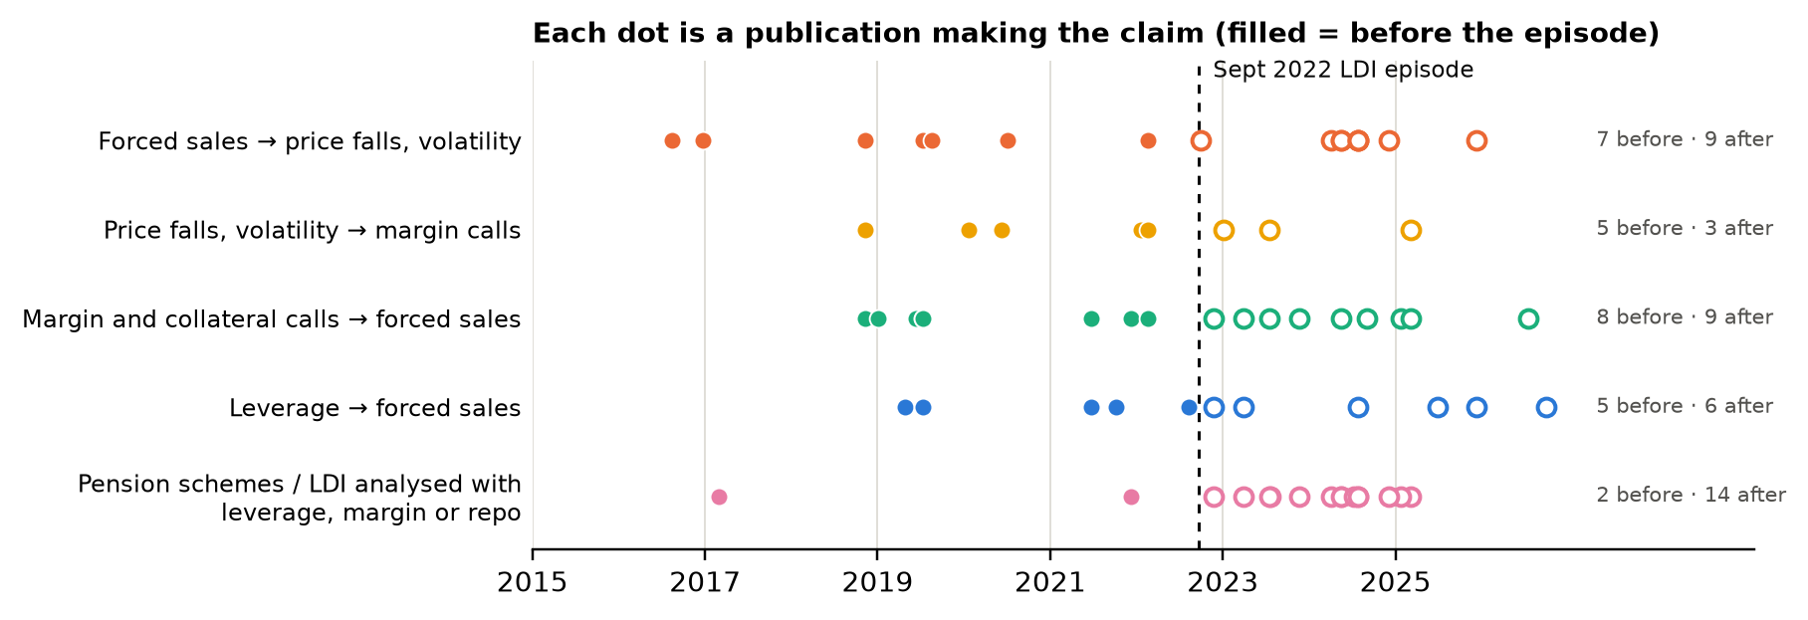
Figure 4. When each claim was published. Filled dots are before the September 2022 LDI episode (dashed line), open dots after; counts at right. The bottom row shows publications analysing pension schemes or LDI with leverage, margin or repo.

4. Know when a finding holds
Example question: “Some of our papers say dealers support liquidity, others that they withdraw it. Which is right?”
When two claims link the same driver and outcome in opposite directions, the graph flags the pair, and a language model judges why they differ. The graph compares each claim with the most recent earlier opposing claim from another publication, which gave 374 pairs to judge.
The model judged none to be a genuine contradiction. In 342 pairs both findings hold, under different conditions. The other 32 say the same thing in different words.
The context-dependent pairs show the conditions under which each finding holds:
- Dealers and market liquidity. Findings vary with the market (equity, swaps, gilts, corporate bonds, FX, repo), the mechanism (venue design, funding costs, information, leverage-ratio rules) and the state of the market. In stress, algorithmic traders and balance-sheet-constrained dealers pull back, while some dealers keep serving informed clients.
- Central bank facilities. Findings vary with the tool. Quantitative easing, corporate bond purchases, swap lines, standing facilities and the short-term repo facility each affect market liquidity in their own way.
So the best answer to “which is right?” is usually “both, under these conditions”, and the graph lists those conditions with their sources.

5. Trace a scenario
Example question: “If there is a disorderly sell-off in US Treasuries, through which channels does our research say it reaches UK markets and borrowers?”
The graph follows causal claims step by step from a starting point to an outcome and reports the evidence at each step (Table 3). It finds a route from US Treasuries to UK markets, but most steps rest on one or two publications.
That tells an economist that Bank research says little about cross-border spillovers through the Treasury market beyond the March 2020 dash for cash, so a briefing would need other sources. (For March 2020, a Bank Underground post estimates that the hedge fund basis-trade unwind led to US$200 billion of Treasury sales; other studies give different figures.)
The trace also shows where the graph falls short. Its US Treasury concept picks up generic statements about interest rates, which is how a UK result ends up as step two and a pension fund claim under step three. Tighter concept definitions would fix this. Until then, readers should check each step against its sources, as the last column of Table 3 does.
Table 3. Scenario trace: how a US Treasury sell-off could reach UK markets, according to Bank MBF publications
Step in the chain | Publications | What the research says | Caveat
US Treasury yields → gilt yields | 1 | UK and US yields move very closely: week to week, day to day and even minute to minute (2015) | Two more publications show similar co-movement (2016, on money-market rates; 2022) but sit under other links
Higher risk-free rates → forced sales of UK corporate bonds | 1 | A 50 basis point rise in the risk-free rate could be amplified by about 30 basis points (2019 simulation) | A UK result, matched here only because the graph files generic rate rises under US Treasuries
US policy shock → gilt market liquidity | 2 | After US tariff announcements in April 2025, gilt liquidity worsened briefly but stayed within the range seen since 2020 | The second match is a misfiled pension fund claim
Market liquidity → dysfunction | 4 | Thin liquidity turned selling into dysfunction in the October 2016 sterling flash episode, the March 2020 corporate bond market and the 2022 gilt crisis | The fourth match, on inflation swaps, is unrelated

6. Brief yourself on a new topic in minutes
Example question: “I’ve been asked to speak on private credit next week. What has the Bank published, what does it establish, and what should I read first?”
One query on a concept returns its publications, the causal claims about it, its open questions, its gaps against each vulnerability and a reading list that starts with short explainers (Table 4). The graph can produce the same pack for any concept in the vocabulary.
For private credit, the pack also shows how little there is: ten publications, only one of them a research paper, and no analysis of the margin and liquidity channels that dominate the rest of MBF research.
Table 4. Briefing pack on private credit and private equity, produced by the graph
Briefing item | Private credit and private equity: what the graph returns
Coverage | 10 publications, 2015–2026: 5 Bank Overground, 3 Bank Underground, 1 Bank Insight and 1 working paper. The concept includes leveraged loans and CLOs; several publications mention private credit only in passing.
Key facts (2024) | Private equity-backed companies hold about 15% of UK corporate debt, employ over two million people and rely more on shorter-term private credit and leveraged loans.
What is argued (all hedged) | Long-term private equity capital may make financing less cyclical (2024). Investors stepping back could cause refinancing problems for these companies (2024). Collateralised loan obligations (CLOs) are complex and their resilience to stress is uncertain (2019).
Open questions | How a sharp fall in leveraged loan prices would reach the real economy. Which UK companies are privately backed, given gaps in commercial data. The right mix of bank, market and non-bank finance for growing firms.
Gaps | No publication analyses private credit together with margin calls, procyclical margin, dealer constraints, interconnectedness or liquidity preparedness (Figure 7).
Reading order (selected from the graph’s list) | How large is the leveraged loan market? (2019) → Who invests in securitisations of leveraged loans? (2019) → Shining a light on private equity backed corporates (2024) → What has driven increased leveraged loan activity over 2024? (2025)

7. Track the agenda and spot blind spots
Example question: “Where has our research effort gone, how quickly do we respond to events, and what are we not looking at?”
- Episodes drive output, with a lag. The March 2020 dash for cash drew 57 publications and the September 2022 LDI episode 29. The first analysis appeared within two or three months, and output peaked about two years later both times (Figure 5, right). Two episodes are too few to call this a rule.
- MBF took a larger share. MBF work made up 9–14% of all publications in the five series in 2015–2018. Its share reached 18% in 2019, dipped to 10–13% in 2020–2021, climbed to 22–24% in 2022–2024 and fell back to 15% in 2025 (Figure 5, left). The base is the 1,657 publications I collected from the five series, and the screen and the language model decided which ones count as MBF.
- The focus moved towards leverage and collateral. Between 2015–2022 and 2023–2026, LDI and pension schemes grew from 8% to 27% of MBF publications (13 to 22 publications). Leverage, repo, hedge funds and procyclical margin also gained share. Their raw counts barely changed, but the later period is less than half as long, so yearly output roughly doubled. Central counterparties fell from 19% to 7%, and open-ended funds and run risk also lost share (Figure 6).
- Evidence became more data-based. The share of MBF publications using granular transaction data rose from 48% in 2015–2019 to 74% in 2022–2023, and has been 66% since 2024.
- Blind spots. No publication analyses LDI with run risk, or central counterparties with run risk. Private credit has at most four publications for any sector–vulnerability pairing, and stablecoins at most one, with two publications in all (Figure 7).
- New questions. The most recent open questions concern AI agents in finance, wider central clearing, how dealers price dollar funding and who should finance growing firms.
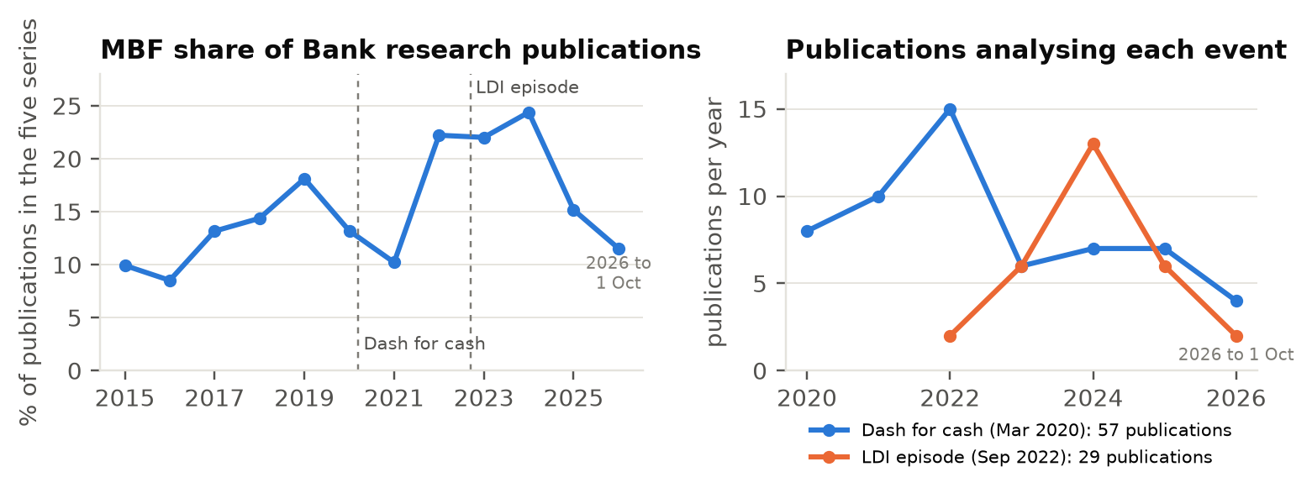
Figure 5. Left: MBF publications as a share of all publications in the five series, by year. Right: publications analysing the dash for cash (blue) and the LDI episode (orange), by year. 2026 data run to 1 October.
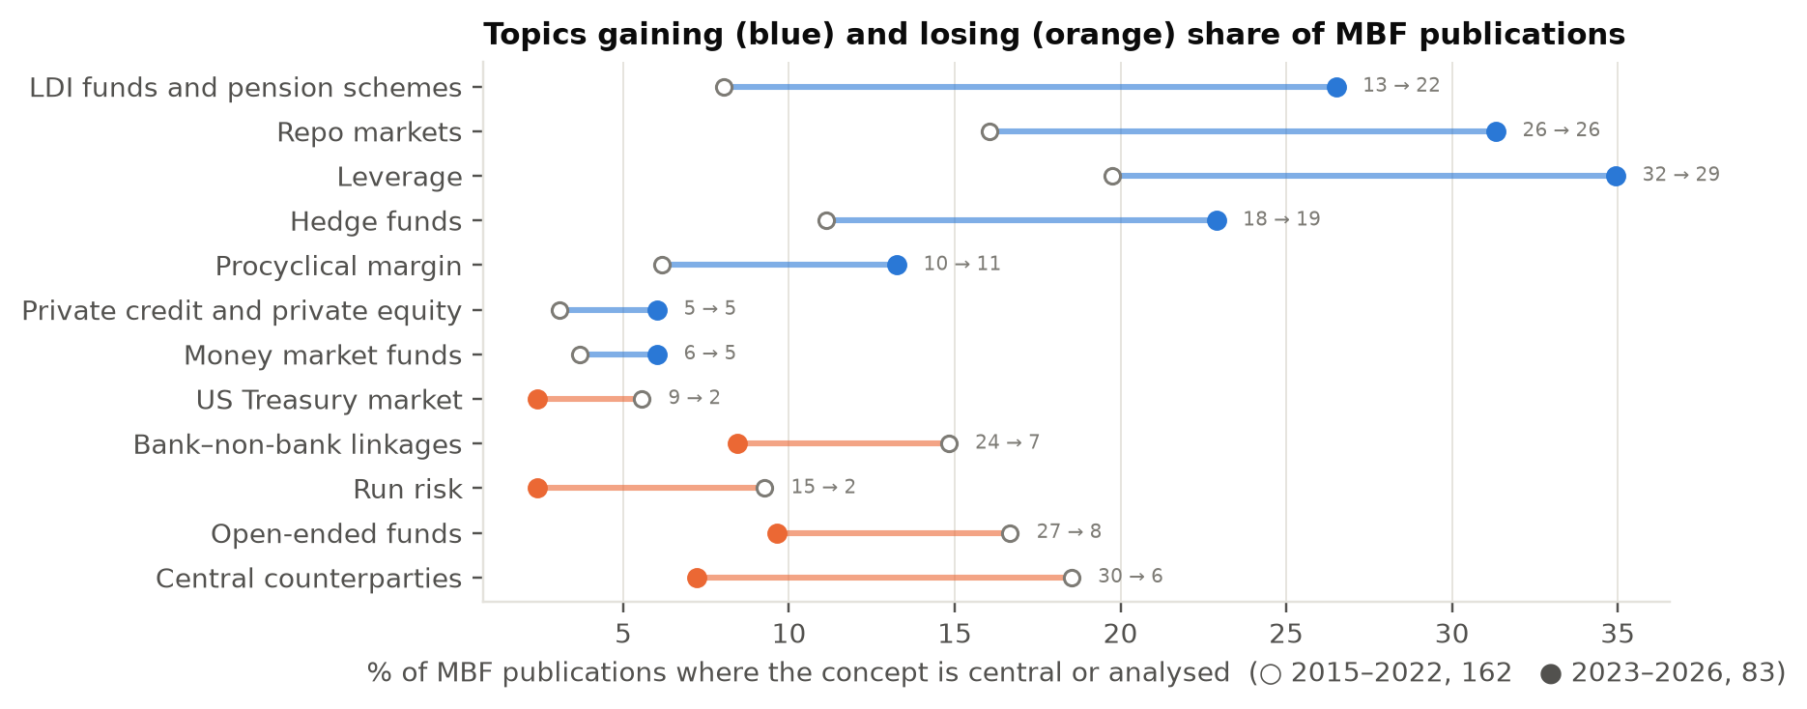
Figure 6. Share of MBF publications in which each concept is central or analysed: 2015–2022 (open circles, 162 publications) and 2023–2026 (filled circles, 83). Blue lines: rising share; orange lines: falling share. Labels give raw counts.
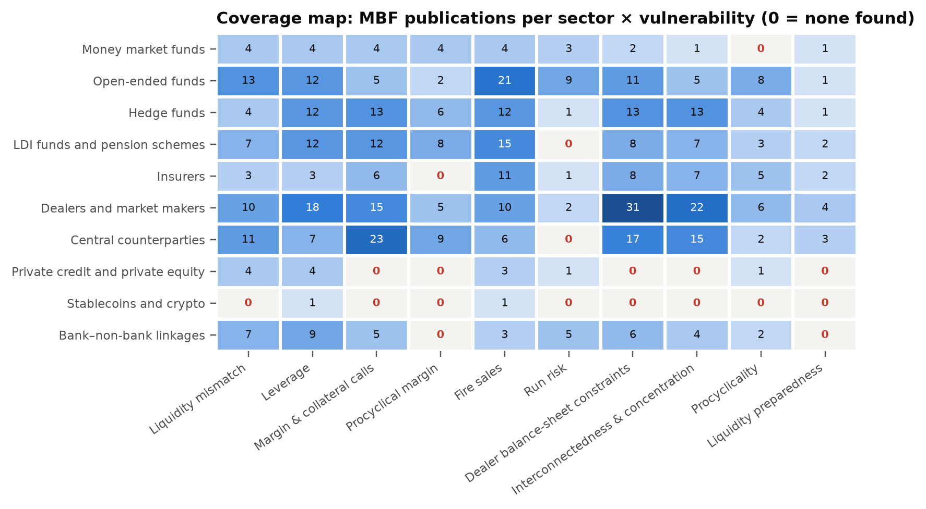
Figure 7. MBF publications since 2015 in which both the sector (rows) and the vulnerability (columns) are central or analysed. A red zero means the graph contains none among the 245 publications, not that nobody has studied the topic. The basis-trade column is omitted.

8. What it would take to use this in earnest
- Expert review of the core claims. The quote checks run automatically, but a language model decided the direction of each effect, how firmly the authors state it and which concept it belongs to. I checked this note against the data with AI agents, not by hand, and they turned up some misfiled claims, such as generic rate claims filed under US Treasuries (section 5). No subject expert has reviewed the claims yet. A short expert review of the most-cited links in Table 1 would make the graph fit for briefings.
- Add the policy record. With Financial Stability Reports, FPC records and speeches added, the graph could compare research with policy: how long a mechanism found by staff takes to reach FPC language or a policy tool, and which findings never get there.
- Keep it current. Adding a new publication costs about a cent, so I can refresh the evidence grades, foresight checks and briefing packs as new research comes out.
- Know the limits. Counts measure attention, not quality. The model read working papers from their abstract, introduction and, where it could find one, conclusion. And about a third of publications (78 of 245) have no named author in the data, so the graph cannot yet tell you who the in-house experts are.

