Customer Analytics and Customer Lifetime Value Analysis
Marketing Analytics —Homework 2
Course: Marketing Analytics
Student: Rishpa Shrestha

1. Executive Summary
This report analyzes customer purchasing behaviour using transactional data stored in a PostgreSQL database. SQL was used to prepare and integrate the data, while Python was used for exploratory analysis, Recency-Frequency-Monetary(RFM) analysis, Customer Lifetime Value(CLV) estimation, predictive CLV modelling, and customer segmentation.
Exploratory analysis identified purchasing patterns, customer activity, and product preferences. RFM analysis classified customers according to their purchasing behaviour and identified high-value customers, while CLV analysis estimated each customer’s financial contribution. Predictive modelling using the BG/NBD and Gamma-Gamma models produced good predictive performance (RMSE = 3.149, MAE = 2.066, R² =0.793), enabling future customer purchases and lifetime value to be estimated.
Based on these analyses, customers were grouped into four business segments: Platinum, Gold, Silver, and Bronze. The findings provide practical recommendations for customer retention, loyalty programmes, promotional strategies, and marketing resource allocation. Overall, the project demonstrates how customer analytics can support data-driven decision-making and improve long-term business performance.

2. Data Overview
The analysis used transactional data stored in a PostgreSQL database. The primary tables included Customer, Order, Order Item, Product, and Price Change. SQL joins were used to create an integrated dataset containing customer information, transactions, products, and prices. This dataset was then analysed using Python for exploratory analysis, RFM analysis, CLV estimation, customer segmentation, and predictive modelling.

3. Exploratory Analysis
Exploratory Data Analysis(EDA) was performed to gain an initial understanding of customer purchasing behaviour and identify important trends within the dataset. The analysis focused on purchase frequency, order activity over time, customer status, product categories, and brand performance.

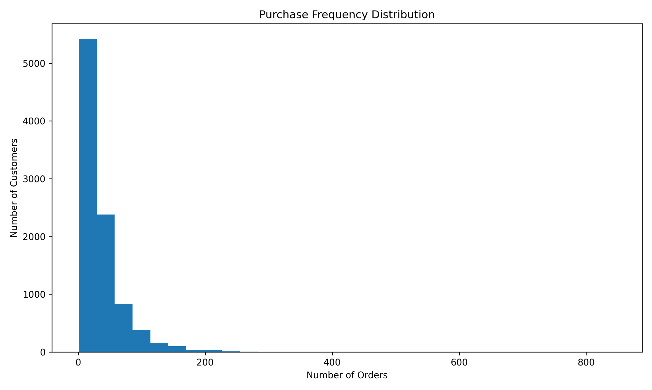
Figure 1: Purchase Frequency Distribution

The purchase frequency distribution(Figure1)shows the most customers place relatively few orders, while only a small number of customers made a very high number of purchases. This indicates that customer purchasing behaviour is highly skewed, with a limited proportion of customers contributing a large share of total transaction. Additional exploratory analysis showed that most customers were classified as active, while a smaller proportion had churned. Product sales were concentrated within a limited number of product categories, with category CAT001 accounting for the highest sales volume. Similarly, NESTLE was identified as the most frequently purchased brand. These findings provide a useful foundation for the subsequent RFM analysis, Customer Lifetime Value estimation, and customer segmentation.
Additional exploratory analyses (see Appendix A) showed that most customers were classified as active, while a smaller proportion had churned. Product sales were concentrated within a limited number of product categories, with Category CAT001 accounting for the highest sales volume. Similarly, NESTLE was identified as the most frequently purchased brand. These findings provide a useful foundation for subsequent RFM analysis, Customer Lifetime Value estimation, and customer segmentation.

4. RFM Analysis
Recency, Frequency, and Monetary (RFM) analysis was performed to evaluate customer purchasing behaviour and identify customers with different levels of business value. Each customer received a score from 1 to 5 for Recency, Frequency, and Monetary value based on their purchasing history. These three scores were combined into an overall RFM score, which was then used to classify customers into meaningful business segments.
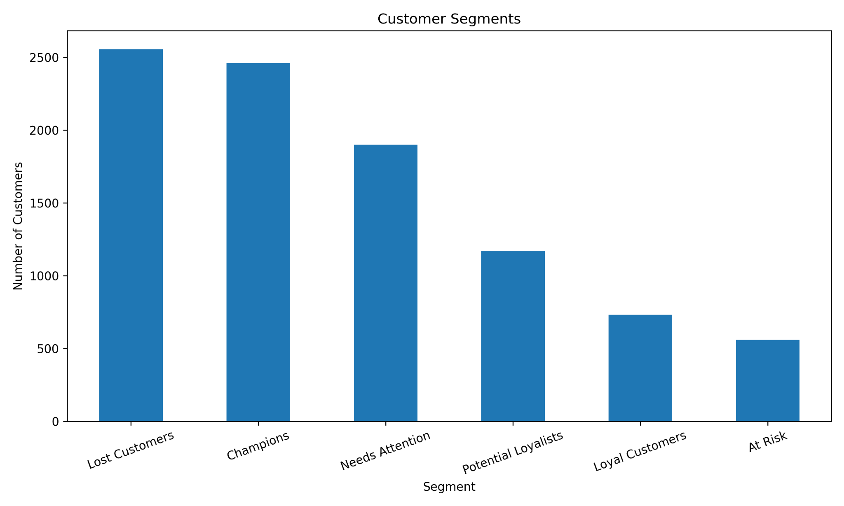
Figure 2: Customer Segmentation (RFM)

The results showed clear differences in customer behaviour across the dataset. Customers with high Recency and Frequency scores were classified as Champions, representing customers who purchase regularly and have made recent transactions. Customers with low Recency scores were classified as Lost Customers, indicating that they had not purchased for a considerable period and may require re-engagement strategies.
The customer segmentation results identified six groups: Champions, Loyal Customers, Potential Loyalists, Needs Attention, At-Risk, and Lost Customers. Champions and Loyal Customers represent the most valuable customer groups and should be prioritised through loyalty programmes and personalised marketing campaigns. In contrast, At-Risk and Lost Customers may benefit from targeted promotional offers designed to encourage repeat purchases.
Overall, the RFM analysis provides a simple yet effective method for understanding customer purchasing behaviour and forms the basis for the Customer Lifetime Value analysis presented in the following section. The complete distribution of RFM scores is provided in Appendix A

5. Customer Lifetime Value (CLTV) Analysis
Customer Lifetime Value (CLTV) analysis was performed to estimate the long-term financial value of each customer based on their purchasing behaviour.The analysis considered three key metrics: Average Purchase Value(APV), Purchase Frequency, and Churn Rate. These measures were combined to estimate the expected lifetime value generated by each customer.
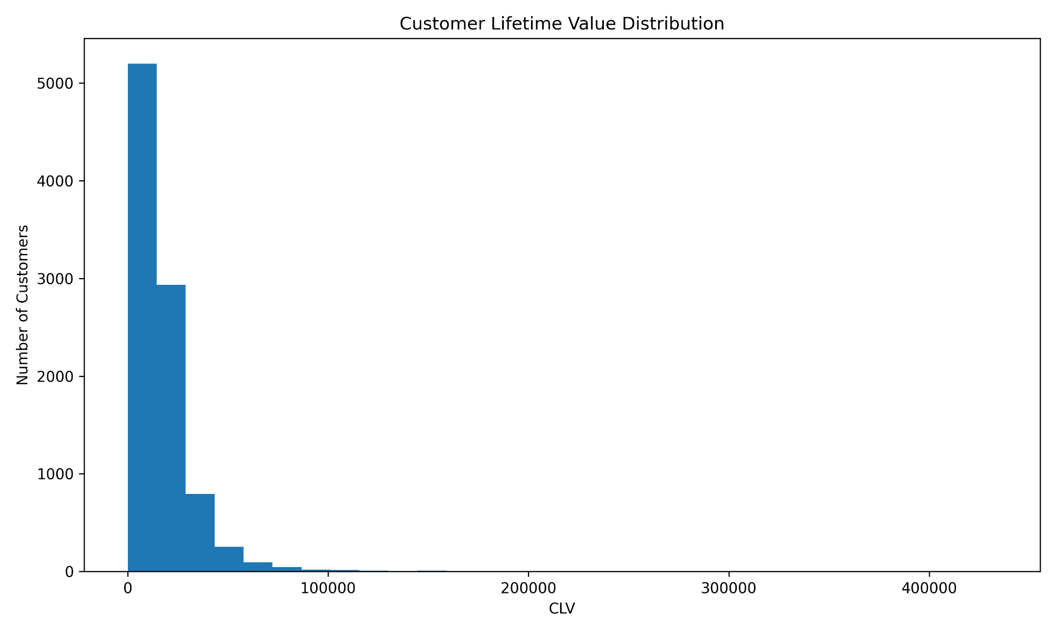
Figure 3: Customer Lifetime Value Distribution

The results showed an average purchase frequency of 35.57 transactions per customer, while the estimated churn rate was 32.45% Considerable variation was observed in customer lifetime value, indicating that a relatively small group of customers contributes a significantly larger share of total revenue. This variation highlights the importance of identifying and retaining high-value customers.
The distribution of CLTV values, shown in Figure 3, demonstrates that most customers generate relatively low lifetime value, whereas a smaller proportion contributes substantially higher value. These findings provide a strong basis for allocating marketing resources more effectively and developing customer-specific retention strategies. Customers with higher estimated CLTV should be prioritized for retention because they are expected to generate greater long-term revenue. The complete list of the top 20 customers ranked by CLV is provided in Appendix B

6. Customer Segmentation
Customer segmentation was performed using the estimated Customer Lifetime Value(CLV). Customers were divided into four business groups based on their CLV values: Platinum(top 20%), Gold(next 30%), Silver(next 30%), and Bronze(bottom 20%).
The segmentation results showed a clear difference in customer value and purchasing behaviour. Platinum customers had the highest average CLV(39,634.28) and represented the most valuable customer group. Although they did not make the highest number of purchases on average, they generated the greatest long-term value for the business. Gold customers also contributed substantial revenue, with an average CLV of 17,841.67 and the highest number of purchases frequency(50.40 transactions). Silver customers demonstrated moderate purchasing behaviour and spending, while Bronze customers had the lowest average CLV(1,404.23), lowest average spending(282.47), and the fewest purchases(14.29 transactions).
Customer demographic analysis indicated that most customers across all four segments were classified as active. The most common cities varied between segments, while product preference analysis showed that Category CAT001 and the NESTLE brand were the most frequently purchased across every customer group.
These findings suggest that different customer segments require different marketing strategies. Platinum and Gold customers should receive personalized loyalty rewards and retention programmes to maintain their long-term value. Silver customers represent an opportunity for growth through targeted promotions, while Bronze customers may benefit from re-engagement campaigns or low-cost promotional offers designed to increase purchasing activity.

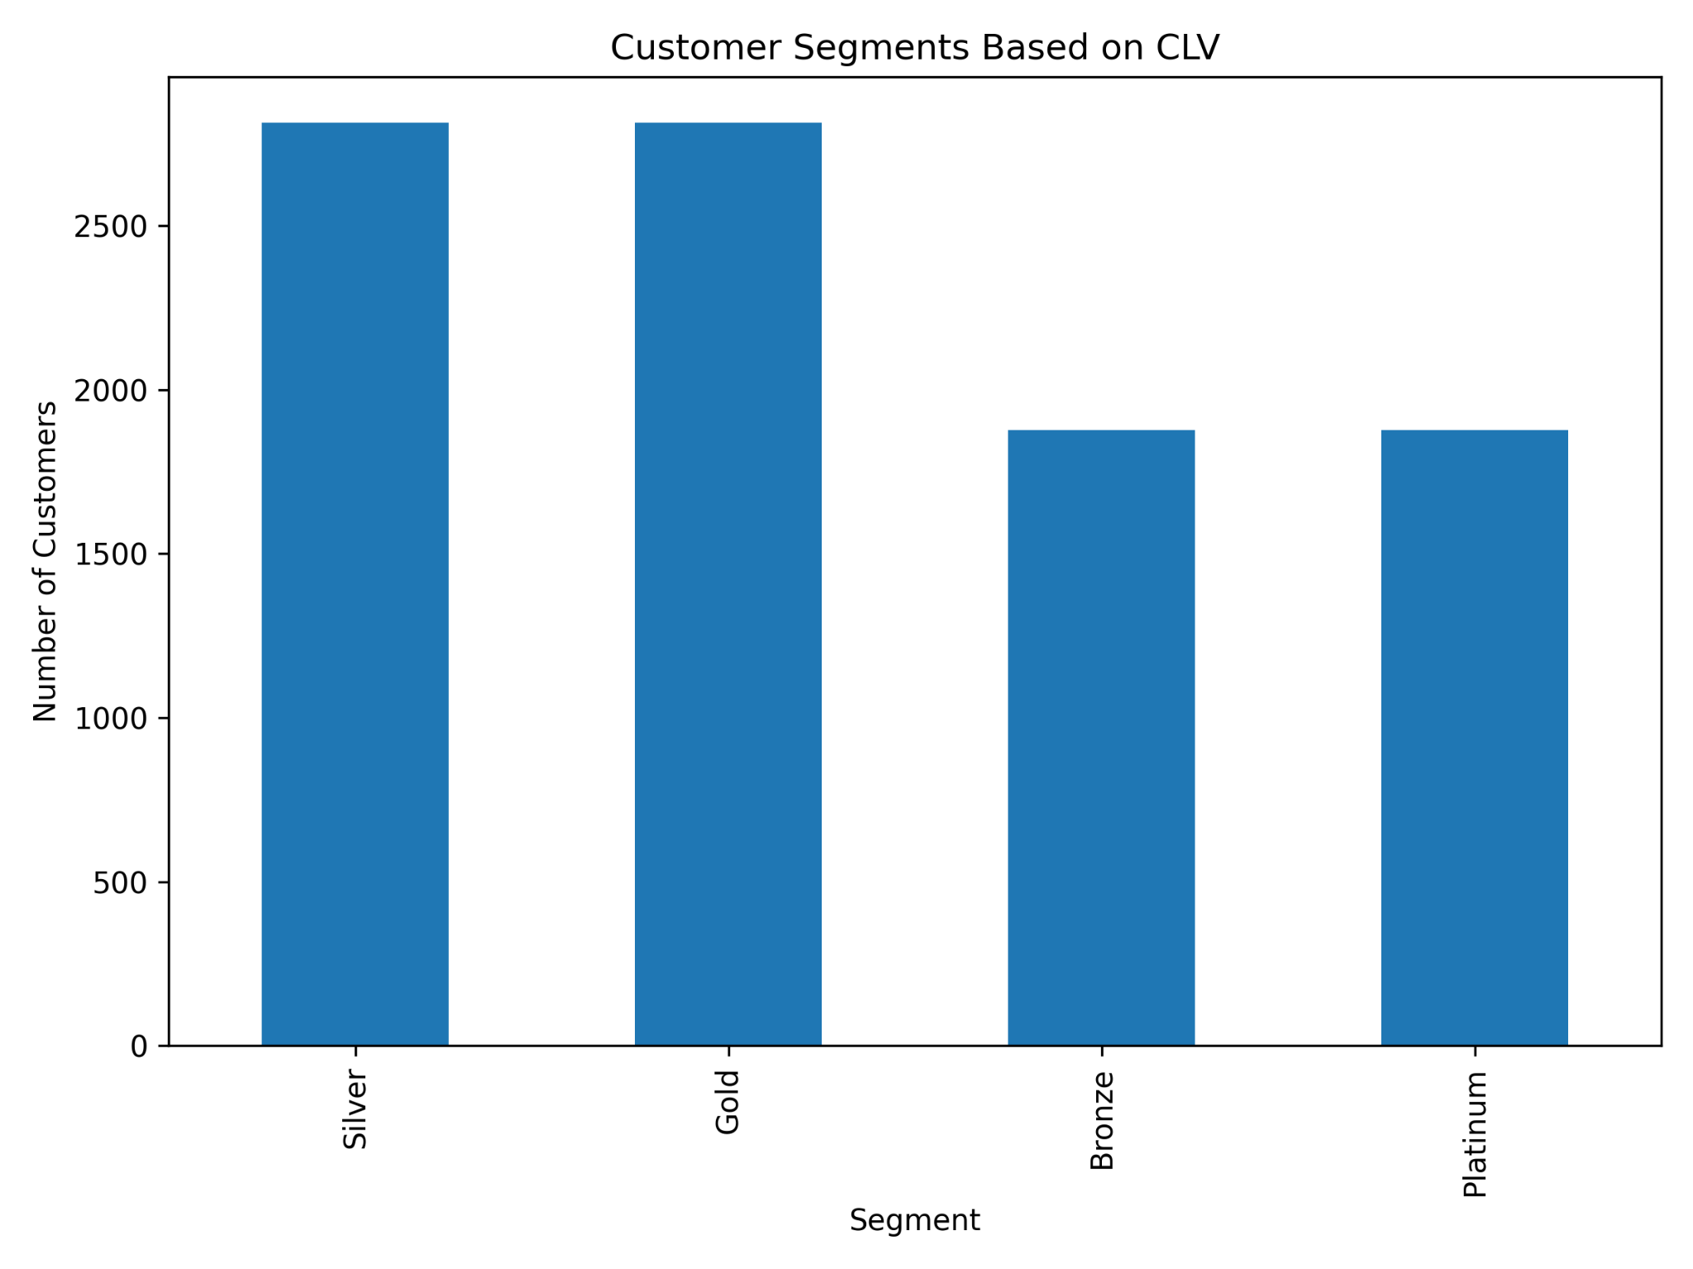
Figure 4: Customer segment based on Customer Lifetime Value

7. Predictive CLTV
Customer Lifetime Value was predicted using the BG/NBD(Beta Geometric/Negative Binomial Distribution) model together with the Gamma-Gamma model from the lifetimes Python library. The BG/NBD model estimates the expected number of future purchases for each customer based on their historical purchasing behaviour, while the Gamma-Gamma model estimates the expected monetary value of those future purchases. Combining these two models provides an estimate of each customer’s future lifetime value.
The predictive model produced good performance, achieving an RMSE of 3.15, an MAE of 2.07, and an R² value of 0.79. These results indicate that the model was able to explain a large proportion of the variation in future customer purchases while maintaining relatively small prediction errors.
The predicted CLV rankings identified a group of customers with substantially higher future value than the rest of the customer base. These customers represent important long-term assets and should be prioritized for retention initiatives, personalised marketing campaigns, and loyalty programmes. Predictive CLV extends the traditional CLV analysis by estimating future customer value rather than relying only on historical transactions, allowing organizations to allocate marketing resources more effectively and make more informed customer relationship management decisions.

8. Recommendations
Executive Recommendations
The analysis performed throughout this project provided several insights that can support strategic decision-making for the marketing management team. By combining exploratory data analysis, RFM analysis, Customer Lifetime Value(CLV), predictive CLV modelling, and customer segmentation, it is possible to identify customers with the highest business value and develop more effective marketing strategies. The following recommendations are based on the findings obtained from the previous sections of this project.

Customer Retention
The RFM analysis identified 2,461 Champion customers, representing one of the company’s most valuable customer groups. These customers purchase frequently, have purchased recently, and generate high monetary value. Similarly, the CLV segmentation showed that the Platinum customer segment achieved the highest average Customer Lifetime Value (39,634.28) and the highest average spending among all customer groups (Table 2). These findings suggest that retaining existing high-value customers should be a priority for the business.

Rather than treating all customers equally, personalised retention strategies should be developed for high-value customers. Exclusive discounts, early access to new products, personalised recommendations, and dedicated customer support can strengthen long-term customer relationships while reducing the risk of customer churn.

Figure 5: RFM Customer Segmentation Chart

For customers classified as At-Risk and Lost Customers in the RFM analysis(Figure 5), re-engagement campaigns should be introduced. Reminder emails, limited-time promotional offers, and personalised discount vouchers may encourage these customers to return before they become permanently inactive.

Loyalty Programmes
The customer segmentation results clearly demonstrate that customer value differs considerably across the business. The Platinum segment generated an average spending of approximately 8,998, compared with only 282 for the Bronze segment. This large difference suggests that loyalty programmes should be designed according to customer value rather than offering identical rewards to every customer.
High-value customers should receive premium loyalty benefits such as bonus reward points, exclusive member promotions, birthday offers, or priority access to new products. Gold and Silver customers should receive targeted incentives that encourage them to buy more frequently and gradually move into higher-value segments. Bronze customers may benefit from introductory promotions designed to increase engagement without requiring significant marketing expenditure.

Resource Allocation
The analysis indicates that customer value is concentrated within a relatively small proportion of customers. The Platinum segment not only generated the highest average CLV but also significantly outperformed the Bronze segment across all spending-related measures. As a result, marketing resources should be allocated according to customer value rather than distributed evenly across the customer base.
Investing additional resources in Platinum and Gold customers is likely to generate a higher return on investment because these customers have already demonstrated strong purchasing behaviour. At the same time, lower cost communication strategies can be maintained for Bronze customers while monitoring whether they develop into higher-value segments over time.

Promotional Strategies
The exploratory data analysis showed that purchasing activity is concentrated within a relatively small number of product categories and brands. In particular, CAT001 was identified as the most frequently purchased product category, while NESTLE was the most popular brand across all customer segments. These findings suggest that future promotional campaigns should focus on products that already demonstrate strong customer demand.
The predictive CLV analysis also produced encouraging results, with the BG/NBD model achieving an R² value of 0.793, indicating good predictive performance. Customers predicted to make future purchases should receive personalized product recommendations and cross-selling offers based on their previous purchasing behaviour. Such targeted promotions are likely to be more effective than broad marketing campaigns that treat all customers similarly.

Customer Acquisition Priorities
The predictive CLV model identified customers with the highest expected future value, providing useful information for customer acquisition strategies. Rather than focusing only on increasing the total number of customers, management should prioritize acquiring customers who share similar purchasing characteristics with existing Platinum and Champion customers.
Marketing campaigns should therefore target customer profiles associated with frequent purchasing behaviour, higher spending levels, and stronger long-term engagement. This approach is expected to improve the overall quality of newly acquired customers while increasing future customer lifetime value.

Overall Recommendation
The analysis performed in this project demonstrates that customer analytics can provide valuable support for marketing decision-making. RFM analysis helps identify customers requiring different marketing strategies, while CLV analysis highlights customers who generate the greatest long-term value. Predictive CLV modelling further enables the business to anticipate future customer behavior and proactively allocate marketing resources.
Overall, the findings suggest that the company should focus on retaining its highest-value customers, developing value-based loyalty programmes, targeting promotions towards customers with strong future potential, and allocating marketing resources according to customer value. Implementing these recommendations would enable the company to improve customer retention, optimise marketing expenditure, strengthen customer relationships, and maximise long-term customer profitability.

9. Conclusion
This project demonstrated how customer analytics can be used to better understand purchasing behaviour and support data-driven marketing decisions. Using transactional data stored in a PostgreSQL database, exploratory data analysis, RFM analysis, Customer Lifetime Value(CLTV) estimation, customer segmentation, and predictive CLTV modelling were performed to identify valuable customers and evaluate their long-term business potential.
The analyses showed that customer value is unevenly distributed across the customer base, with Platinum and Champion customers contributing significantly more value than other segments. The predictive CLTV model also demonstrated good performance(R²=0.79), indicating that future customer purchasing behaviour can be estimated with reasonable accuracy.
Overall, the findings provide practical recommendations for improving customer retention, designing value-based loyalty programmes, optimising marketing resource allocation, and developing targeted promotional strategies. These insights can help organizations strengthen customer relationships and improve long-term business performance.

Appendix A

- Figure A1: Monthly Orders
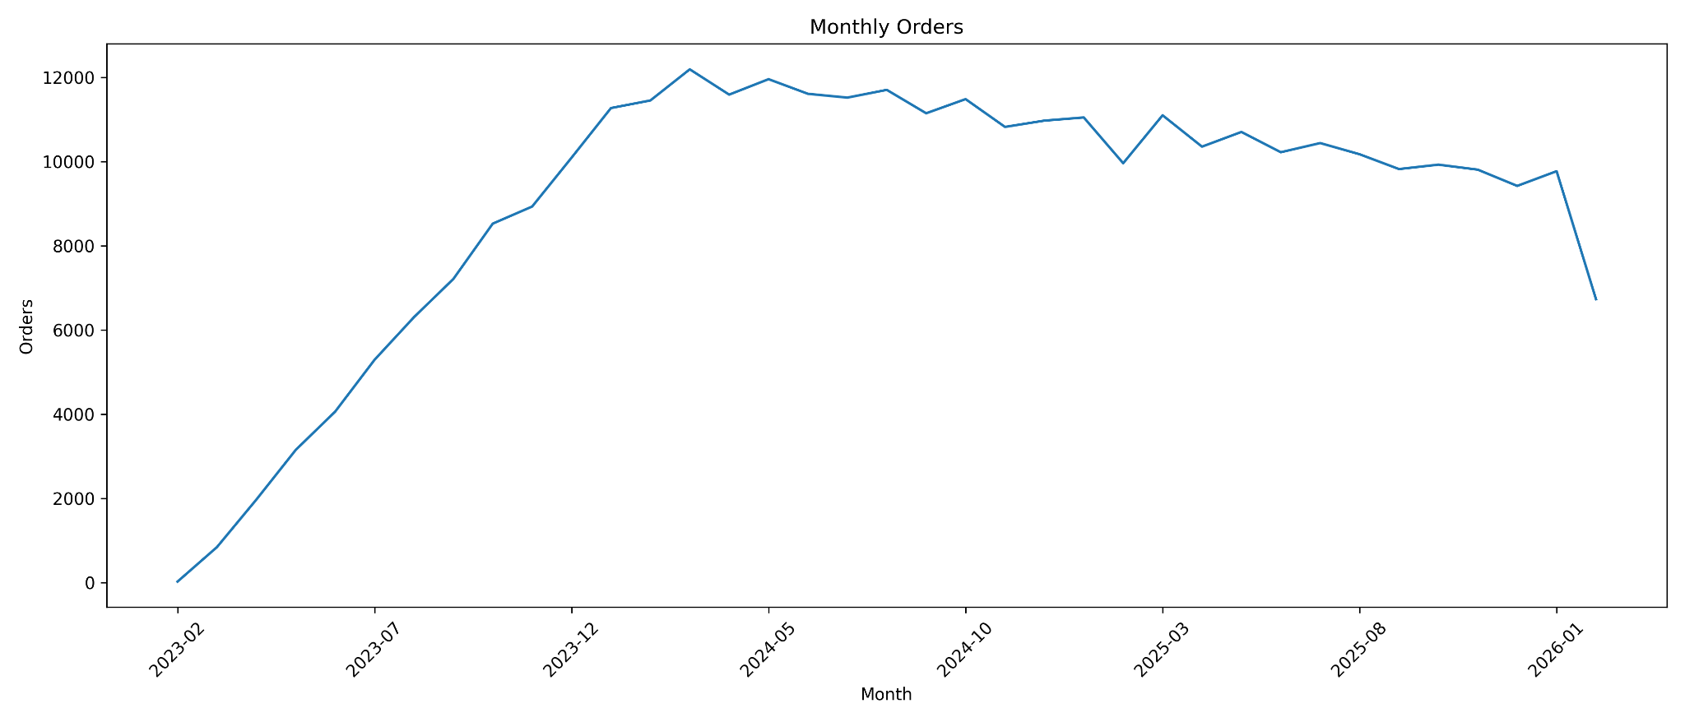

- Figure A2: Customer Status

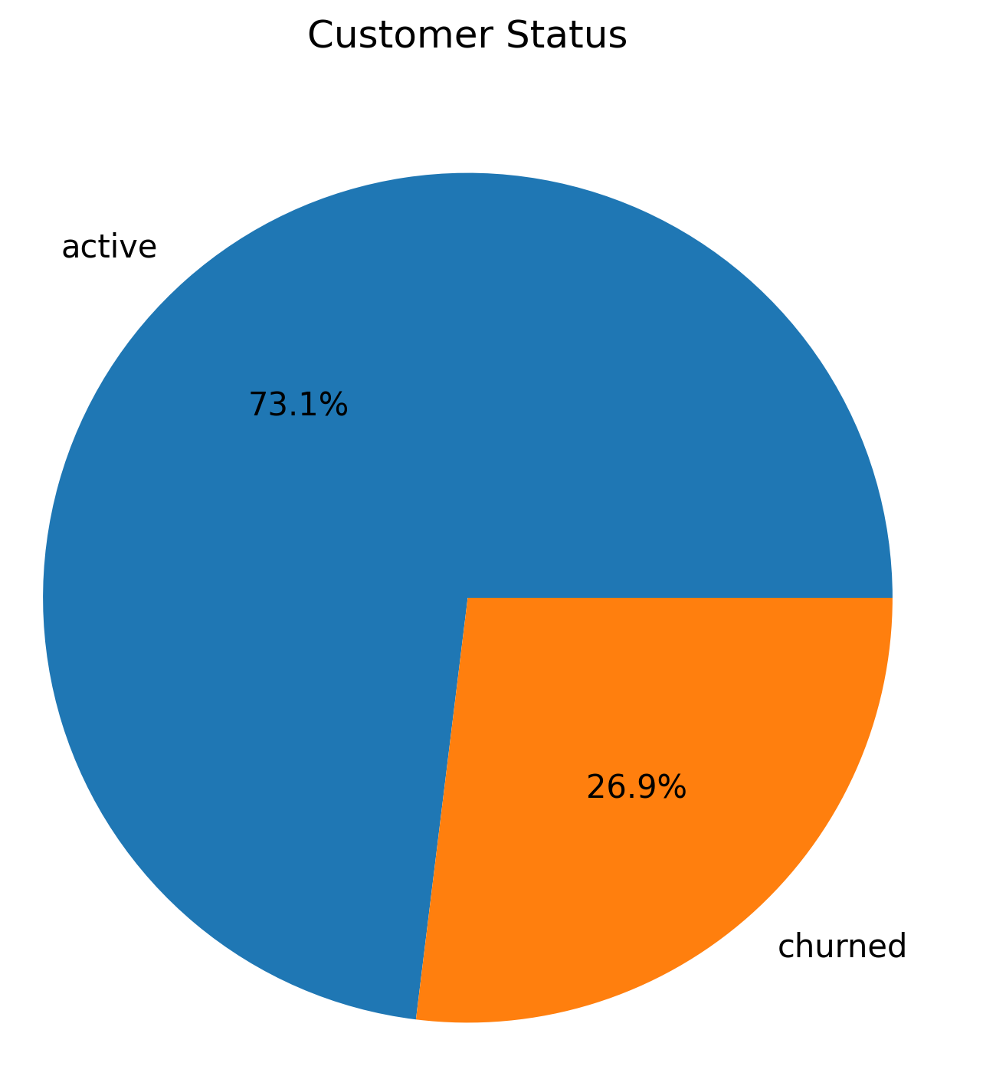

- Figure A3: Customer Sales
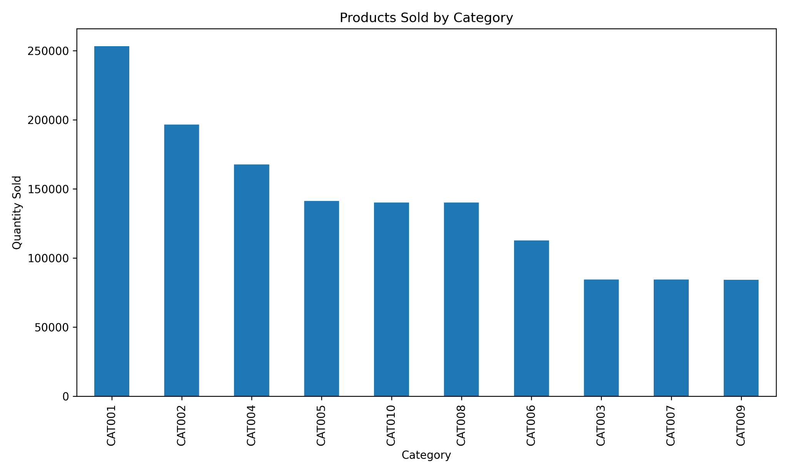
- Figure A4: Top Brands
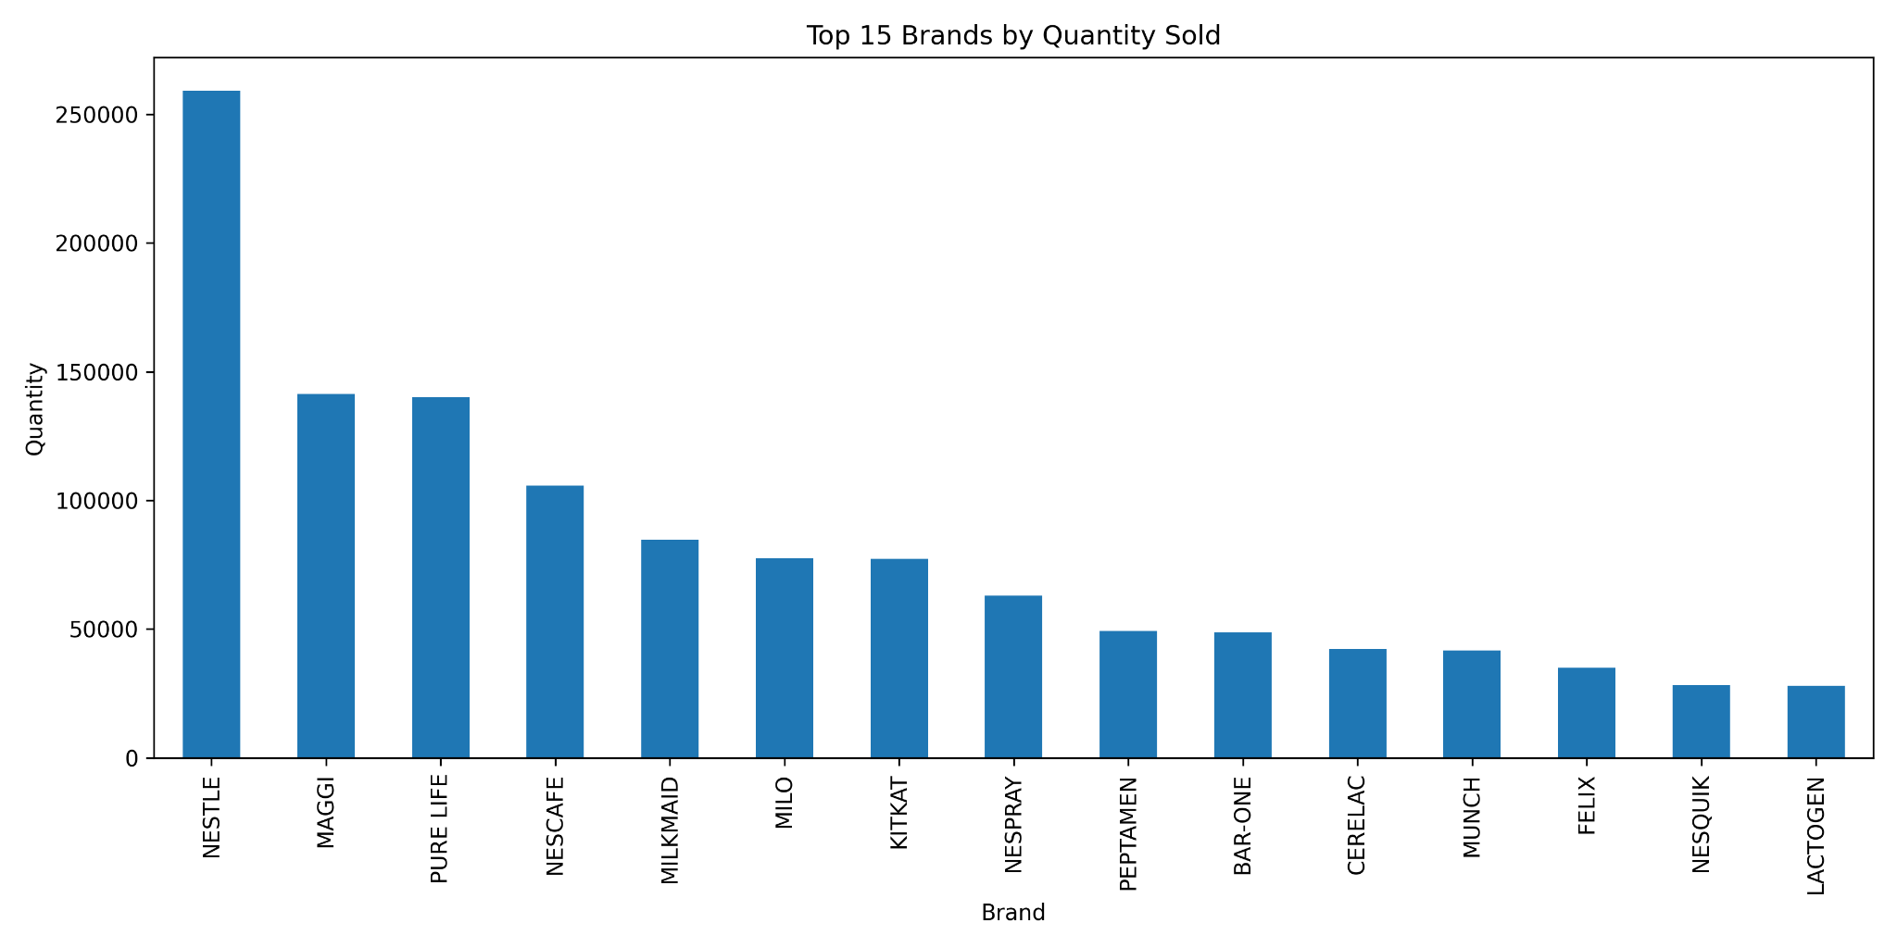
- Figure A5: Distribution of RFM Scores
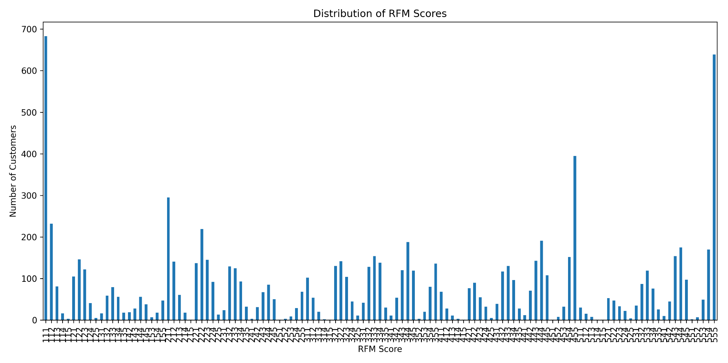

Appendix B
- Table A1: CLTV Segment Summary
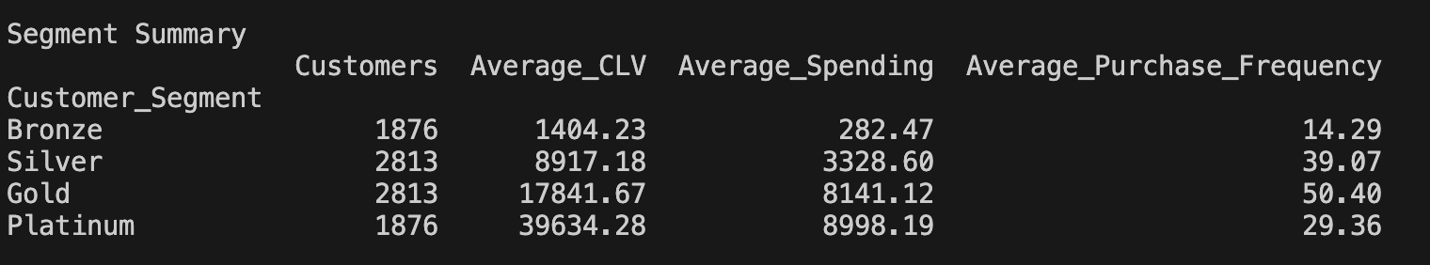

- Table A2: Top 20 CLTV Customers
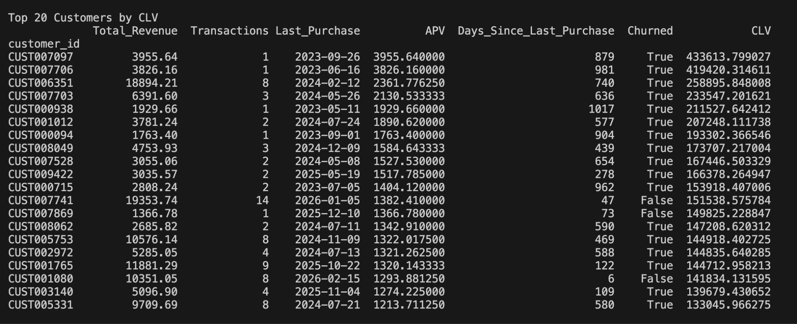

- Table A3: Top 20 Predicted CLTV Customers
