Mapping the Solar Equity Gap Across Illinois Census Tracts
Rishan Shah
Summary
Illinois has committed to 100% clean energy by 2050 under the Illinois Climate and Equitable Jobs Act (CEJA). However, the benefits of solar- reduced electricity bills, energy independence, and cleaner air are not reaching the communities that need them most. This brief analyzes rooftop solar adoption across all 3,213 Illinois census tracts using LBNL Tracking the Sun installation records and U.S. Census American Community Survey data to document a stark equity gap in the social groups that benefit from the clean energy transition.

Key Findings
- 83% of lowest-income tracts have ZERO solar installations
664 of 804 census tracts in the lowest income quartile
- 2.2x higher adoption in wealthiest vs. poorest tracts
Installations per 1,000 housing units: 17.1 (Q4) vs. 7.8 (Q1)
- $52.9M in annual electricity savings inaccessible to low-income residents
14,936 missing installations at avg. 22.7 kW per system

Background
Rooftop solar adoption has grown rapidly in Illinois, driven by falling installation costs, net metering policies, and state incentives including the Illinois Solar for All (ILSFA) program. However, state-wide growth masks deep inequities. Research consistently shows that solar adoption skews heavily toward higher-income, white households, a pattern that is driven by redlining, high installation costs, homeownership rates, rental housing exclusion, and lack of targeted outreach in low-income communities.
The Illinois Climate and Equitable Jobs Act, signed in 2021, explicitly recognized this inequity and created equity provisions requiring that 40% of clean energy benefits flow along with significant economic development funds and workforce training programs to ‘Equity Investment Eligible Communities’. Despite this mandate, granular data on whether adoption patterns have shifted remains limited. This analysis provides a census-tract-level accounting of where solar has been implemented across Illinois.

Methodology
This analysis uses three key data sources:
- Solar Data: LBNL Tracking the Sun (September 2025): A comprehensive registry of rooftop PV installations compiled from state and utility incentive programs, covering 79,100 Illinois installations
- Demographic Data: U.S. Census American Community Survey 5-Year Estimates (2024) : Tract-level median household income (Table B19013), race and ethnicity (B03002), and housing tenure (B25003) for all 3,265 Illinois census tracts
- Geographic Boundaries: TIGER/Line Shapefiles (2022): Tract boundaries for Illinois used for spatial analysis and mapping.

Solar installations were aggregated from the zip code level to census tracts using a spatial join via ZCTA boundaries. Adoption rate is measured as installations per 1,000 housing units. Census tracts were divided into income quartiles based on median household income. Unrealized savings were calculated by projecting the gap between actual Q1 installations and the number expected at Q4 adoption rates, multiplied by average system size (22.7 kW), Illinois average annual solar hours (1,200), and the state-wide average electricity rate ($0.13/kWh).

Results

1. Solar Adoption Correlates with Income
Across Illinois census tracts, solar adoption rises sharply with income. Tracts in the highest income quartile (Q4) average 17.1 solar installations per 1,000 housing units, compared to just 7.8 in the lowest income quartile (Q1), a 220% higher adoption. Middle-income tracts (Q2 and Q3) show intermediate adoption rates of 14.9 and 19.3 respectively.
Q3 boasts a greater adoption rate, showing that suburban communities with high homeownership rates and favorable roof characteristics have benefited from installer expansion beyond the wealthiest neighborhoods.

2. Most Low-Income Tracts have No Solar
83% of the lowest-income census tracts (664 of 804 tracts) have recorded zero rooftop solar installations. The distribution of the installations that do exist is heavily skewed toward wealthier areas: low-income tracts account for a disproportionately small share of total installed capacity despite representing 25% of all tracts.

3. Race and Solar Adoption
Majority non-white census tracts average 12.5 solar installations per 1,000 housing units, compared to 15.0 in majority-white tracts. This gap is smaller than the income gap, suggesting that income is the dominant driver of solar exclusion in Illinois.

4. Economic Cost of Exclusion
If lowest-income tracts adopted solar at the same rate as highest-income tracts, an estimated 14,936 additional installations would exist across Q1 communities. At an average system size of 22.7 kW and Illinois electricity prices, this would generate approximately $52.9 million in annual electricity savings, a figure currently inaccessible to some of Illinois' most cost-burdened households.
Energy cost burden, which is the share of household income spent on utilities, is already 2-3 times higher in low-income households than high-income. Solar adoption directly reduces this burden. The failure to extend solar access to low-income communities thus compounds existing energy inequality.
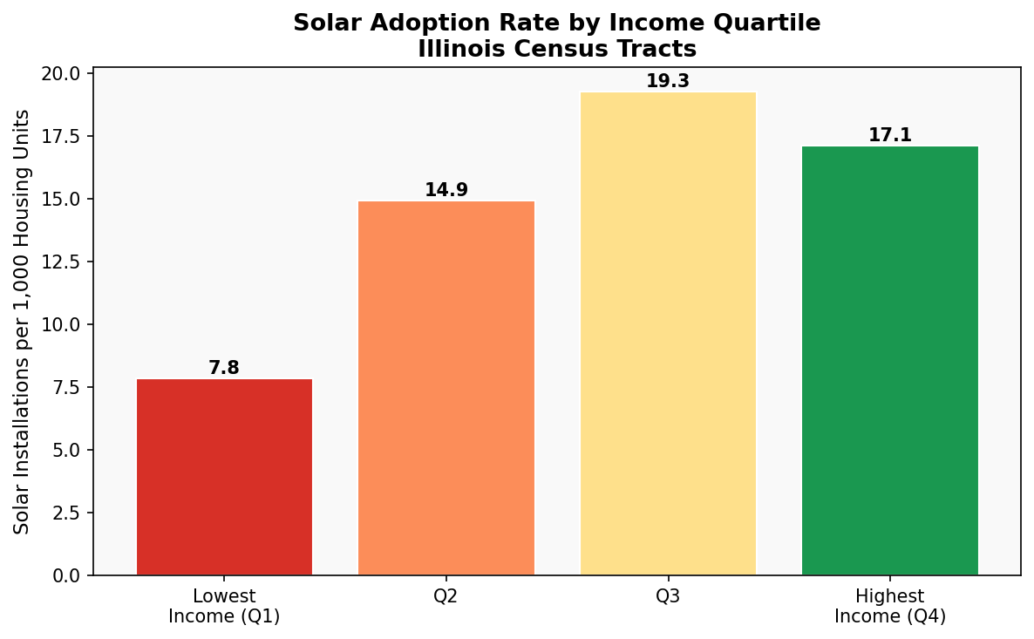

Figure 1: Solar Adoption Rate by Income Quartile

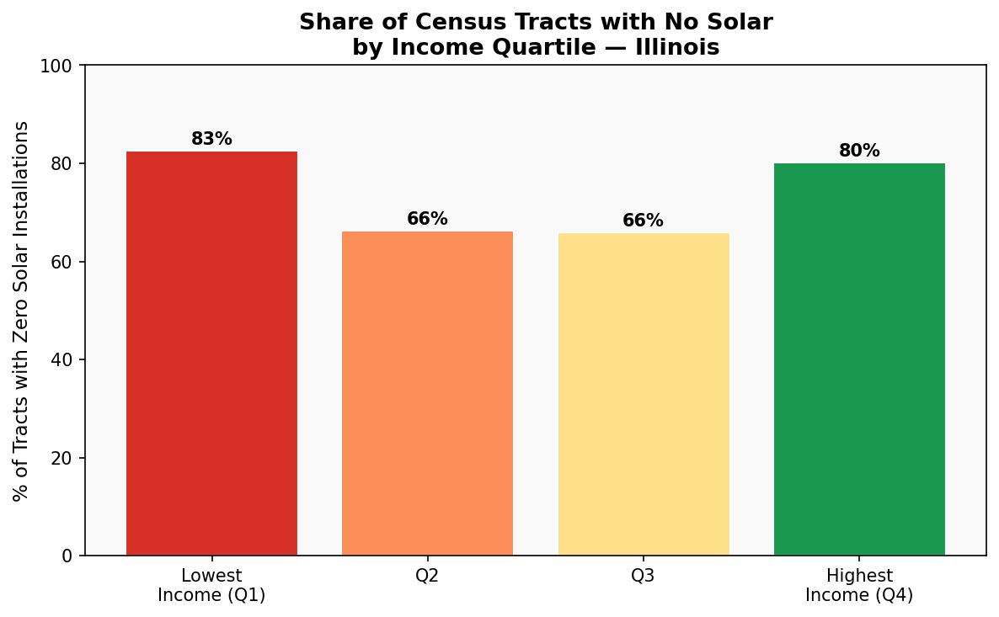

Figure 2: No Solar by Income Quartile
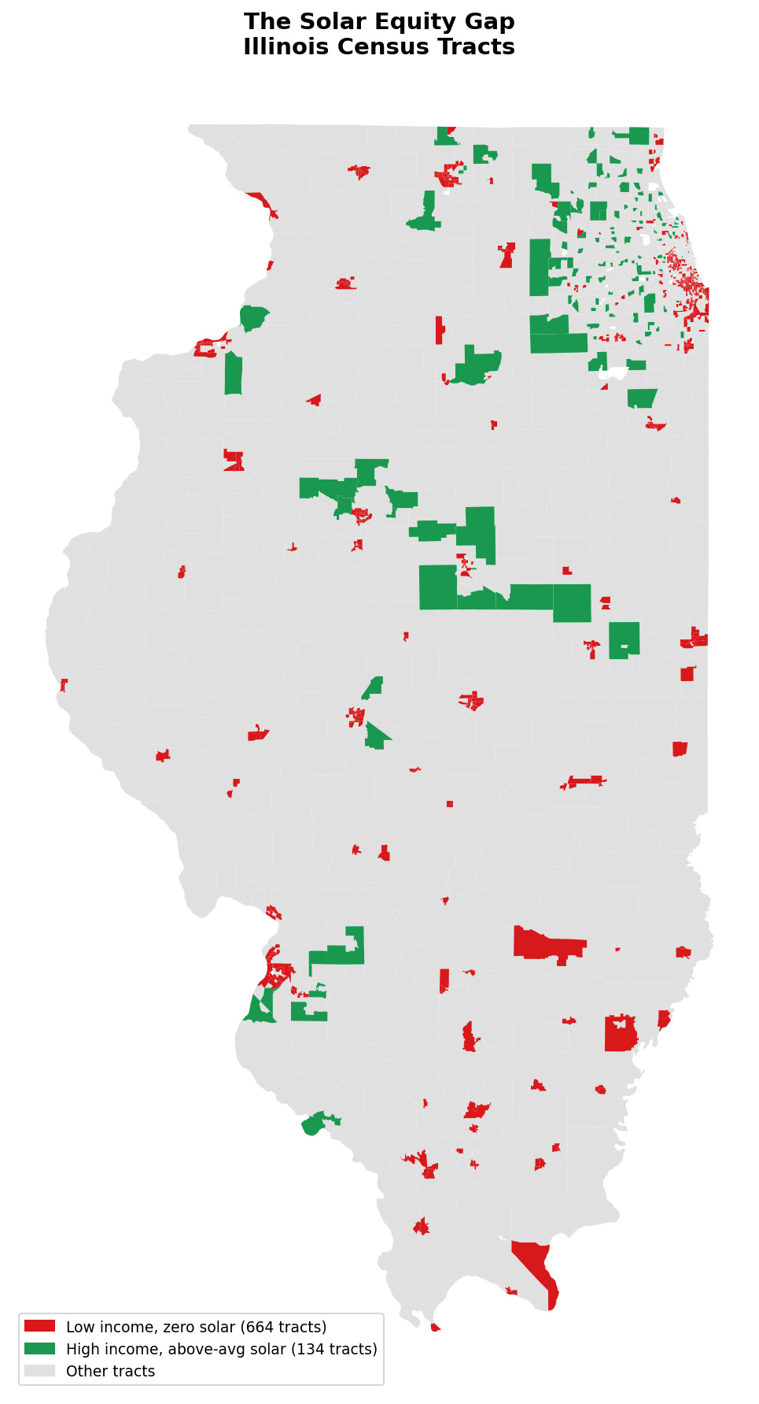

Figure 3: Solar Equity Gap Across Illinois
Policy Recommendations

1. Expand and streamline Illinois Solar for all
The Illinois Solar for All (ILSFA) program was created to make renewable energy more accessible for low-income households, non-profit organizations, and environmental justice communities across Illinois. It provides incentives specifically for low-income solar adoption, but uptake has been limited by application complexity, lack of community awareness and a shortage of approved installers in underserved regions.
To improve participation, Illinois policymakers should focus on simplifying the enrolment and verification process for households. Creating a more user-friendly application system and partnering with trusted community organizations would significantly improve accessibility. Increasing training opportunities through workforce development programs under the Climate and Equitable Jobs Act (CEJA) would not only expand clean energy access but also create employment opportunities in historically marginalized communities, along with improving installer recruitment.

2. Mandate community solar carve-outs for Environmental Justice Communities
For many low-income households, rooftop solar is not a practical option because they rent their homes, live in multifamily buildings, or lack suitable roof conditions for solar installation. Community solar programs provide an alternative solution by allowing residents to subscribe to a shared solar array and receive credits on their electricity bills without installing panels.
Strengthening community solar carve-outs would also help reduce disparities in access to renewable energy technologies across Illinois. Without intentional policy interventions, wealthier communities are often more likely to benefit from clean energy incentives, leaving vulnerable populations behind. Targeted investment in environmental justice communities can help address these inequities while simultaneously supporting Illinois’ state-wide clean energy goals.

3. Public Solar Equity Dashboards
A major challenge in evaluating solar equity progress in Illinois is the lack of publicly accessible, regularly updated tract-level adoption data. Although state-wide solar capacity statistics are available, there is limited transparent reporting for policymakers, researchers, and community organizations to identify which communities remain underserved. Additionally, transparent reporting increases public accountability. Communities are more likely to trust clean energy initiatives when they can clearly see how investments are distributed and whether state agencies are meeting equity goals.

Conclusion
Illinois has the legal mandate, political infrastructure, and economic motivation to close the solar equity gap. The Illinois Climate and Equitable Jobs Act set a clear standard: clean energy benefits must reach environmental justice communities. This analysis demonstrates that by the measure of rooftop solar adoption, that standard is not yet being met. 83% of the state's lowest-income census tracts have zero solar installations, and the annual cost of that exclusion $52.9 million in unrealized electricity savings falls disproportionately on underserved households.

References
All data, analysis scripts, and maps produced for this brief are available as an open-source repository at:
github.com/rishshah2006-prog/solar-equity-gap

Nations, United. “Illinois: Expanding Clean Energy and Local Jobs | United Nations.” United Nations, 2019, www.un.org/en/climatechange/illinois-expanding-clean-energy-and-local-jobs.
“Illinois Solar for All.” Illinois.gov, 2024, cleanenergy.illinois.gov/tracking-illinois-progress/illinois-solar-for-all.html.
Raw data sources: LBNL Tracking the Sun (emp.lbl.gov), U.S. Census ACS (data.census.gov), TIGER/Line Shapefiles (census.gov)

