# **Sign Language Conversion**

**Project Report**

Submitted for the requirement of

**Minor Project- II (MCA- 170)**

*Submitted by*

Ankita (Roll No. 00514504420)

Gurshabad Kaur (Roll No. 00814504420)

Rishabh Gusain (Roll No. 05114504420)

Ritika Rawat (Roll No. 05214504420)

*Under the guidance of*

Dr. Vandana Bhasin

*Associate Professor*



**Lal Bahadur Shastri Institute of Management (LBSIM)**

# **Dwarka, New Delhi**

**(2020-2022)**

**Table of Contents**

|  |  |  |
| --- | --- | --- |
| **S. No.** | **Topic** | **Page No.** |
| **1** | **1-** **Introduction along with Literature Survey** | **3** |
| **2** | **2-** **Body of Proposal** | **3-5** |
|  | 2.1- Methodology and Modules | 3-5 |
|  | 2.2- Hardware and Software Requirements | 5 |
| **3** | **3-****Advantages, Applications and Limitations** | **6** |
| **4** | **4-** **Inception Phase Diagrams** | **7-12** |
|  | 4.1- Use Case Diagram | 7 |
|  | 4.2- Fully Developed Diagram (FDD) | 8-10 |
|  | 4.3- Activity Diagram | 11 |
|  | 4.4- Storyboard | 12 |
| **5** | **5-** **Elaboration Phase Diagrams** | **13-17** |
|  | 5.1- Object Diagrams | 13 |
|  | 5.2- System Sequence Diagrams | 14-16 |
|  | 5.3- Problem Domain Class Diagram | 17 |
| **6** | **6-** **Construction Phase Diagrams** | **18-21** |
|  | 6.1- Sequence Diagrams | 18-19 |
|  | 6.2- State Diagrams | 20 |
|  | 6.3- Design Class Model Diagrams | 21 |
| **7** | **7-** **Screenshots** | **22-23** |
| **9** | **9-** **References** | **24** |
|  |  |  |
|  |  |  |
|  |  |  |

1. Introduction along with Literature Survey

* This system converts sign language into text and then further into speech.
* If a person who is speech and/or hearing impaired wants to communicate with people or vice versa, then they can do so by using this system.
* We have used CNN for detection of gestures.
* The user interface is easily navigable and works efficiently and is also user friendly.
* Most earlier systems converted the sign language into text format only, but we have taken this, one step further for the ease of users.
* The accuracy of this project is 89%.

As Mahesh Kumar stated [1] “Sign Language Recognition is one of the most growing fields of research area”. As we know sign language is not included in education curriculums, this can create quite a barrier which can prove to be difficult. So, to remedy this situation, we have created this system by keeping the said barrier in mind.

2. Body of Proposal

Most people don’t know sign language which often times creates a communication barrier. People who are not hearing-impaired or speech-impaired are unable to communicate with people who are, and vice versa. The purpose of this project is to eliminate this particular barrier and make the process of communication easier. To rid ourselves and the people of this scenario, we have devised a system that converts sign language into text and into speech as well. Some state-of-the-art includes- Hand Talk translator, which is available on google play, it converts text or audio into ASL (American Sign Language) and Brazilian Sign Language. We Capable also does the same but, it is in the form of a website. In this, we enter text and it converts the text into sign language. This system supports both ASL (American Sign Language) and BSL (British Sign Language).

2.1 Methodology & Modules

RUP (Rational Unified Process) Model

Rational Unified Process (RUP) is a software development process for object-oriented models. It is also known as the Unified Process Model. It is created by Rational corporation and is designed and documented using UML (Unified Modeling Language). This process is included in IBM Rational Method Composer (RMC) product.  
There are total five phases of life cycle of RUP:

1. Inception –

* Communication and planning are main.
* Identifies Scope of the project using use-case model allowing managers to estimate costs and time required.
* Customers requirements are identified and then it becomes easy to make a plan of the project.
* Project plan, Project goal, risks, use-case model, Project description, are made.
* Project is checked against the milestone criteria and if it couldn’t pass these criteria then project can be either cancelled or redesigned.

2. Elaboration –

* Planning and modeling are main.
* Detailed evaluation, development plan is carried out and diminish the risks.
* Revise or redefine use-case model (approx. 80%), business case, risks.
* Again, checked against milestone criteria and if it couldn’t pass these criteria then again project can be cancelled or redesigned.
* Executable architecture baseline.

3. Construction –

* Project is developed and completed.
* System or source code is created and then testing is done.
* Coding takes place.

4. Transition –

* Final project is released to public.
* Transit the project from development into production.
* Update project documentation.
* Beta testing is conducted.
* Defects are removed from project based on feedback from public.

5. Production –

* + Final phase of the model.

Project is maintained and updated accordingly.

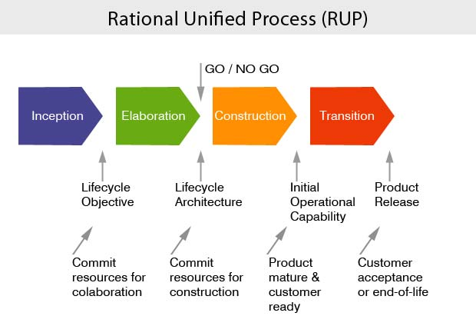

**Figure 1**

Modules:

Admin-

* Create dataset
* Update dataset

User-

* Can scan the symbol
* View the predicted output
* Can see the dataset
* Can listen to the predicted text

2.2 Hardware and Software Requirements

Hardware-

* RAM (4 GB or above)
* Webcam
* Fully functional system

Software-

* Python compiler
* Visual Studio Code (code editor)
* Google Chrome (or any other web browser)
* Microsoft Word (or any other text editor)
* Jupyter Notebook

3. Advantages, Applications & Limitations

* Some advantages of this system are-
* It will eliminate the communication barrier, as mentioned above.
* It will also help people learn sign language, and then use it in times of need.
* It will benefit people as interaction with disabled people will be much easier and meaningful, we will not have to guess as to what they are saying because we would be able to understand them crystal clear.
* Some limitations of this system are-
* it is supporting only one kind of sign language and not the sign languages from around the world. Sign languages like BSL (British Sign Language), Brazilian Sign Language, etc. are not supported.
* Words which have silent alphabets in them, like psychology, psychiatrist, etc. are not supported right now in this system.
* Some of its applications are, this system can be used in multiple different environments, such as-
* Corporate world,
* Schools,
* Colleges, etc.
* It can also be utilized in our daily lives, which will prove be useful. And apart from all this, this is a great learning opportunity for those who wish to learn sign language.

4. Inception Phase Diagrams

4.1 Use case diagram-

4.2 Fully Developed Description (FDD)

|  |  |  |
| --- | --- | --- |
| Use Case Name | View DataSet | |
| Scenario | User can View the DataSet | |
| Triggering Event | When user click on View DataSet Button | |
| Brief Description | In this user can see the dataset and accordingly make hand gestures in the frame. | |
| Actors | User | |
| Related Use Cases |  | |
| Stakeholders |  | |
| Pre-Conditions |  | |
| Post Conditions | System Will predict the hand Gestures. | |
| Flow of Activities | Actor | System |
| 1. Go to the Website. 2. Click on View Dataset | * 1. It will Displaying the Preexisting Dataset. |
| Exception Conditions |  | |

|  |  |  |
| --- | --- | --- |
| Use Case Name | Predict Gestures | |
| Scenario | User can make the hand gestures and System Will Predict the hand Gestures. | |
| Triggering Event | When User Clicks on Predict Gesture Button. | |
| Brief Description | In this, firstly system opens the Webcam, Frame, find ROI and then User can record gestures and system will Predict the text according to the hand Gestures. | |
| Actors | User, System | |
| Related Use Cases | Record Gestures, Open Webcam, Find Region of Interest | |
| Stakeholders |  | |
| Pre-Conditions | Users can view the Dataset. | |
| Post Conditions | After Prediction, predicted word is store in form and shown to the user. | |
| Flow of Activities | Actor | System |
| * 1. User can record the hand Gestures. | 1. Opens Webcam and Frame and Find the Region of Interest |
| Exception Conditions |  | |

|  |  |  |
| --- | --- | --- |
| Use Case Name | Save Predicted Output | |
| Scenario | Predicted Word is stored in a file/form. | |
| Triggering Event | When User Clicks on Save Predicted Output. | |
| Brief Description | After Prediction, predicted word will be save and stored in a file/form and it will be shown to the user. | |
| Actors | System | |
| Related Use Cases |  | |
| Stakeholders |  | |
| Pre-Conditions | There should be prediction before it can be save and store. | |
| Post Conditions | The resulted text will be shown to the user | |
| Flow of Activities | Actor | System |
| 1. User can click on save Predicted Output to save the output.    1. User can view the saved Output. | * 1. System will save the predicted Output.  1. System will display the saved Output. |
| Exception Conditions |  | |

|  |  |  |
| --- | --- | --- |
| Use Case Name | Speak Predicted Word | |
| Scenario | The predicted word will be spoken by the system | |
| Triggering Event | When user clicks on speak button | |
| Brief Description | After saving the predicted word it will speak the text | |
| Actors | System | |
| Related Use Cases |  | |
| Stakeholders |  | |
| Pre-Conditions | There should be a saved predicted word | |
| Post Conditions | System will speak the predicted word for the user to hear | |
| Flow of Activities | Actor | System |
| 1. Click on speak button. 2. The user will hear the spoken word. | * 1. System will speak the saved file. |
| Exception Conditions |  | |

|  |  |  |
| --- | --- | --- |
| Use Case Name | Restore state | |
| Scenario | The state will be restored to original state | |
| Triggering Event | When user click on Restore Button. | |
| Brief Description | Predicted Output is stored in the file it will clear the content of that file/form. | |
| Actors | System | |
| Related Use Cases |  | |
| Stakeholders |  | |
| Pre-Conditions | There should be word stored in that file. | |
| Post Conditions | Data will be cleared out. | |
| Flow of Activities | Actor | System |
| 1. User click on Restore State | * 1. System will restore the state to original state.   2. File will be emptied out. |
| Exception Conditions |  | |

4.3 Activity Diagram

4.4 Storyboard

5 Elaboration Phase Diagrams

5.1 Object Diagrams

1. View Dataset

2. Predict Gestures

3. Save Predicted Word

4. Speak Predicted Word

5.2 System Sequence Diagram

1. View dataset

2. Predict Gestures

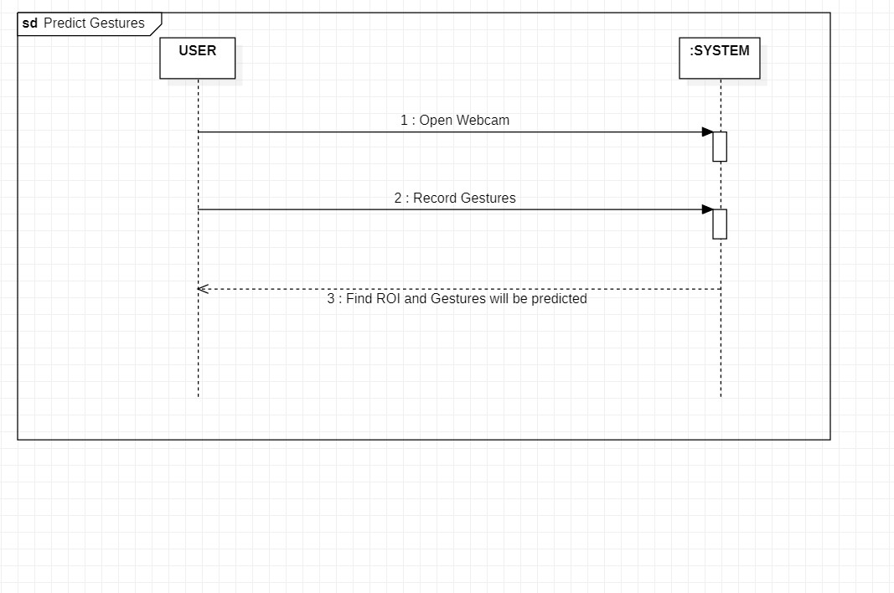

3. Save Predicted Output

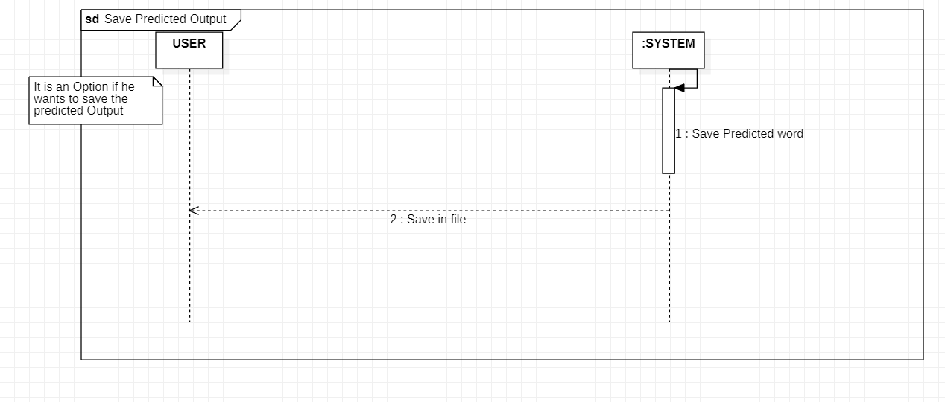

4. Speak Predicted Output

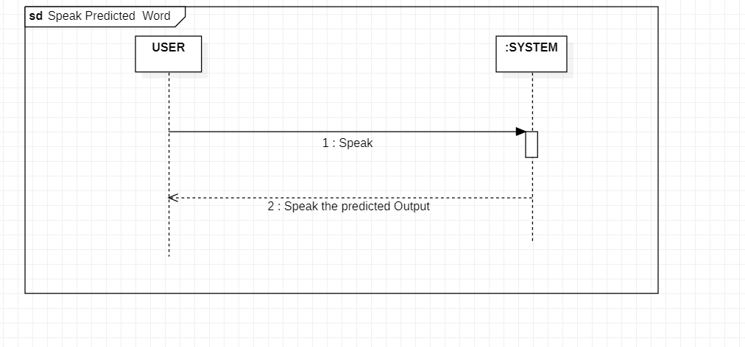

5. Restore State

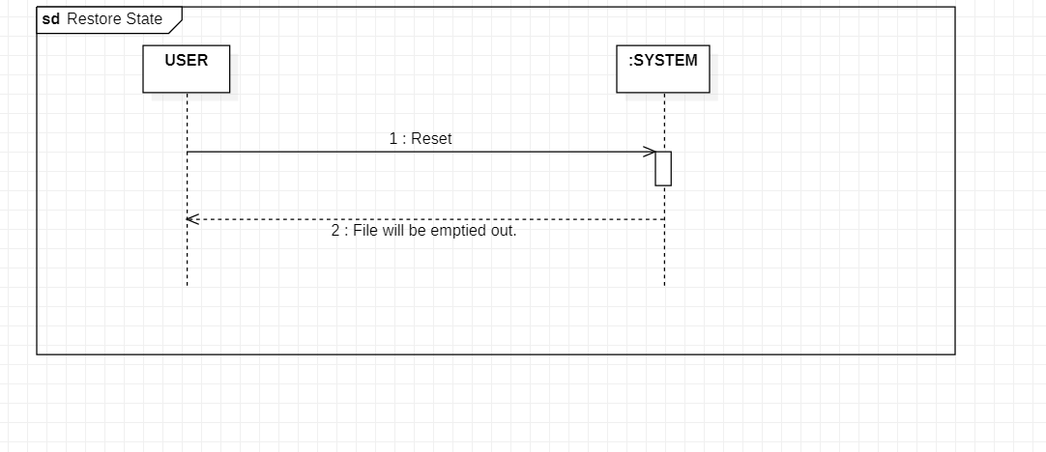

5.3 Problem Domain Class Diagram

6. Construction Phase Diagrams

6.1 Sequence Diagrams

1. View Dataset

2. Predict Gestures

3. Save Predicted Word

4. Speak Predicted Word

6.2 State Diagrams

1. View dataset

2. Predict Gestures

6.3 Design Class Model Diagram

Screenshots

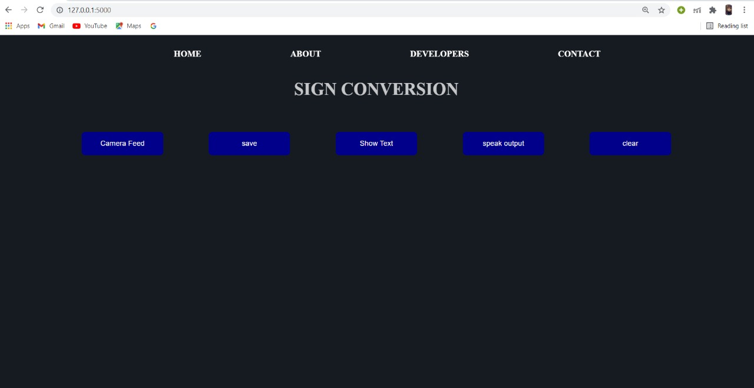

Home Page

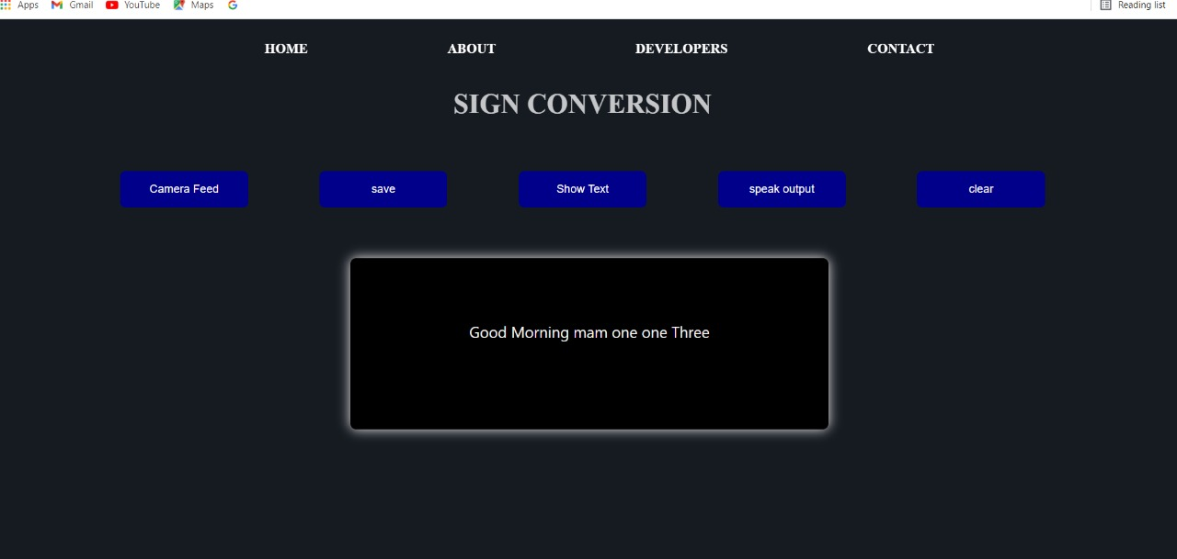

After the user has shown hand gesture, and the system has predicted it.

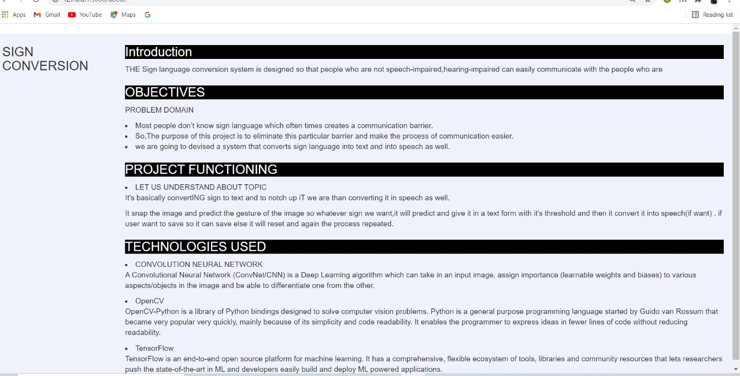

About Page

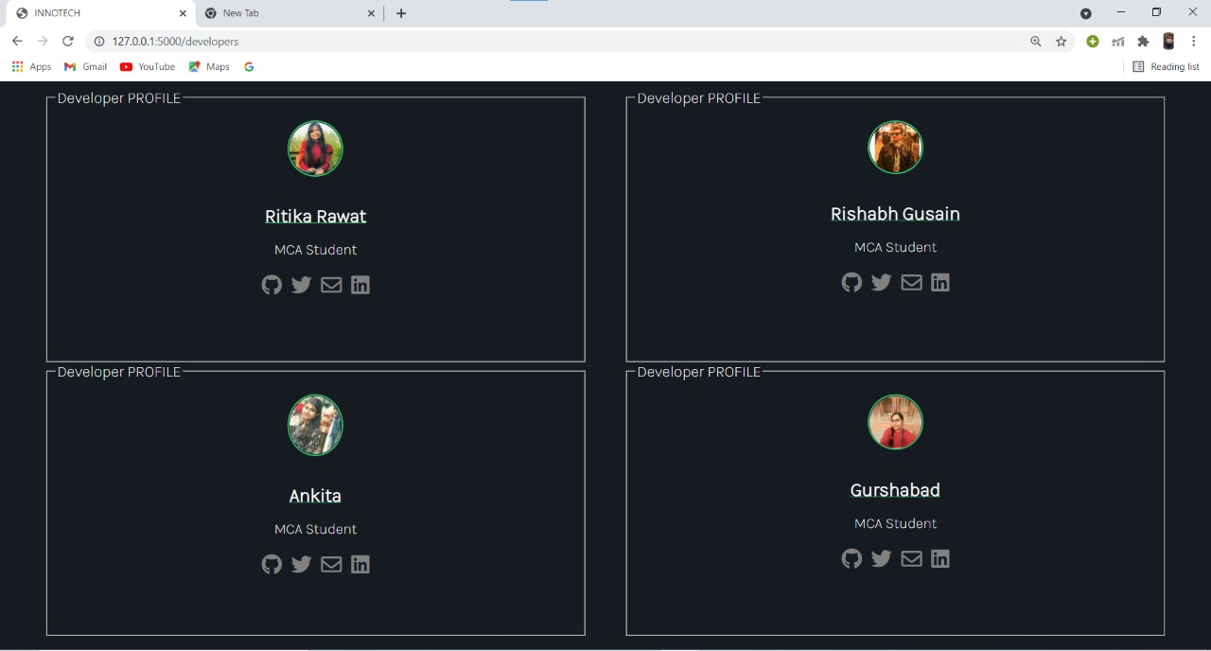

Developer’s Profile Page

References

[1] Bannari Amman Institute of Technology, Sathyamangalam, Erode, India. Conversion of Sign Language into Text. Published in International Journal of Applied Engineering Research ISSN 0973-4562 Volume 13, Number 9 (2018).

Available: https://www.ripublication.com/ijaer18/ijaerv13n9_90.pdf