Experiment 7

Title

Use XSLT (eXtensible Stylesheet Language Transformations) to convert XML data into an HTML table for better presentation.Create an XML file (books.xml) containing book details (Title, Author, Price). Write an XSL file (books.xsl) that transforms the XML data into an HTML table. Link the XSL with XML and open it in a browser to see the formatted output
Theory:
XML (eXtensible Markup Language) is used to store and transport data in a structured and self-descriptive format. However, XML by itself does not define how data should be displayed in a web browser. To present XML data in a readable and user-friendly format, XSLT (eXtensible Stylesheet Language Transformations) is used.
XSLT is a language designed to transform XML documents into other formats such as HTML, XHTML, or plain text. It works by applying transformation rules defined in an XSL stylesheet to an XML document. These rules specify how elements in the XML file should be matched and displayed in the output document.
In this experiment, an XML file named books.xml is created to store book information such as title, author, and price. An XSL file named books.xsl is used to transform this XML data into an HTML table. The XSL file is linked to the XML document so that when the XML file is opened in a browser, the data is displayed in a formatted HTML table.
Algorithm / Procedure:
- Start the experiment.
- Create an XML file named books.xml.
- Define book details such as title, author, and price using XML tags.
- Create an XSL file named books.xsl.
- Write XSLT rules to transform XML elements into an HTML table.
- Link the XSL file to the XML file using the xml-stylesheet instruction.
- Save both files in the same folder.
- Open the XML file in a web browser.
- Observe the formatted HTML table output.
- Stop the experiment.
Program/Code:
- XML File (books.xml)
<?xml version="1.0" encoding="UTF-8"?>
<?xml-stylesheet type="text/xsl" href="books.xsl"?>

<books>
<book>
<title>Web Technology</title>
<author>Deitel</author>
<price>450</price>
</book>

<book>
<title>XML and Web Services</title>
<author>Harold</author>
<price>520</price>
</book>

<book>
<title>Learning PHP</title>
<author>David Sklar</author>
<price>399</price>
</book>
</books>
XSL File (books.xsl)
<?xml version="1.0" encoding="UTF-8"?>

<xsl:stylesheet version="1.0"
xmlns:xsl="http://www.w3.org/1999/XSL/Transform">

<xsl:template match="/">
<html>
<head>
<title>Book Details</title>
<style>
table {
border-collapse: collapse;
width: 60%;
}
th, td {
border: 1px solid black;
padding: 8px;
text-align: center;
}
th {
background-color: #dddddd;
}
</style>
</head>

<body>
<h2 align="center">Book Information</h2>

<table align="center">
<tr>
<th>Title</th>
<th>Author</th>
<th>Price</th>
</tr>

<xsl:for-each select="books/book">
<tr>
<td><xsl:value-of select="title"/></td>
<td><xsl:value-of select="author"/></td>
<td><xsl:value-of select="price"/></td>
</tr>
</xsl:for-each>

</table>
</body>
</html>
</xsl:template>

</xsl:stylesheet>
Output:
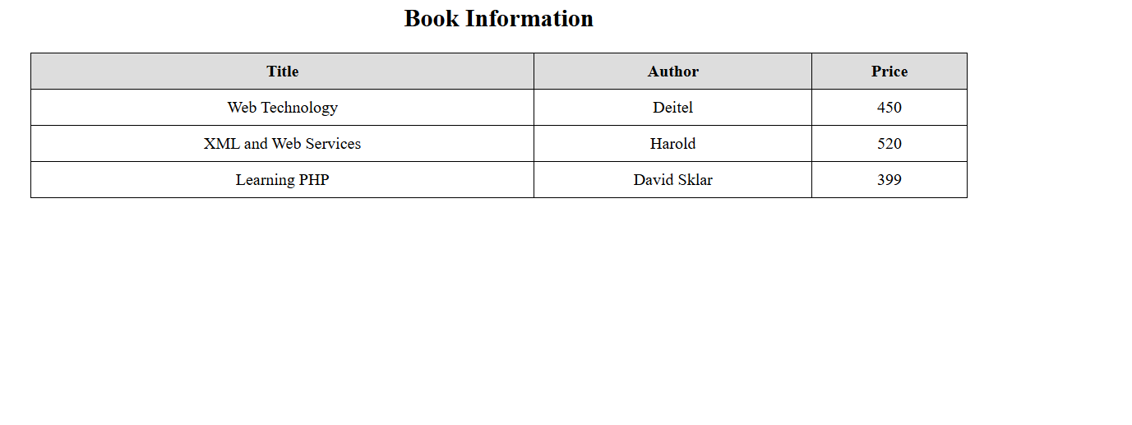

Conclusion
Thus, XML data was successfully transformed into an HTML table using XSLT. This experiment demonstrates how XSL stylesheets can be used to separate data storage from presentation and improve the readability of XML documents in web browsers.
Questions:
- How is XSL linked with XML?
XSL is linked using the <?xml-stylesheet?> instruction in the XML file.
- What does <xsl:for-each> do?
It is used to loop through XML elements and process each node.

- Can XSLT convert XML into formats other than HTML?
Yes, XSLT can convert XML into HTML, XML, or plain text.

