Experiment 5

Title

Develop a web application to fetch real-time weather data for a city. Use AJAX & a public weather API to retrieve information. Display temperature, humidity, and weather conditions dynamically.
Theory:
A weather web application provides real-time climate information by communicating with external servers using web technologies. In this experiment, AJAX (Asynchronous JavaScript and XML) is used to fetch live weather data from a public Weather API without refreshing the webpage.
The Weather API returns data in JSON format, which contains various weather parameters such as temperature, humidity, and weather description. JavaScript processes this data and updates the webpage dynamically using DOM manipulation.
AJAX improves user experience by allowing asynchronous data transfer between client and server. The user enters a city name, and the application retrieves and displays updated weather information instantly.

Role of AJAX
AJAX (Asynchronous JavaScript and XML) enables web applications to send and receive data from a server asynchronously, without refreshing the webpage. This improves performance and user experience. In this experiment, AJAX is implemented using the Fetch API, which allows HTTP requests such as GET to retrieve data from the Weather API. Although the name includes XML, modern AJAX applications mostly exchange data in JSON format.

Fetch API
The Fetch API is a modern JavaScript interface used to make HTTP requests. It returns a Promise, which allows handling asynchronous operations efficiently. Once the API response is received, it is converted into JSON format and processed further. The Fetch API simplifies AJAX implementation compared to older methods like XMLHttpRequest.

Weather API and API Key
A Weather API is a web service that provides access to weather data such as temperature, humidity, pressure, and weather conditions. Most Weather APIs require an API key, which acts as a unique identifier to authenticate users and track API usage. The API key ensures secure access and prevents misuse of the service.

JSON Data Processing
JSON (JavaScript Object Notation) is a lightweight data-exchange format that is easy to read and write. The Weather API sends weather information in JSON format. JavaScript accesses this data using object notation to extract required values like temperature, humidity, and weather description.

DOM Manipulation
The Document Object Model (DOM) represents the structure of a webpage as a tree of objects. JavaScript uses DOM manipulation techniques to dynamically update webpage content. In this application, the fetched weather details are inserted into HTML elements using DOM methods, allowing real-time updates without page reload.

Dynamic Web Page Behavior
Dynamic behavior is achieved when the webpage content changes based on user interaction. In this experiment, when the user clicks the button after entering a city name, the application fetches fresh weather data and updates the display area instantly. This makes the application interactive and responsive.

Error Handling
Error handling is an important aspect of web applications. If the user enters an invalid city name or if there is a network issue, the application displays an appropriate error message. This ensures better usability and reliability.

Algorithm / Procedure
- Start the experiment.
- Create an HTML file for user interface.
- Add an input field to enter the city name.
- Add a button to fetch weather details.
- Use JavaScript to capture the city name entered by the user.
- Send an AJAX request to the Weather API using fetch().
- Receive weather data in JSON format.
- Extract temperature, humidity, and weather condition from the response.
- Display the fetched data dynamically on the webpage.
- Stop the experiment.

Program / Code
<!DOCTYPE html>
<html lang="en">
<head>
<meta charset="UTF-8">
<title>Weather App</title>
<style>
body {
font-family: Arial;
background: #eef2f3;
text-align: center;
}
.box {
background: white;
padding: 20px;
width: 300px;
margin: auto;
box-shadow: 0 0 10px gray;
}
</style>
</head>
<body>

<div class="box">
<h2>Weather Application</h2>
<input type="text" id="city" placeholder="Enter city name">
<br><br>
<button onclick="getWeather()">Get Weather</button>
<p id="result"></p>
</div>

<script>
function getWeather() {
var city = document.getElementById("city").value;
var apiKey = "63e50a85c6a9df2a0802a4bfa387f9b8";
var url = "https://api.openweathermap.org/data/2.5/weather?q="
+ city + "&units=metric&appid=" + apiKey;

fetch(url)
.then(response => response.json())
.then(data => {
document.getElementById("result").innerHTML =
"Temperature: " + data.main.temp + " °C<br>" +
"Humidity: " + data.main.humidity + "%<br>" +
"Condition: " + data.weather[0].description;
})
.catch(() => {
document.getElementById("result").innerHTML = "City not found!";
});
}
</script>

</body>
</html>

Output:
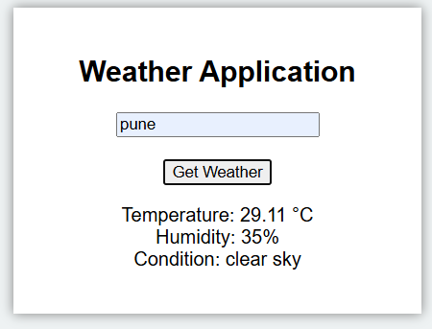

Conclusion
Thus, a dynamic weather web application was successfully developed using AJAX and a public Weather API. This experiment demonstrates real-time data fetching, asynchronous communication, and dynamic content updating using JavaScript and DOM manipulation

Questions:
- What is AJAX?
AJAX is a way to update parts of a webpage without refreshing the whole page.

- What is a Weather API?
A Weather API is a service that sends weather data (like temperature) to your app.

- Why is AJAX preferred over page reload?
AJAX is preferred because it's faster, saves bandwidth, and keeps the page interactive while loading data.

- Which method is used to fetch API data in JavaScript?
The fetch() method is the standard way to get API data in modern JavaScript.

