Delhi AQI Analysis Report

This report computes CPCB AQI from pollutant concentrations (PM2.5, PM10, NO2, SO2, CO, O3, NH3)   
using only NumPy and Pandas for analysis and Matplotlib for plots. The dataset is January-only; season mapping was treated   
as daypart mapping (Morning=Normal, Afternoon=Hot, Night=Cold).

## Libraries used

pandas, numpy, matplotlib, python-docx (for this report generation)

## Key Results

Overall pollutant correlations with AQI (descending):

* no2 : 0.3409
* pm10 : 0.3210
* pm2_5 : 0.3063
* co : 0.2921
* nh3 : 0.0511
* so2 : 0.0009
* o3 : -0.4056

Average AQI by daypart:

1. Morning : 423.35
2. Afternoon : 434.93
3. Night : 429.30

## Top-3 pollutants by daypart (correlation)

### Morning

* co : 0.8590
* nh3 : 0.8257
* no2 : 0.8042

### Afternoon

* no2 : -0.0395
* co : -0.1110
* pm10 : -0.1164

### Night

* pm10 : 0.5275
* no2 : 0.4993
* pm2_5 : 0.4900

## Visualizations

Average AQI by Hour of Day

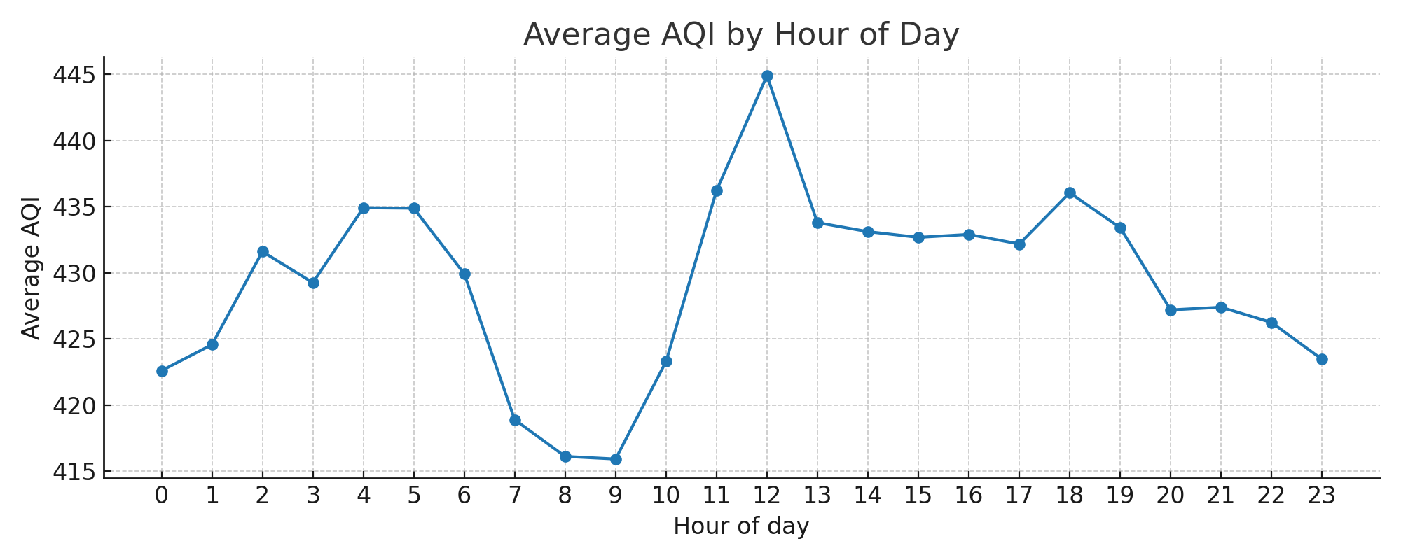

Average AQI by Daypart

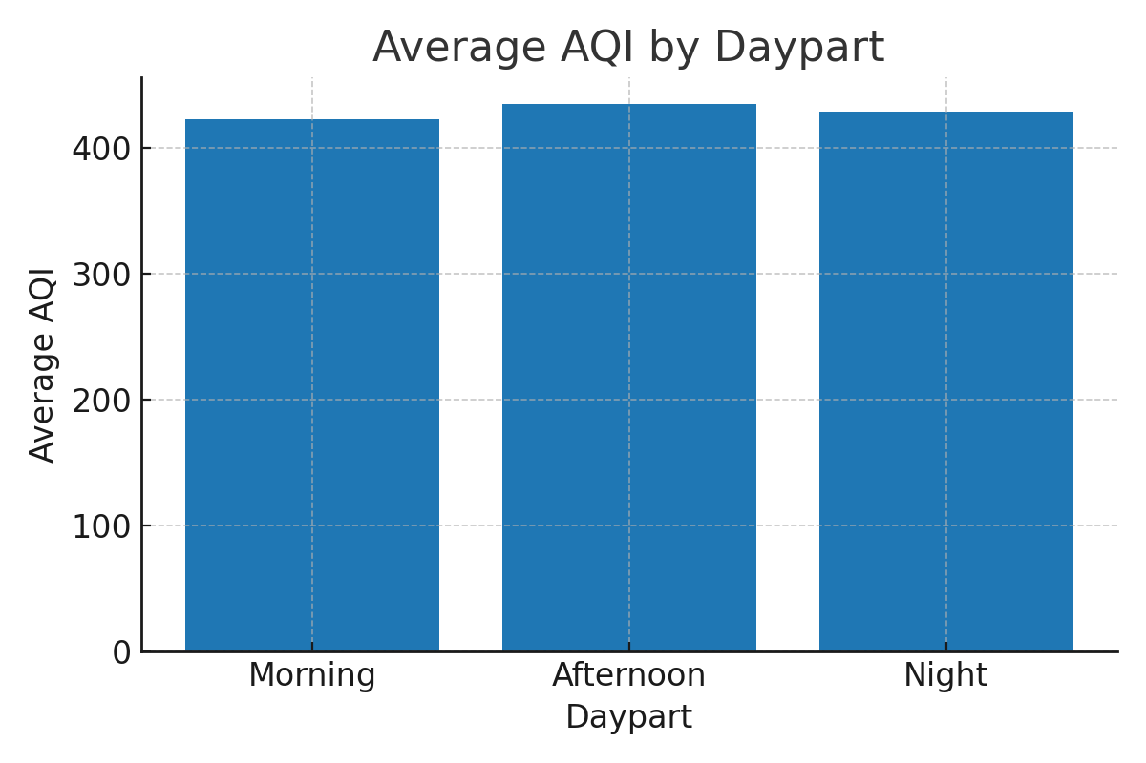

Correlation of pollutants with AQI

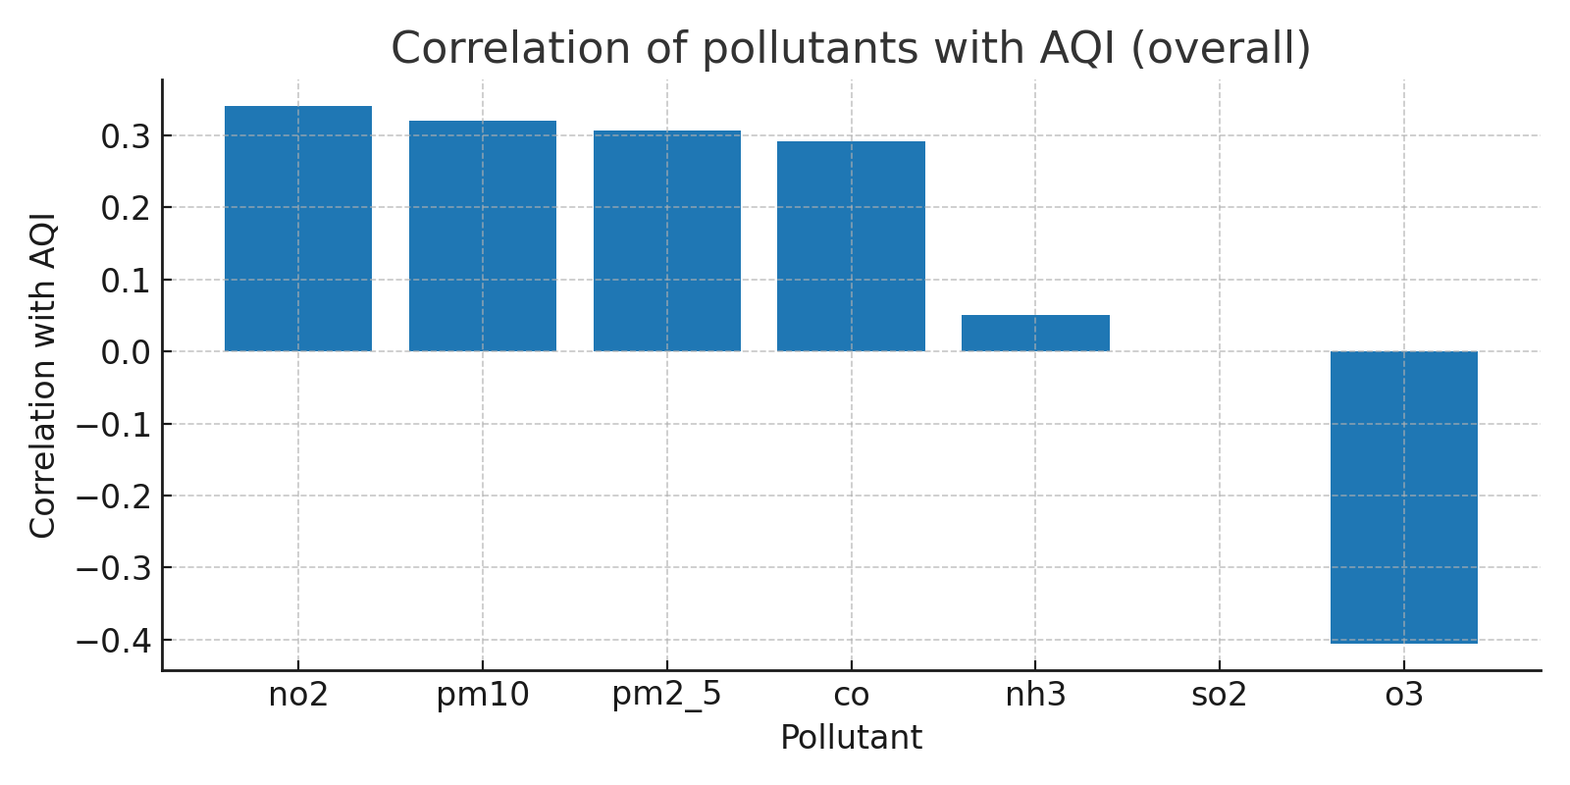

## Conclusion

In this January dataset, overall AQI is high throughout the day. Key pollutants associated with AQI   
 are NO2, PM10 and PM2.5. CO appears frequently as dominant pollutant in the dataset - please verify units for CO.  
 Afternoon shows the highest average AQI (mapped to 'hot' season proxy).