Git link : https://github.com/rishu2088/DevOps_rishabh.git
- Create a directory named test_dir using mkdir.
mkdir command creates a new folder.
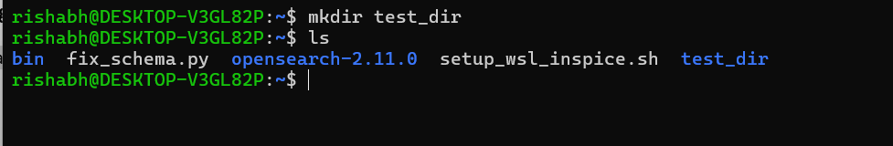
- Inside test_dir, create an empty file called example.txt.

The touch command creates an empty file.
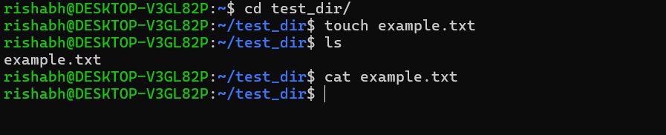
- Rename example.txt to renamed_example.txt using mv.
Change the file name mv command used.
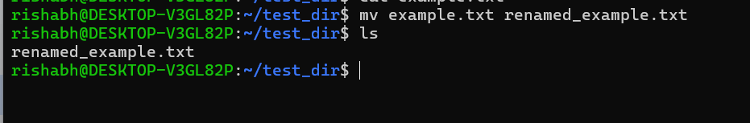
2. Viewing File Contents
- Use cat to display the contents of /etc/passwd
cat command display,read,combine content of text files.
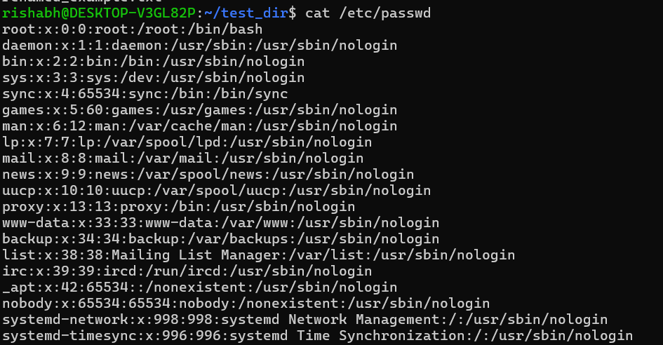
- Display only the first 5 lines of /etc/passwd using head
Head command prints the beginning of the lines files.default 10 lines
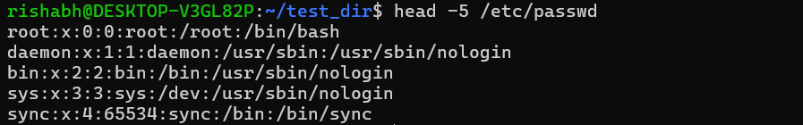
- Display only the last 5 lines of /etc/passwd using tail.
Tail command prints the last of the lines a files.
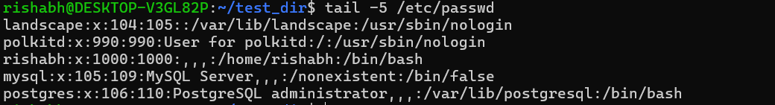

Searching for Patterns
- Use grep to find all lines containing the word “root” in /etc/passwd.
Grep used to search for specific text patterns or regular expressions within files or standard input streams.
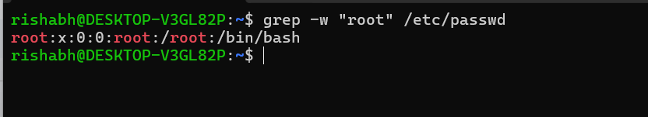
Zipping and Unzipping
- Compress the test_dir directory into a file named test_dir.zip using zip.
zip used to compress the file or directory.
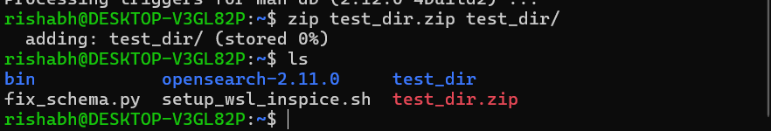
- Unzip test_dir.zip into a new directory named unzipped_dir.
Unzip command used uncompress the file or directory
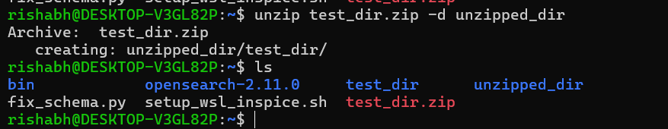
Downloading Files
- Use wget to download a file from a URL (e.g., https://example.com/sample.txt).
Wget command used download a file from a url.
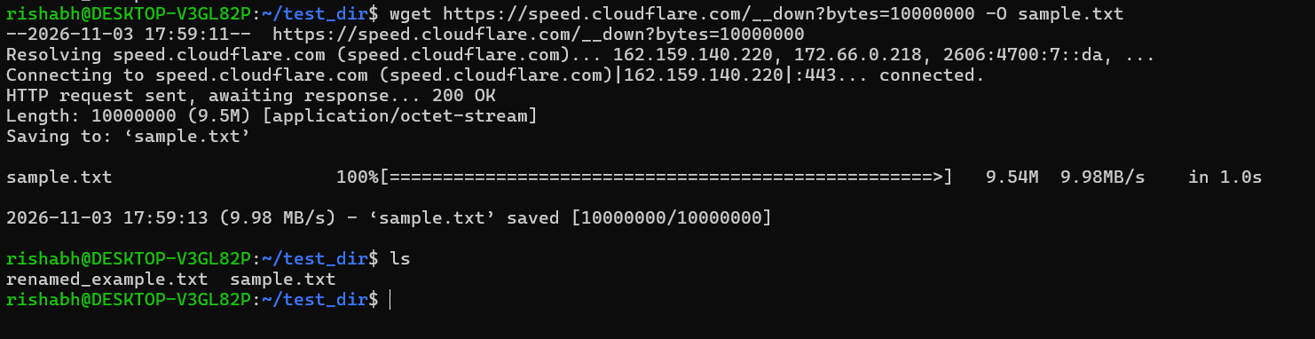
Changing Permissions
- Create a file named secure.txt and change its permissions to read-only for everyone using chmod.
Chmod command to change the permission of the file and dir.
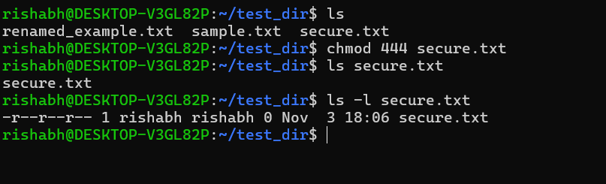
7. Working with Environment Variables
- Use export to set a new environment variable called MY_VAR with the value “Hello, Linux!”.
Export used as environment variable , reused same variable value every where.passed down to child process.


