SMS BASED HOME AUTOMATION

By: Rishabh Gupta

Introduction

Mobile phone is a revolutionary invention of the century. It was primarily designed for making and receiving calls

* text messages, but it has become the whole world after the Smart phone comes into the picture. In this project we are building a home automation system, where one can control the home appliances, using the simple **GSM** **based phone**, just by sending SMS through a phone. Inthis project, no Smart phone is needed, just the old GSM

phone will work to switch ON and OFF any home

electronic appliances, from anywhere.

**COMPONENTS USED :**

Arduino

Relay

GSM

**GSM Modem :**

The SIM900 is a complete Quad-band GSM/GPRS solution in a SMT module which can be embedded in the customer applications. Featuring an industry-standard interface, the SIM900 delivers GSM/GPRS 850/900/1800/1900MHz performance for voice, SMS, Data, and Fax in a small form factor and with low power consumption. With a tiny configuration of 24mm x 24mm x 3 mm, SIM900 can fit almost all the space requirements in your M2M application, especially for slim and compact demand of design.

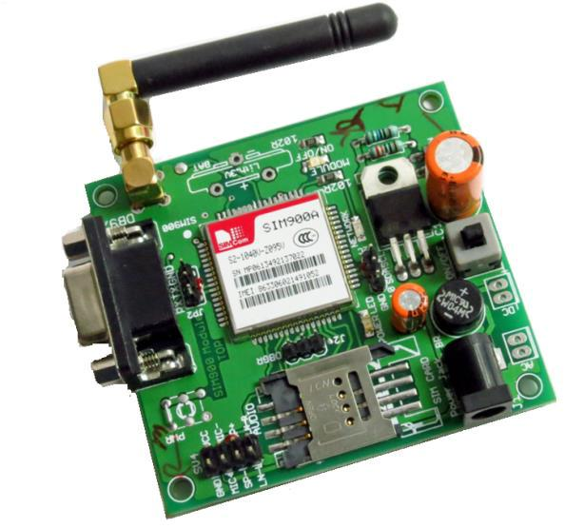

**RELAY :**

A relay is an electrically controllable switch widely

used in industrial controls, automobiles, and appliances.

Fig. below shows a SPDT relay-

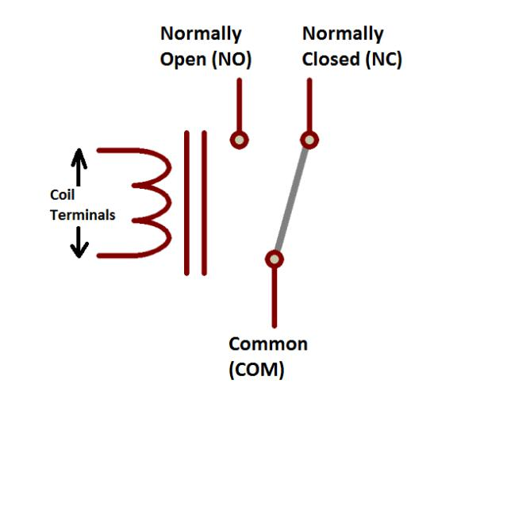

As shown in the above figure a SPDT relay has 5 terminals out of which two are for the coil, one for common, one for normally open contact and one for normally closed contact. When the coil terminal is energized then due to the magnetic force the common terminal contact is pulled from normally closed position to normally open position. A simple npn transistor can be used to energize the coil terminals of the relay.

Fig. below shows the connection diagram of BC547 transistor with the SPDT relay for controlling a lamp. A button is connected at the base terminal with a resistor R2. When the button is pressed then the emitter base junction gets forward biased and transistor switches to “ON” state. In this state the relay coil gets energized and the common terminal of the relay gets shifted to the normally open terminal where a lamp is connected. The common terminal is connected to the voltage at which it is desired to operate the device which is connected on the normally

open terminal. So the device will remain in the “ON” state till the button is in the pressed state. When the button is released then the emitter base junction will not get the enough forward bias voltage to turn the transistor to “ON” state and because of this the transistor switches to off state and the relay coil will get de- energized. The magnetic force collapses and the common terminal of the relay is pulled back to the normally closed position and the device switches to “OFF” state.

**Block Diagram**

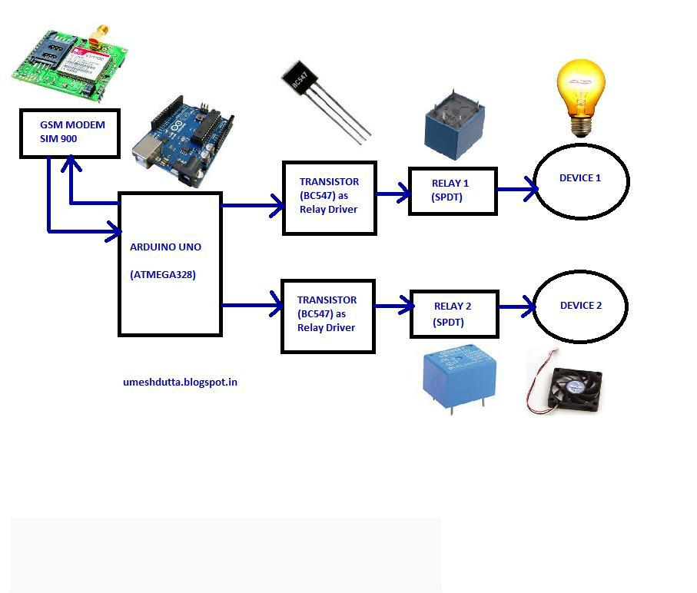

**Arduino**

**Arduino :**

It is an open source computer hardware and softwarecompany, project, and user community that designs and manufactures [single-board](https://en.wikipedia.org/wiki/Single-board_microcontroller)

[microcontrollers](https://en.wikipedia.org/wiki/Single-board_microcontroller) and [microcontroller](https://en.wikipedia.org/wiki/Microcontroller) kits for building digital devices and interactive objects that can sense and control objects in the physical and digital world. Arduino board designs use a variety of microprocessors and controllers. The boards are equipped with sets of digital and analog [input/output](https://en.wikipedia.org/wiki/Input/output) (I/O) pins that may be interfaced to various expansion boards

or [Breadboards](https://en.wikipedia.org/wiki/Breadboard) (*shields*) and other circuits. The boards feature serial communications interfaces, including [Universal Serial](https://en.wikipedia.org/wiki/Universal_Serial_Bus) [Bus](https://en.wikipedia.org/wiki/Universal_Serial_Bus) (USB) on some models, which are also used for loading programs from personal computers. The microcontrollers are typically programmed using a dialect of features from the programming languages [C](https://en.wikipedia.org/wiki/C_(programming_language)) and [C++](https://en.wikipedia.org/wiki/C%2B%2B). In addition to using traditional compiler toolchains, the Arduino project provides an [integrated development environment](https://en.wikipedia.org/wiki/Integrated_development_environment) (IDE) based on the [Processing](https://en.wikipedia.org/wiki/Processing_(programming_language)) language project.

Common examples of such devices intended for beginner hobbyists include simple [robots](https://en.wikipedia.org/wiki/Robot), [thermostats](https://en.wikipedia.org/wiki/Thermostat), and [motion](https://en.wikipedia.org/wiki/Motion_detector) [detectors](https://en.wikipedia.org/wiki/Motion_detector).

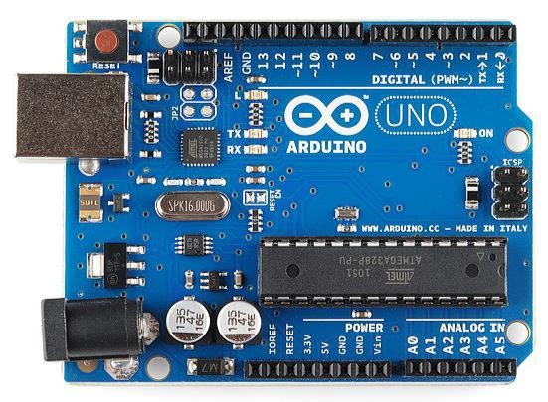

**Working :**

GSM module (SIM900) is interfaced with Arduino using serial pins (0 and 1). AT commands are sent to gsm modem for configuring it in sms mode and also to route the new incoming message to the serial reception pin of the arduino. The incoming message is decoded by the arduino and is compared with the predefined codes. If the match is found then the corresponding action for that code will be performed by the arduino.

Similarly for other codes the corresponding programmed functions are performed.

**ADVANCEMENTS AND FUTURE PROSPECT’S :**

The project can be extended by including the number sensitive feature in which SMS trigger from a particular mobile phone number will be accepted. For sending the SMS using android mobile phone an application can be designed for easy user interface. The system can also be equipped to give feedback messages indicating the status of all the appliances on demand and also on the successful execution of the issued command.

This also helps in Energy saving making it convenient for the user to switch on/off any electronic device from anywhere.

**APPLICATIONS :**

1. This help us in Energy saving making it convenient for the user to switch on/off any electronic device from anywhere.
2. Make life easy for old and disable people as it helps in controlling the room light so that they do not have to go towards the switch.
3. It is cost-efficient as it helps in saving electricity bill.