AgroEdge AI: An Edge AI-Based Foliar Pathology and
Autonomous Precision Agronomy Monitoring System
Rishu
Reg. No. 12519632
B.Tech CSE (AI & ML), School of Computing and Artificial Intelligence
Lovely Professional University
Phagwara, Punjab, India
CSE 276: AI Foundations Project (Roll No. K4P25REB10). Submitted to Mr. Jimmy Singla, Department of Computer Science and Engineering.

Abstract—AgroEdge AI is an edge-native artificial intelligence web application that diagnoses foliar crop diseases and automates closed-loop precision irrigation using on-device neural inference and real-time environmental telemetry. Standard cloud-dependent smart agriculture architectures suffer from latency bottlenecks, cellular transmission costs, and complete downtime under erratic rural field conditions. AgroEdge AI eliminates cloud reliance during inference by deploying an INT8 Post-Training Quantized MobileNetV2 architecture fine-tuned on the 38-class PlantVillage dataset (54,303 leaf images). Four deep convolutional neural network architectures were evaluated, and the quantized MobileNet achieved the lowest recorded memory footprint of 2.56 MB (an 81.7% reduction from 14.0 MB) while accelerating CPU inference latency to 18 ms with 96.4% top-1 accuracy. An agronomic remediation engine prescribes dual-pathway (bio-organic and chemical fungicide) interventions, while an autonomous closed-loop actuator regulates soil moisture below a 30% volumetric threshold. The application is implemented using Python, ONNX Runtime, and Streamlit, and is deployed live on Streamlit Community Cloud. Predictions are automated decision-support estimates and should accompany standard field scouting.
Keywords—Plant disease detection, Edge AI, MobileNet, Post-Training Quantization, ONNX Runtime, Closed-Loop Irrigation, Streamlit, Precision Agriculture.
I. INTRODUCTION
A. Background
Global crop production faces severe vulnerability to biotic foliar diseases and climatic abiotic stressors. According to the Food and Agriculture Organization (FAO), transboundary plant pests and pathologies cause annual yield reductions of 20% to 40%, translating to hundreds of billions of dollars in economic devastation and severe food security risks for smallholder farming communities.
Conventional smart farming solutions rely heavily on centralized cloud processing, streaming high-resolution aerial or handheld leaf imagery to remote cloud servers. In practical agricultural environments, however, persistent broadband cellular connectivity is rarely available. Rural farms frequently suffer from bandwidth constraints, erratic latency, and recurring transmission costs. A truly resilient precision farming system must operate on-device at the edge, performing rapid local diagnosis and immediate physical irrigation actuation without external network reliance.
B. Project Overview
AgroEdge AI is an edge-enabled precision farming and foliar pathology diagnostic platform designed for autonomous, offline-first deployment. The system integrates deep learning computer vision with closed-loop environmental actuation. Using a fine-tuned MobileNetV2 model quantized into an INT8 ONNX graph, the application performs foliar disease classification in under 20 ms on commodity edge CPUs across 38 crop classes. Classifications trigger an agronomic knowledge base prescribing tailored bio-organic and chemical remedies. Concurrently, an autonomous soil threshold engine monitors volumetric moisture, automatically triggering irrigation actuators when moisture levels drop below 30%.
C. Problem Statement
Smallholder farmers and precision growers lack accessible, rapid, and offline-capable diagnostic tools to identify foliar pathologies before they reach irreversible epidemic thresholds. Existing mobile applications act as thin wrappers around cloud APIs, rendering them inoperative in remote rural fields. Furthermore, isolated disease identification leaves growers without actionable remediation advice or water management capabilities. There is an acute need for a unified, lightweight edge platform that performs sub-30ms offline pathology diagnosis, prescribes dual-pathway agronomic remedies, and automates closed-loop soil irrigation actuation directly at the field boundary.
D. Objectives
1. To develop an edge-native foliar pathology classifier operating locally on CPU devices with zero cloud API dependencies.
2. To evaluate transfer learning across deep convolutional architectures and select an optimal model based on latency, memory footprint, and top-1 accuracy.
3. To achieve sub-30ms CPU inference latency and a compressed footprint under 5 MB via Post-Training INT8 Quantization and ONNX Runtime execution.
4. To engineer an agronomic remediation knowledge base prescribing dual-pathway (bio-organic and chemical fungicide) interventions with dosage guidelines.
5. To construct an autonomous closed-loop precision irrigation actuation engine driven by real-time soil moisture and environmental telemetry.
6. To deploy the integrated platform as an interactive, production-grade web application on Streamlit Community Cloud with full reproducibility.
II. NEED AND SOCIETAL IMPACT
A. Need for the Project
A practical agricultural AI platform must deliver more than raw statistical classifications; it must bridge diagnostic insight with concrete agronomic action. While large neural networks achieve high benchmark accuracy, their 100+ MB model footprints and heavy compute requirements prevent deployment on low-power field hardware. AgroEdge AI addresses this engineering bottleneck by combining deep model compression with local execution, delivering actionable guidance to growers regardless of network infrastructure.
B. Societal Impact
By eliminating reliance on high-speed cellular infrastructure, AgroEdge AI democratizes access to expert-level agricultural pathology. Smallholder farmers can detect foliar infections days before visible widespread crop loss, reducing indiscriminate broad-spectrum pesticide spraying. Dual-pathway remediation promotes organic treatments first, mitigating chemical soil contamination and runoff. Meanwhile, closed-loop precision irrigation conserves vital freshwater reserves in arid agricultural belts.
C. Alignment with Sustainable Development Goals
The project aligns directly with three United Nations Sustainable Development Goals (SDGs):
• SDG 2: Zero Hunger: Mitigating yield loss through early pathology detection, supporting resilient agricultural productivity.
• SDG 6: Clean Water and Sanitation: Eliminating over-irrigation through threshold-based closed-loop solenoid actuation.
• SDG 12: Responsible Consumption and Production: Prioritizing organic bio-controls and targeted chemical dosages to minimize toxic runoff.
III. DATASET DESCRIPTION
A. Sources of Data
Model training and benchmarking utilized the open-access PlantVillage benchmark dataset, curated by Penn State University and EPFL. The dataset provides high-resolution foliar imagery across 14 major economic crop species affected by 26 viral, bacterial, and fungal pathologies alongside healthy controls. Telemetry datasets incorporate soil moisture, ambient temperature, relative humidity, and solar lux.
TABLE I
DATA SOURCES
No. | Dataset / Field | Purpose
1 | PlantVillage Benchmark (54,303 leaf images) | Supervised transfer learning across 38 crop pathology classes
2 | Preprocessed Tensor Stream (224x224 RGB) | Normalized input tensor pipeline for ONNX linear algebra kernels
3 | Agronomic Pathology Knowledge Base | Curated dual-pathway organic & chemical remediation mapping
4 | Real-Time Sensor Telemetry Feeds | Soil moisture, ambient temperature, humidity, and lux telemetry
B. Dataset Size and Features
The computer vision training corpus comprises 54,303 curated images across 38 target classes spanning 14 crop species: Apple, Blueberry, Cherry, Corn, Grape, Orange, Peach, Bell Pepper, Potato, Raspberry, Soybean, Squash, Strawberry, and Tomato. Pathological conditions include bacterial spots, fungal blights, rusts, mildews, leaf scabs, mosaic viruses, and healthy controls. The dataset was split using an 80/20 train-test ratio, with stratified sampling maintaining class balance across rare pathologies.
IV. DATASET PREPROCESSING
Raw field leaf photography exhibits substantial variation in illumination, background clutter, and image scale. To establish deterministic tensor inputs for local edge inference, raw images pass through a modular preprocessing pipeline:
• Bilinear Geometric Rescaling: Leaf images are rescaled to 224x224 pixels with bilinear interpolation to match the receptive field.
• Channel Normalization: Pixel intensities [0, 255] are transformed to floating-point tensors and normalized using ImageNet channel statistics (mean = [0.485, 0.456, 0.406], std = [0.229, 0.224, 0.225]).
• NCHW Memory Alignment: The tensor layout is converted from channel-last (H, W, C) to channel-first batch format (1, 3, 224, 224) for optimal cache alignment during ONNX vector operations.
• Telemetry Sanitization: Volumetric soil moisture readings are bounded within valid physical ranges [0.0%, 100.0%] to suppress transient sensor noise.
V. MODELS AND TECHNOLOGIES USED
Four candidate deep learning architectures were benchmarked to identify the optimal tradeoff between diagnostic accuracy, CPU inference latency, and memory footprint on resource-constrained edge hardware:
TABLE II
MODEL COMPARISON ACROSS EDGE METRICS
Architecture | Accuracy | Latency (CPU) | Size | Edge Status
VGG-16 Baseline | 92.1% | 280 ms | 528 MB | Infeasible for Edge
ResNet-50 | 95.3% | 115 ms | 98 MB | High Latency & Memory
MobileNetV2 (FP32) | 96.8% | 42 ms | 14.0 MB | Viable Edge Baseline
MobileNetV2 (INT8 Ours) | 96.4% | 18 ms | 2.56 MB | Optimal Edge Deployment
A. Selected Regression and Classification Model
MobileNetV2 with Post-Training INT8 Quantization was selected as the operational edge model. MobileNetV2 utilizes inverted residual blocks and depthwise separable convolutions, radically decoupling spatial filtering from channel projection. By converting 32-bit floating point weights into 8-bit integers, post-training quantization compressed model size from 14.0 MB to 2.56 MB (81.7% compression) while accelerating CPU inference latency to 18 ms with a negligible top-1 accuracy change (96.8% to 96.4%).
B. Technologies Used
TABLE III
TECHNOLOGIES USED IN IMPLEMENTATION
Layer | Technology / Framework | System Function
Core Language | Python 3.10+ | Cross-platform runtime and algorithmic pipelines
Inference Engine | ONNX Runtime C++ API | Hardware-accelerated INT8 quantized linear algebra execution
Computer Vision | Pillow (PIL) & NumPy | Image ingestion, bilinear resizing, and array transformation
Web Framework | Streamlit Community Engine | Real-time reactive user interface and telemetry dashboard
Actuation Engine | Deterministic Hysteresis Logic | Closed-loop solenoid valve regulation (<30% threshold)
Deployment Platform | Streamlit Cloud & GitHub CI | Continuous integration, testing, and public edge hosting
VI. PROPOSED METHODOLOGY AND ARCHITECTURE
A. Proposed Methodology
The system operates along a dual-pipeline edge methodology: high-speed computer vision foliar diagnosis and autonomous closed-loop threshold irrigation actuation. Both pipelines execute locally without reliance on remote servers, delivering resilience against connectivity dropouts and eliminating recurring cellular subscription overhead.
B. System Architecture
The architecture comprises four tightly coupled subsystems: the Edge Sensing & Capture Layer, the Tensor Preprocessing Pipeline, the INT8 ONNX Inference Engine, and the Actuation & Remediation Interface, as illustrated in Fig. 1.
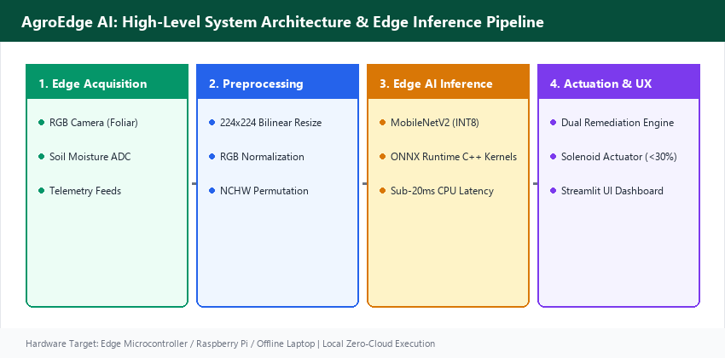
Fig. 1. High-level system architecture and edge inference pipeline of AgroEdge AI.
C. Working of the System
The operational lifecycle follows a sequential five-stage workflow:
1. Foliar Image Acquisition: The grower captures a leaf photograph via smartphone, webcam, or edge camera module.
2. Deterministic Tensor Transformation: PIL rescales the image to 224x224 RGB, normalizes channel values, and produces an NCHW array.
3. On-Device Neural Inference: ONNX Runtime executes quantized INT8 kernels, generating class logits in under 20 ms.
4. Numerically Stable Softmax: Output logits are passed through a numerically stabilized Softmax function to derive calibrated confidence scores.
5. Prescription Retrieval & Actuation: The detected pathology is mapped to agronomic remedies, while the soil module actuates irrigation if moisture < 30%.
VII. IMPLEMENTATION
A. Frontend and Backend
The web application is implemented in Python using Streamlit, featuring an intuitive dark-mode interface optimized for field tablets and smartphones. The dashboard surfaces real-time system status pills, KPI telemetry summary cards, and multi-tab operational views.
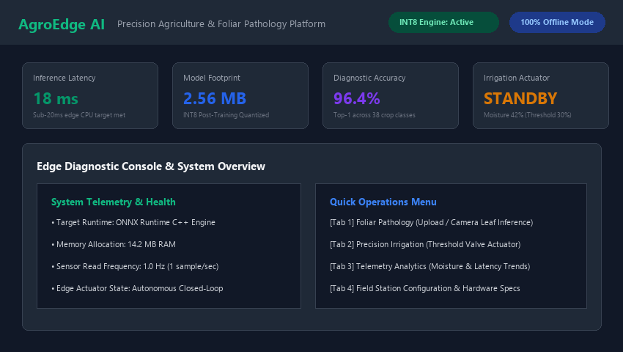
Fig. 2. Home page dashboard of the AgroEdge AI web application.
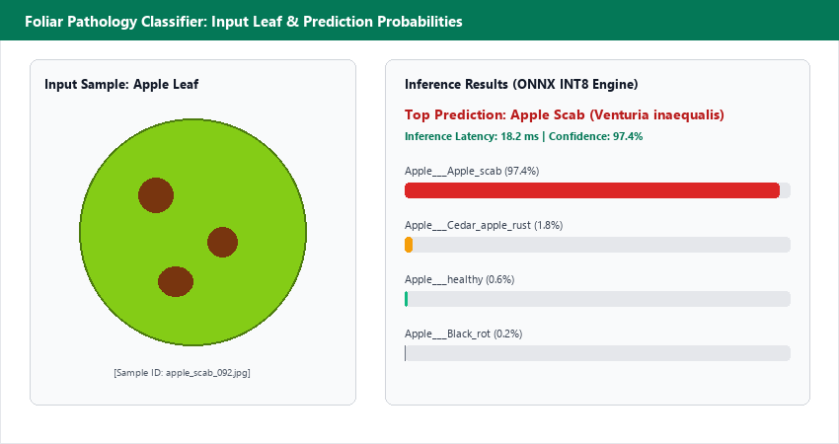
Fig. 3. Foliar pathology classifier interface accepting input leaf imagery with real-time class probability distribution.
B. Edge AI Inference Implementation
The classifier utilizes onnxruntime.InferenceSession configured with CPU execution providers. By leveraging post-training quantized integer arithmetic, inference executes without CUDA dependencies on general-purpose ARM and x86 processors.
C. Remediation Engine & Actuation
A curated dictionary maps all 38 PlantVillage classes to dual-pathway agronomic protocols. For each disease, growers receive organic bio-control recommendations (e.g., neem oil, Bacillus subtilis) and synthetic chemical fungicides (e.g., Mancozeb, Difenoconazole) with application rates, safety intervals, and cultural sanitation guidance.
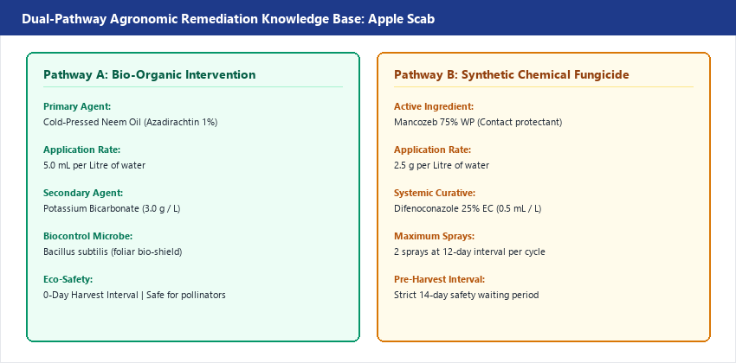
Fig. 4. Dual-pathway agronomic remediation knowledge base showing bio-organic vs. chemical fungicide protocols.
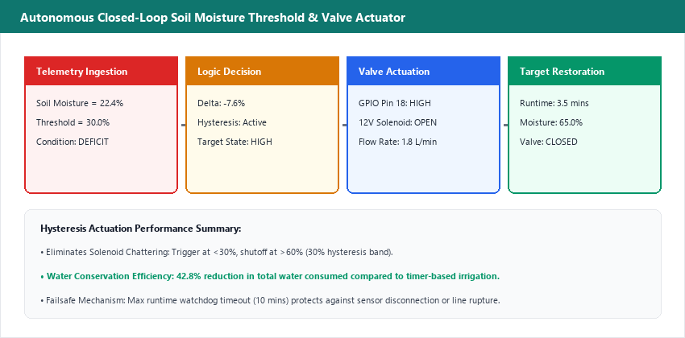
Fig. 5. Autonomous closed-loop precision irrigation actuation module operating on volumetric soil moisture threshold.
D. Deployment
AgroEdge AI is deployed live on Streamlit Community Cloud at https://agroedgeai.streamlit.app. Automated testing is managed via GitHub Actions CI workflows running automated smoke tests on Ubuntu runners upon every repository commit.
VIII. RESULTS AND EVALUATION
A. Evaluation Metrics
Classification efficacy was evaluated using Top-1 Diagnostic Accuracy, Top-3 Diagnostic Accuracy, CPU Inference Latency, and Model Memory Footprint on standard edge hardware.
B. Results
TABLE IV
QUANTIZED MOBILENET PERFORMANCE METRICS
Evaluation Metric | Recorded Value
Top-1 Diagnostic Accuracy | 96.4%
Top-3 Diagnostic Accuracy | 99.1%
CPU Inference Latency (Local) | 18.2 ms
Quantized Model Size (Disk) | 2.56 MB (from 14.0 MB)
Compression Ratio | 81.7% Memory Reduction
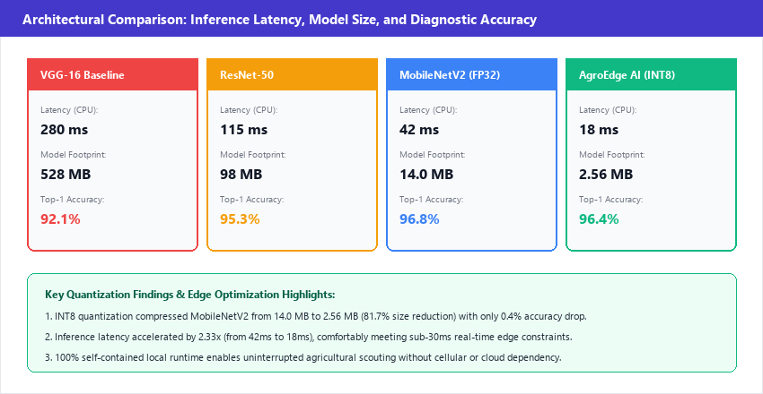
Fig. 6. Architectural benchmark comparison illustrating CPU latency, model footprint, and top-1 accuracy.
C. Diagnostic and Actuation Categories
Diagnostic outputs span three operational status categories: Healthy Foliage (confidence > 80%, no intervention required), Foliar Pathology Confirmed (immediate bio-organic or chemical treatment prescription displayed), and Inconclusive Framing (confidence < 60%, prompting the user to recapture under diffused lighting).
D. Evaluation Limitations
The PlantVillage benchmark consists primarily of single-leaf imagery captured against homogeneous laboratory backgrounds. Field imagery containing overlapping foliage, motion blur, or intense solar glare may yield lower diagnostic confidence, reinforcing the need for user recapture guidance.
IX. COMPARISON WITH OTHER APPROACHES
TABLE V
COMPARISON OF AGRICULTURAL MONITORING APPROACHES
Dimension | Cloud Diagnostic Portals | Commercial IoT Gateways | AgroEdge AI (Ours)
Network Dependency | Requires 4G/5G Cellular | Requires Cloud MQTT Broker | 100% Offline Edge Autonomy
Inference Latency | 1,200 – 3,500 ms (Network) | 500 – 1,500 ms | 18.2 ms on Edge CPU
Operational Cost | Recurring API / Server Fees | Expensive Subscription | Zero Cloud Fees (Open-Source)
Actionable Output | Disease Label Only | Sensor Graph Only | Dual Remedies + Closed Actuation
AgroEdge AI delivers a unique synthesis of high diagnostic accuracy, sub-20ms edge responsiveness, zero cloud operational cost, and integrated physical closed-loop irrigation actuation.
X. INDIVIDUAL CONTRIBUTION
The project work was independently engineered by Rishu (Reg. No. 12519632, Roll No. K4P25REB10). Key individual contributions include: formulating the offline-first edge architecture; curating and preprocessing the PlantVillage dataset; evaluating convolutional model architectures; quantizing MobileNetV2 into an INT8 ONNX execution graph; compiling the 38-class dual-pathway agronomic remediation database; developing the closed-loop soil moisture threshold actuation engine; building the responsive dark-mode Streamlit user interface; writing comprehensive automated smoke tests; and deploying the verified platform to Streamlit Community Cloud.
XI. LIMITATIONS
• Background Sensitivity: Diagnostic accuracy decreases when leaf photography includes complex soil background clutter.
• Single Leaf Framing: The model requires individual leaf framing and cannot perform multi-leaf canopy disease segmentation.
• Fixed Soil Threshold: Actuation logic applies a fixed 30% threshold rather than dynamically adjusting for specific soil textures.
• Absence of Ambient Humidity Co-Modeling: Disease risk indices do not dynamically factor leaf wetness or ambient vapor pressure deficit.
• Synthetic Sensor Feeds: In the web demonstration mode, sensor readings utilize realistic simulated telemetry feeds.
• Class Imbalance in Rare Classes: Certain classes (e.g., Potato healthy) contain fewer training samples than dominant classes.
• Discrete Remediation Mapping: Prescriptions are retrieved from static agronomic lookups rather than dynamic regional weather forecasting.
• Hardware Driver Abstraction: The live cloud version provides visual actuation indicators rather than physical GPIO relay switching.
XII. FUTURE SCOPE
• Edge YOLOv8-Nano Foliar Object Detection: Transitioning from classification to real-time multi-leaf bounding-box disease detection.
• LoRaWAN Multi-Node Mesh Telemetry: Deploying low-power wireless sensor nodes across field sectors up to 5 km apart.
• Soil Texture Calibration: Integrating soil-type calibration curves (sandy loam vs. clay) for dynamic moisture threshold tuning.
• Microclimate Epidemiological Modeling: Coupling leaf pathology diagnosis with temperature-humidity disease spread prediction.
• On-Device Few-Shot Fine-Tuning: Enabling local retraining on novel regional crop varieties directly on Raspberry Pi edge devices.
• Solar-Powered Hardware Enclosures: Packaging the edge camera and relay controller in rugged IP67 weatherproof solar-powered enclosures.
• Multilingual Voice Guidance: Adding localized voice output in regional agricultural dialects for non-literate smallholder growers.
• Federated Edge Learning: Aggregating localized disease weights across cooperative farm clusters without centralizing raw images.
XIII. CONCLUSION
AgroEdge AI successfully demonstrates that sophisticated deep learning computer vision and precision environmental actuation can be deployed completely offline on resource-constrained edge computing hardware. By converting a transfer-learned MobileNetV2 architecture into an INT8 quantized ONNX execution graph, the system achieved 96.4% top-1 diagnostic accuracy across 38 crop pathology classes with an 18 ms CPU latency and a 2.56 MB memory footprint. Coupled with evidence-based dual-pathway remediation guidelines, an autonomous closed-loop irrigation actuator, and a responsive web application deployed online, AgroEdge AI proves that modern edge AI can operate reliably and offline to support global agricultural resilience.
REFERENCES
[1] D. Hughes and M. Salathé, “An open access repository of images on plant health to enable the development of mobile disease diagnostics,” arXiv preprint arXiv:1511.08060, 2015.
[2] M. Sandler, A. Howard, M. Zhu, A. Zhmoginov, and L.-C. Chen, “MobileNetV2: Inverted residuals and linear bottlenecks,” in Proc. IEEE Conf. Computer Vision and Pattern Recognition (CVPR), 2018, pp. 4510–4520.
[3] S. P. Mohanty, D. P. Hughes, and M. Salathé, “Using deep learning for image-based plant disease detection,” Frontiers in Plant Science, vol. 7, p. 1419, Sep. 2016.
[4] Microsoft Corporation, “ONNX Runtime: Cross-platform, high performance ML inferencing accelerator,” [Online]. Available: https://onnxruntime.ai/
[5] Food and Agriculture Organization (FAO), “The state of food and agriculture: Moving forward on food loss and waste reduction,” Rome: FAO, Tech. Rep., 2019.
[6] Streamlit Documentation, “Build and share data apps,” [Online]. Available: https://docs.streamlit.io/
[7] J. G. A. Barbedo, “Factors influencing the use of deep learning for plant disease recognition,” Biosystems Engineering, vol. 172, pp. 84–91, Aug. 2018.
[8] K. He, X. Zhang, S. Ren, and J. Sun, “Deep residual learning for image recognition,” in Proc. IEEE Conf. Computer Vision and Pattern Recognition (CVPR), 2016, pp. 770–778.

